

**Research Paper**

**On**

**Smart CCTV System**

Department of Computer Science and Technology

Sharda University

Greater Noida, Knowledge park-III, India

**Smart CCTV System**

# SagarPandey1•SarahIrshad2•SanjayKumarSingh3

**Abstract**

At this time, one of the most crucial aspects of human life is security. Homes are frequently left unattended due to complex activities. Most individuals use CCTV (Closed Circuit Television) cameras to protect their homes when they are away from home. In smart cities, the footage captured by surveillance cameras is critical for crime prevention and investigation. Because the camera only records without analyzing objects, traditional Video surveillance is less effective. The sensor  camera's purpose is to reflect progress in the motion of entities that are observable to the camera, in this situation, physical movements. This camera's reliable monitoring mechanism can detect approaching items. The adaptive background removal technology proposed in this paper can accommodate to frame changes. The prior background intensity inference will always be used to update the background frame. It will then analyze the method's effectiveness. Along with motion detection, it will only record moving frames, allowing the system to make the most of its capacity.

***Keywords:*** *CCTV surveillance storage optimization, motion detection,*

*background differencing, denoising image using morphology*

# B

# Sagar Pandey: 2019005070.sagar@ug.sharda.ac.in

# Sarah Irshad: [2019574108.sarah@ug.sharda.ac.in](mailto:2019574108.sarah@ug.sharda.ac.in)

# Sanjay Kumar Singh: [2019001156.sanjay@ug.sharda.ac.in](mailto:2019001156.sanjay@ug.sharda.ac.in)

1. Department of computer science and Technology Sharda University Greater Noida Knowledge Park III, India

2.Department of Computer Science and Technology Sharda University Greater Noida Knowledgepark III,India

3.Department of Computer Sciences and Technology, Sharda University Greater Noida , Knowledge park III, India

# Introduction

Nowadays, one of the most popular fields of research is the tracking and monitoring of public human traits. CCTV surveillance systems are capable of permitting a broad variety of applications with a variety of features. In order to improve the technology of the surveillance system, it is essential for the organization to be capable of comprehending what is going on. Most people currently safeguard their dwellings by installing Security cctv systems (Closed Circuit Television). Because conventional CCTV primarily records occurrences without explaining what happened during the filming, this security system is less effective [2]. The disadvantages of this surveillance system can be overcome by designing adaptive background subtraction as well as adding a human presence detection approach. The system will work with this method by detecting the movement of an object, which in this instance is human movement. The identification of this object happens in real time and can be used to monitor a room or environment.

The challenge with object detection is there are multiple disturbances due to the dynamic of the background, including involves based on light intensity as well as the motion of small objects which should not be considered entities. Because this disorder can impact identification outcomes, background parameterization should be modified to compensate for it. So that it can distinguish between the baseline and the objects that will be adequately detected. The image pixels of all frames in a succession are taken into consideration by adaptive background. A Gaussian Mixture Models (GMM) strategy is recommended if the detected information is overbearing and the real interruption is now in the forefront. .

There are several methods used for object detection in previous studies[1,4,6]. Identification of optical flow, pattern matching, background subtraction, and other techniques are among those. Item identification using the dynamic thresholding technique method[2] has been intensively investigated. Some previous studies that have been done include; Active Background Modeling Using the Gaussian Mixture Models. Image enhancement on security camera systems with push notifications to Smart phones employing the dynamic motion detection algorithm methodology. Adaptive Background Subtraction is used to implement Visual Object Tracking on an FPGA. Adaptive Background Subtraction is used to track and detect objects. A Flexible Background[4]. Sensors. Adaptive Background Subtraction Method for Detection And tracking is a new approach to object localization. Kernel Density Estimation-Based Subtraction Method Sensors. Adaptive Background Subtraction Method for Object Detection and Tracking is a novel approach to object detection and tracking. Humans Motion Built on a Background Subtraction Algorithm Moving detection uses an iterative background updates to detect moving objects. Based on earlier work, this work focuses on a moving object detection that can be accomplished in real time from the movement of objectsThe Gaussian mixture model was used to do adjustable thresholding technique. This paradigm is used to modify the backdrop so that it can adapt to continuous changes in the environment, such as effects of light or micro object movement. That should be able to reduce or ignore. The automatic system will then regularly change the parametric model.

Methodology

The proposed method is a foreground subtraction-based motion detection algorithm. Figure 1 depicts a flowchart of the technique. The method is divided into 5 parts: Background (BG)/Foreground (FG) classification of backdrop specimens [4], large components check, store interesting , and post-processing.

**Background Subtraction**:

The backdrop sample module saves and collects backdrop samples which are used to distinguish among high contrast objects. [4]. The BG/FG classification module detects if the present input image is foreground or background by computing the distance between it and the backdrop samples. Background subtraction is a technique for detecting foreground items that compares and contrasts frames and finds differences. Basically, the difference value is compared to the threshold value.

The threshold value is computed using a number of the first frameworks for understanding, rather than being predefined. If the disparity exceeds the threshold value, the image will be classified as an object, while the reverse will be classified as a background picture.

While True

Read Video Frame by Frame

Create Foreground mask and Denoise image

Keep only the large components in foreground mask

5 Consecutive frame detected

Yes

Save the screen to the list

No

No

Escape key press

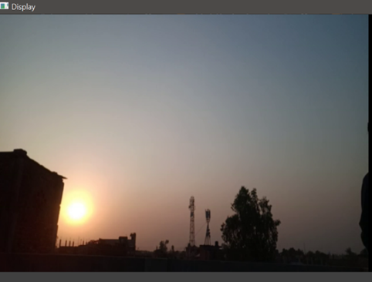

**Figure1**. BACKGROUND

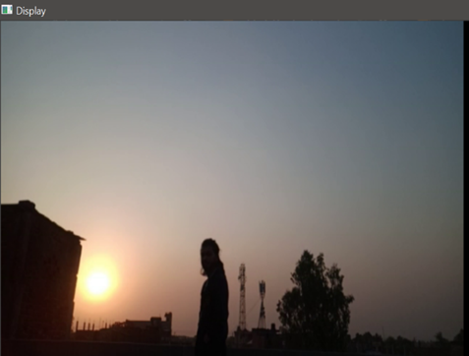

**Figure2**. FOREGROUND

**Denoising Using morphology:**

Image denoising is the act of eliminating noise from a noisy image and reconstructing the original image. Moreover, given noise, edge, and texture are all high-frequency components, identifying them it during de-noising process can sometimes be challenging. and the denoised photos will definitely lose some details. Ultimately, recovering meaningful information from noisy photos during the noise filtering process in order to obtain high-quality images is a big problem nowadays.

In current history, a morphological component analysis method [8] has been suggested and extensively applied in visual analysis. The basic purpose of morphological decomposition method is to decompose visual material into different pieces such as smoothness, texture, and coherence. Because DCT is a facility that can properly exhibit periodic signals, we use it to execute DCT on image blocks and thereafter classify them into different morphological components based on the energies of the alternating (AC) components.. We're utilizing morphology-based picture denoising in this case.

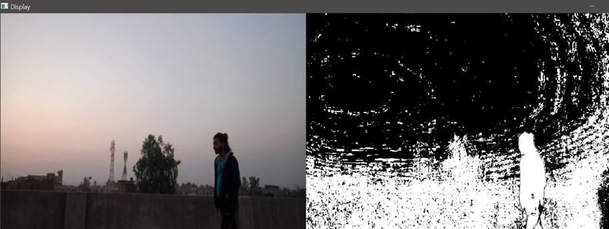

**Figure3**.Noisyimage

Image denoising


**Figure 4** Denoised image

**Optimal Storage**

Abstract-Footage storage is always an issue, particularly when it comes to visual data from Surveillance cameras, which requires a great deal of capacity. The transmission as well as storage of large - scale data volumes in the form of frames and images is a part of image compression. Several scholars [2–7] focused on reducing capacity requirements, whereas others focused on storage efficiency optimization. Because a large amount of data is produced in today's day and age [5], obtaining the necessary information from large large datasets is a difficult task, and preserving high data volumes is an issue. This paper proposes a novel method for motion detection and video storage optimization that does not serve as sources sensors. In this model the CCTV footage is first being.

|  |  |
| --- | --- |
| **Size of video sample before applying model** | **Size of video after applying model** |
| 274mb | 112mb |
| 587mb | 218mb |

Significant optimization was found when the proposed strategy was applied to CCTV camera stored footage. Because the CCTV tape showed little activity, a film with a running time of 268.741 minutes was reduce to 32.25 minutes. The source video had a total of 32,249 frames, however only 3,714 were kept after the superfluous frames were discarded. The whole framing capacity was decreased by 80.4 percent in terms of percentage. Due to the use of a specific color channel for motion detection, the suggested technique outperforms conventional methods by saving several calculations. Moreover, the suggested technique used frame scatter plot to speed it up the calculation procedure. In particular, the proposed approach method is dynamic in nature, due to its adaptive threshold and it achieved a significant reduction in storage needs.

**Result and Conclusion**

This study investigated a video optimization method that decreased storage capacity by disregarding frames with negligible data. The proposed motion detection approach generates a significant information frame. The proposed intrusion detection approach is associated with the reduction of background adaptive, as per the findings of the study and discussion. Capable of object detection and tracking and responding to subtle changes. The suggested technique for modelling the background can adjust well to background changes throughout the day, which modifies the illuminance. As a result, this model is the best option for business CCTV cameras that require a lot of storage.

# References

[1] Dhaya, R., 2020. CCTV Surveillance for Unprecedented Violence and Traffic

Monitoring. *Journal of Innovative Image Processing (JIIP)*, *2*(01), pp.25-34.

[2] Atif, M., Khand, Z.H., Khan, S., Akhtar, F. and Rajput, A., 2021. Storage Optimization using

Adaptive Thresholding Motion Detection. *Engineering, Technology & Applied Science*

*Research*, *11*(2), pp.6869-6872.

[3] Nurhopipah, A. and Harjoko, A., 2018. Motion detection and face recognition for cctv

surveillance system. *IJCCS (Indonesian Journal of Computing and Cybernetics*

*Systems)*, *12*(2), pp.107-118

[4] Miranto, A., Sulistiyanti, S.R. and Setyawan, F.A., 2019, July. Adaptive Background Subtraction

for Monitoring System. In *2019 International Conference on Information and Communications*

*Technology (ICOIACT)* (pp. 153-156). IEEE.

[5] Sedky, M.H., Moniri, M. and Chibelushi, C.C., 2005, September. Classification of smart video

surveillance systems for commercial applications. In *IEEE Conference on Advanced Video and*

*Signal Based Surveillance, 2005.* (pp. 638-643). IEEE.

[6] binti Harum, N., Ali, M.F., Zakaria, N.A. and Anawar, S., 2018. Smart Surveillance System using

Background Subtraction Technique in IoT Application. *Int. J. Adv. Comput. Sci. Appl*, *9*(12),

pp.122-128.

[7] Khan, P.W., Byun, Y.C. and Park, N., 2020. A data verification system for CCTV surveillance

cameras using blockchain technology in smart cities. *Electronics*, *9*(3), p.484.

[8] Hou, Y. and Shen, D., 2018. Image denoising with morphology-and size-adaptive block-matching

transform domain filtering. *EURASIP journal on image and video processing*, *2018*(1), pp.1-16.