ICP 1 Report

**Team Members**

* [Ashish Pant](https://github.com/akkipant/IoT-Fall-2019)
* [Prerana Samant](https://github.com/preranasam/IoT/wiki/ICP_1_lesson_1)
* [Shufeng LI](https://github.com/sflcoder/IoT)

**Introduction-Spaceship Interface and Traffic Light**

Arduino is a Micro-Controller used to preform IoT, signaling and many more tasks. We used it to make spaceship-like blinking lights and Traffic Signal. We used Arduino UNO and other basic Electronic components to complete this ICP.

**Objective**

Make Spaceship lights using LEDs. Make Traffic Light using LEDs.

**Approaches**

Connect all the components as per the Circuit Diagram. Program the Arduino UNO using the Arduino IDE. Do changes in the program as required like changing the value for delay.

**Workflow**

In our code, we first initialize pins 3,4 and 5 as the output pins and pin 2 as an input pin. After that, we changed resistor values to make led brighter in the circuit. Finally, for our second ICP task, we change the program to blink led in order of traffic lights (Red than Green than Amber for the small duration). We change the Power for the pins using High(1) or Low(0) values in our program. Also, we declared int datatype variable so that delay can be controlled by only one variable.

**Circuit Diagram**

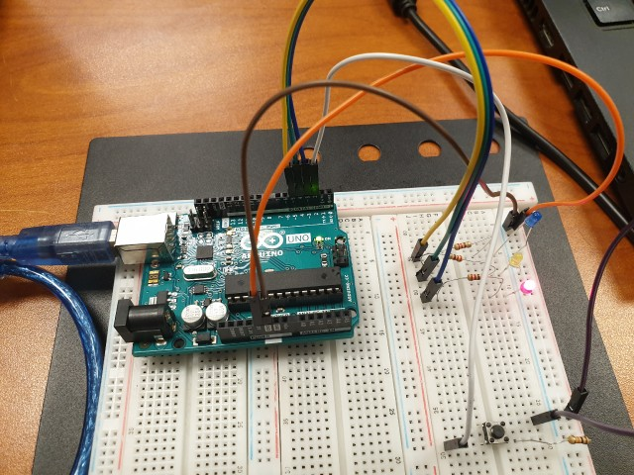 [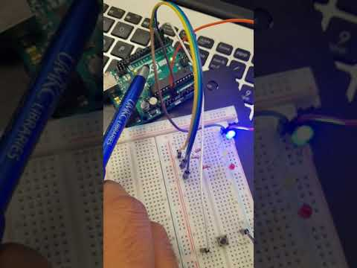](https://www.youtube.com/watch?v=uC098Va-McA)

**Parameters**

For the first ICP task, we changed the delay to observe the blinking pattern. For the second one, we had to only change variable "dlay" so all other delays were changed accordingly.

**Evaluation & Conclusion**

Doing this ICP gave us a very basic syntax idea and basic functionality of Arduino, which can help us to do more complex projects in the future. In conclusion, this ICP is one of the most important basic pillar for upcoming ICPs and there is always a better/efficient program than the current one.