Task 1: Key-Value Pairs
Create person.yaml that describes yourself with:
- name
- role
- experience_years
- learning (a boolean)
Verify: Run cat person.yaml — does it look clean? No tabs?

Person.yaml
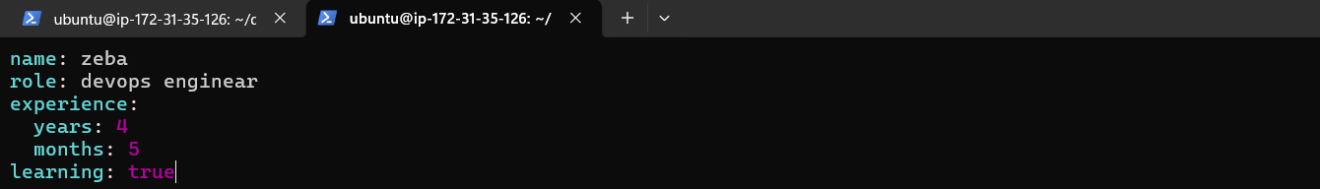

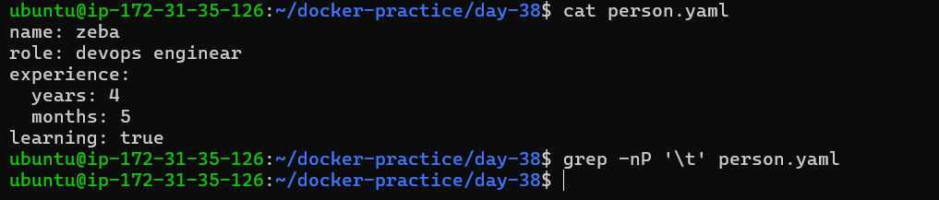

grep -Np ‘\t’ person.yaml

grep – search for the patterns inside the file,
grep [option] [pattern] [filename]
-n – shows the line number
-P – tells grep to use Perl Compatible Regular Expressions (PCRE)
normal regular-expression mode doesn't interpret \t , -P allows us to use \t as the TAB character.
‘\t’ – pattern we are searching for, TAB CHARACTER

Task 2: Lists
Add to person.yaml:
- tools — a list of 5 DevOps tools you know or are learning
- hobbies — a list using the inline format [item1, item2]
Write in your notes: What are the two ways to write a list in YAML?
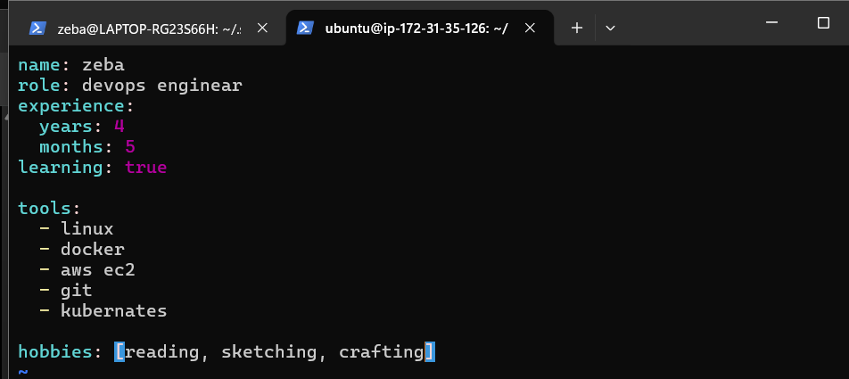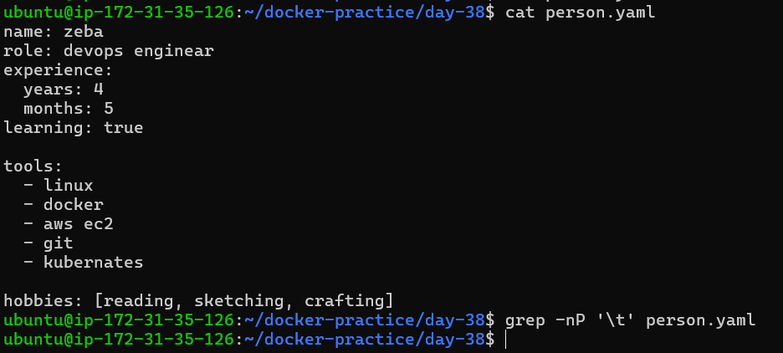
YAML supports two common ways to write lists:
1. **Block-style list** — each item is written on a separate line using `-`.
tools:
- linux
- docker
- git

- Inline (flow-style) list — items are written inside [ ] and separated by commas.
hobbies: [reading, sketching, crafting]

Task 3: Nested Objects
Create server.yaml that describes a server:
- server with nested keys: name, ip, port
- database with nested keys: host, name, credentials (nested further: user, password)
Verify: Try adding a tab instead of spaces — what happens when you validate it?

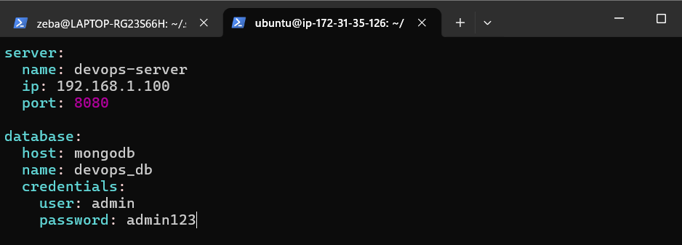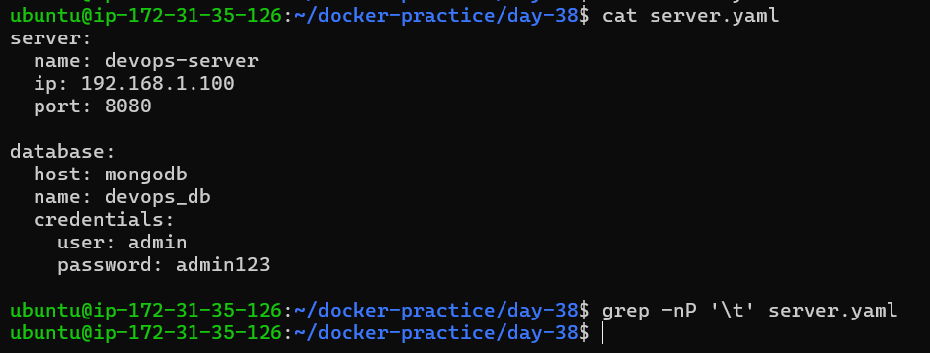

Task 4: Multi-line Strings
In server.yaml, add a startup_script field using:
- The | block style (preserves newlines)
- The > fold style (folds into one line)
Write in your notes: When would you use | vs >?

| - the following lines are one value but keep them separate
> - the following lines are one value so join the values in one sentence

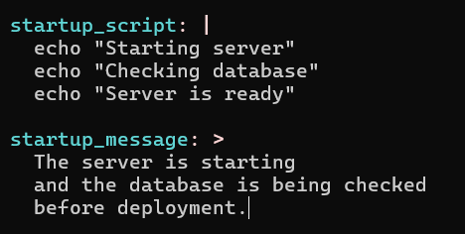
| — keep the lines separate
> — join the lines

YAML provides two useful styles for multi-line strings:
- `|` → keeps the new lines. It is useful for scripts or text where line breaks are important.
- `>` → joins/folds the lines together. It is useful for long text or messages where line breaks are not important.
In short:

`|` → keep new lines

`>` → join new lines
Task 5: Validate Your YAML
- Install yamllint or use an online validator
- Validate both your YAML files
- Intentionally break the indentation — what error do you get?
- Fix it and validate again
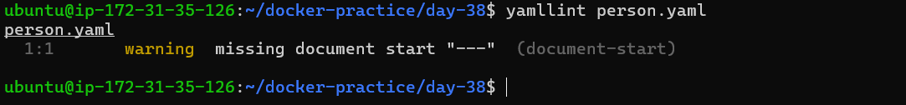
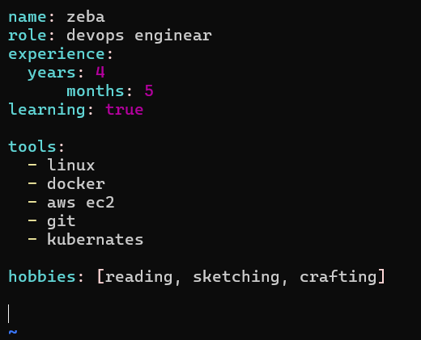
Given 4 tabs to months and added 2 blank lines at last
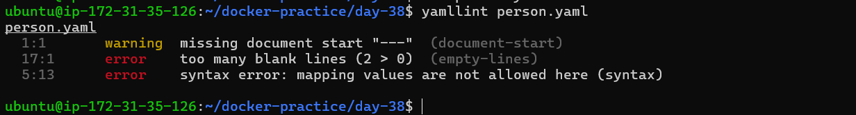

Task 6: Spot the Difference
Read both blocks and write what's wrong with the second one:

# Block 1 - correct
name: devops
tools:
- docker
- Kubernetes

# Block 2 - broken
name: devops
tools:
- docker
- kubernetes

Answer:
The - items are indented 2 spaces under tools:.
The second block has incorrect indentation. The list items under `tools` should be indented consistently. In Block 2, `- docker` is not indented while `- kubernetes` is indented.

