Task 1: Recall the Kubernetes Story
Before touching a terminal, write down from memory:
- Why was Kubernetes created? What problem does it solve that Docker alone cannot?
- Who created Kubernetes and what was it inspired by?
- What does the name "Kubernetes" mean?
Do not look anything up yet. Write what you remember from the session, then verify against the official docs.

- Why was Kubernetes created? What problem does it solve that Docker alone cannot?
- Docker can create and rrun the containers but if we have 100s or 1000s of containers then it will be difficult to manage them across multiple servers.
So Kubernetes came into picture it can manages the containers.
Kubernetes was created to solve the problem of container orchestration, it helps with things like
- Deploying containers across multiple servers
- Restarting failed containers (self healing)
- Scaling up and down (auto scaling)
- Load balancing traffic
- Rolling out updates

- Who created Kubernetes and what was it inspired by?
- Kubernetes was created by google, and it is inspired by the borg – it is google’s internal container-management tool

- What does the name "Kubernetes" mean?
- Kubernetes came from Greek word helmsman that means ship captain, who navigates/steers the ships

Task 2: Draw the Kubernetes Architecture
From memory, draw or describe the Kubernetes architecture. Your diagram should include:
Control Plane (Master Node):
- API Server — the front door to the cluster, every command goes through it
- etcd — the database that stores all cluster state
- Scheduler — decides which node a new pod should run on
- Controller Manager — watches the cluster and makes sure the desired state matches reality
Worker Node:
- kubelet — the agent on each node that talks to the API server and manages pods
- kube-proxy — handles networking rules so pods can communicate
- Container Runtime — the engine that actually runs containers (containerd, CRI-O)
After drawing, verify your understanding:
- What happens when you run kubectl apply -f pod.yaml? Trace the request through each component.
- What happens if the API server goes down?
- What happens if a worker node goes down?

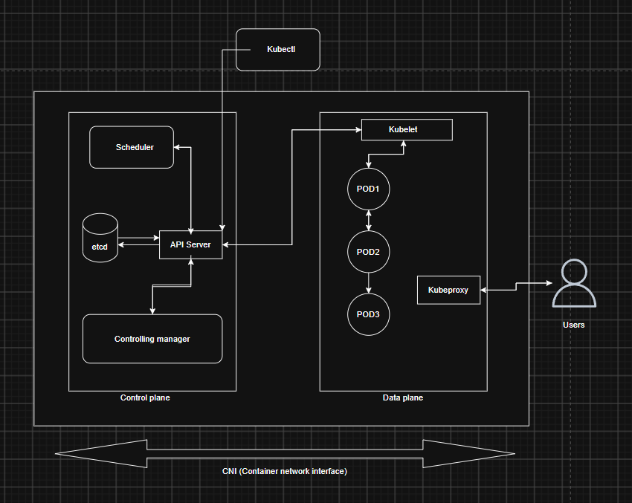
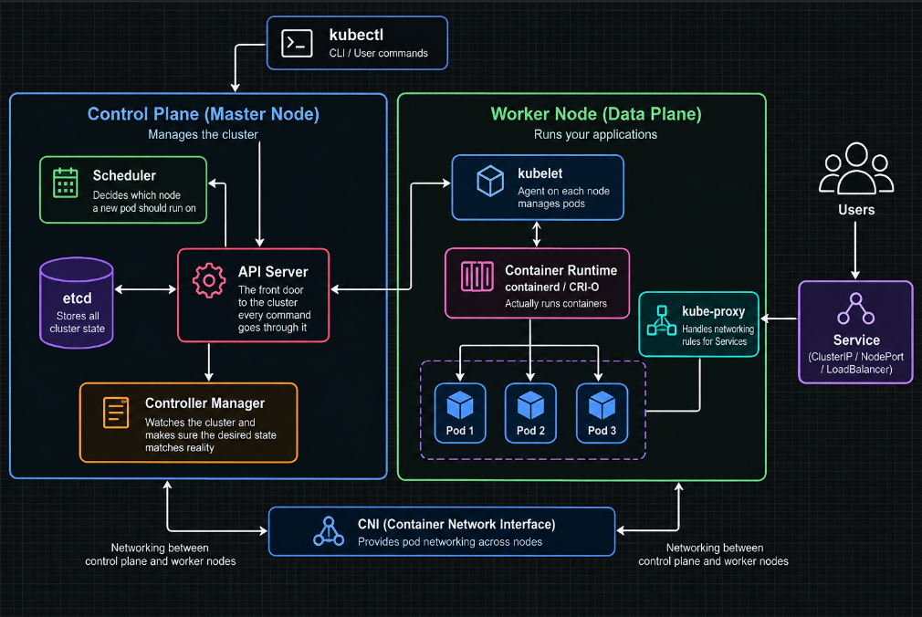
- Kubeclt – CLI/ user commands
- API Server – front door to the cluster, every command goes through it
- Scheduler - Decides which node a new pod should run
- etcd – database which stores cluster state
- controller manager – it watches and manages the cluster
- kublet – agent on each node manages the pods
- container runtime – engine that runs the containers . containerd, CRI-O
- Kube proxy – handles networking rules so pods can communicate

What happens when you run kubectl apply -f pod.yaml? Trace the request through each component.
- kubectl apply -f pod.yaml(you) -> API server -> etcd -> scheduler(selects suitable worker node) -> API Server -> kublet -> Container runtime -> container starts inside the pod

What happens if the API server goes down?
- If API server goes down then communication between Kubernetes API operations and control plane disrupts
- But the pods running wont stop as those ware controlling locally by kublet and container runtime
- You wont be able to manage the clusters using kubeclt until API server comes up

What happens if a worker node goes down?
- If a worker node goes down then the pods won’t be able to run on that node
- Kubernetes detect the node as unhealthy NotReady and tries to restore the workload that ware running in that node.
- If those Pods are managed by a controller such as a Deployment, Kubernetes works toward the desired replica count and the Scheduler can place replacement Pods on healthy nodes.
- A standalone Pod doesn't have a controller to maintain replicas for it.

Task 3: Install kubectl
kubectl is the CLI tool you will use to talk to your Kubernetes cluster.
Install it:
# macOS
brew install kubectl

# Linux (amd64)
curl -LO "https://dl.k8s.io/release/$(curl -L -s https://dl.k8s.io/release/stable.txt)/bin/linux/amd64/kubectl"
chmod +x kubectl
sudo mv kubectl /usr/local/bin/

# Windows (with chocolatey)
choco install kubernetes-cli
Verify:
kubectl version --client

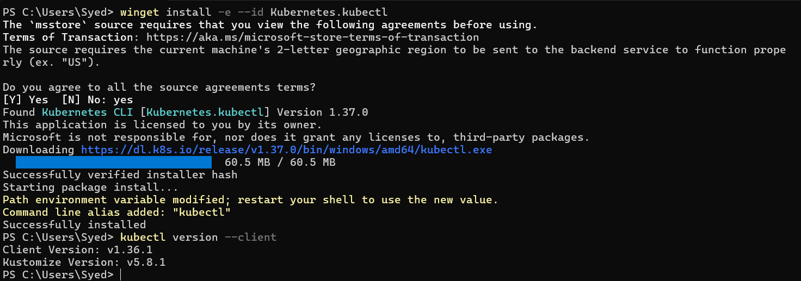

Task 4: Set Up Your Local Cluster
Choose one of the following. Both give you a fully functional Kubernetes cluster on your machine.
Option A: kind (Kubernetes in Docker)
# Install kind
# macOS
brew install kind

# Linux
curl -Lo ./kind https://kind.sigs.k8s.io/dl/latest/kind-linux-amd64
chmod +x ./kind
sudo mv ./kind /usr/local/bin/kind

# Create a cluster
kind create cluster --name devops-cluster

# Verify
kubectl cluster-info
kubectl get nodes
Option B: minikube
# Install minikube
# macOS
brew install minikube

# Linux
curl -LO https://storage.googleapis.com/minikube/releases/latest/minikube-linux-amd64
sudo install minikube-linux-amd64 /usr/local/bin/minikube

# Start a cluster
minikube start

# Verify
kubectl cluster-info
kubectl get nodes
Write down: Which one did you choose and why?
- Choice: kind (Kubernetes in Docker)
I chose kind because I already have Docker Desktop running on my Windows laptop with the WSL 2 backend.
kind allows me to run a Kubernetes cluster locally using Docker containers as Kubernetes nodes. This makes it lightweight and convenient for learning and practicing Kubernetes locally.
I can also create multi-node clusters later to practice concepts such as worker nodes, scheduling, networking, and node failures.

Kind installed
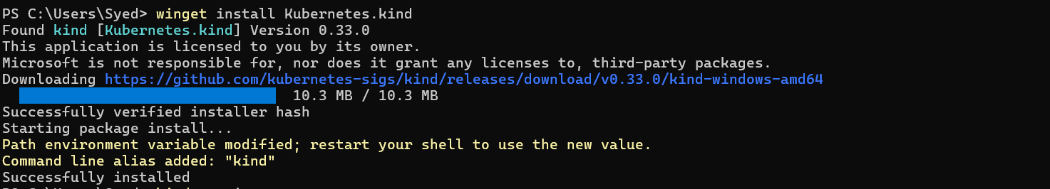

# Create a cluster
kind create cluster --name devops-cluster
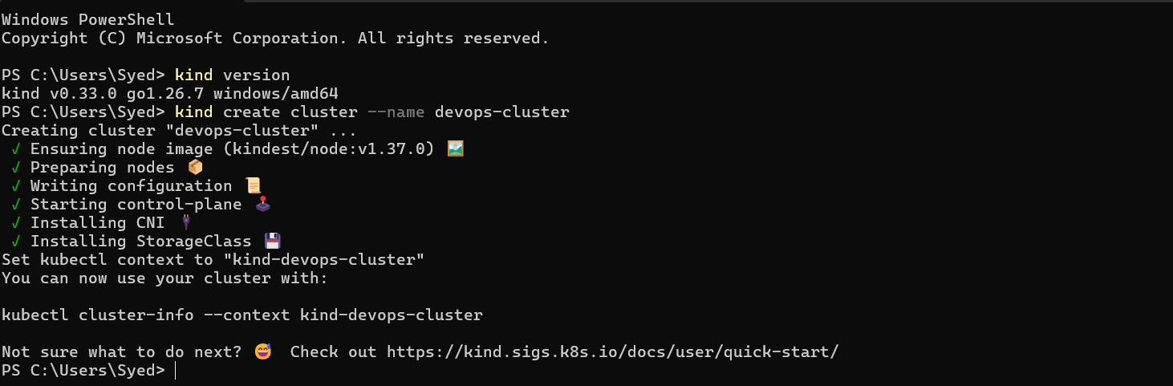
We created the default kind cluster it creates one node, which is the control-plane node
# Verify
kubectl cluster-info
kubectl get nodes
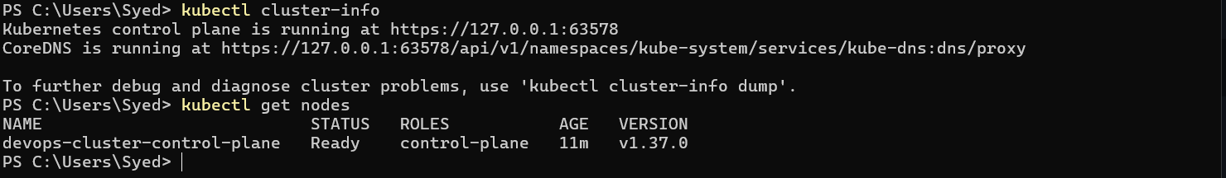
Task 5: Explore Your Cluster
Now that your cluster is running, explore it:
# See cluster info
kubectl cluster-info

# List all nodes
kubectl get nodes

# Get detailed info about your node
kubectl describe node <node-name>

# List all namespaces
kubectl get namespaces

# See ALL pods running in the cluster (across all namespaces)
kubectl get pods -A
Look at the pods running in the kube-system namespace:
kubectl get pods -n kube-system
You should see pods like etcd, kube-apiserver, kube-scheduler, kube-controller-manager, coredns, and kube-proxy. These are the architecture components you drew in Task 2 — running as pods inside the cluster.
Verify: Can you match each running pod in kube-system to a component in your architecture diagram?

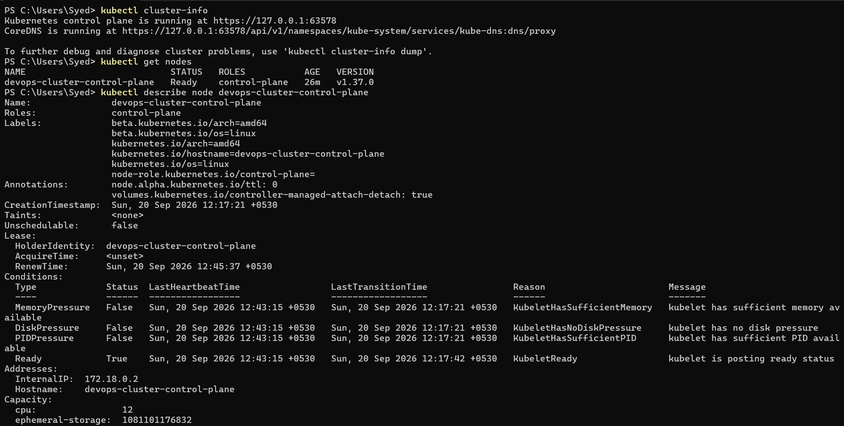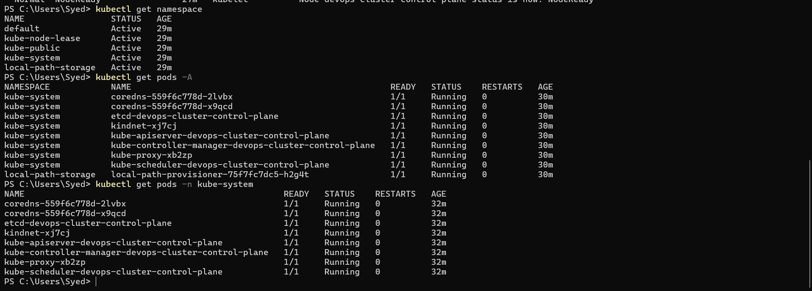
Your diagram had:
CONTROL PLANE
│
┌──────────┼──────────┐
│ │ │
etcd API Server Scheduler
│
Controller Manager

Your actual cluster has:
kube-system
│
┌──────────┼───────────┐
│ │ │
etcd kube-apiserver kube-scheduler
│
kube-controller-manager

Task 6: Practice Cluster Lifecycle
Build muscle memory with cluster operations:
# Delete your cluster
kind delete cluster --name devops-cluster
# (or: minikube delete)

# Recreate it
kind create cluster --name devops-cluster
# (or: minikube start)

# Verify it is back
kubectl get nodes
Try these useful commands:
# Check which cluster kubectl is connected to
kubectl config current-context

# List all available contexts (clusters)
kubectl config get-contexts

# See the full kubeconfig
kubectl config view
Write down: What is a kubeconfig? Where is it stored on your machine?

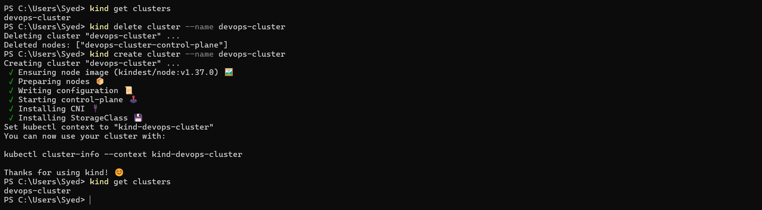

# Check which cluster kubectl is connected to
kubectl config current-context

# List all available contexts (clusters)
kubectl config get-contexts

# See the full kubeconfig
kubectl config view
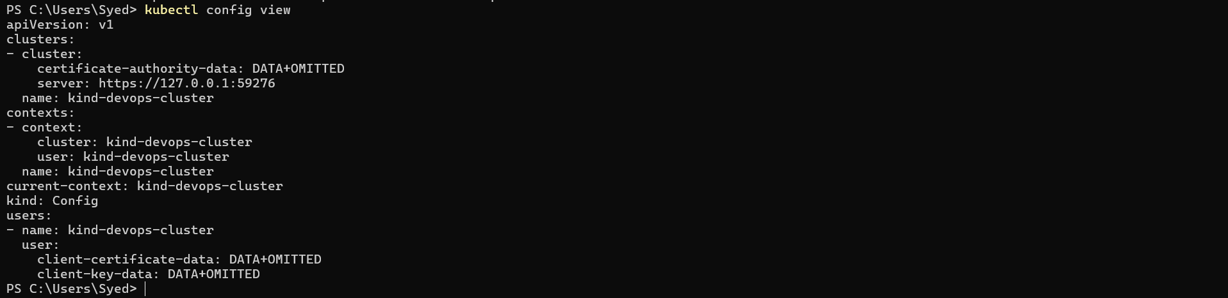

Write down: What is a kubeconfig? Where is it stored on your machine?
- Kubeconfig is a configuration file of kubectl used to connect and authenticate Kubernetes clusters
- It contains clusters, users, current-context, context
- By defaut it is stored at C:\Users\<your-username>\.kube\config

