https://github.com/bezkoder/node-express-mongodb?utm_source=chatgpt.com

Our application is:
Node.js + Express + MongoDB

Our project has 2 services
Docker Compose
│
┌────────┴────────┐
│ │
▼ ▼
Node.js + Express MongoDB
APP container DB container
│ │
│ ▼
│ Named Volume
│
└──── Docker Network ────┘

- We will create Dockerfile for Node.js/Express application (the app service).
- MongoDB → NO Dockerfile needed , We will use the official MongoDB image directly in docker-compose.yml.

Task 1: Pick Your App
Choose one of these (or use your own project):
- A Python Flask/Django app with a database
- A Node.js Express app with MongoDB
- A static website served by Nginx with a backend API
- Any app from your GitHub that doesn't have Docker yet
If you don't have an app, clone a simple open-source one and Dockerize it.

Cloned the repository
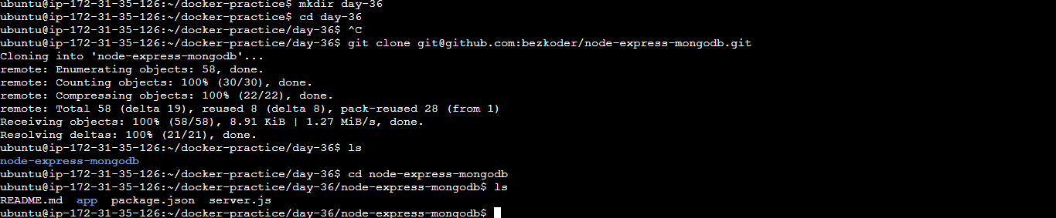

inspect two things:
package.json — to understand the Node.js dependencies and start command.
MongoDB configuration — to see how the application currently connects to MongoDB.
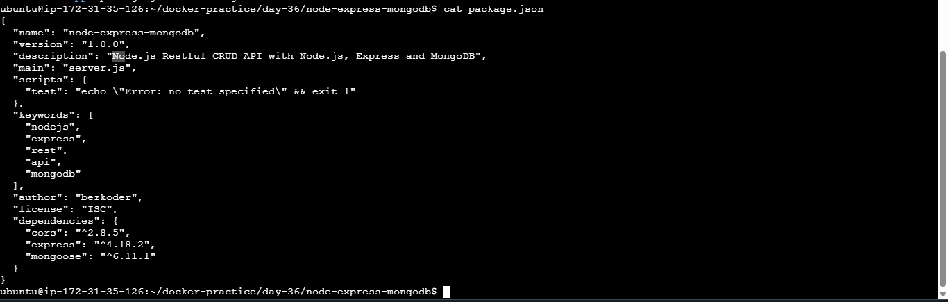

This command searches the project for the MongoDB connection configuration
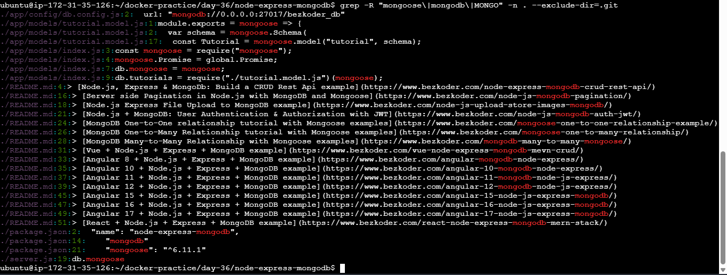
What we have
This is a Node.js + Express + MongoDB REST API:
- Node.js → runtime
- Express 4.18.2 → web/API framework
- Mongoose 6.11.1 → MongoDB ODM
- CORS → cross-origin requests
- server.js → application entry point
- MongoDB connection is currently configured in app/config/db.config.js
- The current connection is:
mongodb://0.0.0.0:27017/bezkoder_db

created new branch for our work

Vim app/config/db.config.js
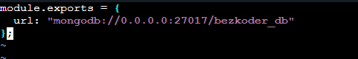
Its hardcoded

Changed to

Task 2: Write the Dockerfile
- Create a Dockerfile for your application
- Use a multi-stage build if applicable
- Use a non-root user
- Keep the image small — use alpine or slim base images
- Add a .dockerignore file
Build and test it locally.

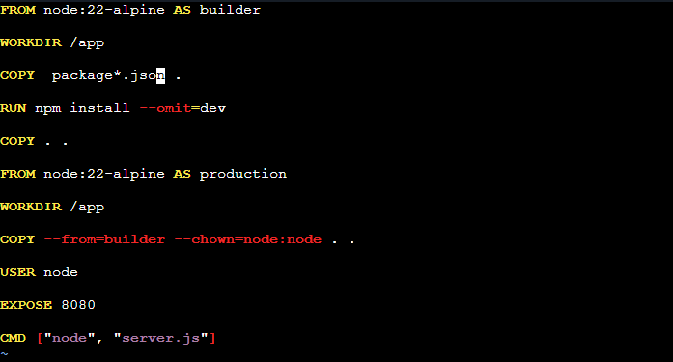

.dockerignore
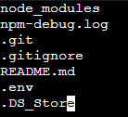

image build
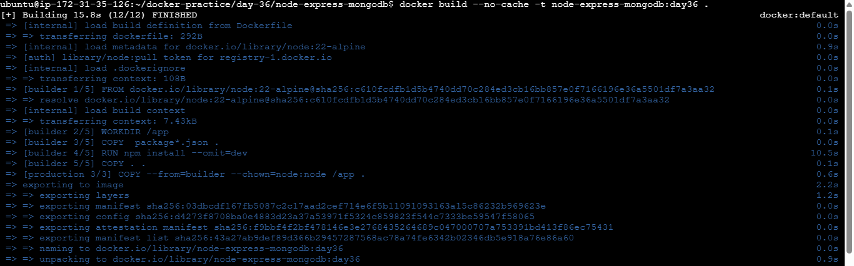

Verified
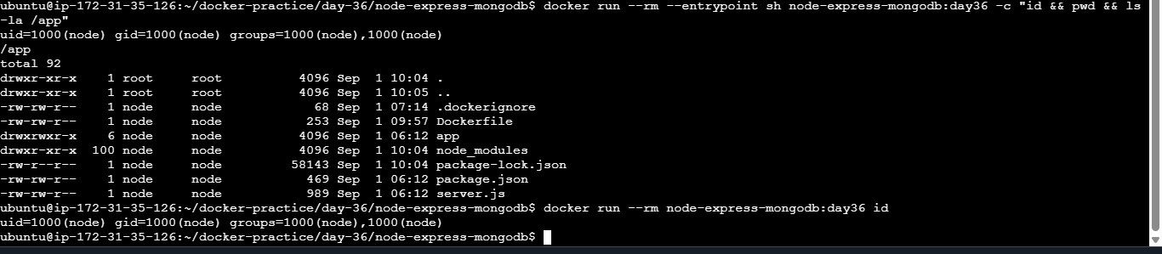

Task 3: Add Docker Compose
Write a docker-compose.yml that includes:
- Your app service (built from Dockerfile)
- A database service (Postgres, MySQL, MongoDB — whatever your app needs)
- Volumes for database persistence
- A custom network
- Environment variables for configuration (use .env file)
- Healthchecks on the database
Run docker compose up and verify everything works together

Docker Compose
│
┌──────────┴──────────┐
│ │
▼ ▼
Node.js App MongoDB
port 8080 port 27017
│ │
└──── devops-net -----─────┘
│
mongo-data
(volume)

.env
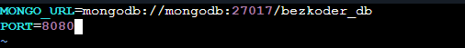

Dockre-compose.yml

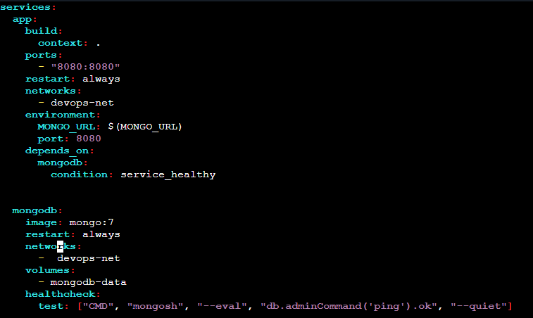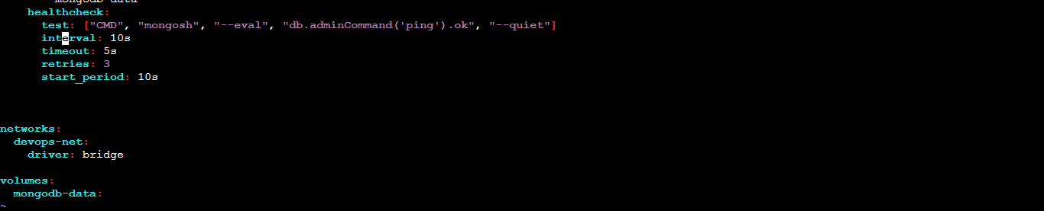

Verify using docker compose config
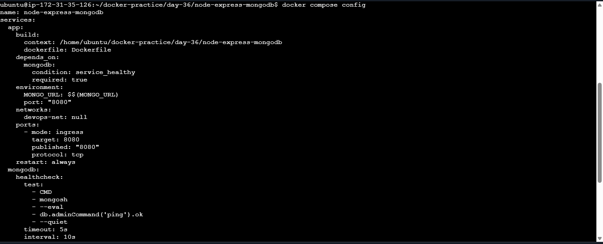
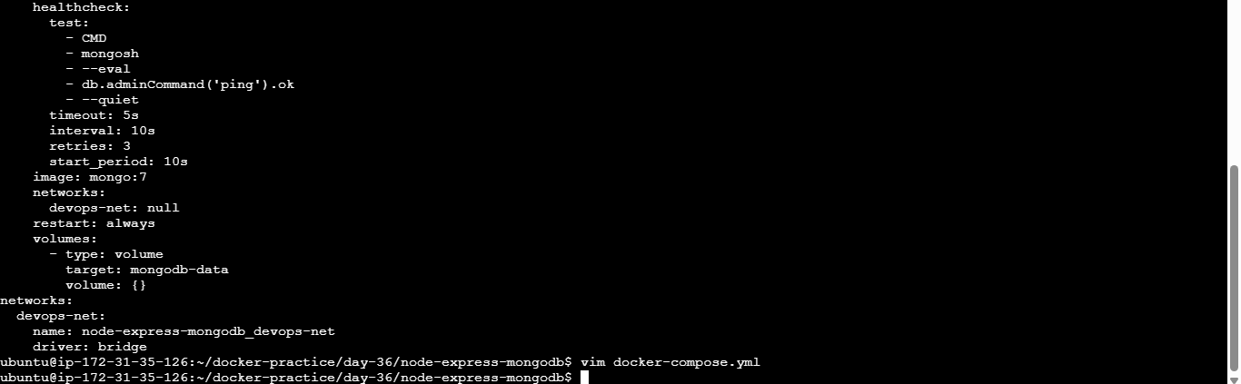
Docker compose up
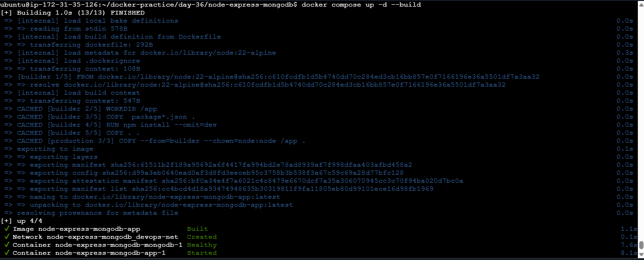

Verify
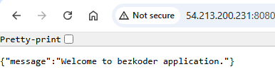
Task 4: Ship It
- Tag your app image
- Push it to Docker Hub
- Share the Docker Hub link
- Write a README.md in your project with:
  - What the app does
  - How to run it with Docker Compose
  - Any environment variables needed

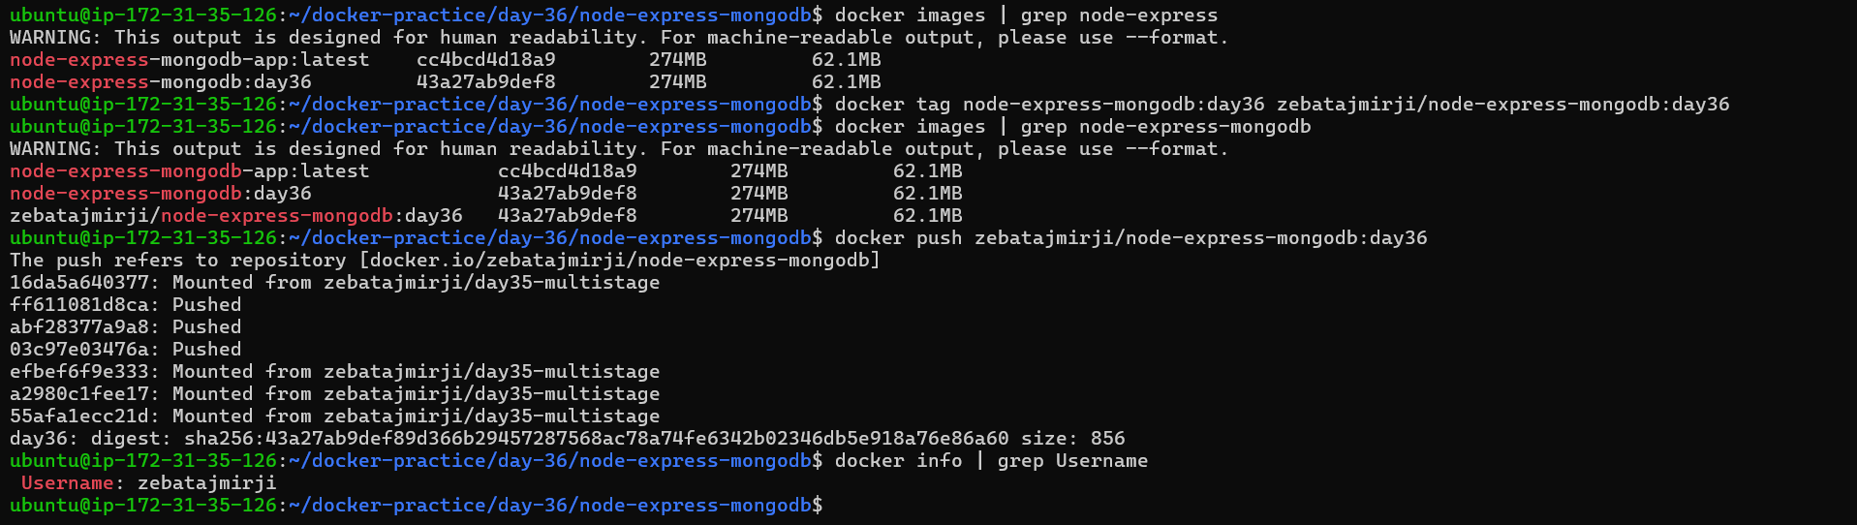
Docker Hub: https://hub.docker.com/repositories/zebatajmirji

Commit history before pushing our work to github
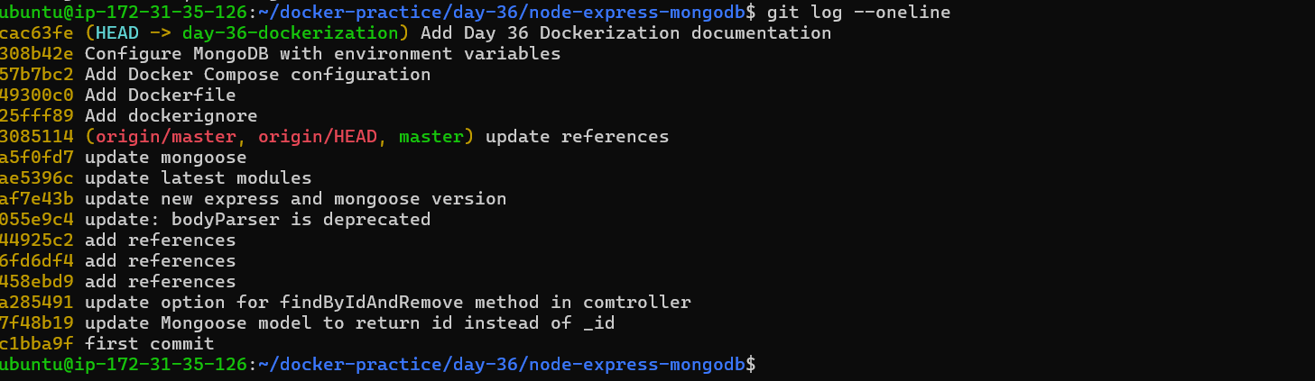
Pushed to github
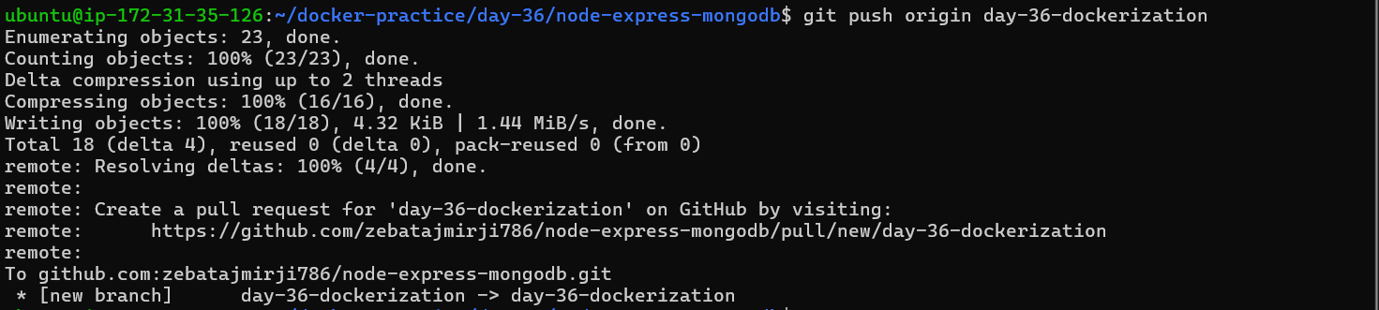

Task 5: Test the Whole Flow
- Remove all local images and containers
- Pull from Docker Hub and run using only your compose file
- Does it work fresh? If not — fix it until it does

We need to change this bcz we already have image in docker hub if we still use build:…. In our docker-compose.yml file then it wont use the image present in dockerhub, it will start building the image again
So we need to give the image name

app:
build:
context: .
dockerfile: Dockerfile
Replace those two lines with:
app:
image: zebatajmirji/node-express-mongodb:day36

So docker-compose.yml
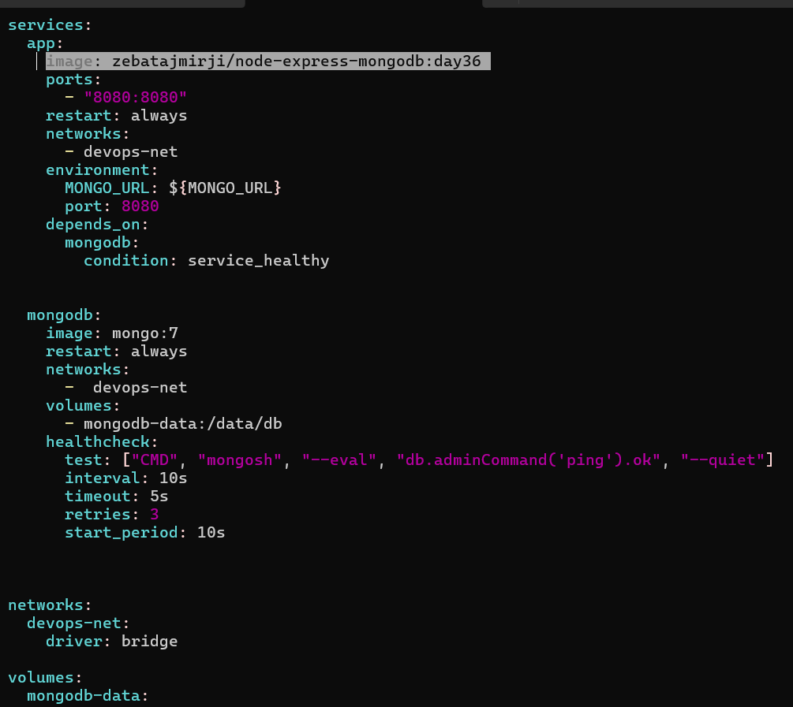

- Remove all local images and containers
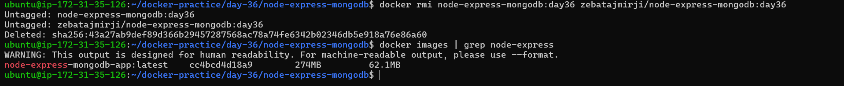
We removed these 2 images which we had used

- Pull from Docker Hub and run using only your compose file
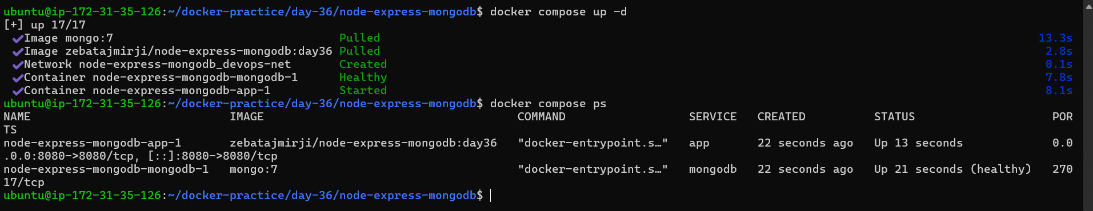

Its working

