Task 1: Docker Images
- Pull the nginx, ubuntu, and alpine images from Docker Hub
- List all images on your machine — note the sizes
- Compare ubuntu vs alpine — why is one much smaller?
- Inspect an image — what information can you see?
- Remove an image you no longer need

Pull the nginx, ubuntu, and alpine images from Docker Hub
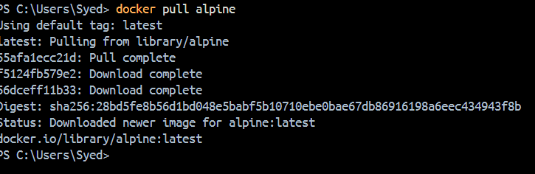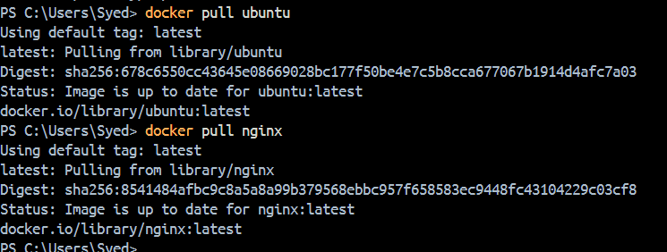
List all images on your machine — note the sizes
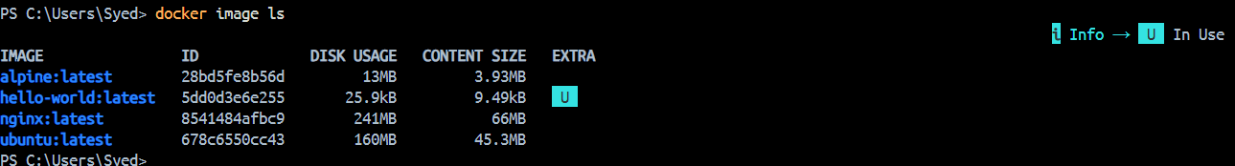

Compare ubuntu vs alpine — why is one much smaller?
Ubuntu vs Alpine: Alpine is much smaller than Ubuntu because it is designed as a minimal Linux distribution. It uses lightweight components such as BusyBox and musl libc and includes fewer packages by default. Smaller images require less storage and are generally faster to pull, but Ubuntu may provide broader compatibility and more tools out of the box.

Inspect an image — what information can you see?
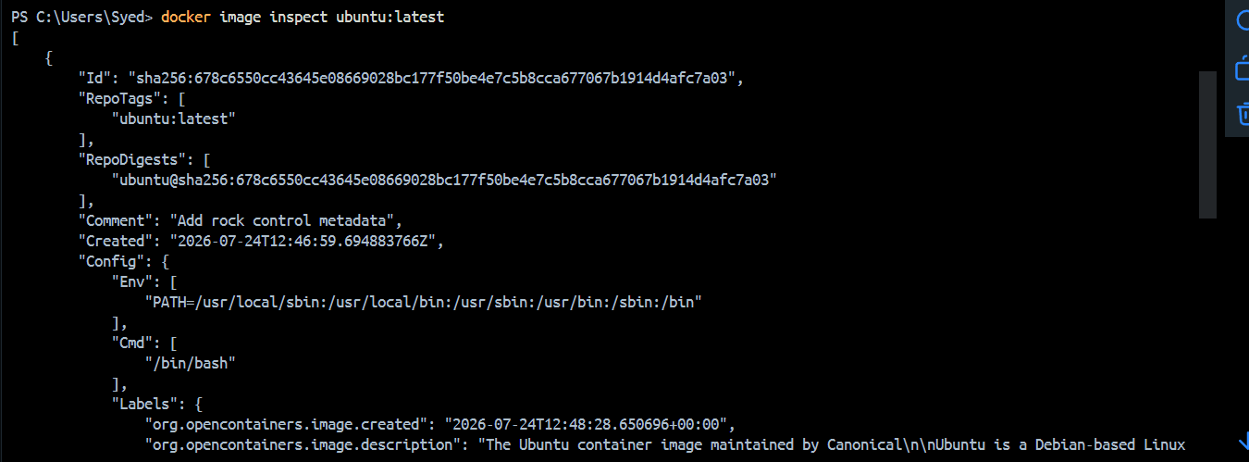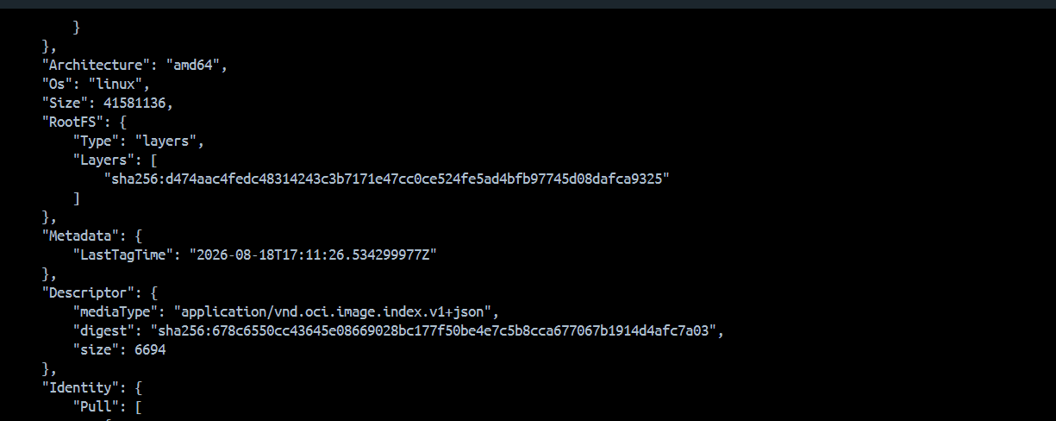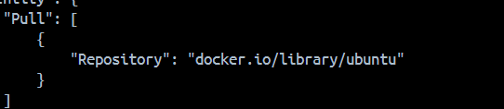

Remove an image you no longer need
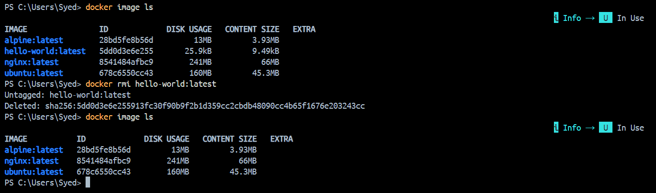

Task 2: Image Layers
- Run docker image history nginx — what do you see?
- Each line is a layer. Note how some layers show sizes and some show 0B
- Write in your notes: What are layers and why does Docker use them?
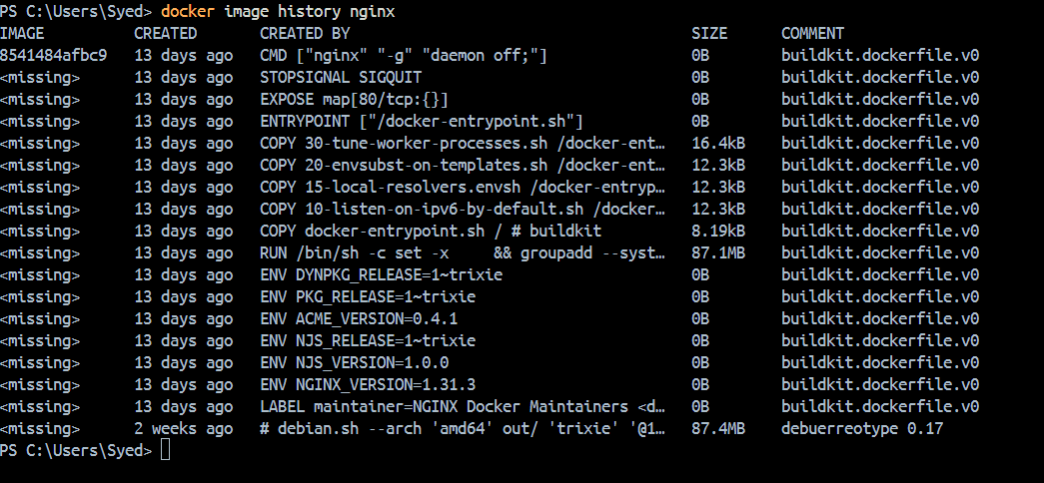
Step 2 — Why does Docker use layers?
Think of an image like a stack:
┌─────────────────────────────┐
│ Layer 5 — configuration │
├─────────────────────────────┤
│ Layer 4 — application files │
├─────────────────────────────┤
│ Layer 3 — packages │
├─────────────────────────────┤
│ Layer 2 — libraries │
├─────────────────────────────┤
│ Layer 1 — base filesystem │
└─────────────────────────────┘
Each layer represents a set of filesystem changes.
Why layers are useful
1. Reuse
If two images use the same layer, Docker can reuse it instead of storing another copy.

IMAGE A:
Layer 1 → Ubuntu base
Layer 2 → Python
Layer 3 → Application A

IMAGE B:
Layer 1 → Ubuntu base
Layer 2 → Python
Layer 3 → Application B

2. Caching
When Docker builds an image, unchanged layers can be taken from the cache instead of being rebuilt.
Imagine you have this Dockerfile:
Step 1 → FROM ubuntu
Step 2 → RUN apt-get update
Step 3 → RUN apt-get install nginx
Step 4 → COPY index.html
Now you change only index.html.
Docker doesn't need to redo everything.
It can reuse:
Layer 1 → CACHE ✅
Layer 2 → CACHE ✅
Layer 3 → CACHE ✅
and rebuild the changed part:
Layer 4 → BUILD AGAIN 🔄

3. Faster builds
If only the last part of an image changes, Docker doesn't necessarily need to rebuild everything above it.
So your build becomes much faster.

4. Storage efficiency
Shared layers reduce duplicated data on the host.
Suppose
Ubuntu layer = 100 MB
Python layer = 50 MB
App A = 10 MB
App B = 10 MB

Without sharing:
Image A = 160 MB
Image B = 160 MB
----------------------
Total = 320 MB

With shared layers:
Ubuntu 100 MB
Python 50 MB
App A 10 MB
App B 10 MB
-------------------
Total 170 MB

Docker Image Layers
Docker images are built using multiple layers. Each layer represents filesystem changes or image configuration created during the image build process. In docker image history nginx, layers with a size such as 87.1MB or 16.4KB contain filesystem changes, while 0B entries usually represent metadata/configuration such as CMD, EXPOSE, ENTRYPOINT, and STOPSIGNAL.
Docker uses layers because they can be cached and reused. If a layer hasn't changed, Docker can reuse it instead of rebuilding it. This makes image builds faster and reduces duplicated storage.

Q: Why does Docker use image layers?
A good answer:
"Docker uses layers to make images efficient. Each build instruction creates a layer, and unchanged layers can be cached and reused. This reduces build time, storage usage, and network transfer."

Write in your notes: What are layers and why does Docker use them?
Docker Image Layers
Docker images are made up of multiple layers. Each layer represents filesystem changes or configuration added during the image build process.
Docker uses layers because they can be cached and reused. If a layer hasn't changed, Docker can reuse it instead of rebuilding it, which makes image builds faster and reduces storage usage and duplicate data.
Ex: Docker Image
├── Base OS layer
├── Package/library layer
├── Application files layer
└── Configuration layer

Task 3: Container Lifecycle
Practice the full lifecycle on one container:
- Create a container (without starting it)
- Start the container
- Pause it and check status
- Unpause it
- Stop it
- Restart it
- Kill it
- Remove it
Check docker ps -a after each step — observe the state changes.

Create the container without starting it
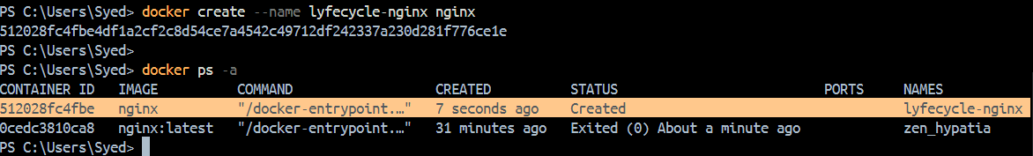

Start the container
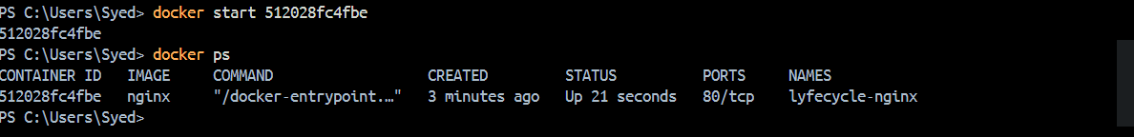
Pause it and check status
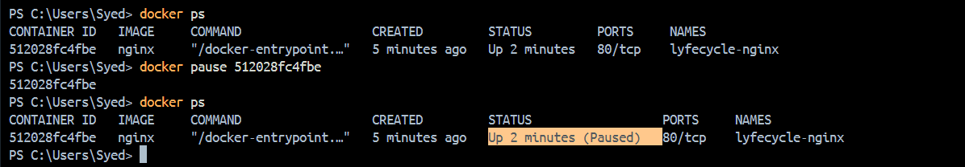
Unpause it
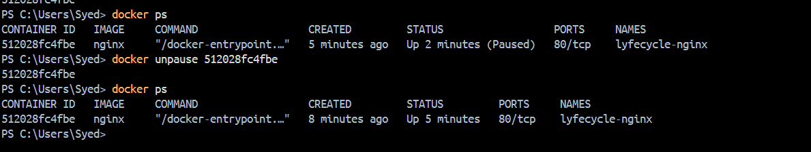
Stop it
Restart it
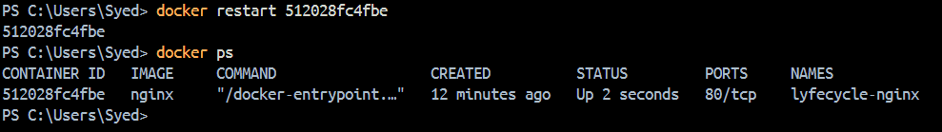
Kill it
Remove it
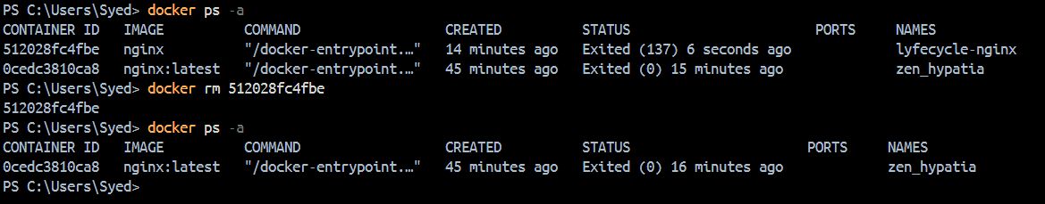
Task 4: Working with Running Containers
- Run an Nginx container in detached mode
- View its logs
- View real-time logs (follow mode)
- Exec into the container and look around the filesystem
- Run a single command inside the container without entering it
- Inspect the container — find its IP address, port mappings, and mounts

Run an Nginx container in detached mode
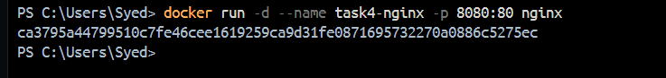
44
View its logs
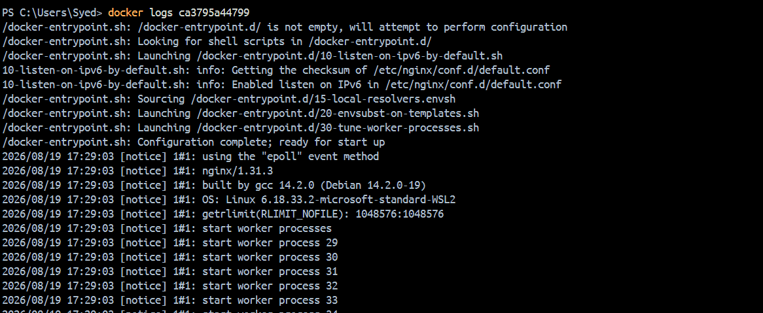
View real-time logs (follow mode)
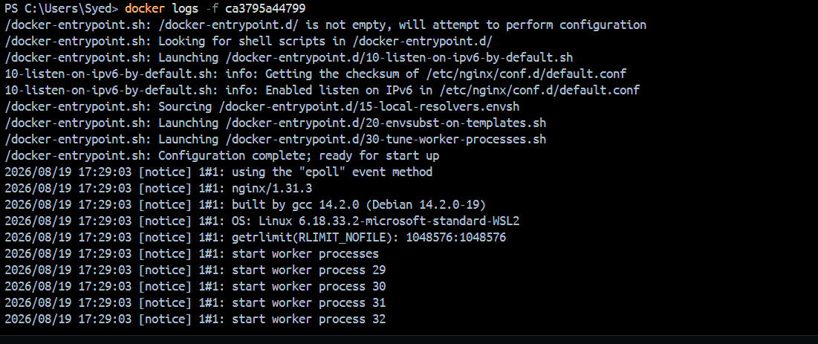
Exec into the container and look around the filesystem
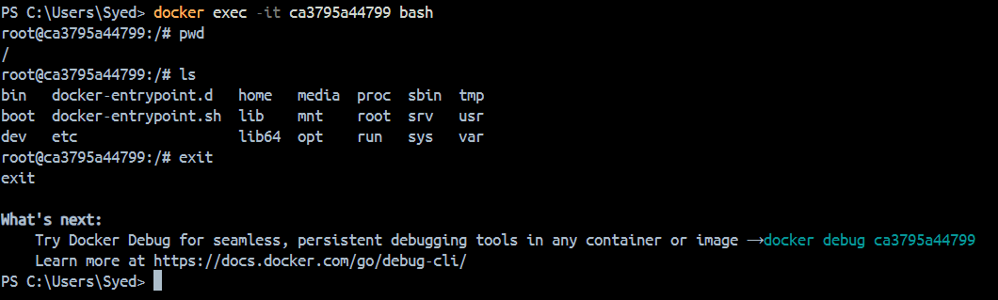
Run a single command inside the container without entering it
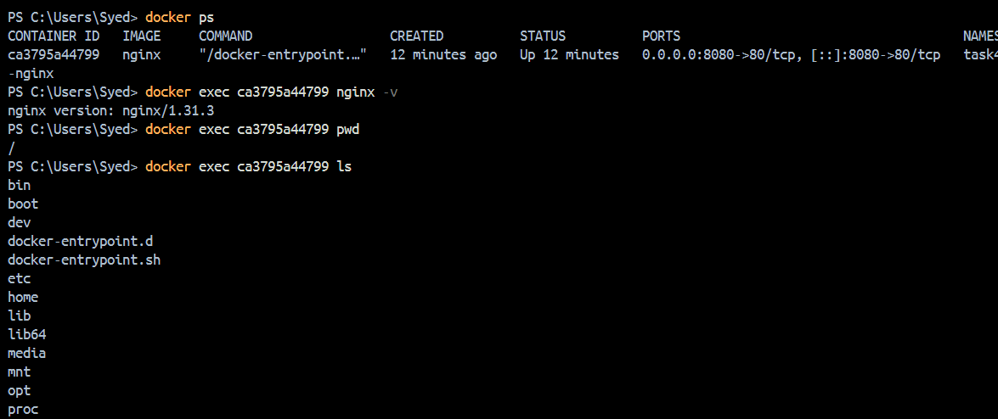

Inspect the container — find its IP address, port mappings, and mounts
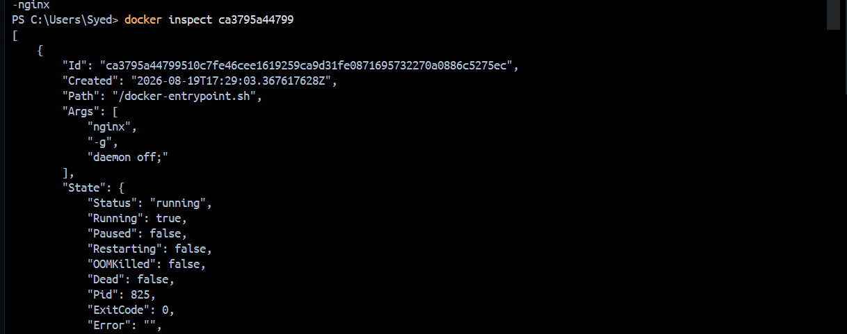
mounts :
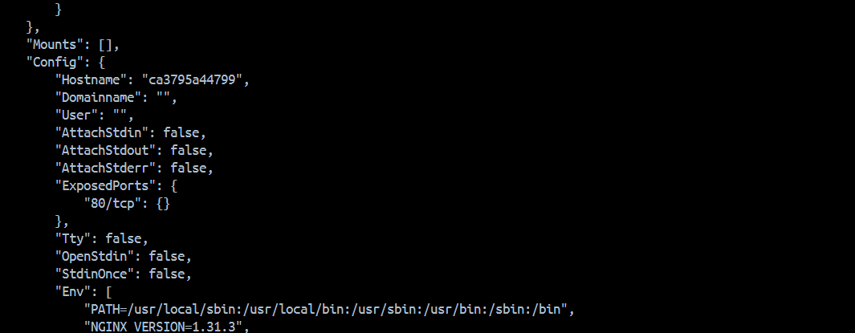
Task 5: Cleanup
- Stop all running containers in one command
- Remove all stopped containers in one command
- Remove unused images
- Check how much disk space Docker is using

Stop all running containers in one command
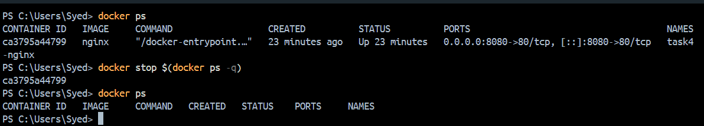
Remove all stopped containers in one command
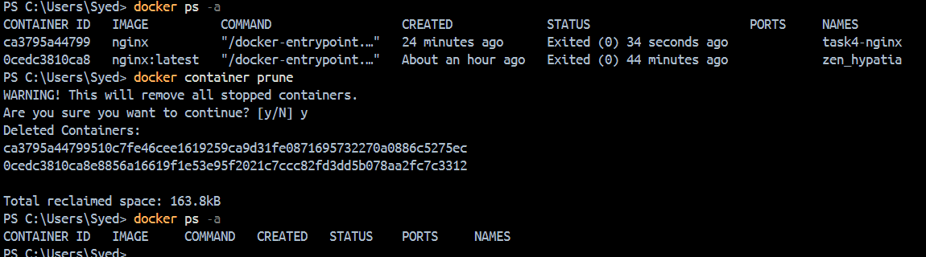
Remove unused images
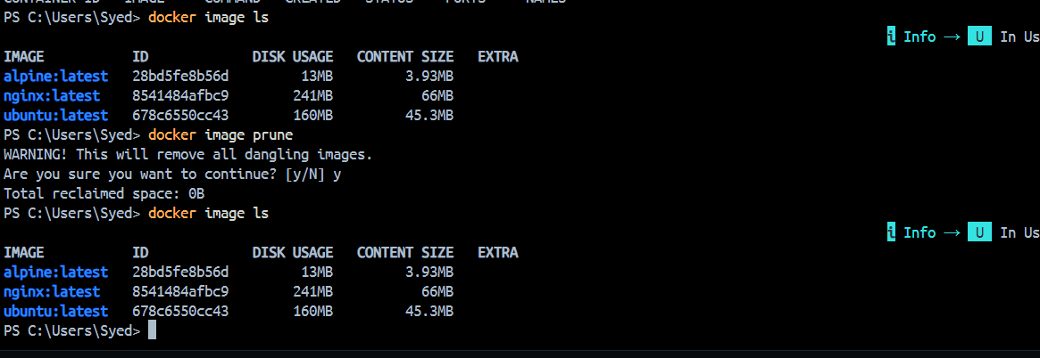
Here there ware no any dandling images
Hence after running docker image prune it did not remove anything
If we use docker image prune -a Removes all images not currently used by a container

Check how much disk space Docker is using
