Task 1: Set Up
- Create a new public GitHub repository called github-actions-practice
- Clone it locally
- Create the folder structure: .github/workflows/
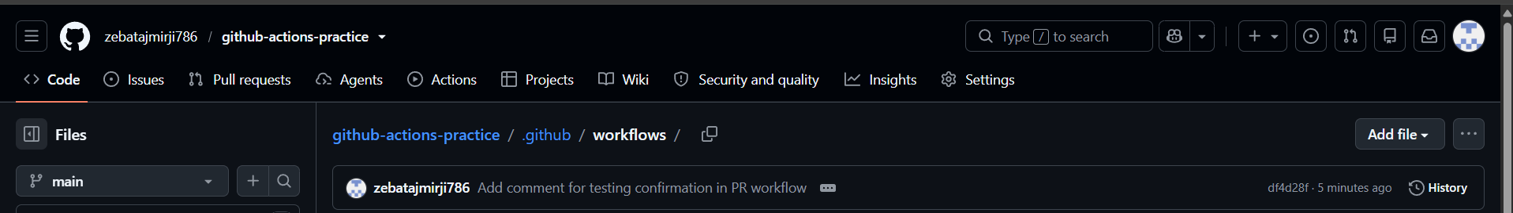
Created on remote
still did not clone it to local

Task 2: Hello Workflow
Create .github/workflows/hello.yml with a workflow that:
- Triggers on every push
- Has one job called greet
- Runs on ubuntu-latest
- Has two steps:
  - Step 1: Check out the code using actions/checkout
  - Step 2: Print Hello from GitHub Actions!
Push it. Go to the Actions tab on GitHub and watch it run.
Verify: Is it green? Click into the job and read every step.
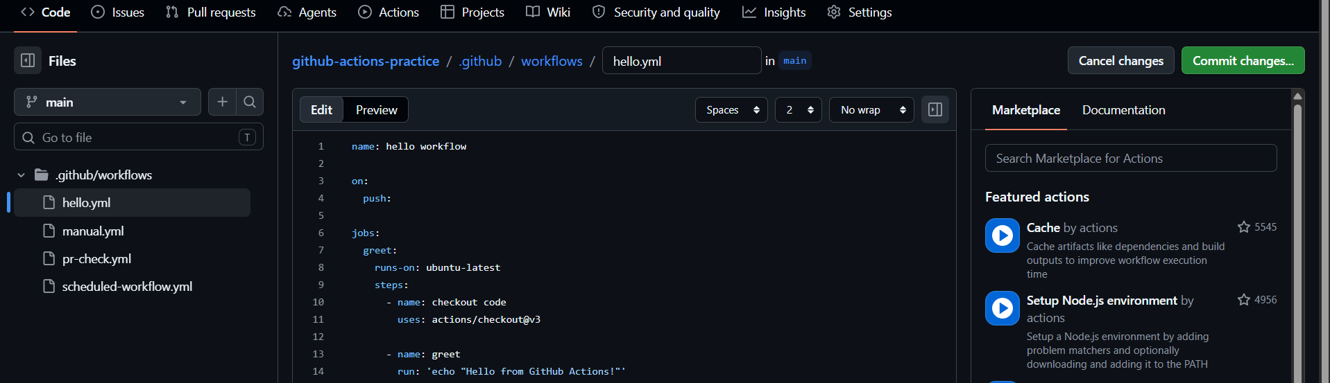

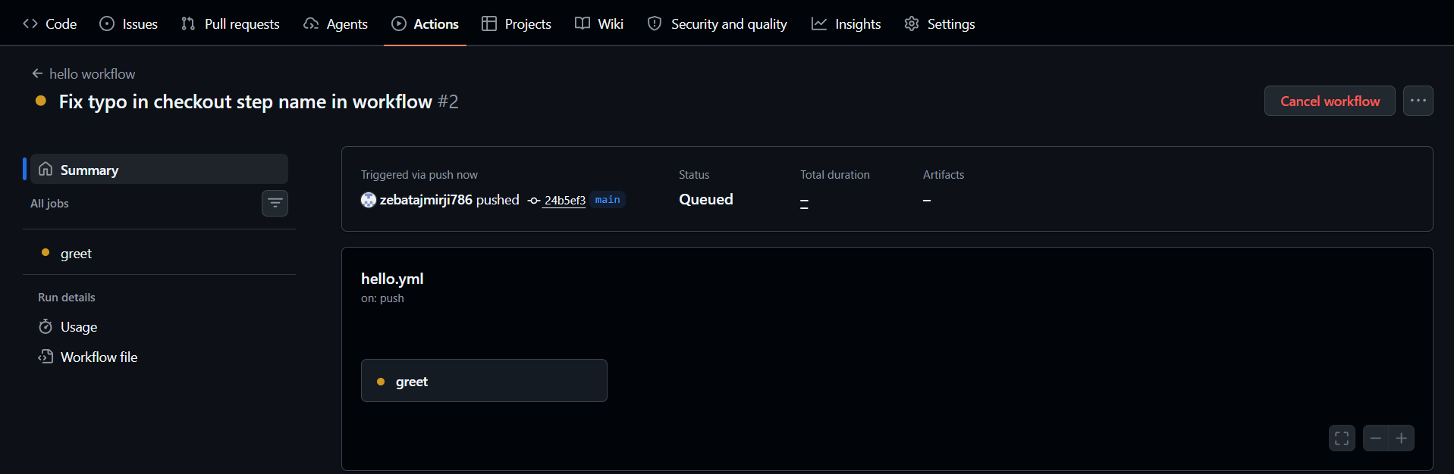
Started automatically after push
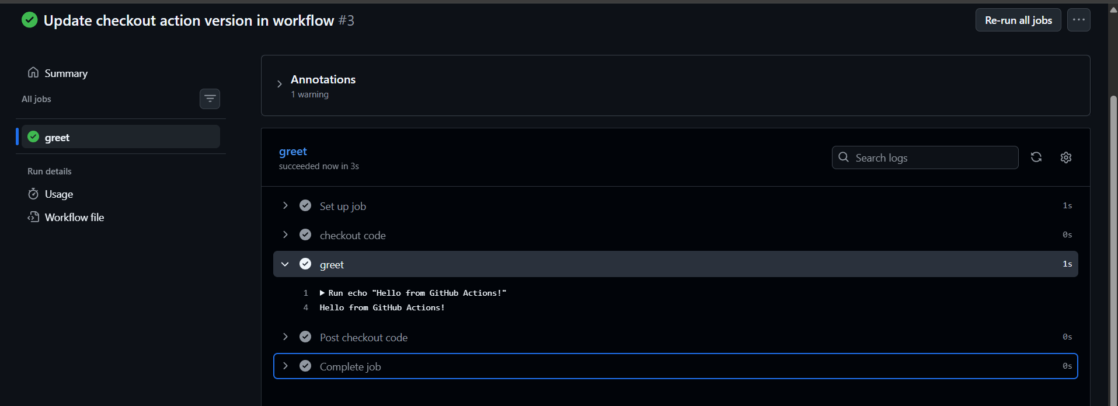

Task 3: Understand the Anatomy
Look at your workflow file and write in your notes what each key does:
- on:
- jobs:
- runs-on:
- steps:
- uses:
- run:
- name: (on a step)
on:
it shows the trigger – when the workflow needs to be started
EX:
on:
push:
- run the workflow when something gets push

jobs:
specific task/ work to be performed
EX:
Jobs:
greet:
- job name is greet

runs on:
is the computer/machine on which the jobs will run
EX:
runs on: ubuntu-latest
- task will run on ubuntu latest machine

steps:
It is a single command or instruction to be executed and its present inside the job
EX:
Steps:
- Name: execute this
Run: or uses:

Here
- = represents one step

uses:
use ready made code
EX:
uses: actions/checkout@4

run:
runs a shell command
EX:
Run: ‘echo “Hello its Github Actions”’

name: (On a step)
it is the name of the each command/action to be performed
EX:
- Name: say hello
Task 4: Add More Steps
Update hello.yml to also:
1. Print the current date and time
2. Print the name of the branch that triggered the run (hint: GitHub provides this as a variable)
3. List the files in the repo
4. Print the runner's operating system
Push again — watch the new run.
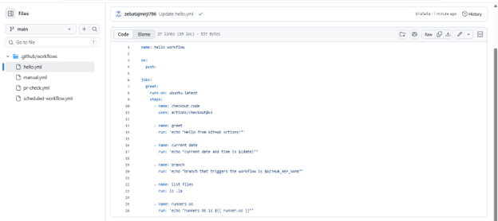
$GITHUB_REF_NAME = branch name
${{ runner.os }} = machine on which the jobs are running
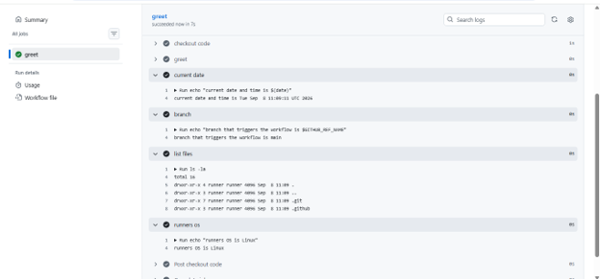
Task 5: Break It On Purpose
1. Add a step that runs a command that will fail (e.g., exit 1 or a misspelled command)
2. Push and observe what happens in the Actions tab
3. Fix it and push again
Write in your notes: What does a failed pipeline look like? How do you read the error?

exit 0 → success ✅
exit 1 → failure ❌
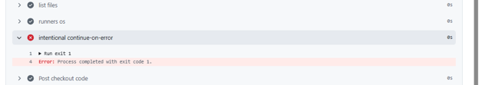
failed pipeline appears with a red ❌ **Failure** status in the GitHub Actions tab.
Inside the workflow, the step that failed is also shown with a red ❌.

For example:
❌ Intentional Failure
Error: Process completed with exit code 1.

