Task 1: Prepare
- Use the app you Dockerized on Day 36 (or any simple Dockerfile)
- Add the Dockerfile to your github-actions-practice repo (or create a minimal one)
- Make sure DOCKER_USERNAME and DOCKER_TOKEN secrets are set from Day 44
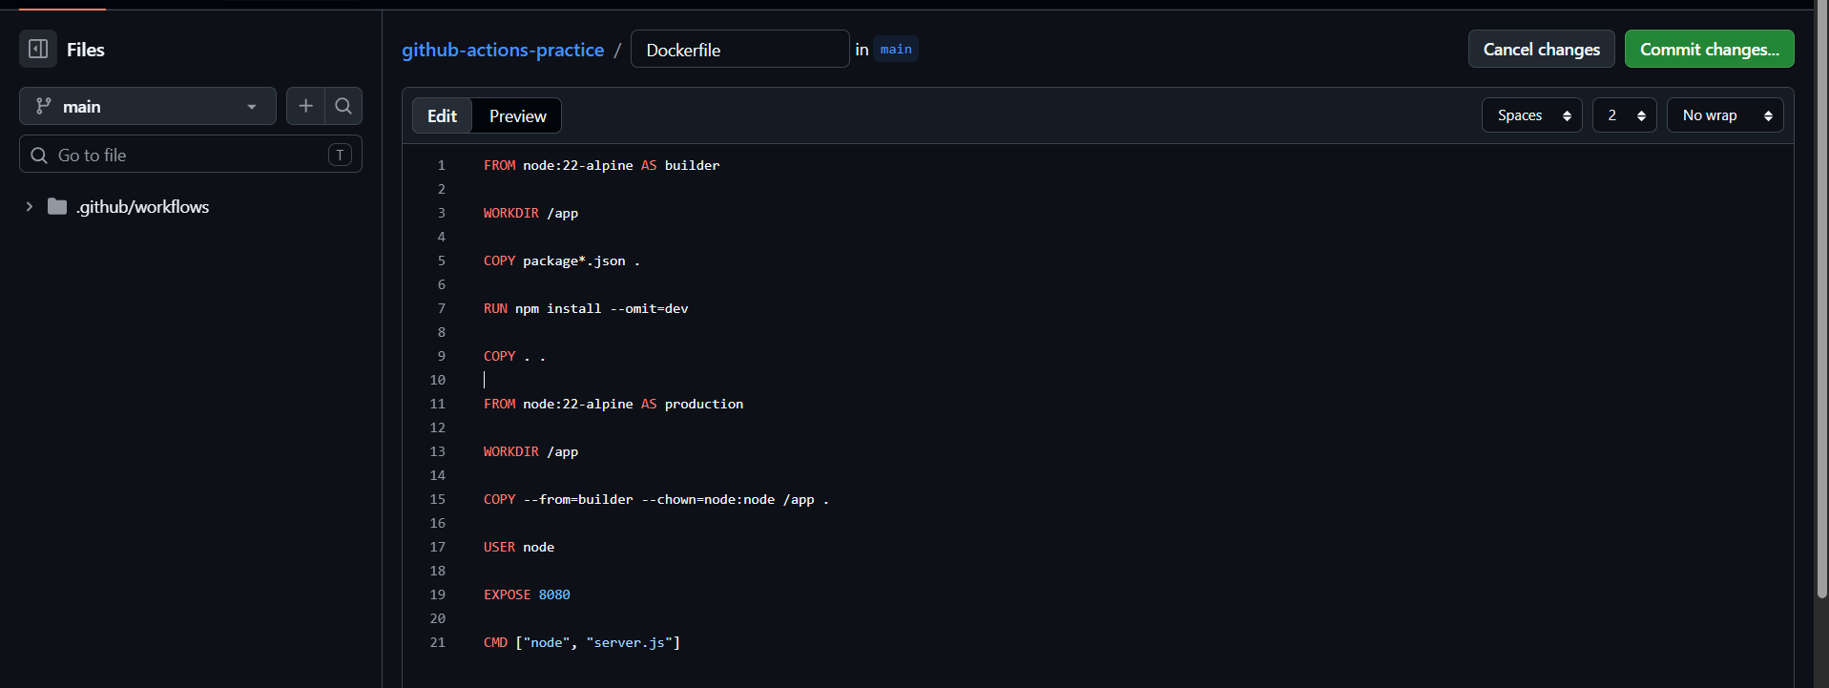
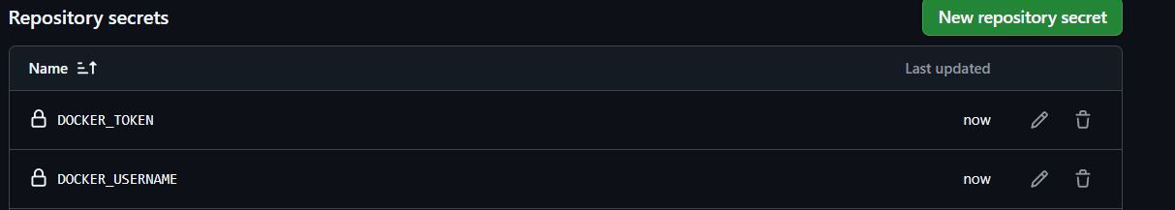
Task 2: Build the Docker Image in CI
Create .github/workflows/docker-publish.yml that:
- Triggers on push to main
- Checks out the code
- Builds the Docker image and tags it
Verify: Check the build step logs — does the image build successfully?
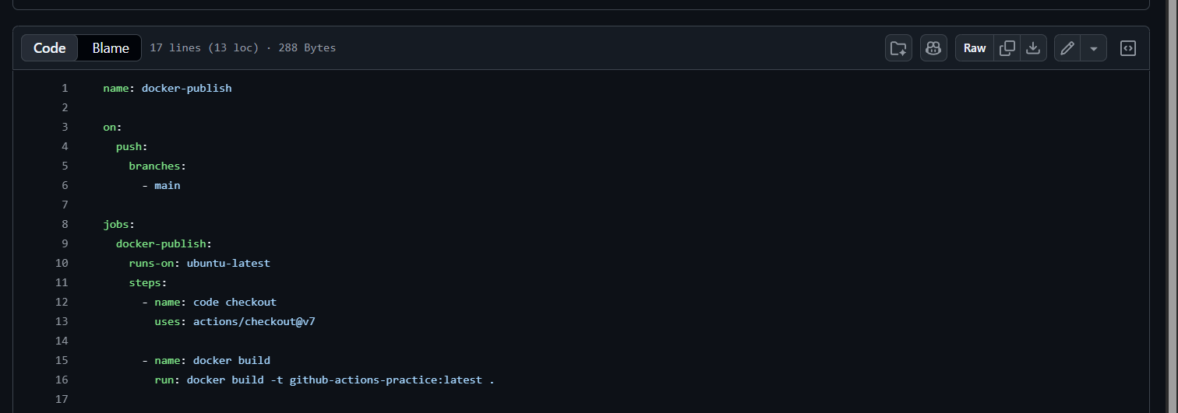
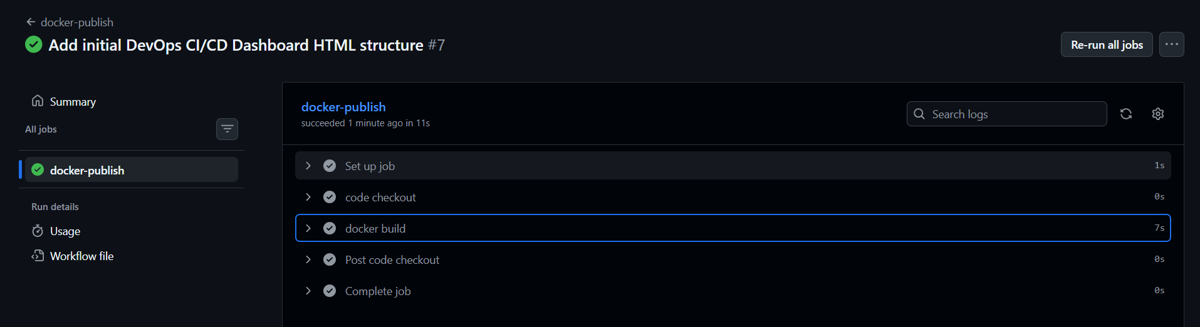
Task 3: Push to Docker Hub
Add steps to:
- Log in to Docker Hub using your secrets
- Tag the image as username/repo:latest and also username/repo:sha-<short-commit-hash>
- Push both tags
Verify: Go to Docker Hub — is your image there with both tags?
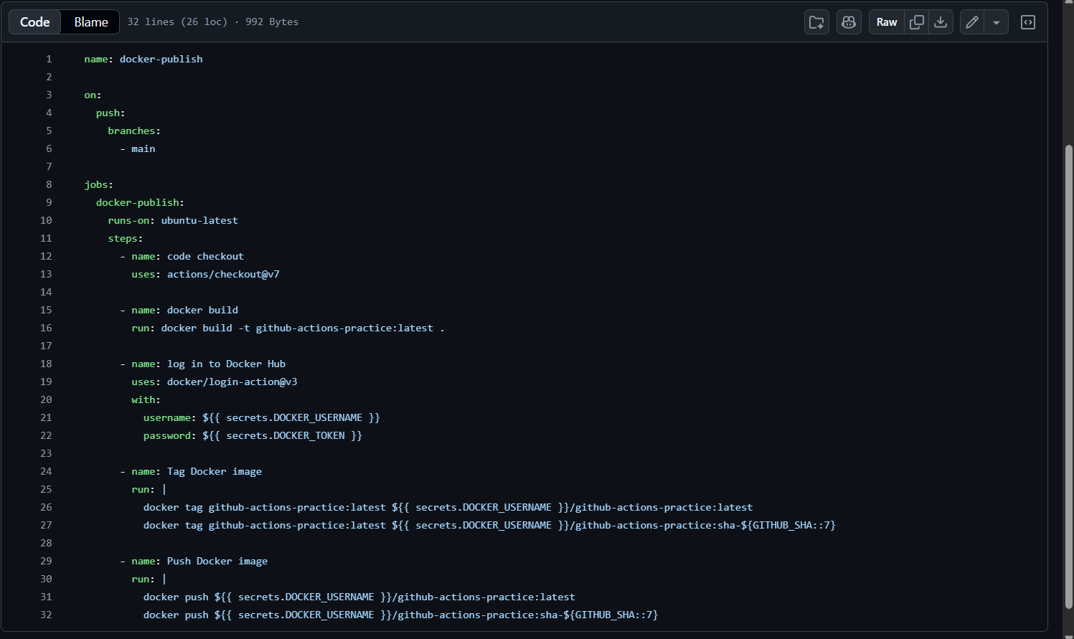
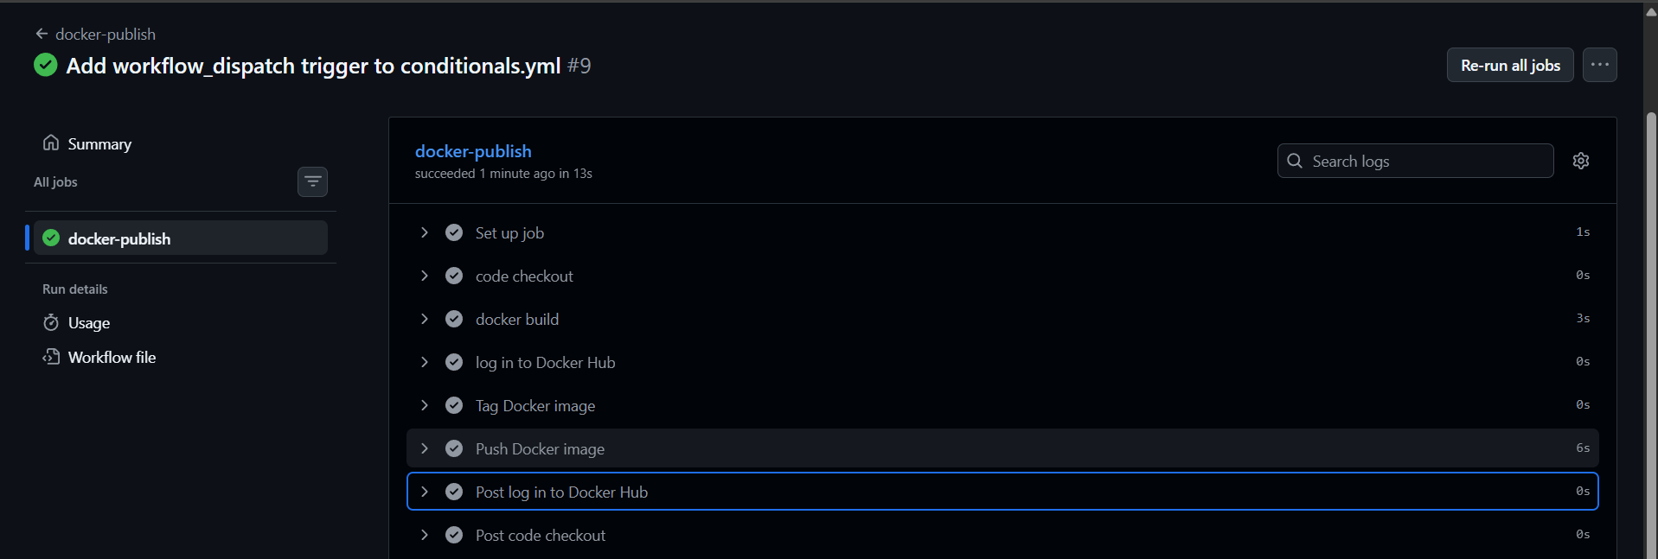
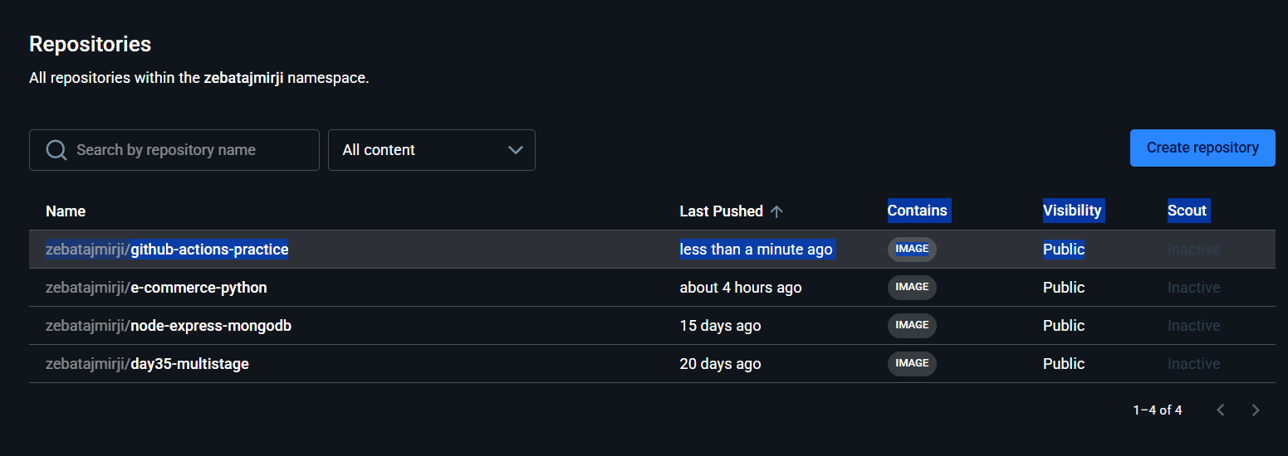

Task 5: Add a Status Badge
- Get the badge URL for your docker-publish workflow from the Actions tab
- Add it to your README.md
- Push — the badge should show green
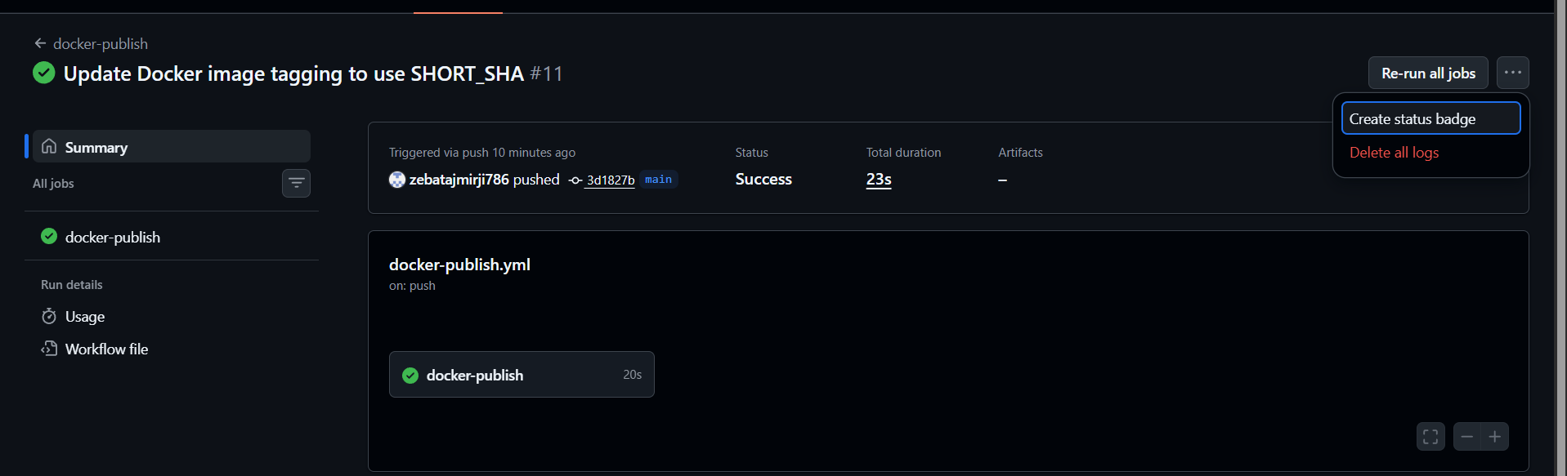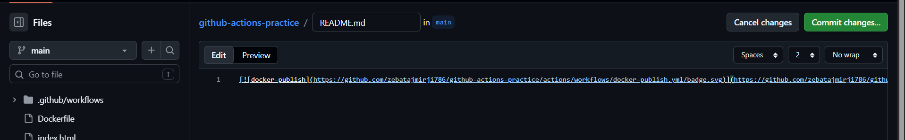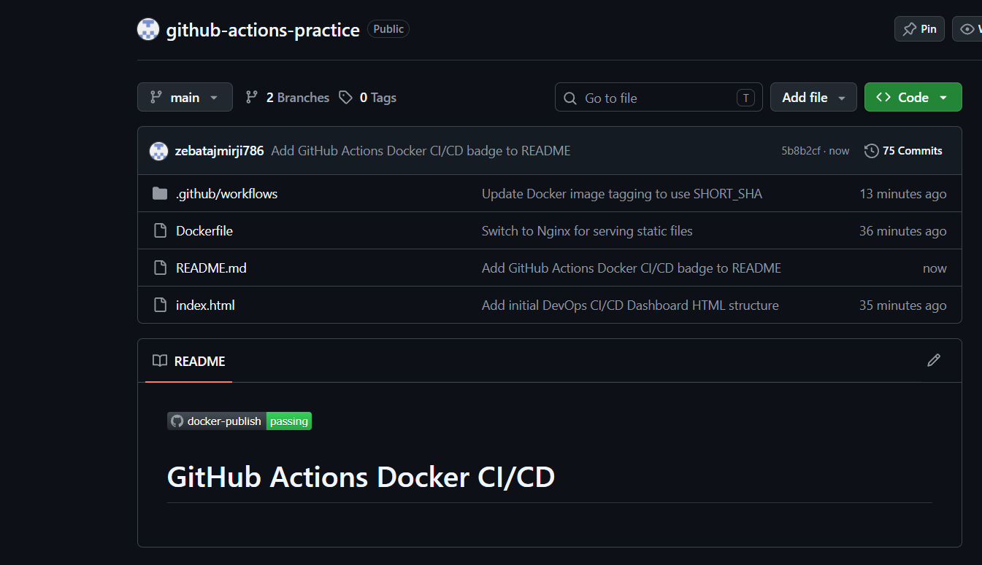
Task 6: Pull and Run It
- On your local machine (or a cloud server), pull the image you just pushed
- Run it
- Confirm it works
Write in your notes: What is the full journey from git push to a running container?

