Task 1: Build Your Own App Stack
Create a docker-compose.yml for a 3-service stack:
- A web app (use Python Flask, Node.js, or any language you know)
- A database (Postgres or MySQL)
- A cache (Redis)
Write a simple Dockerfile for the web app. The app doesn't need to be complex — even a "Hello World" that connects to the database is enough.

We'll use:
- Flask → web app
- PostgreSQL → database
- Redis → cache
- Dockerfile → builds our Flask app image
- docker-compose.yml → runs all 3 together

we have written app.py for flask app
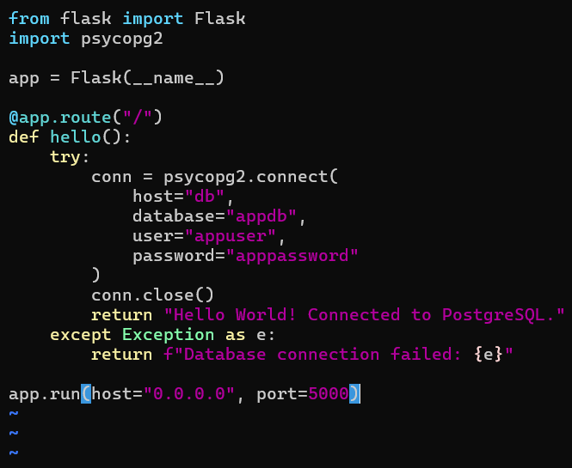
Dockerfile for webapp
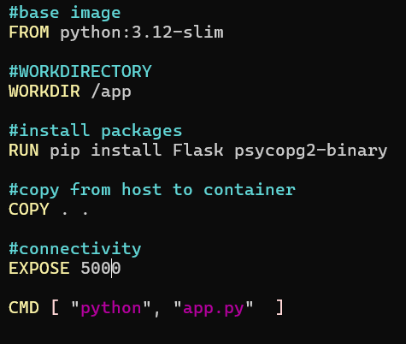
Written docker-compose.yml
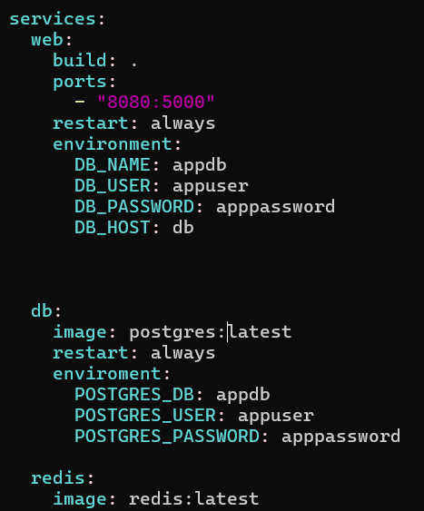
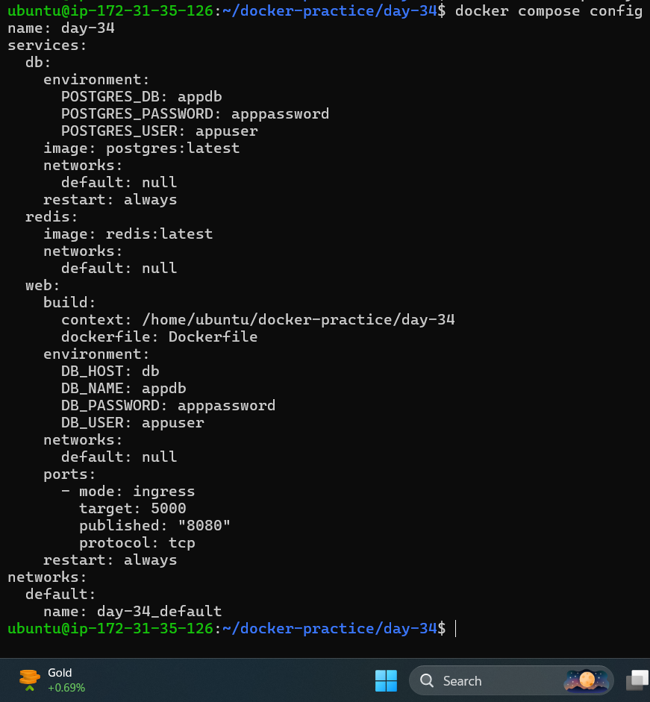
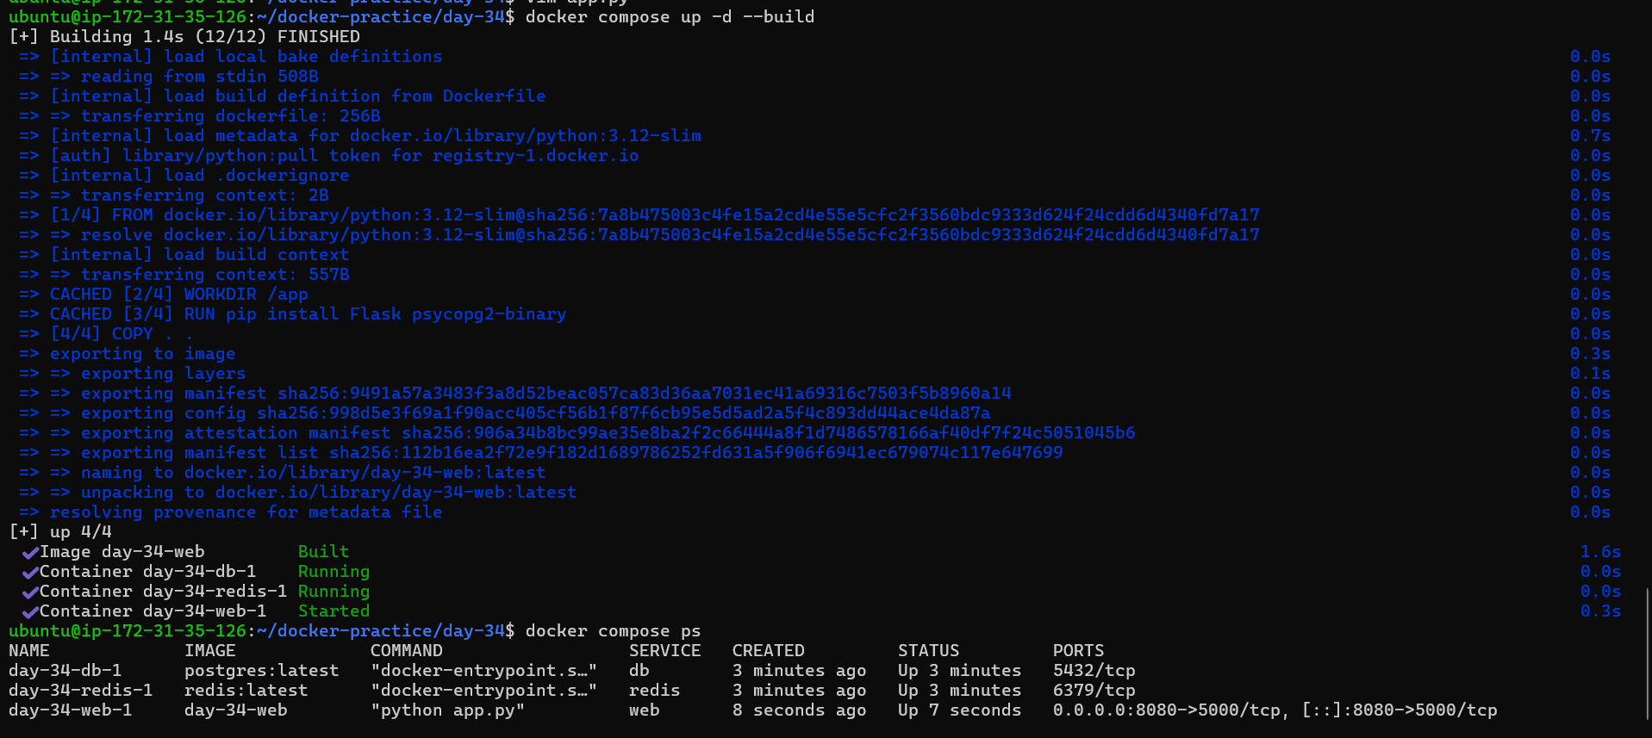
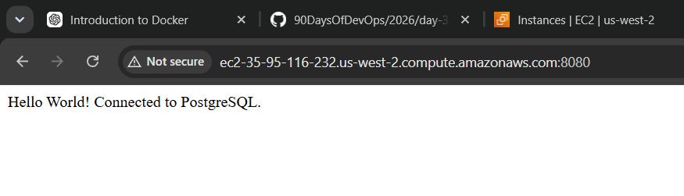

Task 2: depends_on & Healthchecks
- Add depends_on to your compose file so the app starts after the database
- Add a healthcheck on the database service
- Use depends_on with condition: service_healthy so the app waits for the database to be truly ready, not just started
Test: Bring everything down and up — does the app wait for the DB?

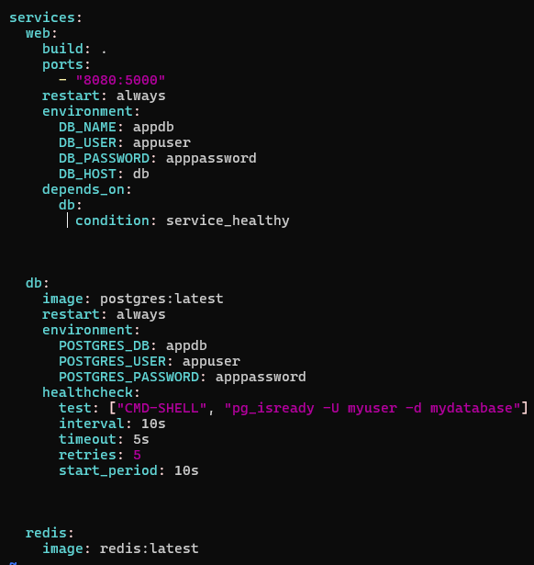
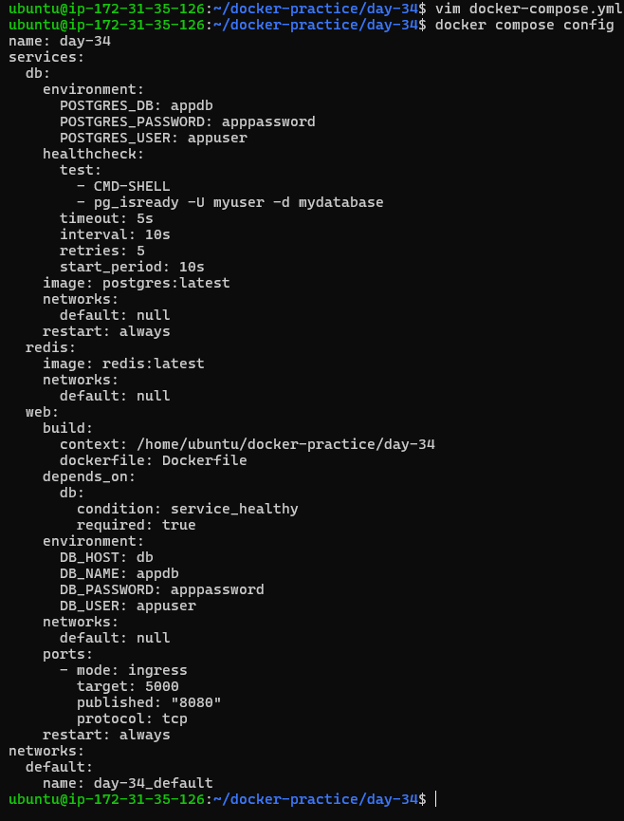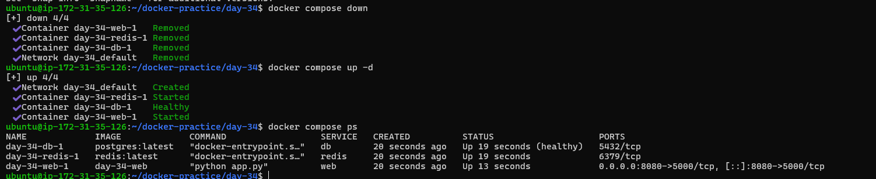What I learned
depends_on controls the startup dependency between services. By using condition: service_healthy, the web service waits for PostgreSQL to become healthy before starting.
The PostgreSQL healthcheck uses pg_isready to check whether the database is ready to accept connections.
Task 3: Restart Policies
- Add restart: always to your database service
- Manually kill the database container — does it come back?
- Try restart: on-failure — how is it different?
- Write in your notes: When would you use each restart policy?
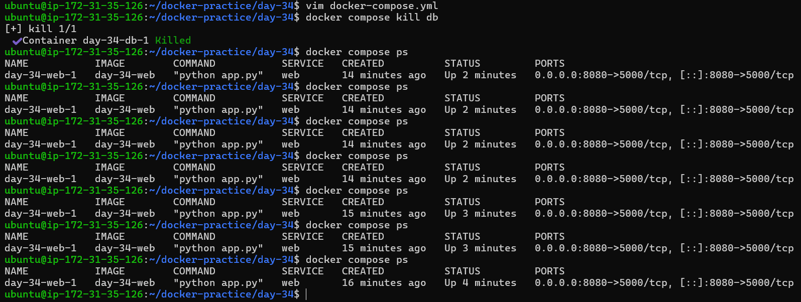Then docker compose ps shows only the web container. The DB did not come back automatically.
Why?
This is an important Docker behavior:
restart: always does not necessarily restart a container that you manually stop/kill. Docker treats an explicit manual stop as intentional.
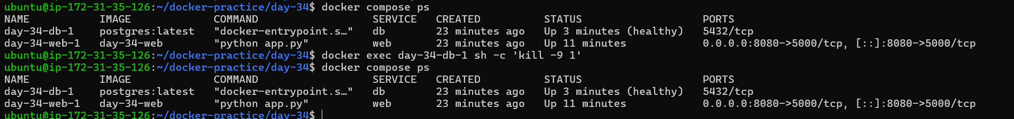
Try restart: on-failure — how is it different?
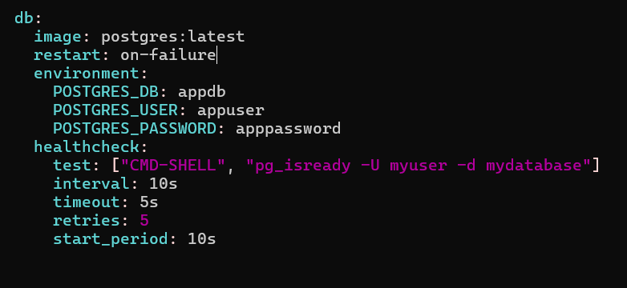

Difference between the two
Policy | Behavior
restart: always | Restarts the container when it exits/stops, subject to Docker's handling of explicit manual stops
restart: on-failure | Restarts only when the container exits with a failure/non-zero exit code
Your kill -9 1 simulated a failure, so on-failure restarted the DB.
restart: always is useful for services that should continuously stay available. restart: on-failure is useful when a service should restart only after an unexpected failure. In my test, killing the PostgreSQL main process caused the container to restart automatically with both policies.

restart: always — Used for important services such as databases and web applications that should automatically come back after unexpected stops.
restart: on-failure — Used when a container should restart only after a failure/crash, not after a normal successful exit.
restart: unless-stopped — Used for long-running production services that should automatically restart but should remain stopped if I intentionally stop them.
restart: no — Used mainly for temporary or development containers where automatic restarting is not required.

Task 4: Custom Dockerfiles in Compose
- Instead of using a pre-built image for your app, use build: in your compose file to build from a Dockerfile
- Make a code change in your app
- Rebuild and restart with one command

Instead of using a pre-built image for your app, use build: in your compose file to build from a Dockerfile
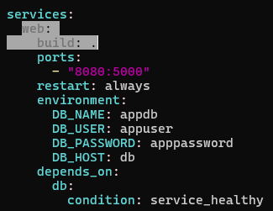
Make a code change in your app
app.py
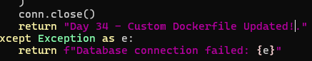
Rebuild and restart with one command
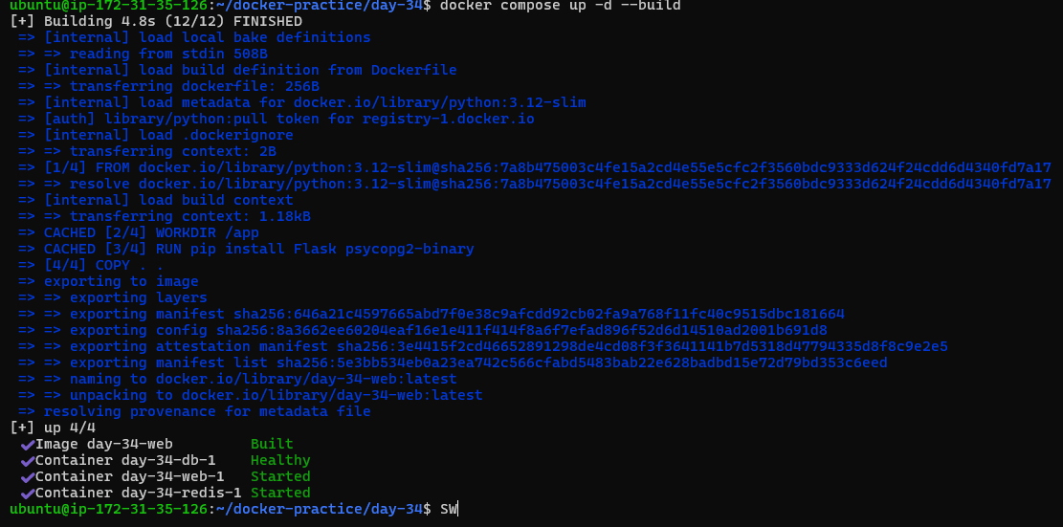  What I learned:
build: allows Docker Compose to build my application image from my own Dockerfile instead of relying on a pre-built application image. After changing the application code, docker compose up -d --build rebuilds the image and restarts the service with the updated code.
Task 5: Named Networks & Volumes
- Define explicit networks in your compose file instead of relying on the default
- Define named volumes for database data
- Add labels to your services for better organization

Define explicit networks in your compose file instead of relying on the default
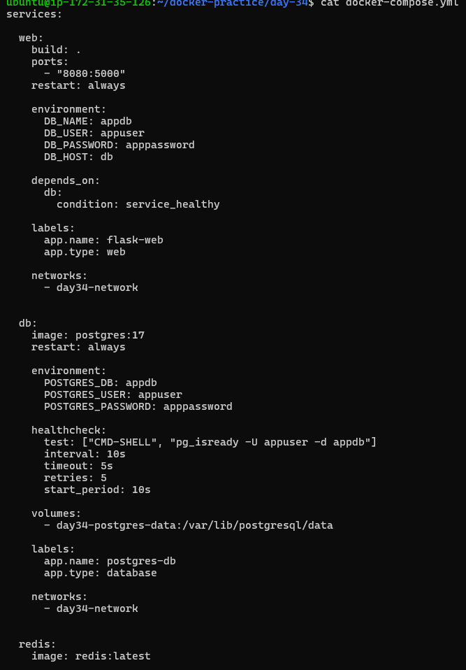
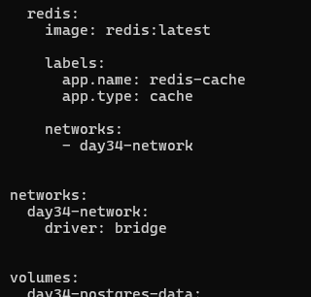
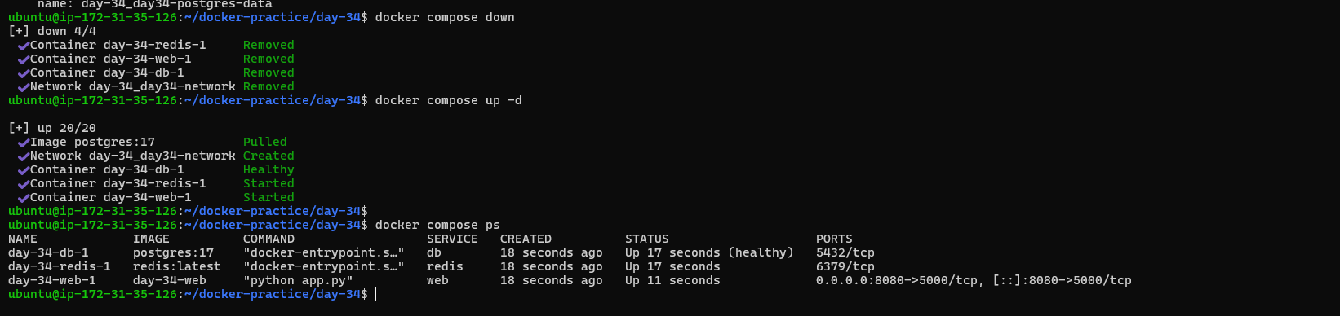
Task 6: Scaling (Bonus)
- Try scaling your web app to 3 replicas using docker compose up --scale
- What happens? What breaks?
- Write in your notes: Why doesn't simple scaling work with port mapping?
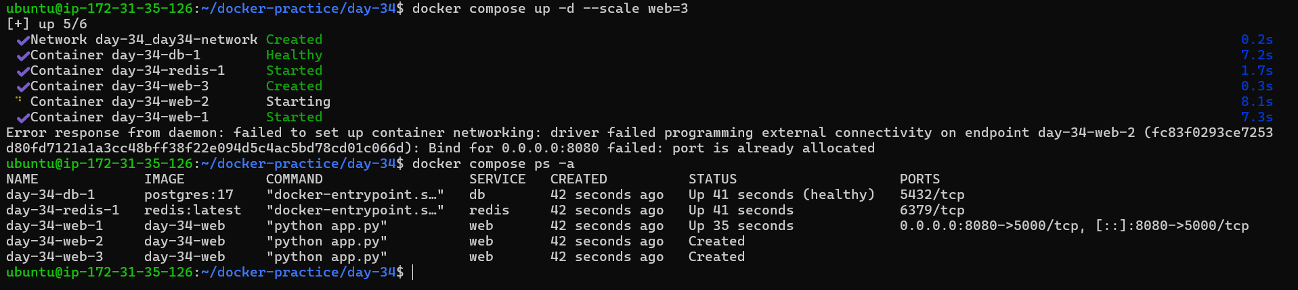

2. What happens? What breaks?
Your web service currently has:
ports:
- "8080:5000"
This means:
EC2 host port 8080 → container port 5000
Compose tries to make all 3 replicas use the same host port:
web-1 → 8080:5000 ✅
web-2 → 8080:5000 ❌
web-3 → 8080:5000 ❌
So the additional replicas cannot be started because host port 8080 is already being used by web-1.
Your database and Redis are not the problem. The problem is specifically the fixed host port mapping.

3. Why doesn't simple scaling work with port mapping?

Simple scaling does not work with a fixed host port because multiple
containers cannot bind to the same host port at the same time.

The container port 5000 can be used by every replica because each
container has its own network. However, host port 8080 belongs to the
EC2 host and can only be assigned once.

