Day 61 -- Introduction to Terraform and Your First AWS Infrastructure
Task 1: Understand Infrastructure as Code
Before touching the terminal, research and write short notes on:
- What is Infrastructure as Code (IaC)? Why does it matter in DevOps?
- problems does IaC solve compared to manually creating resources in the AWS What console?
- How is Terraform different from AWS CloudFormation, Ansible, and Pulumi?
- What does it mean that Terraform is "declarative" and "cloud-agnostic"?
Write this in your own words -- not copy-pasted definitions.

- What is Infrastructure as Code (IaC)? Why does it matter in DevOps?
- Infrastructure as a code is a process of creating and managing the infrastructure using configuration files, rather than setting up the things manually in cloud console.
Ex: to create AWS EC2 Instance no need to go to the console and set the security group, and setting up networking in AWS, we can give all these information in terraform file and terraform creates the infrastructure using the configuration file
In DevOps its matter for
Automation
Reuseability
Consistency
Fast deployment

- problems does IaC solve compared to manually creating resources in the AWS What console?
Creating infrastructure manually through the AWS Console can take time and may lead to mistakes, especially when managing many resources.
IaC helps solve these problems:
- Human errors: Automated configurations reduce mistakes caused by manually entering settings.
- Configuration differences: Multiple environments can use the same configuration instead of being created differently by different people.
- Time consumption: Resources can be created together through automation rather than setting up each one individually.
- Difficult tracking: Changes to infrastructure code can be recorded in Git and reviewed by team members.
- Difficult recovery: Infrastructure can be recreated from saved configuration files when required, although state and external dependencies must also be managed correctly.
- Poor collaboration: Teams can review, test, and share infrastructure changes through a common repository.
For example, if I need three EC2 instances with the same instance type and security settings, I can define them in Terraform instead of manually creating each one in the AWS Console.

- How is Terraform different from AWS CloudFormation, Ansible, and Pulumi?
Tool | Main purpose | How it differs
Terraform | Provisioning and managing infrastructure | Uses declarative configuration files and supports many cloud providers.
AWS CloudFormation | Provisioning AWS infrastructure | AWS-native service that manages AWS resources using templates.
Ansible | Configuration management and automation | Commonly configures operating systems, installs packages, and deploys applications; it can also provision infrastructure.
Pulumi | Infrastructure as Code | Lets developers define infrastructure using programming languages such as Python, TypeScript, Go, and C#.
In simple words:
- Terraform: I describe the infrastructure I need, and Terraform works toward that desired configuration.
- CloudFormation: Similar to Terraform, but designed primarily for AWS infrastructure.
- Ansible: Commonly used to configure servers after they have been created, such as installing Docker or setting up services.
- Pulumi: Provides an IaC approach using familiar programming languages instead of a dedicated configuration language.

4. What does it mean that Terraform is "declarative" and "cloud-agnostic"?
Declarative:
Terraform is declarative because I describe the final infrastructure I want rather than writing every individual step required to create it.
For example, I can specify that an EC2 instance should use a particular AMI, instance type, and security group. Terraform compares the configuration with its state and plans the changes needed to reach the desired configuration.
Cloud-agnostic:
Terraform is cloud-agnostic because it can manage resources across different infrastructure providers using provider plugins.
For example, I can use Terraform to manage AWS EC2 instances, Azure virtual machines, and Google Cloud resources. Each provider has its own resource types and configuration, so the code is not automatically interchangeable between clouds.
Conclusion
Infrastructure as Code makes infrastructure management more automated, consistent, repeatable, and easier to review. Terraform is a useful DevOps tool because it allows teams to define infrastructure in code, track changes through version control, and manage resources across multiple providers.
Task 2: Install Terraform and Configure AWS
- Install Terraform
- Verify
- Install and configure the AWS CLI
- Verify AWS access
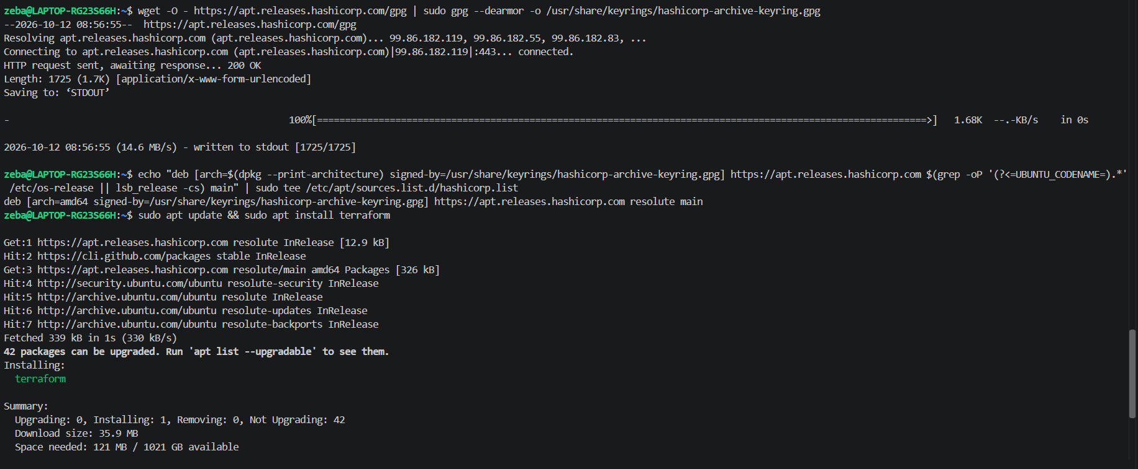
Terraform installed and verified

Install and configure aws cli and verifoed
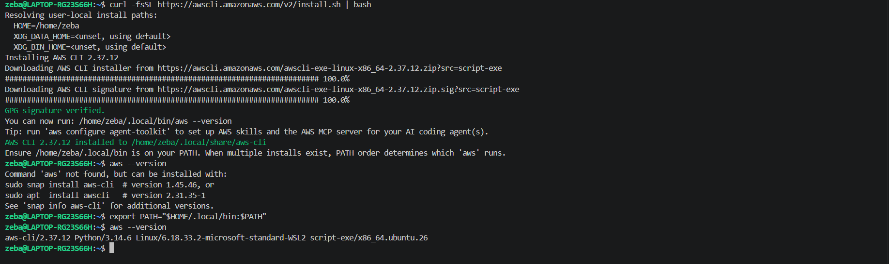
Task 3: Your First Terraform Config -- Create an S3 Bucket
Create a project directory and write your first Terraform config:
mkdir terraform-basics && cd terraform-basics
Create a file called main.tf with:
- A terraform block with required_providers specifying the aws provider
- A provider "aws" block with your region
- A resource "aws_s3_bucket" that creates a bucket with a globally unique name
Run the Terraform lifecycle:
terraform init # Download the AWS provider
terraform plan # Preview what will be created
terraform apply # Create the bucket (type 'yes' to confirm)
Go to the AWS S3 console and verify your bucket exists.
Document: What did terraform init download? What does the .terraform/ directory contain?

Providers.tf
S3.tf
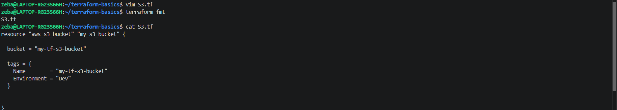
Validate and plan
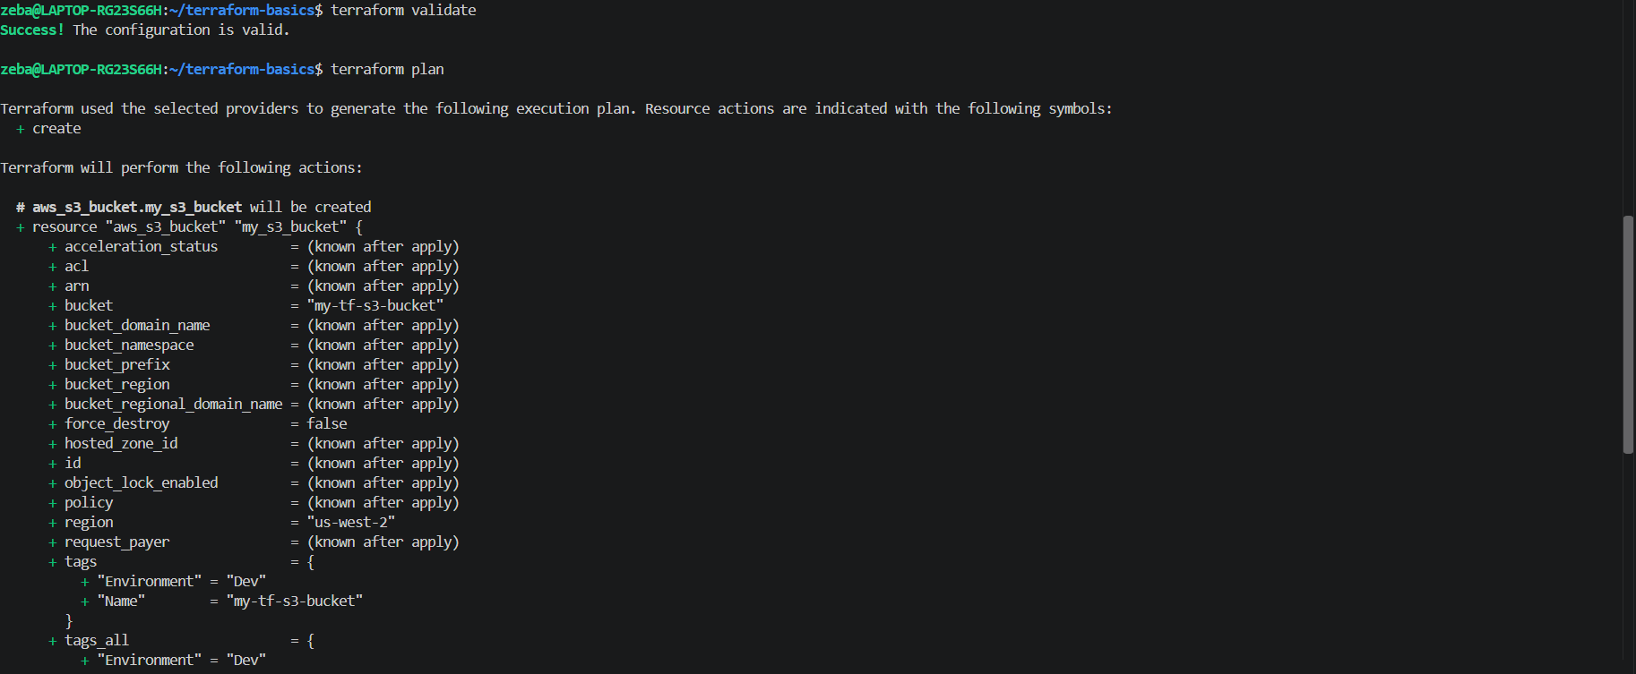

Got the error as to have a uniqe bucket name
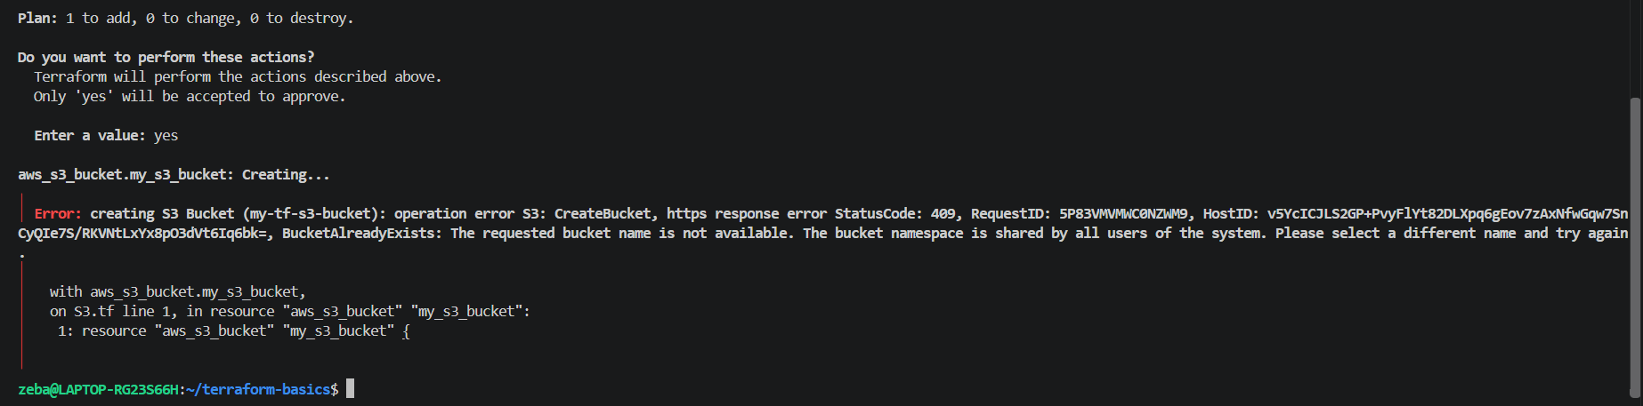
Changed bucket name
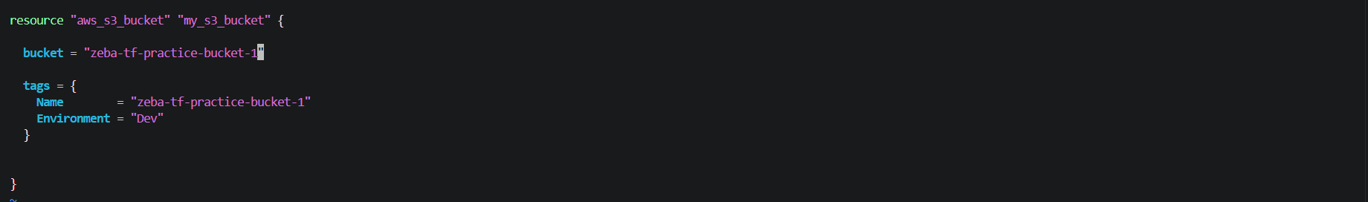
Then validate and apply
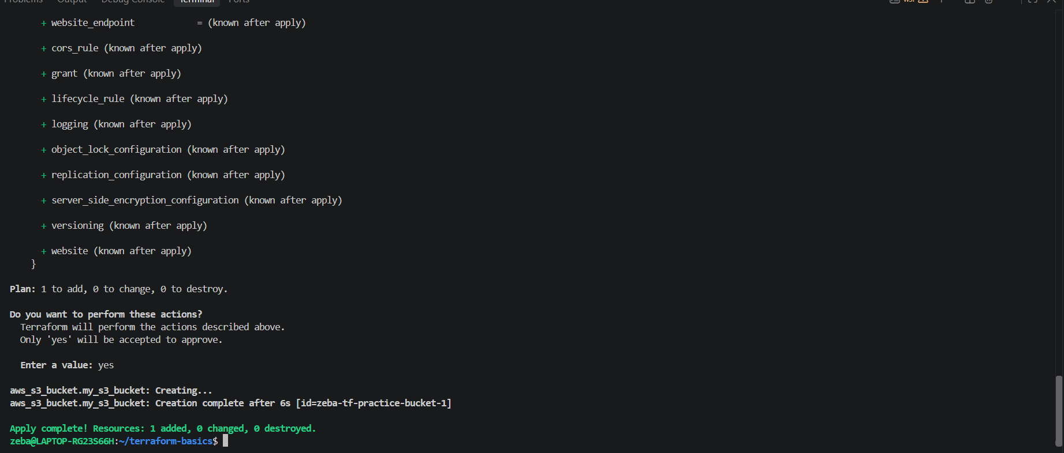

Bucket got created
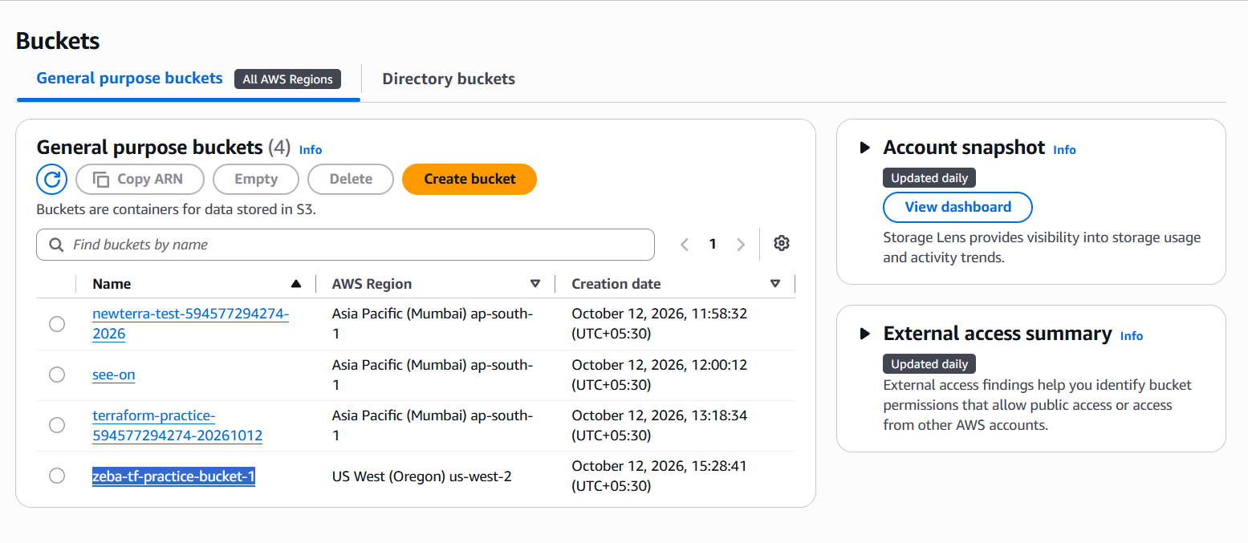

1. What did terraform init download?
It downloaded the AWS provider plugin from the Terraform Registry.

2. What does the .terraform/ directory contain?
It stores local Terraform working data, including downloaded provider plugins and related metadata.
Task 4: Add an EC2 Instance
In the same main.tf, add:
- A resource "aws_instance" using AMI ami-0f5ee92e2d63afc18 (Amazon Linux 2 in ap-south-1 -- use the correct AMI for your region)
- Set instance type to t2.micro
- Add a tag: Name = "TerraWeek-Day1"
Run:
terraform plan # You should see 1 resource to add (bucket already exists)
terraform apply
Go to the AWS EC2 console and verify your instance is running with the correct name tag.
Document: How does Terraform know the S3 bucket already exists and only the EC2 instance needs to be created?
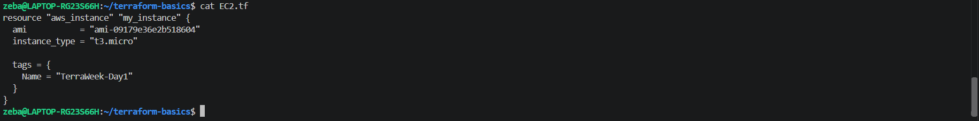
Terraform plan
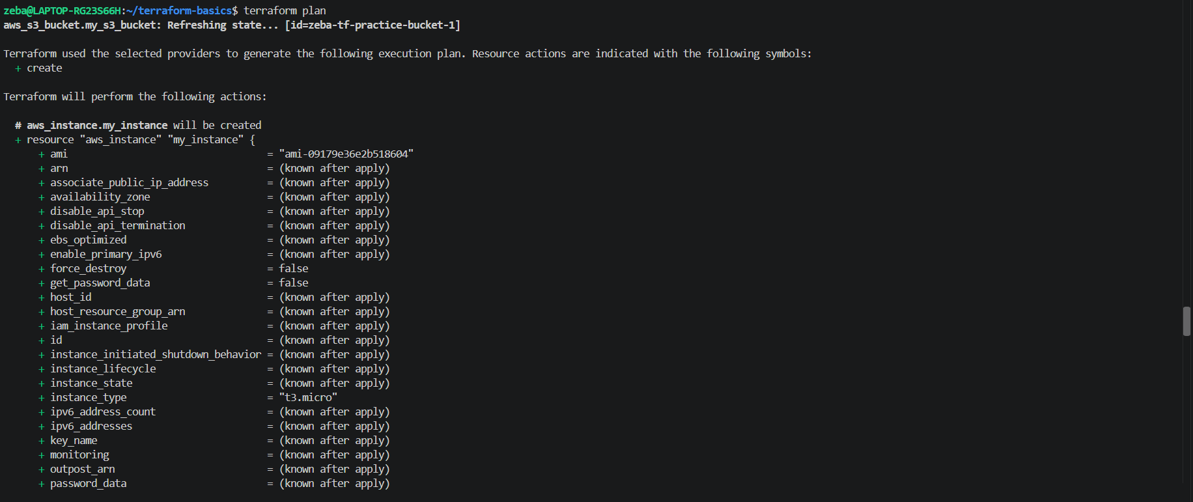
Terraform apply
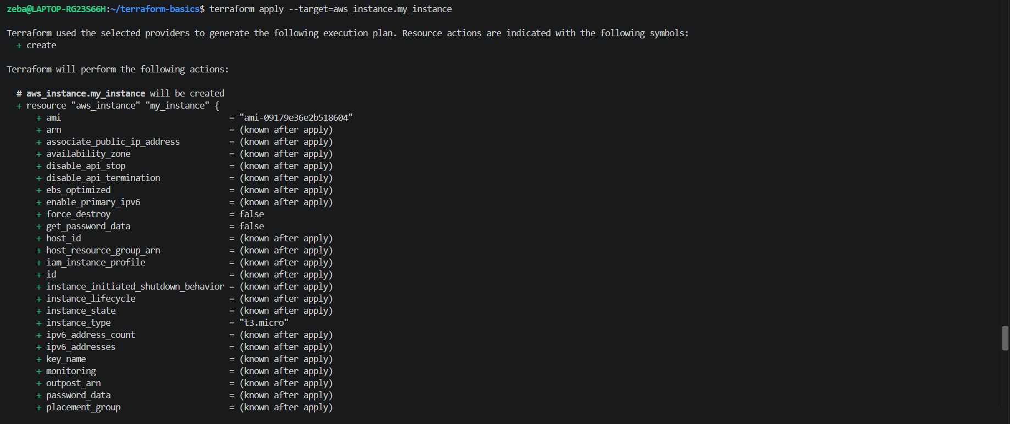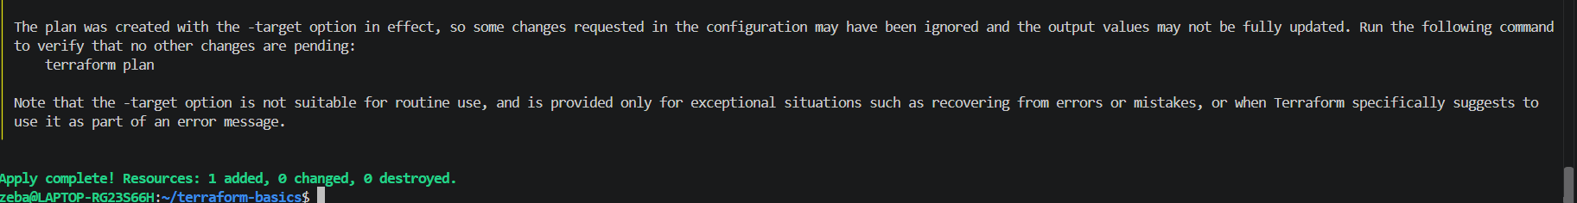

Instance got created
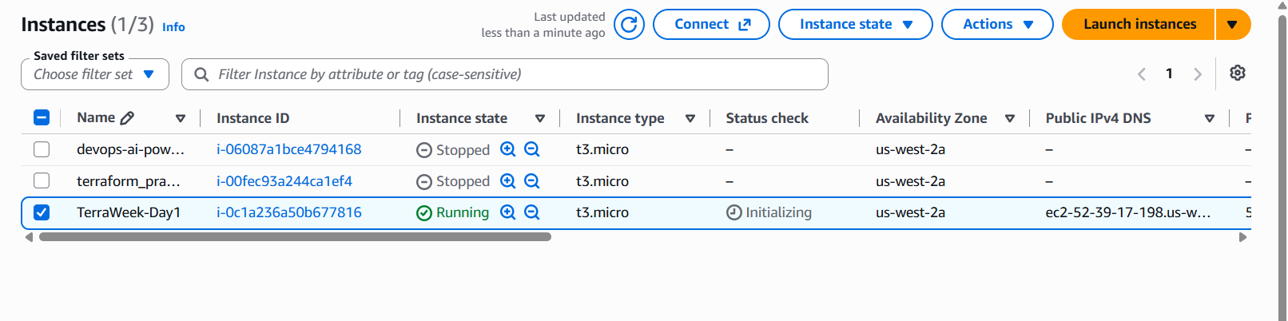
Task 5: Understand the State File
Terraform tracks everything it creates in a state file. Time to inspect it.
- Open terraform.tfstate in your editor -- read the JSON structure
- Run these commands and document what each returns:
terraform show # Human-readable view of current state
terraform state list # List all resources Terraform manages
terraform state show aws_s3_bucket.<name> # Detailed view of a specific resource
terraform state show aws_instance.<name>
- Answer these questions in your notes:
  - What information does the state file store about each resource?
  - Why should you never manually edit the state file?
  - Why should the state file not be committed to Git?

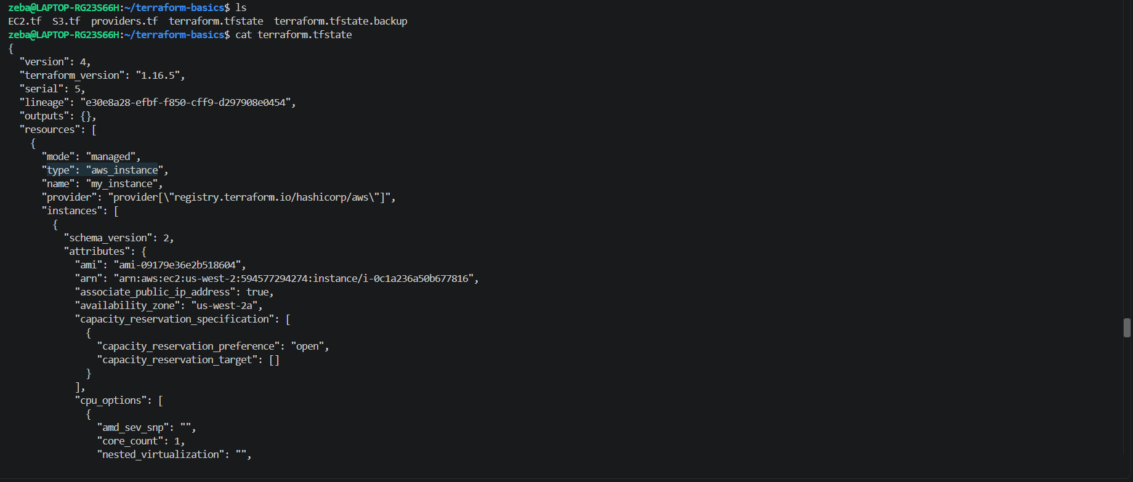
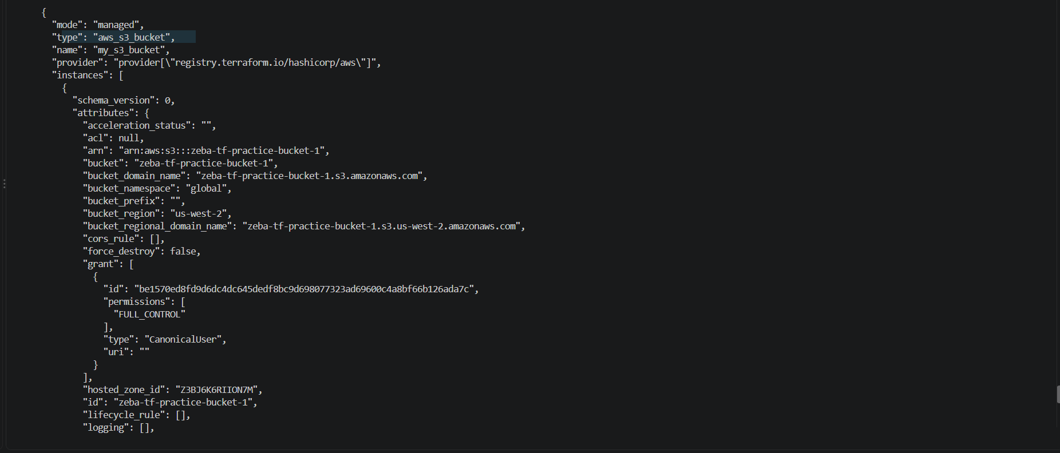
Terraform show - Human-readable view of current state
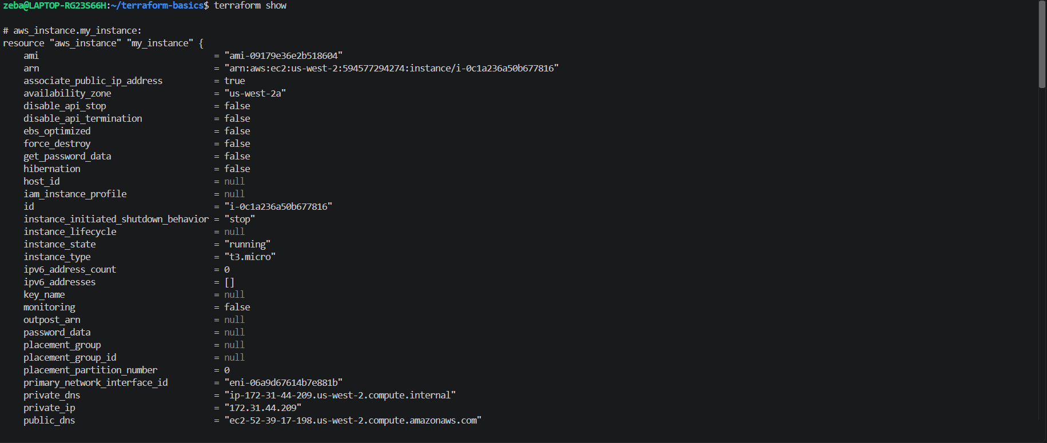
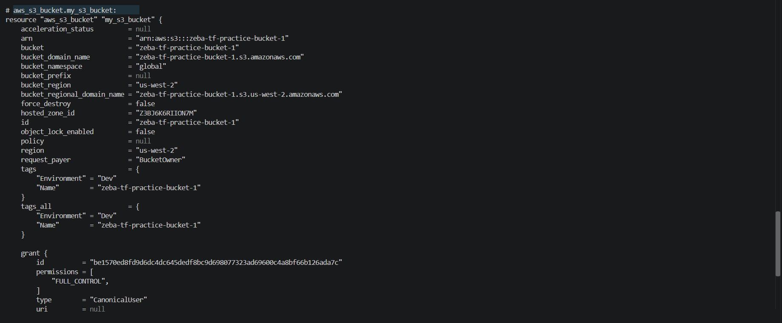
terraform state list - List all resources Terraform manages
terraform state show aws_s3_bucket.<name> - Detailed view of a specific resource
terraform state show aws_instance.<name> - Detailed view of a specific resource
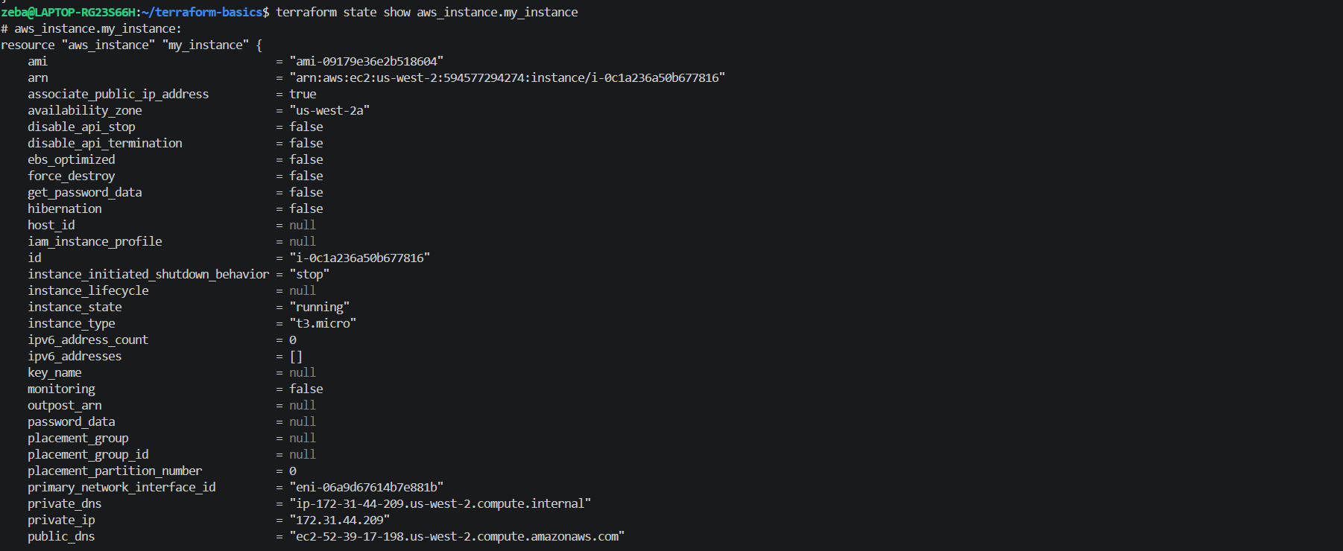

Q1. What information does the state file store about each resource?
Terraform stores the resource type and name, provider information, resource identifiers, and attributes needed to map the configuration to real infrastructure. Depending on the resource, this can include IDs, regions, tags, networking details, and sensitive values.

Q2. Why should you never manually edit the state file?
Manual edits can corrupt the state or cause Terraform to lose track of real infrastructure. This can lead to incorrect plans, unwanted changes, or resource recreation. Use Terraform state commands for supported state operations instead.

Q3. Why should the state file not be committed to Git?
The state file may contain passwords, tokens, connection details, or other sensitive information. Committing it can expose those values in repository history. It can also cause conflicts when multiple people manage the same infrastructure.
For team projects, use a secured remote backend with access controls, encryption, and state locking where supported.
Task 6: Modify, Plan, and Destroy
- Change the EC2 instance tag from "TerraWeek-Day1" to "TerraWeek-Modified" in your main.tf
- Run terraform plan and read the output carefully:
  - What do the ~, +, and - symbols mean?
  - Is this an in-place update or a destroy-and-recreate?
- Apply the change
- Verify the tag changed in the AWS console
- Finally, destroy everything:
terraform destroy
- Verify in the AWS console -- both the S3 bucket and EC2 instance should be gone

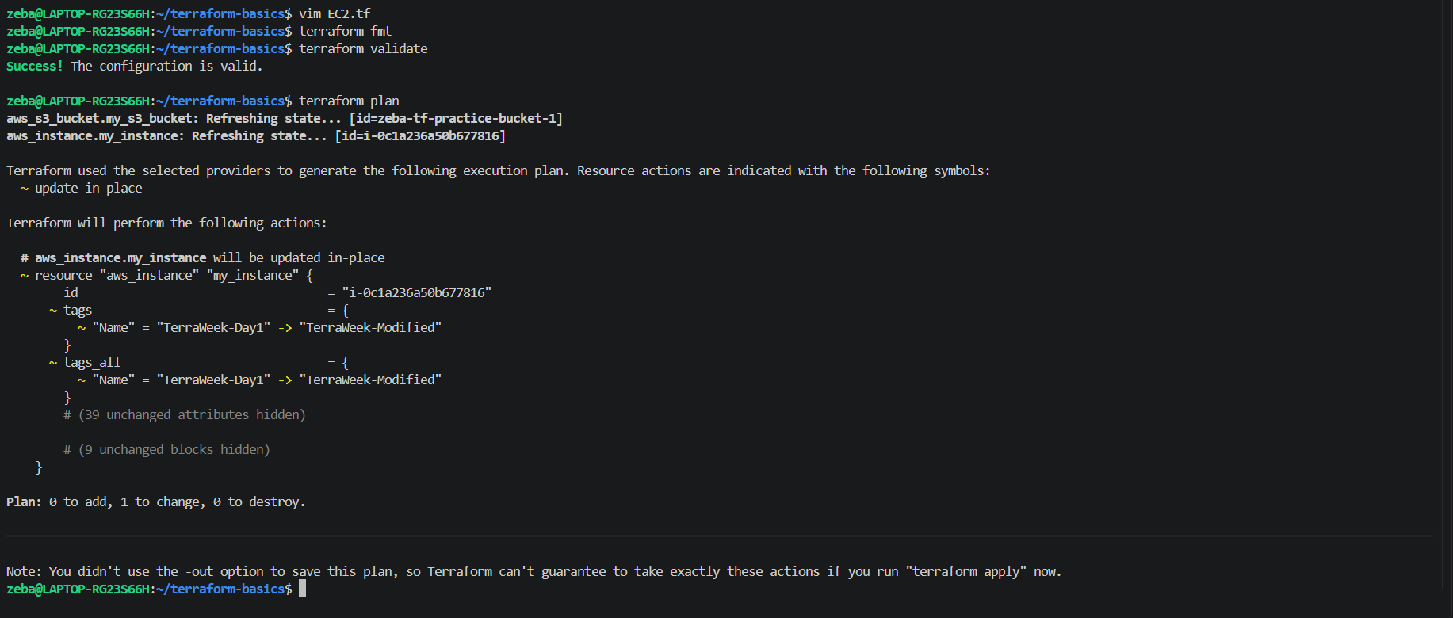
In our output
~ = means an update.
0 to add = means no new resources.
1 to change = means one resource will be updated.
0 to destroy = means no resources will be deleted.

- ~ — Update an existing resource or its attributes.
- + — Create a new resource.
- - — Destroy an existing resource.

is this an in-place update or a destroy-and-recreate?
It is an in-place update. We are changing the EC2 instance's Name tag from TerraWeek-Day1 to TerraWeek-Modified. The instance remains the same; Terraform does not destroy and recreate it.

Applied
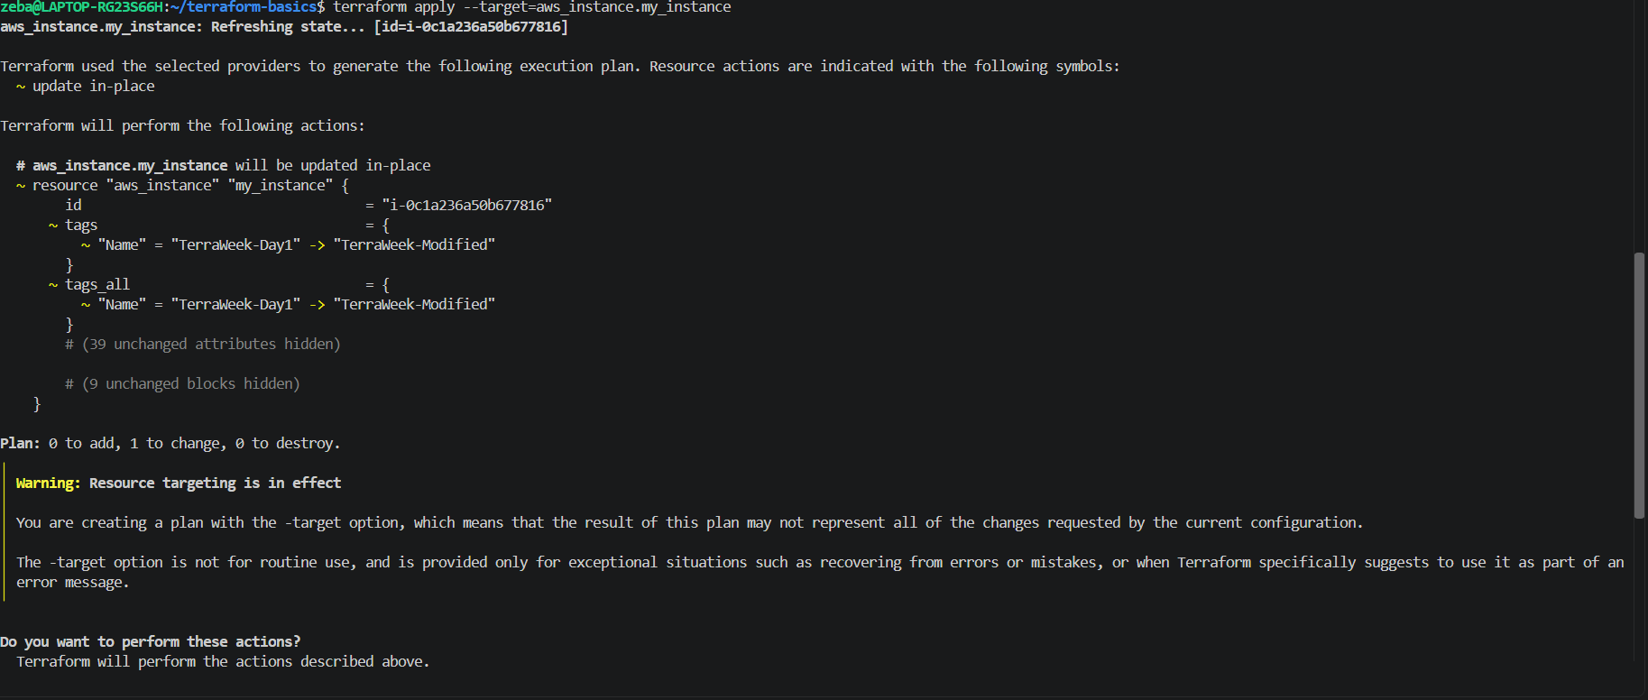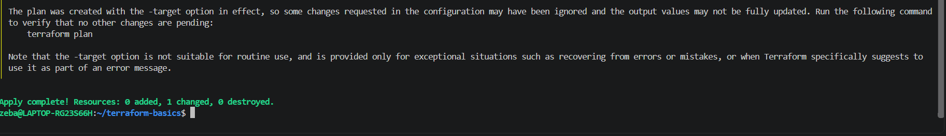
Tag got modified
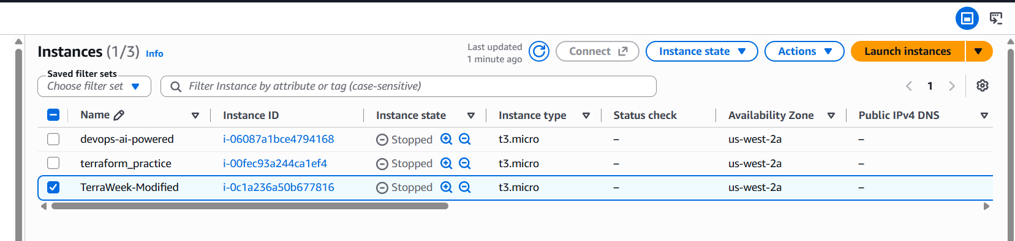
Destroy everything
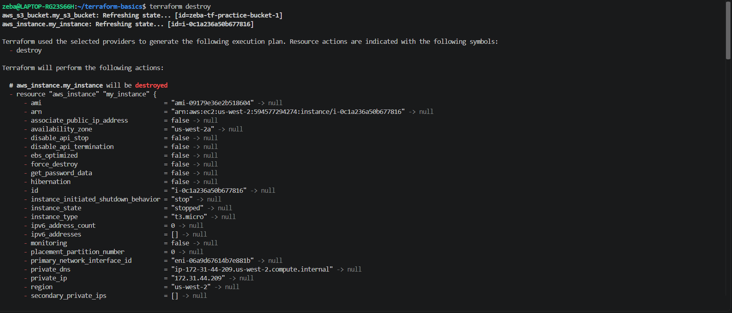
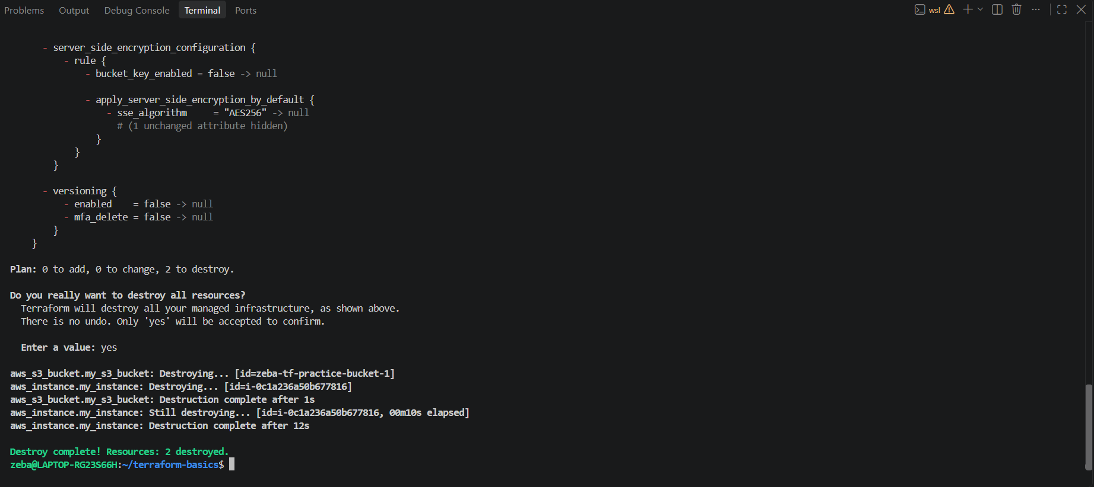
Instance got terminated
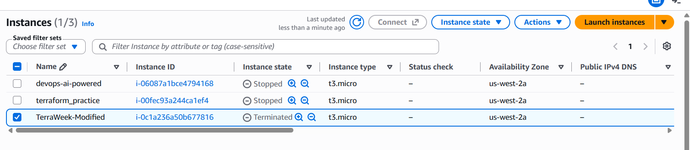
S3 bucket deleted
