Day 64 -- Terraform State Management and Remote Backends

Task 1: Inspect Your Current State
Use your Day 63 config (or create a small config with a VPC and EC2 instance). Apply it and then explore the state:
terraform show # Full state in human-readable format
terraform state list # All resources tracked by Terraform
terraform state show aws_instance.<name> # Every attribute of the instance
terraform state show aws_vpc.<name> # Every attribute of the VPC
Answer:
- How many resources does Terraform track?
- What attributes does the state store for an EC2 instance? (hint: way more than what you defined)
- Open terraform.tfstate in an editor -- find the serial number. What does it represent?

terraform show – gives complete terraform.tfstate file in human readable formate
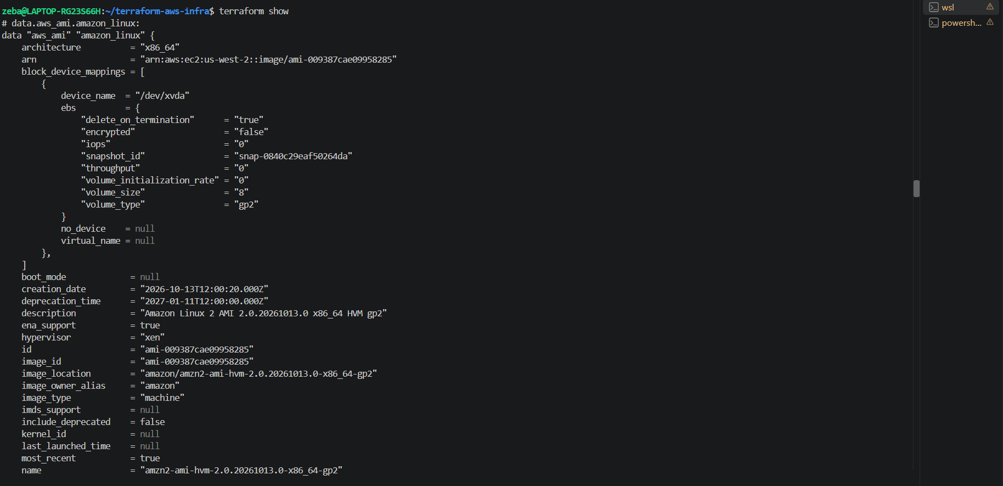

terraform state list – gives list of resources terraform managing
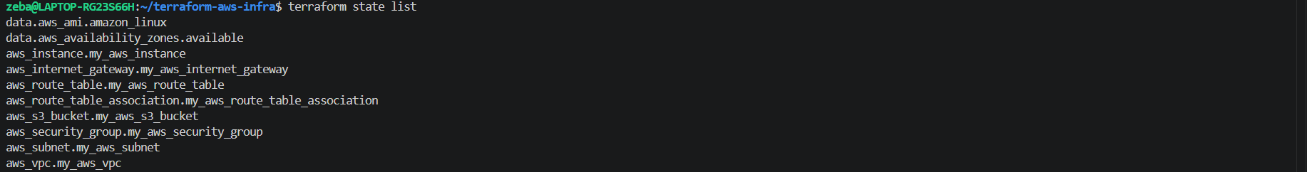

Terraform state show aws_instance <name> - shows every attribute of the instance
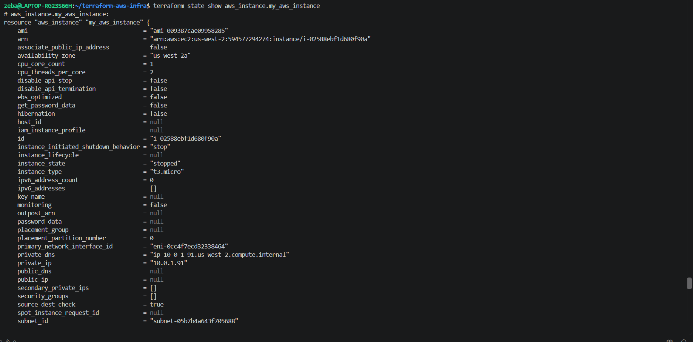

Terraform state show aws_vpc <name> - shows every attribute of the vpc
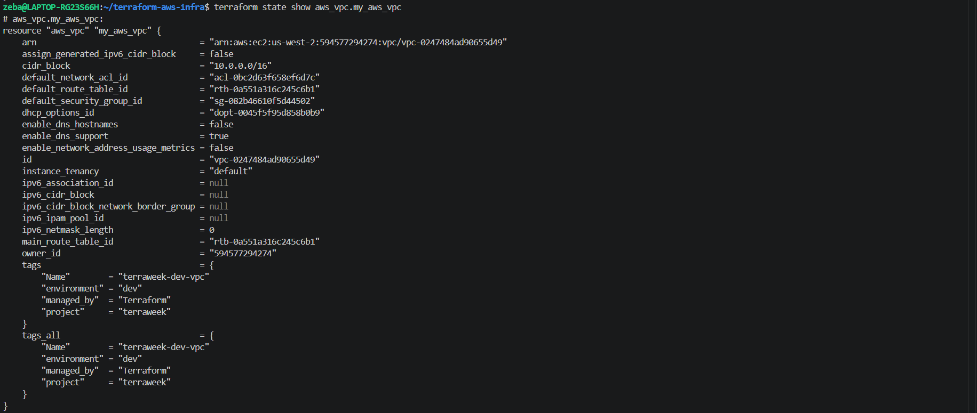

- How many resources does Terraform track?
- In our infrastructure Result: 10 state entries terraform is managing
8 managed AWS resources
  - data sources

- What attributes does the state store for an EC2 instance? (hint: way more than what you defined)
- Command: terraform state show aws_instance.my_aws_instance
- id — EC2 instance ID
- ami — image used to launch the instance
- instance_type — instance size
- subnet_id — subnet ID
- private_ip and public_ip — IP addresses
- vpc_security_group_ids — attached security groups
- availability_zone — availability zone
- arn — Amazon Resource Name
- tags — resource tags
- root_block_device — root volume details

- Open terraform.tfstate in an editor -- find the serial number. What does it represent?
The serial is a version counter for the Terraform state snapshot. It normally increases when Terraform writes updated state and helps detect stale snapshots. It does not represent the number of resources or commands executed.

Task 2: Set Up S3 Remote Backend
Storing state locally is dangerous -- one deleted file and you lose everything. Time to move it to S3.
- First, create the backend infrastructure (do this manually or in a separate Terraform config):
# Create S3 bucket for state storage
aws s3api create-bucket \
--bucket terraweek-state-<yourname> \
--region ap-south-1 \
--create-bucket-configuration LocationConstraint=ap-south-1

# Enable versioning (so you can recover previous state)
aws s3api put-bucket-versioning \
--bucket terraweek-state-<yourname> \
--versioning-configuration Status=Enabled

# Create DynamoDB table for state locking
aws dynamodb create-table \
--table-name terraweek-state-lock \
--attribute-definitions AttributeName=LockID,AttributeType=S \
--key-schema AttributeName=LockID,KeyType=HASH \
--billing-mode PAY_PER_REQUEST \
--region ap-south-1
- Add the backend block to your Terraform config:
terraform {
backend "s3" {
bucket = "terraweek-state-<yourname>"
key = "dev/terraform.tfstate"
region = "ap-south-1"
dynamodb_table = "terraweek-state-lock"
encrypt = true
}
}
- Run:
terraform init
Terraform will ask: "Do you want to copy existing state to the new backend?" -- say yes.
- Verify:
  - Check the S3 bucket -- you should see dev/terraform.tfstate
  - Your local terraform.tfstate should now be empty or gone
  - Run terraform plan -- it should show no changes (state migrated correctly)

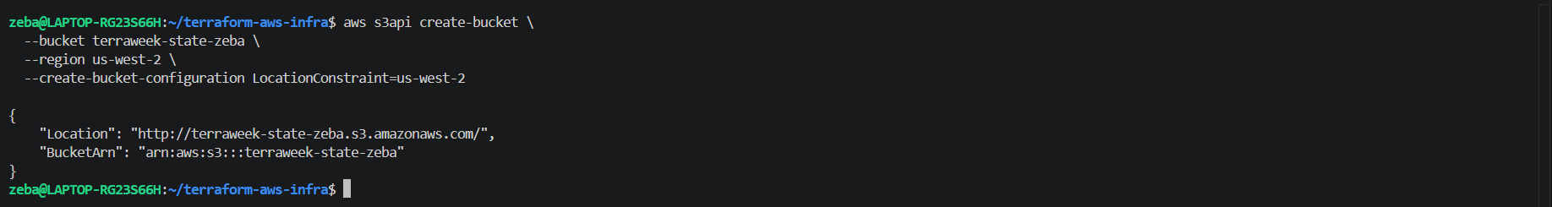
S3 bucket created

Enable versioning (so you can recover previous state) – versioning allows you to recover previous versions of terraform state object if it is accidentally overwritten
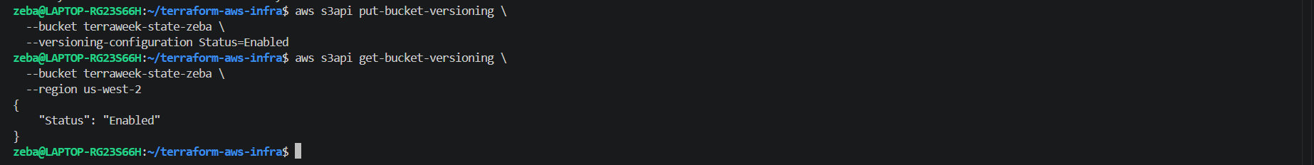
Versioning enabled

DynamoDB table – for state locking
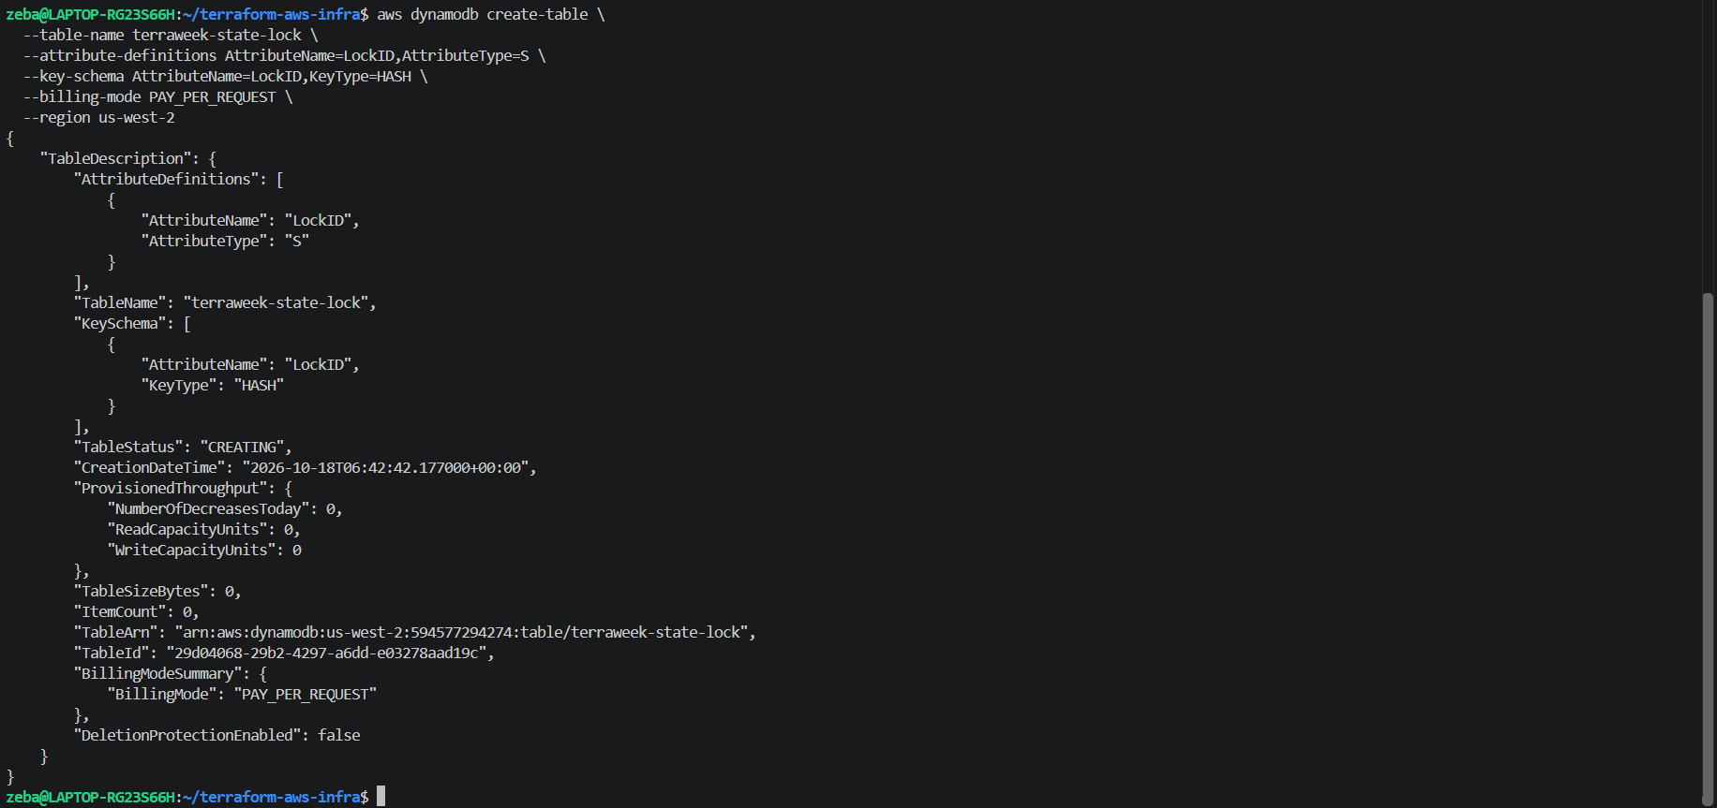
Verified
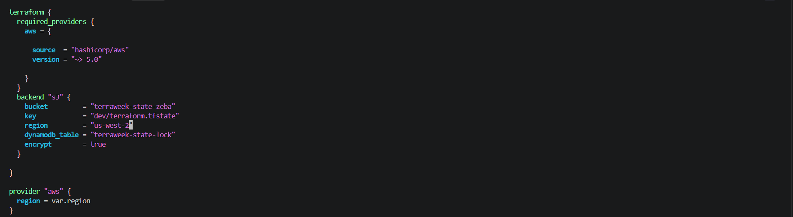
Added backend s3 block in providers.tf where we have already given terraform black
We need to add backend block in terraform
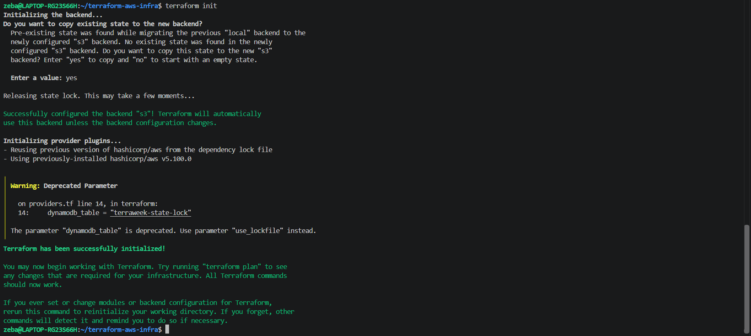
Terraform init – asked – do u want to copy existing state to the new backend

W got the below warning -
DynamoDB locking warning
Terraform says dynamodb_table is deprecated and recommends use_lockfile instead. This is a warning, not a migration failure.

So in backend block we have used dynamodb_table , instead of that it is recommending to use use_lockfile parameter . so lets do that
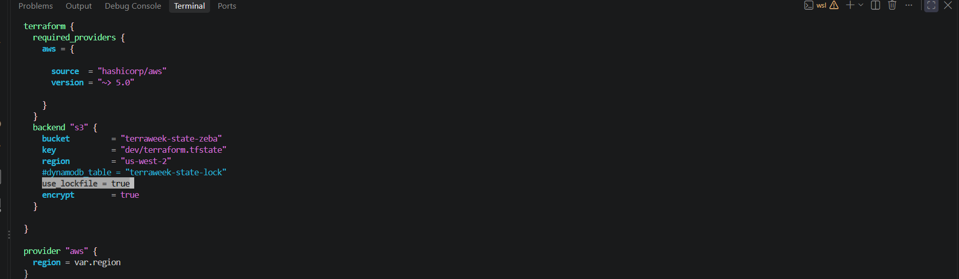
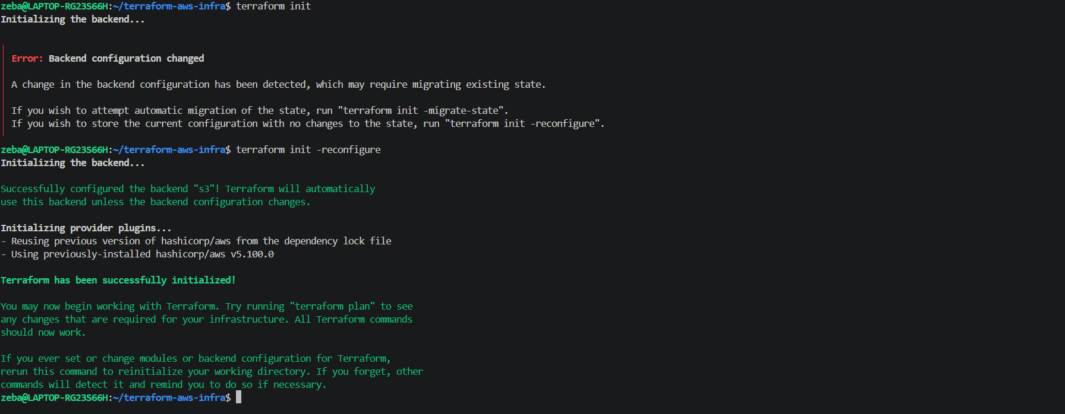

Check the S3 bucket -- you should see dev/terraform.tfstate
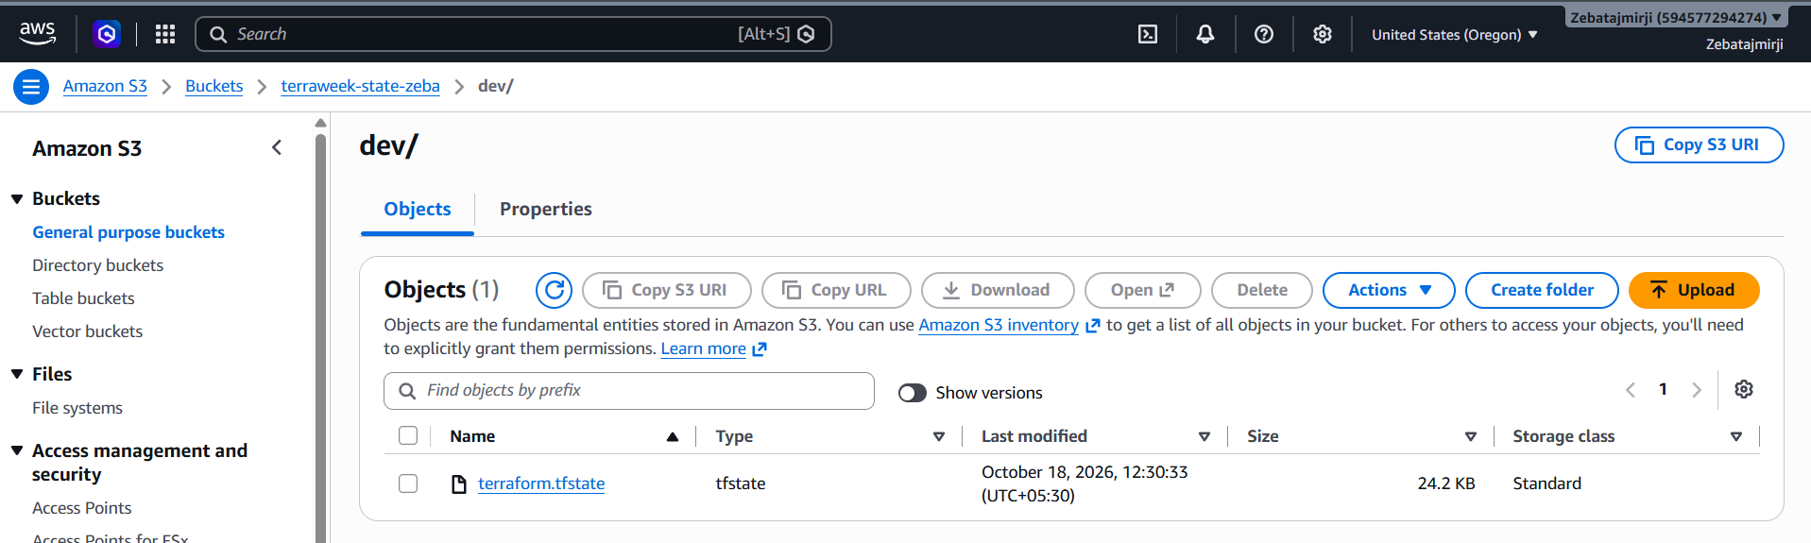

Now after migration of the backend from local to s3 our terrafor.tfstate file in local is empty

Run terraform plan -- it should show no changes (state migrated correctly)
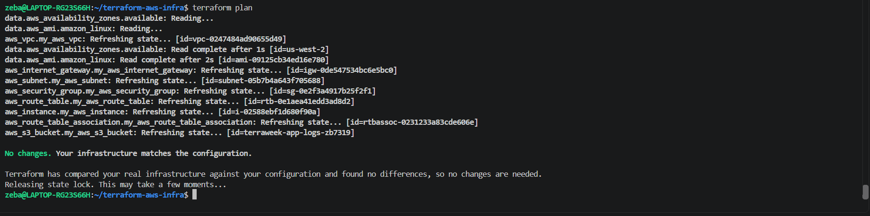
Task 3: Test State Locking
State locking prevents two people from running terraform apply at the same time and corrupting the state.
- Open two terminals in the same project directory
- In Terminal 1, run:
terraform apply
- While Terminal 1 is waiting for confirmation, in Terminal 2 run:
terraform plan
- Terminal 2 should show a lock error with a Lock ID
Document: What is the error message? Why is locking critical for team environments?
- After the test, if you get stuck with a stale lock:
terraform force-unlock <LOCK_ID>

1st terminal – terraform apply
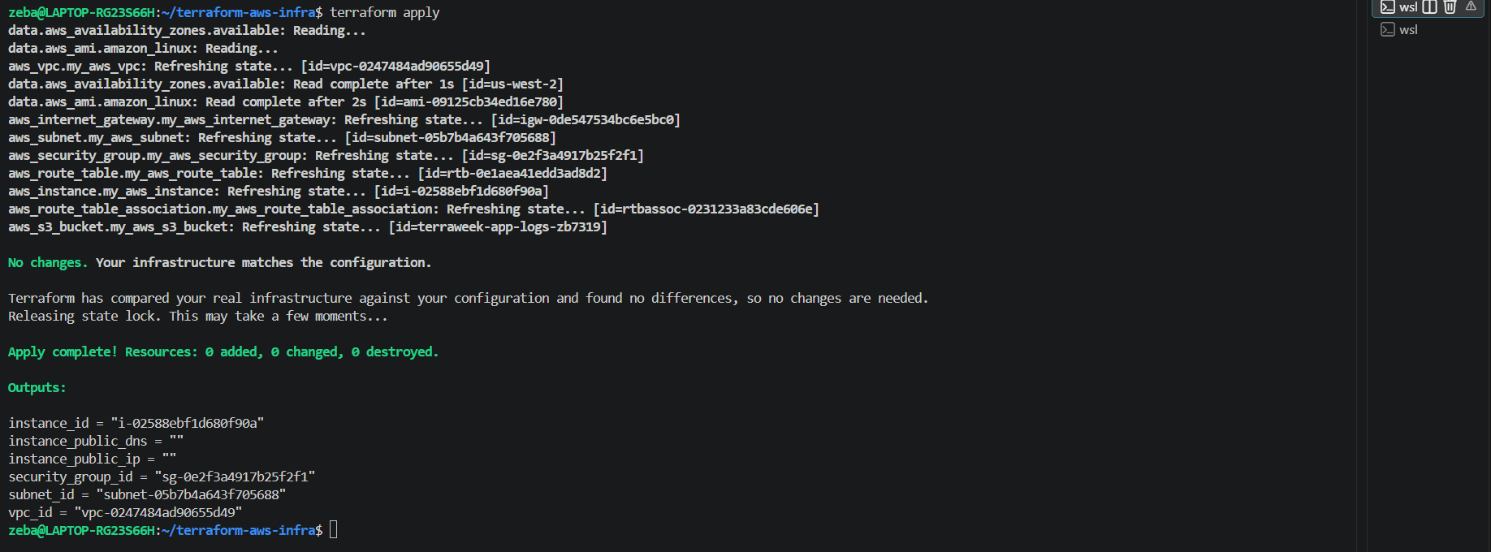

2nd terminal - terraform plan – it through state lock error
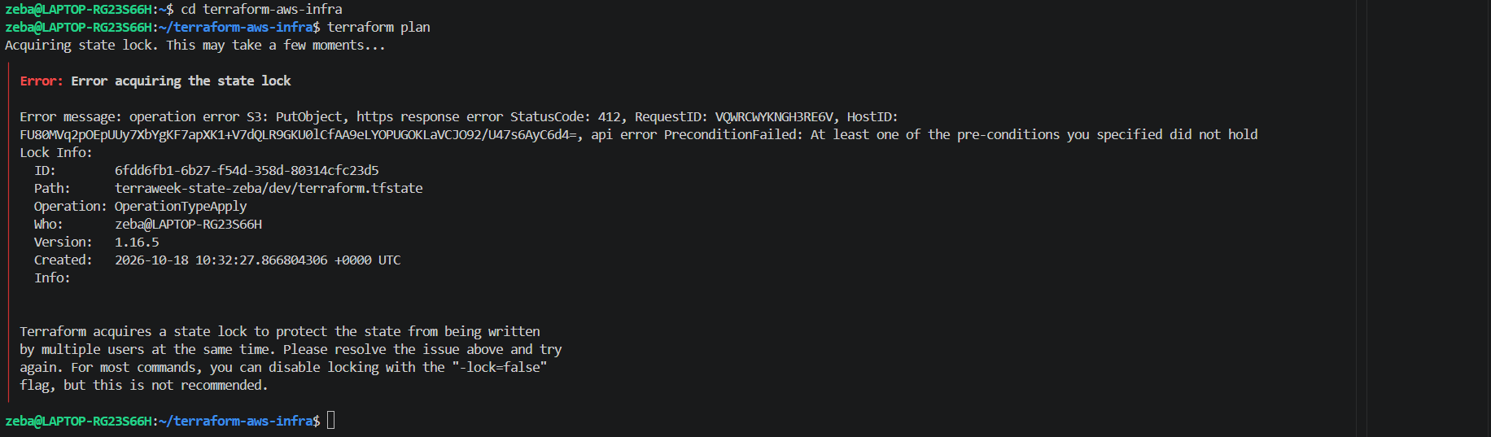
Lock ID : 6fdd6fb1-6b27-f54d-358d-80314cfc23d5

Observed error:
- Error: Error acquiring the state lock
- HTTP status: 412 PreconditionFailed
- Operation: OperationTypeApply
- Lock ID: 6fdd6fb1-6b27-f54d-358d-80314cfc23d5
Why state locking is critical:
- Prevents concurrent Terraform operations from writing conflicting state updates.
- Reduces the risk of state corruption.
- Coordinates infrastructure changes when multiple team members work with the same remote state.
Result: State locking successfully prevented the second Terraform operation from acquiring the lock while the first operation held it.
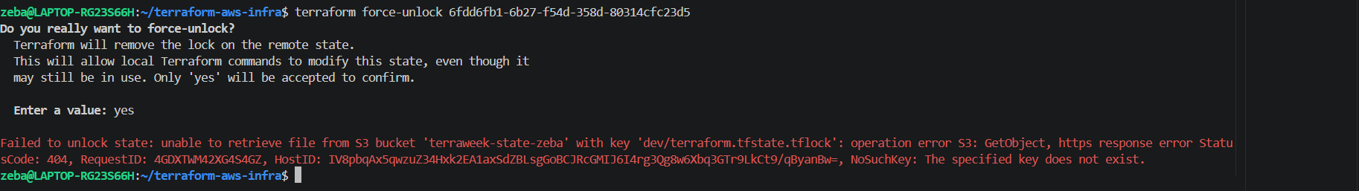
Terraform force-unlock <ID> - to force unlock the state lock
Here there is no state lock for now so showing error

Task 4: Import an Existing Resource
Not everything starts with Terraform. Sometimes resources already exist in AWS and you need to bring them under Terraform management.
- Manually create an S3 bucket in the AWS console -- name it terraweek-import-test-<yourname>
- Write a resource "aws_s3_bucket" block in your config for this bucket (just the bucket name, nothing else)
- Import it:
terraform import aws_s3_bucket.imported terraweek-import-test-<yourname>
- Run terraform plan:
  - If you see "No changes" -- the import was perfect
  - If you see changes -- your config does not match reality. Update your config to match, then plan again until you get "No changes"
- Run terraform state list -- the imported bucket should now appear alongside your other resources
Document: What is the difference between terraform import and creating a resource from scratch?

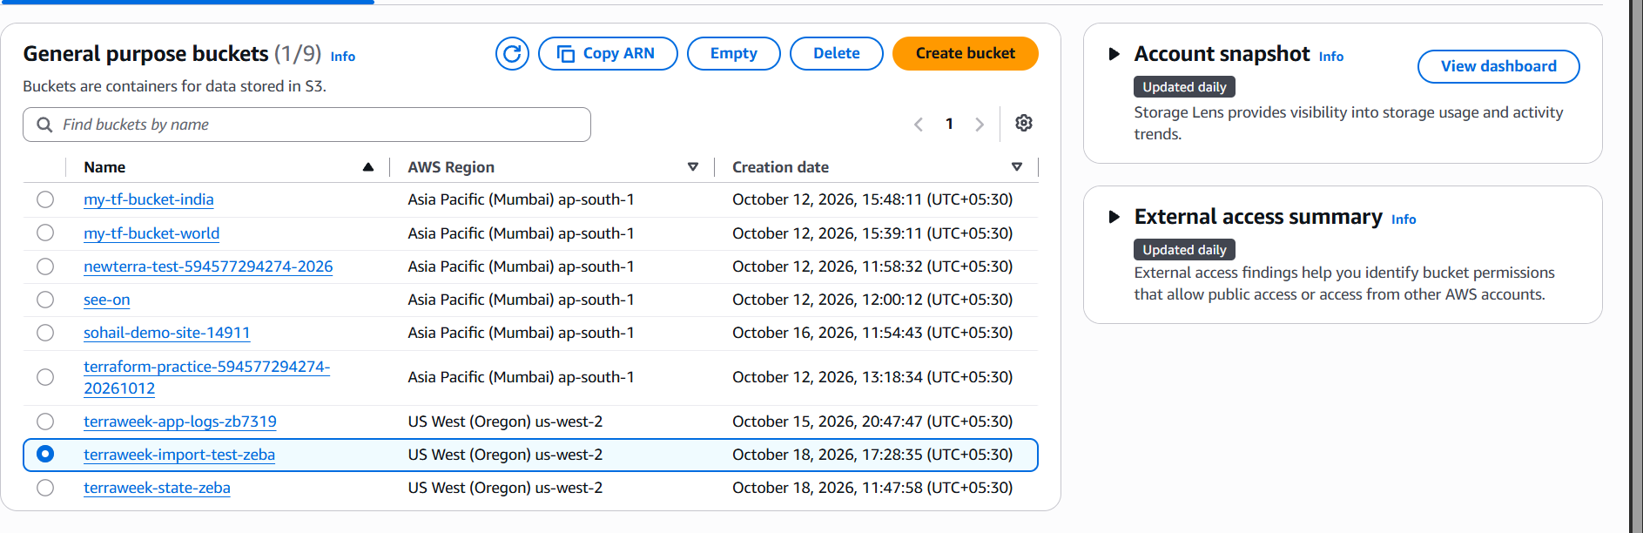
Bucket created by name terrawek-import-test-zeba
Added resource block for s3 bucket with just the name of the bucket created in the main.tf file
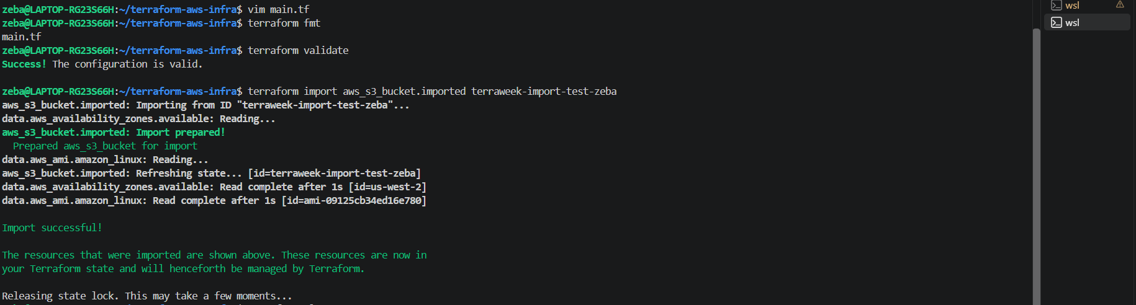
Terraform import
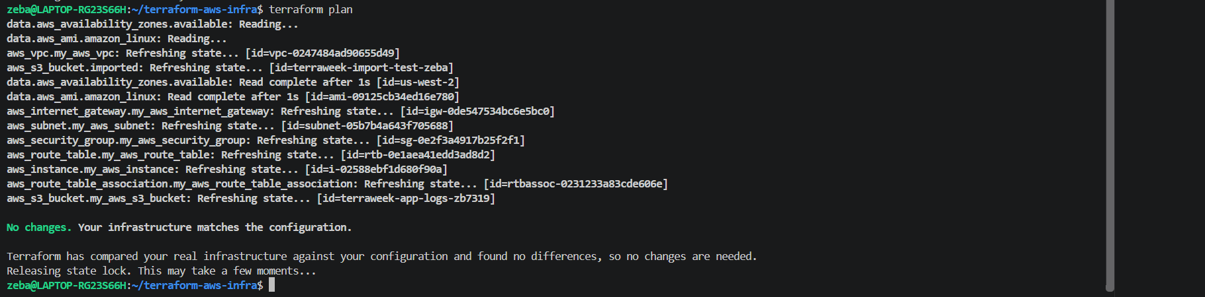
Terraform plan is showing no change that means import was successful
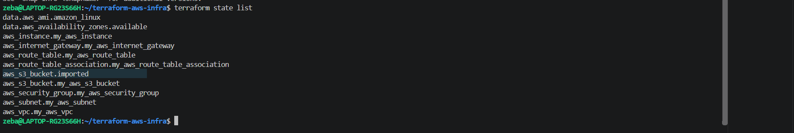
Verified – we could see the aws_s3_bucket.imported is being tracked and managed by terraform now

Difference between terraform import and creating a resource from scratch
1. Terraform Import
- Used when a resource already exists in AWS but is not yet managed by Terraform state.
- The resource is created manually or by another process.
- The Terraform resource block must be written in the configuration.
- Running terraform import associates the existing resource with Terraform state without creating a new resource in AWS.
2. Creating a Resource from Scratch
- Used when a resource does not yet exist in AWS.
- Define the resource in a Terraform configuration file.
- Run terraform plan to review the proposed changes and terraform apply to create the resource.
- Terraform creates the resource in AWS and records it in the state file.

Task 5: State Surgery -- mv and rm
Sometimes you need to rename a resource or remove it from state without destroying it in AWS.
- Rename a resource in state:
terraform state list # Note the current resource names
terraform state mv aws_s3_bucket.imported aws_s3_bucket.logs_bucket
Update your .tf file to match the new name. Run terraform plan -- it should show no changes.
- Remove a resource from state (without destroying it):
terraform state rm aws_s3_bucket.logs_bucket
Run terraform plan -- Terraform no longer knows about the bucket, but it still exists in AWS.
- Re-import it to bring it back:
terraform import aws_s3_bucket.logs_bucket terraweek-import-test-<yourname>
Document: When would you use state mv in a real project? When would you use state rm?

- Rename a resource in state:
Terraform state mv will just remain the resource name which is getting track by terraform , it wont change the actual name of the aws resource
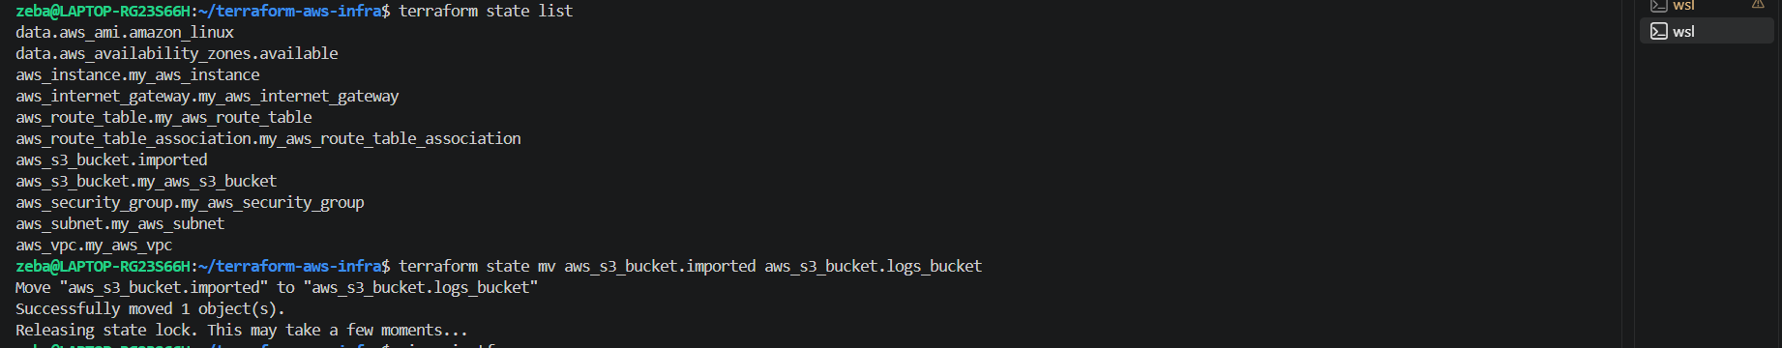
Updated main.tf to match the name
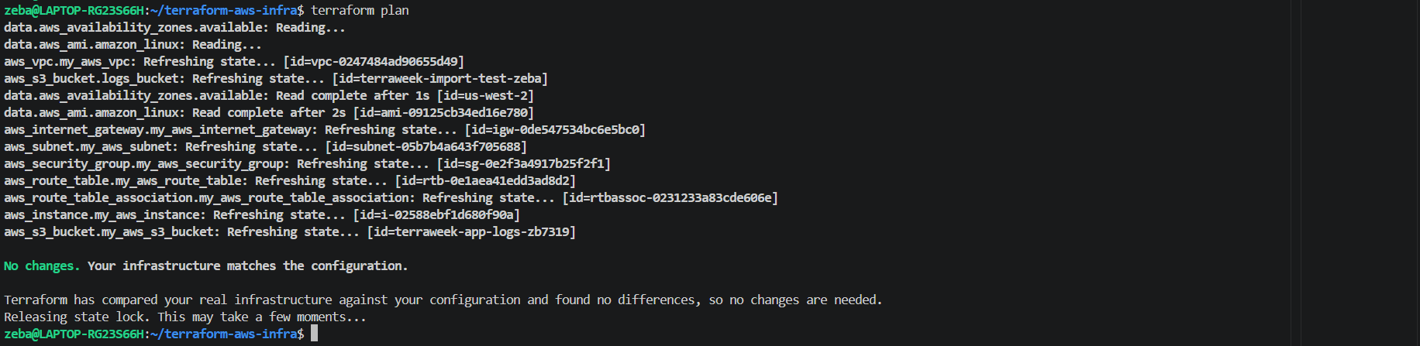
Terraform plan is showing no changes hence our renaming of the resource was done successfully

- Remove a resource from state (without destroying it):
Removed the resource from state
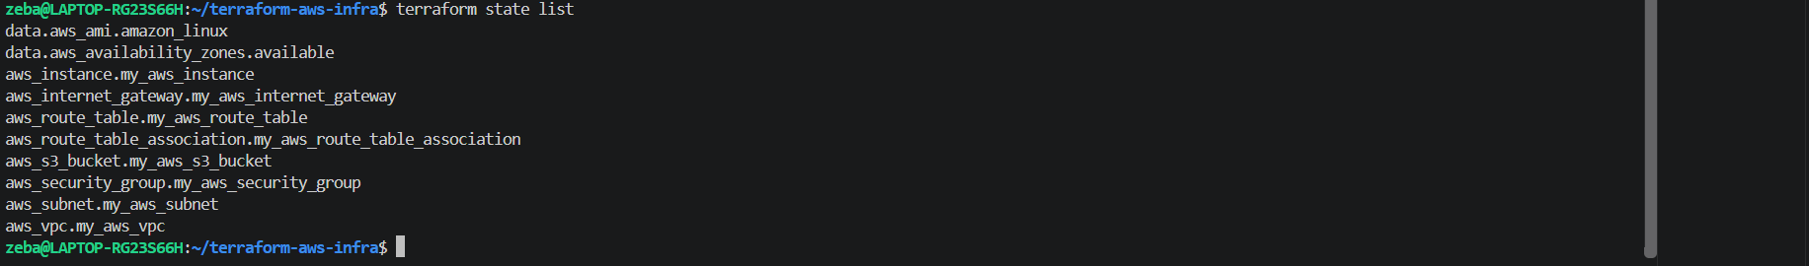
Verified it is not getting tracked by the terraform in state now
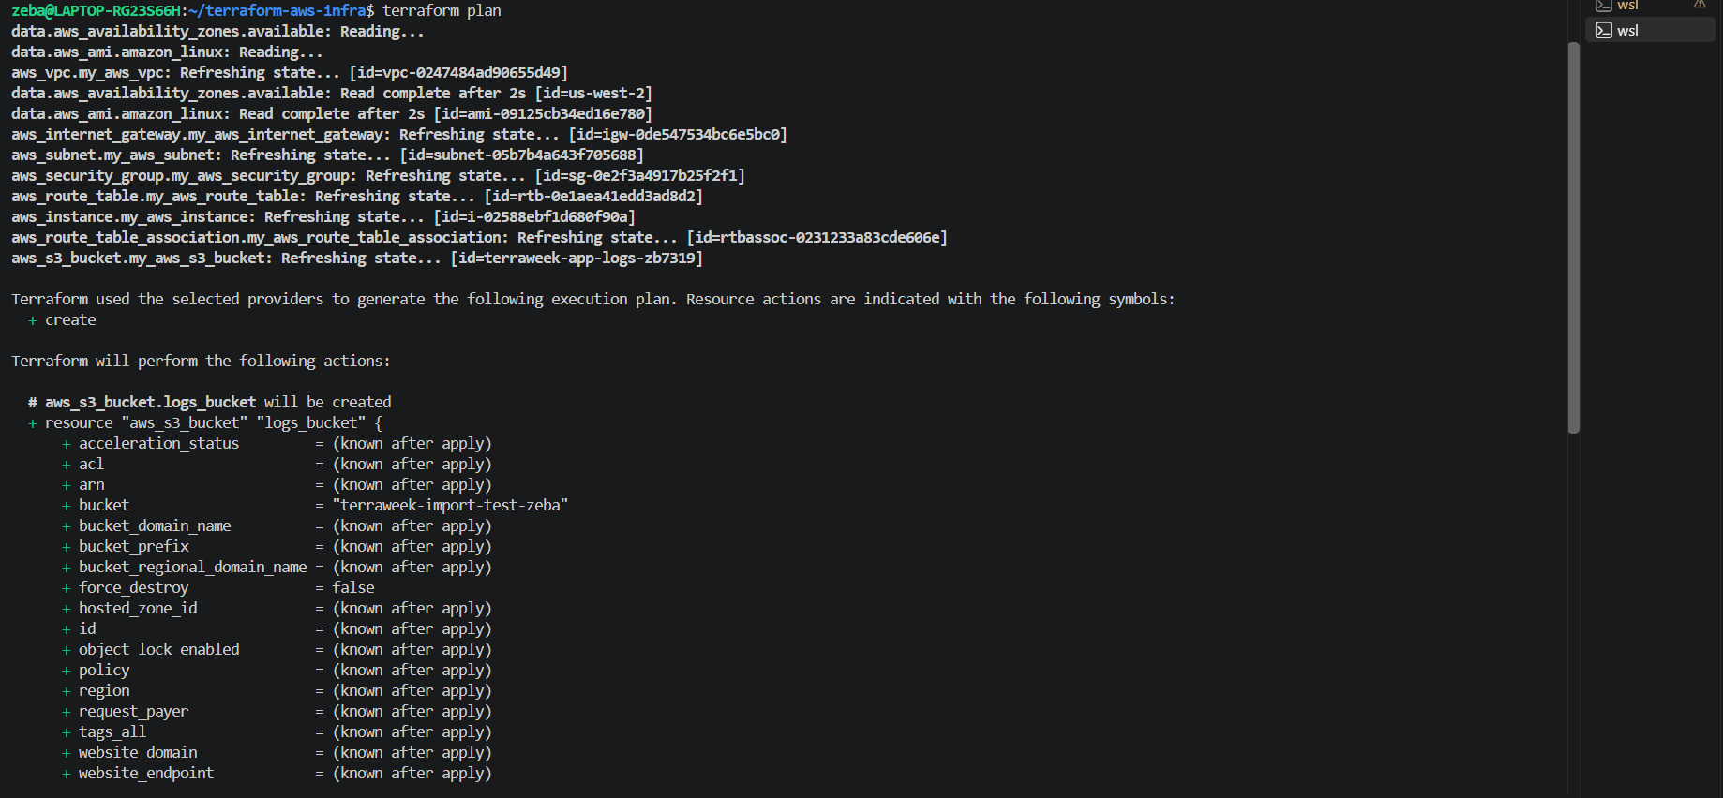
Terraform plan is asking to create the bucket why because I have not removed the s3 bucket block from the main.tf . but it still exits in aws though it is not being tracked.
- Re-import it to bring it back:
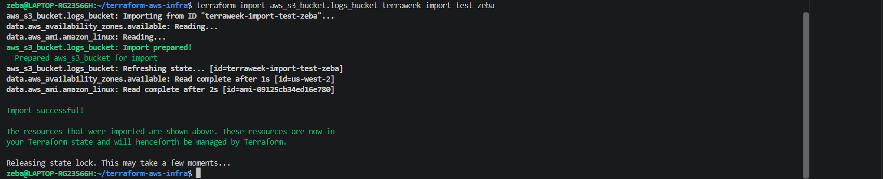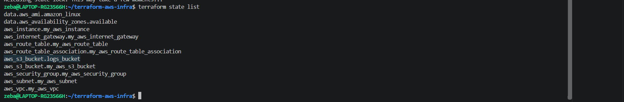
Veriffied – again it is started getting track by terraform

1. When would you use terraform state mv in a real project?
terraform state mv is used when a resource's address changes in Terraform configuration, but the actual infrastructure should remain unchanged.
Example: When renaming a resource from aws_s3_bucket.imported to aws_s3_bucket.logs_bucket, or moving a resource into a Terraform module. It updates the resource's address in state without recreating the AWS resource.
2. When would you use terraform state rm?
terraform state rm is used to remove a resource from Terraform state without destroying the actual infrastructure.
Example: When transferring responsibility for a resource to another Terraform configuration or when Terraform should stop managing that resource.
Important: If the resource block remains in the configuration after state rm, Terraform may propose creating the resource again because it no longer tracks the existing resource.
Conclusion: terraform state mv changes a resource's address in state, while terraform state rm removes its state tracking. Neither command directly renames or deletes the actual AWS resource.

Task 6: Simulate and Fix State Drift
State drift happens when someone changes infrastructure outside of Terraform -- through the AWS console, CLI, or another tool.
- Apply your full config so everything is in sync
- Go to the AWS console and manually:
  - Change the Name tag of your EC2 instance to "ManuallyChanged"
  - Change the instance type if it's stopped (or add a new tag)
- Run:
terraform plan
You should see a diff -- Terraform detects that reality no longer matches the desired state.
- You have two choices:
  - Option A: Run terraform apply to force reality back to match your config (reconcile)
  - Option B: Update your .tf files to match the manual change (accept the drift)
- Choose Option A -- apply and verify the tags are restored.
- Run terraform plan again -- it should show "No changes." Drift resolved.
Document: How do teams prevent state drift in production? (hint: restrict console access, use CI/CD for all changes)

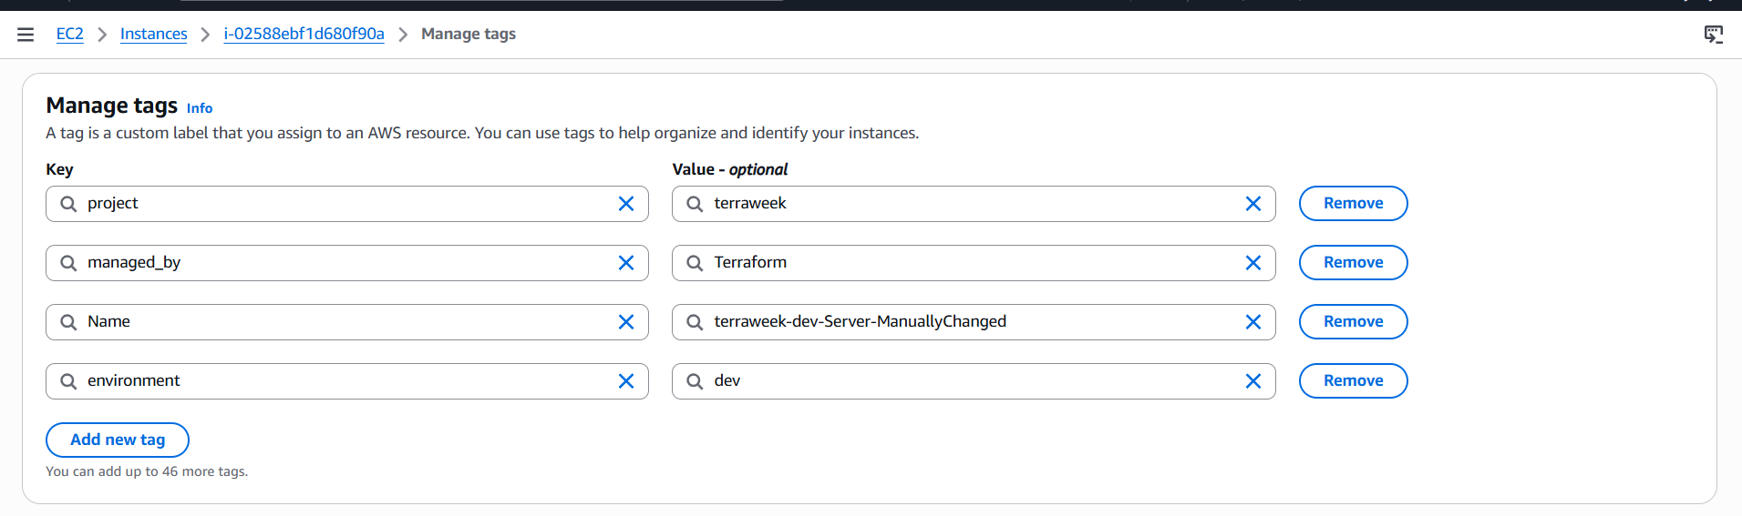
Name tag is changed in console

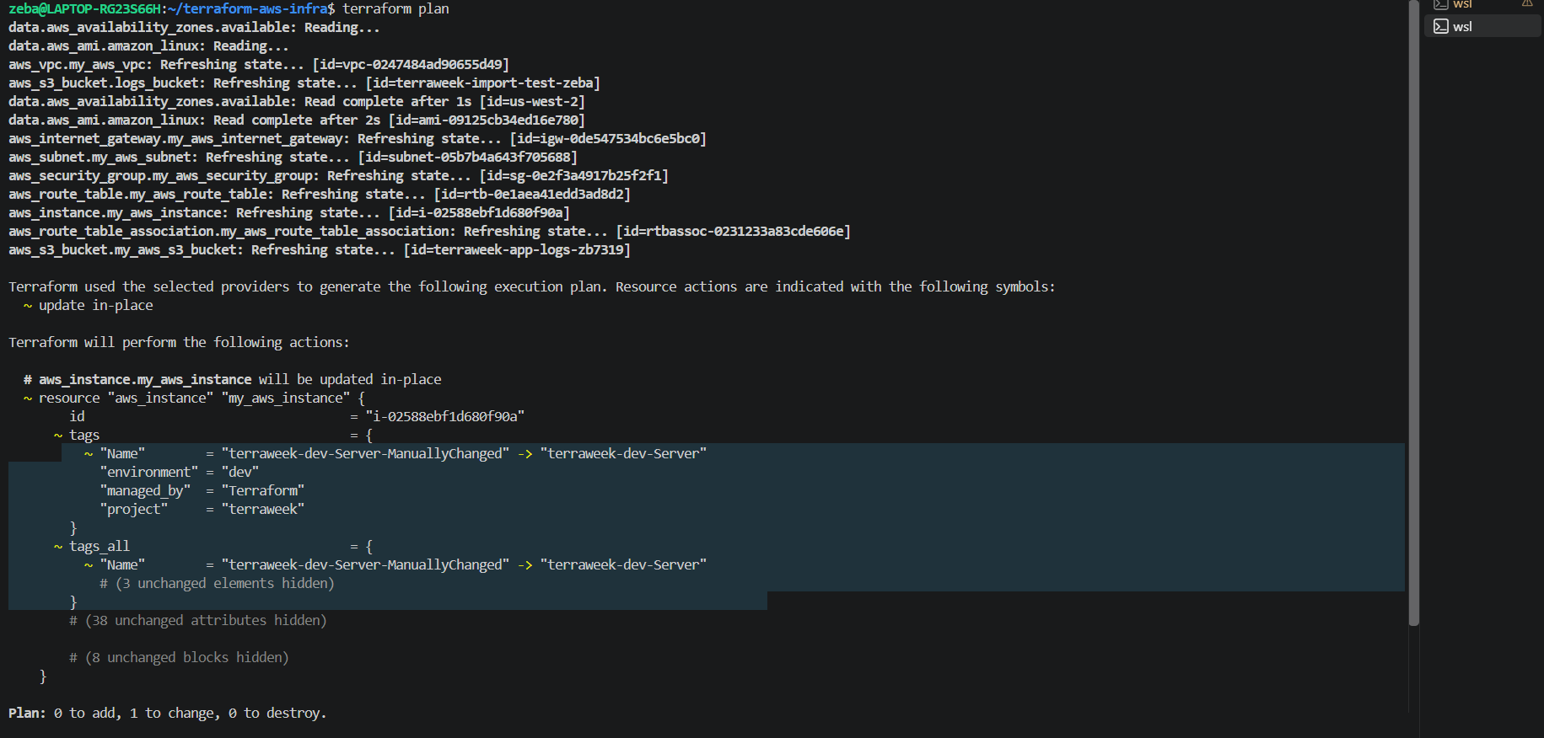
Terraform plan is proposing to change the tag back to the one matching the configuration

We have 2 options now
  - Option A: Run terraform apply to force reality back to match your config (reconcile)
  - Option B: Update your .tf files to match the manual change (accept the drift)
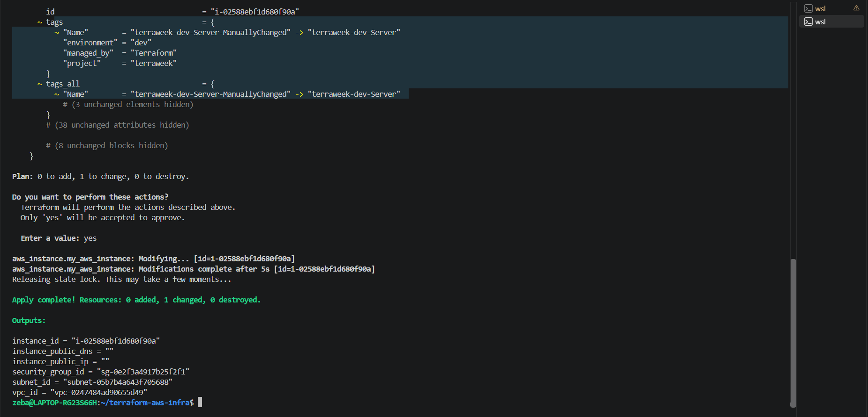
We applied the changes back to the original
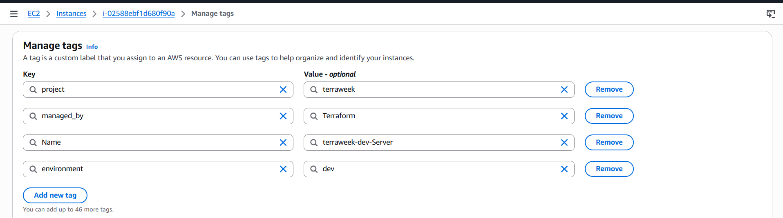
Here also it got changed
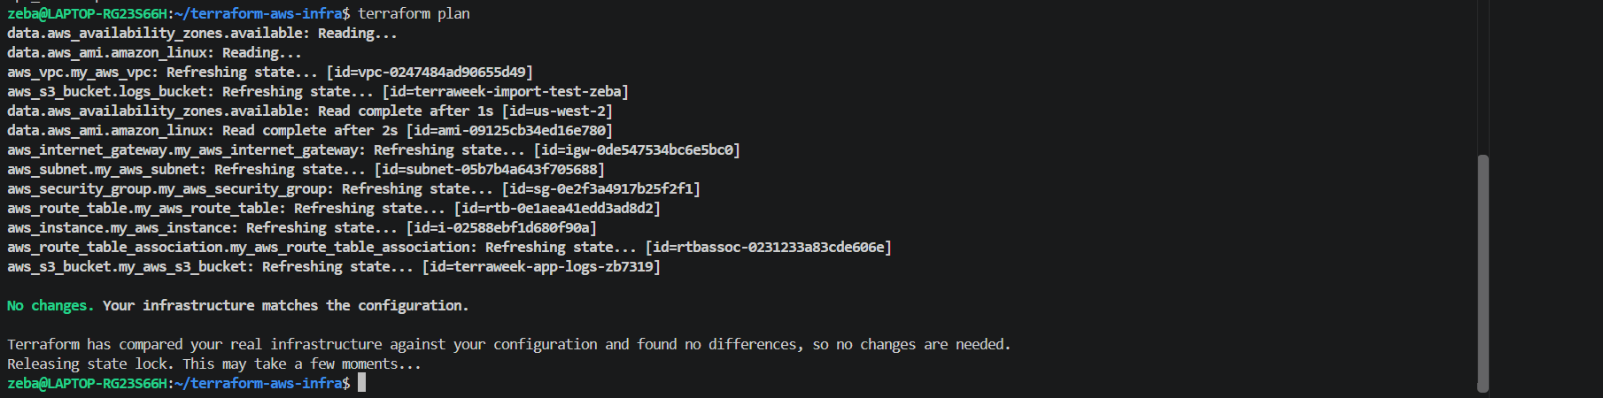
No changes hence drift resolved

Teams prevent state drift by maintaining consistent control over infrastructure changes.
- Restrict console access: Use AWS IAM permissions and the principle of least privilege to prevent unauthorized manual changes.
- Use CI/CD pipelines: Make infrastructure changes through reviewed Terraform code and automated deployment pipelines.
- Implement code reviews: Require team members to review and approve Terraform changes before applying them.
- Detect drift regularly: Run scheduled Terraform plans to identify differences between the actual infrastructure and the desired configuration.
- Enable auditing and monitoring: Use AWS CloudTrail to track infrastructure changes and identify who made them.
- Use remote state and locking: Store Terraform state remotely and use state locking to coordinate concurrent operations.
- Manage emergency changes: Document emergency manual changes and update the Terraform configuration afterward to keep it synchronized with reality.
Conclusion: Production teams minimize state drift by restricting unauthorized changes, managing infrastructure through version-controlled Terraform and CI/CD, and regularly detecting and reconciling differences.

