Task 1: Install and Configure Git
- Verify Git is installed on your machine
- Set up your Git identity — name and email
- Verify your configuration
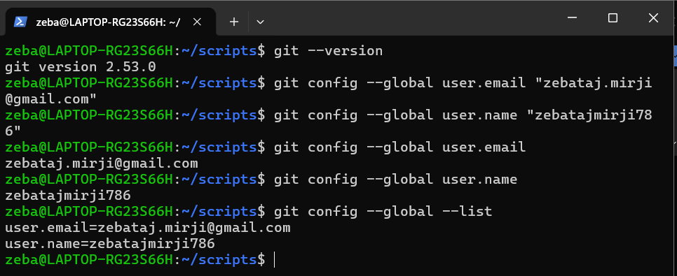

Task 2: Create Your Git Project
- Create a new folder called devops-git-practice
- Initialize it as a Git repository
- Check the status — read and understand what Git is telling you
- Explore the hidden .git/ directory — look at what's inside

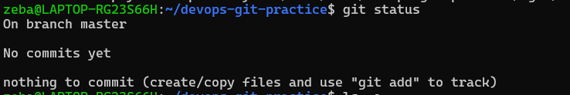
- On branch main/master → You're currently working on that branch.
- No commits yet → You haven't saved any version/snapshot yet.
- nothing to commit → There are no files for Git to track yet.
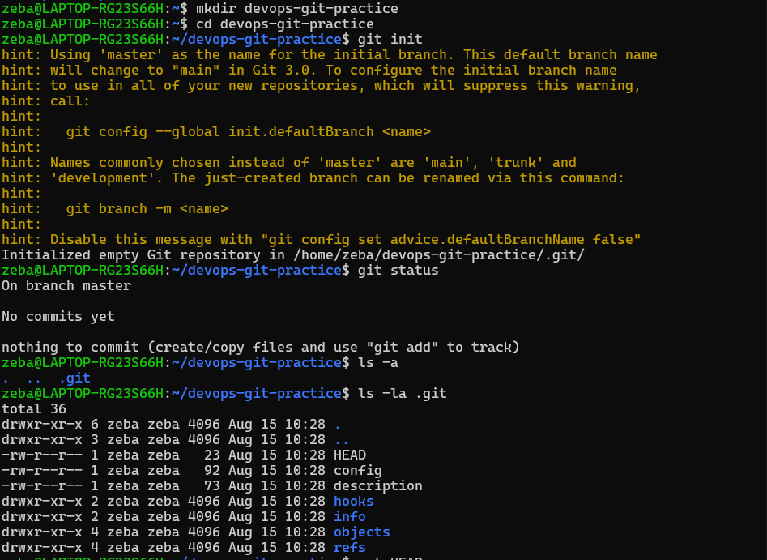

Task 3: Create Your Git Commands Reference
- Create a file called git-commands.md inside the repo
- Add the Git commands you've used so far, organized by category:
  - Setup & Config
  - Basic Workflow
  - Viewing Changes
- For each command, write:
  - What it does (1 line)
  - An example of how to use it

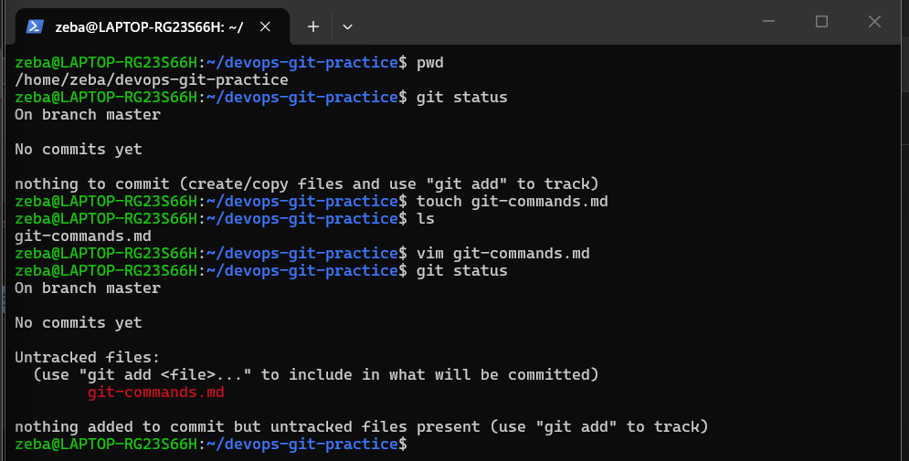

Task 4: Stage and Commit
- Stage your file
- Check what's staged
- Commit with a meaningful message
- View your commit history
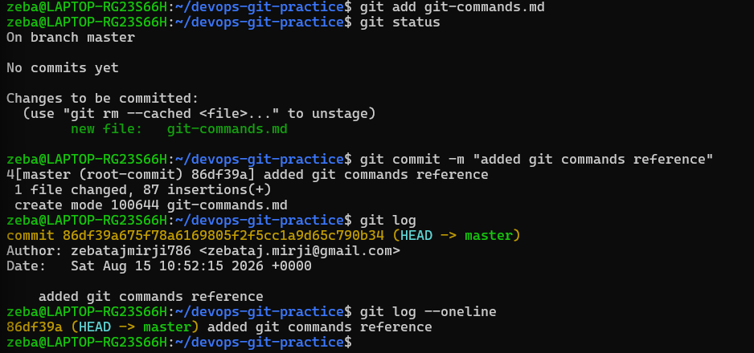

Task 5: Make More Changes and Build History
- Edit git-commands.md — add more commands as you discover them
- Check what changed since your last commit
- Stage and commit again with a different, descriptive message
- Repeat this process at least 3 times so you have multiple commits in your history
- View the full history in a compact format

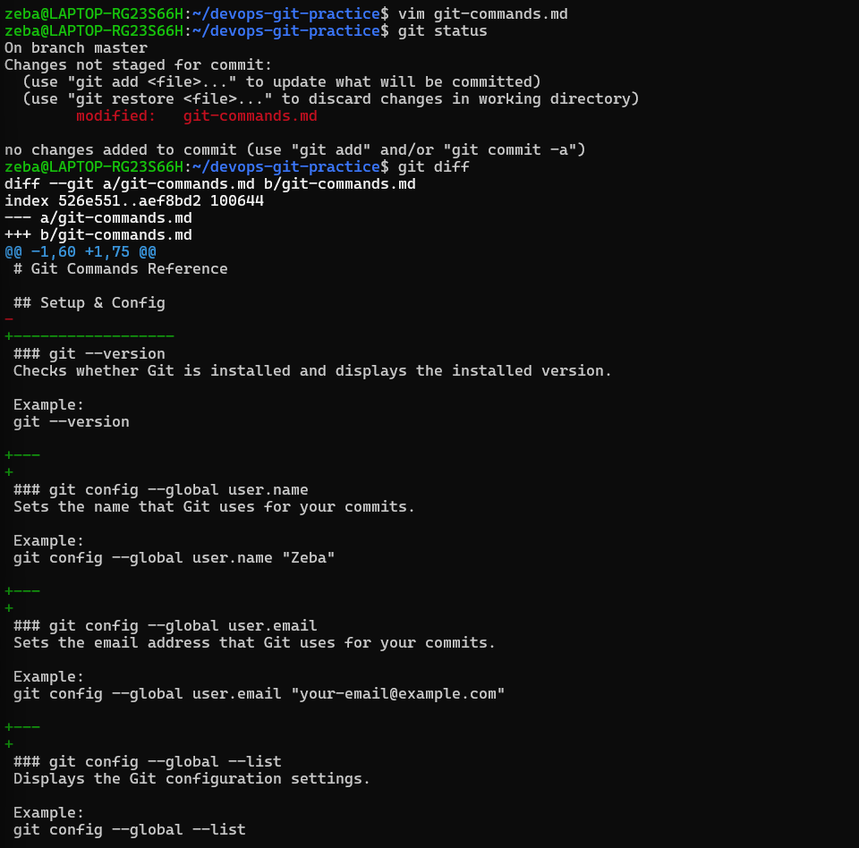

Stage and commit again with a different, descriptive message
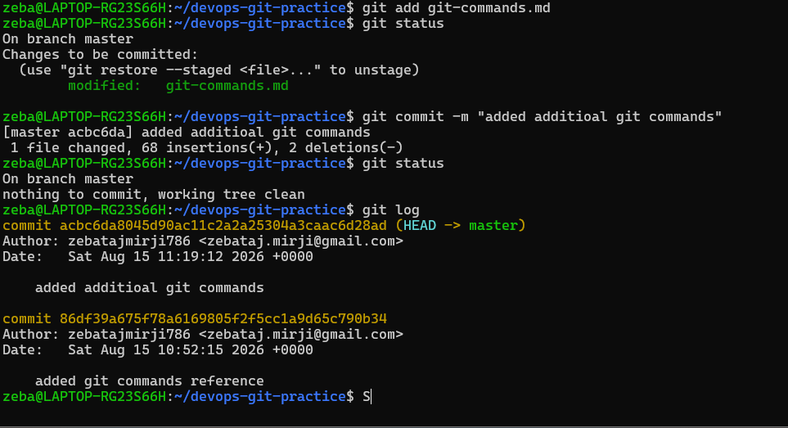

Repeat this process at least 3 times so you have multiple commits in your history
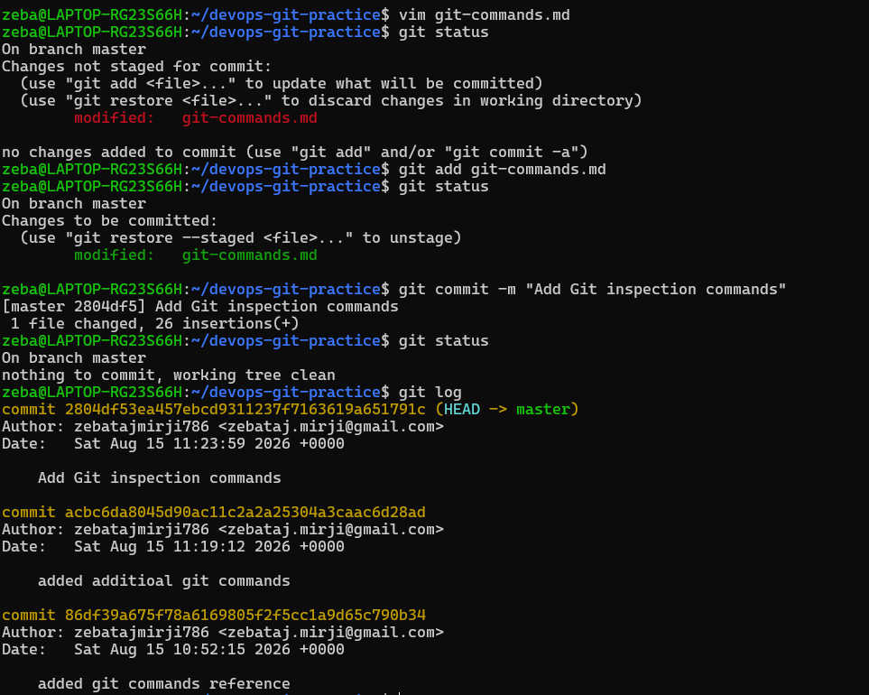
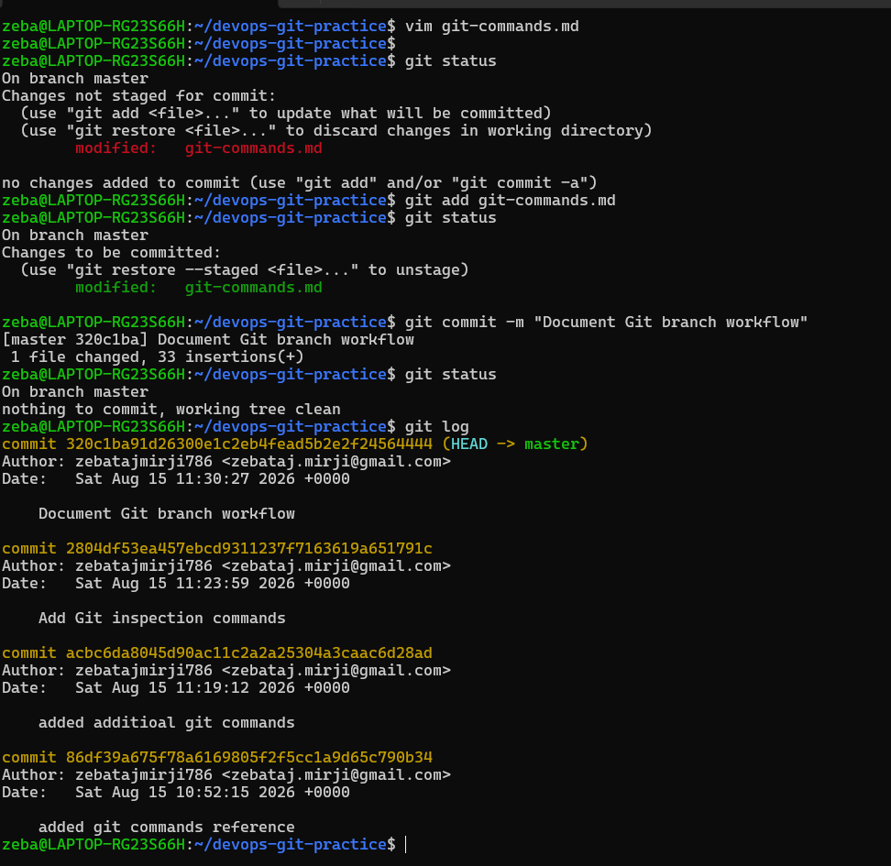

View the full history in a compact format
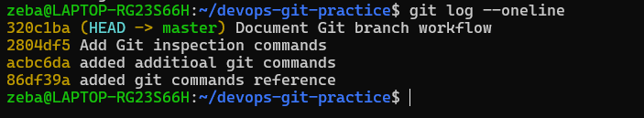

Task 6: Understand the Git Workflow
Answer these questions in your own words (add them to a day-22-notes.md file):
- What is the difference between git add and git commit?
- What does the staging area do? Why doesn't Git just commit directly?
- What information does git log show you?
- What is the .git/ folder and what happens if you delete it?
- What is the difference between a working directory, staging area, and repository?

- What is the difference between git add and git commit?

git add moves the changes from the working directory to the staging area. It tells Git which changes I want to include in my next commit.
git add git-commands.md

git commit takes the staged changes and saves them as a permanent snapshot in the Git repository.
git commit -m "Update Git commands reference"
========================================

- What does the staging area do? Why doesn't Git just commit directly?

The staging area allows me to choose exactly which changes I want to include in the next commit.
Git does not commit everything automatically because I may have multiple changes but want to save only some of them in one commit.

For example, if I modify three files:
file1.txt
file2.txt
file3.txt

I can stage only:
git add file1.txt
and commit only that change.

The staging area gives me control over what goes into each commit.
=========================================

- What information does git log show you?

git log shows the history of commits in the repository.

It normally shows:
- Commit ID
- Author
- Date
- Commit message
Example:
git log
For a shorter view:
git log –oneline

This helps me understand what changes were made and when.
=========================================

- What is the .git/ folder and what happens if you delete it?

The .git/ folder contains Git's internal information for the repository.
It stores things such as:
- Commit history
- Branch information
- Git configuration
- Objects and references

When I run:
git init
Git creates the .git/ folder.

If I delete .git/, the project files themselves will usually remain, but Git will no longer recognize that directory as a Git repository.
The Git history, branches, and other repository information will also be lost from that local repository.
========================================

- What is the difference between a working directory, staging area, and repository?

In simple words:
Working Directory = I make changes
Staging Area = I choose what to save
Repository = Git permanently saves the snapshot

Working Directory
This is where I create and modify my actual project files.
Example:
git-commands.md
day-22-notes.md
hello.sh
Staging Area
This is where I prepare the changes that I want to include in my next commit.
I use:
git add
to move changes into the staging area.

Repository
This is where Git stores the committed snapshots and history of my project.
I use:
git commit
to save staged changes into the repository.

Working Directory
|
| git add
↓
Staging Area
|
| git commit
↓
Repository

