Task 1: Your First Dockerfile
- Create a folder called my-first-image
- Inside it, create a Dockerfile that:
  - Uses ubuntu as the base image
  - Installs curl
  - Sets a default command to print "Hello from my custom image!"
- Build the image and tag it my-ubuntu:v1
- Run a container from your image
Verify: The message prints on docker run

#Uses ubuntu as the base image
FROM ubuntu:24.04

#install curl
RUN get apt-get update && apt-get install curl -y

#Sets a default command to print "Hello from my custom image!"
CMD [“echo”, “Hello from my custom image!” ]
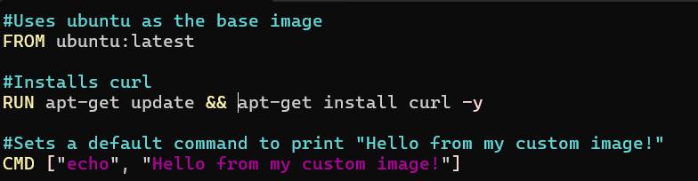
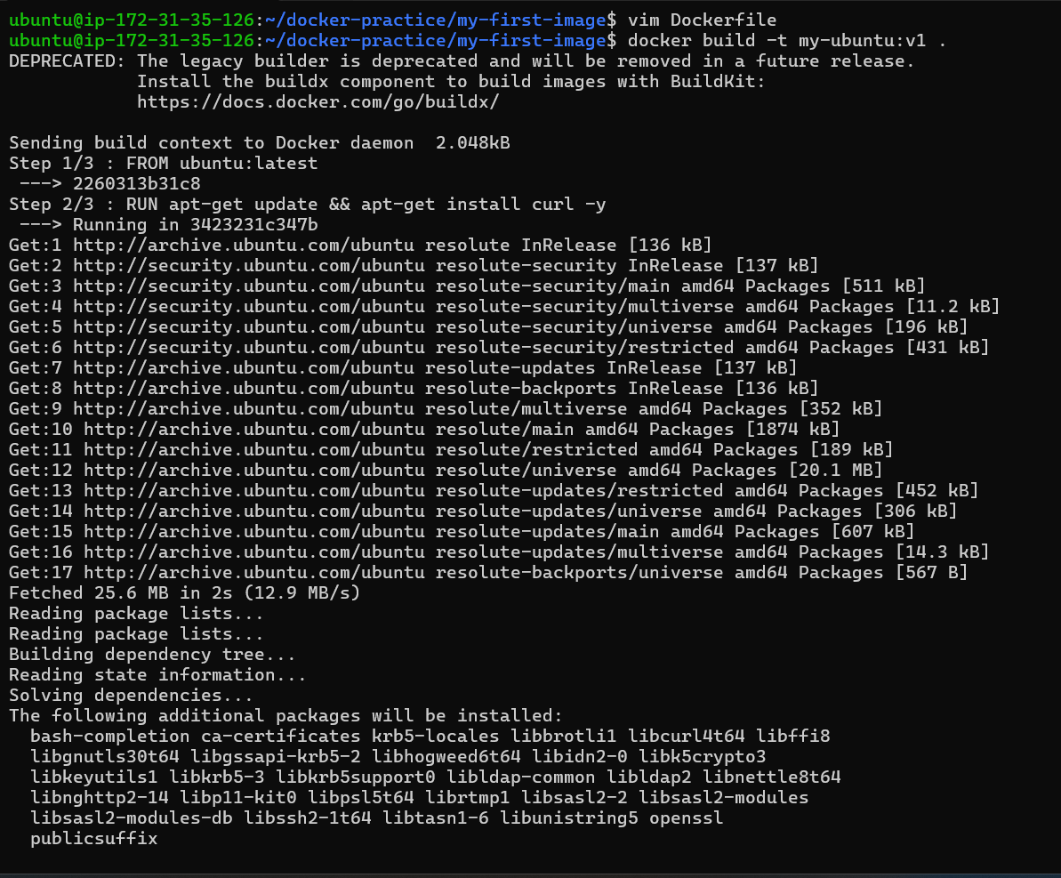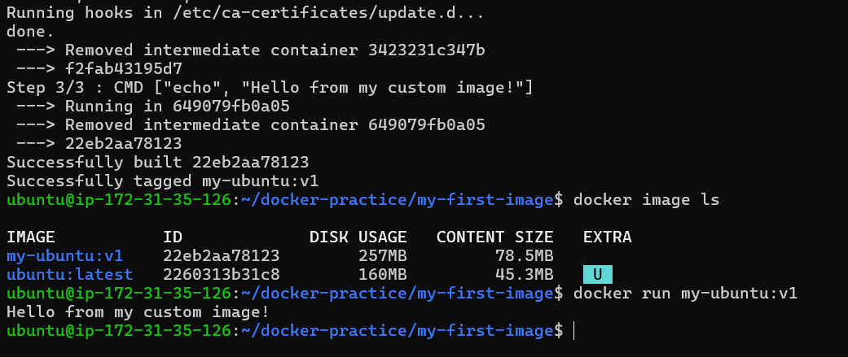

Task 2: Dockerfile Instructions
Create a new Dockerfile that uses all of these instructions:
- FROM — base image
- RUN — execute commands during build
- COPY — copy files from host to image
- WORKDIR — set working directory
- EXPOSE — document the port
- CMD — default command
Build and run it. Understand what each line does.

#FROM — base image
FROM ubuntu:latest

# RUN — execute commands during build
RUN apt-get update && apt-get install nginx -y

#WORKDIR — set working directory
WORKDIR /app

# COPY — copy files from host to image - COPY <source-on-host> <destination-in-container>.
COPY . .

#EXPOSE — document the port
EXPOSE 80

#CMD — default command
CMD[ “nginx”, “-g”, “daemon off;” ]

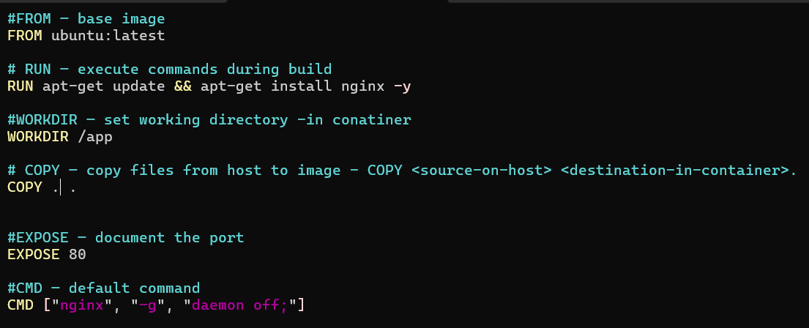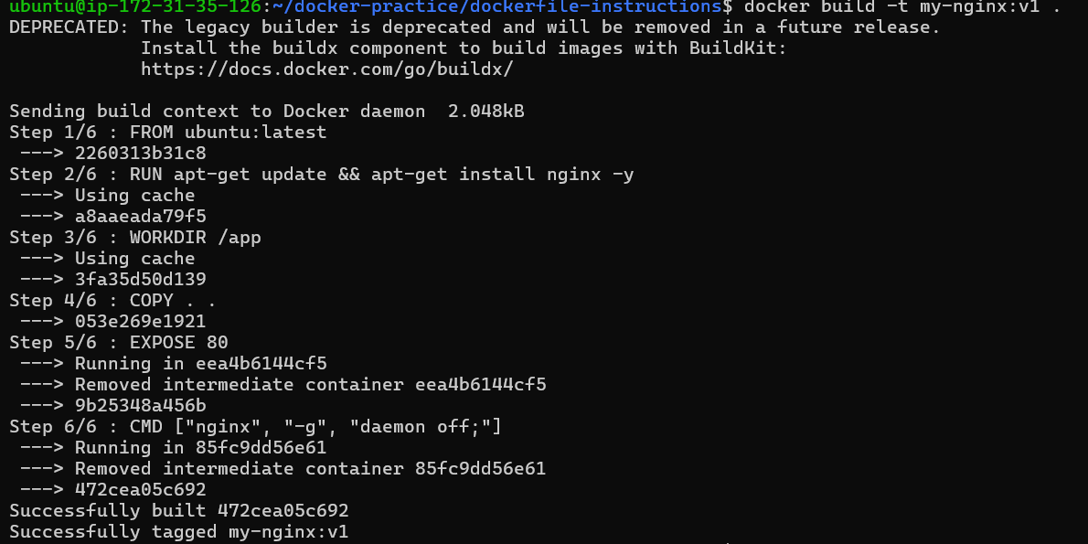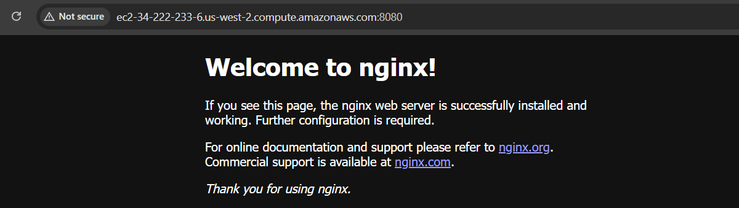

Task 3: CMD vs ENTRYPOINT
- Create an image with CMD ["echo", "hello"] — run it, then run it with a custom command. What happens?
- Create an image with ENTRYPOINT ["echo"] — run it, then run it with additional arguments. What happens?
- Write in your notes: When would you use CMD vs ENTRYPOINT?

Create an image with CMD ["echo", "hello"] — run it, then run it with a custom command. What happens?

FROM ubuntu:latest
CMD ["echo", "hello"]
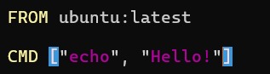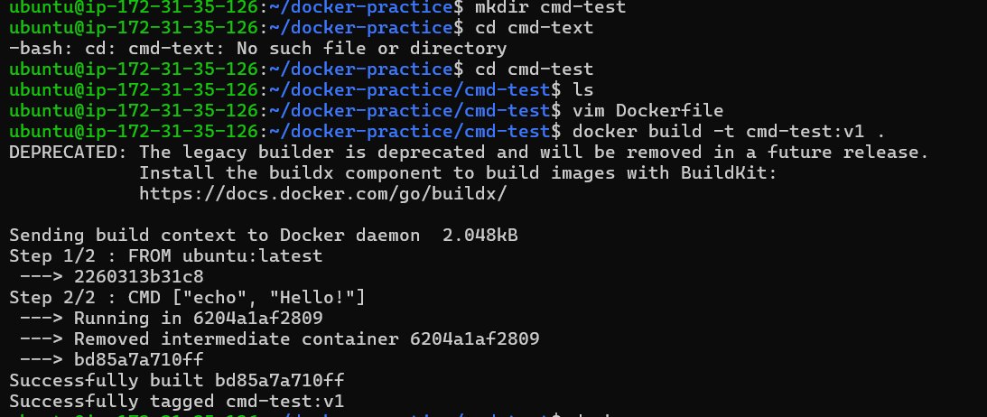What happened?
Docker replaced the CMD with your new command. Docker documents CMD as the default command, which can be overridden by arguments supplied to docker run.

Create an image with ENTRYPOINT ["echo"] — run it, then run it with additional arguments. What happens?

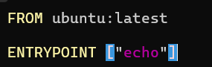 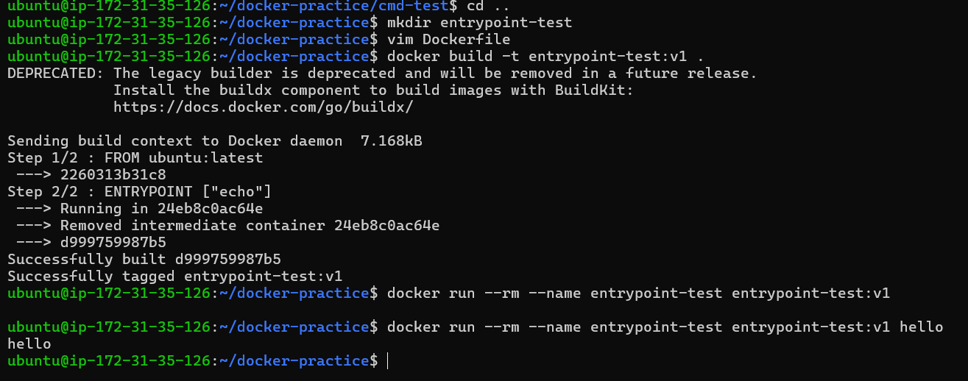 What happened?
echo becomes the main executable.
Anything you put after the image name gets passed as arguments to echo

Write in your notes: When would you use CMD vs ENTRYPOINT?
 | CMD | ENTRYPOINT
Purpose | Default command | Main executable
Can docker run arguments replace it? | Yes | No, they are normally passed as arguments
Example | CMD ["echo","hello"] | ENTRYPOINT ["echo"]
Good for | Default/flexible commands | Fixed application/tool
Common combination | — | ENTRYPOINT + CMD

Task 4: Build a Simple Web App Image
- Create a small static HTML file (index.html) with any content
- Write a Dockerfile that:
  - Uses nginx:alpine as base
  - Copies your index.html to the Nginx web directory
- Build and tag it my-website:v1
- Run it with port mapping and access it in your browser

FROM nginx:alpine
COPY index.html /usr/share/nginx/html/

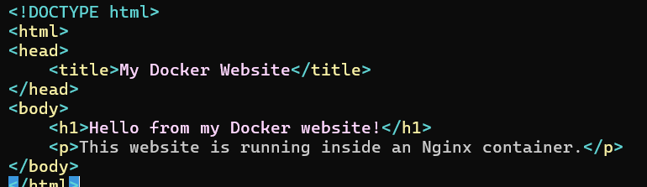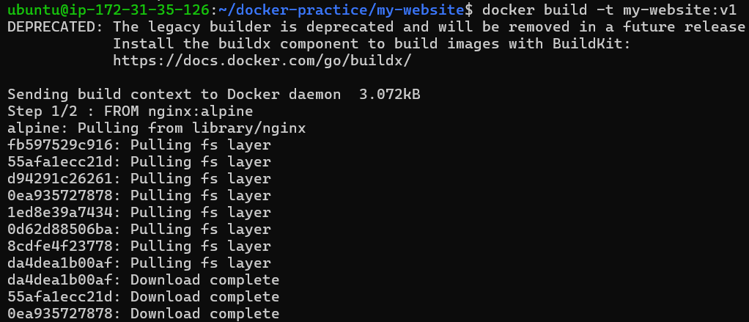
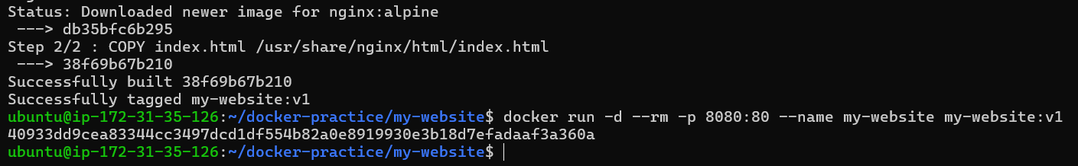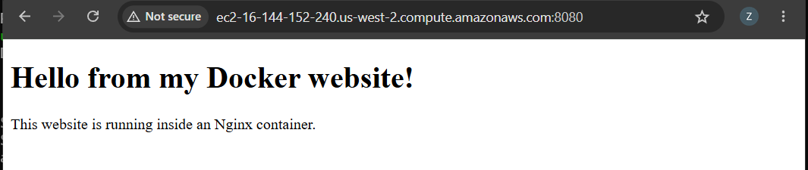

Task 5: .dockerignore
- Create a .dockerignore file in one of your project folders
- Add entries for: node_modules, .git, *.md, .env
- Build the image — verify that ignored files are not included

We will user my-website project created in task-4
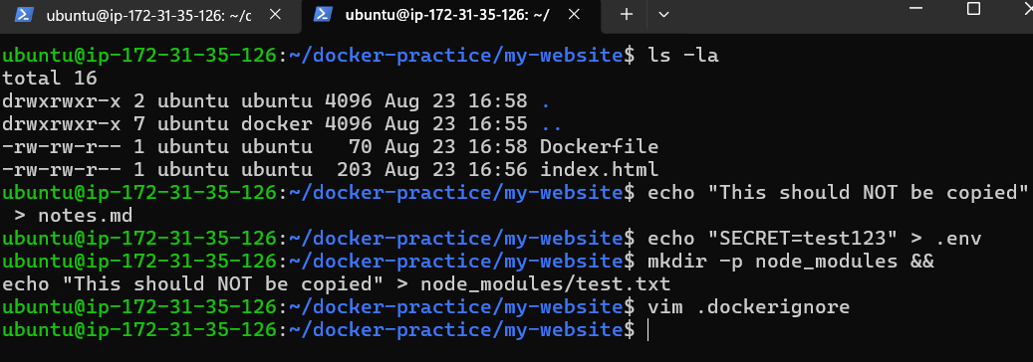
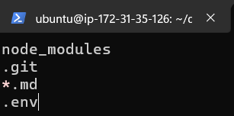
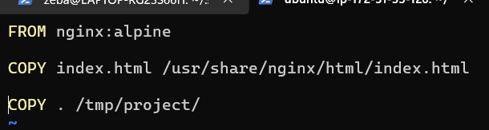
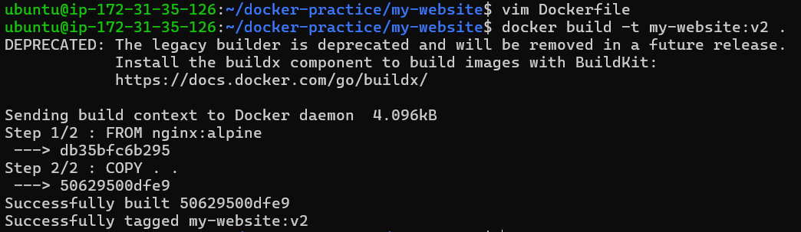

Here in below image we noticed that node_modules, .git, *.md, .env file which we have kept in .dockerignore actually not getting displayed that got ignored

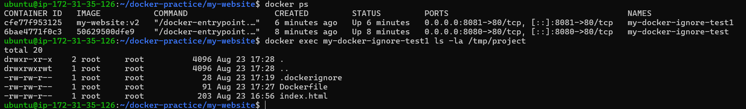

Task 6: Build Optimization
- Build an image, then change one line and rebuild — notice how Docker uses cache
- Reorder your Dockerfile so that frequently changing lines come last
- Write in your notes: Why does layer order matter for build speed?
Lets use my-website as it has html file we can change it and do rebuild
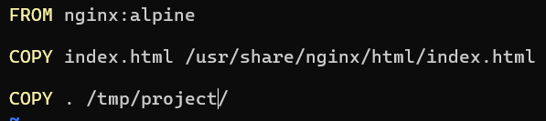

Build an image, then change one line and rebuild — notice how Docker uses cache

Built an image
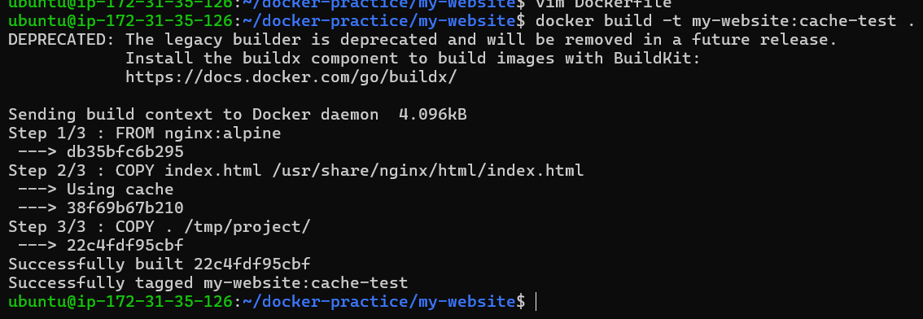
Made changes
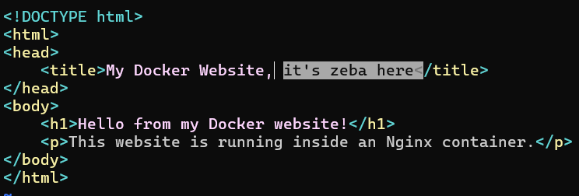

Rebuilt image
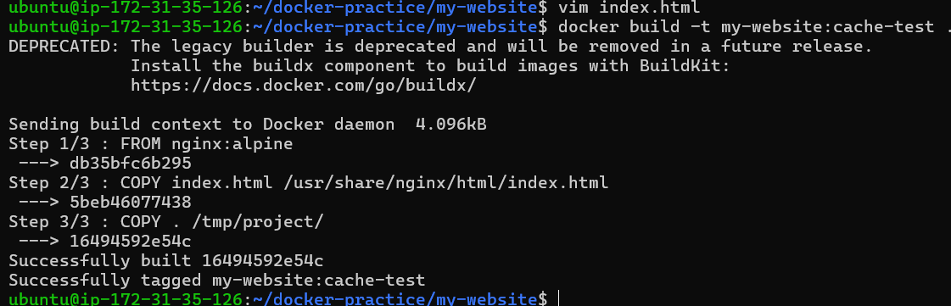

Reorder your Dockerfile so that frequently changing lines come last
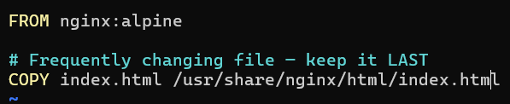

Write in your notes: Why does layer order matter for build speed?
Docker builds an image layer by layer and caches each layer. If one layer changes, Docker rebuilds that layer and all the layers after it.
Therefore, we should:
- Put rarely changing instructions first → Docker can reuse the cache.
- Put frequently changing instructions last → only the final layers need to rebuild.

