Task 1: Log Rotation Script
Create log_rotate.sh that:
- Takes a log directory as an argument (e.g., /var/log/myapp)
- Compresses .log files older than 7 days using gzip
- Deletes .gz files older than 30 days
- Prints how many files were compressed and deleted
- Exits with an error if the directory doesn't exist
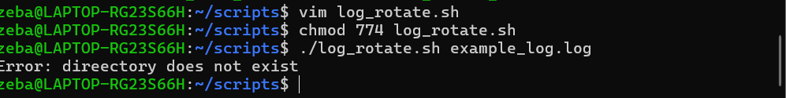
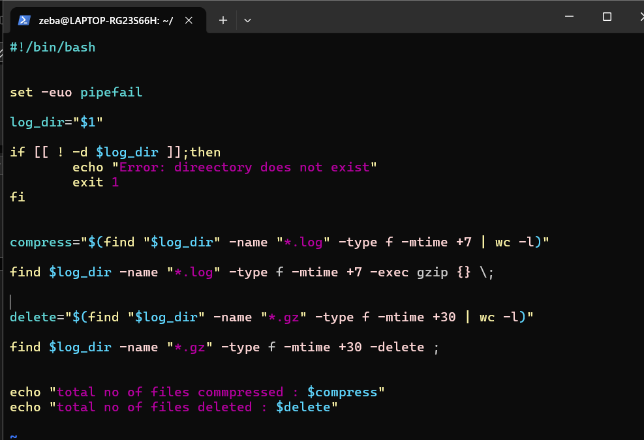
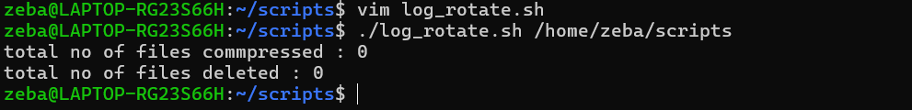

Task 2: Server Backup Script
Create backup.sh that:
- Takes a source directory and backup destination as arguments
- Creates a timestamped .tar.gz archive (e.g., backup-2026-02-08.tar.gz)
- Verifies the archive was created successfully
- Prints archive name and size
- Deletes backups older than 14 days from the destination
- Handles errors — exit if source doesn't exist
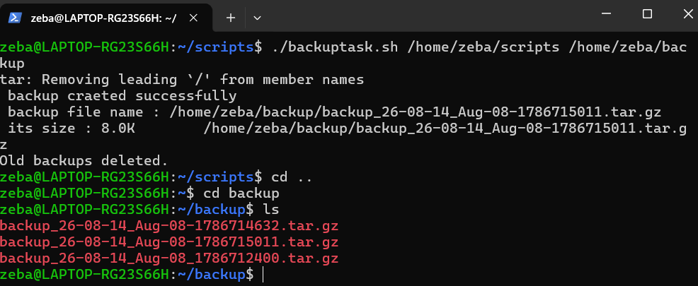
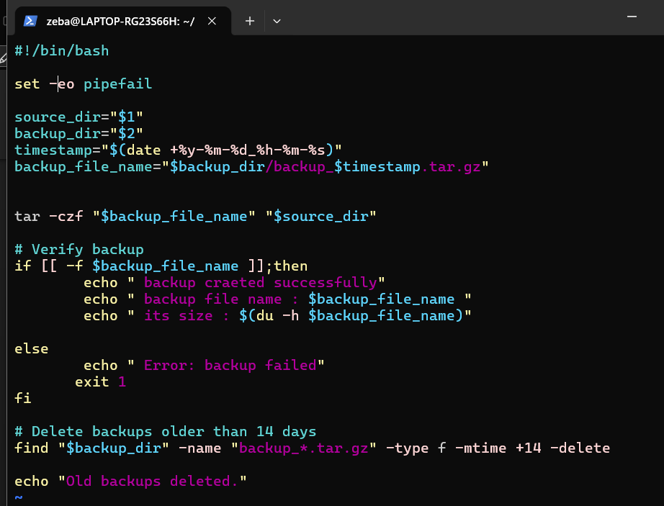

Task 3: Crontab
- Read: crontab -l — what's currently scheduled?
- Understand cron syntax:
* * * * * command
│ │ │ │ │
│ │ │ │ └── Day of week (0-7)
│ │ │ └──── Month (1-12)
│ │ └────── Day of month (1-31)
│ └──────── Hour (0-23)
└────────── Minute (0-59)
Minute(o - 59), hour(0 - 23), day of the month(1- 31), month(1 - 12), day of the week(0 -7)

- Write cron entries (in your markdown, don't apply if unsure) for:
  - Run log_rotate.sh every day at 2 AM
  - Run backup.sh every Sunday at 3 AM
  - Run a health check script every 5 minutes
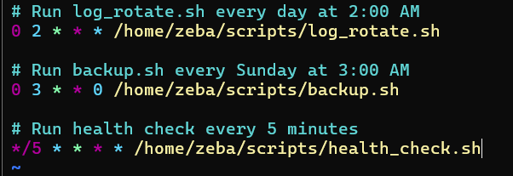
Schedule | Cron
Every day at 2 AM | 0 2 * * *
Every Sunday at 3 AM | 0 3 * * 0
Every 5 minutes | */5 * * * *

Task 4: Combine — Scheduled Maintenance Script
Create maintenance.sh that:
- Calls your log rotation function
- Calls your backup function
- Logs all output to /var/log/maintenance.log with timestamps
- Write the cron entry to run it daily at 1 AM
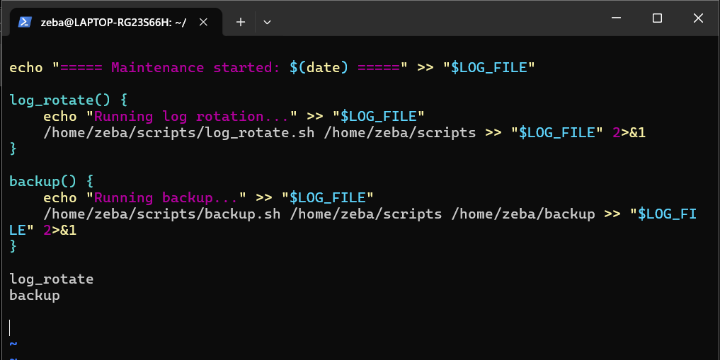
crontab -e
0 1 * * * /home/zeba/scripts/maintenance.sh

