RUNNERS:
- Github hosted runners
Github give temporary runners
Runs-on: ubuntu-latest
- Self-hosted runners
We will provide the machine/runner
Runs-on: self-hosted

Task 1: GitHub-Hosted Runners
- Create a workflow with 3 jobs, each on a different OS:
  - ubuntu-latest
  - windows-latest
  - macos-latest
- In each job, print:
  - The OS name
  - The runner's hostname
  - The current user running the job
- Watch all 3 run in parallel
Write in your notes: What is a GitHub-hosted runner? Who manages it?
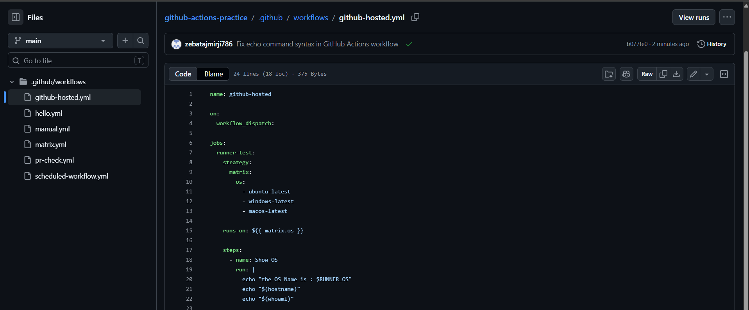
Used strategy: matrix for 3 os and used | for printing 3 sentence in only 1 run: ratherthan creating 3 separate tasks

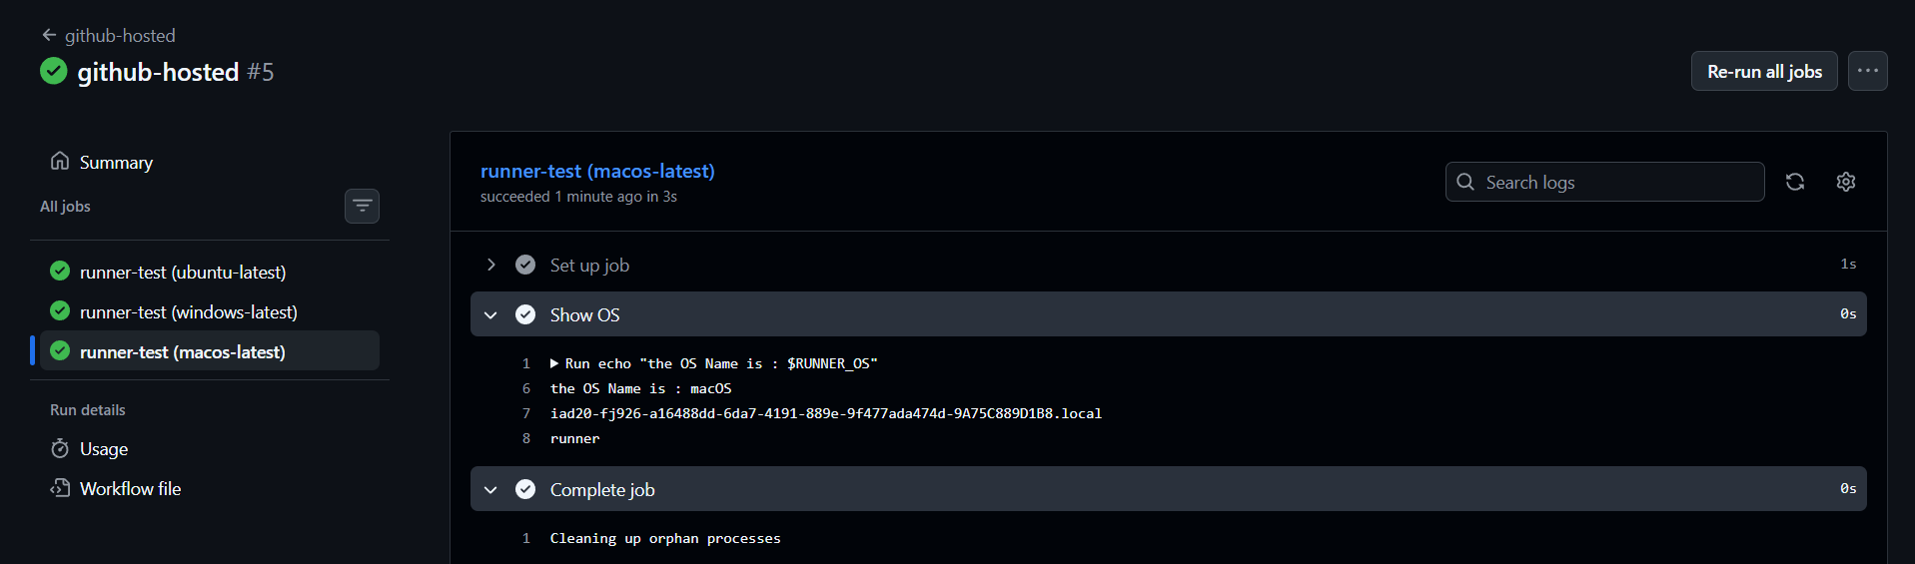
Task 2: Explore What's Pre-installed
- On the ubuntu-latest runner, run a step that prints:
  - Docker version
  - Python version
  - Node version
  - Git version
- Look up the GitHub docs for the full list of pre-installed software on ubuntu-latest
Write in your notes: Why does it matter that runners come with tools pre-installed?
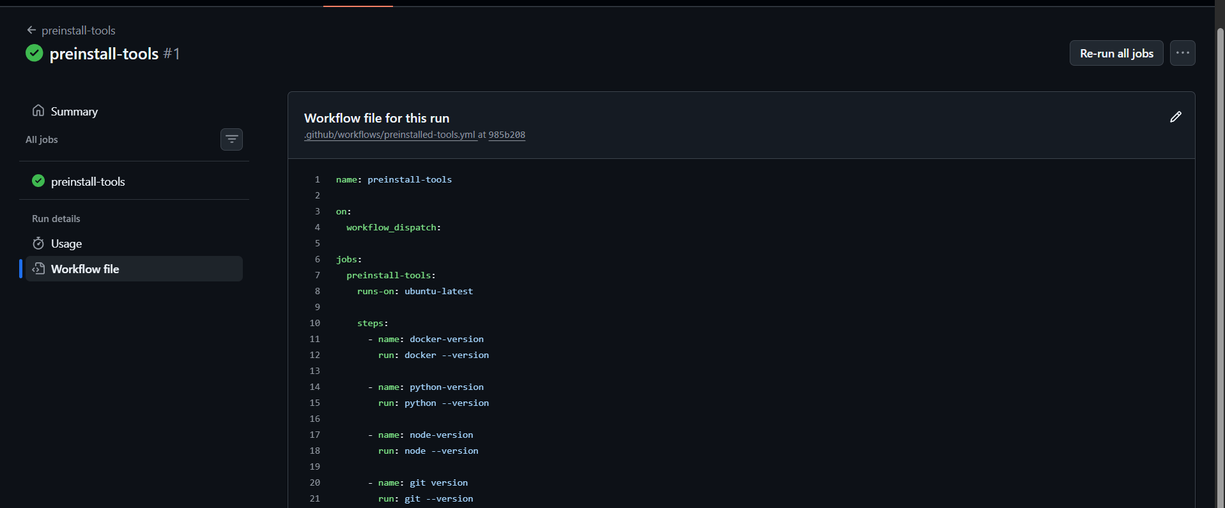

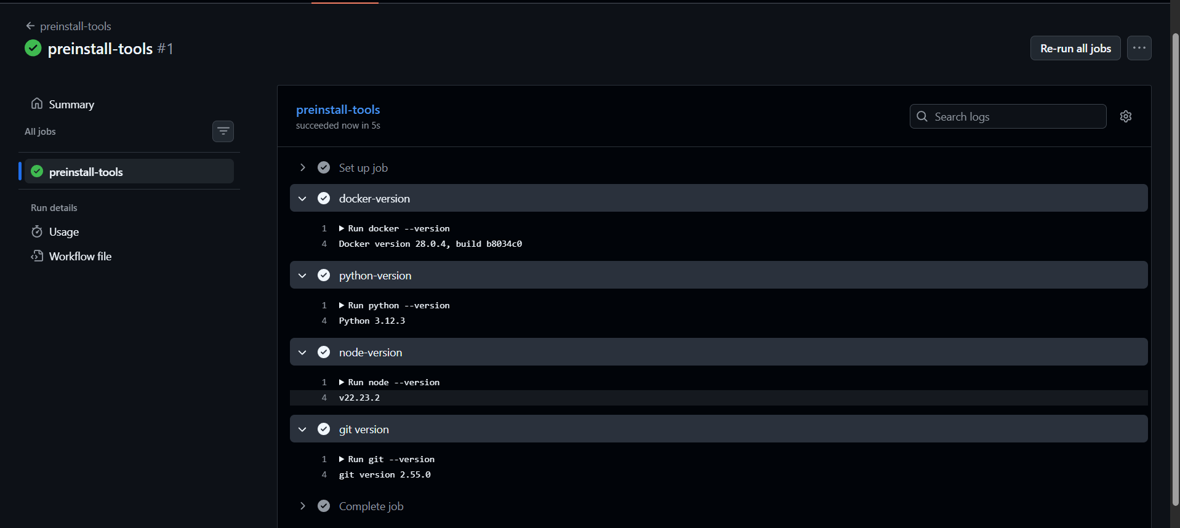

Explore What's Pre-installed On the `ubuntu-latest` GitHub-hosted runner,
I checked:
- Docker version
- Python version
- Node.js version
- Git version
These tools were already available on the runner, so I did not need to install them manually.
Why does it matter that runners come with tools pre-installed?
Pre-installed tools save time because we do not have to install common tools every time a workflow runs.
This makes CI/CD workflows:
- Faster - Easier to set up
- More convenient
- More consistent
GitHub provides a list of the software included in its runner images.
Easy way to remember
Pre-installed tools = Start working immediately instead of installing everything first.

Task 3: Set Up a Self-Hosted Runner
- Go to your GitHub repo → Settings → Actions → Runners → New self-hosted runner
- Choose Linux as the OS
- Follow the instructions to download and configure the runner on:
  - Your local machine, OR
  - A cloud VM (EC2, Utho, or any VPS)
- Start the runner — verify it shows as Idle in GitHub
Verify: Your runner appears in the Runners list with a green dot.

Go to:
GitHub repo → repo Settings → Actions → Runners → New self-hosted runner → Linux → x64
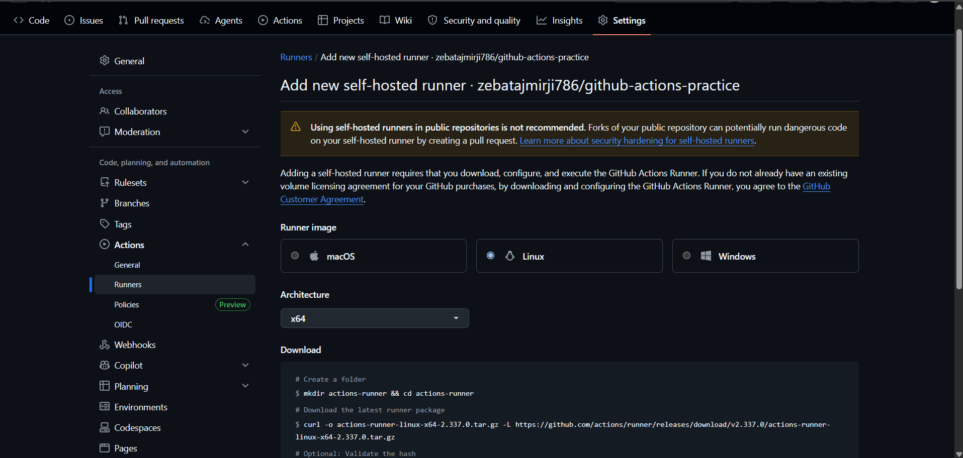
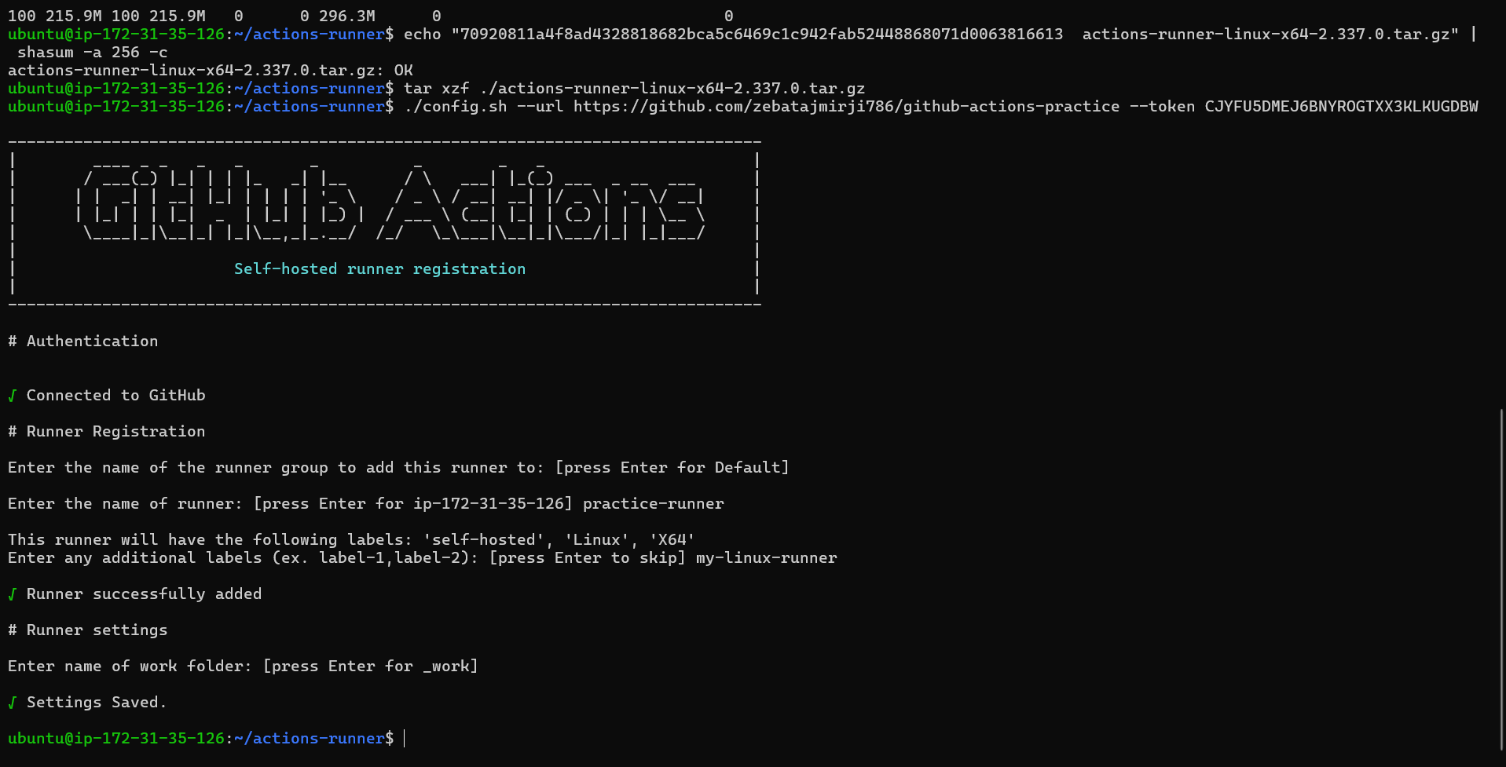
Connected to github
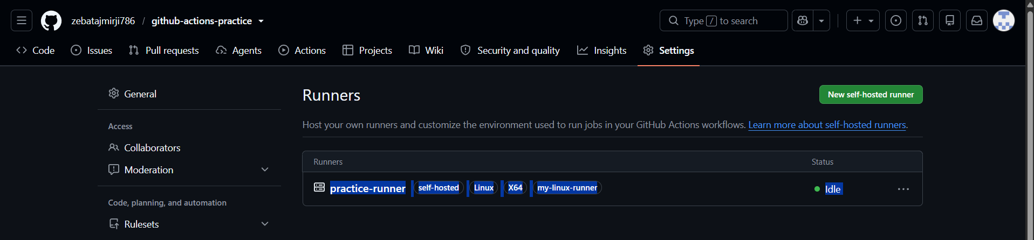
Task 4: Use Your Self-Hosted Runner
- Create .github/workflows/self-hosted.yml
- Set runs-on: self-hosted
- Add steps that:
  - Print the hostname of the machine (it should be YOUR machine/VM)
  - Print the working directory
  - Create a file and verify it exists on your machine after the run
- Trigger it and watch it run on your own hardware
Verify: Check your machine — is the file there?

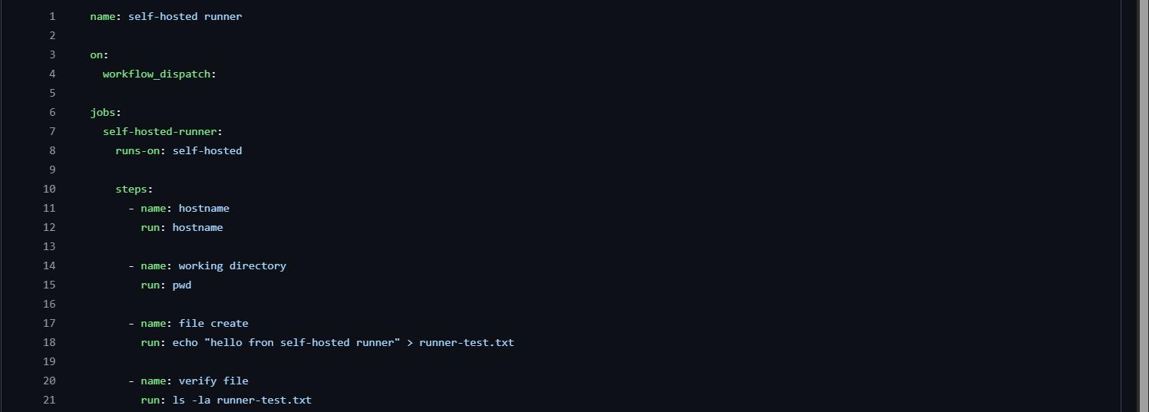
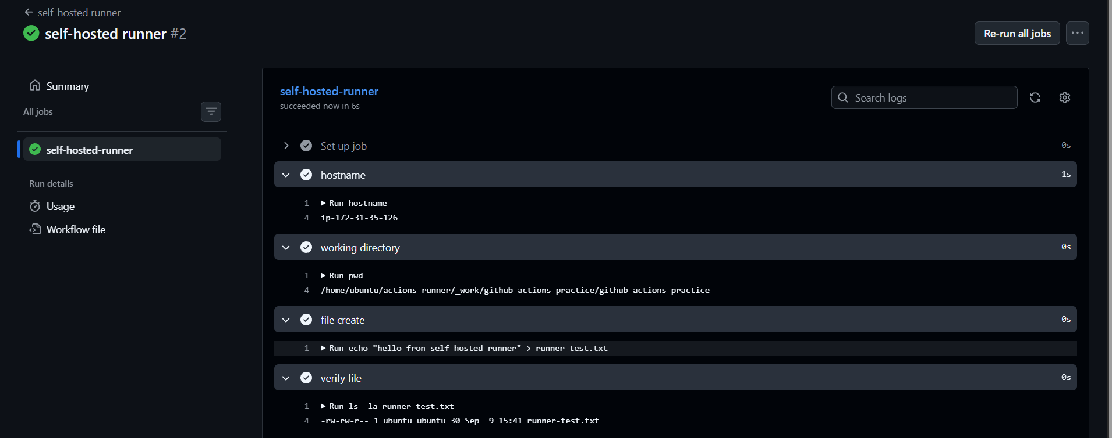
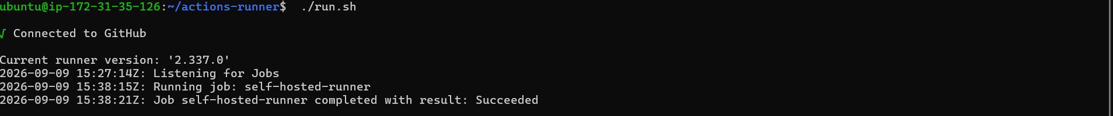
Task 5: Labels
- Add a label to your self-hosted runner (e.g., my-linux-runner)
- Update your workflow to use runs-on: [self-hosted, my-linux-runner]
- Trigger it — does it still pick up the job?
Write in your notes: Why are labels useful when you have multiple self-hosted runners?
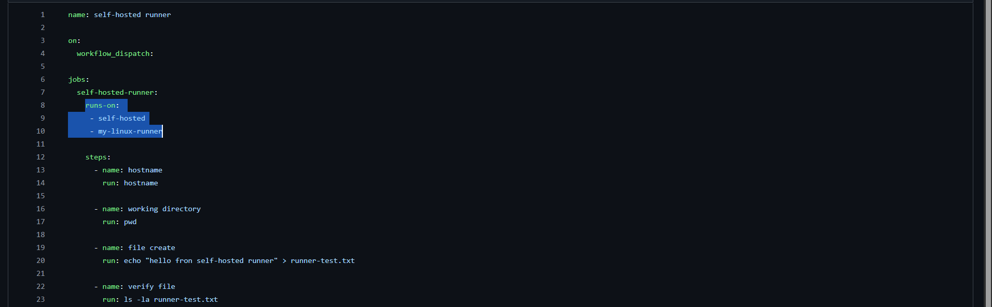
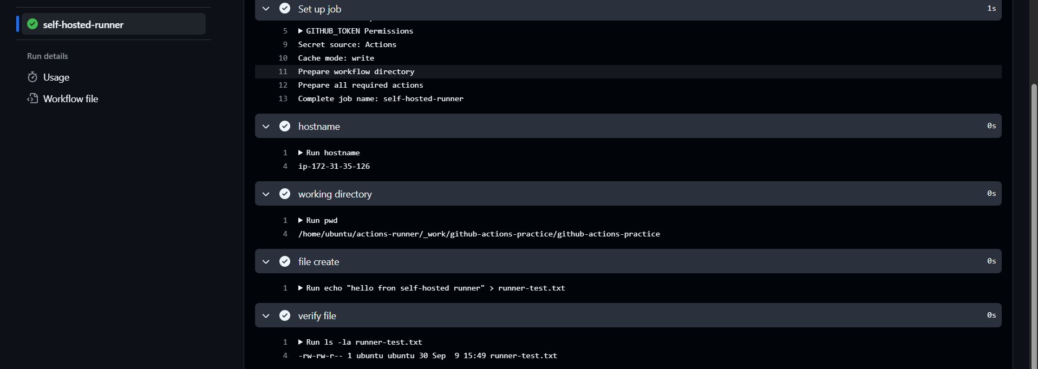

Why are labels useful?
Labels are useful when we have multiple self-hosted runners. They help GitHub choose the correct runner for a particular job based on its OS, tools, or purpose.
For example:
- `linux-runner` → Linux machine
- `windows-runner` → Windows machine
- `docker-runner` → Machine with Docker
- `production-runner` → Production machine
A workflow can specify the labels it needs, and GitHub will send the job only to a runner that has those labels.
Easy way to remember
Labels = Tell GitHub which runner to use.

Task 6: GitHub-Hosted vs Self-Hosted
Fill this in your notes:
 | GitHub-Hosted | Self-Hosted
Who manages it? | github | self
Cost | Pay based on github action usage | We pay and maintain our own machine
Pre-installed tools | Yes, most of the tools are preinstalled | No, we need to install
Good for | CI/CD projects and quick setup | Custom environments, special hardware, or more control
Security concern | GitHub manages the runner environment | GitHub manages the runner environment

