Task 1: Git Reset — Hands-On
- Make 3 commits in your practice repo (commit A, B, C)
- Use git reset --soft to go back one commit — what happens to the changes?
- Re-commit, then use git reset --mixed to go back one commit — what happens now?
- Re-commit, then use git reset --hard to go back one commit — what happens this time?
- Answer in your notes:
  - What is the difference between --soft, --mixed, and --hard?
  - Which one is destructive and why?
  - When would you use each one?
  - Should you ever use git reset on commits that are already pushed?

Make 3 commits in your practice repo (commit A, B, C)
Reset | Commit/HEAD | Staging Area | Working Directory
--soft | moves back | keeps changes staged | keeps changes
--mixed | moves back | unstages changes | keeps changes
--hard | moves back | resets | resets files too
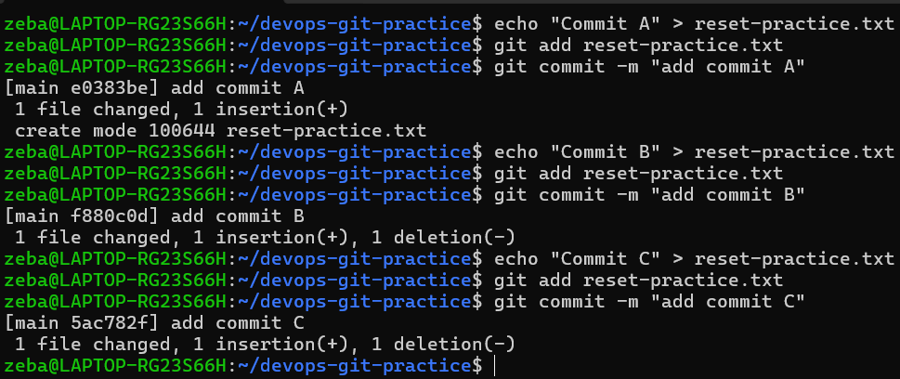

Use git reset --soft to go back one commit — what happens to the changes?
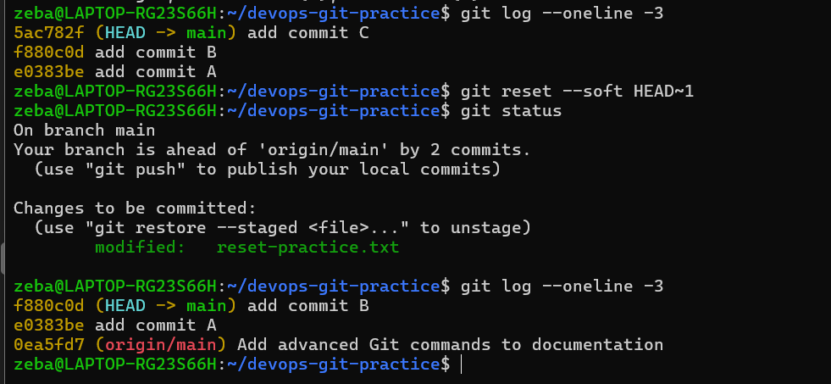
What happened?
The commit C disappeared from the current branch history, but its changes are still staged.

Re-commit, then use git reset --mixed to go back one commit — what happens now?
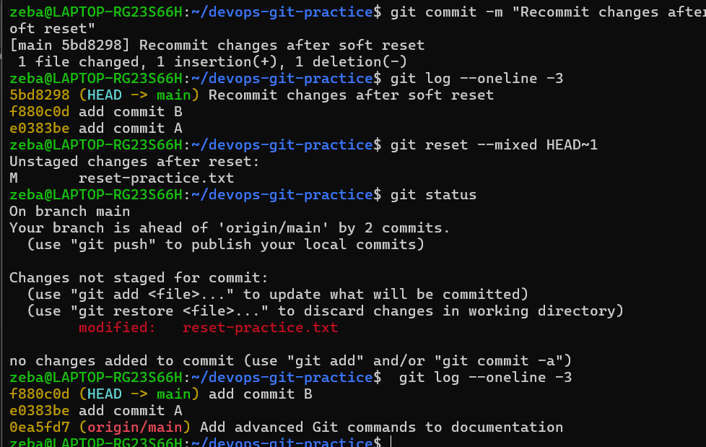

What happened?
The commit was removed from the current branch, but the file changes remain in your working directory(unstaged).
However, they are no longer staged.

Re-commit, then use git reset --hard to go back one commit — what happens this time?
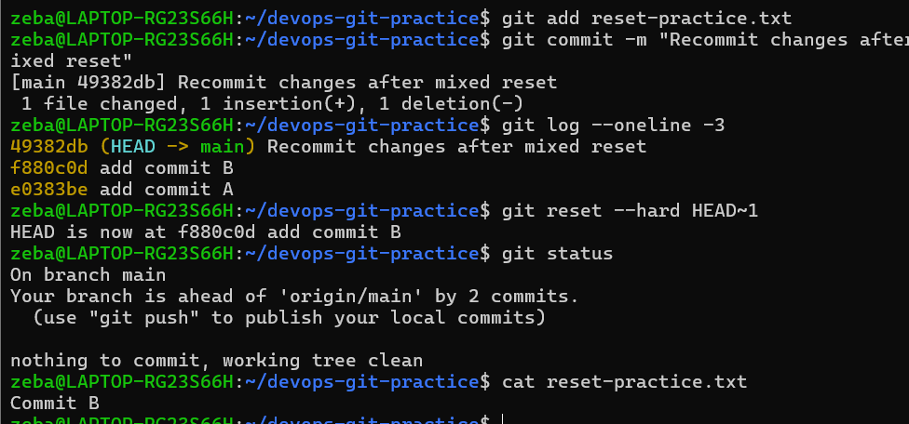 What happened?
--hard moved HEAD backward and reset the staging area and working directory to match that commit. Changes in tracked files that aren't present in the target commit can therefore be discarded.

Answer in your notes:
  - What is the difference between --soft, --mixed, and --hard?
  - Which one is destructive and why?
  - When would you use each one?
  - Should you ever use git reset on commits that are already pushed?

What is the difference between --soft, --mixed, and --hard?
git reset --soft HEAD~1 moves HEAD back by one commit but keeps the changes staged.

git reset --mixed HEAD~1 moves HEAD back and unstages the changes, but keeps the changes in the working directory(un staged) area. This is also the default reset mode.

git reset --hard HEAD~1 moves HEAD back and resets both the staging area and working directory to match the target commit.

--soft
HEAD → moves back
Staging → keeps changes
Working → keeps changes

--mixed
HEAD → moves back
Staging → changes become unstaged
Working → keeps changes

--hard
HEAD → moves back
Staging → resets
Working → resets

Which one is destructive and why?
git reset --hard is destructive because it can discard changes from the working directory and staging area. If those changes were never committed or otherwise saved, they may be difficult or impossible to recover.
When would you use each one?
I would use --soft when I want to undo a commit but keep all its changes staged so I can create a new commit.
I would use --mixed when I want to undo a commit but keep the changes as unstaged working-directory changes so I can modify or selectively stage them again.
I would use --hard when I am certain that I want to completely discard the commits and associated tracked working-tree changes.

Should you ever use git reset on commits that are already pushed?
Generally, I should avoid using git reset to rewrite commits that have already been pushed and shared with others because it changes the branch history. Other people may already have the original commits, causing history divergence and synchronization problems.
For shared/public history, git revert is usually safer because it creates a new commit that reverses the earlier change instead of rewriting history.

SOFT → Undo commit, KEEP staged
MIXED → Undo commit, UNSTAGE changes
HARD → Undo commit, DELETE changes

Task 2: Git Revert — Hands-On
- Make 3 commits (commit X, Y, Z)
- Revert commit Y (the middle one) — what happens?
- Check git log — is commit Y still in the history?
- Answer in your notes:
  - How is git revert different from git reset?
  - Why is revert considered safer than reset for shared branches?
  - When would you use revert vs reset?

Make 3 commits (commit X, Y, Z)
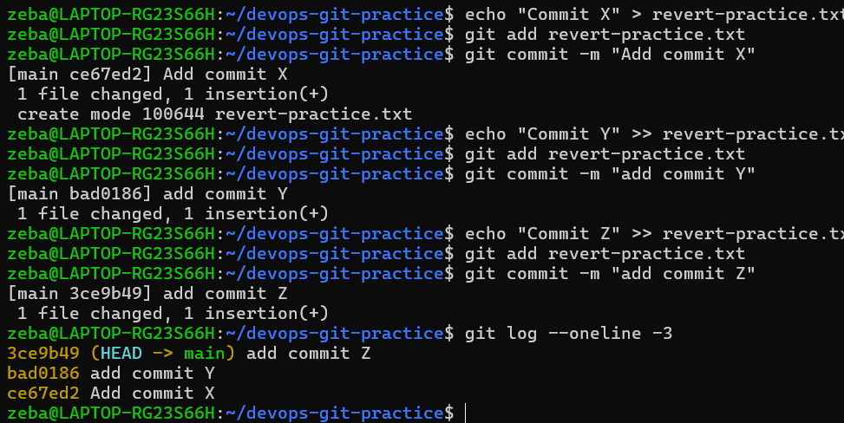
Revert commit Y (the middle one) — what happens?
Check git log — is commit Y still in the history?
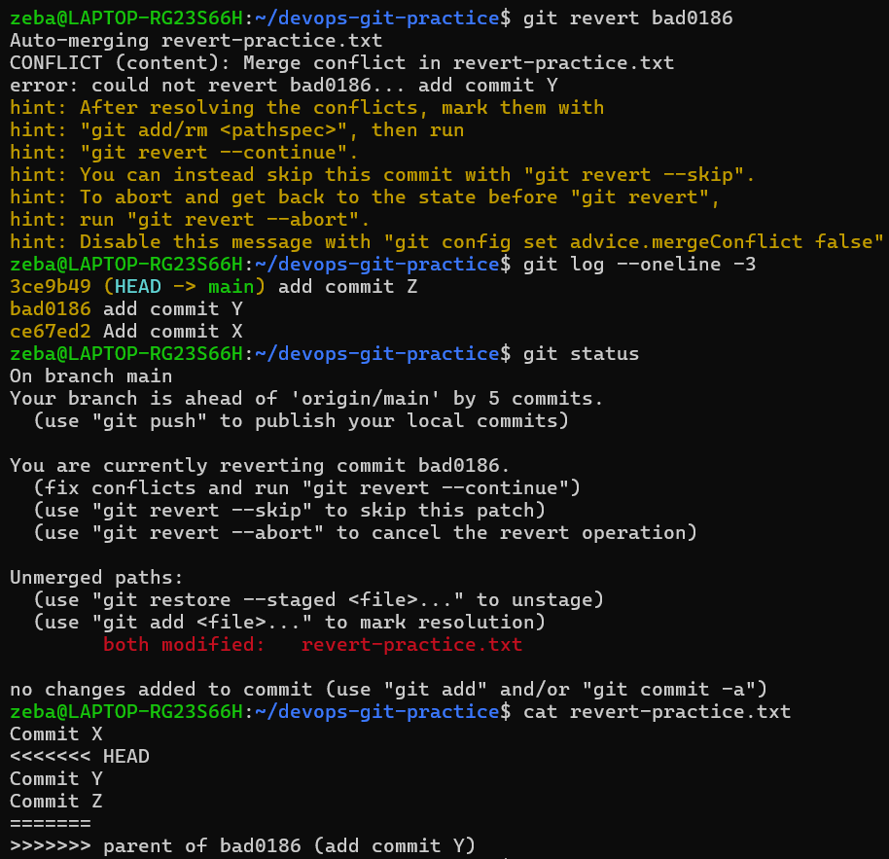
While reverting conflict happened
Now we need to resolve the conflict and then add it then git revert –continue can see in options also
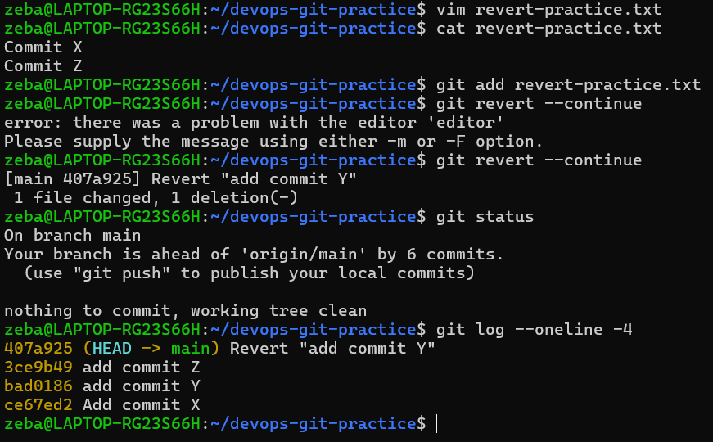
Commit Y is still in the history!
Git did NOT delete Y.
Instead, Git created a new commit that reverses the changes introduced by Y.
The changes made by Y are undone, but Y itself remains in history.

Answer in your notes:
  - How is git revert different from git reset?
  - Why is revert considered safer than reset for shared branches?
  - When would you use revert vs reset?

How is git revert different from git reset?
git reset moves the branch pointer (HEAD) backward to an earlier commit and can rewrite the branch history.

git revert does not remove the original commit. Instead, it creates a new commit that reverses the changes made by an earlier commit.

Example:
git reset:
X → Y → Z
↓
X → Y

Z are removed from the current branch history.

git revert Y:
X → Y → Z → Revert Y
Y remains in the history, but its changes are undone.

Why is revert considered safer than reset for shared branches?
git revert is safer because it does not rewrite existing history. It creates a new commit that undoes the previous change.
This means other developers can safely pull the new commit without their existing history being rewritten.
git reset, especially git reset --hard, can rewrite history and cause problems for other developers if the commits have already been pushed and shared.

When would you use revert vs reset?
I would use git revert for commits that have already been pushed to a shared branch such as main, because it safely creates a new commit that undoes the unwanted change.
I would use git reset mainly for local commits that have not been pushed or shared, when I want to move the branch back and rewrite my local history.

Simple rule
Local/unshared commit
↓
RESET

Already pushed/shared commit
↓
REVERT

Task 3: Reset vs Revert — Summary
Create a comparison in your notes:
 | git reset | git revert
What it does | ? | ?
Removes commit from history? | ? | ?
Safe for shared/pushed branches? | ? | ?
When to use | ? | ?

git reset | git revert
What it does: Moves HEAD/branch pointer to an earlier commit and can rewrite history. | What it does: Creates a new commit that reverses the changes of an earlier commit.
Removes commit from history? Yes, the commit is removed from the current branch history. | Removes commit from history? No, the original commit remains in history.
Safe for shared/pushed branches? No, generally unsafe because it rewrites history. | Safe for shared/pushed branches? Yes, safer because it preserves existing history.
When to use: Mainly for local/unshared commits when you want to rewrite history. | When to use: For already pushed/shared commits when you need to safely undo a change.

Task 4: Branching Strategies
Research the following branching strategies and document each in your notes with:
- How it works (short description)
- A simple diagram or flow (text-based is fine)
- When/where it's used
- Pros and cons
- GitFlow — develop, feature, release, hotfix branches
- GitHub Flow — simple, single main branch + feature branches
- Trunk-Based Development — everyone commits to main, short-lived branches
- Answer:
  - Which strategy would you use for a startup shipping fast?
  - Which strategy would you use for a large team with scheduled releases?
  - Which one does your favorite open-source project use? (check any repo on GitHub)

1. GitFlow
How it works
GitFlow uses several types of branches:
- main → production-ready code
- develop → main development branch
- feature/* → new features
- release/* → prepare and test a release
- hotfix/* → urgent production fixes

Development normally happens in develop.
Features branch from develop and are merged back into it.
When a release is ready, a release branch is created for final testing.
Production fixes use hotfix branches.

feature-login
/
develop ──────────┼───────────────
\
feature-payment
|
↓
release-1.0
|
↓
main
↑
hotfix-1.1
( or )
FEATURE 1
↗ ↘
develop ─────────────────────→ release ──→ main
↘ ↗
FEATURE 2
main ──→ hotfix ──→ main
↘
develop

When/where is it used?
Best suited for projects with structured and scheduled releases, multiple versions, and a need for dedicated release/hotfix stages.

Pros
- Clear separation between development and production
- Dedicated release and hotfix branches
- Good control for scheduled releases
- Useful when maintaining multiple versions
Cons
- More branches to manage
- More complicated workflow
- More merging and potential conflicts
- Can be unnecessarily complex for projects that deploy frequently
GitHub Flow
How it works
GitHub Flow is much simpler:
- Start from main
- Create a feature branch
- Make commits
- Push the branch
- Open a Pull Request
- Review and test
- Merge into main
- Deploy
GitHub's documentation describes separate branches for individual changes and Pull Requests for review before merging.
Simple flow
feature-login
/
main ──────────●──────────────→ main
\
Pull Request
↓
Review
↓
Merge
↓
main
When/where is it used?
Good for web applications, startups, small-to-medium teams, and continuous delivery, where changes are released frequently instead of waiting for large scheduled releases. GitLab also describes the simple feature-branch-to-main approach as a sensible default for many teams.
Pros
- Simple to understand
- Fewer long-lived branches
- Easy Pull Request/code-review workflow
- Works well with CI/CD
- Faster development and deployment
Cons
- Requires good CI/testing
- Not ideal when you need complex release management
- main must remain stable and deployable

3. Trunk-Based Development
How it works
Everyone works around one main branch called the trunk (main). Developers integrate their changes frequently rather than maintaining long-lived feature branches. Short-lived branches may still be used for a small change and merged quickly.
Simple flow
Developer A ──┐
Developer B ──┼──→ main/trunk ──→ Production
Developer C ──┘
↑
Short-lived branches
Or:
main ──●──●──●──●──●──●──→
↑ ↑ ↑
small small small
change change change
When/where is it used?
Common in teams practicing continuous integration and continuous delivery, where developers integrate small changes frequently.
Pros
- Very fast integration
- Less long-lived branch management
- Smaller and easier-to-resolve conflicts
- Works very well with CI/CD
- Encourages frequent integration
Cons
- Requires strong automated testing
- Developers need discipline
- main must stay stable
- Large unfinished features may require techniques such as feature flags

Comparison
Strategy | Main idea | Best suited for
GitFlow | develop + feature + release + hotfix branches | Large teams with scheduled releases
GitHub Flow | main + short-lived feature branches + PR | Startups, web apps, frequent deployments
Trunk-Based | Frequent integration into main with very short-lived branches | CI/CD and teams shipping continuously

Which strategy would I use?
Startup shipping fast → GitHub Flow
I would choose GitHub Flow because it is simple: create a feature branch, make changes, open a Pull Request, review/test it, and merge into main. This keeps the workflow lightweight while supporting fast releases.
Large team with scheduled releases → GitFlow
I would choose GitFlow when the organization has planned release cycles and needs separate development, release, and hotfix stages.
Open-source project example → Kubernetes
For the open-source example, Kubernetes is a useful one to study. Its repository uses Pull Requests and a review-based contribution workflow, and it also maintains release branches/versions rather than having only one permanent development line. Its current repository activity shows work being merged through PRs, while releases are maintained separately.
So I would describe Kubernetes as a PR/feature-branch workflow with release branches, rather than calling it pure GitFlow or pure GitHub Flow.
Kubernetes GitHub repository
⭐ Easy interview memory
GitFlow
→ Complex
→ Scheduled releases
→ develop + feature + release + hotfix

GitHub Flow
→ Simple
→ Fast releases
→ main + feature branches + Pull Requests

Trunk-Based
→ Very frequent integration
→ CI/CD
→ main/trunk + short-lived branches

Task 5: Git Commands Reference Update
Update your git-commands.md to cover everything from Days 22–25:
- Setup & Config
- Basic Workflow (add, commit, status, log, diff)
- Branching (branch, checkout, switch)
- Remote (push, pull, fetch, clone, fork)
- Merging & Rebasing
- Stash & Cherry Pick
- Reset & Revert
