Day 59 – Helm — Kubernetes Package Manager

Task 1: Install Helm
- Install Helm (brew, curl script, or chocolatey depending on your OS)
- Verify with helm version and helm env
Three core concepts:
- Chart — a package of Kubernetes manifest templates
- Release — a specific installation of a chart in your cluster
- Repository — a collection of charts (like a package repo)
Verify: What version of Helm is installed?

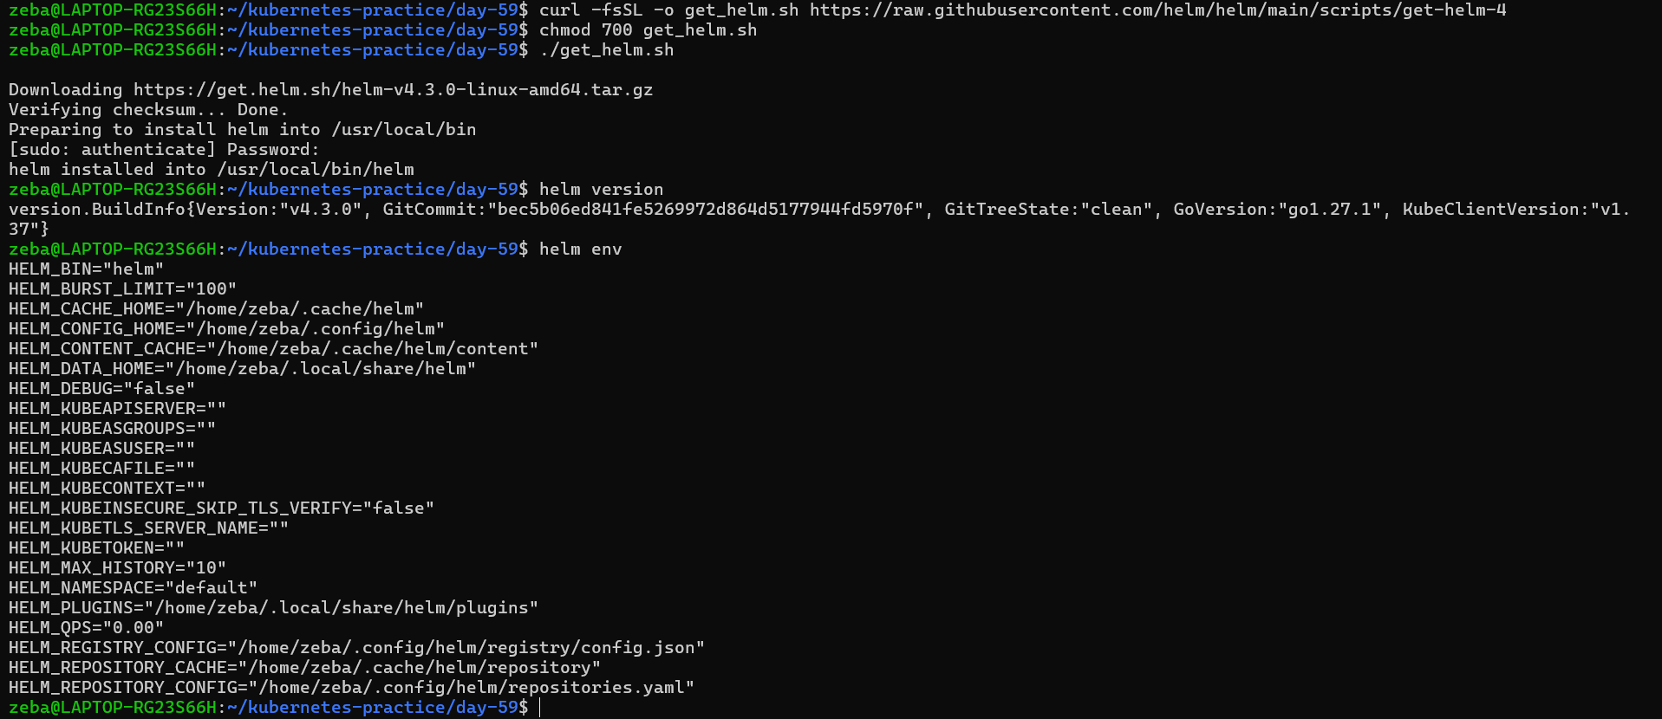
Helm installed
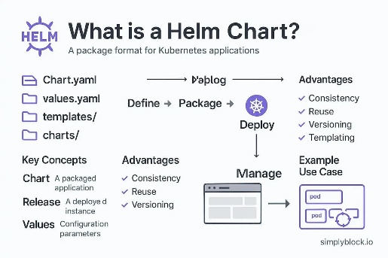
1. Chart
A package containing Kubernetes manifest templates and configuration values.
Example: An Nginx chart defines how to create the application's Kubernetes resources.
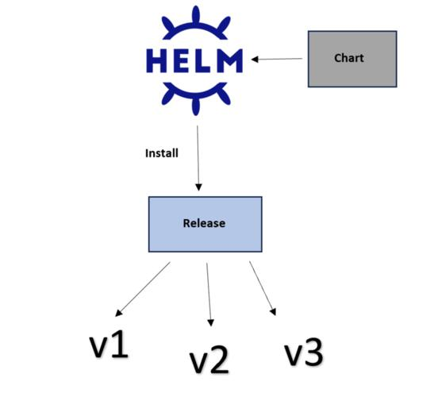
2. Release
A specific installed instance of a chart in a Kubernetes cluster.
Example: Installing the Nginx chart as my-nginx creates a release named my-nginx.
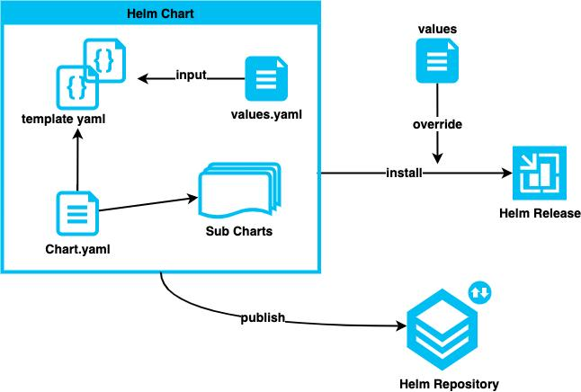
3. Repository
A location that stores and distributes Helm charts.
Example: A chart repository lets you find and install charts without creating every Kubernetes manifest yourself.

Task 2: Add a Repository and Search
- Add the Bitnami repository: helm repo add bitnami https://charts.bitnami.com/bitnami
- Update: helm repo update
- Search: helm search repo nginx and helm search repo bitnami
Verify: How many charts does Bitnami have?

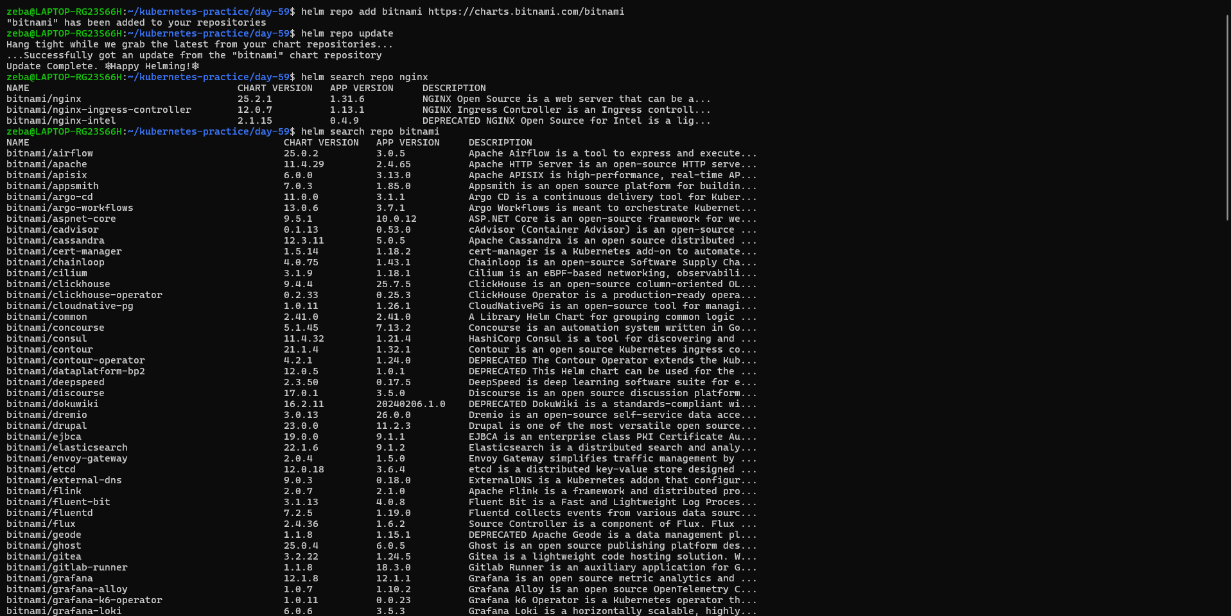
Bitnami has 144 charts

Task 3: Install a Chart
- Deploy nginx: helm install my-nginx bitnami/nginx
- Check what was created: kubectl get all
- Inspect the release: helm list, helm status my-nginx, helm get manifest my-nginx
One command replaced writing a Deployment, Service, and ConfigMap by hand.
Verify: How many Pods are running? What Service type was created?
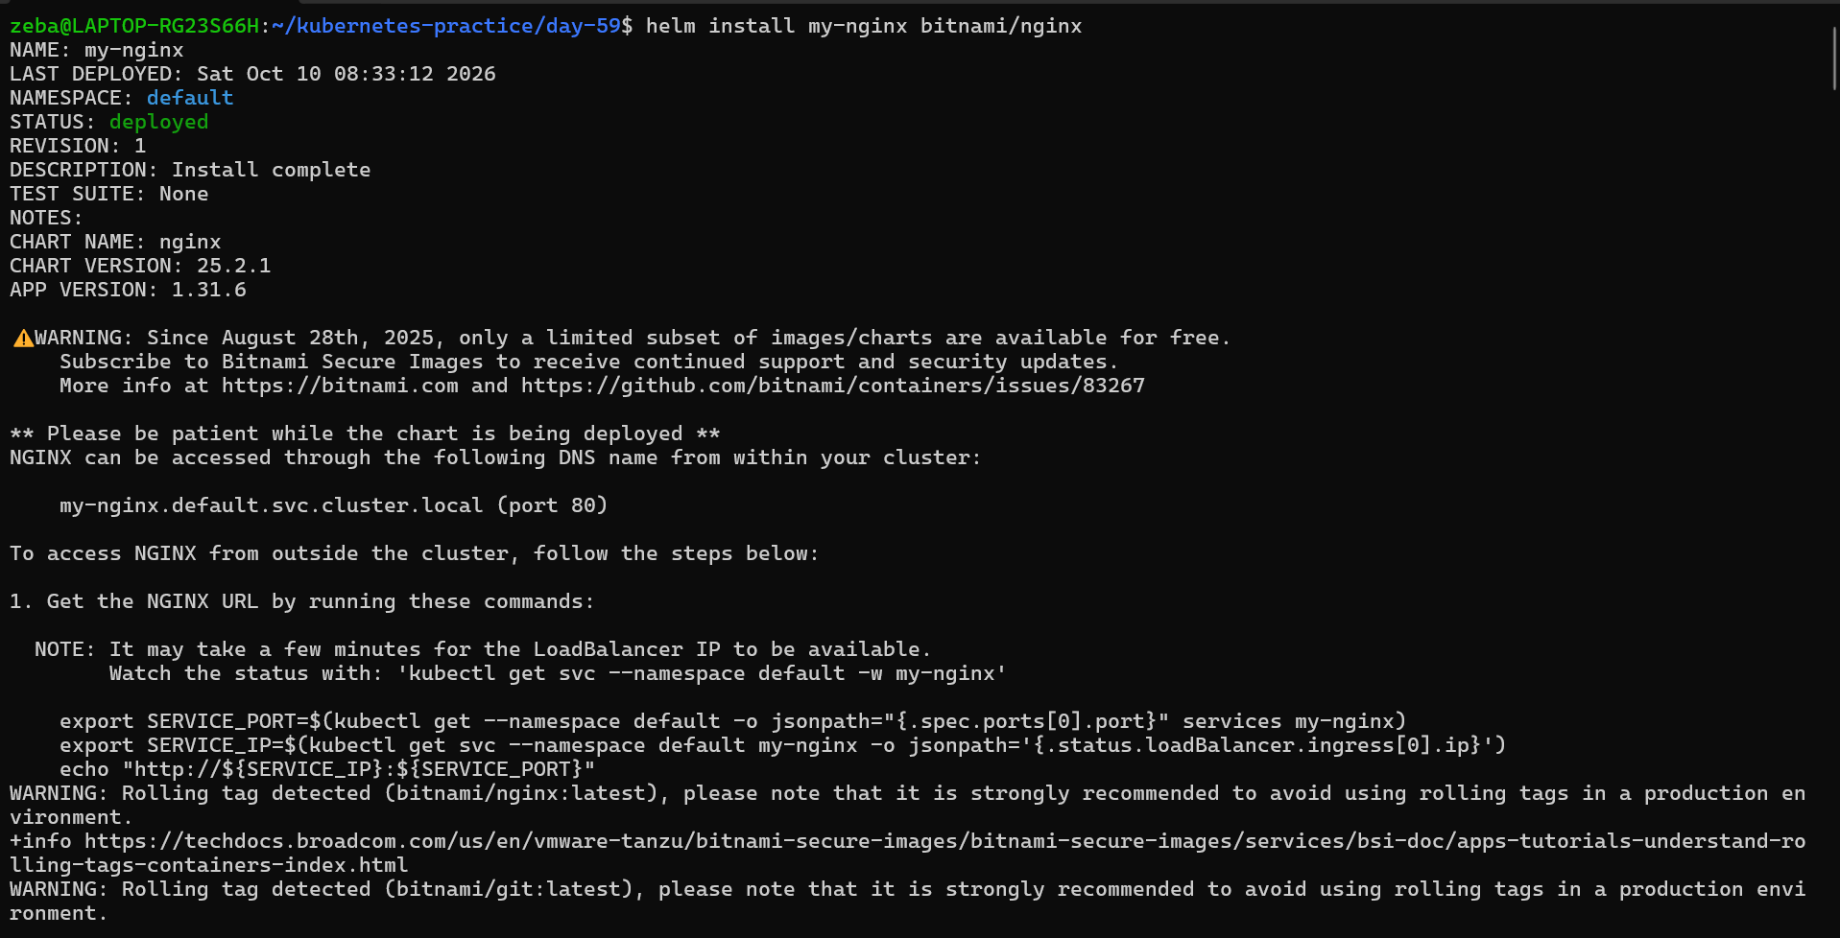
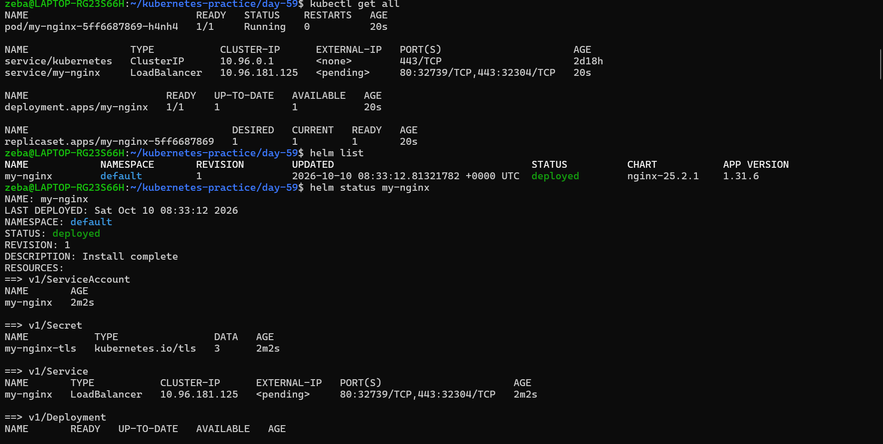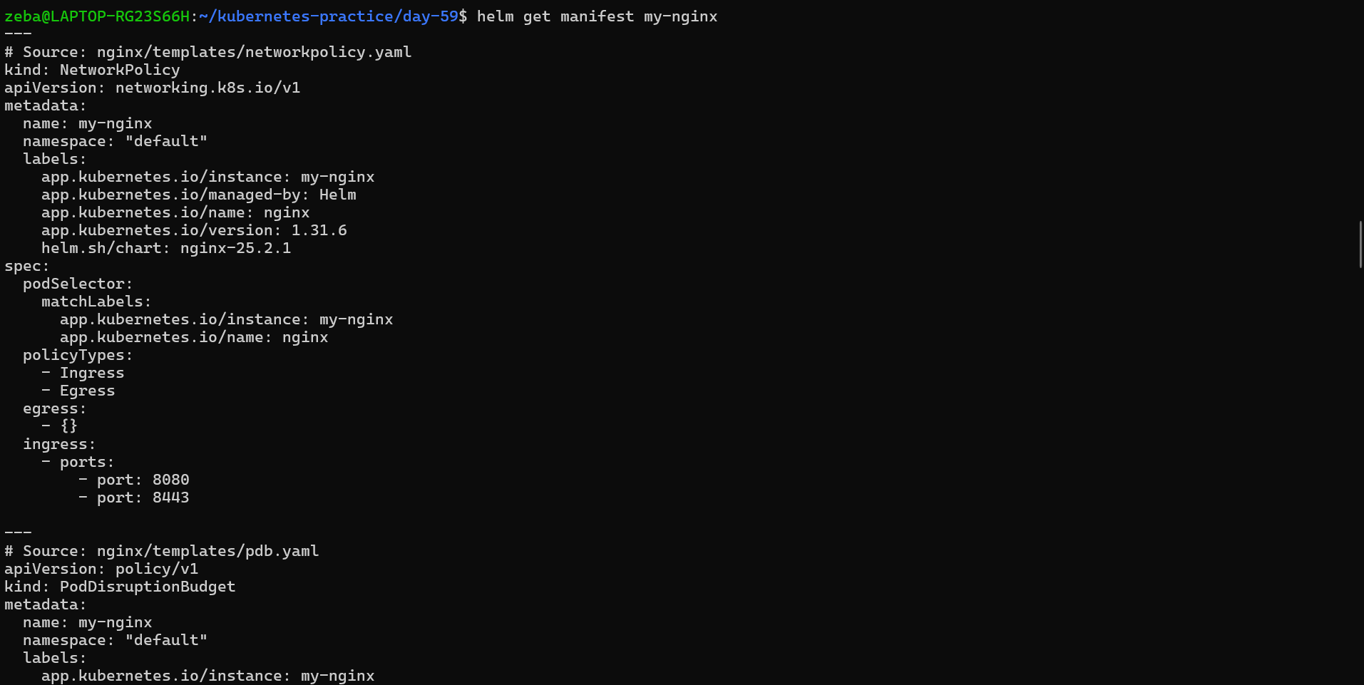
1. How many Pods are running?
One Nginx Pod is running:
2. What Service type was created?
LoadBalancer
Task 4: Customize with Values
- View defaults: helm show values bitnami/nginx
- Install a custom release with --set replicaCount=3 --set service.type=NodePort
- Create a custom-values.yaml file with replicaCount, service type, and resource limits
- Install another release using -f custom-values.yaml
- Check overrides: helm get values <release-name>
Verify: Does the values file release have the correct replicas and service type?
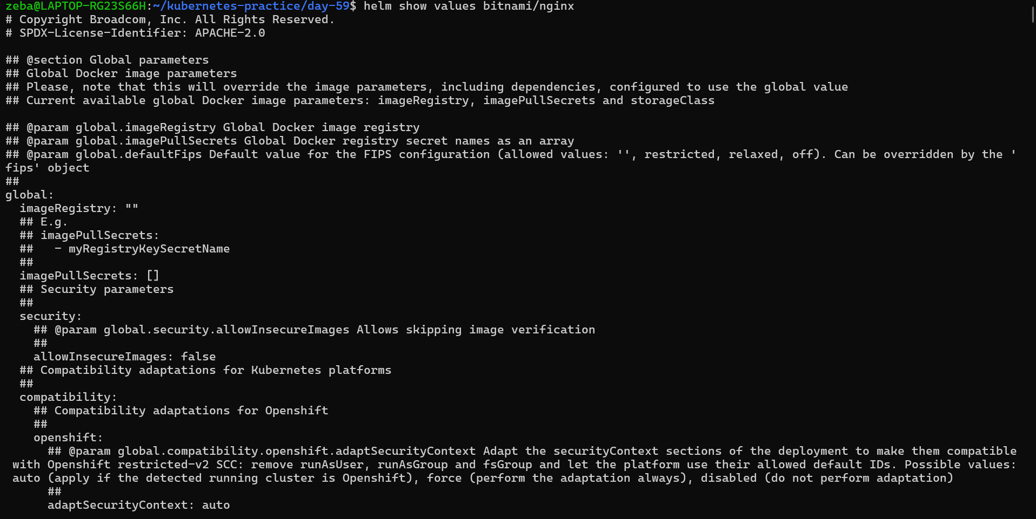

Custom release installed
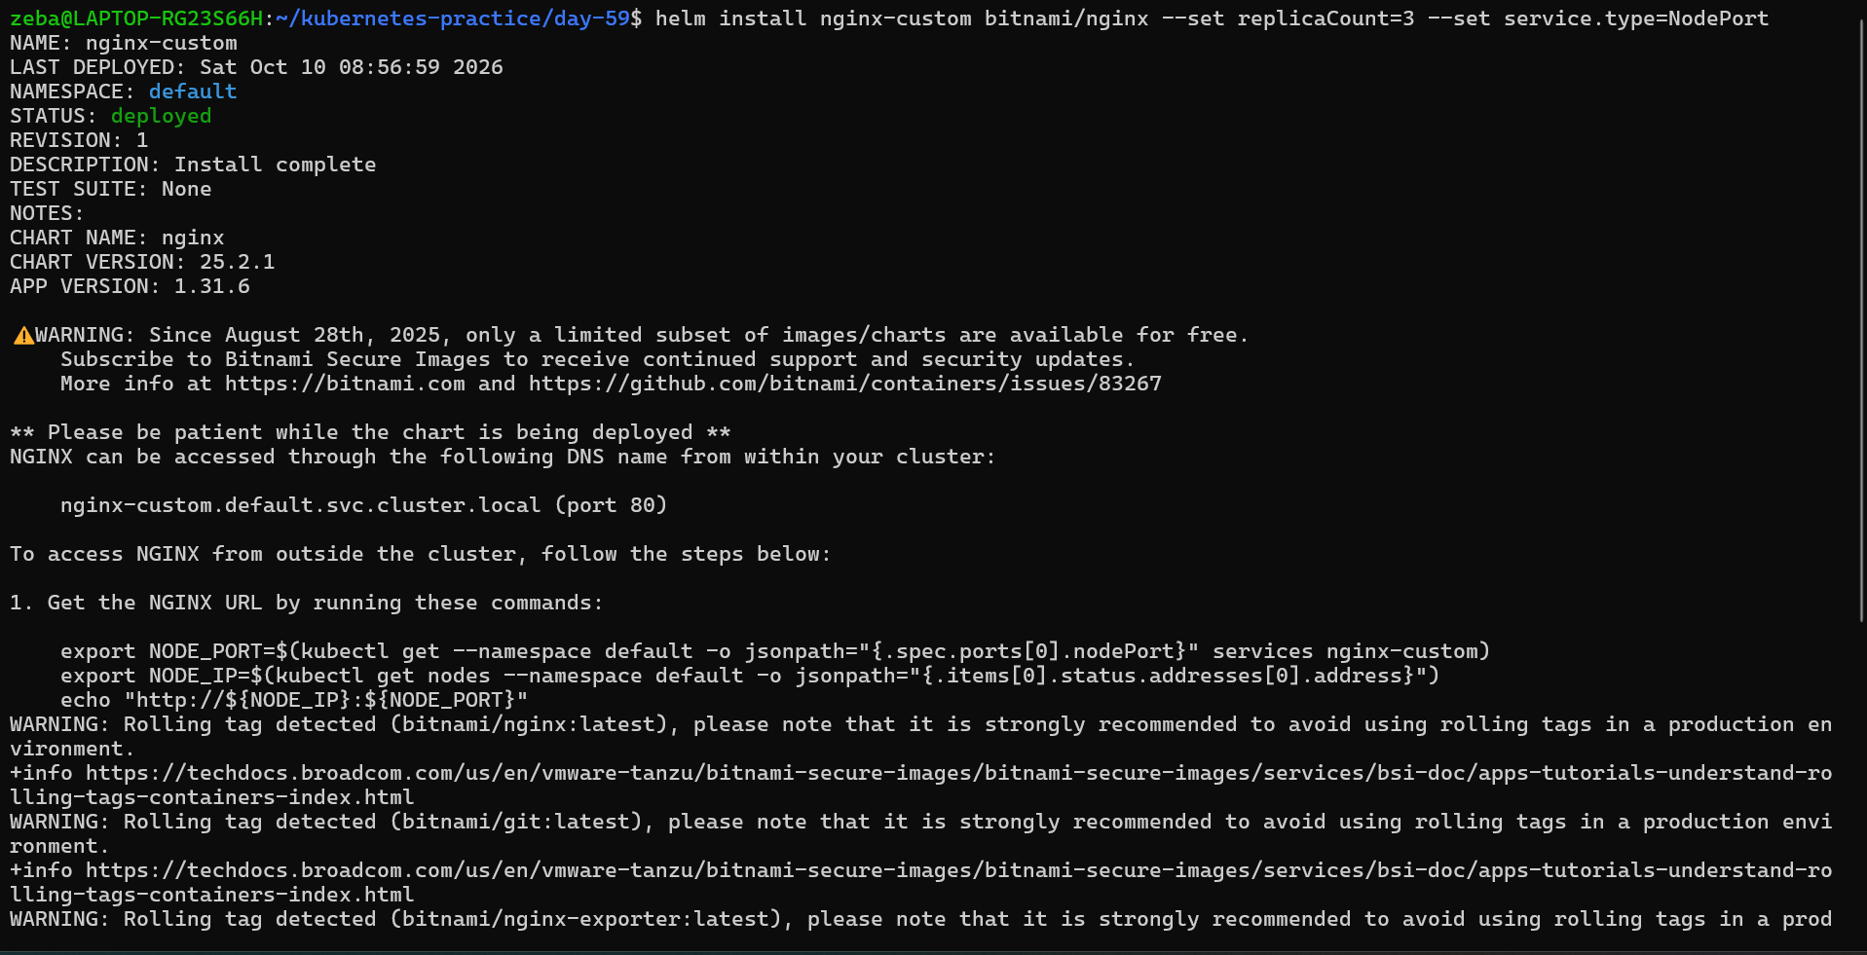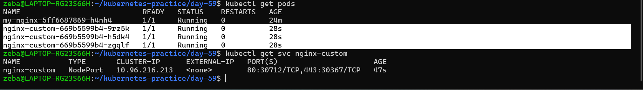
Verified 3 replicas with nodeport service
custom-values.yaml
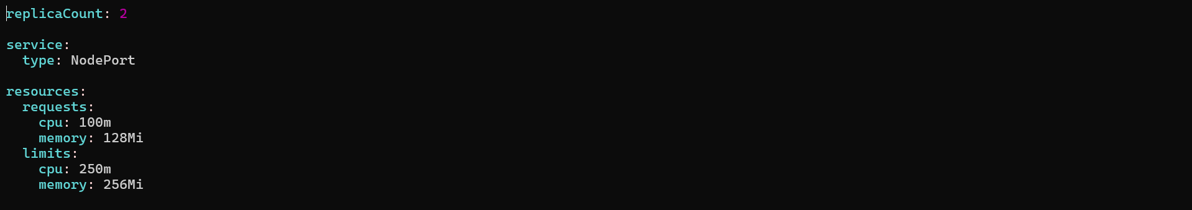

Install new release
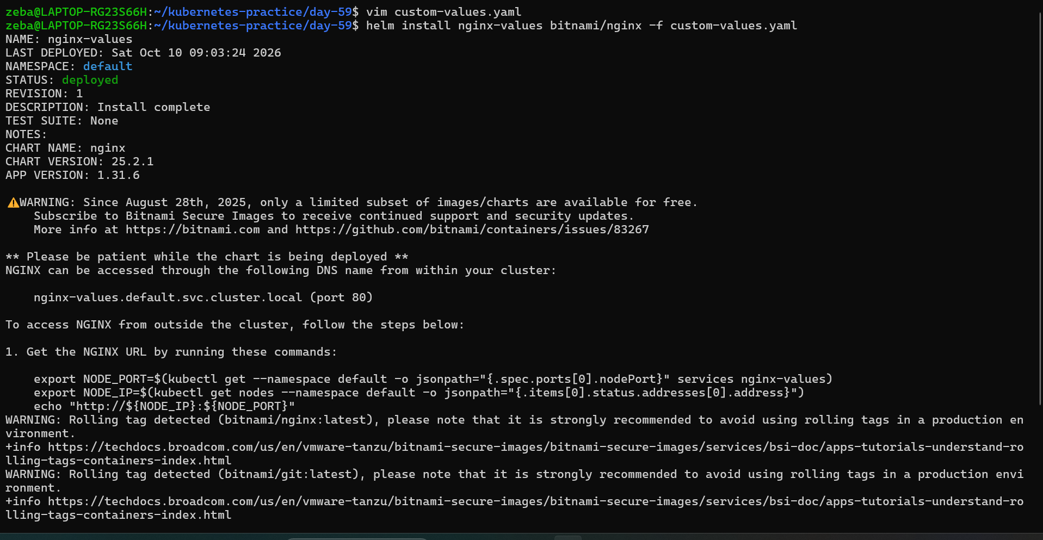

Values got override
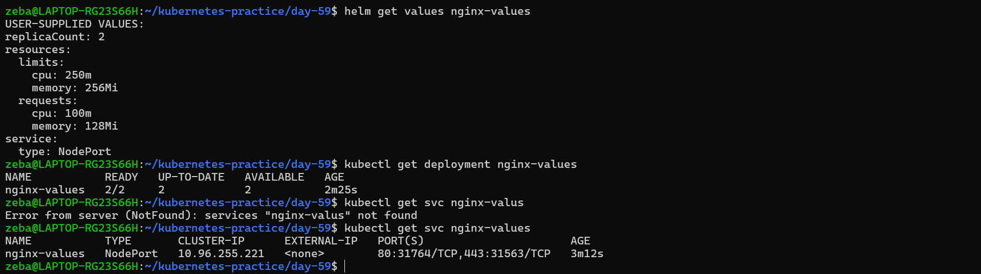
Task 5: Upgrade and Rollback
- Upgrade: helm upgrade my-nginx bitnami/nginx --set replicaCount=5
- Check history: helm history my-nginx
- Rollback: helm rollback my-nginx 1
- Check history again — rollback creates a new revision (3), not overwriting revision 2
Same concept as Deployment rollouts from Day 52, but at the full stack level.
Verify: How many revisions after the rollback?
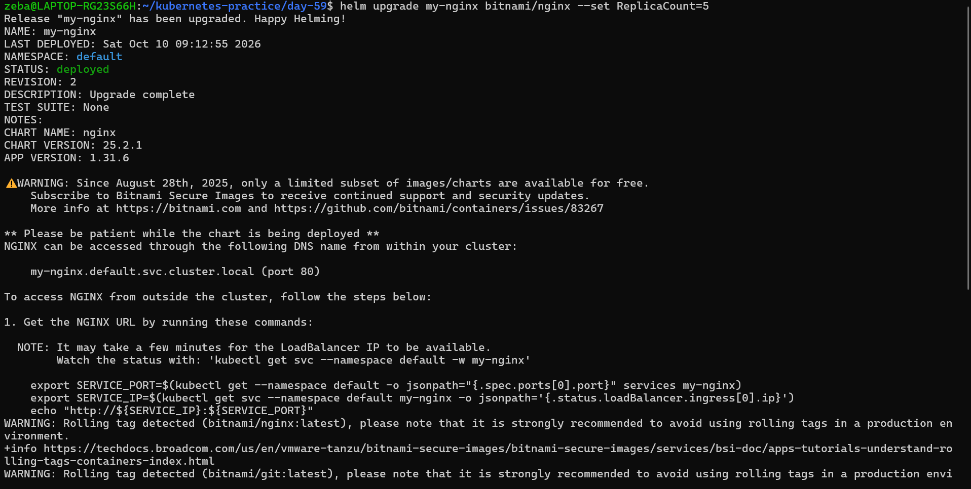
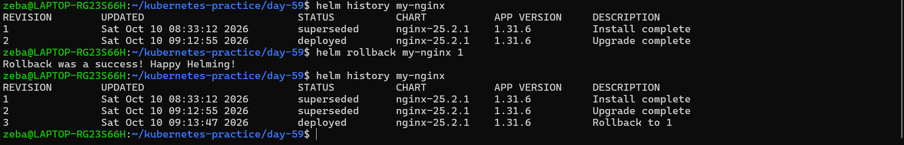 How many revisions after the rollback?
3 revisions after the rollback
Task 6: Create Your Own Chart
- Scaffold: helm create my-app
- Explore the directory: Chart.yaml, values.yaml, templates/deployment.yaml
- Look at the Go template syntax in templates: {{ .Values.replicaCount }}, {{ .Chart.Name }}
- Edit values.yaml — set replicaCount to 3 and image to nginx:1.25
- Validate: helm lint my-app
- Preview: helm template my-release ./my-app
- Install: helm install my-release ./my-app
- Upgrade: helm upgrade my-release ./my-app --set replicaCount=5
Verify: After installing, 3 replicas? After upgrading, 5?
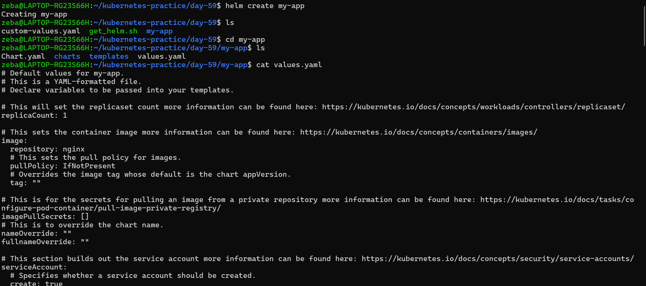

Changed the image tag and replica count in values.yml
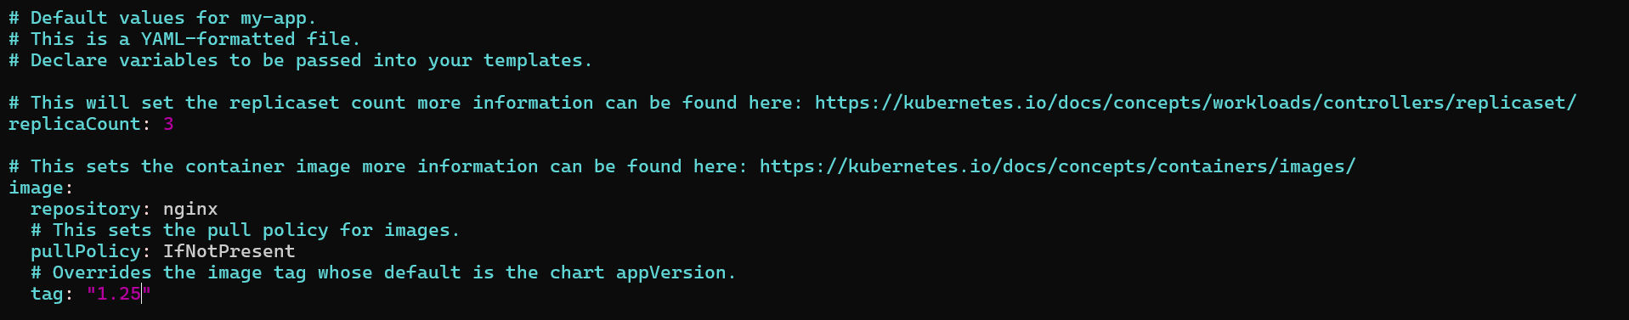

My-app linted
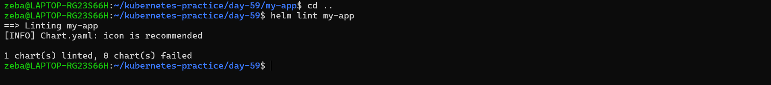

Preview
Helm combines your values.yaml settings with the chart templates and prints the resulting Kubernetes YAML. It previews the resources without installing them in your cluster.
In the output, look for:
- replicas: 3
- image: "nginx:1.25"

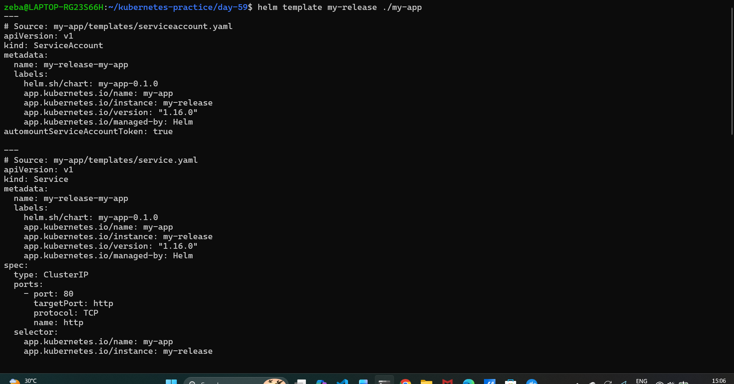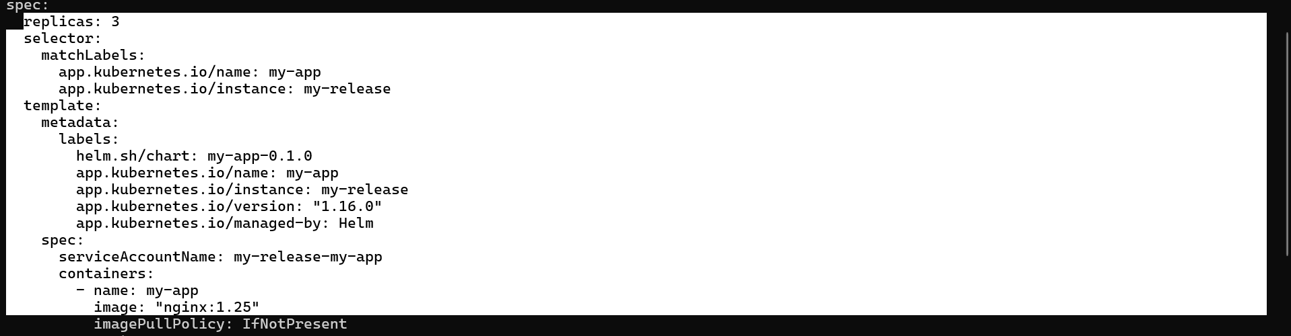

Installed my-release
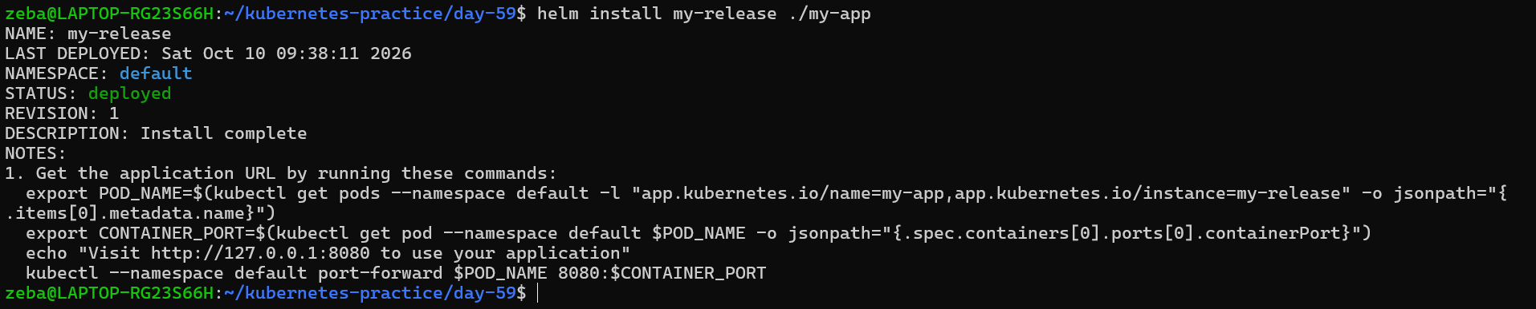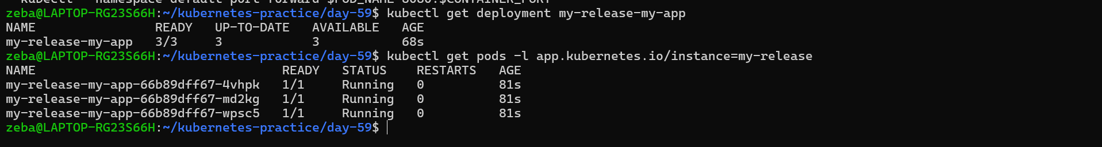

Upgraded to 5 replicas
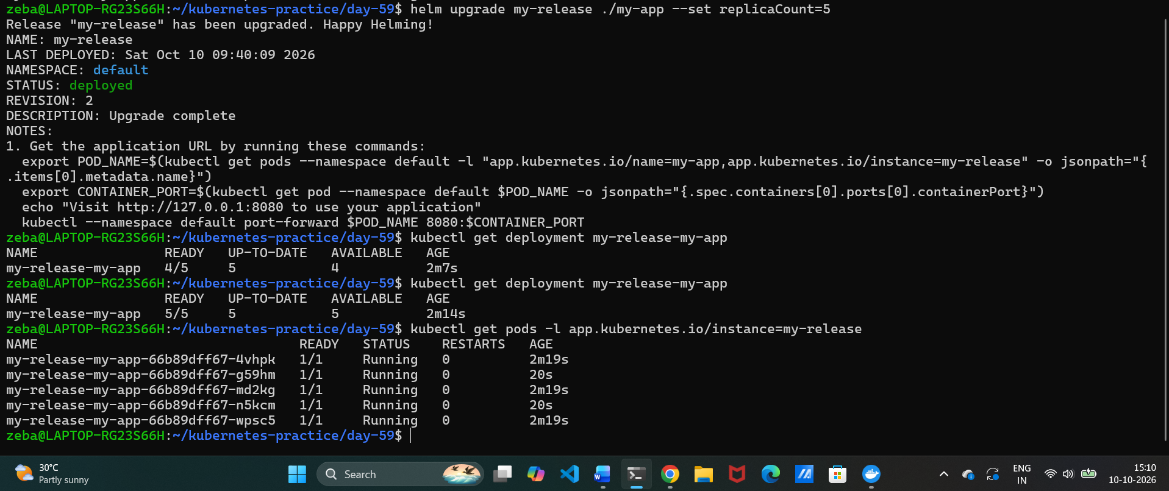
Task 7: Clean Up
- Uninstall all releases: helm uninstall <name> for each
- Remove chart directory and values file
- Use --keep-history if you want to retain release history for auditing
Verify: Does helm list show zero releases?
