Day 62 -- Providers, Resources and Dependencies

Task 1: Explore the AWS Provider
- Create a new project directory: terraform-aws-infra
- Write a providers.tf file:
  - Define the terraform block with required_providers pinning the AWS provider to version ~> 5.0
  - Define the provider "aws" block with your region
- Run terraform init and check the output -- what version was installed?
- Read the provider lock file .terraform.lock.hcl -- what does it do?
Document: What does ~> 5.0 mean? How is it different from >= 5.0 and = 5.0.0?
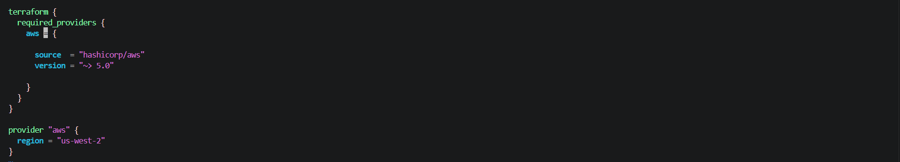
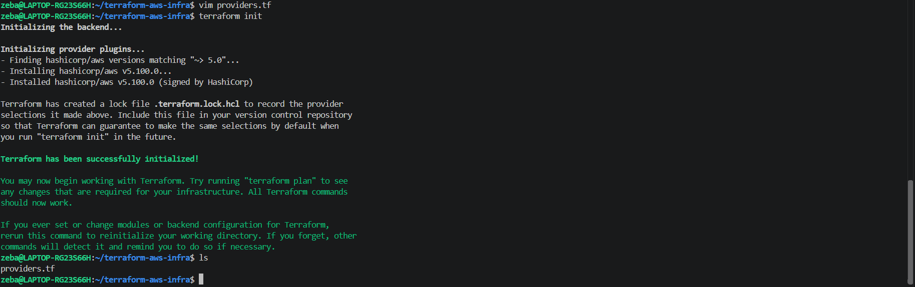

Installed version :
Initializing provider plugins...
- Finding hashicorp/aws versions matching "~> 5.0"...
- Installing hashicorp/aws v5.100.0...
- Installed hashicorp/aws v5.100.0 (signed by HashiCorp)
So AWS provider installed = v5.100.0
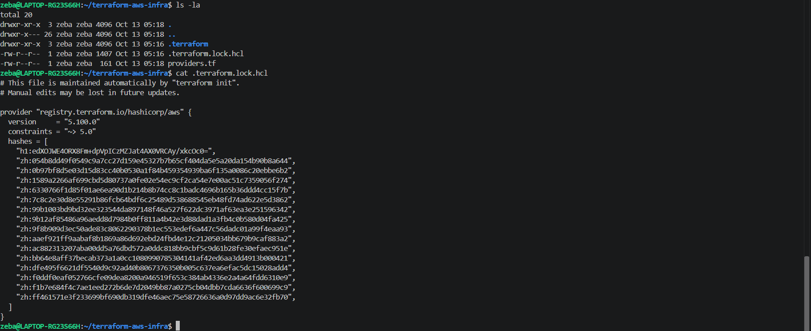
.terraform.lock.hcl – contains which terraform provider version our project is using and how to verify the provider

~> 5.0 = pessimistic version control
It can have the versions in the range 5.0.0 …. 5… but not 6.0.0
It can have all the series of 5. But excludes 6. Series

>= 5.0 = greater than or equals to
It can have the versions 5.0.0 and greater than that and can contain 6.0 series and above , there is no limit

= 5.0 = exact version control
It can have the specific version 5.0.0

Task 2: Build a VPC from Scratch
Create a main.tf and define these resources one by one:
- aws_vpc -- CIDR block 10.0.0.0/16, tag it "TerraWeek-VPC"
- aws_subnet -- CIDR block 10.0.1.0/24, reference the VPC ID from step 1, enable public IP on launch, tag it "TerraWeek-Public-Subnet"
- aws_internet_gateway -- attach it to the VPC
- aws_route_table -- create it in the VPC, add a route for 0.0.0.0/0 pointing to the internet gateway
- aws_route_table_association -- associate the route table with the subnet
Run terraform plan -- you should see 5 resources to create.
Verify: Apply and check the AWS VPC console. Can you see all five resources connected?

VPC (Virtual private cloud) :- it is an isolated logical network in aws in which we will deploy resources like ec2 instance , subnets, security groups etc.
Subnet – smaller ip address range in the vpc, in which mainly EC2 instance will deploy
Internet gateway (IGW) :- it is the aws networking component it connects our VPC to internet
Route table :- it defines the network direction, it contains rules that tells network traffic where to go
Route table association:- apply those directions to subnet

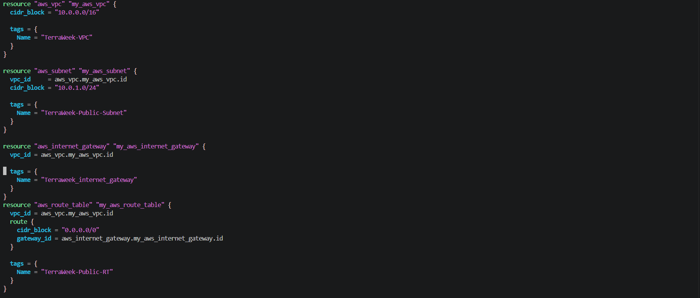
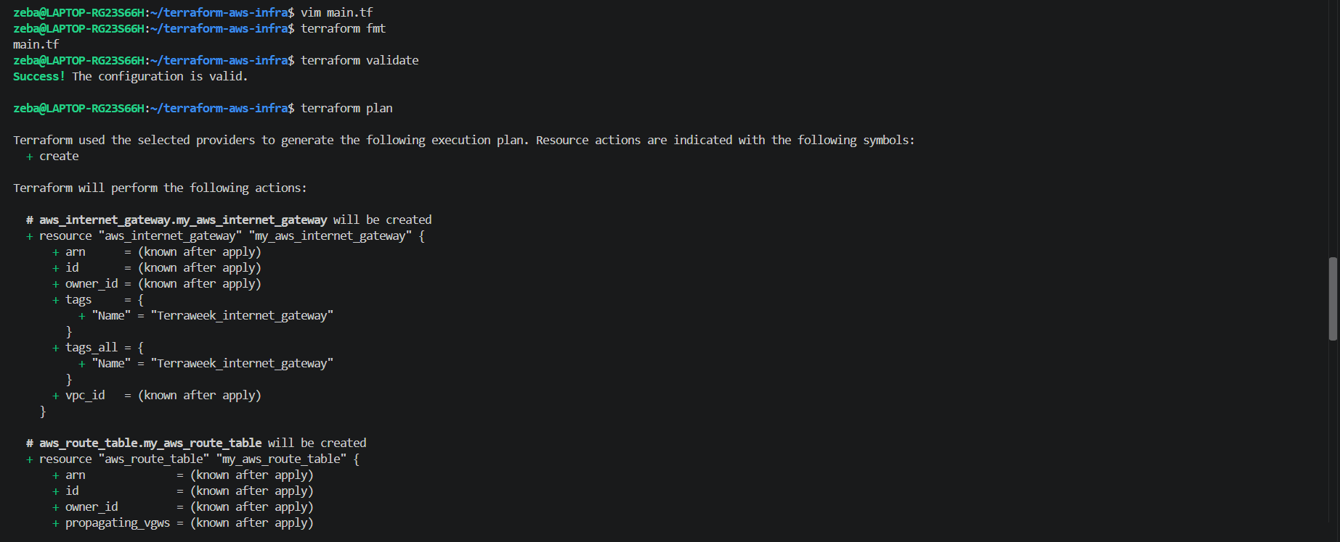
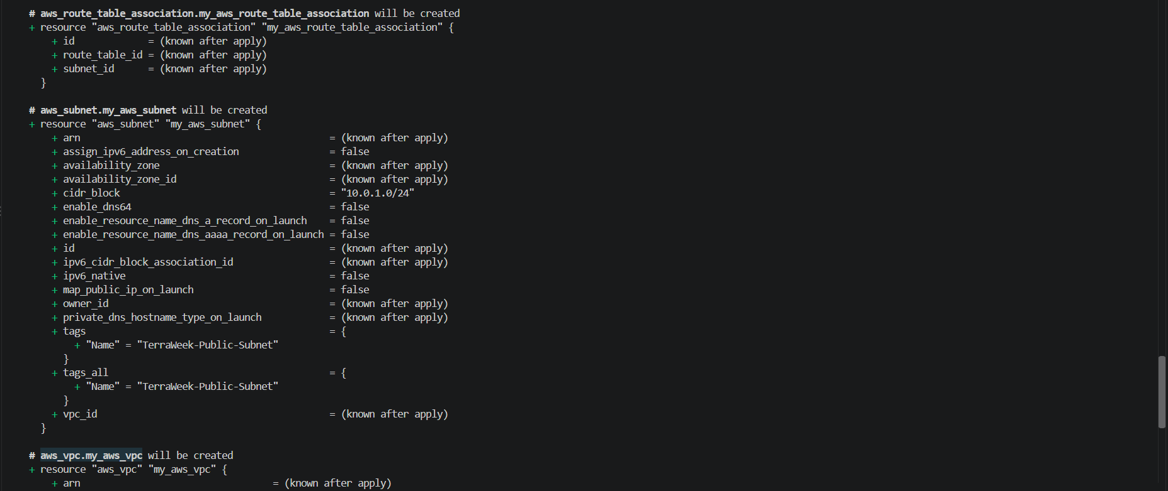

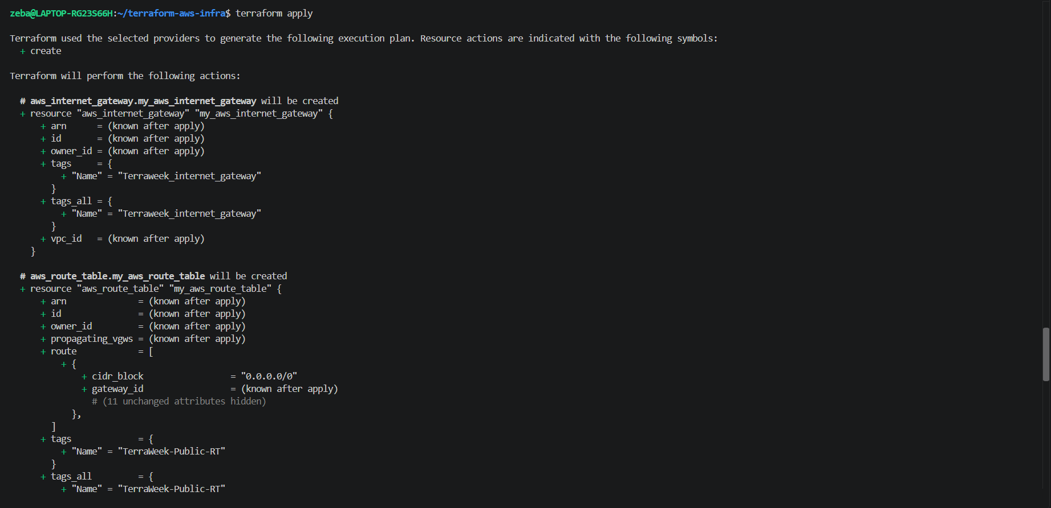
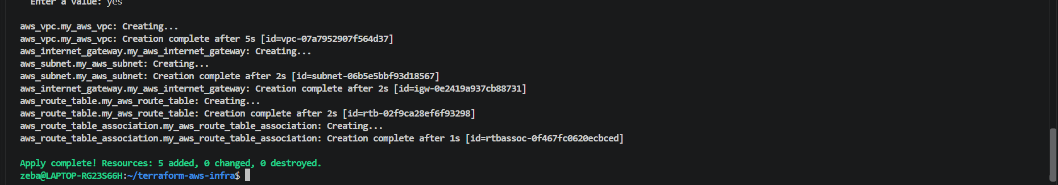
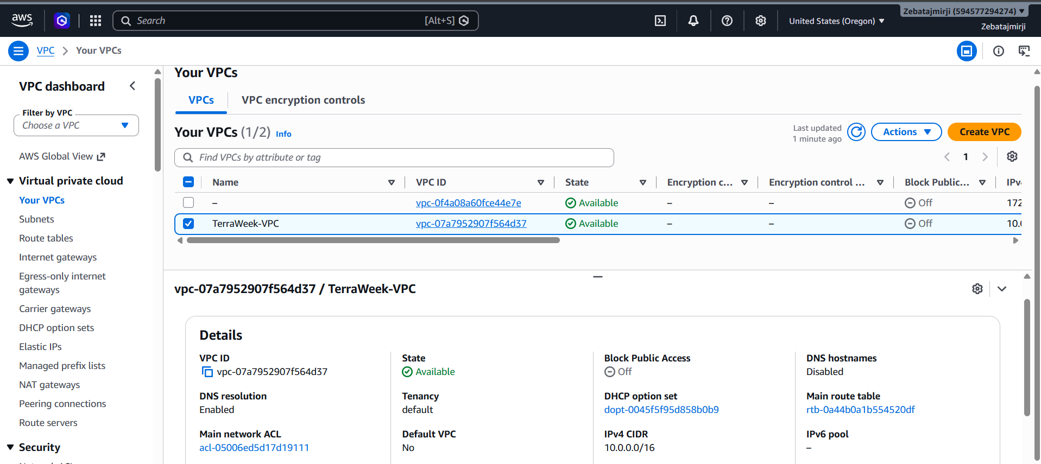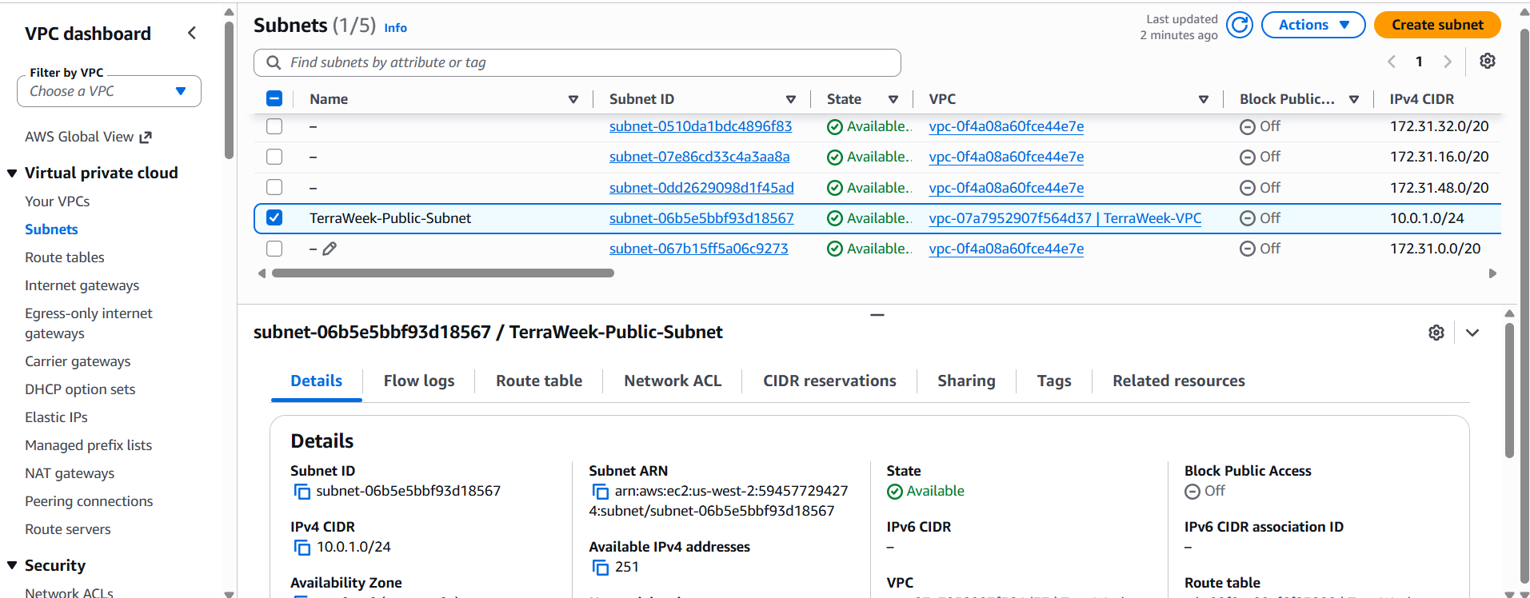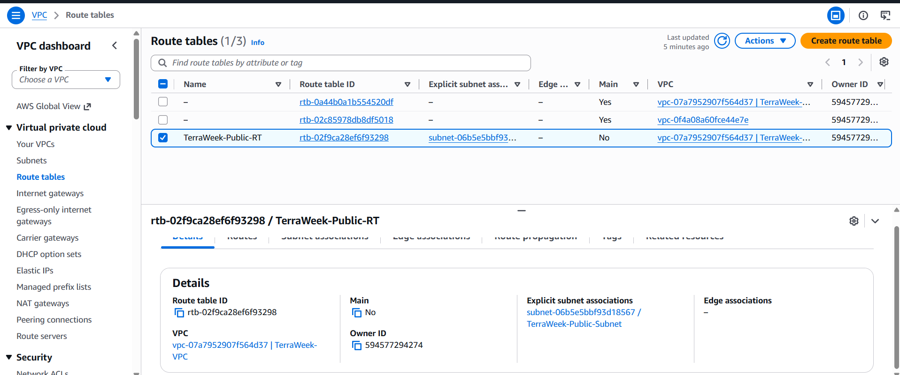
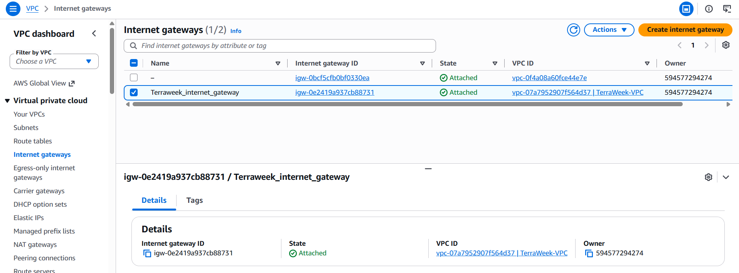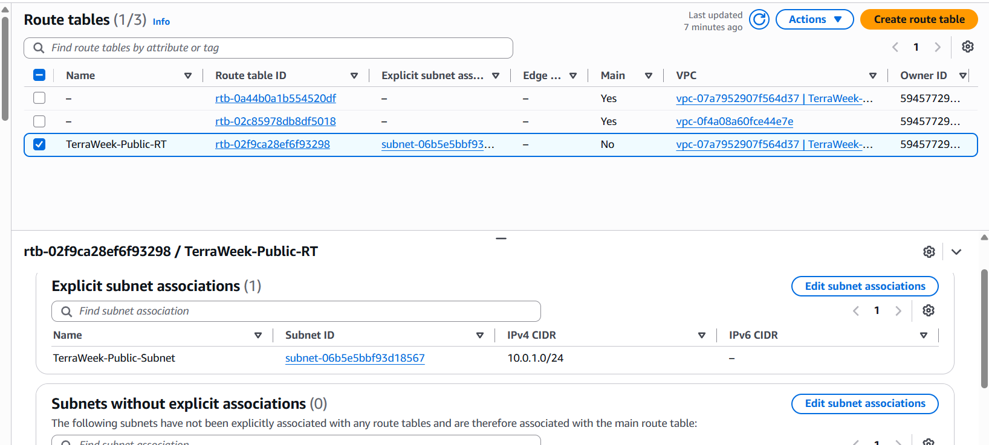
Task 3: Understand Implicit Dependencies
Look at your main.tf carefully:
- The subnet references aws_vpc.main.id -- this is an implicit dependency
- The internet gateway references the VPC ID -- another implicit dependency
- The route table association references both the route table and the subnet
Answer these questions:
- How does Terraform know to create the VPC before the subnet?
- What would happen if you tried to create the subnet before the VPC existed?
- Find all implicit dependencies in your config and list them

1. How does Terraform know to create the VPC before the subnet?
Terraform identifies implicit dependencies by looking at references between resources.
For example, your subnet contains:
vpc_id = aws_vpc.my_aws_vpc.id
This tells Terraform that the subnet needs the ID of the VPC resource aws_vpc.my_aws_vpc.
Terraform therefore creates the VPC first, obtains its ID, and then creates the subnet.
You don't need to specify the creation order manually. Terraform builds a dependency graph and determines a valid execution order.

2. What happens if you try to create the subnet before the VPC exists?
If you mean creating the subnet through Terraform before the VPC resource has been created, Terraform handles this automatically: it creates the VPC first because of the dependency.
If you manually try to create a subnet in AWS using a VPC ID that doesn't exist, AWS rejects the request because the referenced VPC cannot be found.
Important: The order in which resources appear in main.tf does not determine their creation order. Resource references determine the dependencies.

Find all implicit dependencies in your configuration
Based on your resource names, these are the dependencies in main.tf.
Resource that depends on another | Reference in your code | Dependency
aws_subnet.my_aws_subnet | aws_vpc.my_aws_vpc.id | Subnet depends on VPC
aws_internet_gateway.my_aws_internet_gateway | aws_vpc.my_aws_vpc.id | Internet gateway depends on VPC
aws_route_table.my_aws_route_table | aws_vpc.my_aws_vpc.id | Route table depends on VPC
aws_route_table.my_aws_route_table | aws_internet_gateway.my_aws_internet_gateway.id | Route table depends on internet gateway
aws_route_table_association.my_aws_route_table_association | aws_subnet.my_aws_subnet.id | Association depends on subnet
aws_route_table_association.my_aws_route_table_association | aws_route_table.my_aws_route_table.id | Association depends on route table
That gives you six implicit dependency relationships in configuration.

- Subnet → VPC
- Internet Gateway → VPC
- Route Table → VPC
- Route Table → Internet Gateway
- Route Table Association → Subnet
- Route Table Association → Route Table

Task 4: Add a Security Group and EC2 Instance
Add to your config:
- aws_security_group in the VPC:
  - Ingress rule: allow SSH (port 22) from 0.0.0.0/0
  - Ingress rule: allow HTTP (port 80) from 0.0.0.0/0
  - Egress rule: allow all outbound traffic
  - Tag: "TerraWeek-SG"
- aws_instance in the subnet:
  - Use Amazon Linux 2 AMI for your region
  - Instance type: t2.micro
  - Associate the security group
  - Set associate_public_ip_address = true
  - Tag: "TerraWeek-Server"
Apply and verify -- your EC2 instance should have a public IP and be reachable.
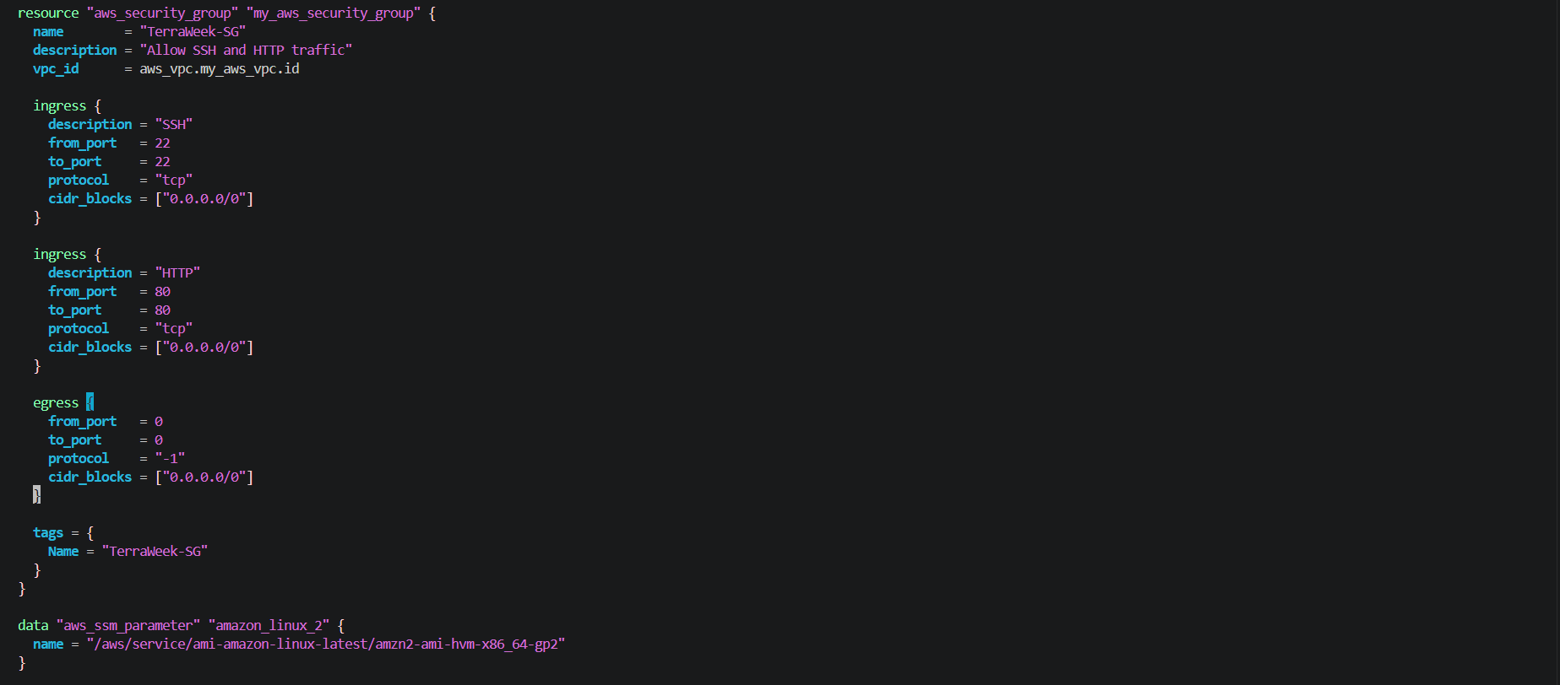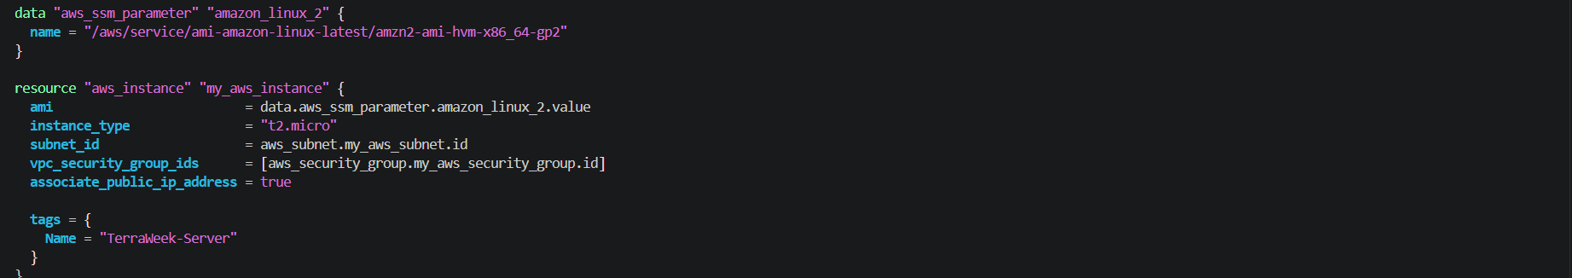
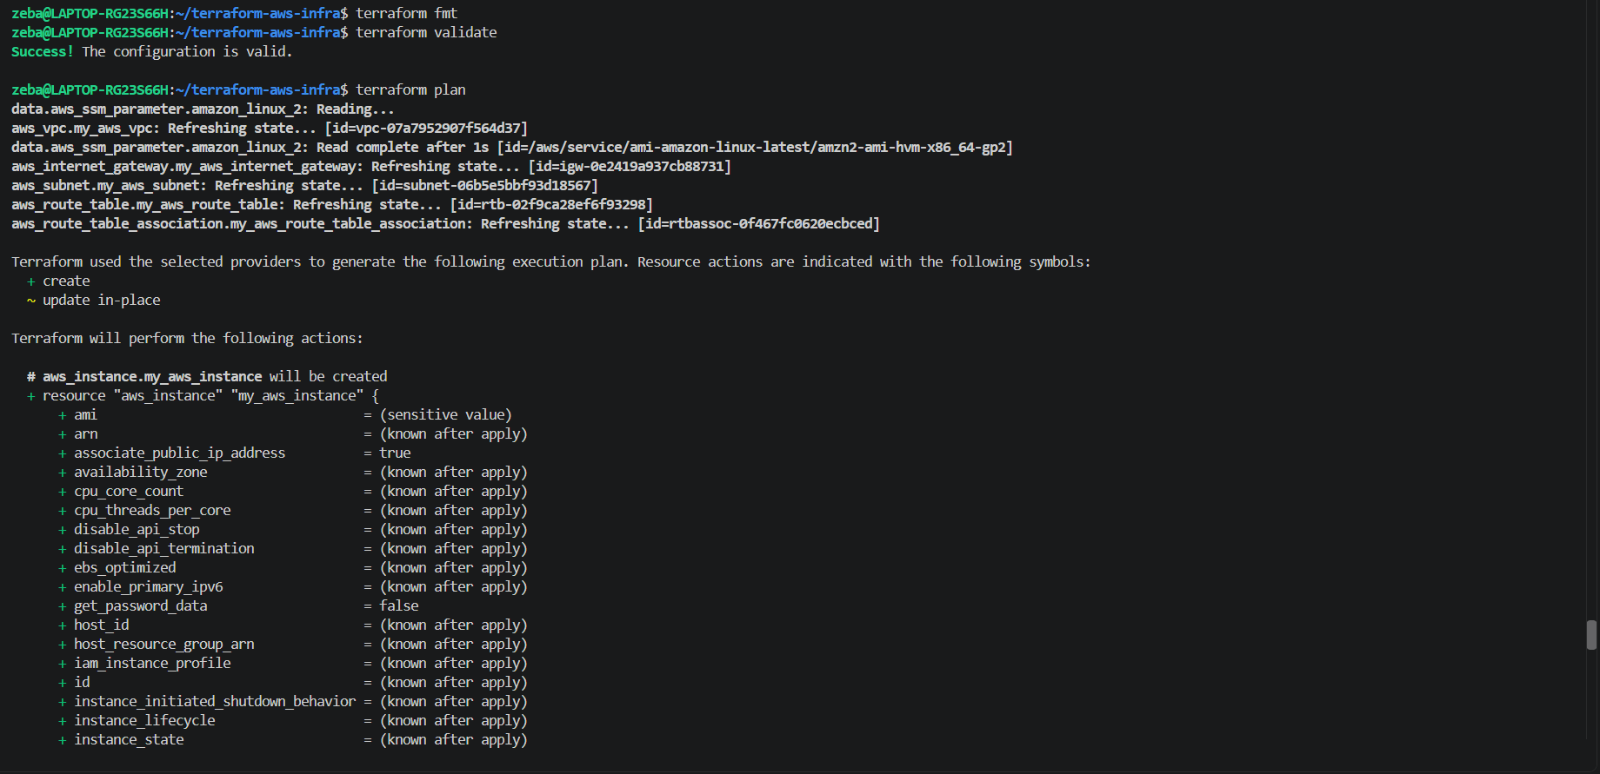
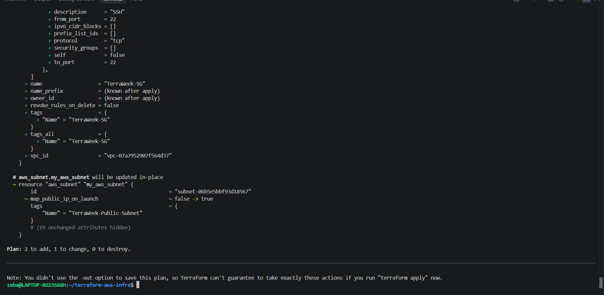

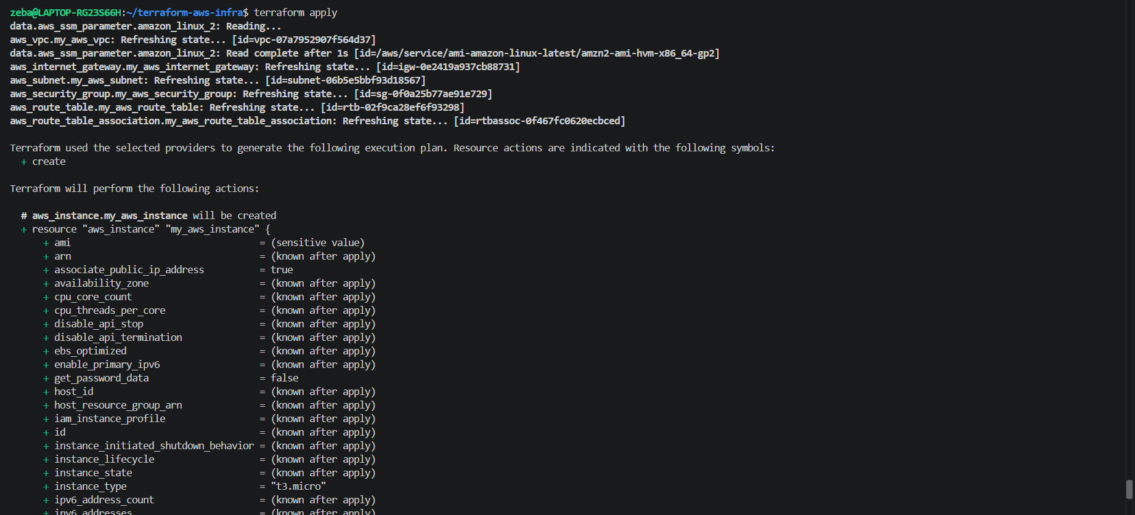
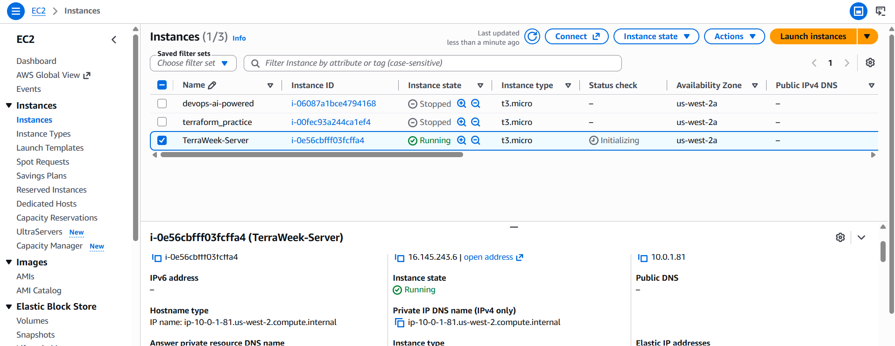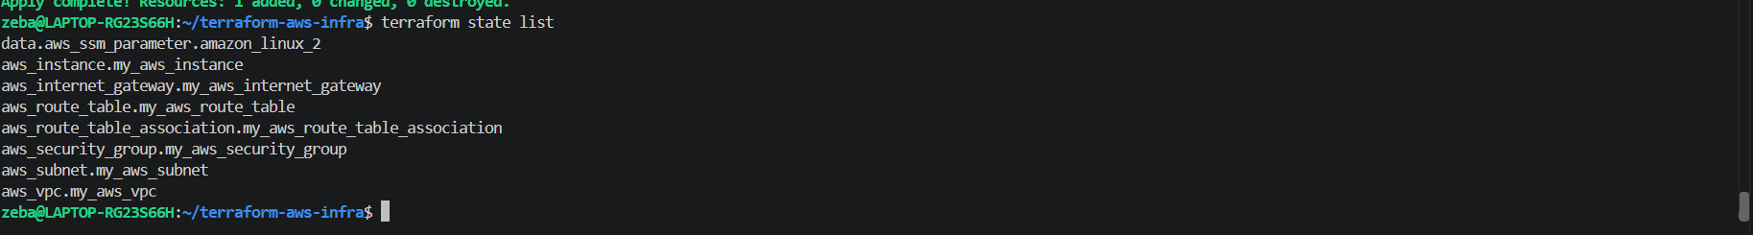
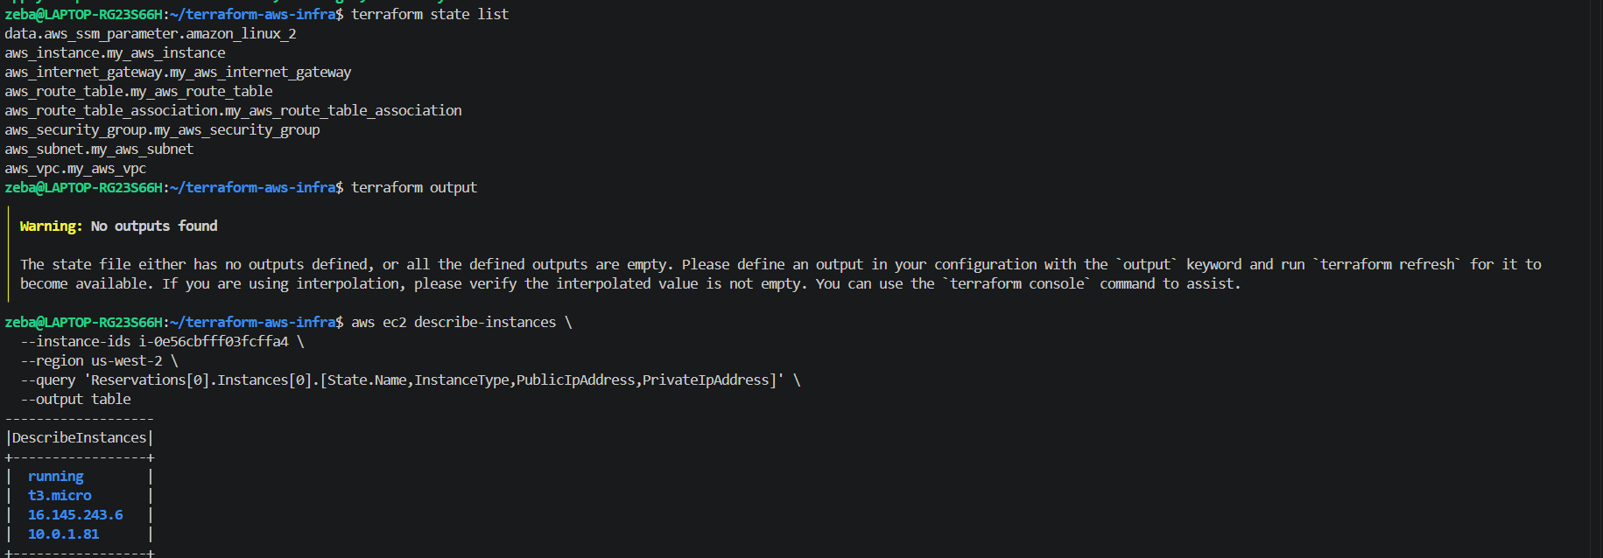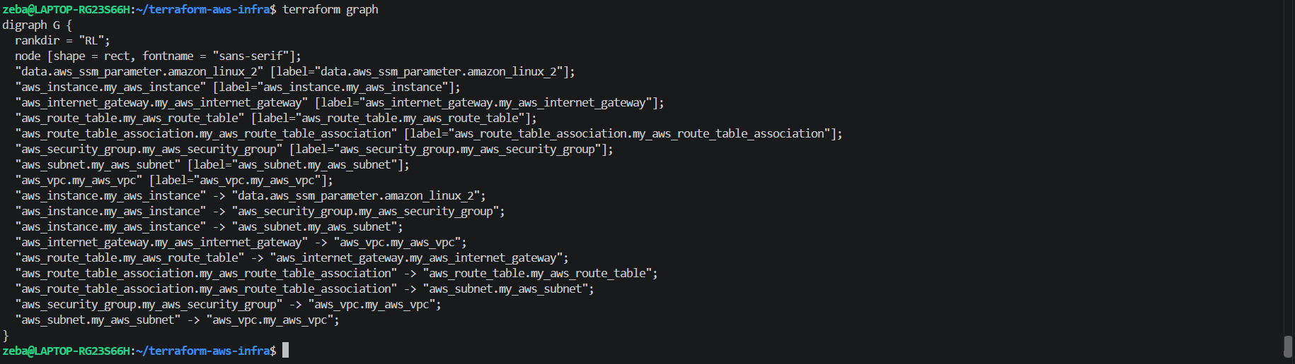
Task 5: Explicit Dependencies with depends_on
Sometimes Terraform cannot detect a dependency automatically.
- Add a second aws_s3_bucket resource for application logs
- Add depends_on = [aws_instance.main] to the S3 bucket -- even though there is no direct reference, you want the bucket created only after the instance
- Run terraform plan and observe the order
Now visualize the entire dependency tree:
terraform graph | dot -Tpng > graph.png
If you don't have dot (Graphviz) installed, use:
terraform graph
and paste the output into an online Graphviz viewer.
Document: When would you use depends_on in real projects? Give two examples.
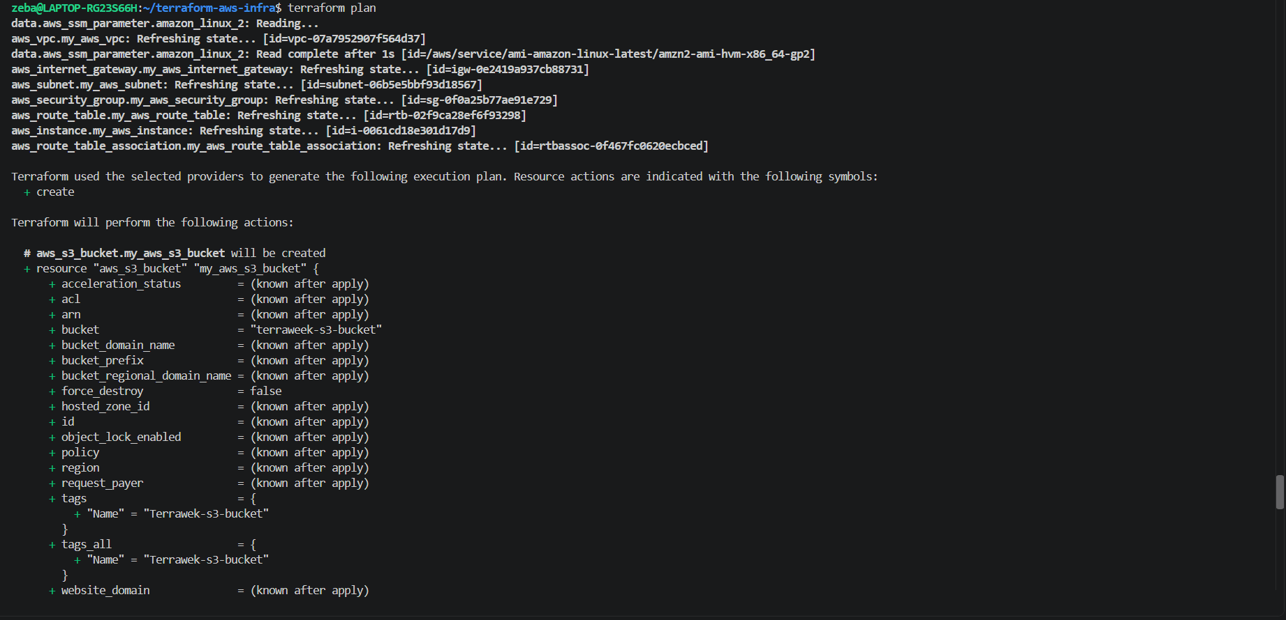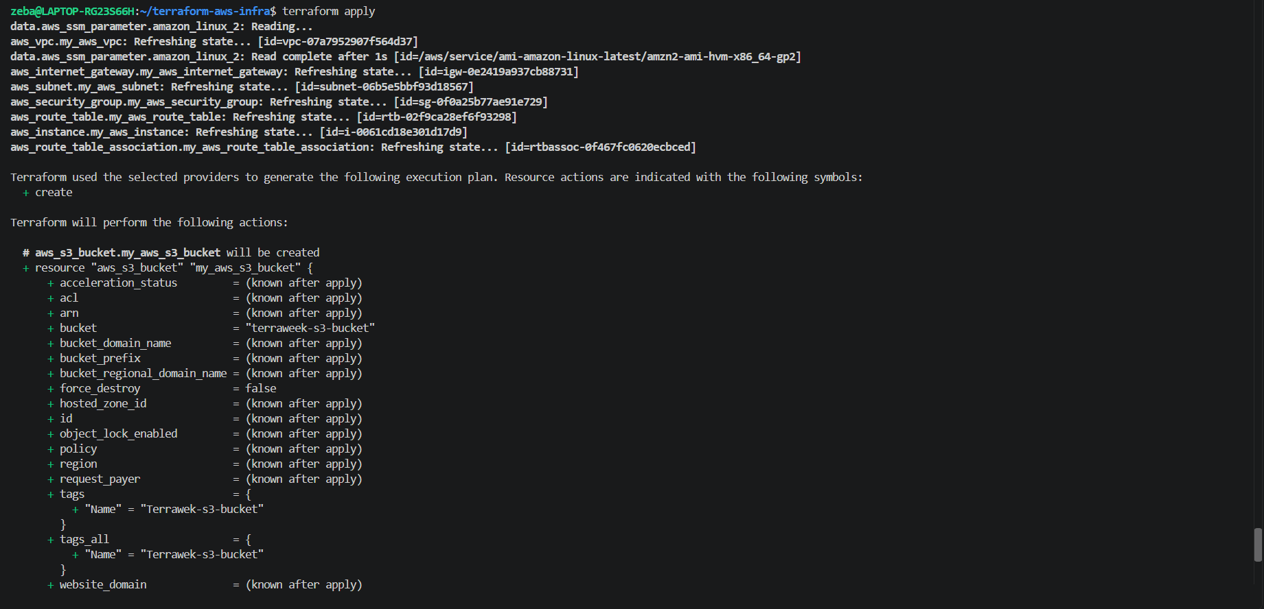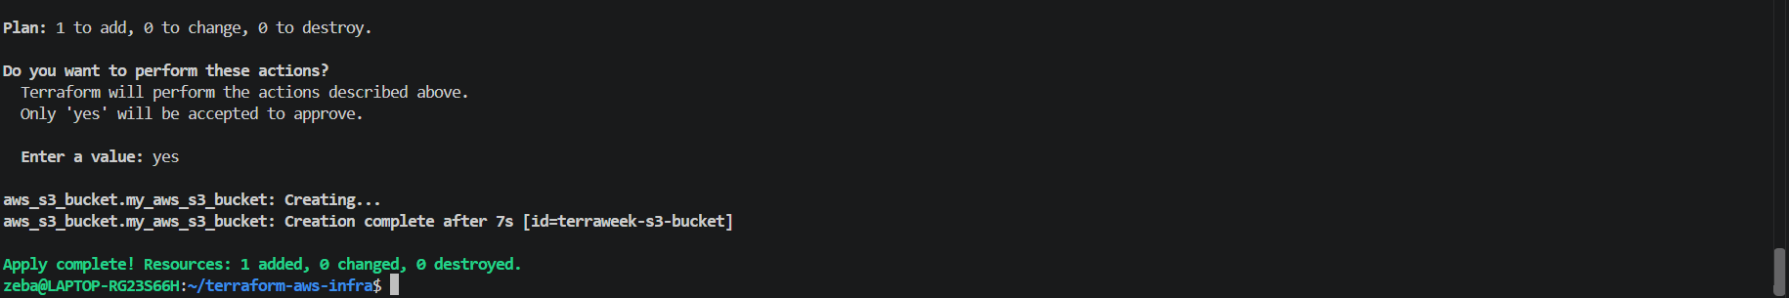
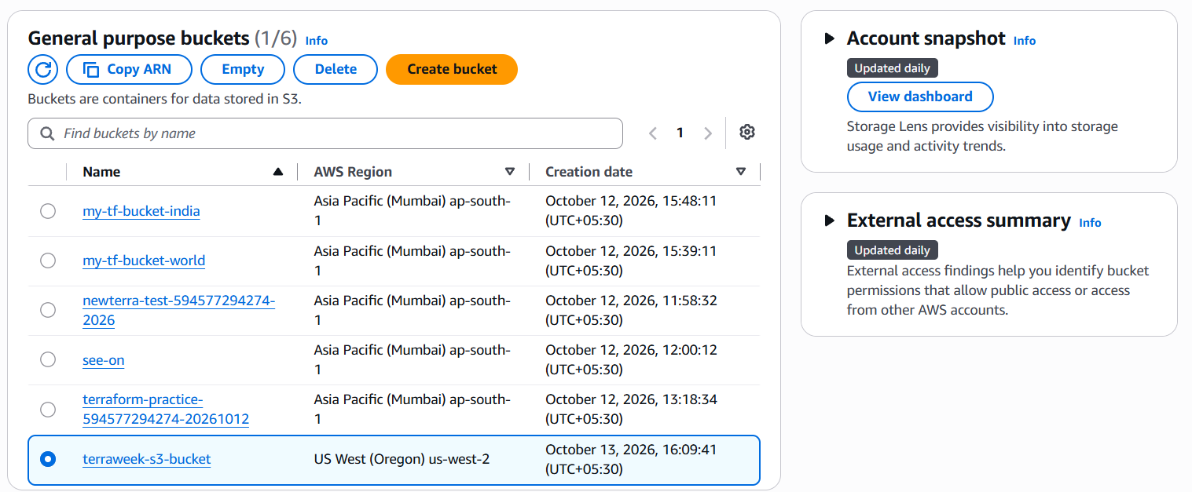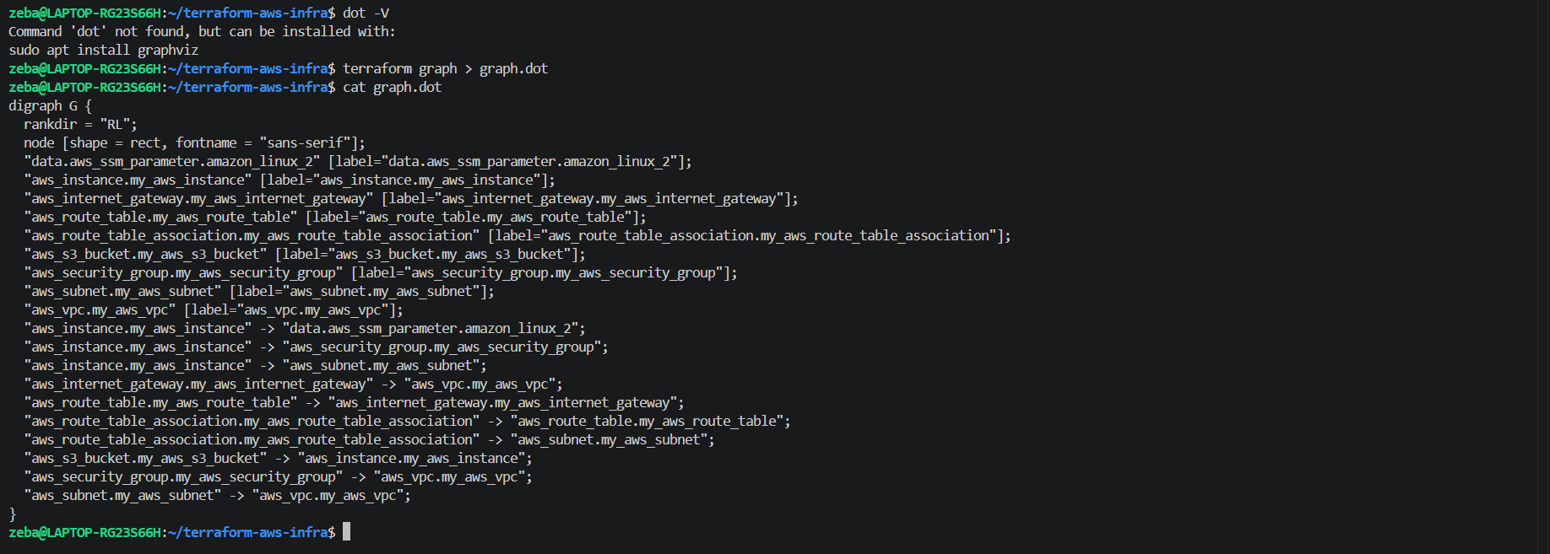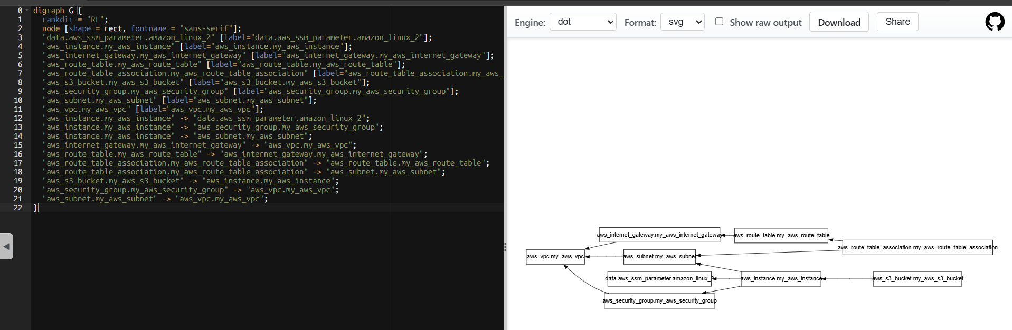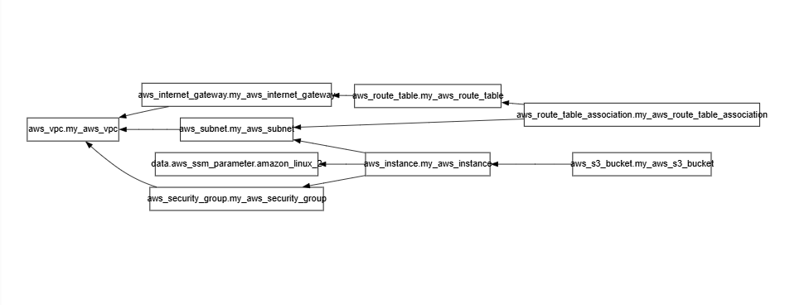
When Would You Use depends_on in Real Projects?
Terraform automatically detects dependencies through resource references. However, sometimes a dependency exists even when one resource does not directly reference another. In such cases, we use depends_on to enforce the correct creation order.
Example 1: Application Setup After Infrastructure Creation
An EC2 instance must be created before a separate resource that configures application logging or monitoring for that instance. If Terraform cannot infer this dependency from resource references, depends_on ensures the EC2 instance is created first.
Example 2: IAM Permissions Before Application Deployment
An application deployment may require specific IAM permissions to be established before it starts. If Terraform cannot automatically detect this dependency, depends_on can ensure the relevant IAM policy or attachment is created before the deployment resource.
Conclusion: Use depends_on only when Terraform cannot automatically determine a necessary dependency. This helps maintain the correct resource creation and destruction order.

Task 6: Lifecycle Rules and Destroy
- Add a lifecycle block to your EC2 instance:
lifecycle {
create_before_destroy = true
}
- Change the AMI ID to a different one and run terraform plan -- observe that Terraform plans to create the new instance before destroying the old one
- Destroy everything:
terraform destroy
- Watch the destroy order -- Terraform destroys in reverse dependency order. Verify in the AWS console that everything is cleaned up.
Document: What are the three lifecycle arguments (create_before_destroy, prevent_destroy, ignore_changes) and when would you use each?
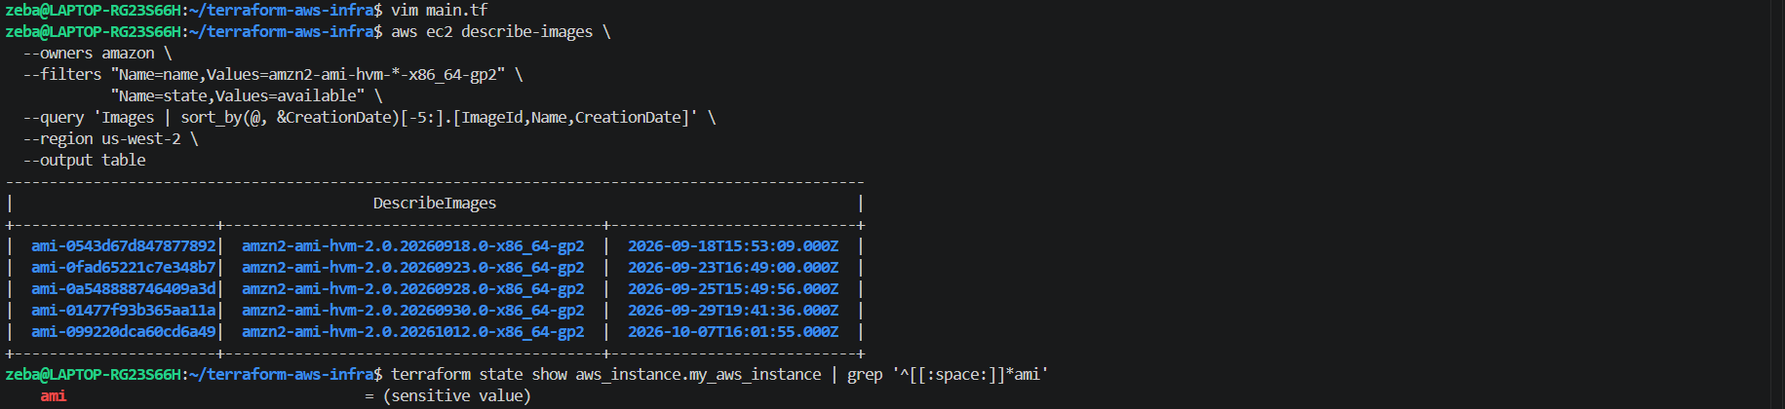
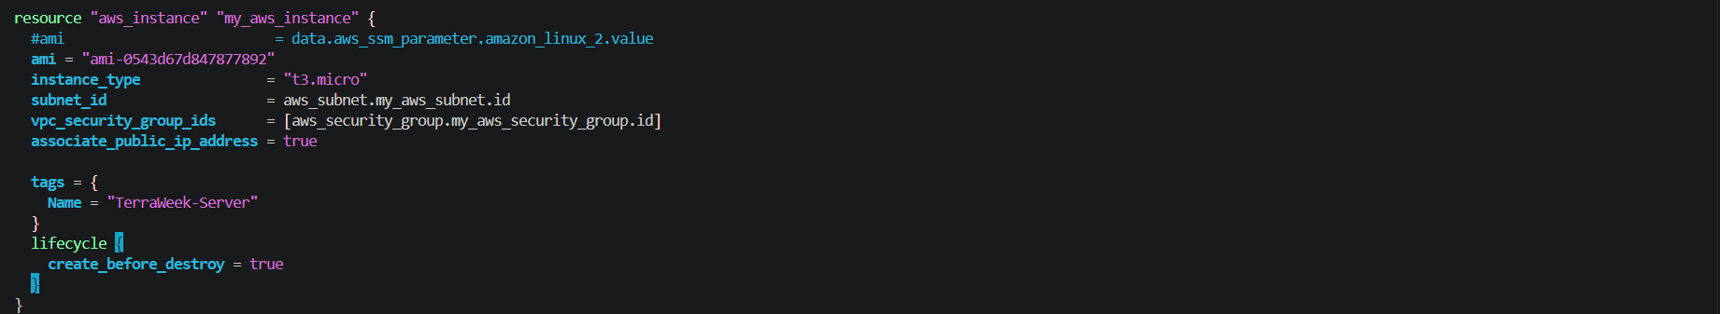

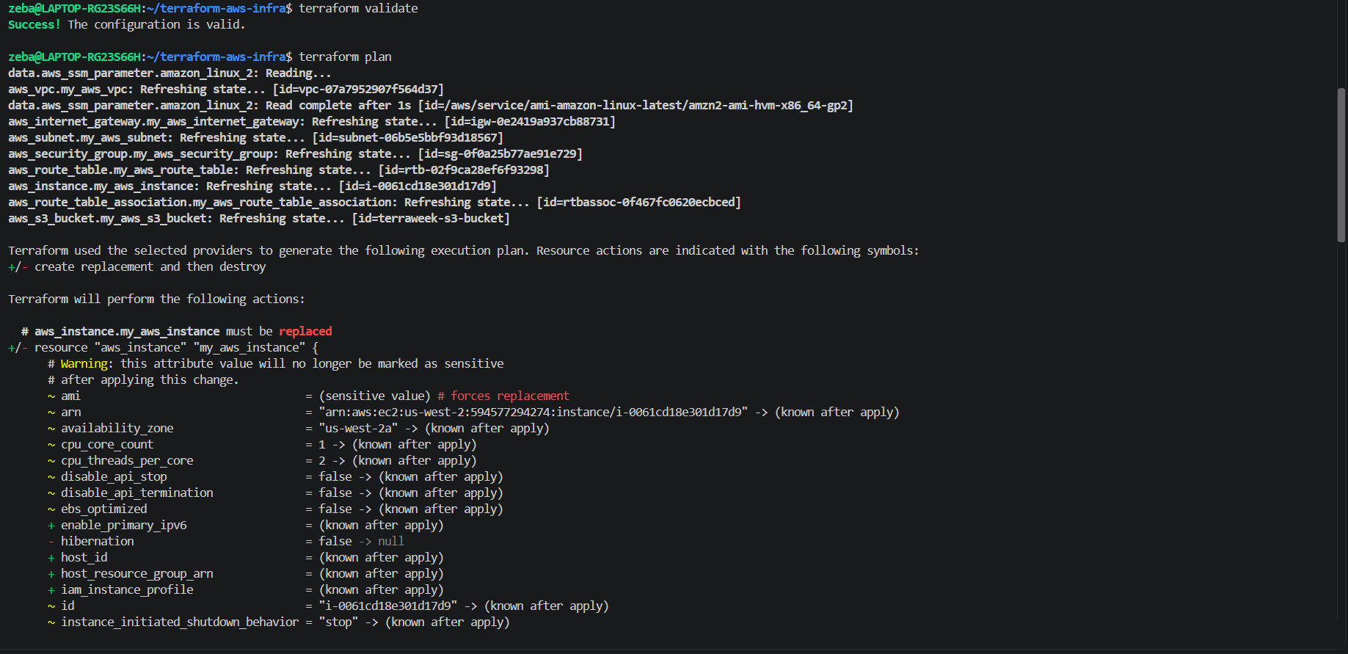
Terraform destroy
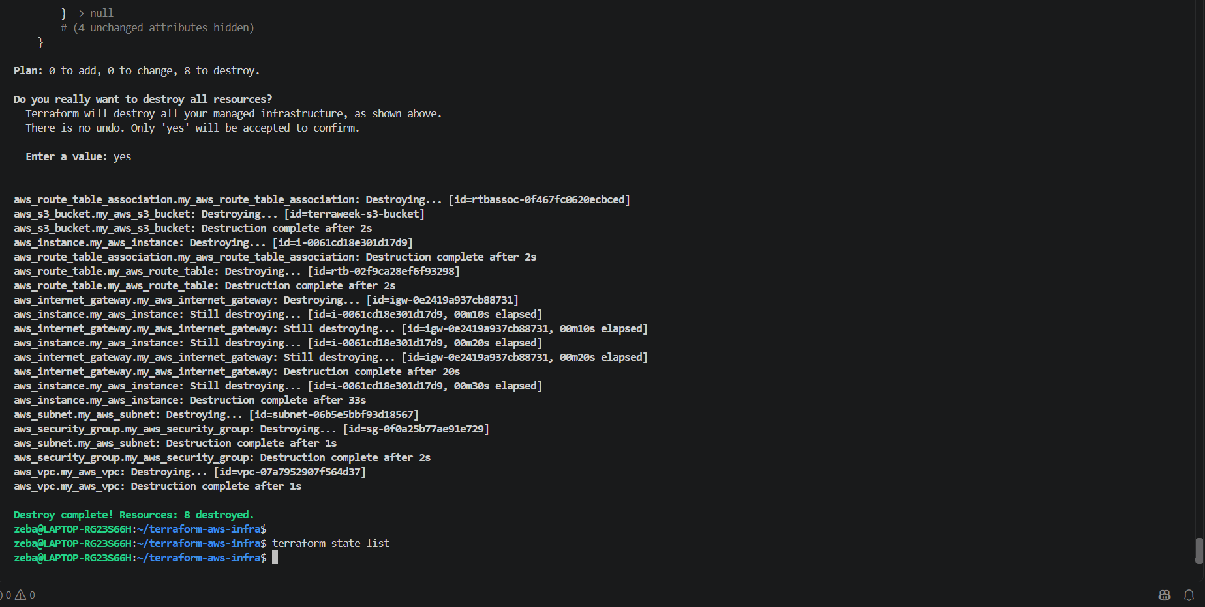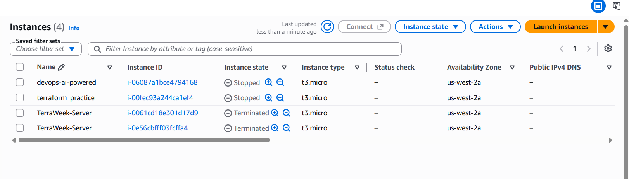

Task 6: Lifecycle Rules and Destroy
1. Destroy Order and Verification
Terraform destroys resources in reverse dependency order. A resource that depends on another resource is generally destroyed first, before the resource it depends on.
Example from this project:
- The S3 bucket is destroyed before the EC2 instance because of depends_on.
- The route table association is destroyed before the subnet and route table.
- The internet gateway and other networking resources are removed before the VPC.
Verification:
- terraform destroy completed successfully with 8 resources destroyed.
- terraform state list returned no managed resources.
- The AWS EC2 console showed both TerraWeek-Server instances in the Terminated state.
The VPC and S3 bucket should also be checked in their respective AWS console pages to confirm complete cleanup.
2. Terraform Lifecycle Arguments
Terraform lifecycle arguments control how Terraform creates, replaces, updates, and protects resources.
A. create_before_destroy
Purpose: Creates a replacement resource before destroying the existing resource.
When to use it: When replacing infrastructure while minimizing service interruption, provided the old and new resources can coexist.
Example:
lifecycle {
create_before_destroy = true
}
Real-world example: Replacing an EC2 instance with one using an updated AMI while keeping the old instance available during provisioning.
B. prevent_destroy
Purpose: Prevents Terraform from planning to destroy a resource while this lifecycle rule remains in its configuration.
When to use it: To protect critical resources from accidental deletion.
Example:
lifecycle {
prevent_destroy = true
}
Real-world example: Protecting a production database against accidental deletion during routine infrastructure changes.
Note: This is not a substitute for backups. Removing the resource configuration can also remove this protection.
C. ignore_changes
Purpose: Tells Terraform to ignore changes to specified resource attributes when planning updates.
When to use it: When selected attributes are intentionally managed by another system or process.
Example:
lifecycle {
ignore_changes = [tags]
}
Real-world example: Allowing an external automation process to manage resource tags without Terraform repeatedly trying to overwrite them.
3. Summary
Lifecycle argument | Main purpose
create_before_destroy | Create a replacement before destroying the existing resource.
prevent_destroy | Prevent planned destruction while the rule remains configured.
ignore_changes | Ignore changes to specified attributes during update planning.
Key learning: Lifecycle rules help control replacement order, protect important resources, and coordinate Terraform with external management systems.

