Task 1: Basic Functions
- Create functions.sh with:
  - A function greet that takes a name as argument and prints Hello, <name>!
  - A function add that takes two numbers and prints their sum
  - Call both functions from the script
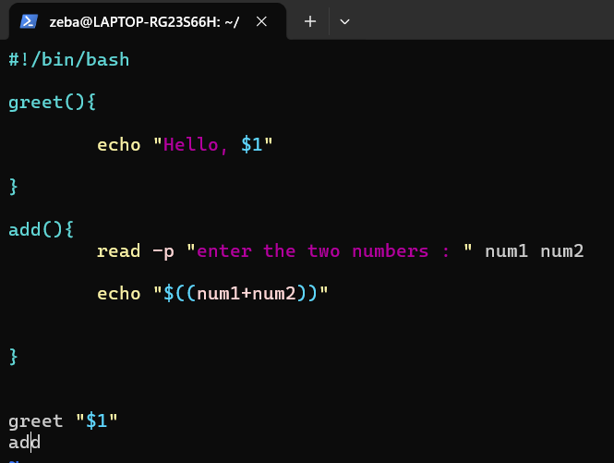
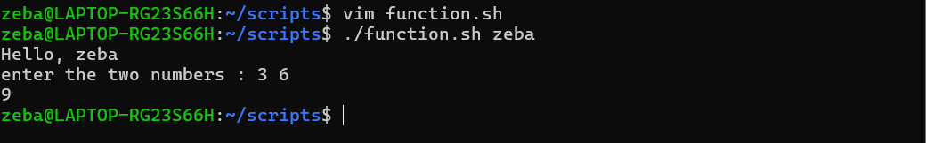

Task 2: Functions with Return Values
- Create disk_check.sh with:
  - A function check_disk that checks disk usage of / using df -h
  - A function check_memory that checks free memory using free -h
  - A main section that calls both and prints the results

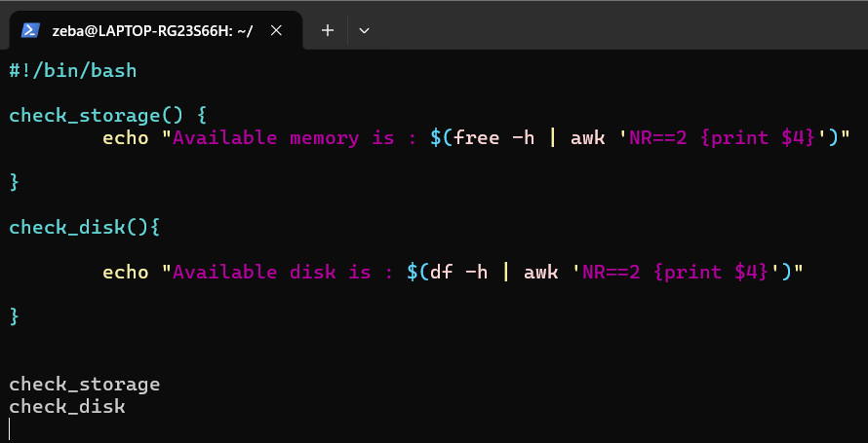
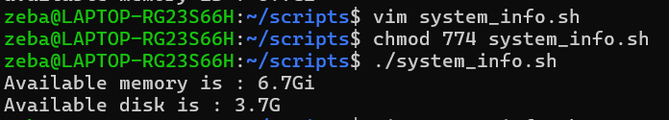

Task 3: Strict Mode — set -euo pipefail
- Create strict_demo.sh with set -euo pipefail at the top
- Try using an undefined variable — what happens with set -u?
- Try a command that fails — what happens with set -e?
- Try a piped command where one part fails — what happens with set -o pipefail?

Document: What does each flag do
- set -e → Exit the script if a command fails.
- set -u → Exit/error if the script tries to use an unset variable.
- set -o pipefail → Makes a pipeline fail if any command in the pipeline fails.

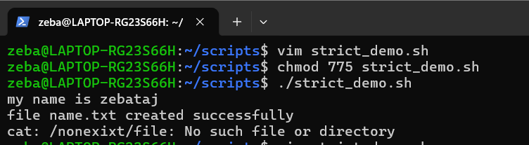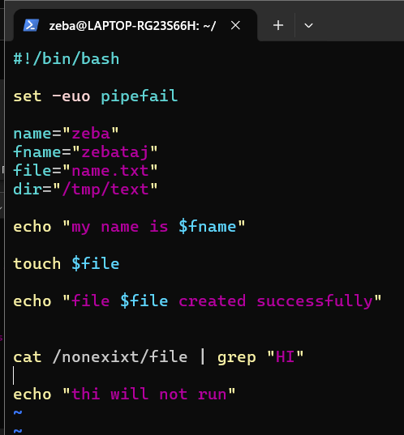

Task 4: Local Variables
- Create local_demo.sh with:
  - A function that uses local keyword for variables
  - Show that local variables don't leak outside the function
  - Compare with a function that uses regular variables
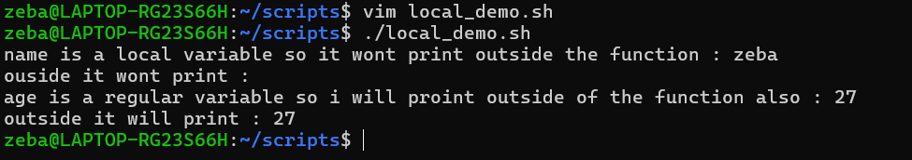
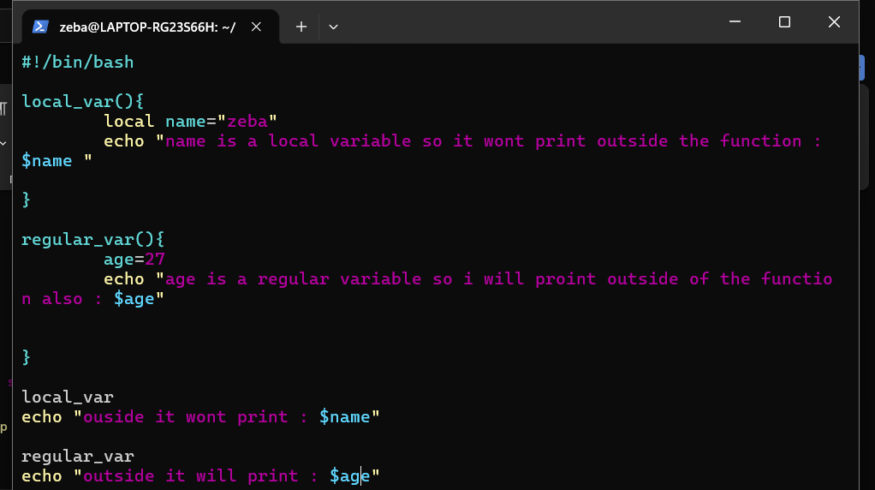

Task 5: Build a Script — System Info Reporter
Create system_info.sh that uses functions for everything:
- A function to print hostname and OS info
- A function to print uptime
- A function to print disk usage (top 5 by size)
- A function to print memory usage
- A function to print top 5 CPU-consuming processes
- A main function that calls all of the above with section headers
- Use set -euo pipefail at the top
Output should look clean and readable.

