Task 1: Understanding Branches
Answer these in your day-23-notes.md:
- What is a branch in Git?
- Why do we use branches instead of committing everything to main?
- What is HEAD in Git?
- What happens to your files when you switch branches?

- What is a branch in Git?
A branch is a separate line of development in Git. It allows me to work on changes independently without directly affecting the ‘main’ branch.
For example:
git branch dev

- Why do we use branches instead of committing everything to main?
Branches allow us to work on new features, fixes, or experiments separately from the stable main branch.
This helps prevent unfinished or incorrect changes from affecting the main code.
main → Stable code
dev → New development

- What is HEAD in Git?
HEAD is a pointer that tells Git where I am currently working.
Usually, HEAD points to the current branch, and that branch points to the latest commit.

- What happens to your files when you switch branches?
It means Git updates the files in your current folder to the versions that belong to the branch you switched to.
Important: Git isn't creating two separate folders. You have one working folder, and Git changes its contents according to the branch you're currently on.
For Example:
main → README.md → "Hello Git"
dev → README.md → "Hello Git - I'm learning branching"

Task 2: Branching Commands — Hands-On
In your devops-git-practice repo, perform the following:
- List all branches in your repo
- Create a new branch called feature-1
- Switch to feature-1
- Create a new branch and switch to it in a single command — call it feature-2
- Try using git switch to move between branches — how is it different from git checkout?
- Make a commit on feature-1 that does not exist on main
- Switch back to main — verify that the commit from feature-1 is not there
- Delete a branch you no longer need
- Add all branching commands to your git-commands.md
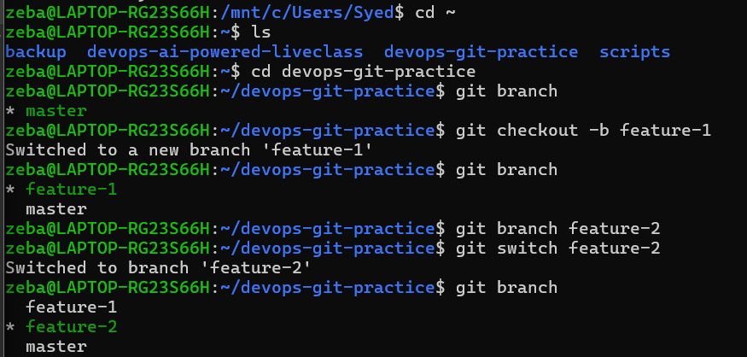 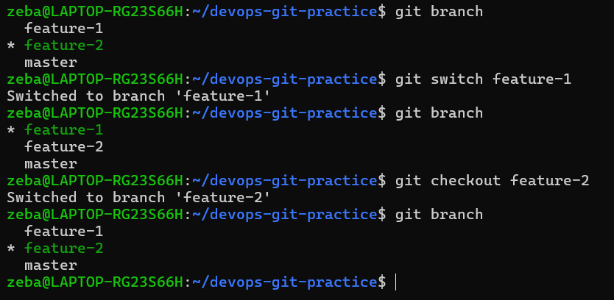 git checkout can do more than branch switching—it can also be used for restoring files and other operations. git switch was introduced to make branch-related operations clearer.
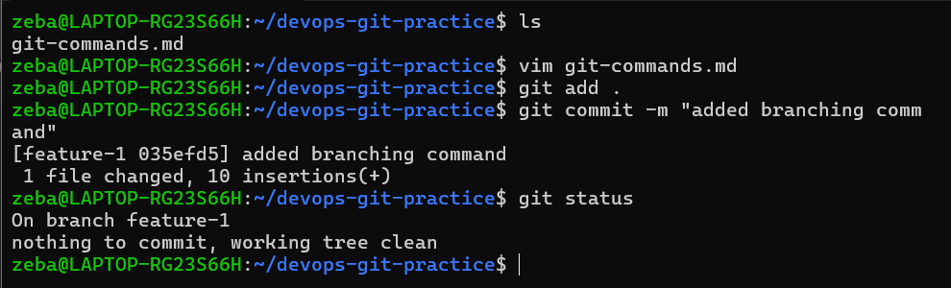
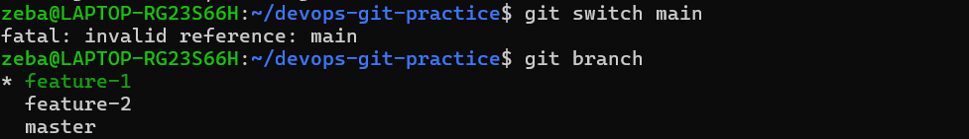 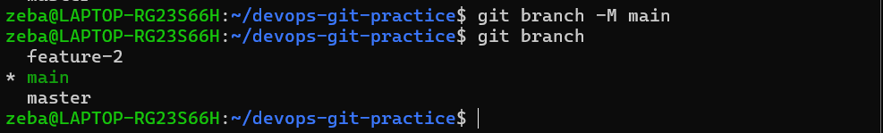instead of main branch it was master so we changed the name to main by using command (remaning)
git branch -M main 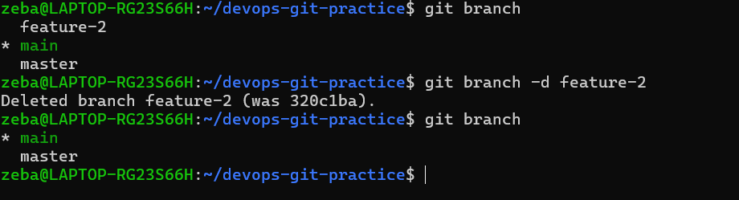 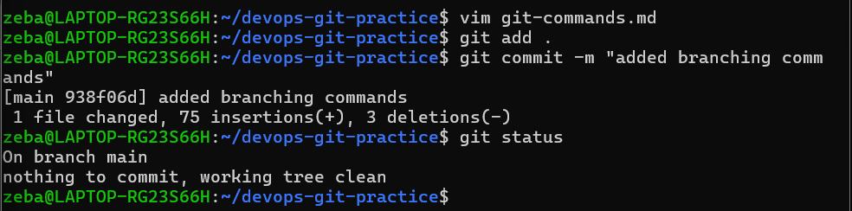

Task 3: Push to GitHub
- Create a new repository on GitHub (do NOT initialize it with a README)
- Connect your local devops-git-practice repo to the GitHub remote
- Push your main branch to GitHub
- Push feature-1 branch to GitHub
- Verify both branches are visible on GitHub
- Answer in your notes: What is the difference between origin and upstream?

Created repo in github and connected to my local(main)
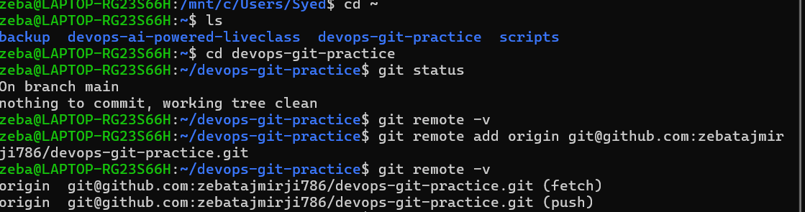
Pushed branches in origin
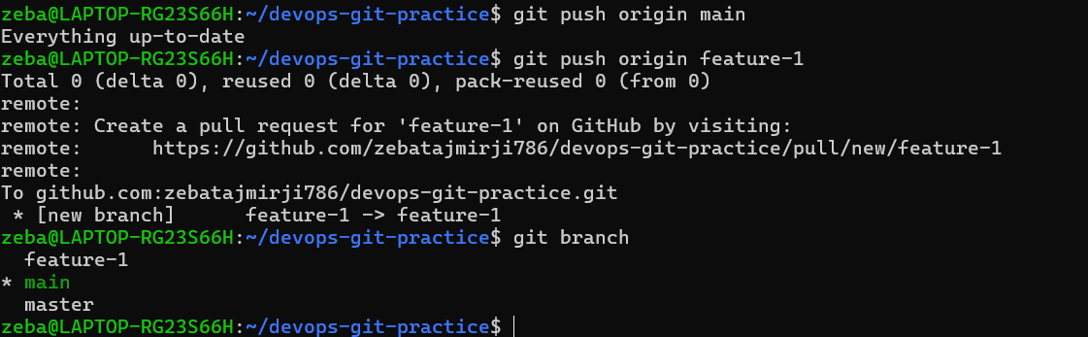
Verified main and feature-1 branches got push successfully
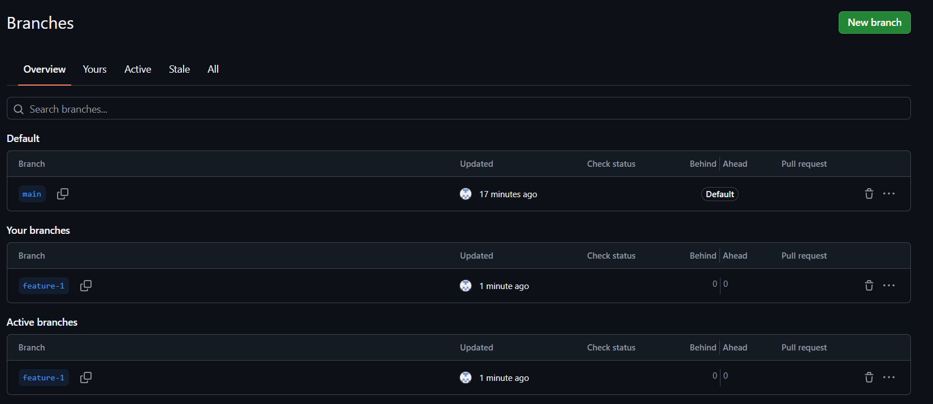

Answer in your notes: What is the difference between origin and upstream?
Origin: is the name of our github repository, your GitHub repository/fork
Where I push my work
Upstream: is the our original/main repository, the original repository
Where I get the original project's updates
Simple difference
 | origin | upstream
Meaning | Your remote repository | Original remote repository
Common use | Push your work | Get updates from original project
Example | git push origin main | git pull upstream main
Automatically created? | Usually yes | Usually no

Task 4: Pull from GitHub
- Make a change to a file directly on GitHub (use the GitHub editor)
- Pull that change to your local repo
- Answer in your notes: What is the difference between git fetch and git pull?
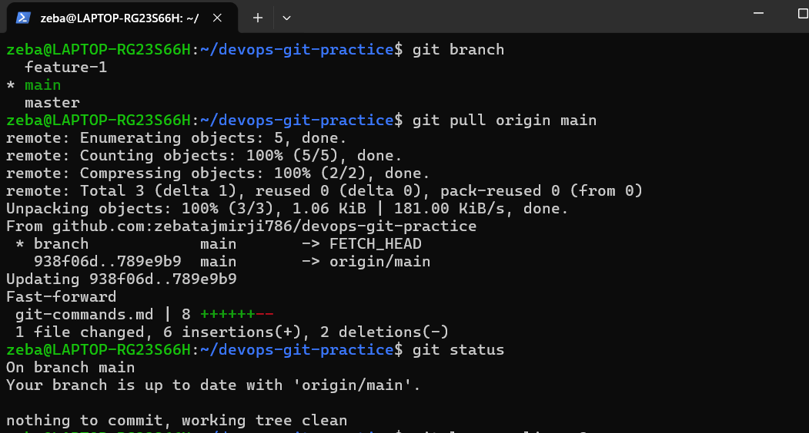
git fetch only downloads remote changes without modifying your local working files, whereas git pull downloads those changes and immediately merges them into your current branch

Task 5: Clone vs Fork
- Clone any public repository from GitHub to your local machine
- Fork the same repository on GitHub, then clone your fork
- Answer in your notes:
  - What is the difference between clone and fork?
  - When would you clone vs fork?
  - After forking, how do you keep your fork in sync with the original repo?

- Clone any public repository from GitHub to your local machine
Public repository (github docs): https://github.com/octocat/Spoon-Knife
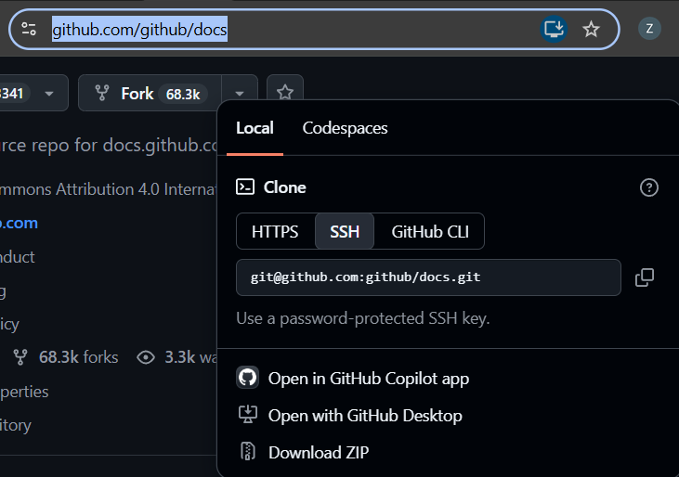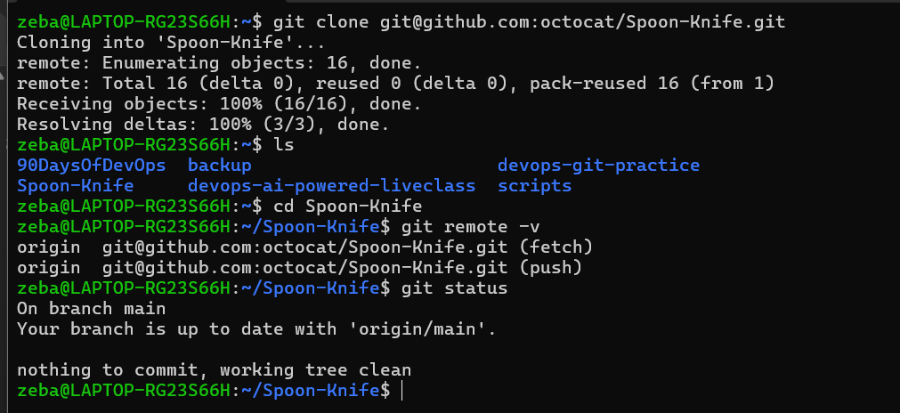
- Fork the same repository on GitHub, then clone your fork
Click on fork then create fork
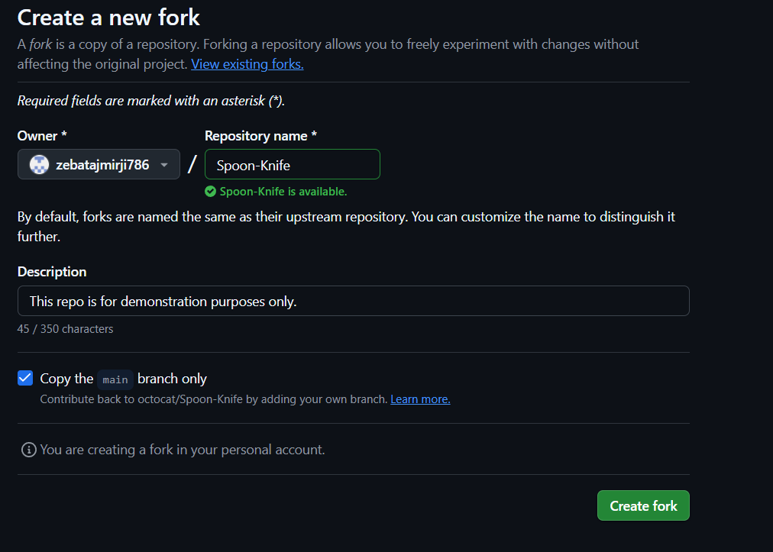
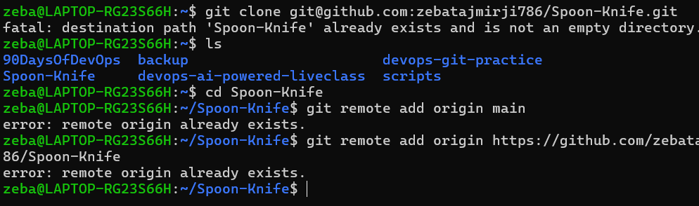
Now I have connected to my remore
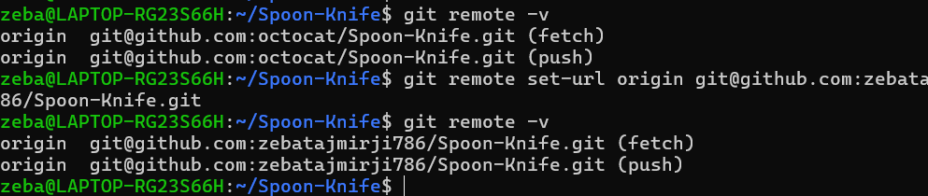
- Answer in your notes:
  - What is the difference between clone and fork?
  - When would you clone vs fork?
  - After forking, how do you keep your fork in sync with the original repo?

What is the difference between clone and fork?
3rd repository (github) -> local = cloning
3rd repository (github) -> remote(my github) = forking

Clone: Copies a GitHub repository from GitHub to my local machine so I can work with it locally.
Fork: Creates my own copy of another person's GitHub repository under my GitHub account.

Example:
- Clone:
GitHub Repository
↓
My Local Machine

- Fork:
Other Person's GitHub Repository
↓
My GitHub Account

2. When would you clone vs fork?
Clone: I would clone a repository when I want to get a local copy of a repository for studying, using, or working on it, and I already have the required access.
Fork: I would fork a repository when I want my own GitHub copy of someone else's repository, especially when I don't have permission to push directly to the original repository.

