Day 58 – Metrics Server and Horizontal Pod Autoscaler (HPA)

Task 1: Install the Metrics Server
- Check if it is already running: kubectl get pods -n kube-system | grep metrics-server
- If not, install it:
  - Minikube: minikube addons enable metrics-server
  - Kind/kubeadm: apply the official manifest from the metrics-server GitHub releases
- On local clusters, you may need the --kubelet-insecure-tls flag (never in production)
- Wait 60 seconds, then verify: kubectl top nodes and kubectl top pods -A
Verify: What is the current CPU and memory usage of your node?
The URL you pasted is the official Metrics Server manifest:
https://github.com/kubernetes-sigs/metrics-server/releases/latest/download/components.yaml

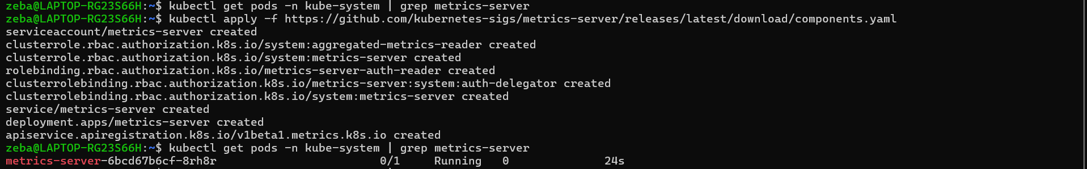
Matrix server installed

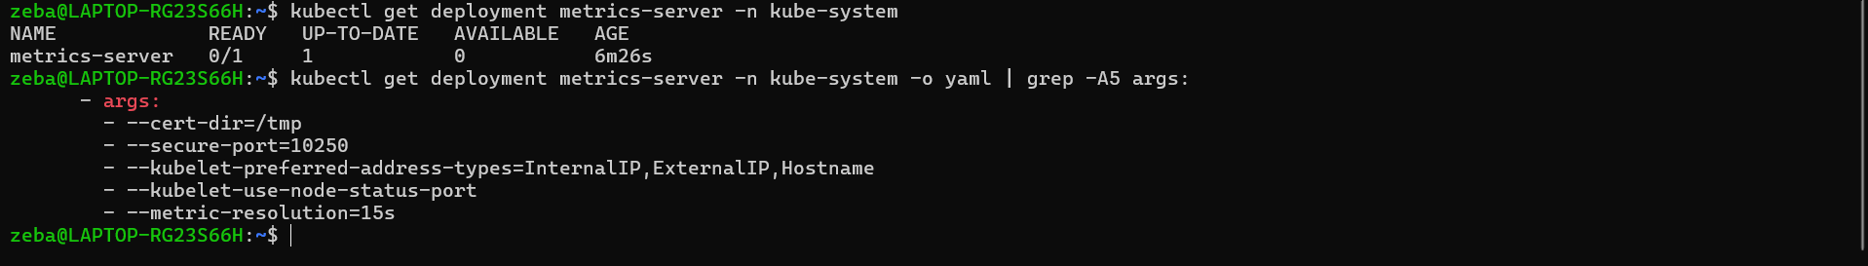
--kubelet-insecure-tls is not present

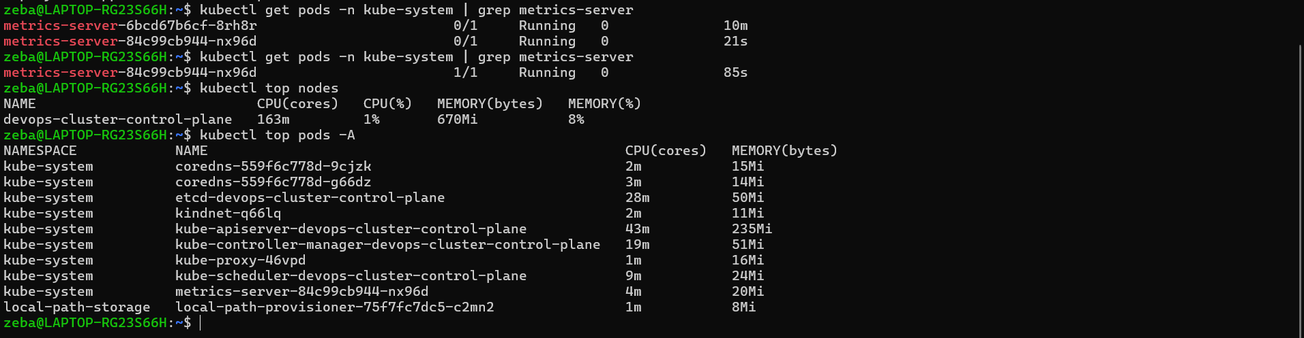

Resource | Current usage
CPU | 163m
CPU percentage | 1%
Memory | 670 MiB
Memory percentage | 8%

Task 2: Explore kubectl top
- Run kubectl top nodes, kubectl top pods -A, kubectl top pods -A --sort-by=cpu
- kubectl top shows real-time usage, not requests or limits — these are different things
- Data comes from the Metrics Server, which polls kubelets every 15 seconds
Verify: Which pod is using the most CPU right now?
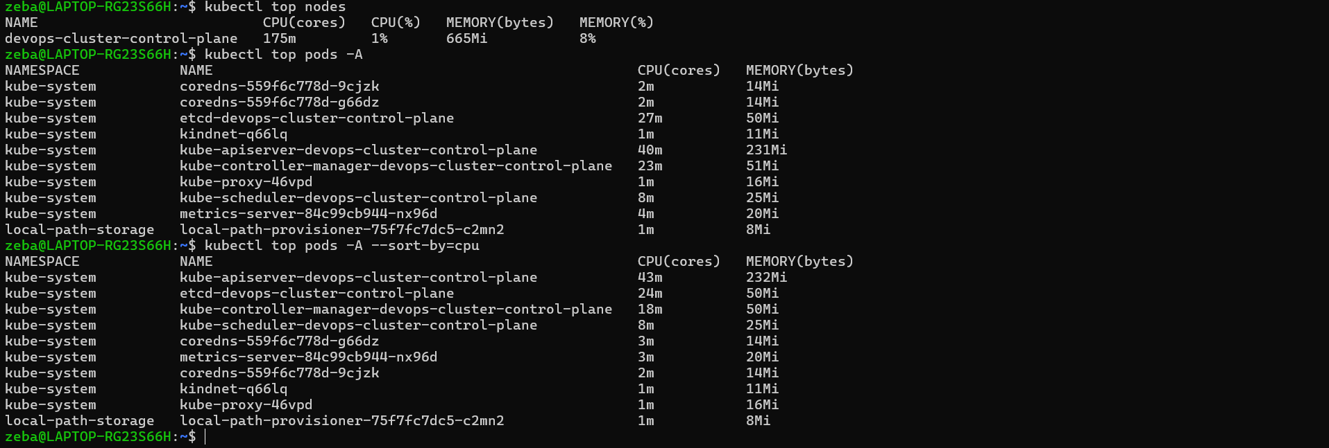
Task 3: Create a Deployment with CPU Requests
- Write a Deployment manifest using the registry.k8s.io/hpa-example image (a CPU-intensive PHP-Apache server)
- Set resources.requests.cpu: 200m — HPA needs this to calculate utilization percentages
- Expose it as a Service: kubectl expose deployment php-apache --port=80
Without CPU requests, HPA cannot work — this is the most common HPA setup mistake.
Verify: What is the current CPU usage of the Pod?
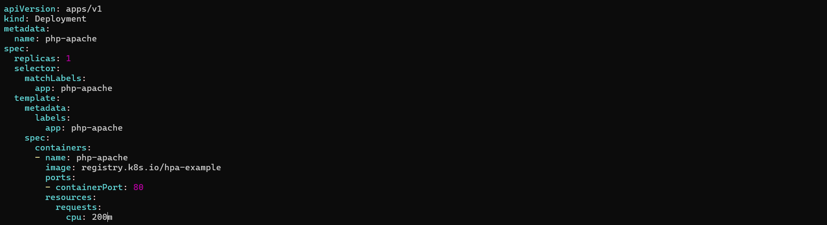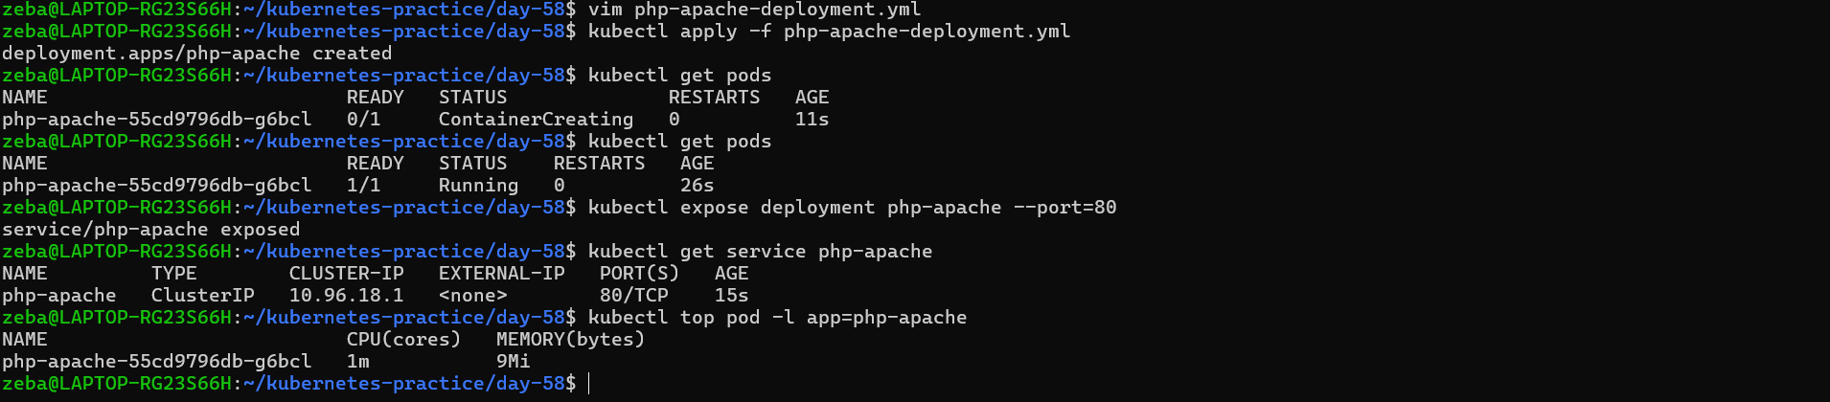
Task 4: Create an HPA (Imperative)
- Run: kubectl autoscale deployment php-apache --cpu-percent=50 --min=1 --max=10
- Check: kubectl get hpa and kubectl describe hpa php-apache
- TARGETS may show <unknown> initially — wait 30 seconds for metrics to arrive
This scales up when average CPU exceeds 50% of requests, and down when it drops below.
Verify: What does the TARGETS column show?

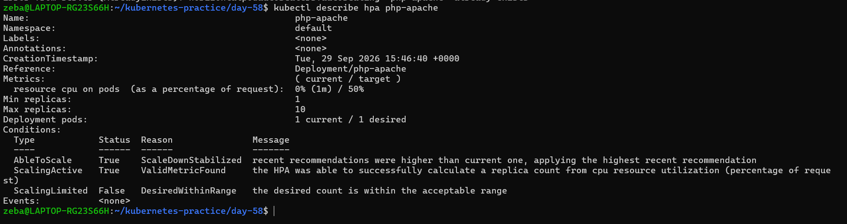

Task 5: Generate Load and Watch Autoscaling
- Start a load generator: kubectl run load-generator --image=busybox:1.36 --restart=Never -- /bin/sh -c "while true; do wget -q -O- http://php-apache; done"
- Watch HPA: kubectl get hpa php-apache --watch
- Over 1-3 minutes, CPU climbs above 50%, replicas increase, CPU stabilizes
- Stop the load: kubectl delete pod load-generator
- Scale-down is slow (5-minute stabilization window) — you do not need to wait
Verify: How many replicas did HPA scale to under load?
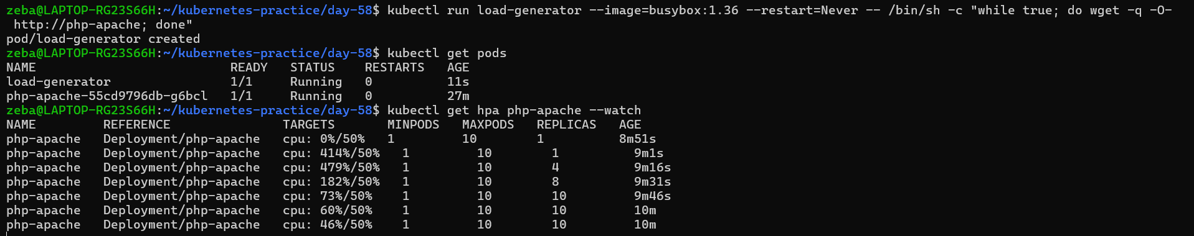
Load is increasing
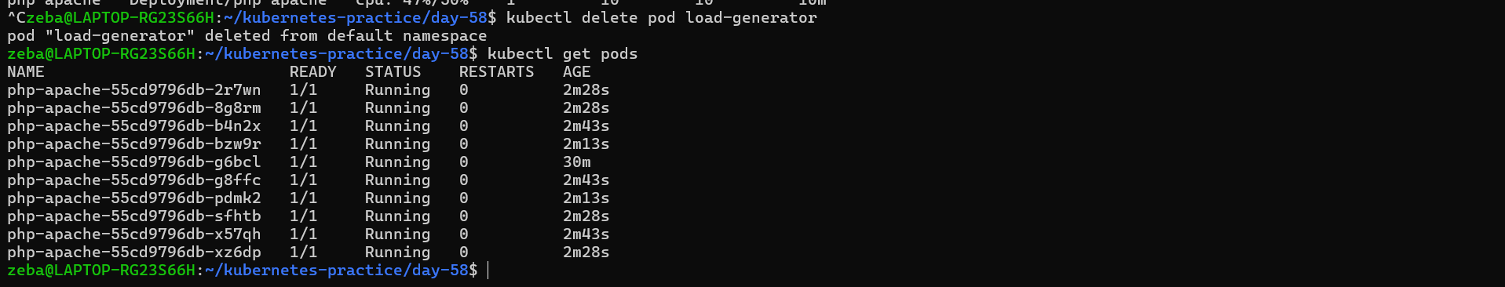
When load increased pods got auto scaled and now we have 10 pods

Task 6: Create an HPA from YAML (Declarative)
- Delete the imperative HPA: kubectl delete hpa php-apache
- Write an HPA manifest using autoscaling/v2 API with CPU target at 50% utilization
- Add a behavior section to control scale-up speed (no stabilization) and scale-down speed (300 second window)
- Apply and verify with kubectl describe hpa
autoscaling/v2 supports multiple metrics and fine-grained scaling behavior that the imperative command cannot configure.
Verify: What does the behavior section control?
Hpa deleted
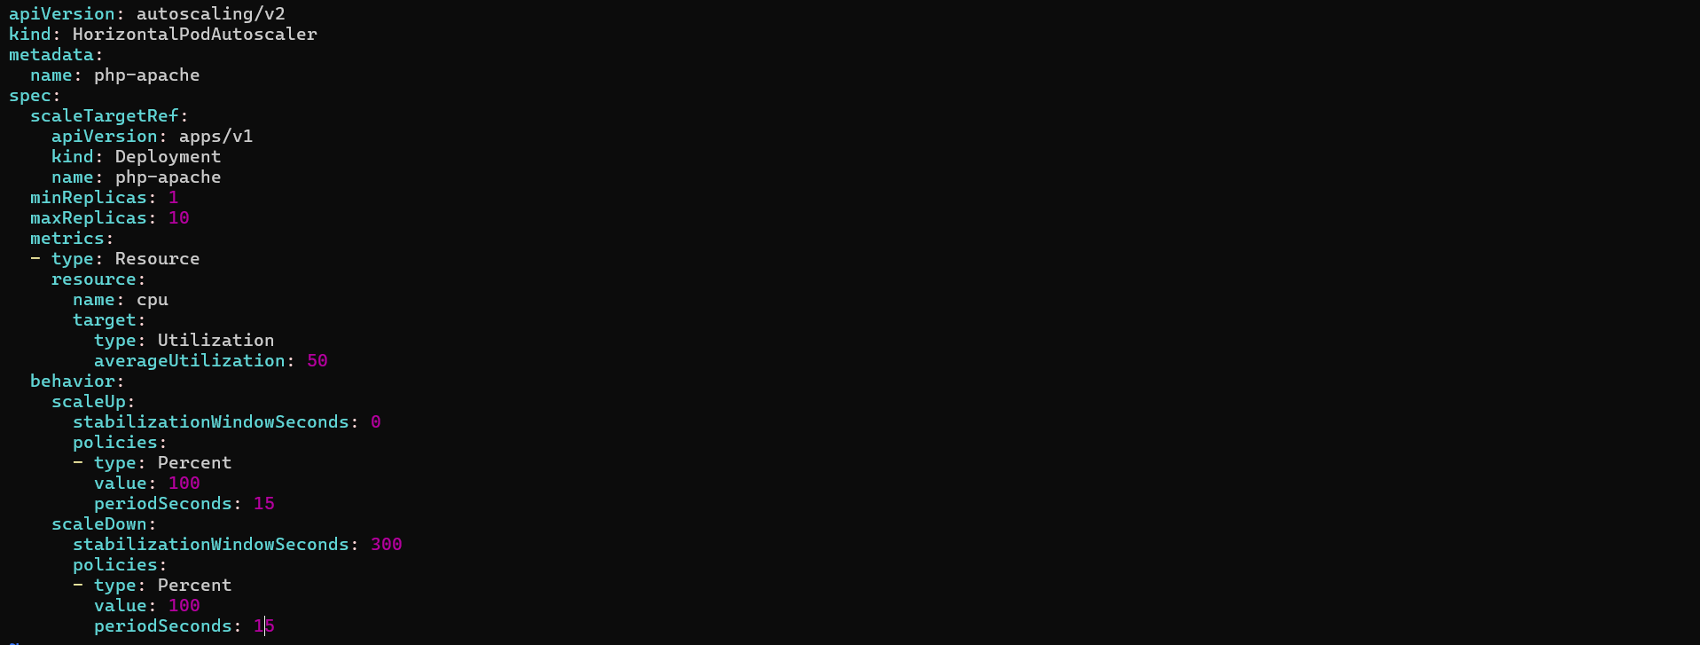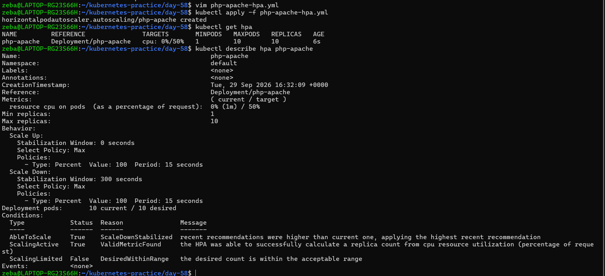
The behavior section controls how quickly the HPA scales up or down. In this configuration, scale-up has a 0-second stabilization window, while scale-down uses a 300-second (5-minute) stabilization window.

