Day 65 -- Terraform Modules: Build Reusable Infrastructure

Task 1: Understand Module Structure
A Terraform module is just a directory with .tf files. Create this structure:
terraform-modules/
main.tf # Root module -- calls child modules
variables.tf # Root variables
outputs.tf # Root outputs
providers.tf # Provider config
modules/
ec2-instance/
main.tf # EC2 resource definition
variables.tf # Module inputs
outputs.tf # Module outputs
security-group/
main.tf # Security group resource definition
variables.tf # Module inputs
outputs.tf # Module outputs
Create all the directories and empty files. This is the standard layout every Terraform project follows.
Document: What is the difference between a "root module" and a "child module"?
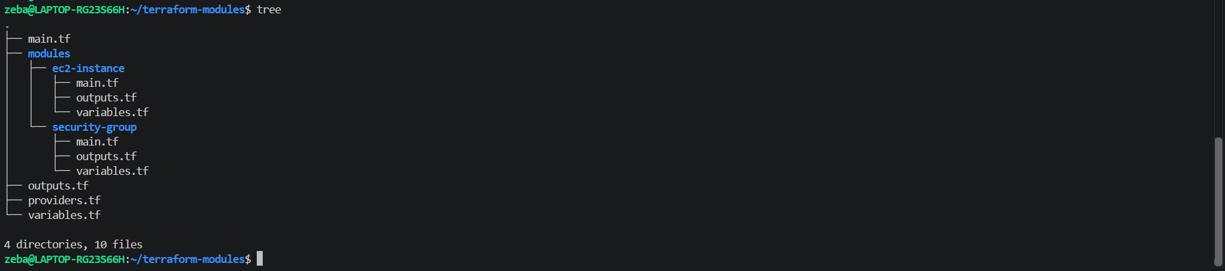
Module structure created

Day 65 — Task 1: Understand Module Structure
What is a root module?
The root module is the main Terraform working directory where you run commands such as terraform init, terraform plan, and terraform apply. It contains the main configuration and calls child modules to create reusable infrastructure components.
What is a child module?
A child module is a separate directory containing Terraform configuration files that define a specific set of resources. The root module calls it using a module block and passes input variables to configure it.
Example from this project:
- Root module: terraform-modules/
- Child module 1: terraform-modules/modules/ec2-instance/
- Child module 2: terraform-modules/modules/security-group/
Key difference: The root module coordinates the overall infrastructure, while child modules organize reusable components that the root module can call.
Conclusion: Terraform modules make infrastructure configuration more reusable, organized, and maintainable.
Task 2: Build a Custom EC2 Module
Create modules/ec2-instance/:
- variables.tf -- define inputs:
  - ami_id (string)
  - instance_type (string, default: "t2.micro")
  - subnet_id (string)
  - security_group_ids (list of strings)
  - instance_name (string)
  - tags (map of strings, default: {})
- main.tf -- define the resource:
  - aws_instance using all the variables
  - Merge the Name tag with additional tags
- outputs.tf -- expose:
  - instance_id
  - public_ip
  - private_ip
Do NOT apply yet -- just write the module.

modules/ec2-instance/variables.tf
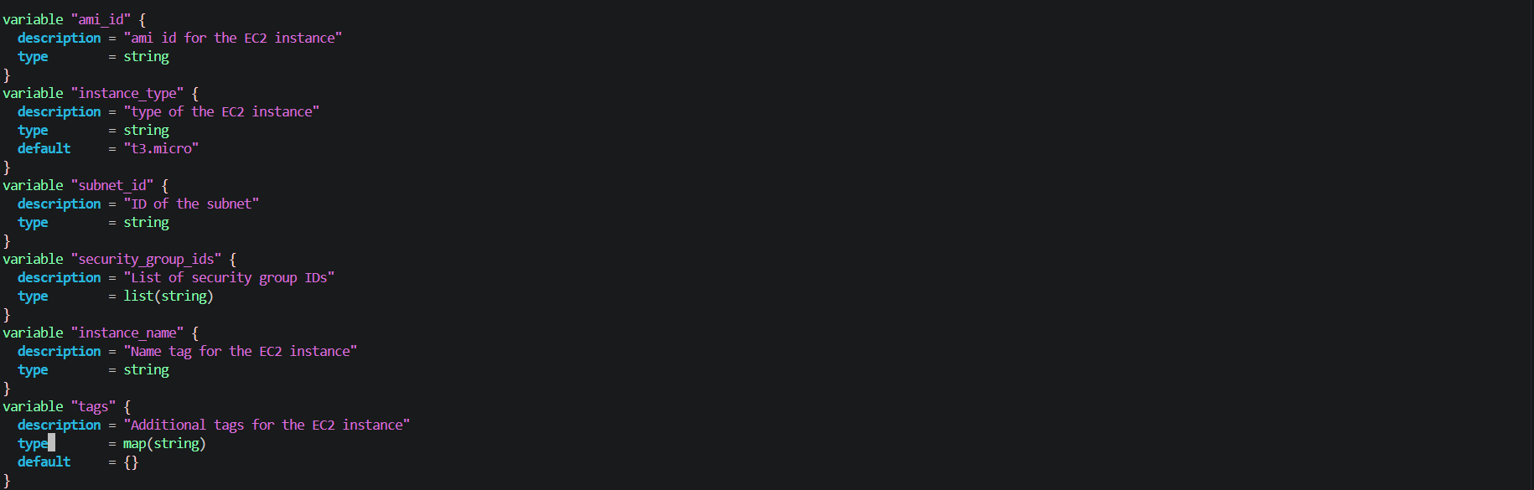
modules/ec2-instance/main.tf
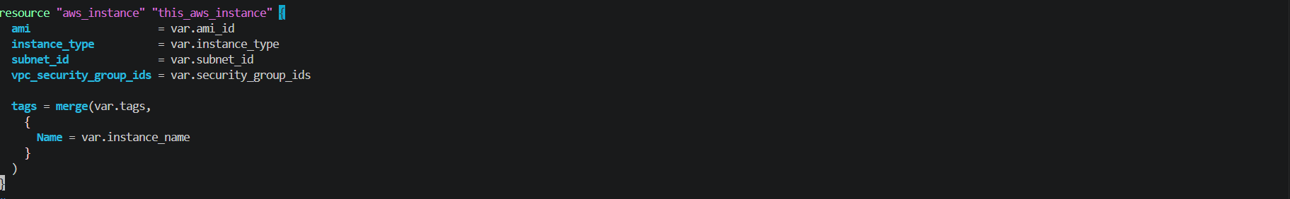
modules/ec2-instance/output.tf
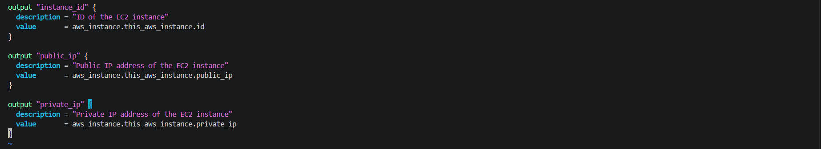
Task 3: Build a Custom Security Group Module
Create modules/security-group/:
- variables.tf -- define inputs:
  - vpc_id (string)
  - sg_name (string)
  - ingress_ports (list of numbers, default: [22, 80])
  - tags (map of strings, default: {})
- main.tf -- define the resource:
  - aws_security_group in the given VPC
  - Use dynamic "ingress" block to create rules from the ingress_ports list
  - Allow all egress
- outputs.tf -- expose:
  - sg_id
This is your first time using a dynamic block -- it loops over a list to generate repeated nested blocks.

modules/security-group/variables.tf 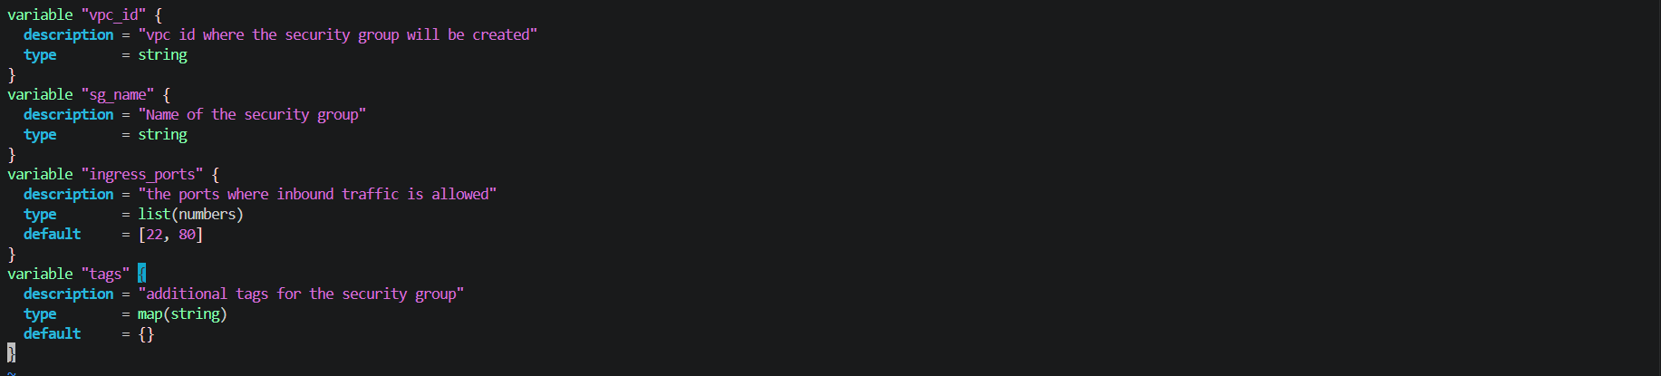
modules/security-group/main.tf
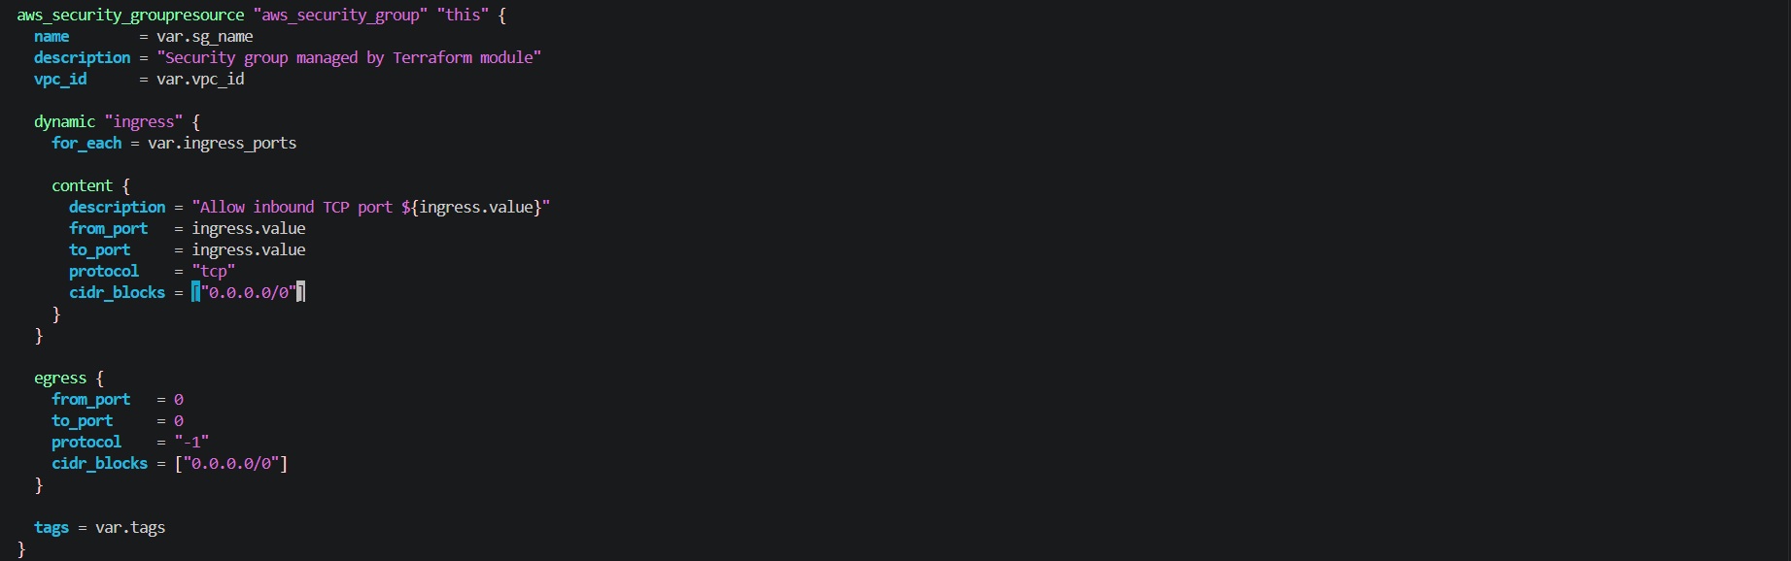
modules/security-group/outputs.tf
Task 4: Call Your Modules from Root
In the root main.tf, wire everything together:
- Create a VPC and subnet directly (or reuse your Day 62 config)
- Call the security group module:
module "web_sg" {
source = "./modules/security-group"
vpc_id = aws_vpc.main.id
sg_name = "terraweek-web-sg"
ingress_ports = [22, 80, 443]
tags = local.common_tags
}
- Call the EC2 module -- deploy two instances with different names using the same module:
module "web_server" {
source = "./modules/ec2-instance"
ami_id = data.aws_ami.amazon_linux.id
instance_type = "t2.micro"
subnet_id = aws_subnet.public.id
security_group_ids = [module.web_sg.sg_id]
instance_name = "terraweek-web"
tags = local.common_tags
}

module "api_server" {
source = "./modules/ec2-instance"
ami_id = data.aws_ami.amazon_linux.id
instance_type = "t2.micro"
subnet_id = aws_subnet.public.id
security_group_ids = [module.web_sg.sg_id]
instance_name = "terraweek-api"
tags = local.common_tags
}
- Add root outputs that reference module outputs:
output "web_server_ip" {
value = module.web_server.public_ip
}

output "api_server_ip" {
value = module.api_server.public_ip
}
- Apply:
terraform init # Downloads/links the local modules
terraform plan # Should show all resources from both module calls
terraform apply
Verify: Two EC2 instances running, same security group, different names. Check the AWS console.

terraform-modules/providers.tf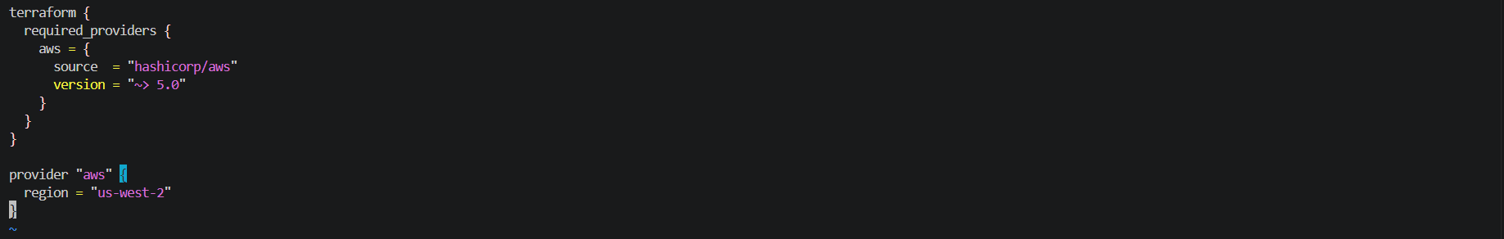
terraform-modules/main.tf
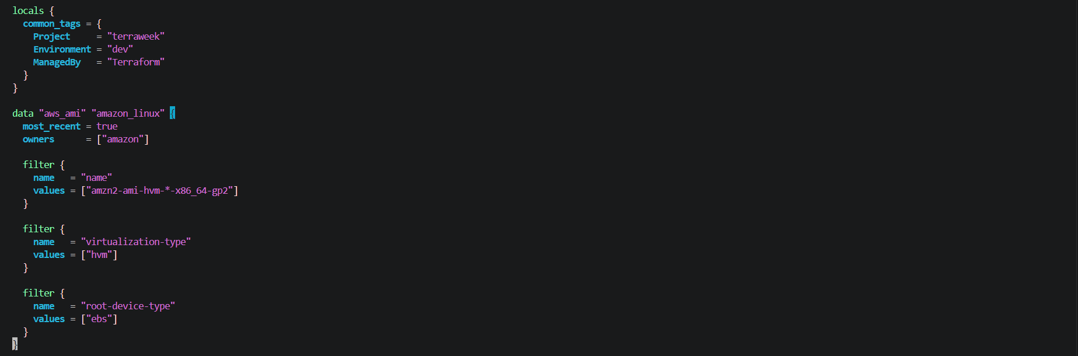
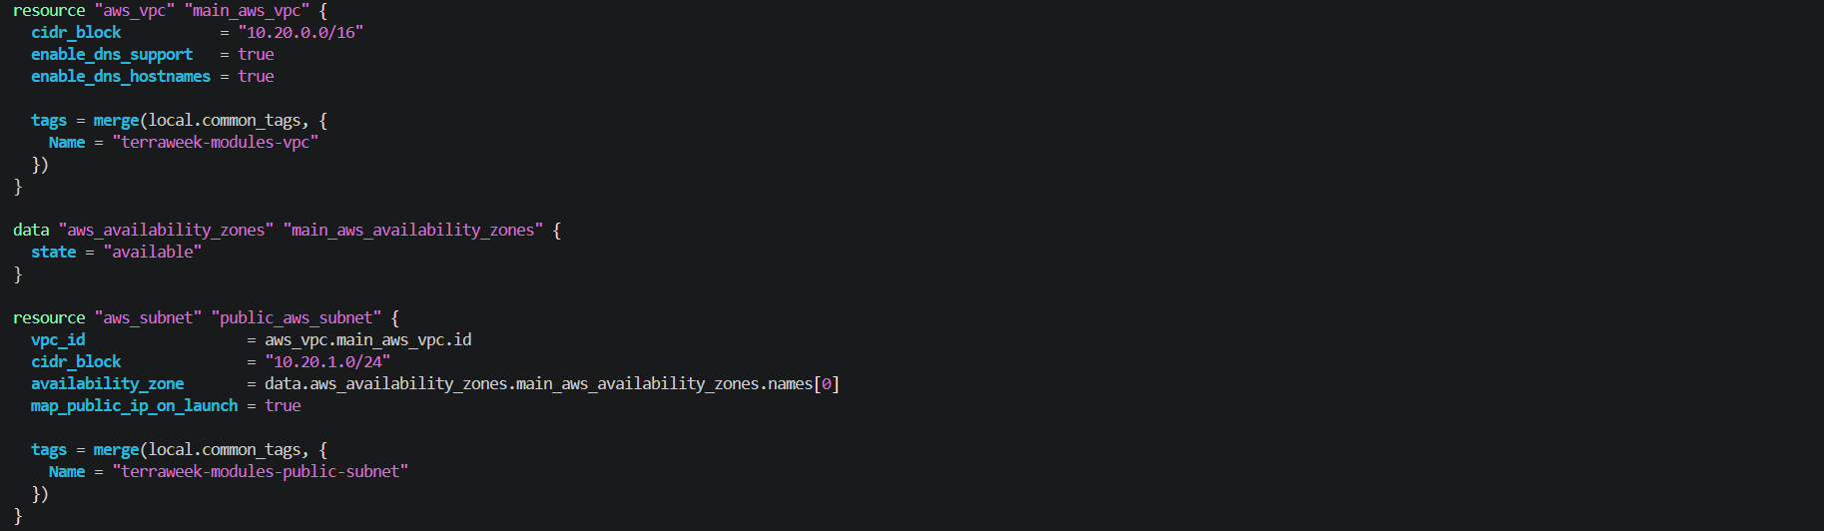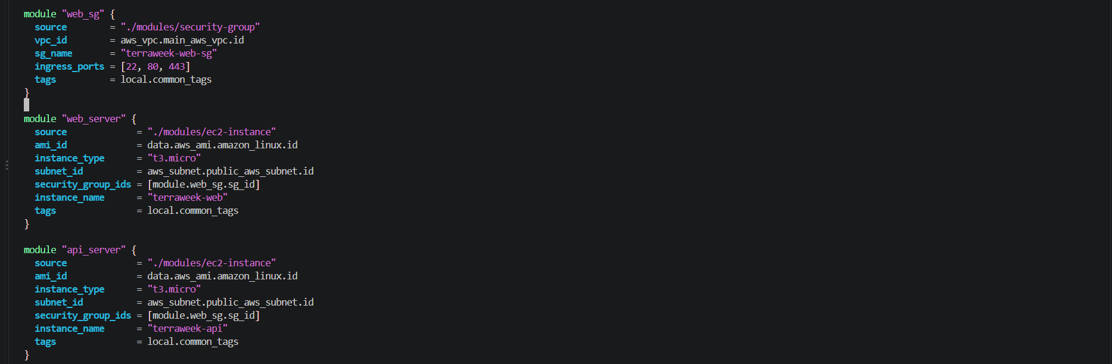
Terraform init
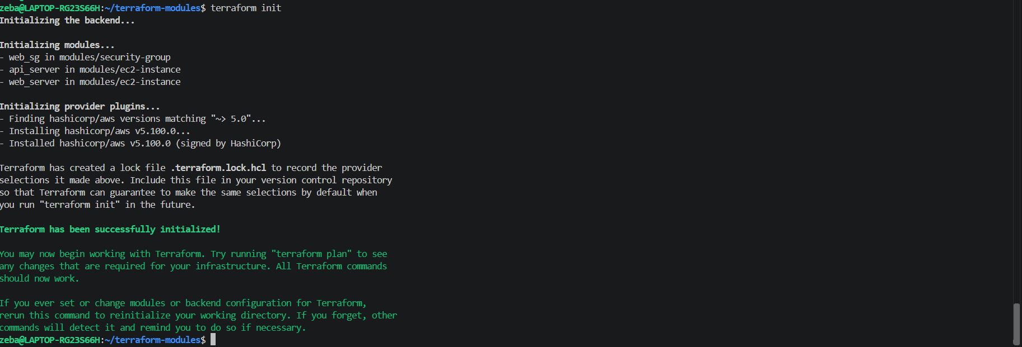

Terraform plan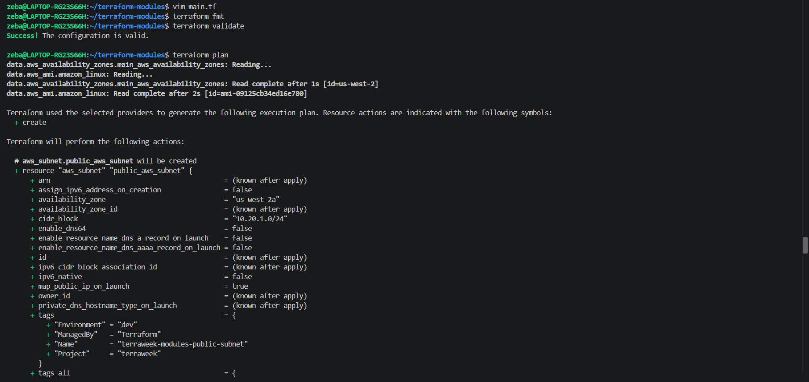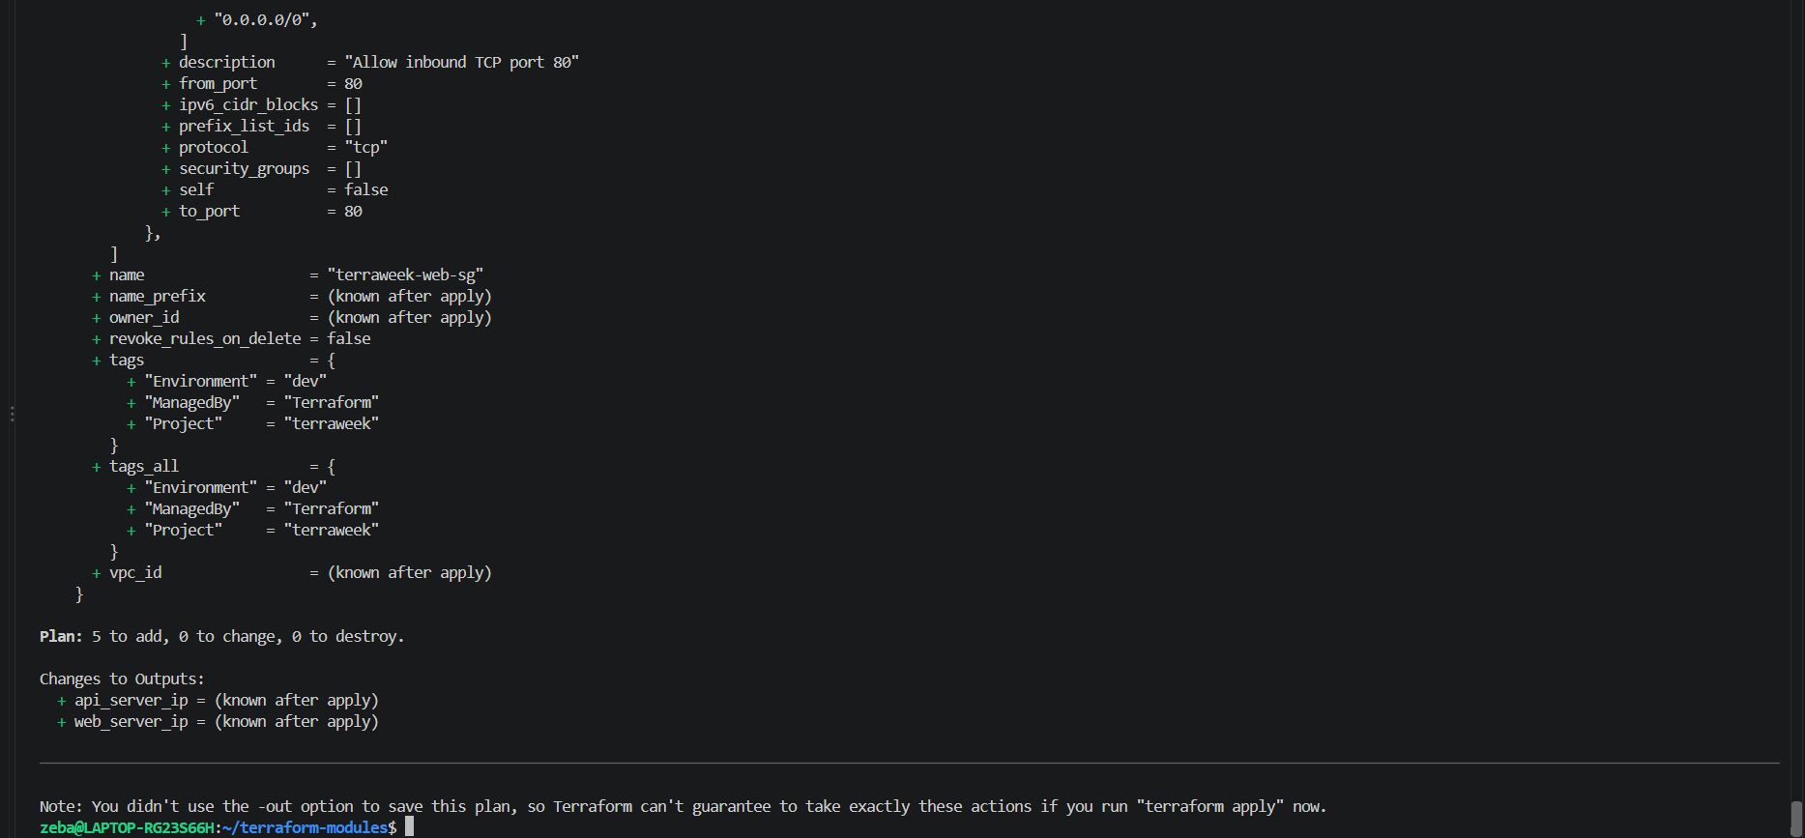
Terraform apply
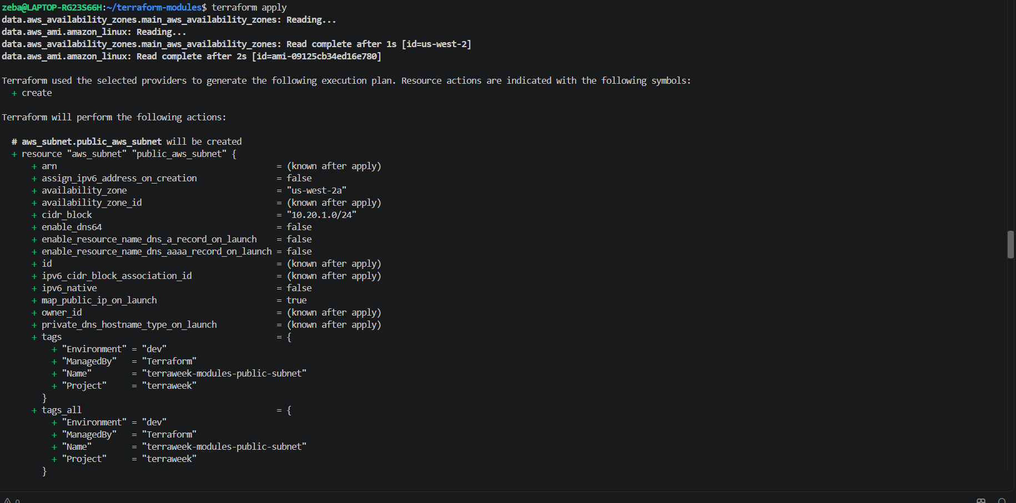
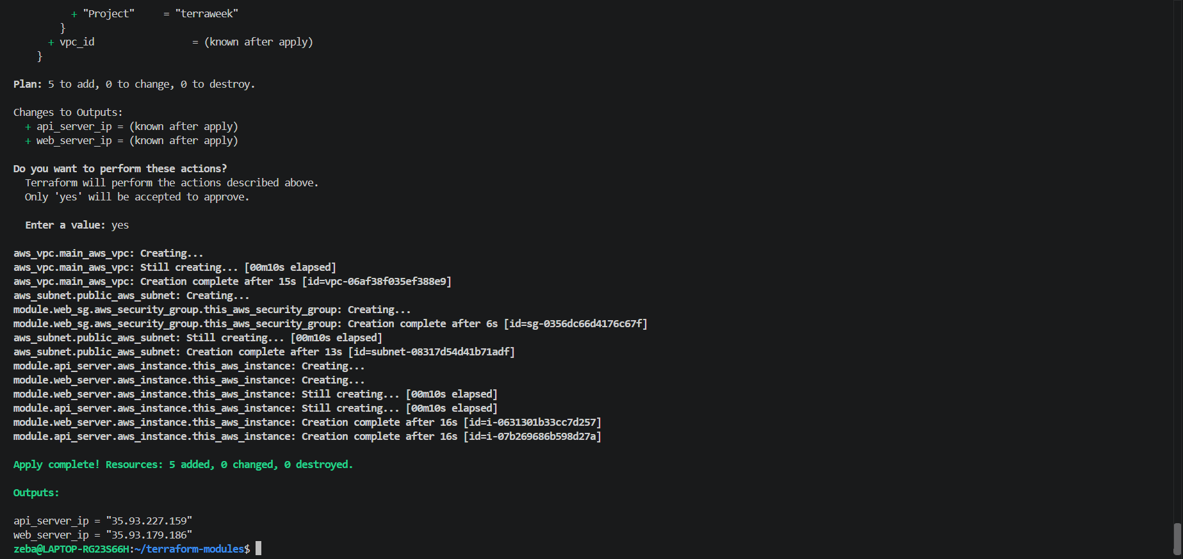
Both instances created and running
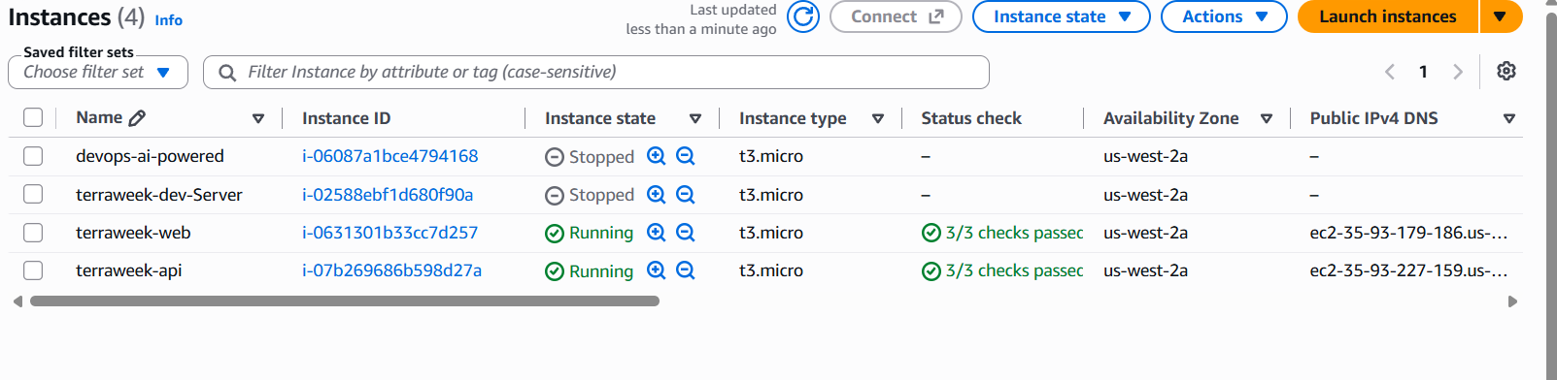

Both have same security group
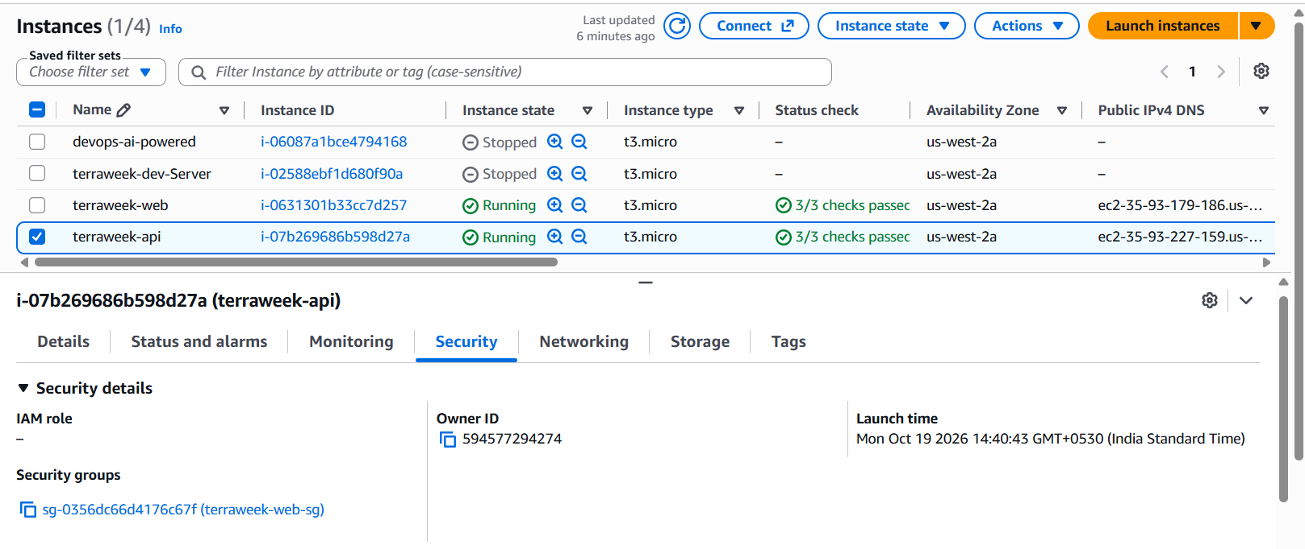
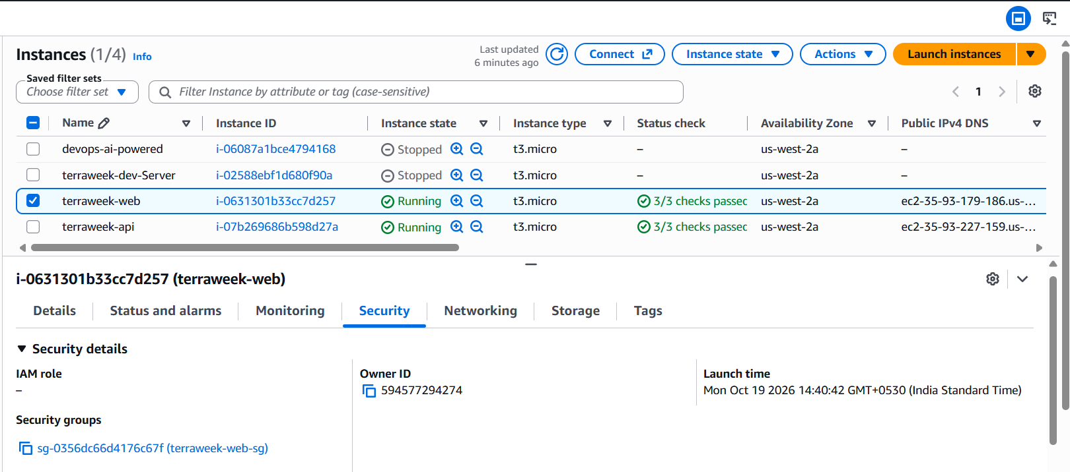
Task 5: Use a Public Registry Module
Instead of building your own VPC from scratch, use the official module from the Terraform Registry.
- Replace your hand-written VPC resources with:
module "vpc" {
source = "terraform-aws-modules/vpc/aws"
version = "~> 5.0"

name = "terraweek-vpc"
cidr = "10.0.0.0/16"

azs = ["ap-south-1a", "ap-south-1b"]
public_subnets = ["10.0.1.0/24", "10.0.2.0/24"]
private_subnets = ["10.0.3.0/24", "10.0.4.0/24"]

enable_nat_gateway = false
enable_dns_hostnames = true

tags = local.common_tags
}
- Update your EC2 and SG module calls to reference module.vpc.vpc_id and module.vpc.public_subnets[0]
- Run:
terraform init # Downloads the registry module
terraform plan
terraform apply
- Compare: how many resources did the VPC module create vs your hand-written VPC from Day 62?
Document: Where does Terraform download registry modules to? Check .terraform/modules/.
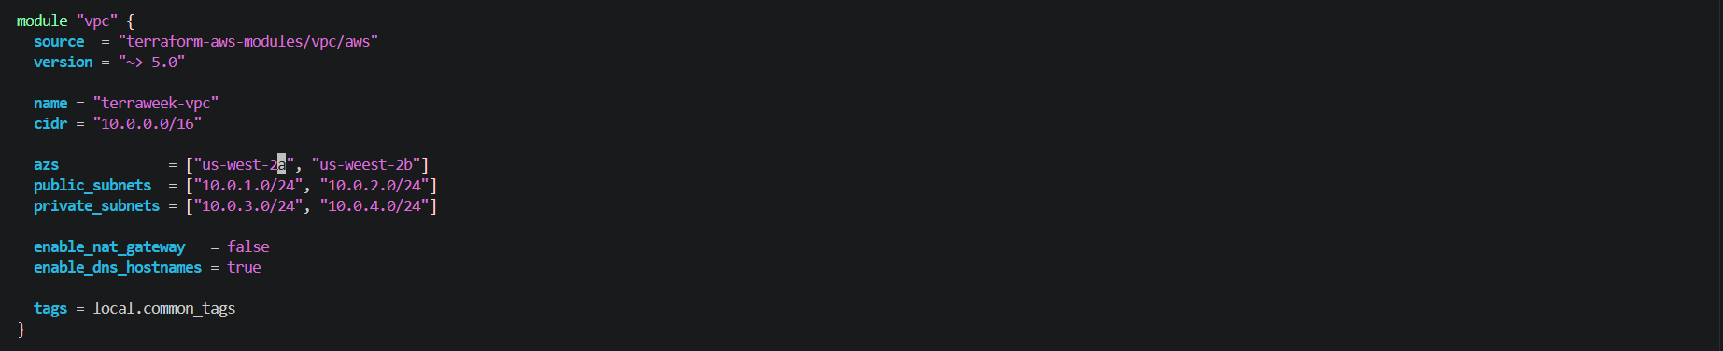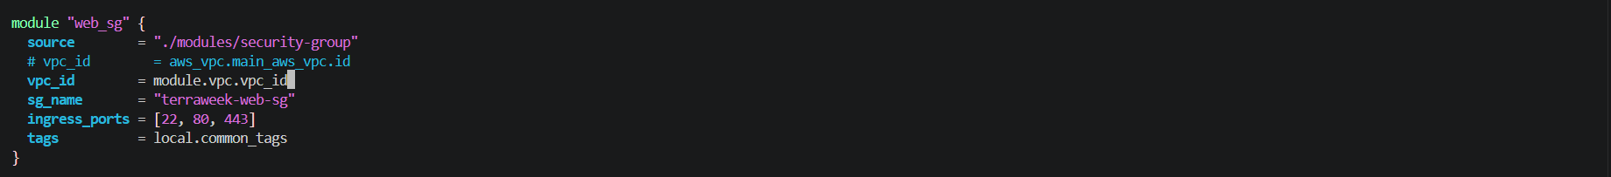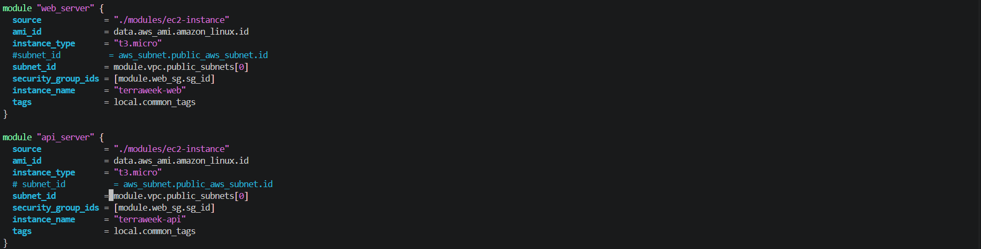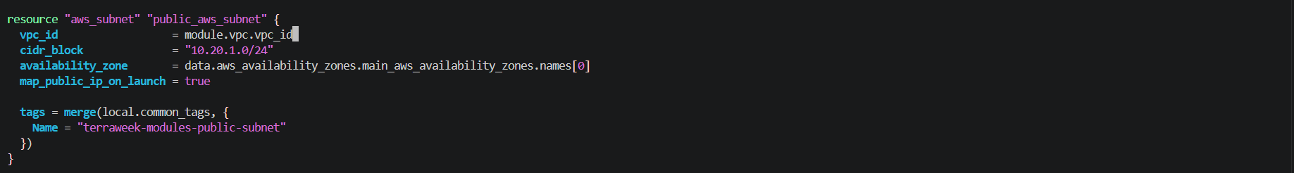
Terraform init
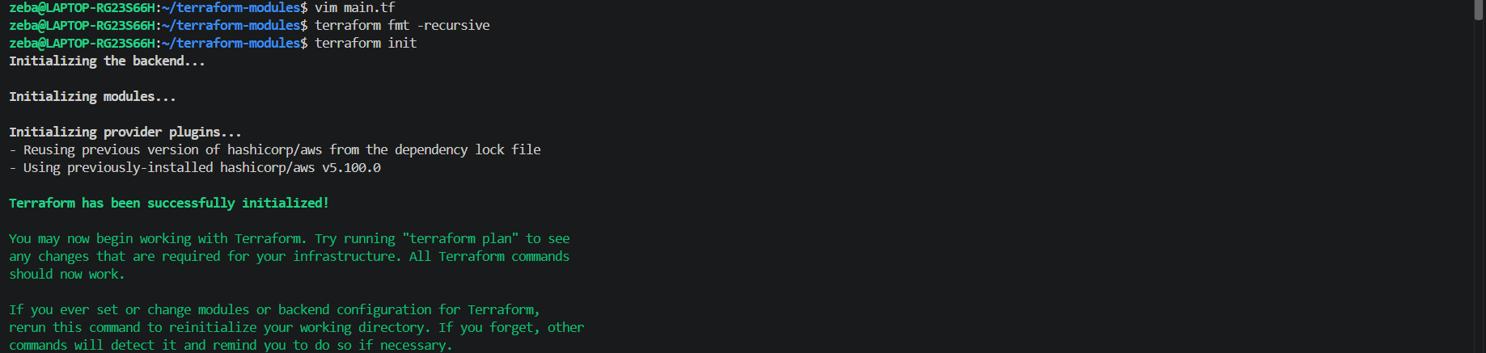
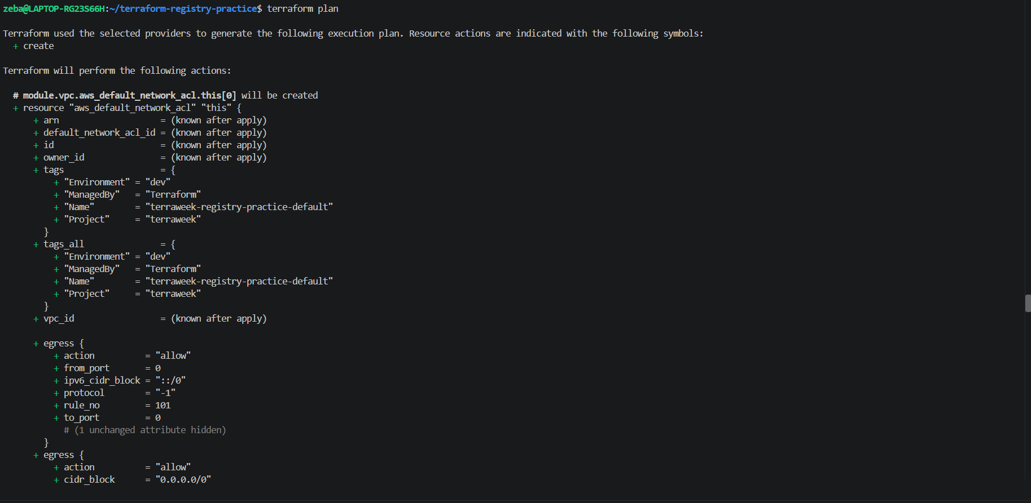
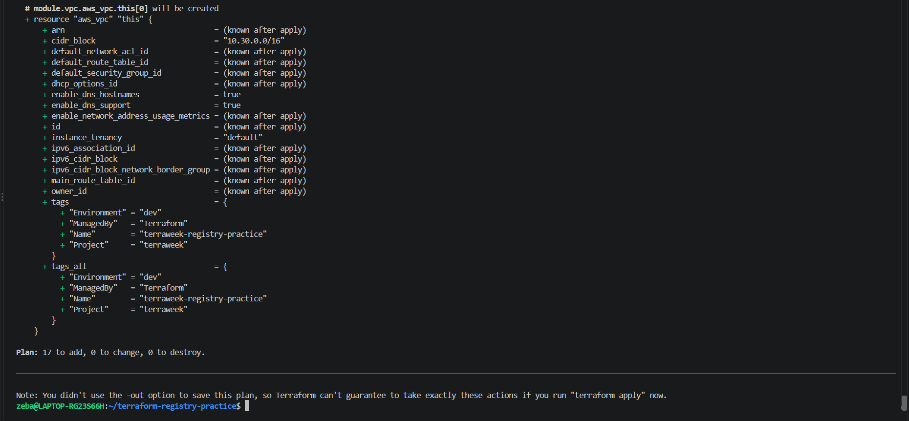
Plan is showing 17 to add
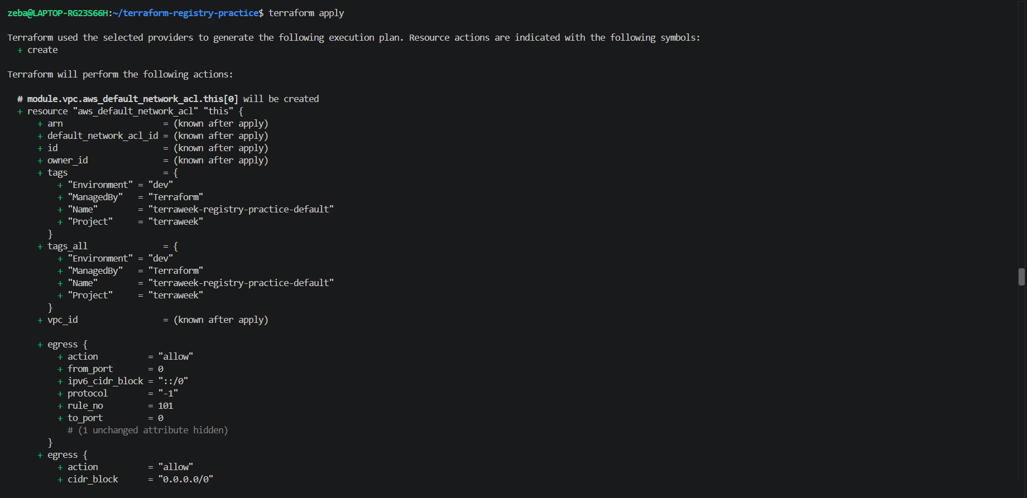
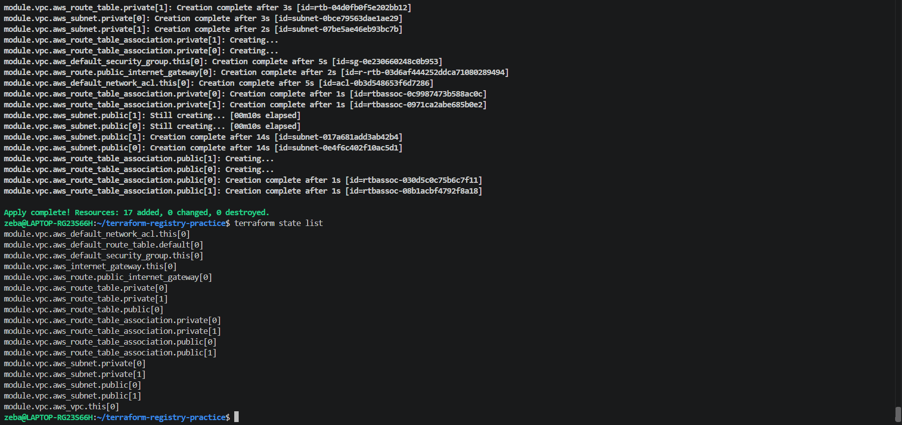
Module: terraform-aws-modules/vpc/aws
Version constraint: ~> 5.0
AWS Region: us-west-2
Configuration
- VPC CIDR: 10.30.0.0/16
- Public subnets: 10.30.1.0/24, 10.30.2.0/24
- Private subnets: 10.30.3.0/24, 10.30.4.0/24
- NAT Gateway: Disabled
- DNS hostnames: Enabled
Result
Terraform successfully applied the configuration:
- 17 resources added
- 0 resources changed
- 0 resources destroyed
Module Download Location
Terraform downloads Registry modules into .terraform/modules/ in the current working directory. The modules.json file records information about installed modules.
Learning Outcome
The official VPC module automates the creation of networking resources, including the VPC, subnets, Internet Gateway, route tables, and route table associations. This reduces the amount of infrastructure code that must be written and maintained manually.
Task 6: Module Versioning and Best Practices
- Pin your registry module version explicitly:
  - version = "5.1.0" -- exact version
  - version = "~> 5.0" -- any 5.x version
  - version = ">= 5.0, < 6.0" -- range
- Run terraform init -upgrade to check for newer versions
- Check the state to see how modules appear:
terraform state list
Notice the module.vpc., module.web_server., module.web_sg. prefixes.
- Destroy everything:
terraform destroy
Document: Write down five module best practices:
- Always pin versions for registry modules
- Keep modules focused -- one concern per module
- Use variables for everything, hardcode nothing
- Always define outputs so callers can reference resources
- Add a README.md to every custom module

Main.tf – exact versioning
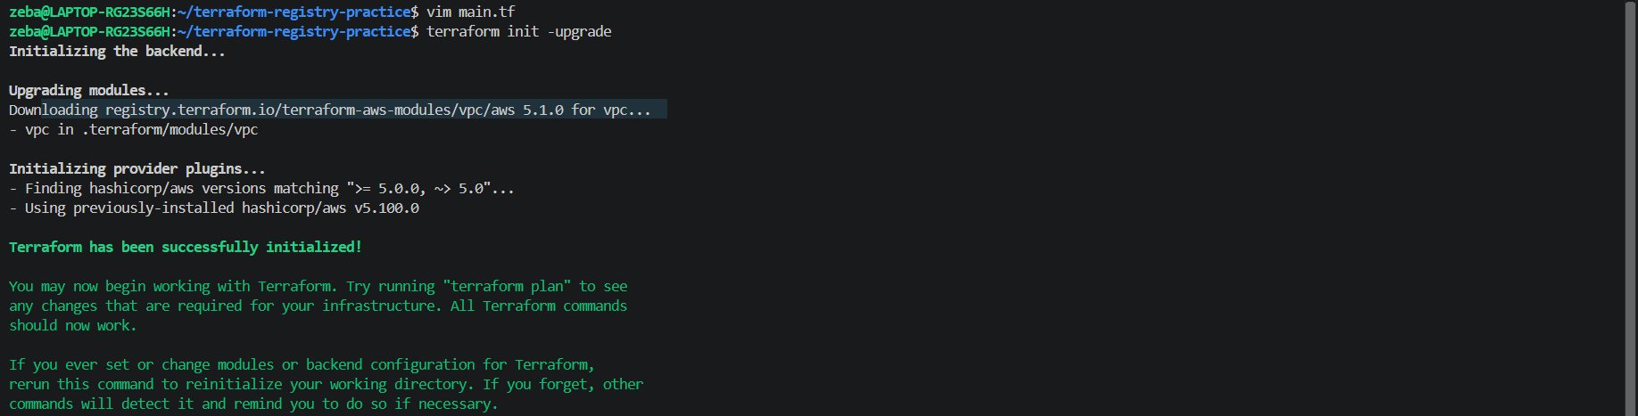
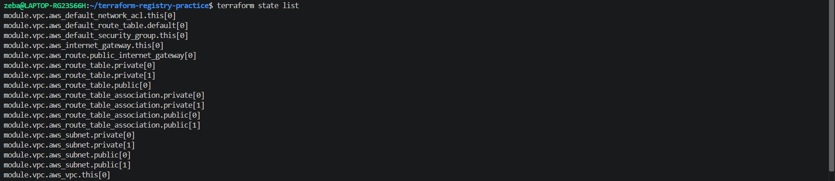
Terraform destroy
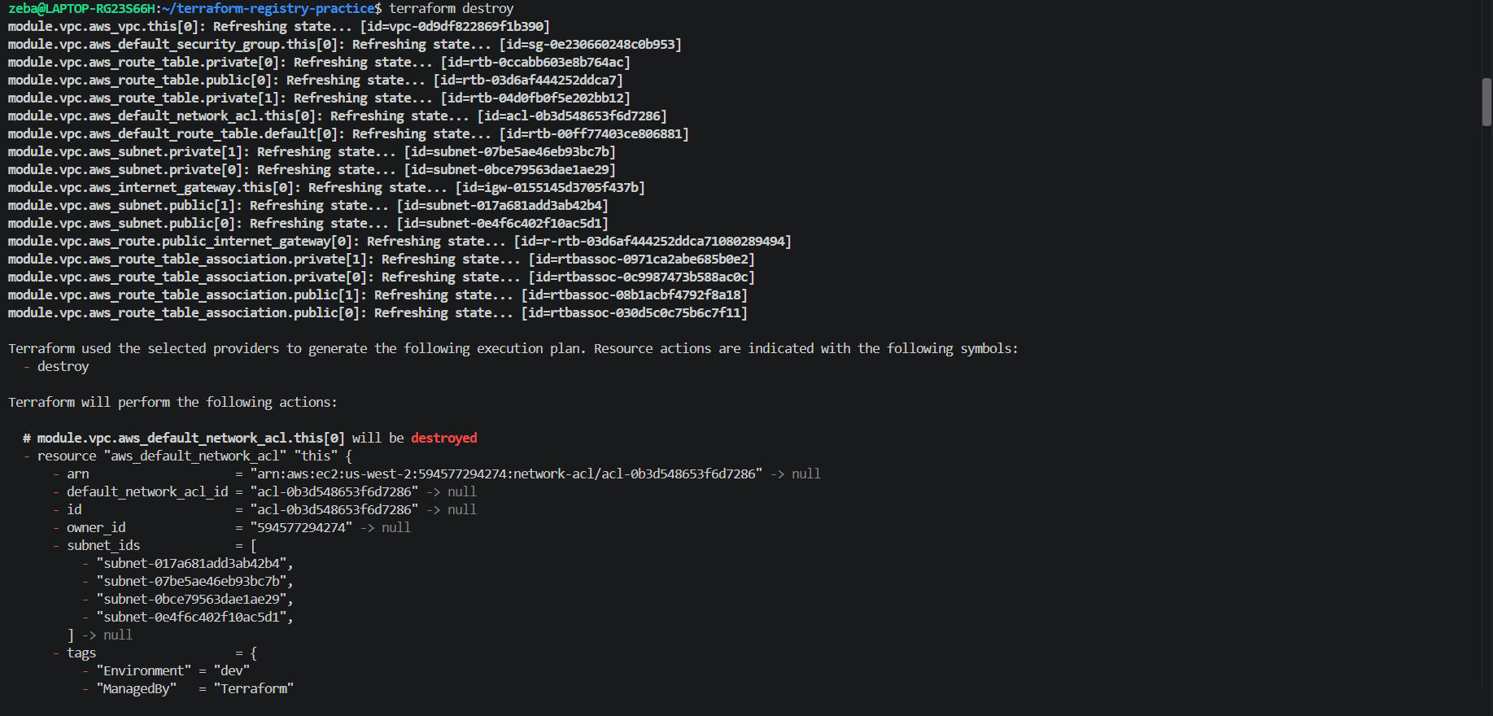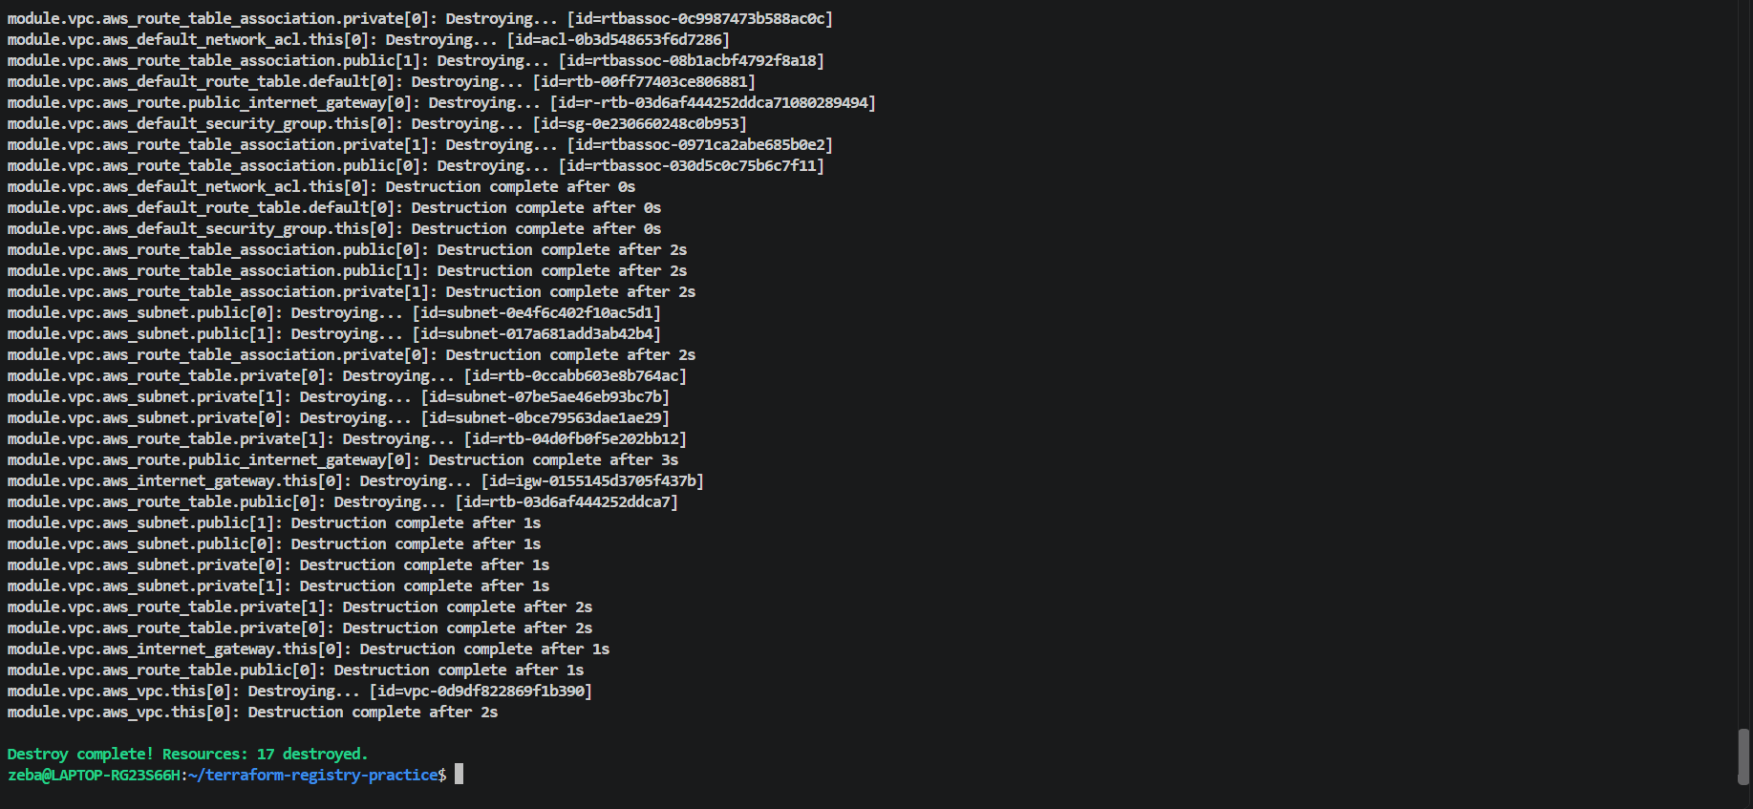
All 17 resources destroyed
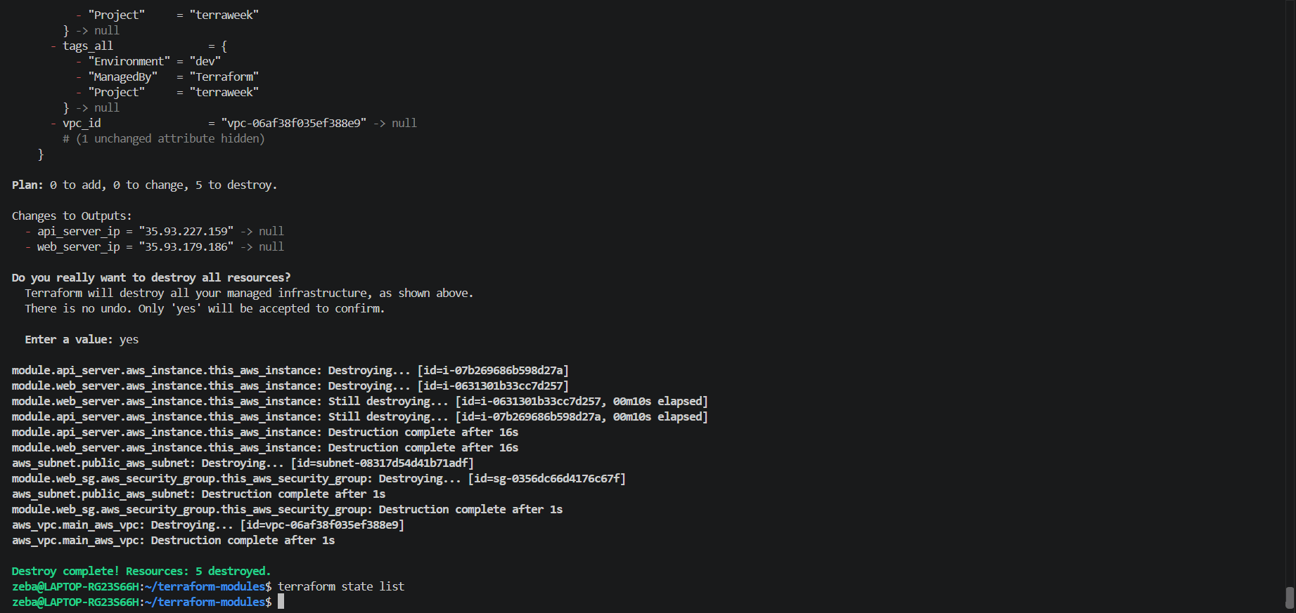
Task 6: Terraform Module Best Practices
1. Always Pin Versions for Registry Modules
Specify a module version to ensure predictable deployments and reduce the risk of unexpected changes when a new module version is released.
Example:
module "vpc" {
source = "terraform-aws-modules/vpc/aws"
version = "5.1.0"
}
2. Keep Modules Focused — One Concern per Module
Each module should have one clear responsibility. For example, create separate modules for VPC networking, security groups, and EC2 instances. This improves reusability, readability, and maintenance.
3. Use Variables Instead of Hardcoding Values
Use input variables for configurable values such as instance types, CIDR blocks, subnet IDs, and resource names. This makes modules flexible and reusable across development, testing, and production environments.

4. Define Outputs for Resource References
Define outputs to expose useful resource attributes, such as VPC IDs, security group IDs, instance IDs, and IP addresses. Other modules and root configurations can reference these outputs without hardcoding resource identifiers.
5. Add a README.md to Every Custom Module
Include a README file explaining the module's purpose, requirements, input variables, outputs, and a usage example. Good documentation helps other developers understand and reuse the module.
Conclusion
Following these best practices makes Terraform modules more reusable, maintainable, predictable, and easier to collaborate on.

