Day 74 -- Node Exporter, cAdvisor, and Grafana Dashboards

Task 1: Add Node Exporter for Host Metrics
Node Exporter exposes Linux system metrics (CPU, memory, disk, filesystem, network) in Prometheus format.
Update your docker-compose.yml from Day 73 -- add the Node Exporter service:
node-exporter:
image: prom/node-exporter:latest
container_name: node-exporter
ports:
- "9100:9100"
volumes:
- /proc:/host/proc:ro
- /sys:/host/sys:ro
- /:/rootfs:ro
command:
- '--path.procfs=/host/proc'
- '--path.sysfs=/host/sys'
- '--path.rootfs=/rootfs'
- '--collector.filesystem.mount-points-exclude=^/(sys|proc|dev|host|etc)($$|/)'
restart: unless-stopped
Why these volume mounts?
- /proc -- kernel and process information (CPU stats, memory info)
- /sys -- hardware and driver details
- / -- filesystem usage (disk space)
All mounted read-only (ro) -- Node Exporter only reads, never modifies.
Add it as a scrape target in prometheus.yml:
scrape_configs:
- job_name: "prometheus"
static_configs:
- targets: ["localhost:9090"]

- job_name: "node-exporter"
static_configs:
- targets: ["node-exporter:9100"]
Restart the stack:
docker compose up -d
Verify Node Exporter is healthy:
curl http://localhost:9100/metrics | head -20
Check Prometheus Targets page -- node-exporter should show as UP.
Run these queries in Prometheus to see host metrics:
# CPU: percentage of time spent idle (per core)
node_cpu_seconds_total{mode="idle"}

# Memory: total vs available
node_memory_MemTotal_bytes
node_memory_MemAvailable_bytes

# Memory usage percentage
(1 - node_memory_MemAvailable_bytes / node_memory_MemTotal_bytes) * 100

# Disk: filesystem usage percentage
(1 - node_filesystem_avail_bytes / node_filesystem_size_bytes) * 100

# Network: bytes received per second
rate(node_network_receive_bytes_total[5m])

Added node exporter as service in docker-compose.yml
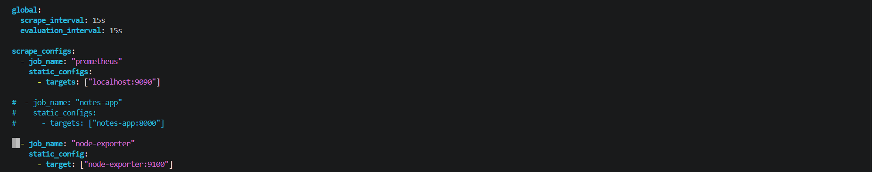
Added the node-exporter target in Prometheus.yml
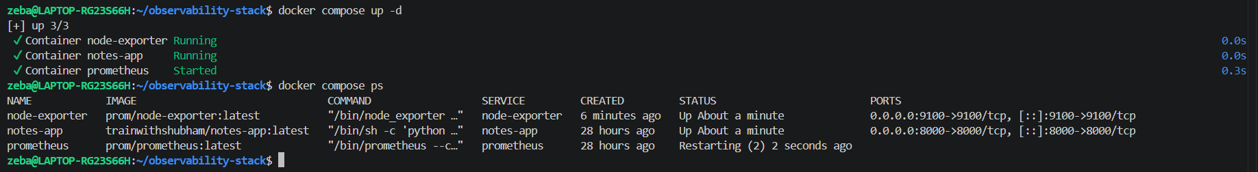
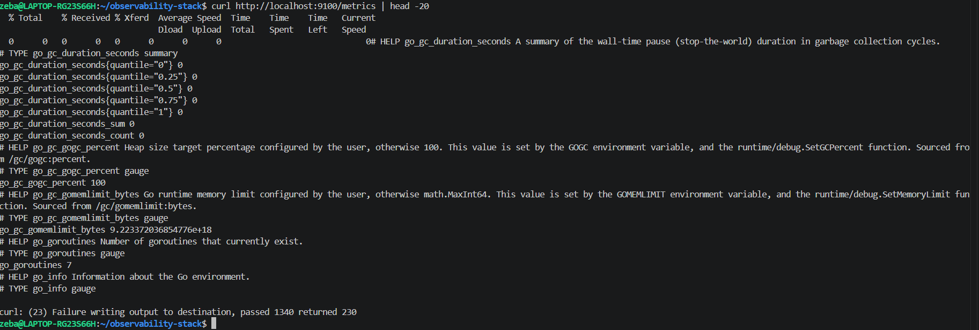

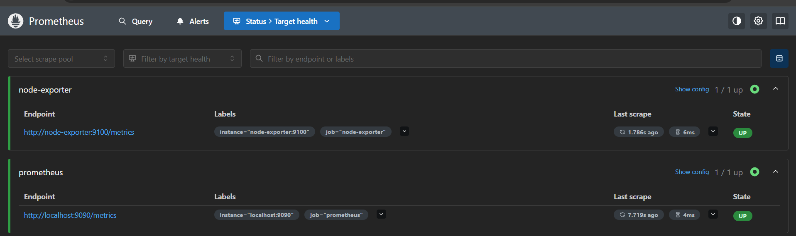
Node exporter is up in Prometheus target page

# CPU: percentage of time spent idle (per core)
node_cpu_seconds_total{mode="idle"}
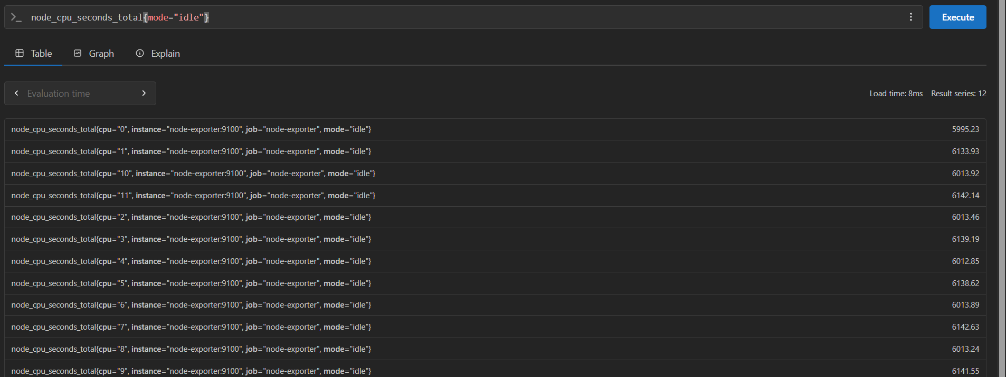

# Memory: total vs available
node_memory_MemTotal_bytes
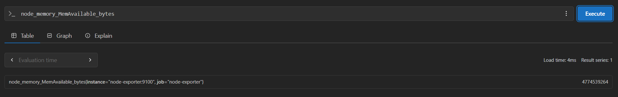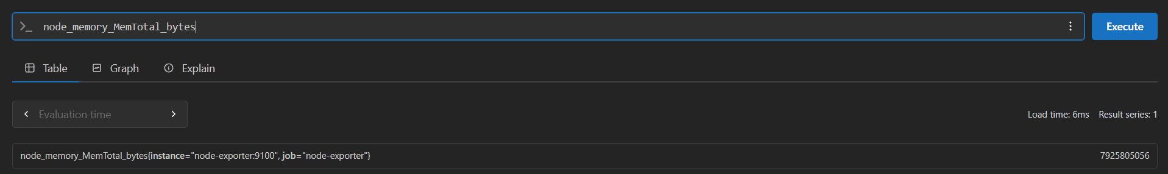

# Memory usage percentage
(1 - node_memory_MemAvailable_bytes / node_memory_MemTotal_bytes) * 100
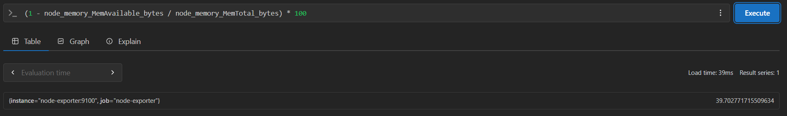

# Disk: filesystem usage percentage
(1 - node_filesystem_avail_bytes / node_filesystem_size_bytes) * 100
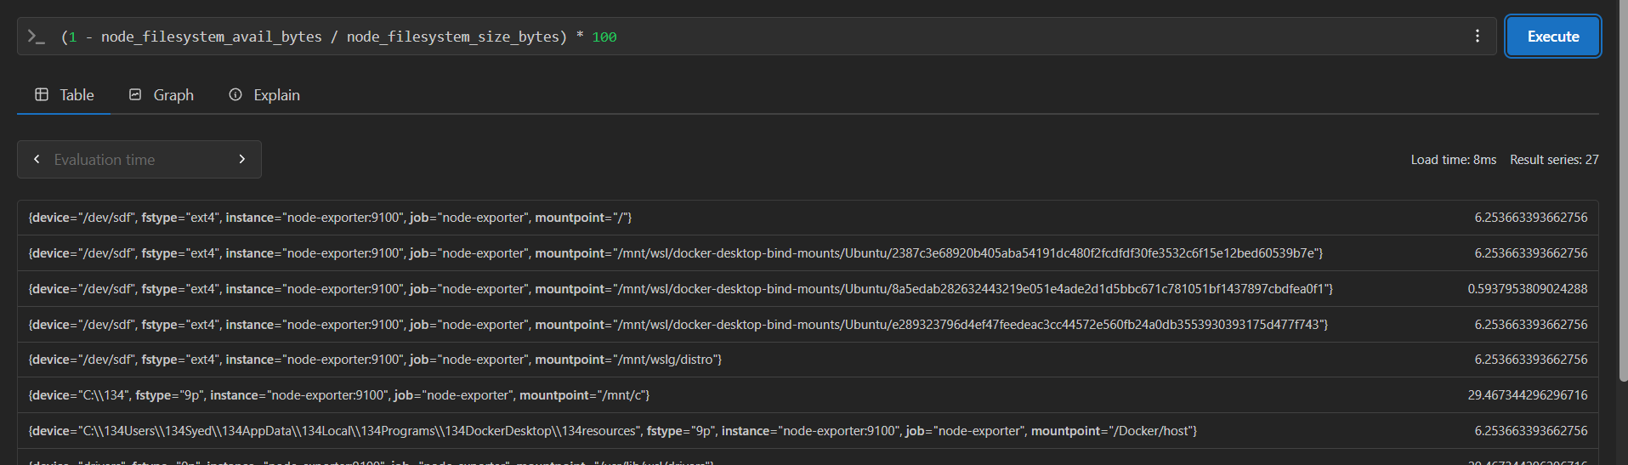

# Network: bytes received per second
rate(node_network_receive_bytes_total[5m])
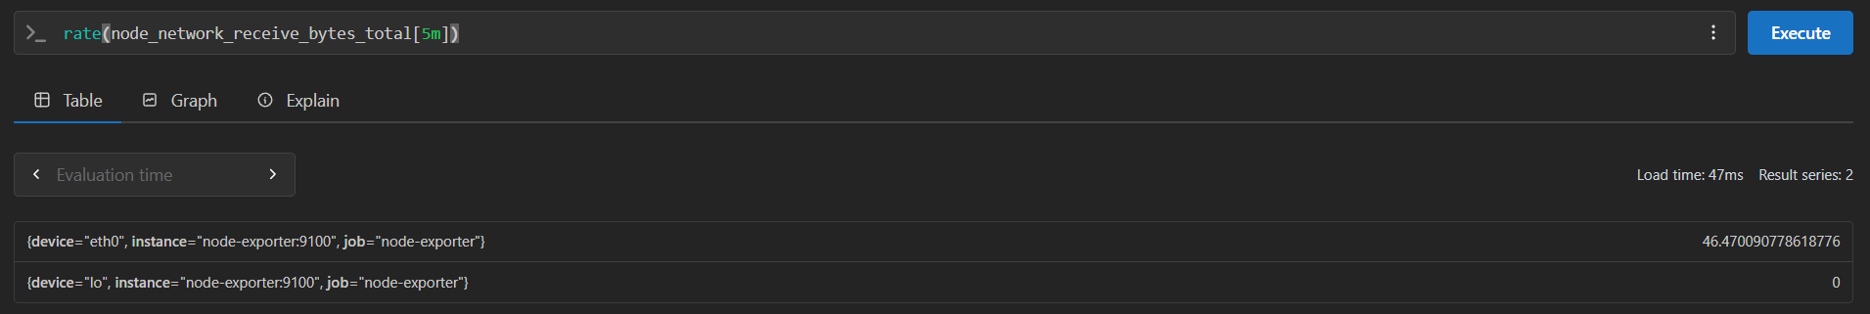
Task 2: Add cAdvisor for Container Metrics
cAdvisor (Container Advisor) monitors resource usage and performance of running Docker containers.
Add it to your docker-compose.yml:
cadvisor:
image: gcr.io/cadvisor/cadvisor:latest
container_name: cadvisor
ports:
- "8080:8080"
volumes:
- /var/run/docker.sock:/var/run/docker.sock:ro
- /sys:/sys:ro
- /var/lib/docker/:/var/lib/docker:ro
restart: unless-stopped
Why these volume mounts?
- Docker socket (docker.sock) -- lets cAdvisor discover and query running containers
- /sys -- kernel-level container stats (cgroups)
- /var/lib/docker/ -- container filesystem information
Add cAdvisor as a Prometheus scrape target:
- job_name: "cadvisor"
static_configs:
- targets: ["cadvisor:8080"]
Restart and verify:
docker compose up -d
Open http://localhost:8080 to see the cAdvisor web UI. Click on Docker Containers to see per-container stats.
Run these queries in Prometheus:
# CPU usage per container (in seconds)
rate(container_cpu_usage_seconds_total{name!=""}[5m])

# Memory usage per container
container_memory_usage_bytes{name!=""}

# Network received bytes per container
rate(container_network_receive_bytes_total{name!=""}[5m])

# Which container is using the most memory?
topk(3, container_memory_usage_bytes{name!=""})
The {name!=""} filter removes aggregated/system-level entries and shows only named containers.
Document: What is the difference between Node Exporter and cAdvisor? When would you use each?

Added cAdvisor in docker-compose.yml
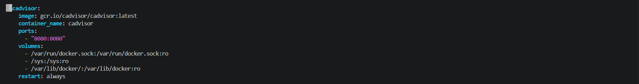

cAdvisor job added to the Prometheus.yml
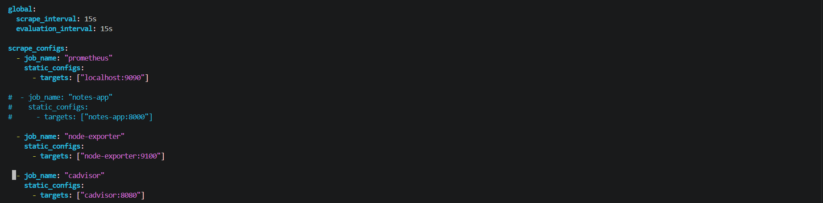
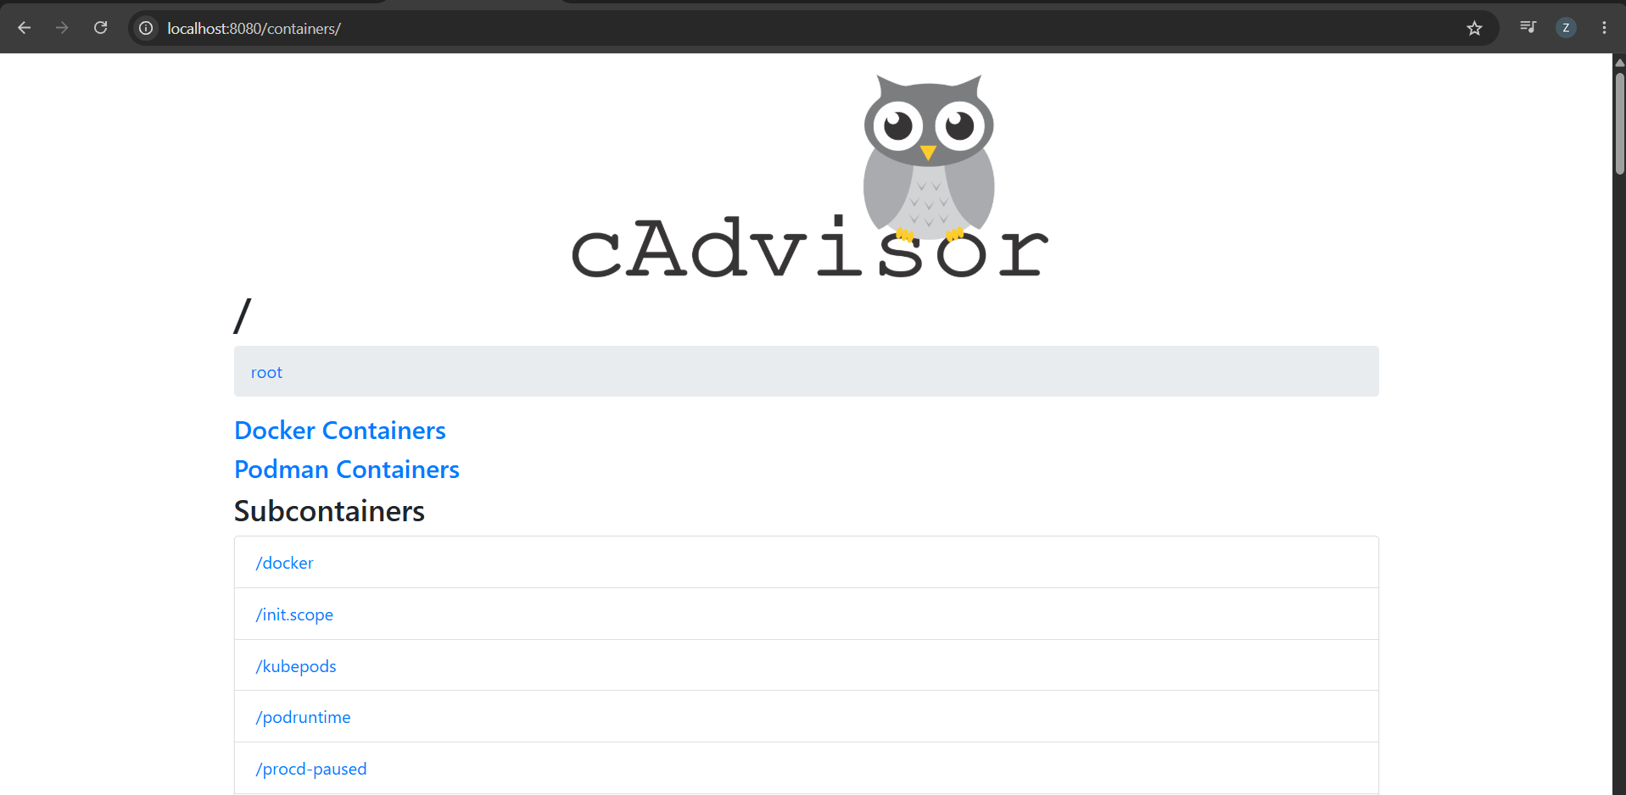
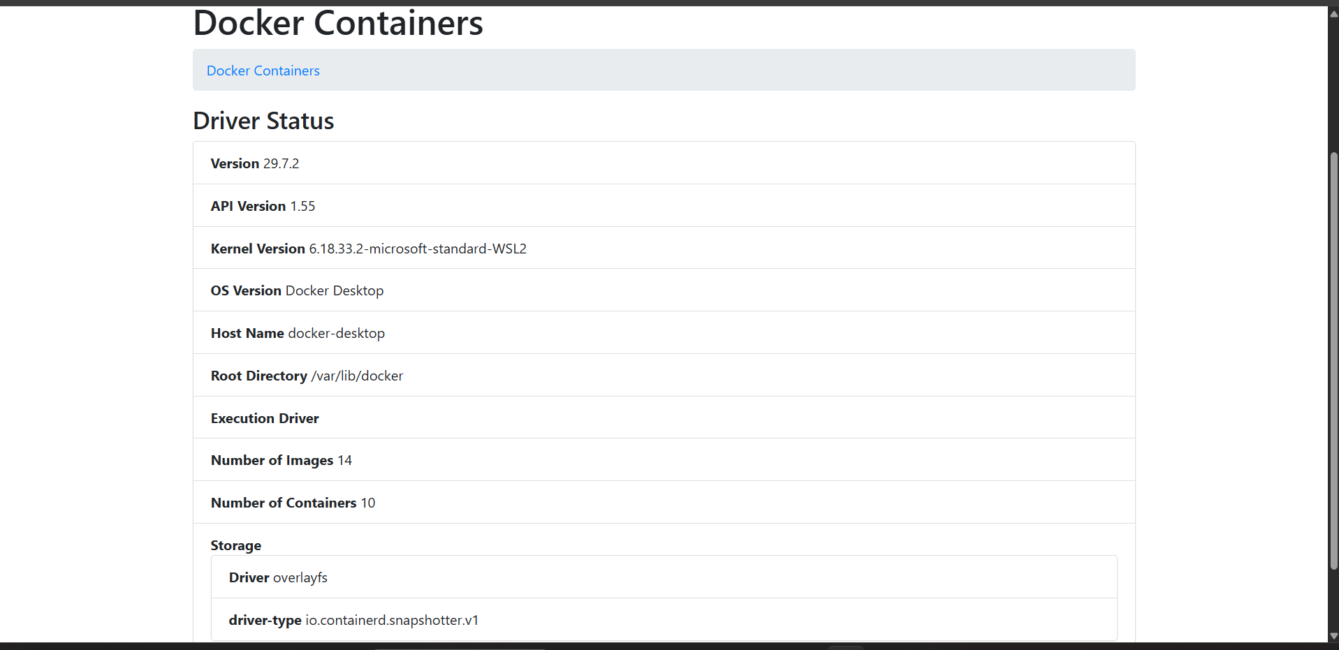
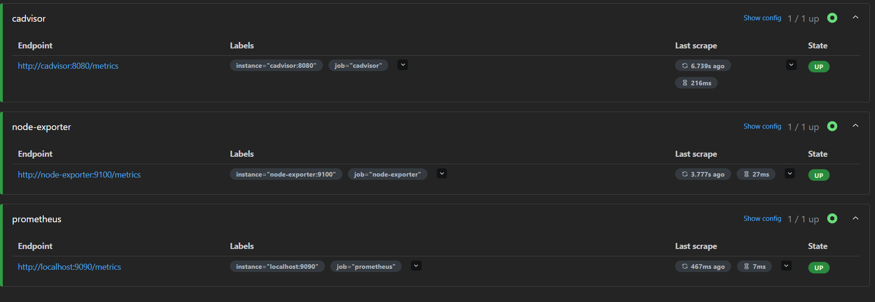

# CPU usage per container (in seconds)
rate(container_cpu_usage_seconds_total{name!=""}[5m])
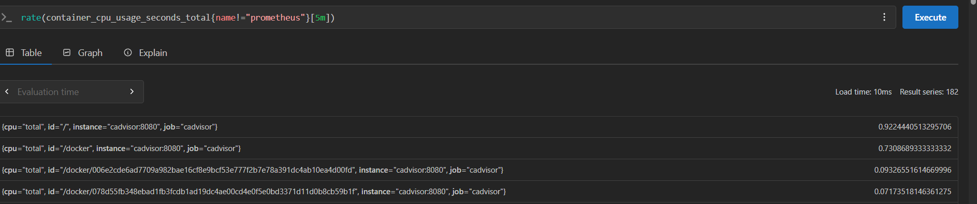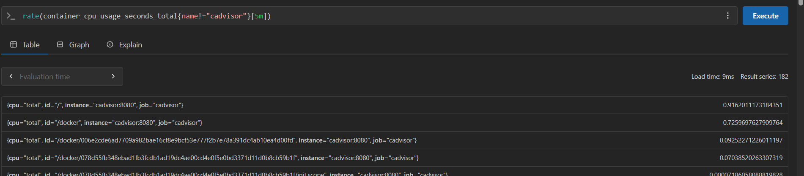
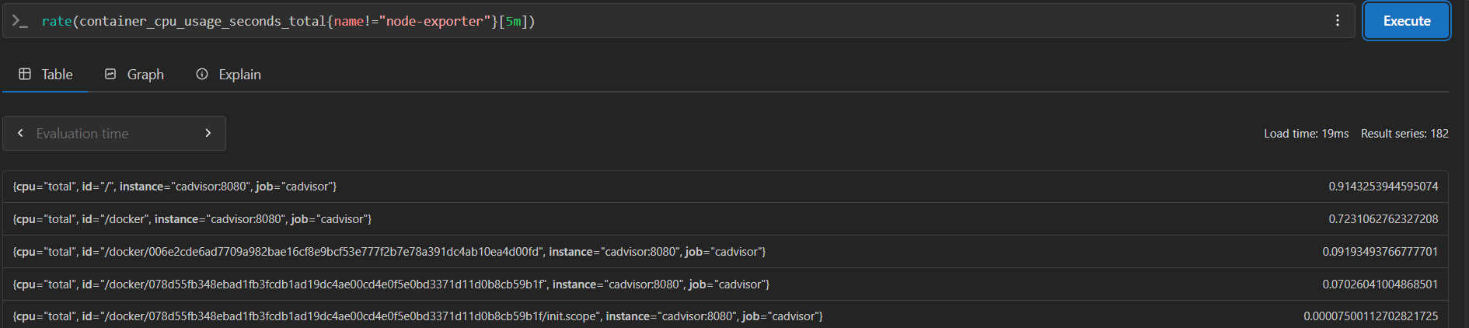

# Memory usage per container
container_memory_usage_bytes{name!=""}
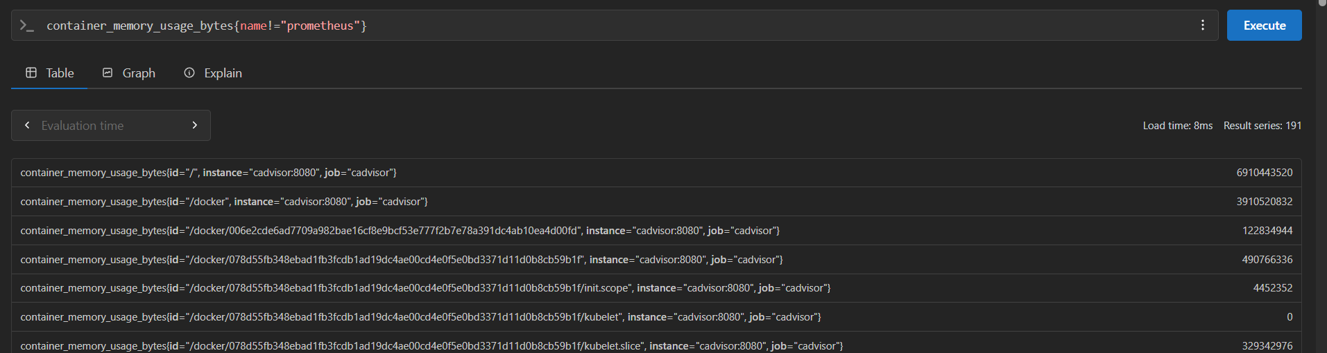

# Network received bytes per container
rate(container_network_receive_bytes_total{name!=""}[5m])
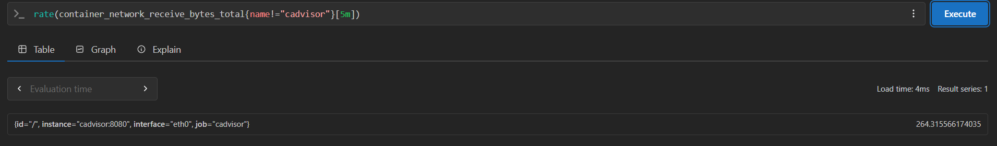

# Which container is using the most memory?
topk(3, container_memory_usage_bytes{name!=""})
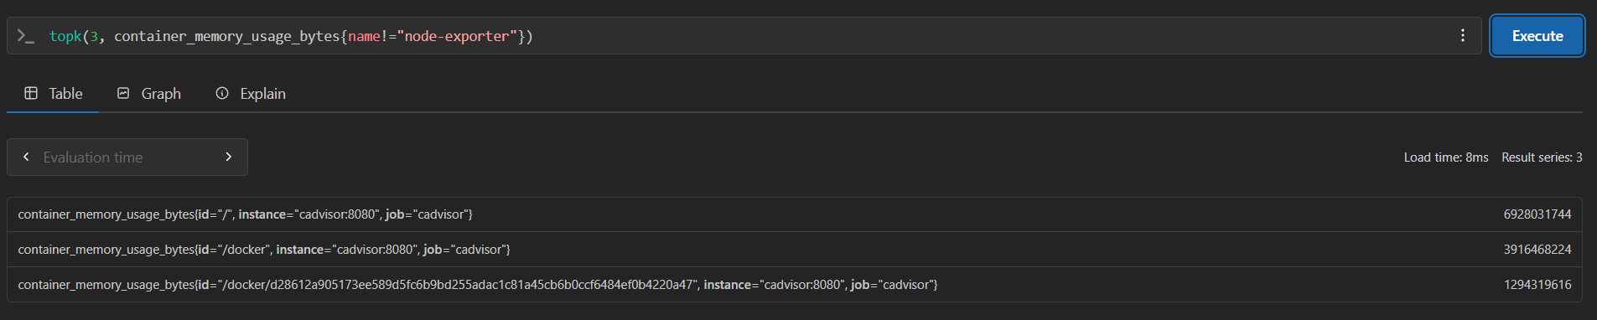

Task 3: Set Up Grafana
Grafana is the visualization layer. It connects to Prometheus (and later Loki) and lets you build dashboards, set alerts, and share views with your team.
Add Grafana to your docker-compose.yml:
grafana:
image: grafana/grafana-enterprise:latest
container_name: grafana
ports:
- "3000:3000"
volumes:
- grafana_data:/var/lib/grafana
environment:
- GF_SECURITY_ADMIN_USER=admin
- GF_SECURITY_ADMIN_PASSWORD=admin123
restart: unless-stopped
Add the volume at the bottom of your compose file:
volumes:
prometheus_data:
grafana_data:
Restart:
docker compose up -d
Open http://localhost:3000. Log in with admin / admin123.
Add Prometheus as a datasource:
- Go to Connections > Data Sources > Add data source
- Select Prometheus
- Set URL to http://prometheus:9090 (use the container name, not localhost -- they are on the same Docker network)
- Click Save & Test -- you should see "Successfully queried the Prometheus API"

Added Grafana to docker-compose.yml
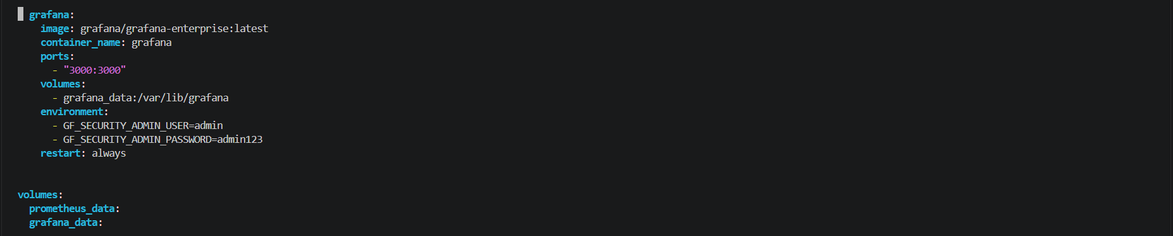
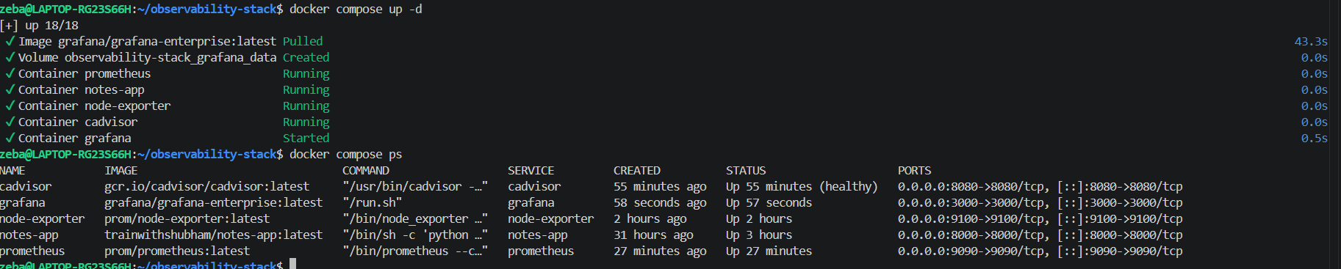
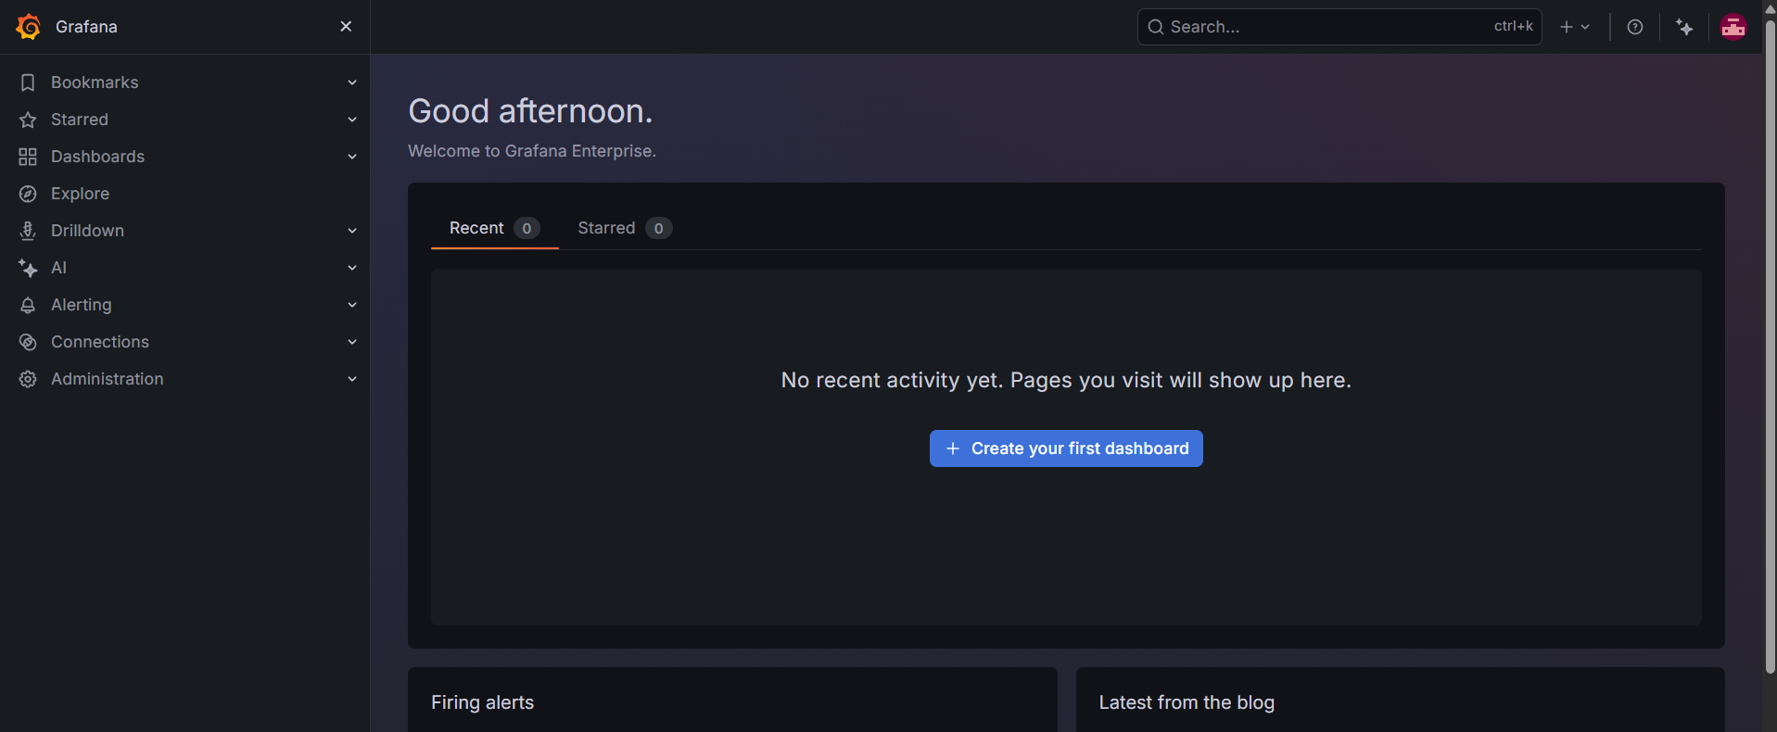

Add Prometheus as a datasource:
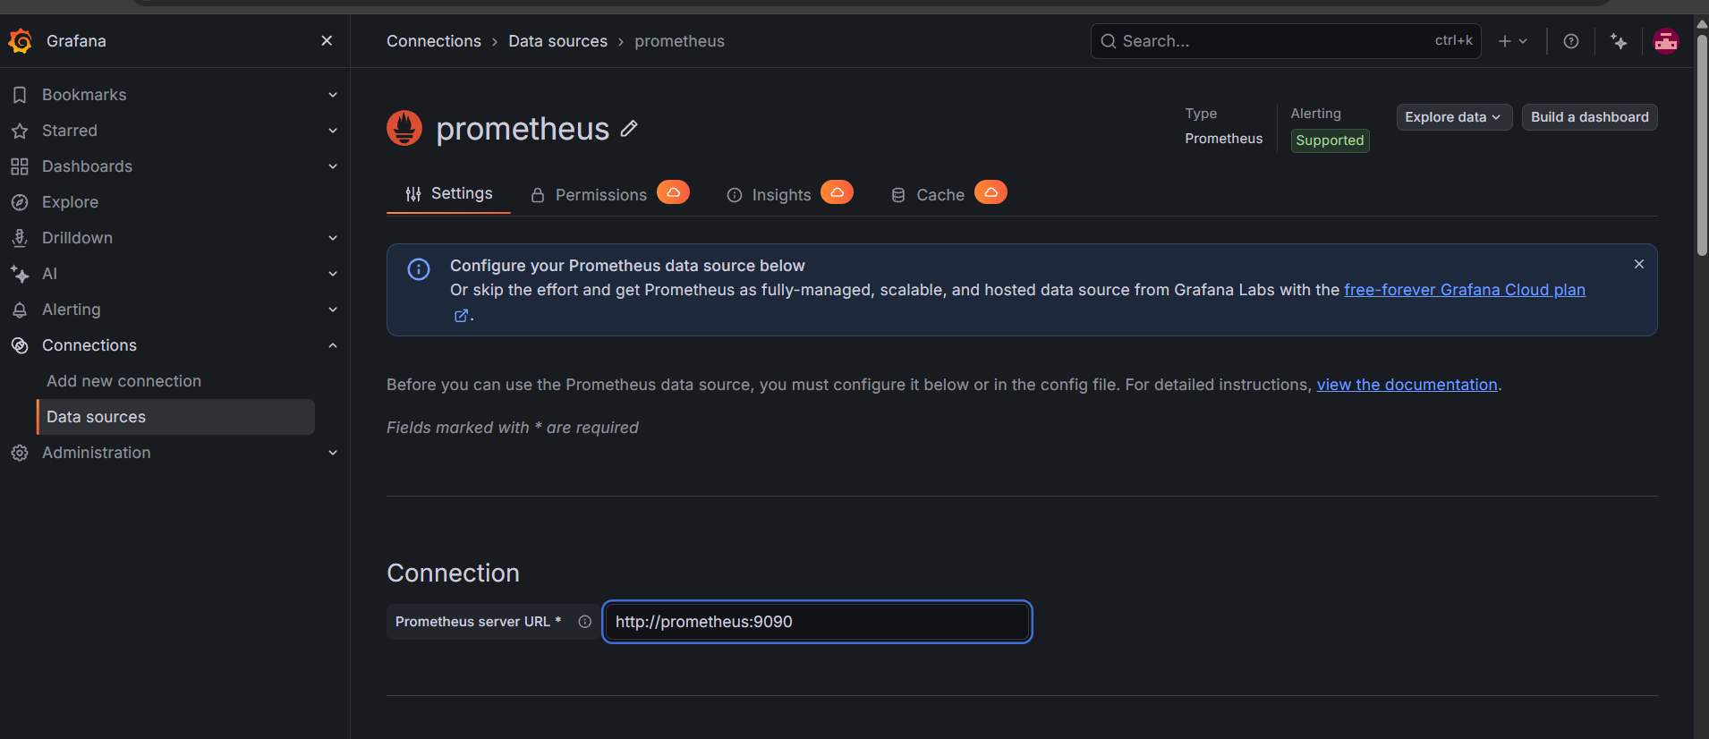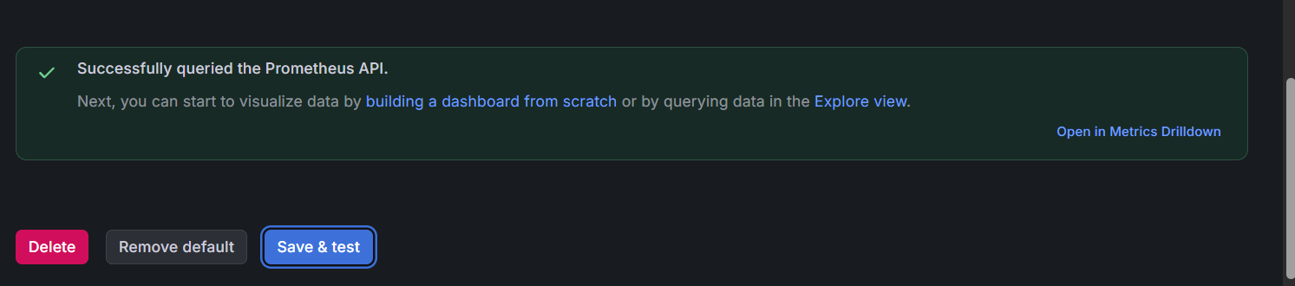
Task 4: Build Your First Dashboard
Create a dashboard that shows the health of your system at a glance.
- Go to Dashboards > New Dashboard > Add Visualization
- Select Prometheus as the datasource
Panel 1 -- CPU Usage (Gauge):
100 - (avg(rate(node_cpu_seconds_total{mode="idle"}[5m])) * 100)
- Visualization: Gauge
- Title: "CPU Usage %"
- Set thresholds: green < 60, yellow < 80, red >= 80
Panel 2 -- Memory Usage (Gauge):
(1 - node_memory_MemAvailable_bytes / node_memory_MemTotal_bytes) * 100
- Visualization: Gauge
- Title: "Memory Usage %"
Panel 3 -- Container CPU Usage (Time Series):
rate(container_cpu_usage_seconds_total{name!=""}[5m]) * 100
- Visualization: Time series
- Title: "Container CPU Usage"
- Legend: {{name}}
Panel 4 -- Container Memory Usage (Bar Chart):
container_memory_usage_bytes{name!=""} / 1024 / 1024
- Visualization: Bar chart
- Title: "Container Memory (MB)"
- Legend: {{name}}
Panel 5 -- Disk Usage (Stat):
(1 - node_filesystem_avail_bytes{mountpoint="/"} / node_filesystem_size_bytes{mountpoint="/"}) * 100
- Visualization: Stat
- Title: "Disk Usage %"
Save the dashboard as "DevOps Observability Overview".

Panel 1 -- CPU Usage (Gauge):

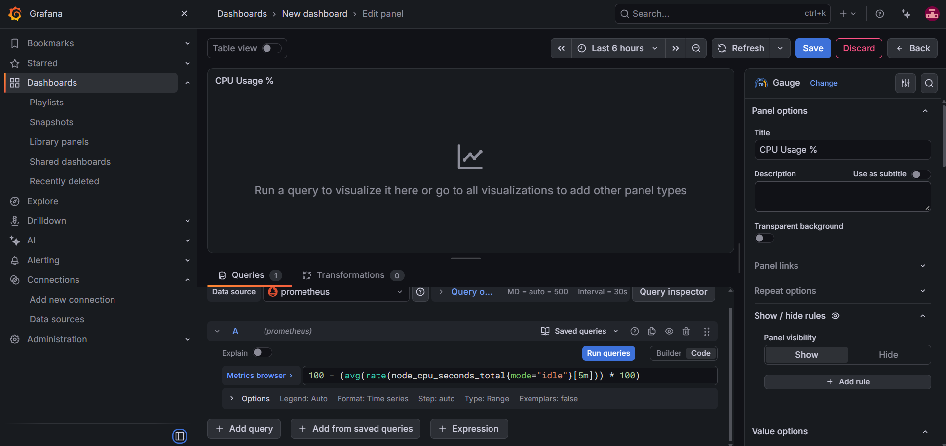
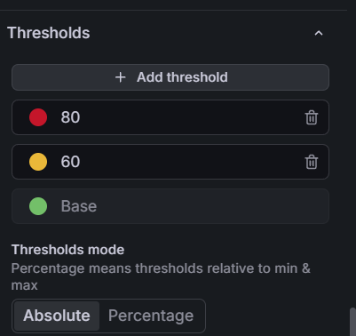
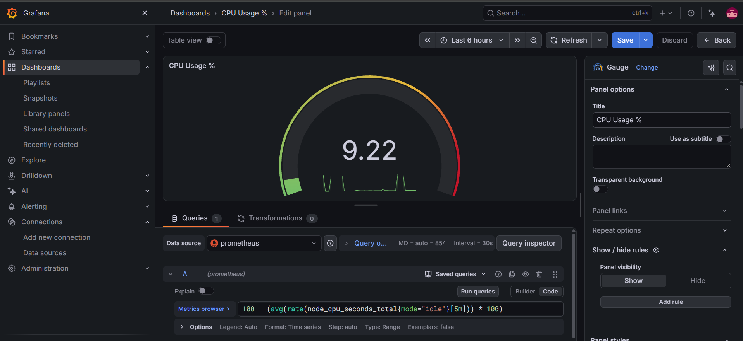
Panel 2 -- Memory Usage (Gauge):
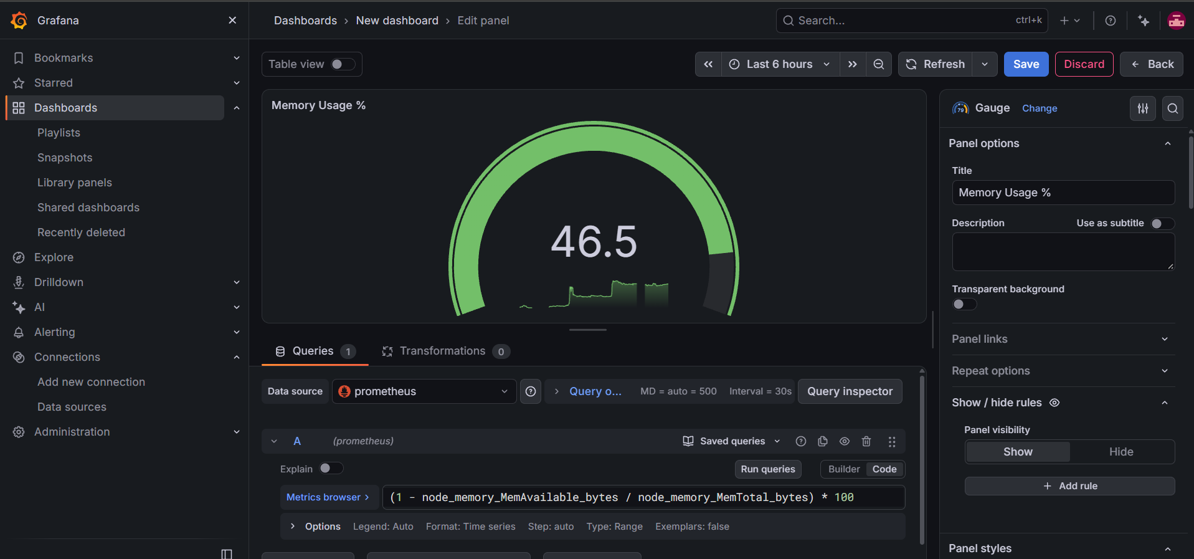
Panel 3 -- Container CPU Usage (Time Series):
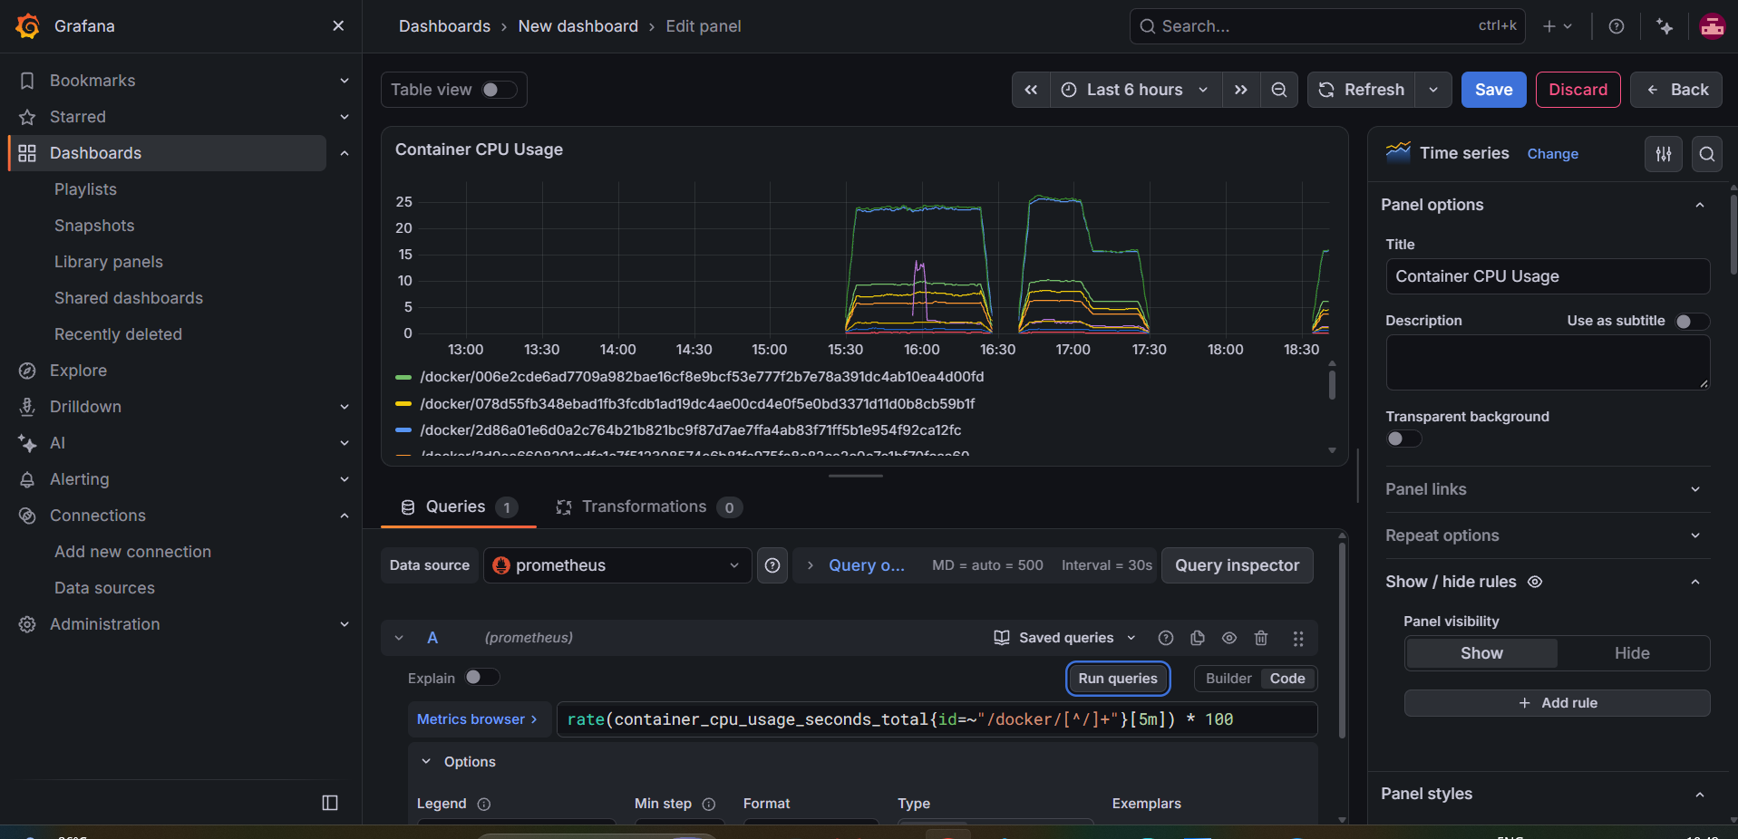

rate(container_cpu_usage_seconds_total{id=~"/docker/[^/]+"}[5m]) * 100 – used this query instead of given one
here we used id and also in legend we used {{id}} instead of {{name}} because in our cAdvisor matrics contain labels as id not name

Panel 4 -- Container Memory Usage (Bar Chart):
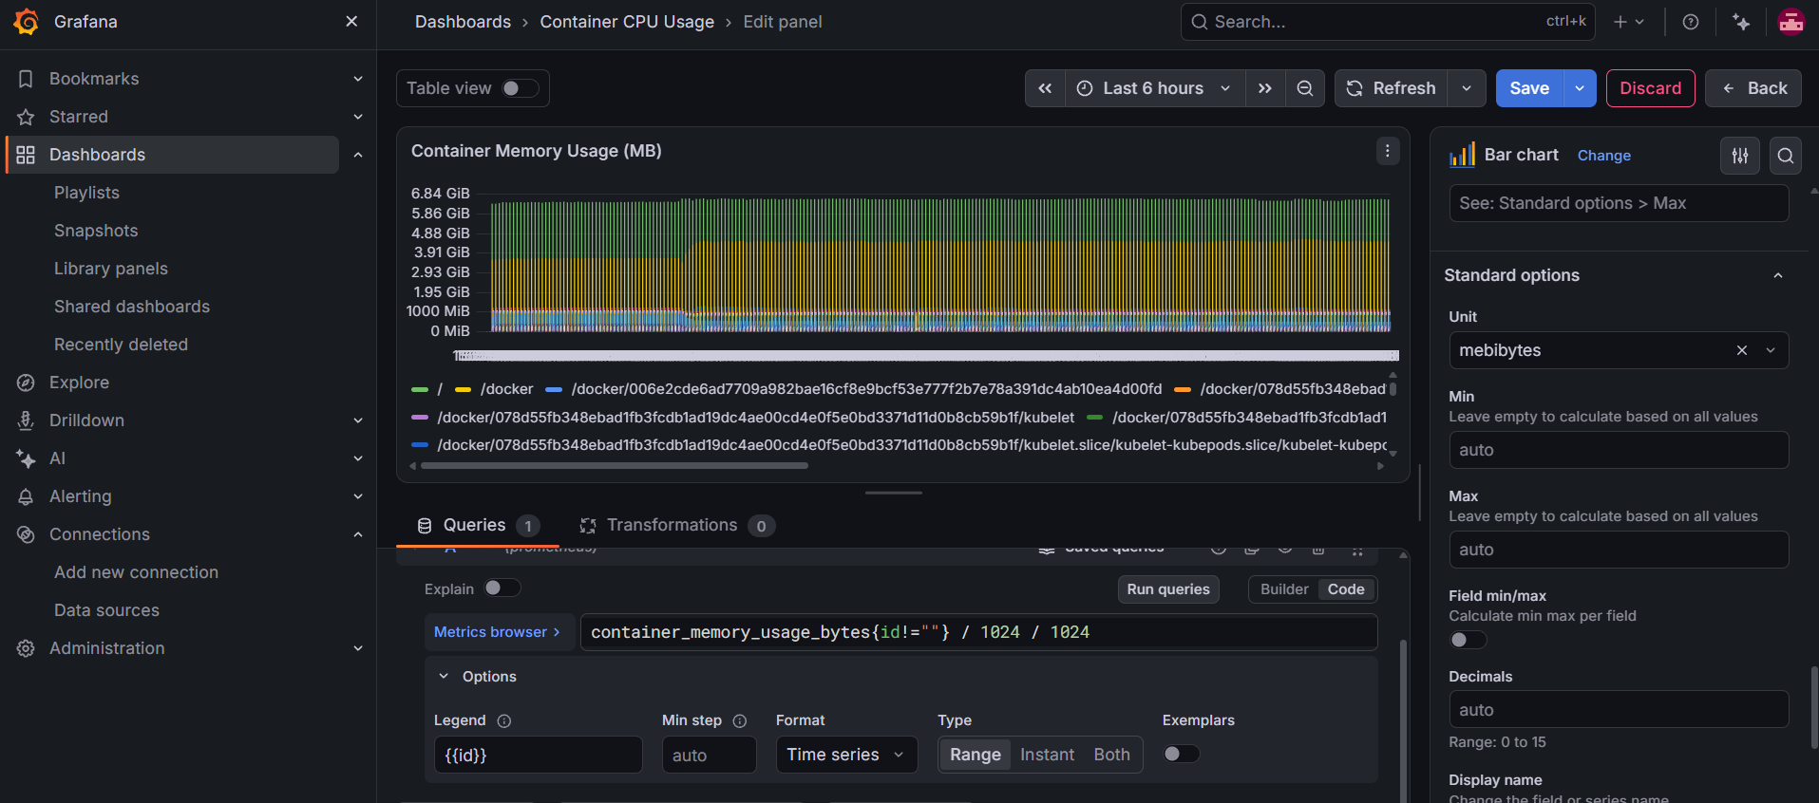
container_memory_usage_bytes{id!=""} / 1024 / 1024
legend = {{id}}
Panel 5 -- Disk Usage (Stat):
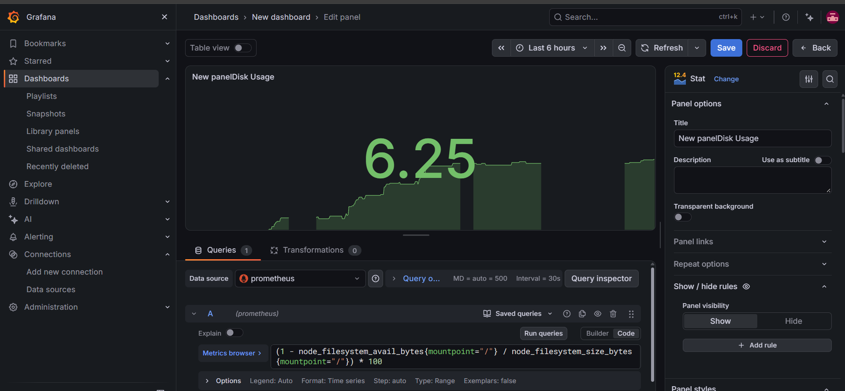
Task 5: Auto-Provision Datasources with YAML
In production, you do not click through the UI to add datasources. You provision them with configuration files so the setup is repeatable.
Create the provisioning directory structure:
mkdir -p grafana/provisioning/datasources
mkdir -p grafana/provisioning/dashboards
Create grafana/provisioning/datasources/datasources.yml:
apiVersion: 1

datasources:
- name: Prometheus
type: prometheus
access: proxy
url: http://prometheus:9090
isDefault: true
editable: false
Update the Grafana service in docker-compose.yml to mount the provisioning directory:
grafana:
image: grafana/grafana-enterprise:latest
container_name: grafana
ports:
- "3000:3000"
volumes:
- grafana_data:/var/lib/grafana
- ./grafana/provisioning:/etc/grafana/provisioning
environment:
- GF_SECURITY_ADMIN_USER=admin
- GF_SECURITY_ADMIN_PASSWORD=admin123
restart: unless-stopped
Restart Grafana:
docker compose up -d grafana
Check Connections > Data Sources -- Prometheus should already be there without any manual setup.
Document: Why is provisioning datasources via YAML better than configuring them manually through the UI?

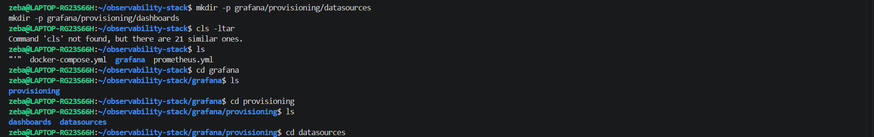
Datasource.yml
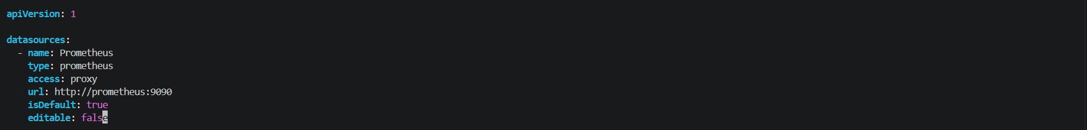

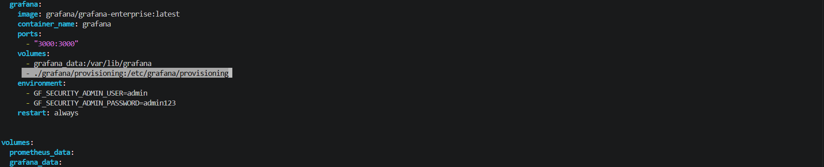
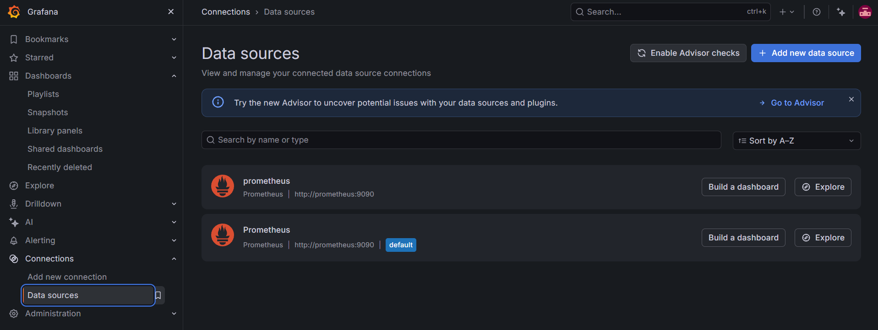
Why is provisioning datasources via YAML better than configuring them manually through the UI?
Advantages of YAML provisioning:

1. Automation: Datasources are configured
automatically when Grafana starts.

2. Consistency: The same configuration can
be reused across different environments.

3. Version Control: Configuration files can
be maintained in Git.

4. Reduced Manual Effort: No need to configure
datasources manually through the UI.

5. Reproducibility: Grafana configuration can
be recreated using the same YAML files.

Task 6: Import a Community Dashboard
The Grafana community maintains thousands of pre-built dashboards. Import one for Node Exporter:
- Go to Dashboards > New > Import
- Enter dashboard ID: 1860 (Node Exporter Full)
- Select your Prometheus datasource
- Click Import
Explore the imported dashboard. It has dozens of panels covering CPU, memory, disk, network, and more -- all built on the same Node Exporter metrics you queried manually.
Try another one: Import dashboard ID 193 (Docker monitoring via cAdvisor). Select Prometheus as the datasource and explore container-level stats.
Your full docker-compose.yml should now have these services:
- prometheus
- node-exporter
- cadvisor
- grafana
- notes-app (from Day 73)
Verify all are running:
docker compose ps



