Day 57 – Resource Requests, Limits, and Probes

Task 1: Resource Requests and Limits
- Write a Pod manifest with resources.requests (cpu: 100m, memory: 128Mi) and resources.limits (cpu: 250m, memory: 256Mi)
- Apply and inspect with kubectl describe pod — look for the Requests, Limits, and QoS Class sections
- Since requests and limits differ, the QoS class is Burstable. If equal, it would be Guaranteed. If missing, BestEffort.
CPU is in millicores: 100m = 0.1 CPU. Memory is in mebibytes: 128Mi.
Requests = guaranteed minimum (scheduler uses this for placement). Limits = maximum allowed (kubelet enforces at runtime).
Verify: What QoS class does your Pod have?
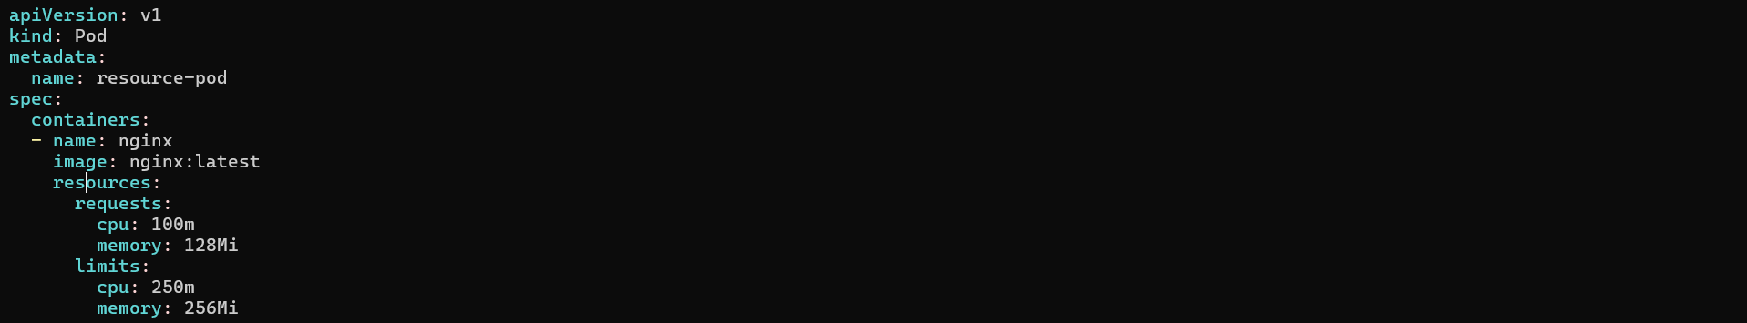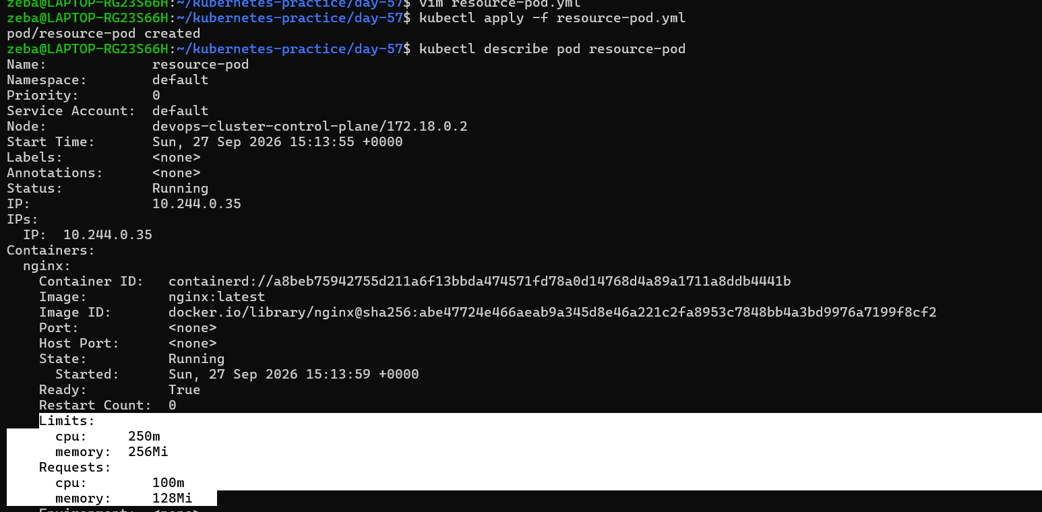
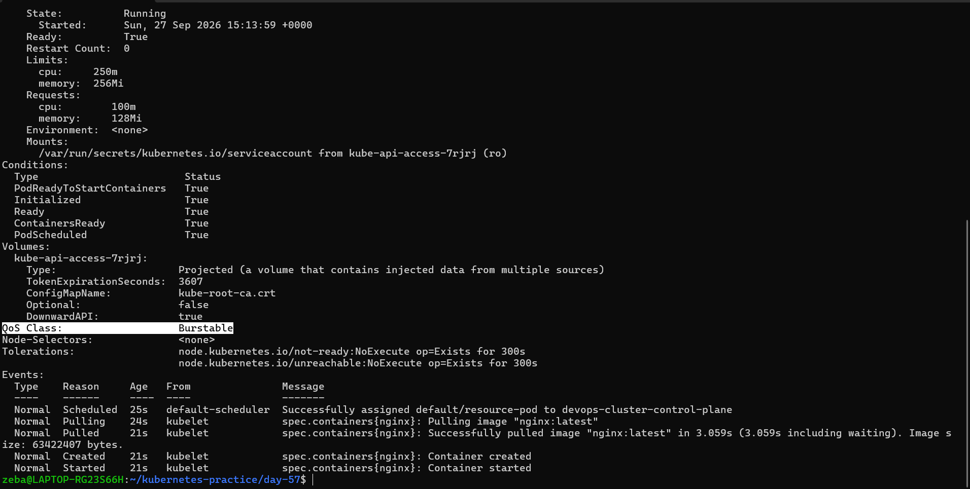

QoS = Quality of service
Kubernetes classifies pods Into QoS classes based on resource requests, limits
There are 3 QoS classes
- Guaranteed = requests and limits both are same
- Burstable = when both are different, when request can burst above to its normal requested amount but stays below the limit
- BestEffort = no requests and no limits,

Task 2: OOMKilled — Exceeding Memory Limits
- Write a Pod manifest using the polinux/stress image with a memory limit of 100Mi
- Set the stress command to allocate 200M of memory: command: ["stress"] args: ["--vm", "1", "--vm-bytes", "200M", "--vm-hang", "1"]
- Apply and watch — the container gets killed immediately
CPU is throttled when over limit. Memory is killed — no mercy.
Check kubectl describe pod for Reason: OOMKilled and Exit Code: 137 (128 + SIGKILL).
Verify: What exit code does an OOMKilled container have?
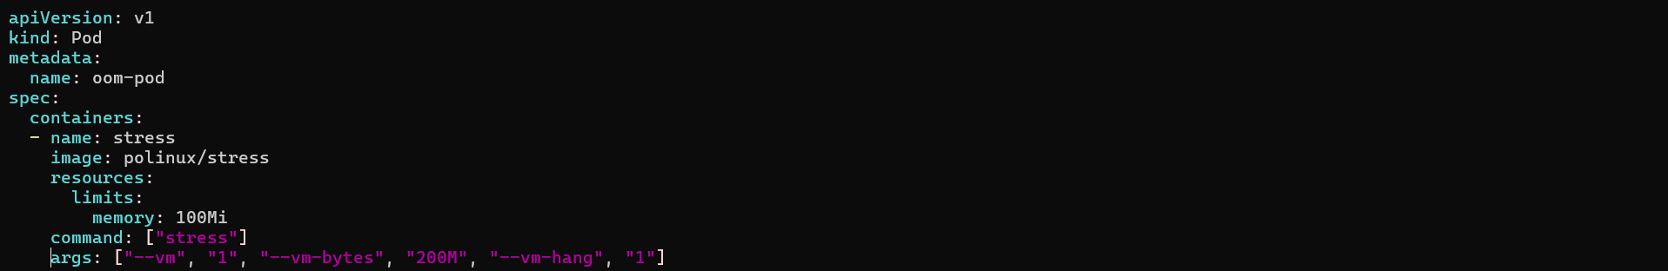
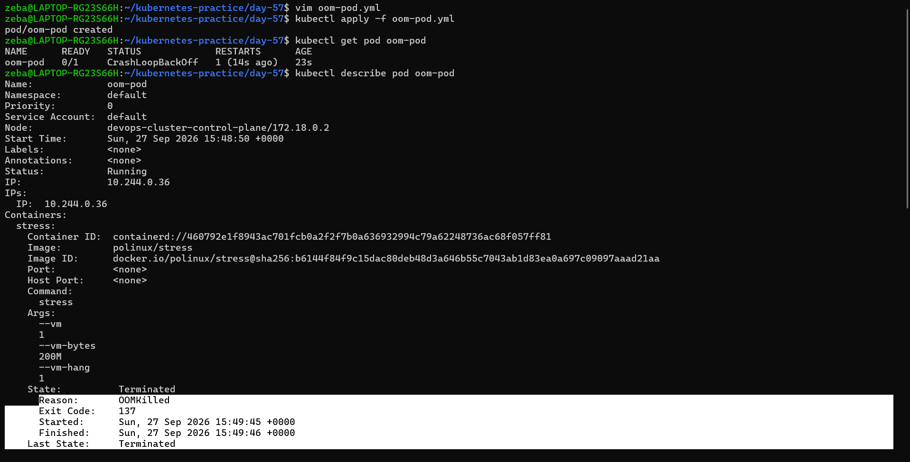
OOM = Out of memory
Task 3: Pending Pod — Requesting Too Much
- Write a Pod manifest requesting cpu: 100 and memory: 128Gi
- Apply and check — STATUS stays Pending forever
- Run kubectl describe pod and read the Events — the scheduler says exactly why: insufficient resources
Verify: What event message does the scheduler produce?
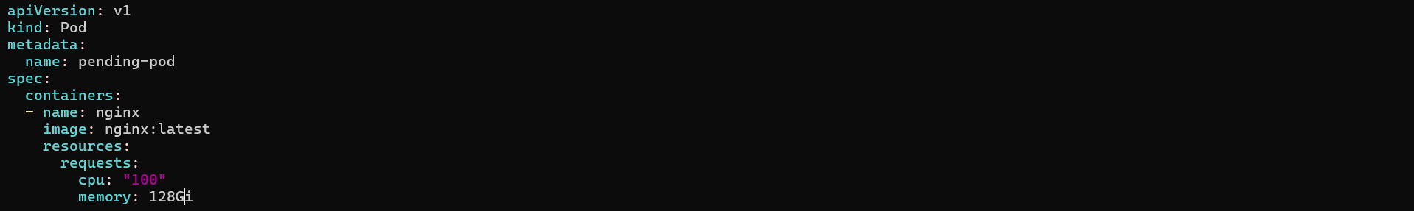
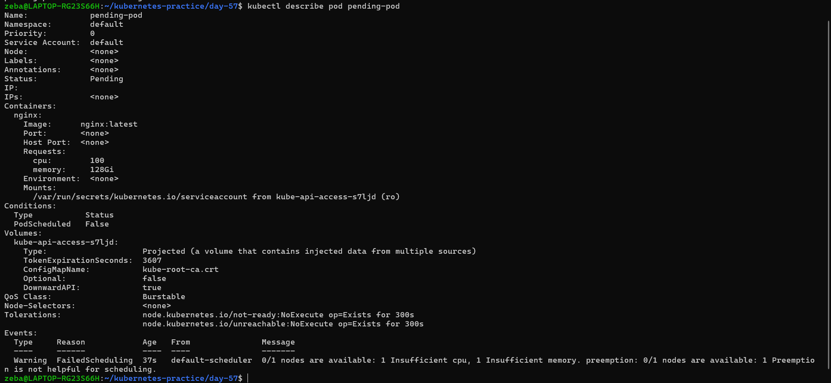
Task 4: Liveness Probe
A liveness probe detects stuck containers. If it fails, Kubernetes restarts the container.
- Write a Pod manifest with a busybox container that creates /tmp/healthy on startup, then deletes it after 30 seconds
- Add a liveness probe using exec that runs cat /tmp/healthy, with periodSeconds: 5 and failureThreshold: 3
- After the file is deleted, 3 consecutive failures trigger a restart. Watch with kubectl get pod -w
Verify: How many times has the container restarted?
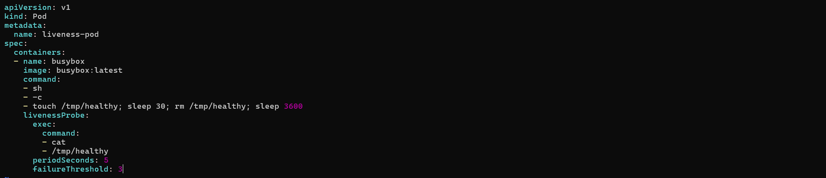
After 40 to 50 seconds

Task 5: Readiness Probe
A readiness probe controls traffic. Failure removes the Pod from Service endpoints but does NOT restart it.
- Write a Pod manifest with nginx and a readinessProbe using httpGet on path / port 80
- Expose it as a Service: kubectl expose pod <name> --port=80 --name=readiness-svc
- Check kubectl get endpoints readiness-svc — the Pod IP is listed
- Break the probe: kubectl exec <pod> -- rm /usr/share/nginx/html/index.html
- Wait 15 seconds — Pod shows 0/1 READY, endpoints are empty, but the container is NOT restarted
Verify: When readiness failed, was the container restarted?
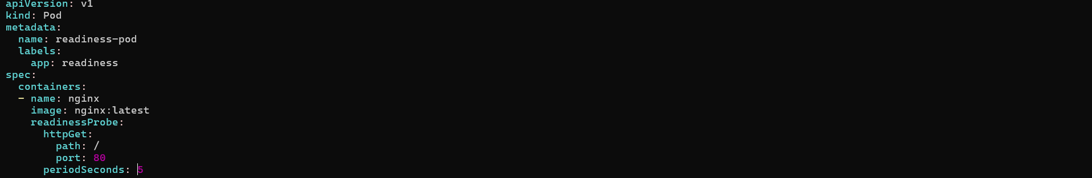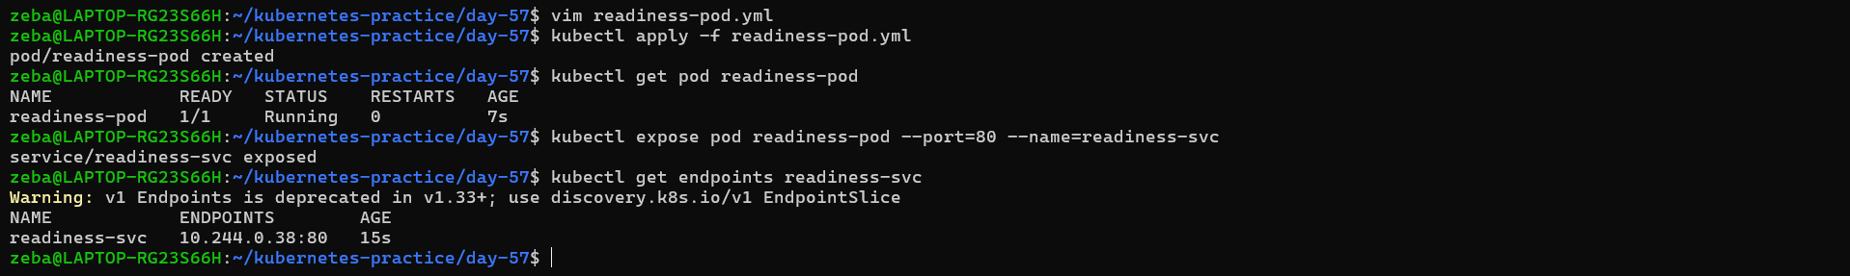
Task 6: Startup Probe
A startup probe gives slow-starting containers extra time. While it runs, liveness and readiness probes are disabled.
- Write a Pod manifest where the container takes 20 seconds to start (e.g., sleep 20 && touch /tmp/started)
- Add a startupProbe checking for /tmp/started with periodSeconds: 5 and failureThreshold: 12 (60 second budget)
- Add a livenessProbe that checks the same file — it only kicks in after startup succeeds
Verify: What would happen if failureThreshold were 2 instead of 12?
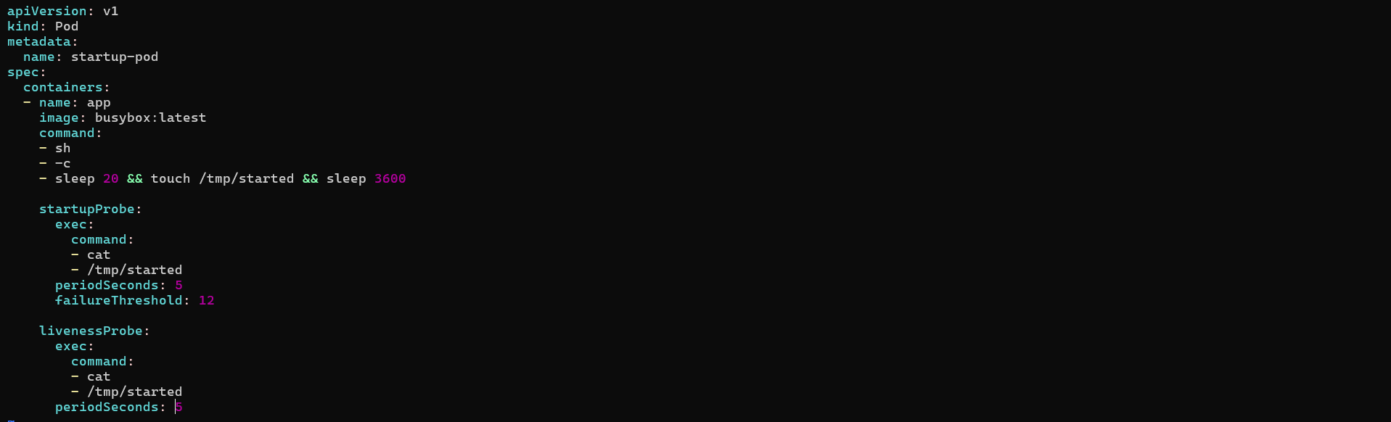
After 20 seconds

Probe | Simple question | If it fails

🟢 Startup | "Have you started?" | Container can be restarted

❤️ Liveness | "Are you still alive?" | Restart container

🔵 Readiness | "Are you ready for traffic?" | Stop sending traffic

Task 7: Clean Up
Delete all pods and services you created.

