Quick Concepts (write 1–2 bullets each)
- OSI layers (L1–L7) vs TCP/IP stack (Link, Internet, Transport, Application)
- Where IP, TCP/UDP, HTTP/HTTPS, DNS sit in the stack
- One real example: “curl https://example.com = App layer over TCP over IP”

OSI (Open System Interconnection model)

7 layers of OSI (Open system interconnection) model are
L1 = physical layer
- transmits the bits (0s and 1s)/physically carries the digital data over cables
- Signals, cables, bits
L2 = date link layer
- It handles the mac addresses, frames and switches which are responsible for the communication over same network
- communication within the local network.
- MAC Address = identifies the device, frames = packets of the data, switch = forward the frames In the network
L3 = network layer
- Handles the ip address (logical addressing) and routes the packets over different networks
- used for routing between different networks

L4 = transport layer
- it provides end-to-end communication, flow control
- UDP(User datagram protocol), TCP(transmission control protocol) –
- TCP – data transfer without data loss
- UDP – for data streaming with data loss
L5 = session
- It establishes, manages, and terminates the communication session between applications
- Authentication happens
L6 = presentation layer
- It handles formatting (Converts data into a format which applications can understand), encryption/decryption and compression of the data
L7 = application layer
- Provides network services directly to applications
- HTTPS/ DNS/ HTTP/ FTP

TCP/IP model

L1, l2 = Link - handles physical transmission, frames, and MAC addressing
L3 = internet - handles IP addressing and routing
L4 = transport - provides TCP/UDP communication between devices
L5-L7 = application - provides protocols such as HTTP, DNS, SSH, FTP.

Where IP, TCP/UDP, HTTP/HTTPS, DNS sit in the stack
- IP = network layer
- TCP/UDP = transport layer
- HTTP/HTTPS, DNS = application layer

Hands-on Checklist (run these; add 1–2 line observations)
- Identity: hostname -I (or ip addr show) — note your IP.
- Reachability: ping <target> — mention latency and packet loss.
- Path: traceroute <target> (or tracepath) — note any long hops/timeouts.
- Ports: ss -tulpn (or netstat -tulpn) — list one listening service and its port.
- Name resolution: dig <domain> or nslookup <domain> — record the resolved IP.
- HTTP check: curl -I <http/https-url> — note the HTTP status code.
- Connections snapshot: netstat -an | head — count ESTABLISHED vs LISTEN (rough).
Pick one target service/host (e.g., google.com, your lab server, or a local service) and stick to it for ping/traceroute/curl where possible.

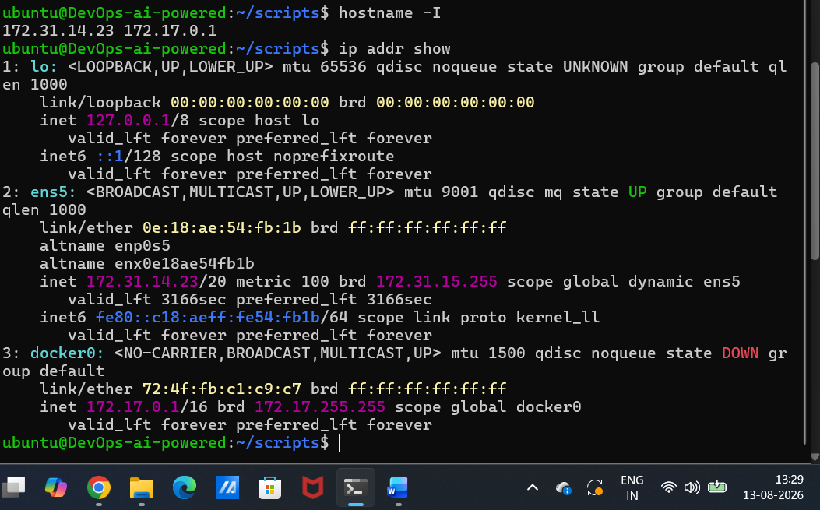
Hostname -I = it shows IP address
172.31.14.23 = EC2 instance private IP
172.17.0.1 = Dockers internal network IP

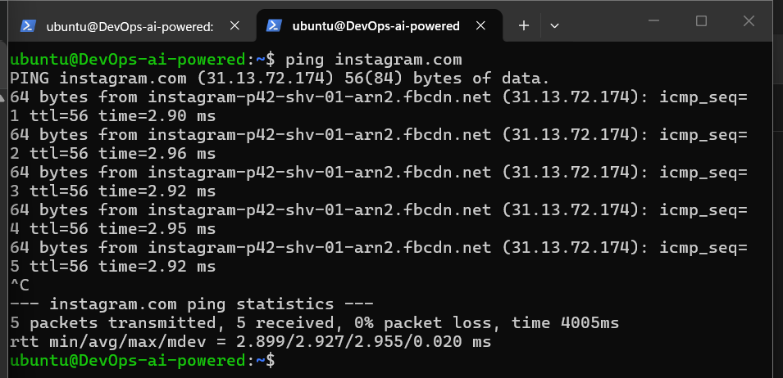
Latency is the amount of time it takes for data to travel from your computer to the destination and back.

From your ping output:
- Packet loss: 0%
  - 5 packets transmitted
  - 5 packets received
  - So, 0 packets were lost
- Latency (RTT):
  - Minimum: 2.899 ms
  - Average: 2.927 ms
  - Maximum: 2.955 ms

Path: traceroute <target> (or tracepath) — note any long hops/timeouts.
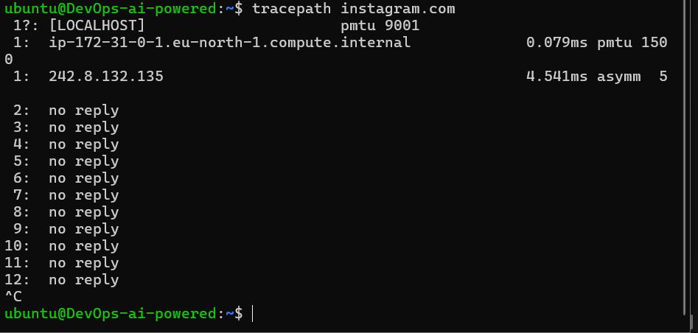

Ports: ss -tulpn (or netstat -tulpn) — list one listening service and its port.
This command shows which network ports are currently being listened to or used by processes on your Ubuntu server.

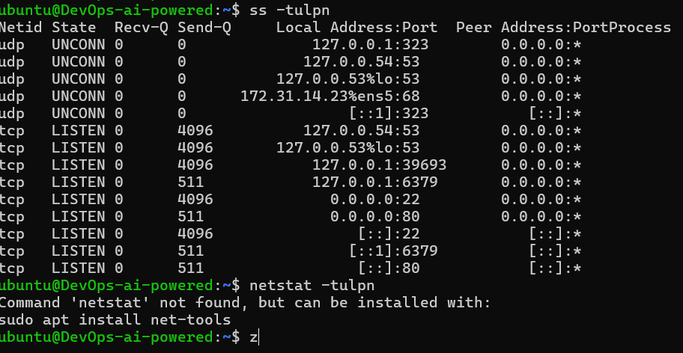

Name resolution: dig <domain> or nslookup <domain> — record the resolved IP.

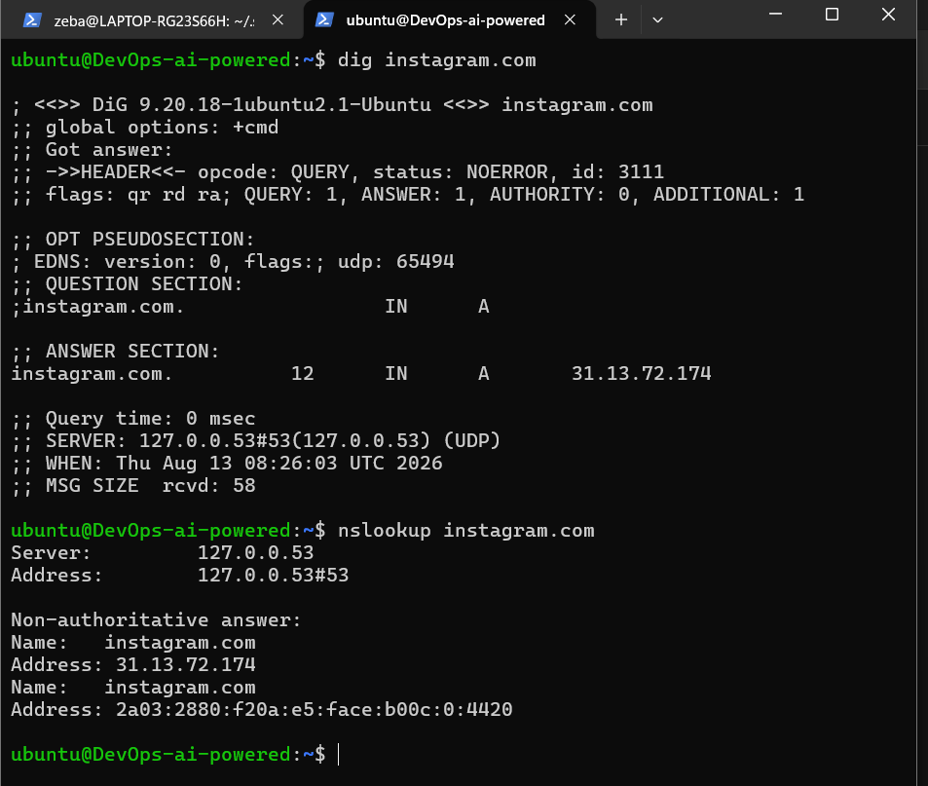
instagram.com. 12 IN A 31.13.72.174
This means:
- instagram.com → the domain you asked about
- A → IPv4 address record
- 31.13.72.174 → the IPv4 address returned by DNS

HTTP check: curl -I <http/https-url> — note the HTTP status code.
