Task 1: The Problem with Large Images
- Write a simple Go, Java, or Node.js app (even a "Hello World" is fine)
- Create a Dockerfile that builds and runs it in a single stage
- Build the image and check its size
Note down the size — you'll compare it later.

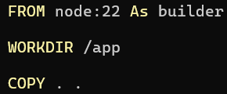
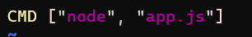
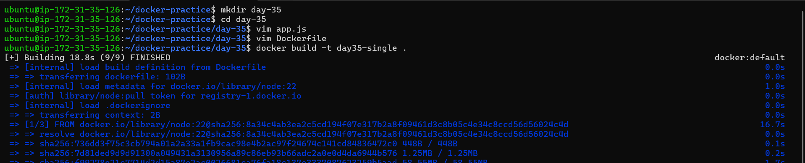

Task 2: Multi-Stage Build
- Rewrite the Dockerfile using multi-stage build:
  - Stage 1: Build the app (install dependencies, compile)
  - Stage 2: Copy only the built artifact into a minimal base image (alpine, distroless, or scratch)
- Build the image and check its size again
- Compare the two sizes
Write in your notes: Why is the multi-stage image so much smaller?
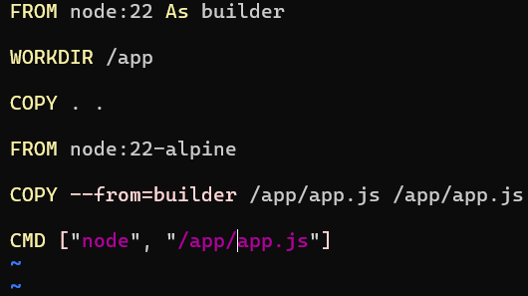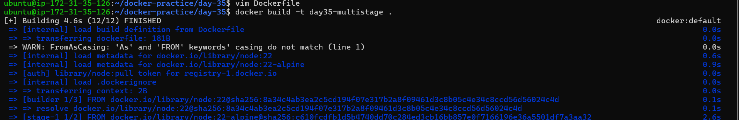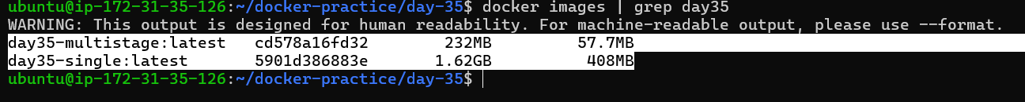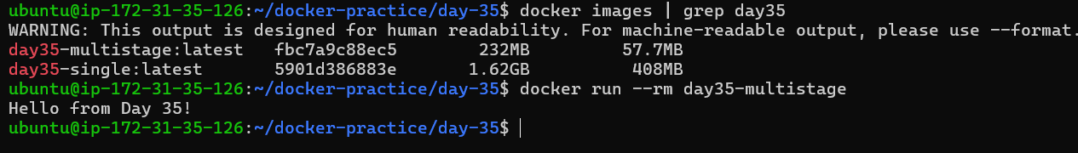

Task 3: Push to Docker Hub
- Create a free account on Docker Hub (if you don't have one)
- Log in from your terminal
- Tag your image properly: yourusername/image-name:tag
- Push it to Docker Hub
- Pull it on a different machine (or after removing locally) to verify

yourusername/image-name:tag

command to tag a image for docker hub is
docker tag <source image> <target image>
docker tag day35-multistage:latest zebatajmirji/day35-multistage:v1
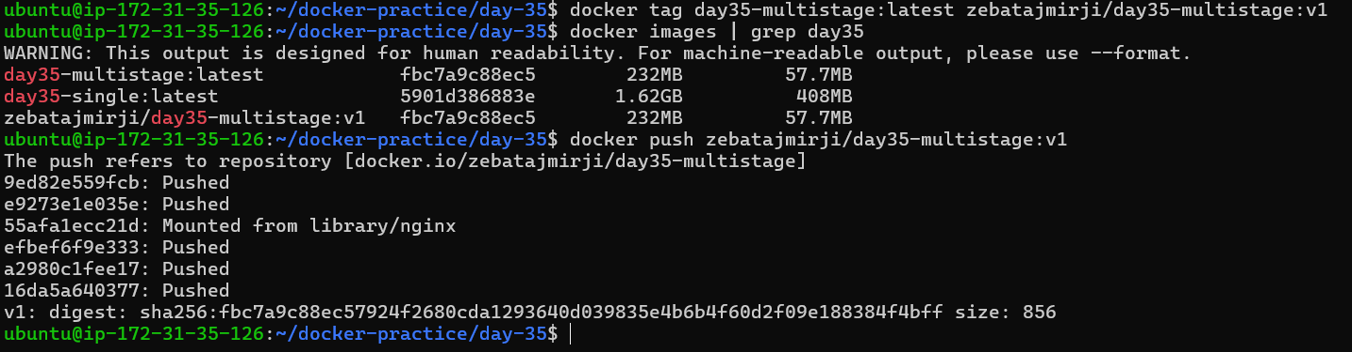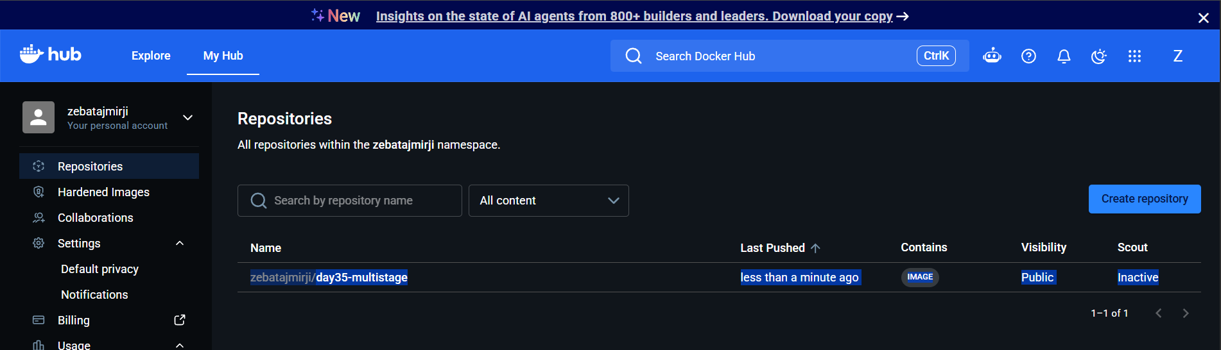

Pull it on a different machine (or after removing locally) to verify
We removed the image from our local to test with pull, image is present in docker hub
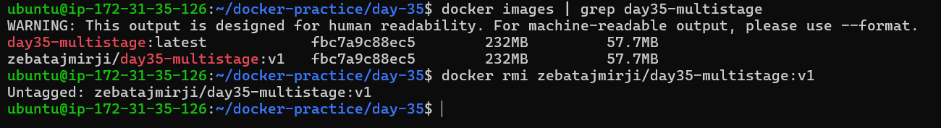
Pull successful
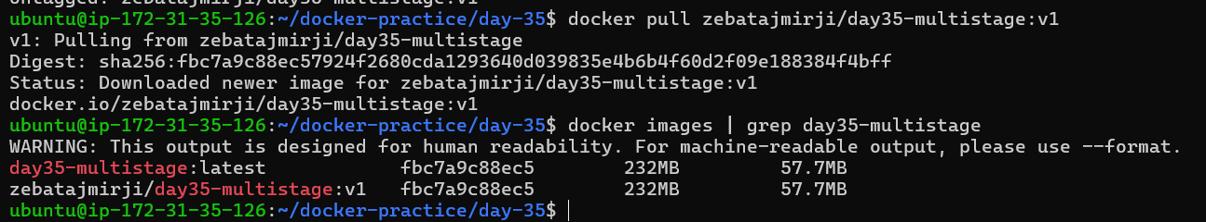

Task 4: Docker Hub Repository
- Go to Docker Hub and check your pushed image
- Add a description to the repository
- Explore the tags tab — understand how versioning works
- Pull a specific tag vs latest — what happens?

Go to Docker Hub and check your pushed image
Add a description to the repository
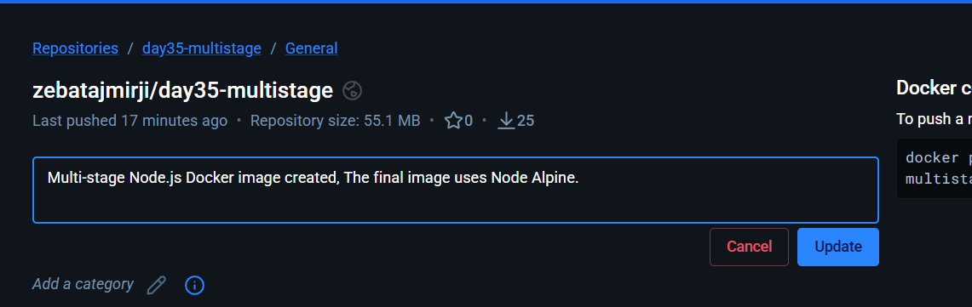
Explore the tags tab — understand how versioning works
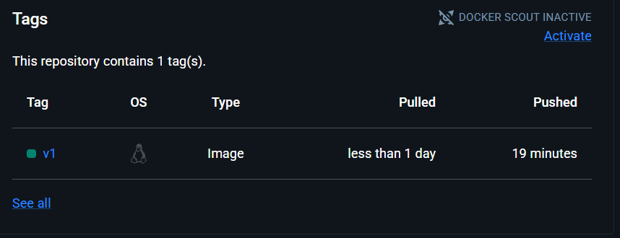
Pull a specific tag vs latest — what happens?
We are un able to pull latest tag image , why bcz latest image is npot present in th our docker hub, first we need to push it then only we can pull it

Task 5: Image Best Practices
Apply these to one of your images and rebuild:
- Use a minimal base image (alpine vs ubuntu — compare sizes)
- Don't run as root — add a non-root USER in your Dockerfile
- Combine RUN commands to reduce layers
- Use specific tags for base images (not latest)
Check the size before and after.
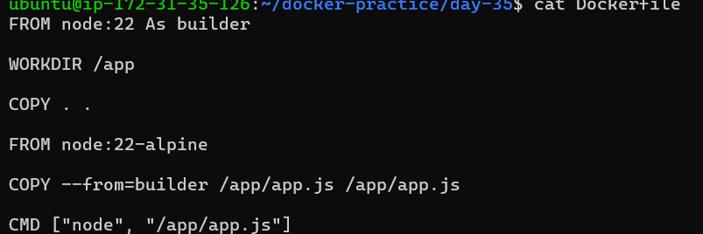
Image changed
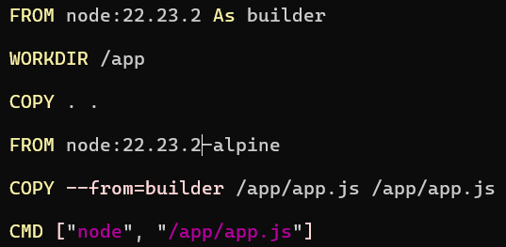
Built and checked size
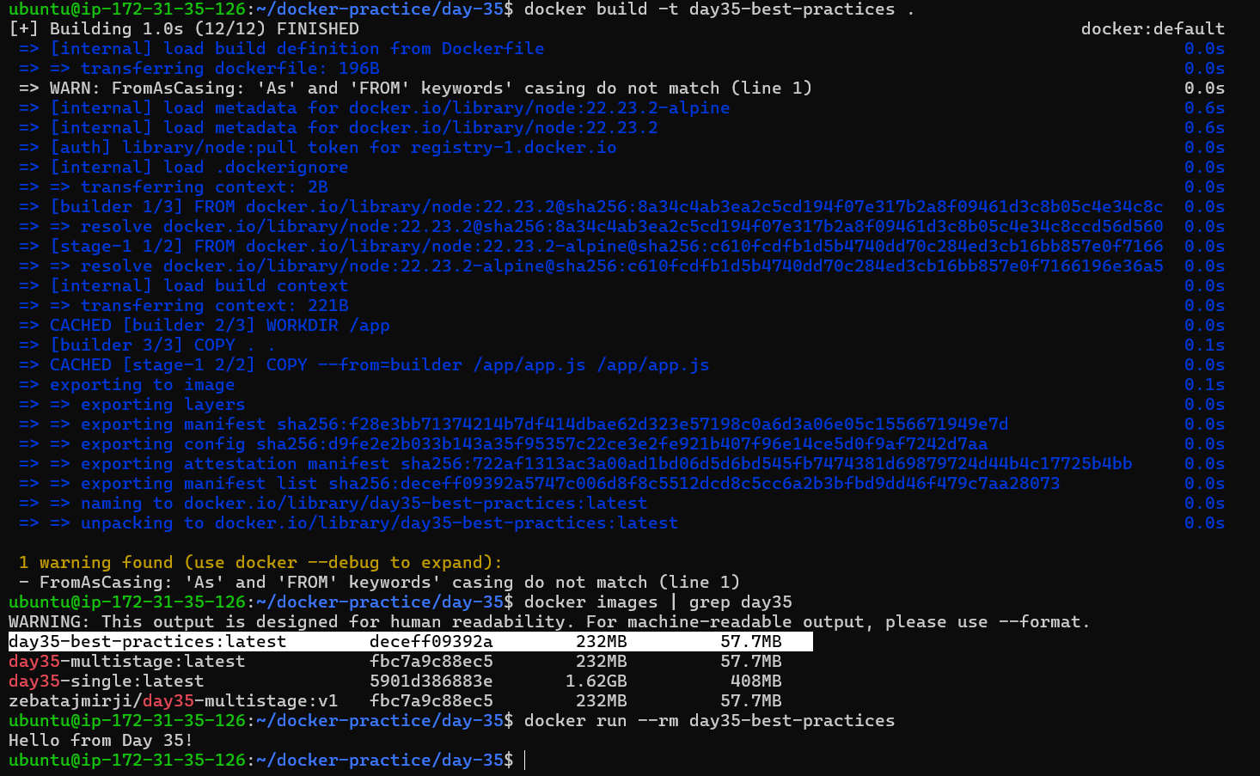
Don't run as root — add a non-root USER in your Dockerfile
- By default, many Docker containers run their main application as the root user inside the container.
Her we can see container is running as a root
- So we can add a non-root user
- Node image already provides a non-root user called: node
- --chown=node:node --- it will give node as a note by changing from root
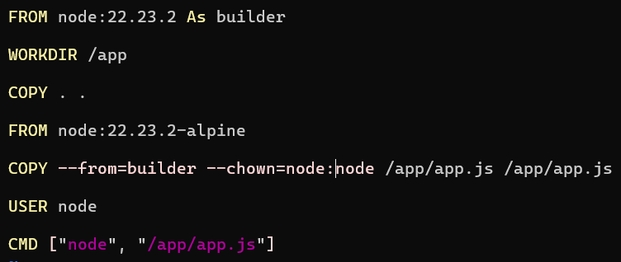
Here we can see container is running as a node
