Task 1: Understanding Ownership (10 minutes)
- Run ls -l in your home directory
- Identify the owner and group columns
- Check who owns your files
Format: -rw-r--r-- 1 owner group size date filename
Document: What's the difference between owner and group?

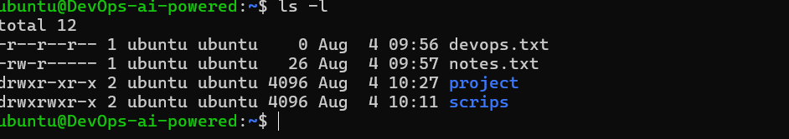

Owner | Group
The user who owns the file or directory. | A collection of users who share access to the file or directory.
The owner has permissions based on the owner permission bits. | All users in the group have permissions based on the group permission bits.
There can be only one owner for a file. | There can be only one group assigned to a file, but that group can have multiple users.

Task 2: Basic chown Operations (20 minutes)
- Create file devops-file.txt
- Check current owner: ls -l devops-file.txt
- Change owner to tokyo (create user if needed)
- Change owner to berlin
- Verify the changes
Try:
sudo chown tokyo devops-file.txt

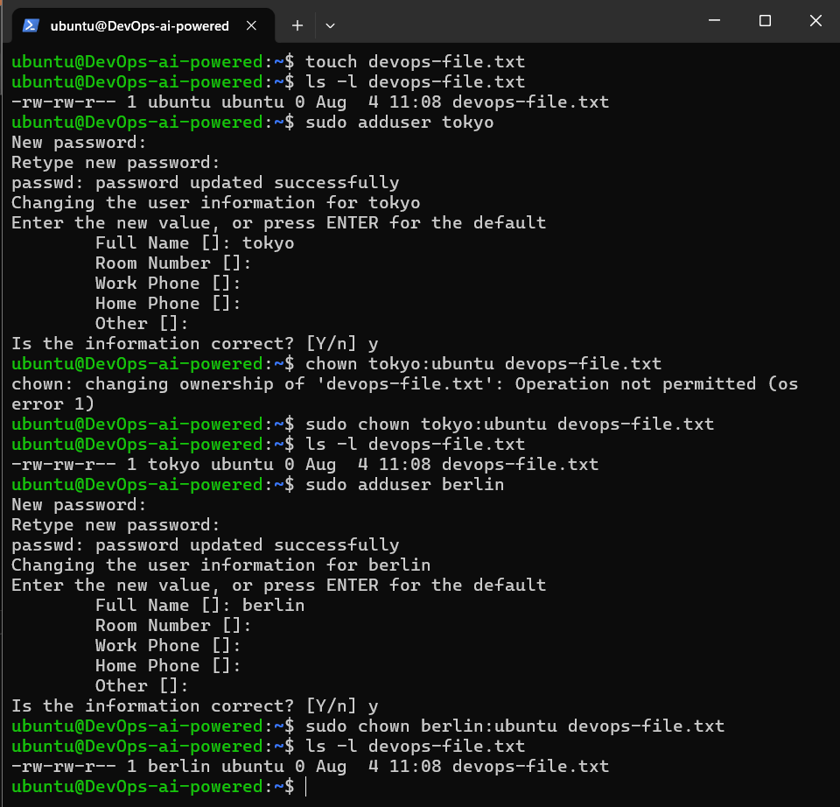
Task 3: Basic chgrp Operations (15 minutes)
- Create file team-notes.txt
- Check current group: ls -l team-notes.txt
- Create group: sudo groupadd heist-team
- Change file group to heist-team
- Verify the change
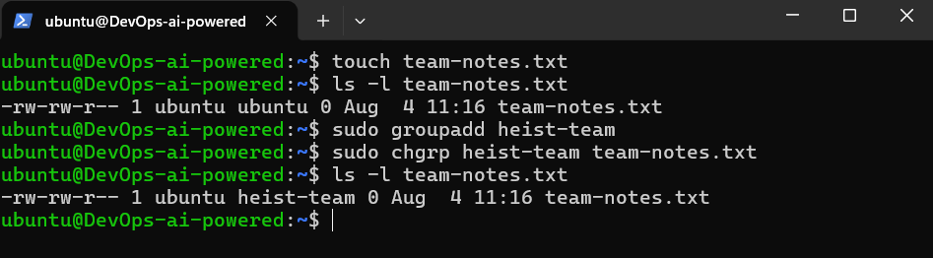
Task 4: Combined Owner & Group Change (15 minutes)
Using chown you can change both owner and group together:
- Create file project-config.yaml
- Change owner to professor AND group to heist-team (one command)
- Create directory app-logs/
- Change its owner to berlin and group to heist-team
Syntax: sudo chown owner:group filename

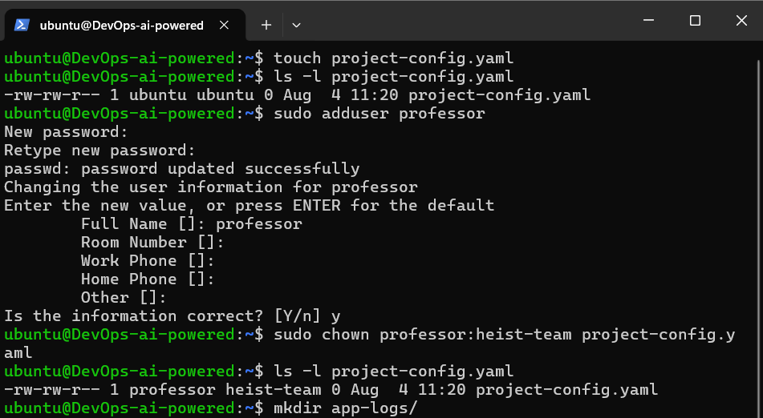
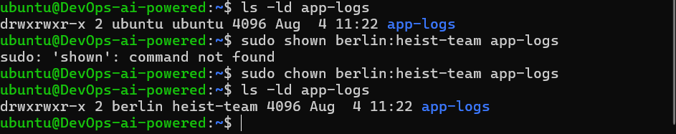
Task 5: Recursive Ownership (20 minutes)
- Create directory structure:
- mkdir -p heist-project/vault
- mkdir -p heist-project/plans
- touch heist-project/vault/gold.txt
- touch heist-project/plans/strategy.conf
- Create group planners: sudo groupadd planners
- Change ownership of entire heist-project/ directory:
  - Owner: professor
  - Group: plannersls -
  - Use recursive flag (-R)
- Verify all files and subdirectories changed: ls -lR heist-project/

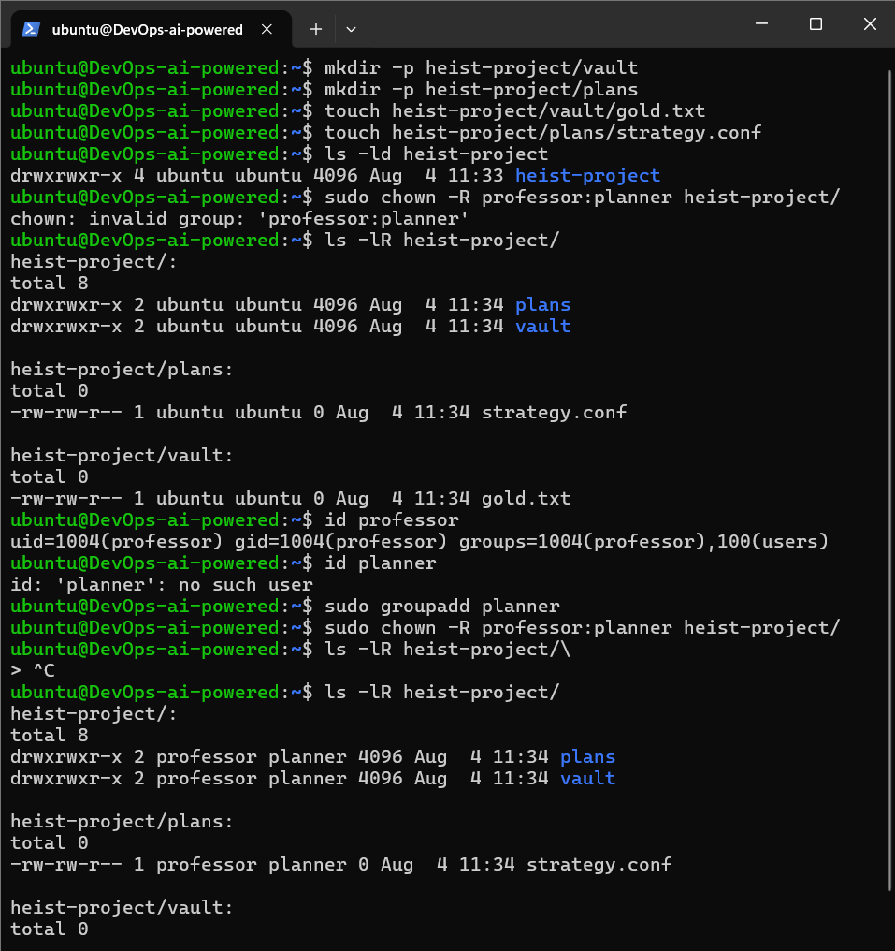
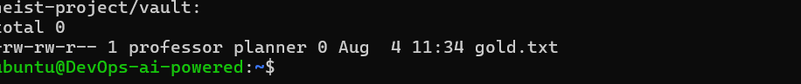
Task 6: Practice Challenge (20 minutes)
- Create users: tokyo, berlin, nairobi (if not already created)
- Create groups: vault-team, tech-team
- Create directory: bank-heist/
- Create 3 files inside:
- touch bank-heist/access-codes.txt
- touch bank-heist/blueprints.pdf
- touch bank-heist/escape-plan.txt
- Set different ownership:
  - access-codes.txt → owner: tokyo, group: vault-team
  - blueprints.pdf → owner: berlin, group: tech-team
  - escape-plan.txt → owner: nairobi, group: vault-team
Verify: ls -l bank-heist/

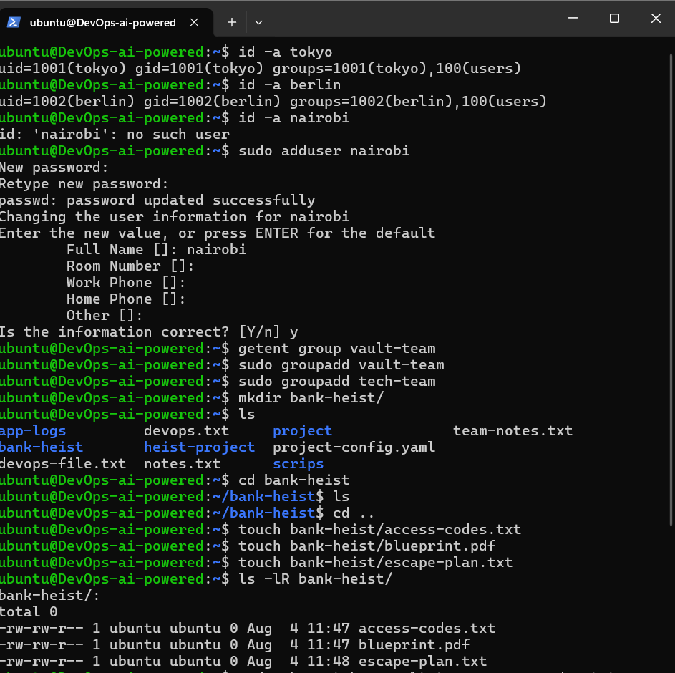
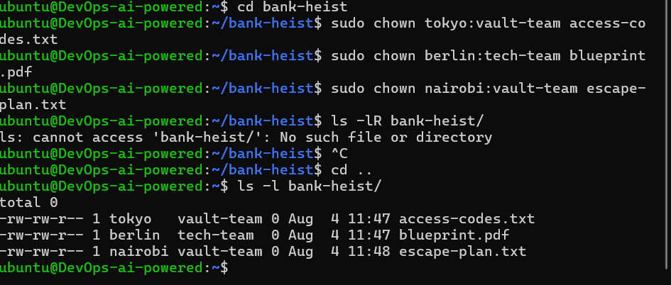

# View ownership
ls -l filename

# Change owner only
sudo chown newowner filename

# Change group only
sudo chgrp newgroup filename

# Change both owner and group
sudo chown owner:group filename

# Recursive change (directories)
sudo chown -R owner:group directory/

# Change only group with chown
sudo chown :groupname filename

