Why Services?
Every Pod gets its own IP address. But there are two problems:
- Pod IPs are not stable — when a Pod restarts or gets replaced, it gets a new IP
- A Deployment runs multiple Pods — which IP do you connect to?
A Service solves both problems. It provides:
- A stable IP and DNS name that never changes
- Load balancing across all Pods that match its selector
[Client] --> [Service (stable IP)] --> [Pod 1]
--> [Pod 2]
--> [Pod 3]

Task 1: Deploy the Application
First, create a Deployment that you will expose with Services. Create app-deployment.yaml:
apiVersion: apps/v1
kind: Deployment
metadata:
name: web-app
labels:
app: web-app
spec:
replicas: 3
selector:
matchLabels:
app: web-app
template:
metadata:
labels:
app: web-app
spec:
containers:
- name: nginx
image: nginx:1.25
ports:
- containerPort: 80
kubectl apply -f app-deployment.yaml
kubectl get pods -o wide
Note the individual Pod IPs. These will change if pods restart — that is the problem Services fix.
Verify: Are all 3 pods running? Note down their IP addresses.

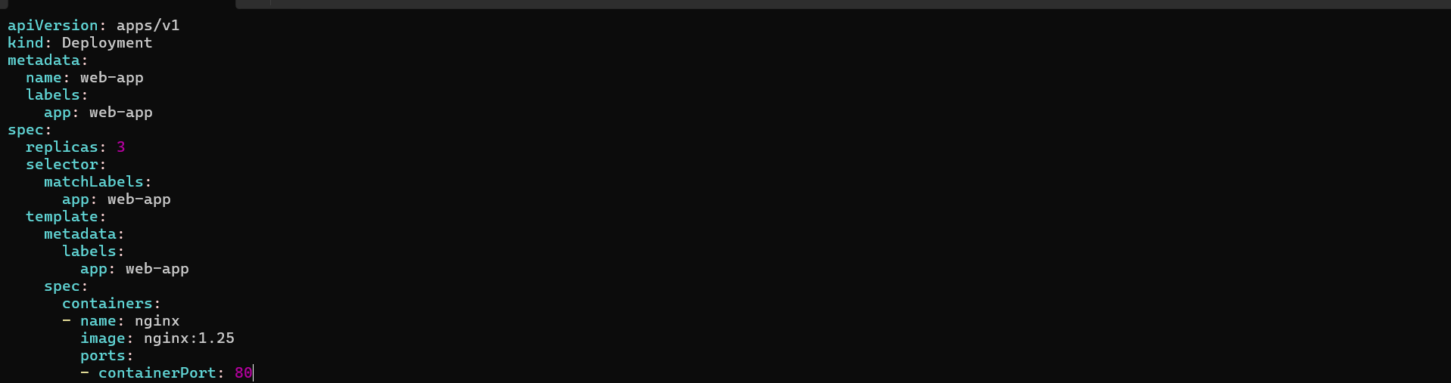
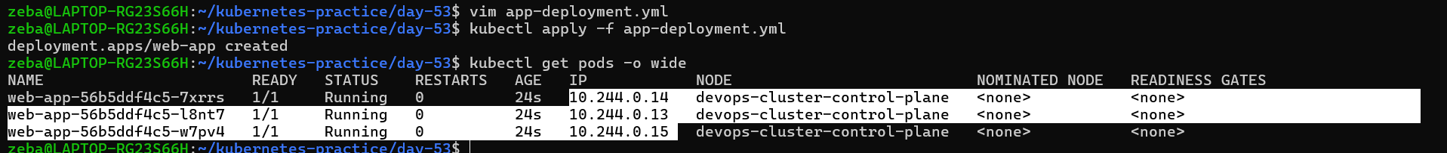
Created a deployment with 3 pods they have different Ips
10.244.0.14
10.244.0.13
10.244.0.15

Task 2: ClusterIP Service (Internal Access)
ClusterIP is the default Service type. It gives your Pods a stable internal IP that is only reachable from within the cluster.
Create clusterip-service.yaml:
apiVersion: v1
kind: Service
metadata:
name: web-app-clusterip
spec:
type: ClusterIP
selector:
app: web-app
ports:
- port: 80
targetPort: 80
Key fields:
- selector.app: web-app — this Service routes traffic to all Pods with the label app: web-app
- port: 80 — the port the Service listens on
- targetPort: 80 — the port on the Pod to forward traffic to
kubectl apply -f clusterip-service.yaml
kubectl get services
You should see web-app-clusterip with a CLUSTER-IP address. This IP is stable — it will not change even if Pods restart.
Now test it from inside the cluster:
# Run a temporary pod to test connectivity
kubectl run test-client --image=busybox:latest --rm -it --restart=Never -- sh

# Inside the test pod, run:
wget -qO- http://web-app-clusterip
exit
You should see the Nginx welcome page. The Service load-balanced your request to one of the 3 Pods.
Verify: Does the Service respond? Try running the wget command multiple times — the Service distributes traffic across all healthy Pods.

  - ClusterIP Service (Internal Access) - default
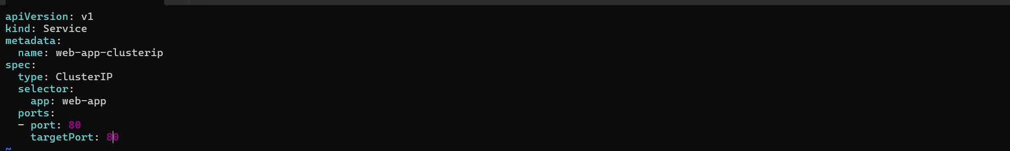
Key fields:
- selector.app: web-app — this Service routes traffic to all Pods with the label app: web-app
- port: 80 — the port the Service listens on
- targetPort: 80 — the port on the Pod to forward traffic to
Service created
10.96.26.217 – this IP is a stable ip , if pods restarts or deletes and creates new then also this IP wont change

# Run a temporary pod to test connectivity
kubectl run test-client --image=busybox:latest --rm -it --restart=Never -- sh

# Inside the test pod, run:
wget -qO- http://web-app-clusterip
exit
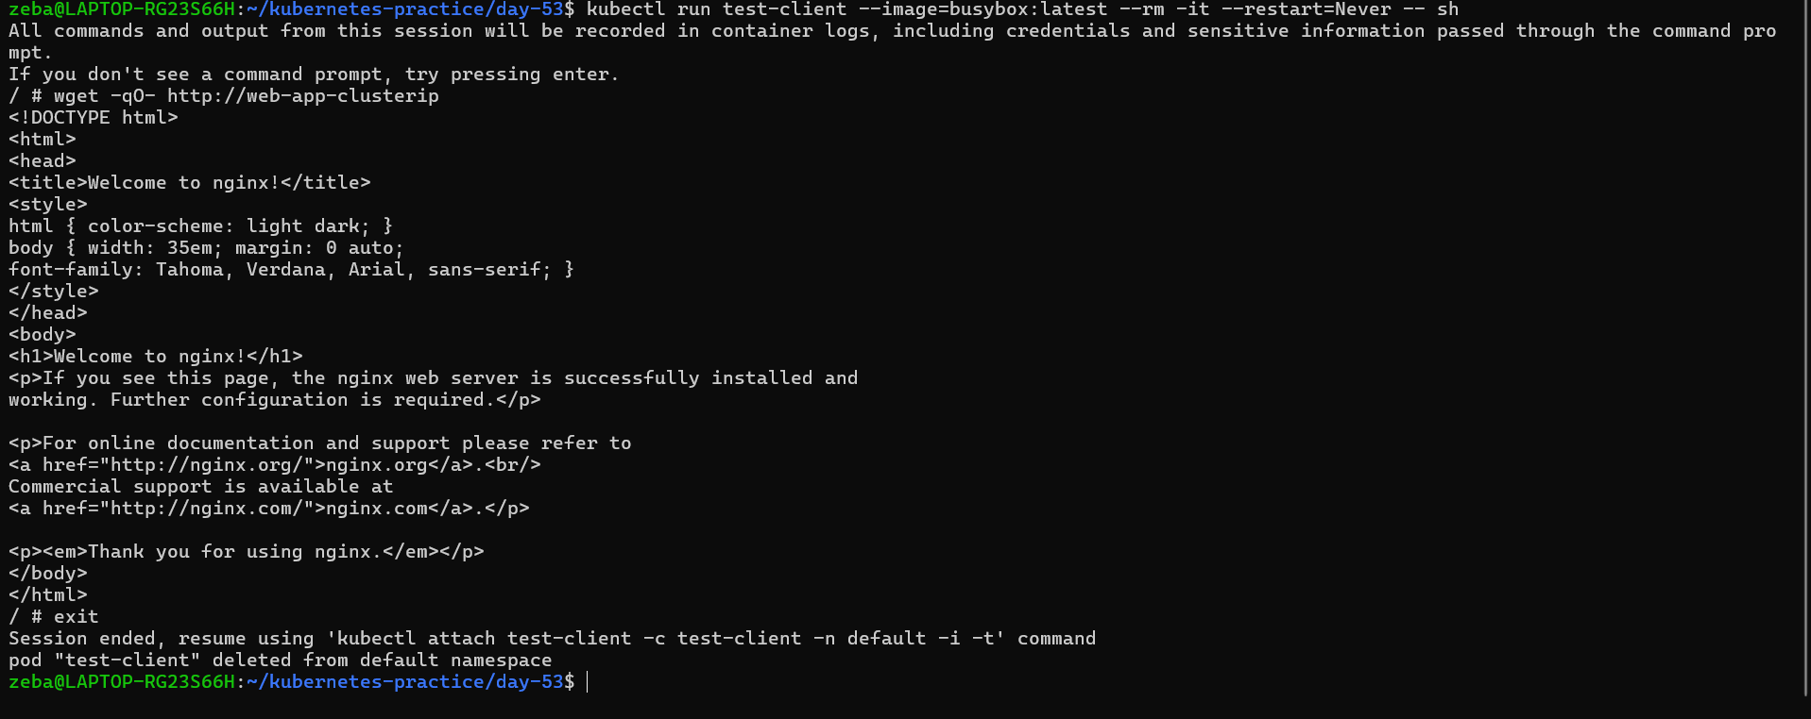
Task 3: Discover Services with DNS
Kubernetes has a built-in DNS server. Every Service gets a DNS entry automatically:
<service-name>.<namespace>.svc.cluster.local
Test this:
kubectl run dns-test --image=busybox:latest --rm -it --restart=Never -- sh

# Inside the pod:
# Short name (works within the same namespace)
wget -qO- http://web-app-clusterip

# Full DNS name
wget -qO- http://web-app-clusterip.default.svc.cluster.local

# Look up the DNS entry
nslookup web-app-clusterip
exit
Both the short name and the full DNS name resolve to the same ClusterIP. In practice, you use the short name when communicating within the same namespace and the full name when reaching across namespaces.
Verify: What IP does nslookup return? Does it match the CLUSTER-IP from kubectl get services?
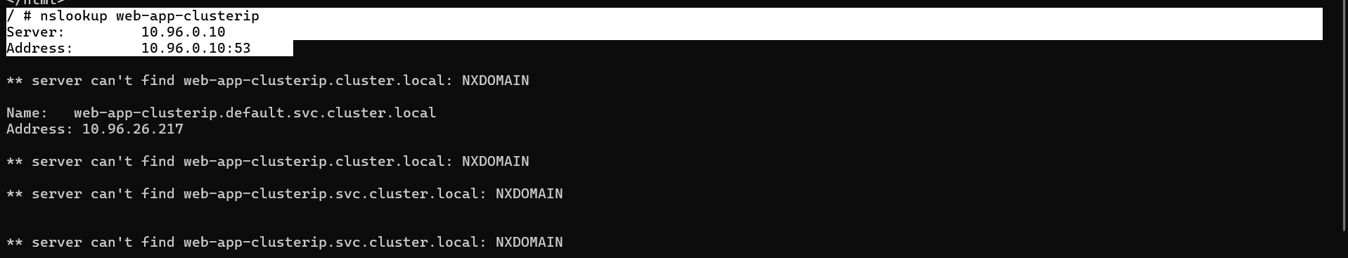
Check | IP

nslookup web-app-clusterip | 10.96.26.217

kubectl get services → web-app-clusterip | 10.96.26.217

Task 4: NodePort Service (External Access via Node)
A NodePort Service exposes your application on a port on every node in the cluster. This lets you access the Service from outside the cluster.
Create nodeport-service.yaml:
apiVersion: v1
kind: Service
metadata:
name: web-app-nodeport
spec:
type: NodePort
selector:
app: web-app
ports:
- port: 80
targetPort: 80
nodePort: 30080
- nodePort: 30080 — the port opened on every node (must be in range 30000-32767)
- Traffic flow: <NodeIP>:30080 -> Service -> Pod:80
kubectl apply -f nodeport-service.yaml
kubectl get services
Access the service:
# If using Minikube
minikube service web-app-nodeport --url

# If using Kind, get the node IP first
kubectl get nodes -o wide
# Then curl <node-internal-ip>:30080

# If using Docker Desktop
curl http://localhost:30080
Verify: Can you see the Nginx welcome page from your browser or terminal using the NodePort?

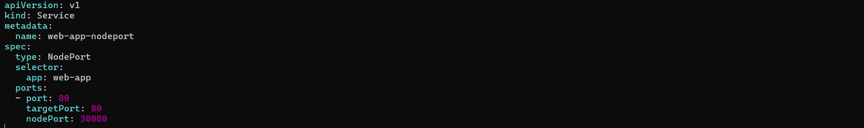
- nodePort: 30080 — the port opened on every node (must be in range 30000-32767)
- Traffic flow: <NodeIP>:30080 -> Service -> Pod:80
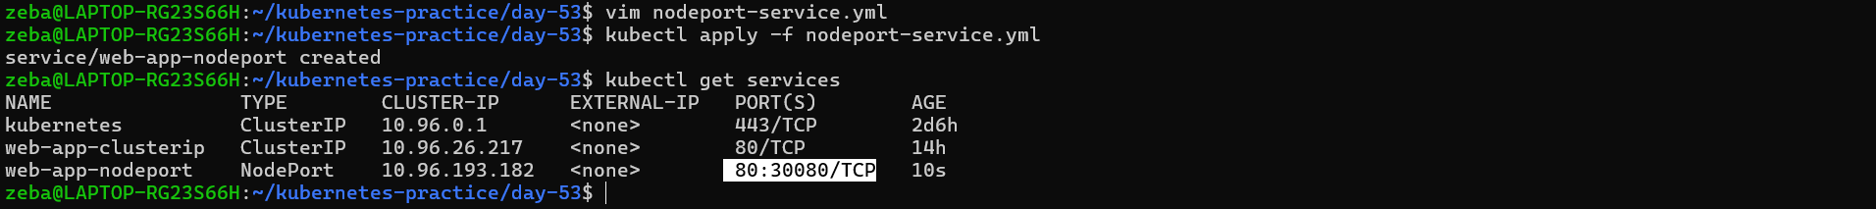
# If using Kind, get the node IP first
kubectl get nodes -o wide
# Then curl <node-internal-ip>:30080

# If using Docker Desktop
curl http://localhost:30080
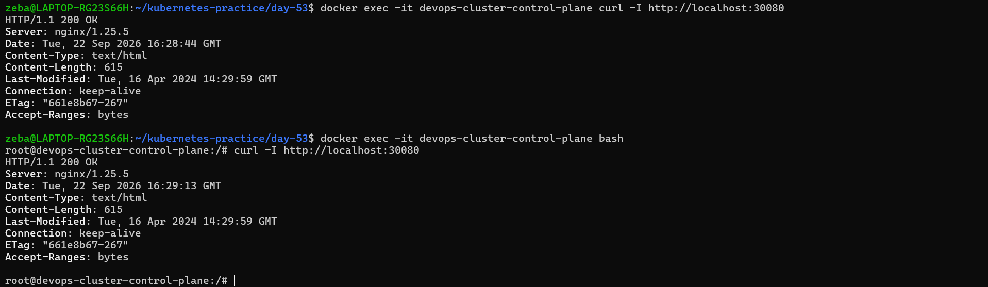
Task 5: LoadBalancer Service (Cloud External Access)
In a cloud environment (AWS, GCP, Azure), a LoadBalancer Service provisions a real external load balancer that routes traffic to your nodes.
Create loadbalancer-service.yaml:
apiVersion: v1
kind: Service
metadata:
name: web-app-loadbalancer
spec:
type: LoadBalancer
selector:
app: web-app
ports:
- port: 80
targetPort: 80
kubectl apply -f loadbalancer-service.yaml
kubectl get services
On a local cluster (Minikube, Kind, Docker Desktop), the EXTERNAL-IP will show <pending> because there is no cloud provider to create a real load balancer. This is expected.
If you are using Minikube:
# Minikube can simulate a LoadBalancer
minikube tunnel
# In another terminal, check again:
kubectl get services
In a real cloud cluster, the EXTERNAL-IP would be a public IP address or hostname provisioned by the cloud provider.
Verify: What does the EXTERNAL-IP column show? Why is it <pending> on a local cluster?
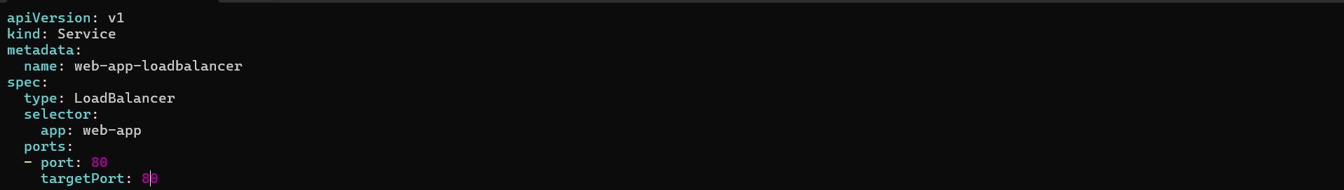 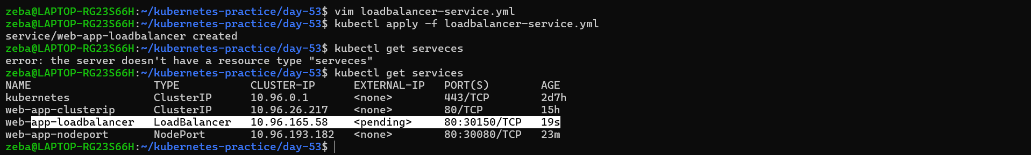 On a local cluster (Minikube, Kind, Docker Desktop), the EXTERNAL-IP will show <pending> because there is no cloud provider to create a real load balancer. This is expected.

Task 6: Understand the Service Types Side by Side
Check all three services:
kubectl get services -o wide
Compare them:
Type | Accessible From | Use Case
ClusterIP | Inside the cluster only | Internal communication between services
NodePort | Outside via <NodeIP>:<NodePort> | Development, testing, direct node access
LoadBalancer | Outside via cloud load balancer | Production traffic in cloud environments
Each type builds on the previous one:
- LoadBalancer creates a NodePort, which creates a ClusterIP
- So a LoadBalancer service also has a ClusterIP and a NodePort
Verify this:
kubectl describe service web-app-loadbalancer
You should see all three: a ClusterIP, a NodePort, and the LoadBalancer configuration.
Verify: Does the LoadBalancer service also have a ClusterIP and NodePort assigned?

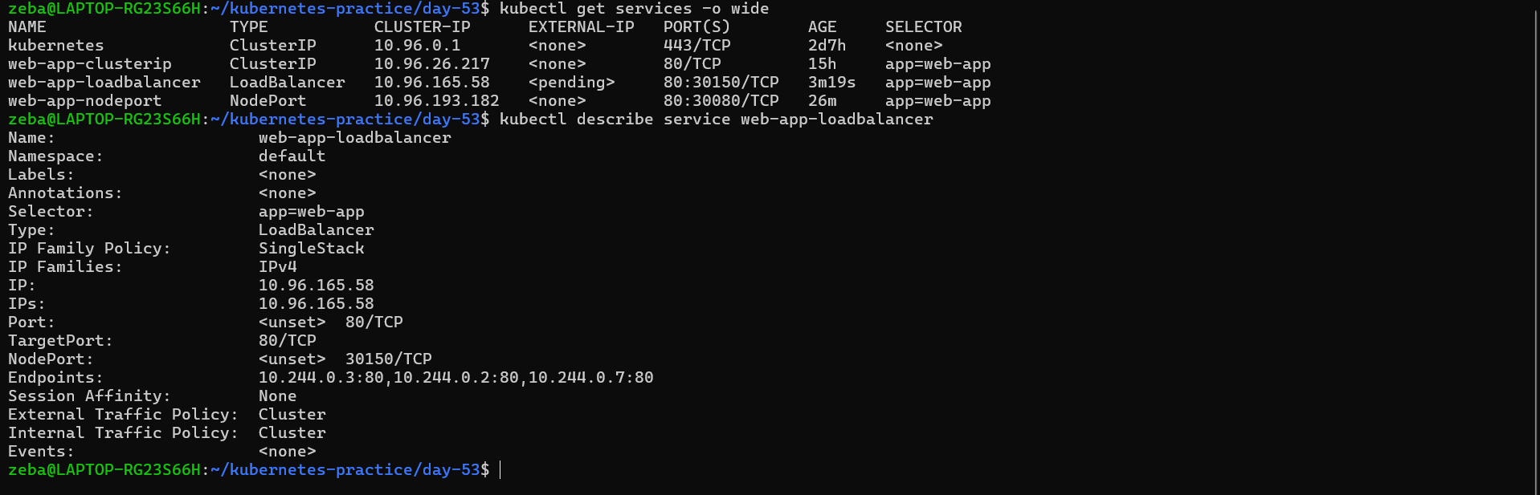
ClusterIP — internal door
=====================
Other Pod
↓
ClusterIP Service - 10.96.26.217:80
↓
Nginx Pods

NodePort — adds an outside door
=============================
Node │ port 30080
↓
web-app-nodeport ClusterIP :80
↓
Nginx Pods
NodePort 30080
↓
Service port 80
↓
Pod port 80

LoadBalancer — adds another layer
==============================
Load Balancer
│
↓
NodePort 30150
│
↓
ClusterIP 10.96.165.58
│
↓
Nginx Pods

Task 7: Clean Up
kubectl delete -f app-deployment.yaml
kubectl delete -f clusterip-service.yaml
kubectl delete -f nodeport-service.yaml
kubectl delete -f loadbalancer-service.yaml

kubectl get pods
kubectl get services
Only the built-in kubernetes service in the default namespace should remain.
Verify: Is everything cleaned up?
