Task 1: What is Docker?
Research and write short notes on:
- What is a container and why do we need them?
- Containers vs Virtual Machines — what's the real difference?
- What is the Docker architecture? (daemon, client, images, containers, registry)
Draw or describe the Docker architecture in your own words.

DOCKER: docker is a containerization tool, which provides virtual environment containing packages, libraries, OS, dependencies needed to run a code/application.

- What is a container and why do we need them?
Container is a light weight, isolated environment which we will use to run the application with all the dependencies it needed
We need containers because they:
- They packages application and its dependencies together
- They start quickly
- They use less resources than virtual machine
- Makes the application run consistently on different environment
- Make deployment and scaling easier

- Containers vs Virtual Machines — what's the real difference?

Containers | Virtual Machines
Share the host OS kernel | Have their own complete guest OS
Lightweight | Heavier
Start in seconds or less | Usually take longer to start
Use fewer CPU/RAM resources | Use more resources
Isolate applications/processes | Isolate complete operating systems
Can run many containers on one host | Usually fewer VMs due to higher resource usage

- What is the Docker architecture? (daemon, client, images, containers, registry)
Docker architecture is a client-server architecture
Main components are :
- Docker client
- Docker daemon
- Docker image
- Docker container
- Docker registry
Docker client:
Docker client is a command line interface which we will use to interact with the Docker.
Ex: docker run ubuntu
Client sends the request to docker daemon.
Docker Daemon:
Docker daemon (dockerd) runs at the background and does the actual docker work
It manages:
- Images
- Containers
- Network
- Volumes

Docker Image:
Image Is the read-only template which used to create containers
ubuntu:latest
nginx:latest

Docker container:
Docker container is the running/stopped instance of the image

Docker registry:
Docker registry stores docker images.
Docker Hub is a public registry

Docker Architecture diagram
Docker Registry
(Docker Hub)

Pull / Push

Docker daemon (dockerd)

docker client (CLI)
Commands
(CLI) (dockerd)

manages
Docker Resources
Images Containers Networks Volumes

Task 2: Install Docker
- Install Docker on your machine (or use a cloud instance)
- Verify the installation
- Run the hello-world container
- Read the output carefully — it explains what just happened

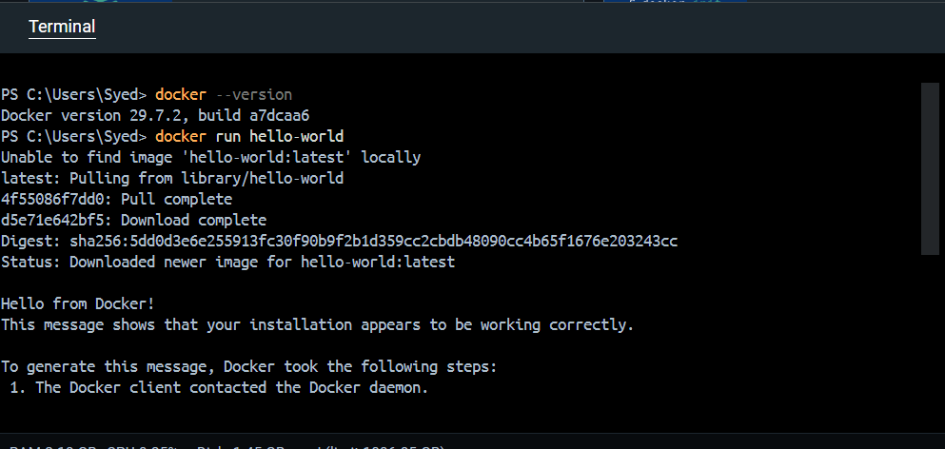 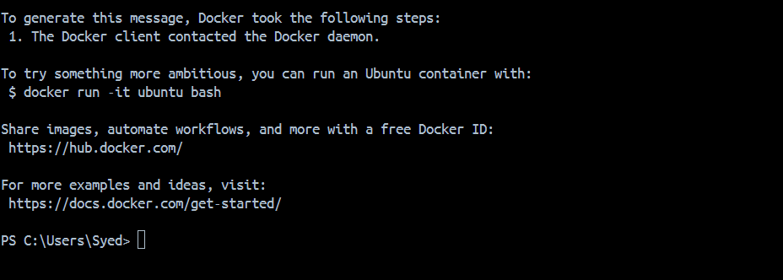 docker run hello-world -> Docker Client -> Docker Daemon ->Is hello-world image available locally? -> NO -> Pull image from Docker Hub -> Create container from image -> Start container -> Display "Hello from Docker!" -> Container exits

Important observation
The container doesn't keep running after printing the message. It performs its task and exits.

ask 3: Run Real Containers
- Run an Nginx container and access it in your browser
- Run an Ubuntu container in interactive mode — explore it like a mini Linux machine
- List all running containers
- List all containers (including stopped ones)
- Stop and remove a container

Run an Nginx container and access it in your browser
Command : docker run -d --name my-nginx -p 8080:80 nginx
- Docker run : create and start the container
- -d : euns in the background
- --name <name> : gives name to my container
- -p 8080:80 : conect my local port 8080 to nginx port 80
- Nginx : nginx image

In the browser run this
http://localhost:8080
we will see welcome to nginx page
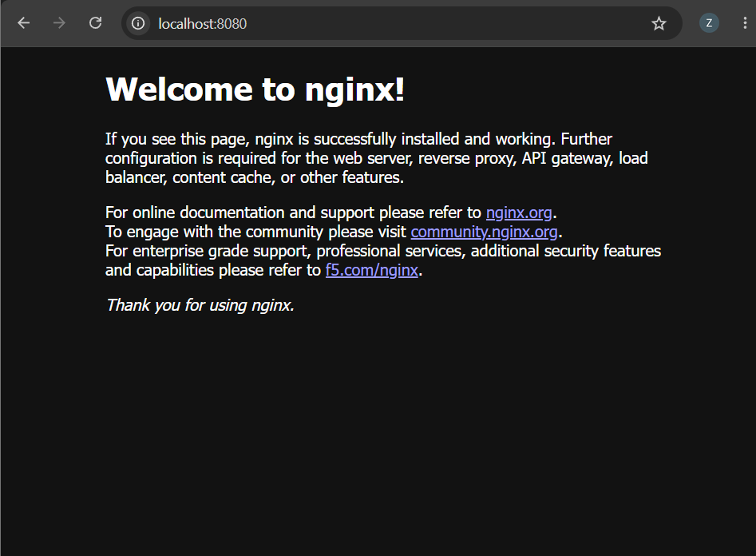

Run an Ubuntu container in interactive mode — explore it like a mini Linux machine
Command : docker run -it --name my-ubuntu ubuntu
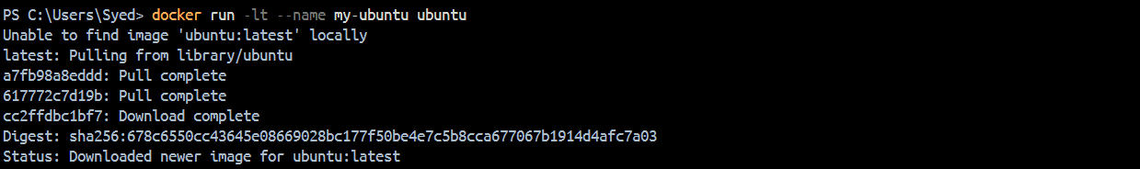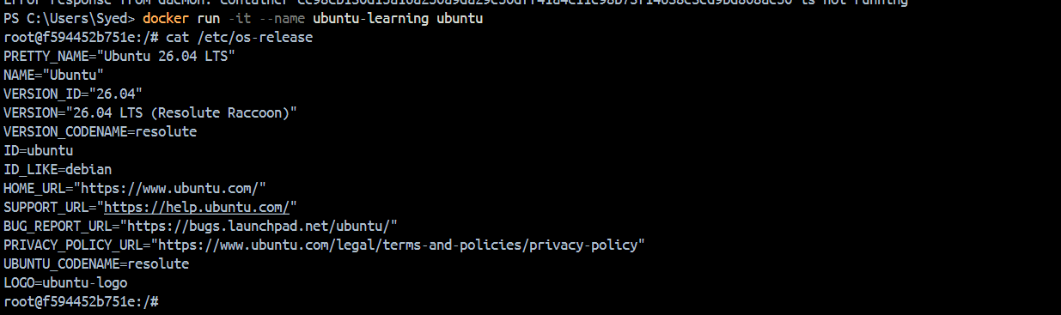
List all running containers
List all containers (including stopped ones)
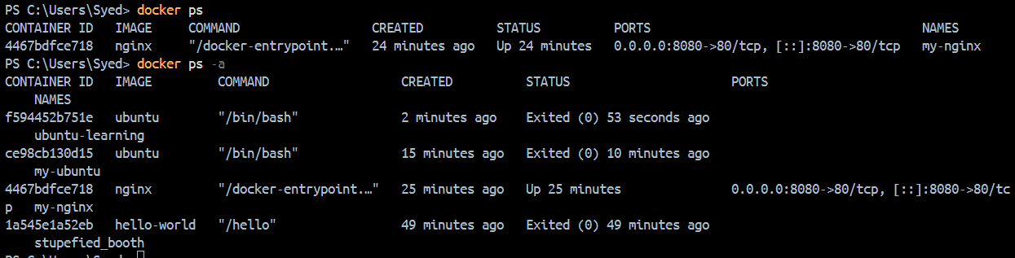
Stop and remove a container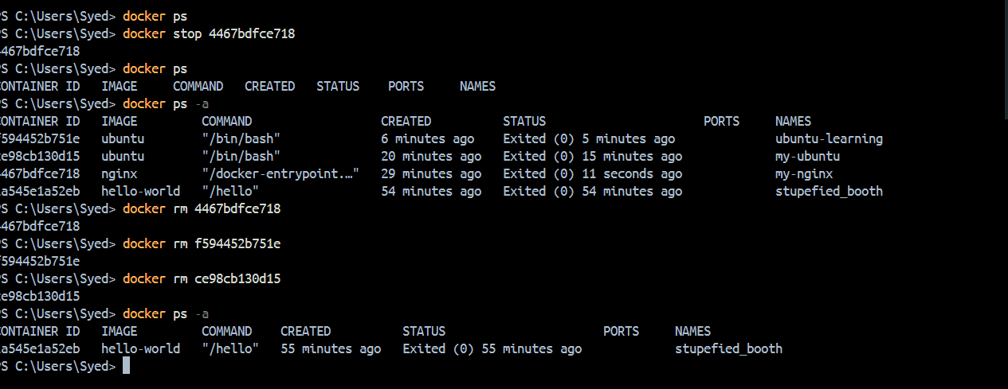

Task 4: Explore
- Run a container in detached mode — what's different?
- Give a container a custom name
- Map a port from the container to your host
- Check logs of a running container
- Run a command inside a running container

