LINUIX VOLUMES AND LVM

- sudo su or sudo i
- lsblk
- pvs
- pvdisplay
- pvcreate /dev/sdf dev/sdg
- vgcreate <name> /dev/sdf dev/sdg
- vgs
- vgshow
- vgdisplay
- lvcreate -L <size> -n <lv-name> <vg-name>
disk -> physical volume (PV) -> Volume group (VG) -> Logical volume (LV) -> File system -> mount

Day 13 -- Linux Volume Management (LVM)
Objective
Learn how to manage storage using LVM by creating a Physical Volume
(PV), Volume Group (VG), Logical Volume (LV), filesystem, and mount
point, and by extending the LV.
Practice Environment
No spare physical disk was used. A 1 GiB virtual disk image was created
and attached as a loop device.
The practice device used was:
/dev/loop0
Important: /dev/loop0 was used instead of /dev/sdb because it
was the virtual practice disk created for this lab.

Task 0 -- Create a Virtual Disk
dd if=/dev/zero of=/tmp/disk1.img bs=1M count=1024
losetup -fP /tmp/disk1.img
losetup -a
The file /tmp/disk1.img was created as a 1 GiB virtual disk and
attached to /dev/loop0.
Screenshot
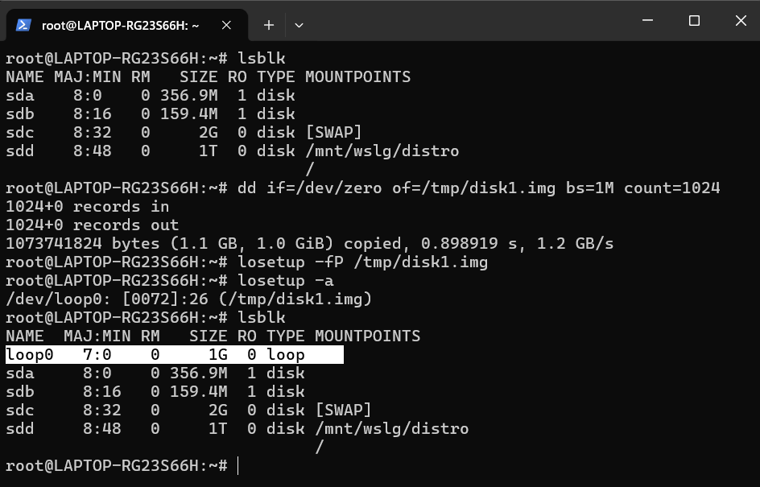

Task 1 -- Check Current Storage
Run: lsblk, pvs, vgs, lvs, df -h

Commands used:
lsblk
pvs
vgs
lvs
df -h
What I checked
- lsblk -- listed the available block devices.
- pvs -- checked existing Physical Volumes.
- vgs -- checked existing Volume Groups.
- lvs -- checked existing Logical Volumes.
- df -h -- checked mounted filesystem usage.
Screenshot
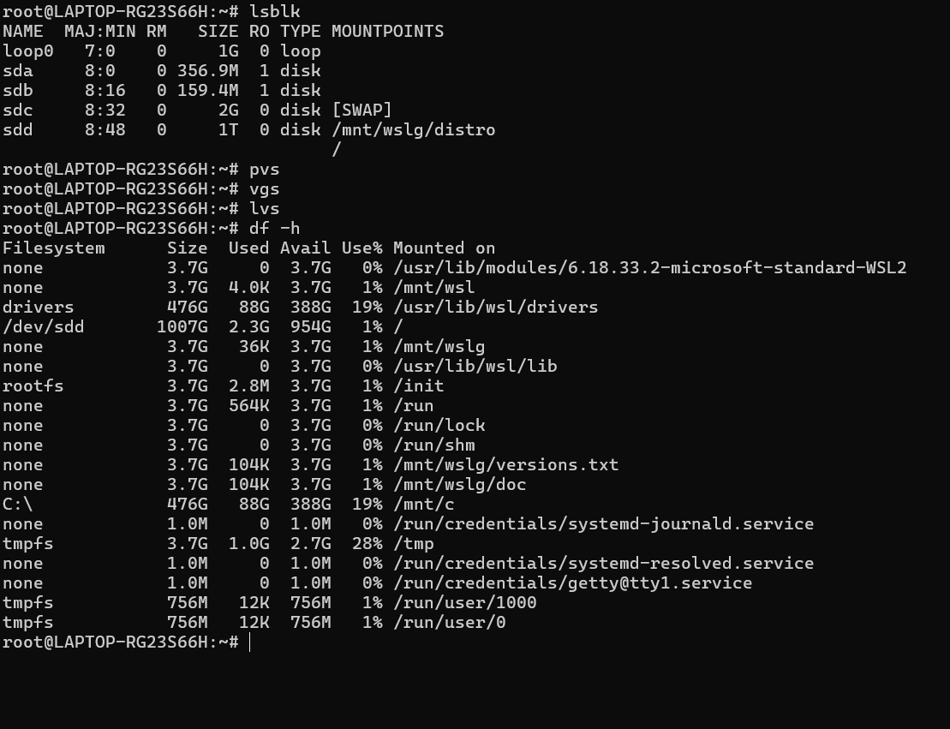

Task 2 -- Create Physical Volume
pvcreate /dev/sdb # or your loop device
pvs

Command used:
pvcreate /dev/loop0
pvs
This converted /dev/loop0 into an LVM Physical Volume.
Screenshot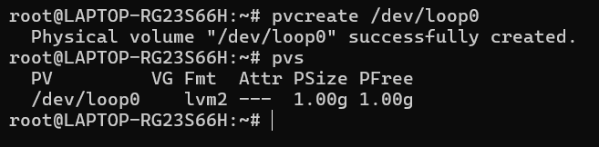

Task 3 -- Create Volume Group
vgcreate devops-vg /dev/sdb
vgs

Command used:
vgcreate devops-vg /dev/loop0
vgs
This created a Volume Group named devops-vg using the Physical Volume
/dev/loop0.
Screenshot
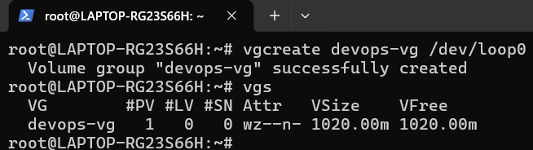
Add the screenshot showing vgcreate succeeded and vgs displays
devops-vg.

Task 4: Create Logical Volume
lvcreate -L 500M -n app-data devops-vg
lvs

Command used:
lvcreate -L 500M -n app-data devops-vg
lvs
This created a 500 MB Logical Volume named app-data from the
devops-vg storage pool.
Screenshot
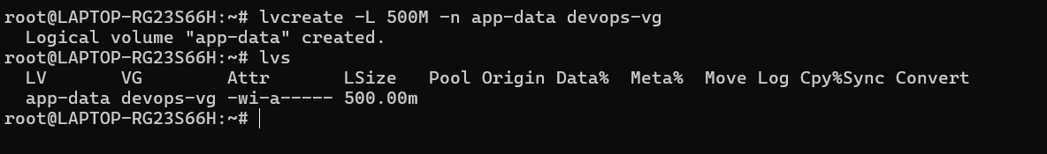
Add the screenshot showing app-data under the LV column and
devops-vg under the VG column.

Task 5: Format and Mount
mkfs.ext4 /dev/devops-vg/app-data
mkdir -p /mnt/app-data
mount /dev/devops-vg/app-data /mnt/app-data
df -h /mnt/app-data

Commands used:
mkfs.ext4 /dev/devops-vg/app-data
mkdir -p /mnt/app-data
mount /dev/devops-vg/app-data /mnt/app-data
df -h /mnt/app-data
The LV was formatted with the ext4 filesystem and mounted at
/mnt/app-data.
Screenshot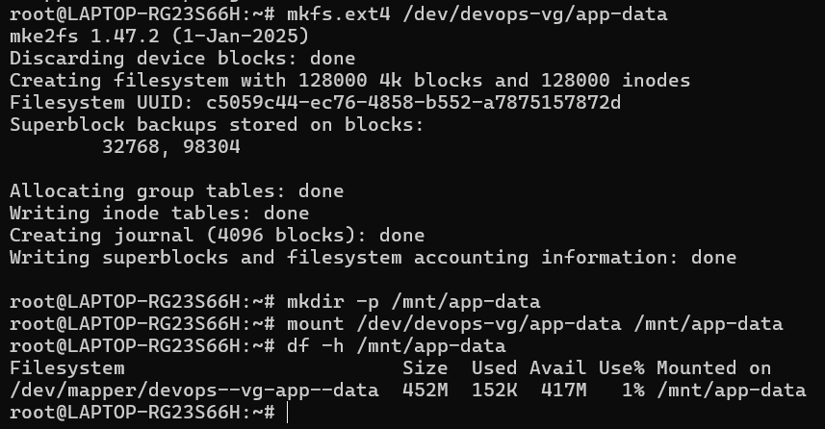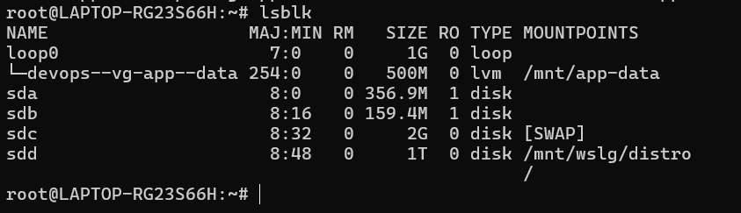

Add the screenshot showing /dev/devops-vg/app-data mounted on
/mnt/app-data.

Task 6: Extend the Volume
lvextend -L +200M /dev/devops-vg/app-data
resize2fs /dev/devops-vg/app-data
df -h /mnt/app-data

Commands used:
lvextend -L +200M /dev/devops-vg/app-data
resize2fs /dev/devops-vg/app-data
df -h /mnt/app-data
The LV was extended by 200 MB. Since the filesystem was ext4,
resize2fs was used to expand the filesystem so it could use the
additional space.
Screenshot 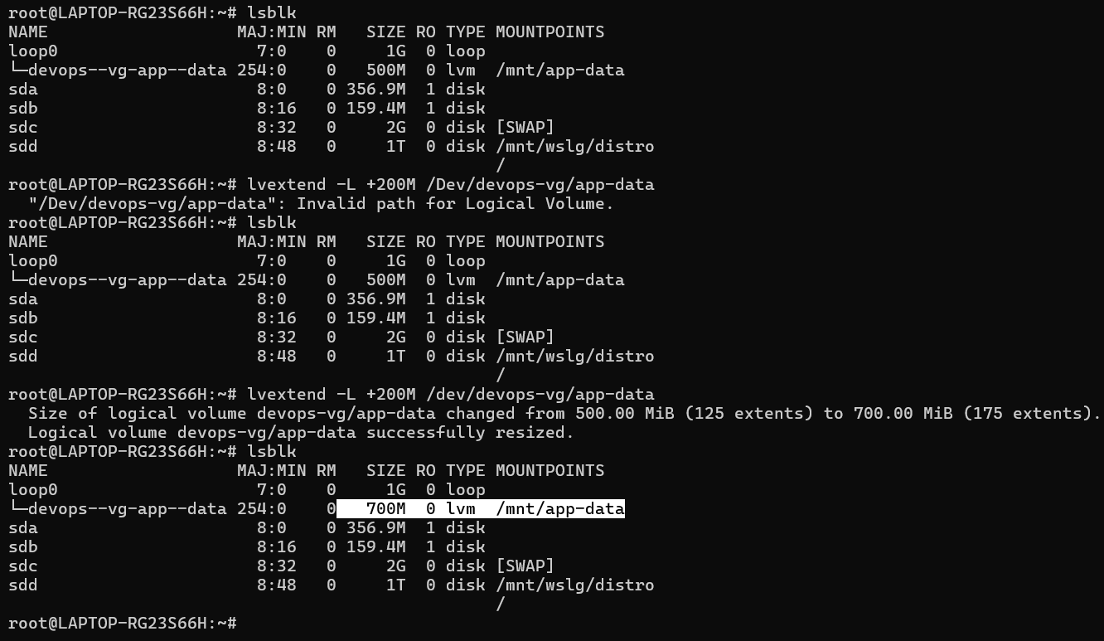
Add the final screenshot showing the increased filesystem size with
df -h /mnt/app-data.

What I Learned
- LVM storage is organized as Disk → PV → VG → LV → Filesystem →
Mount. A PV is an LVM-managed storage device, a VG is a storage
pool, and an LV is storage allocated from that pool.
- Extending an LV and extending its filesystem are separate
operations. lvextend increases the LV size, while resize2fs
makes the ext4 filesystem use the additional space.
- Always verify the storage device before running LVM commands. In
this lab, /dev/loop0 was used as the practice disk so the real
system disks were not used.

Useful Commands
lsblk
pvs
vgs
lvs
df -h

pvcreate /dev/loop0
vgcreate devops-vg /dev/loop0
lvcreate -L 500M -n app-data devops-vg

mkfs.ext4 /dev/devops-vg/app-data
mkdir -p /mnt/app-data
mount /dev/devops-vg/app-data /mnt/app-data

lvextend -L +200M /dev/devops-vg/app-data
resize2fs /dev/devops-vg/app-data
df -h /mnt/app-data

