Day 56 – Kubernetes StatefulSets

Deployment vs StatefulSet

 | Deployment | StatefulSet
Usually used for | Stateless apps | Stateful apps
Pod identity | Usually not important | Important
Pod names | Can change | Stable
Example | Nginx, web server | MySQL, PostgreSQL
Persistent identity | Not normally required | Yes
Stable storage per replica | Not built in as the main pattern | Supported
Startup/shutdown ordering | Usually not important | Can be ordered

Task 1: Understand the Problem
- Create a Deployment with 3 replicas using nginx
- Check the pod names — they are random (app-xyz-abc)
- Delete a pod and notice the replacement gets a different random name
This is fine for web servers but not for databases where you need stable identity.
Feature | Deployment | StatefulSet
Pod names | Random | Stable, ordered (app-0, app-1)
Startup order | All at once | Ordered: pod-0, then pod-1, then pod-2
Storage | Shared PVC | Each pod gets its own PVC
Network identity | No stable hostname | Stable DNS per pod
Delete the Deployment before moving on.
Verify: Why would random pod names be a problem for a database cluster?
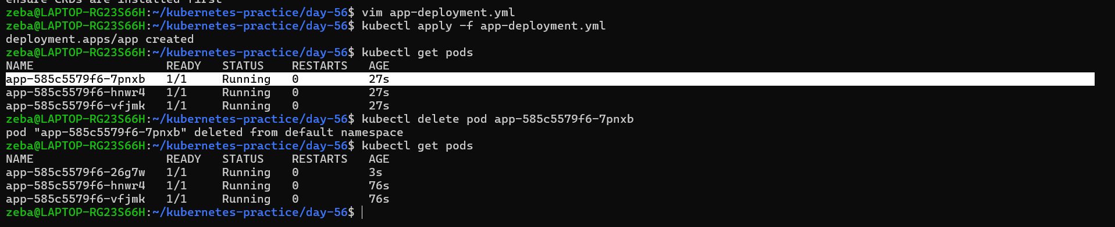
I have deleted the first pod as soon as I deleted that pod deployment created the pod with a new random name
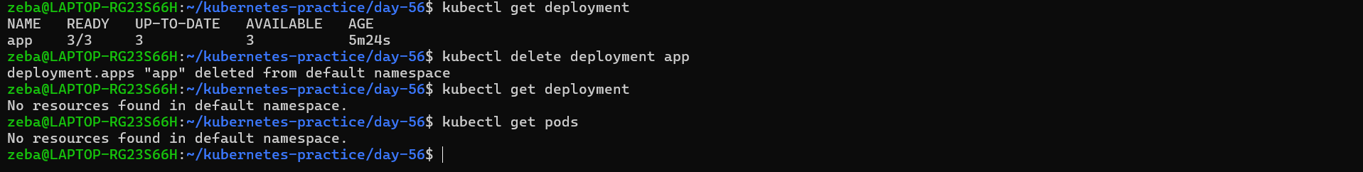
Deployment deleted and also pods/replicas got deleted
Task 2: Create a Headless Service
- Write a Service manifest with clusterIP: None — this is a Headless Service
- Set the selector to match the labels you will use on your StatefulSet pods
- Apply it and confirm CLUSTER-IP shows None
A Headless Service creates individual DNS entries for each pod instead of load-balancing to one IP. StatefulSets require this.
Verify: What does the CLUSTER-IP column show?

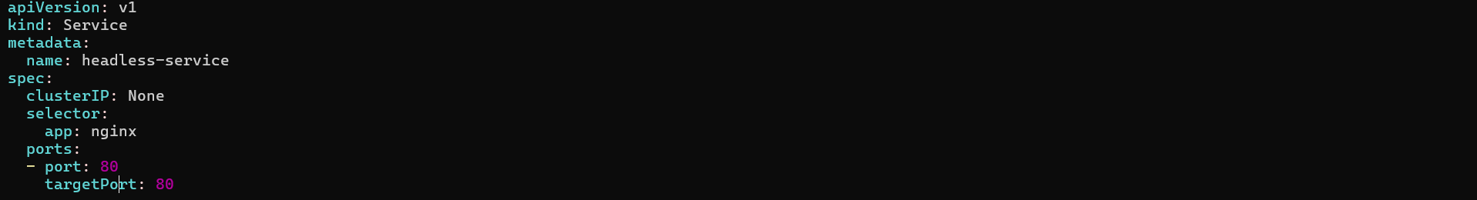
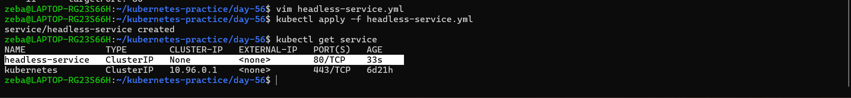
Task 3: Create a StatefulSet
- Write a StatefulSet manifest with serviceName pointing to your Headless Service
- Set replicas to 3, use the nginx image
- Add a volumeClaimTemplates section requesting 100Mi of ReadWriteOnce storage
- Apply and watch: kubectl get pods -l <your-label> -w
Observe ordered creation — web-0 first, then web-1 after web-0 is Ready, then web-2.
Check the PVCs: kubectl get pvc — you should see web-data-web-0, web-data-web-1, web-data-web-2 (names follow the pattern <template-name>-<pod-name>).
Verify: What are the exact pod names and PVC names?

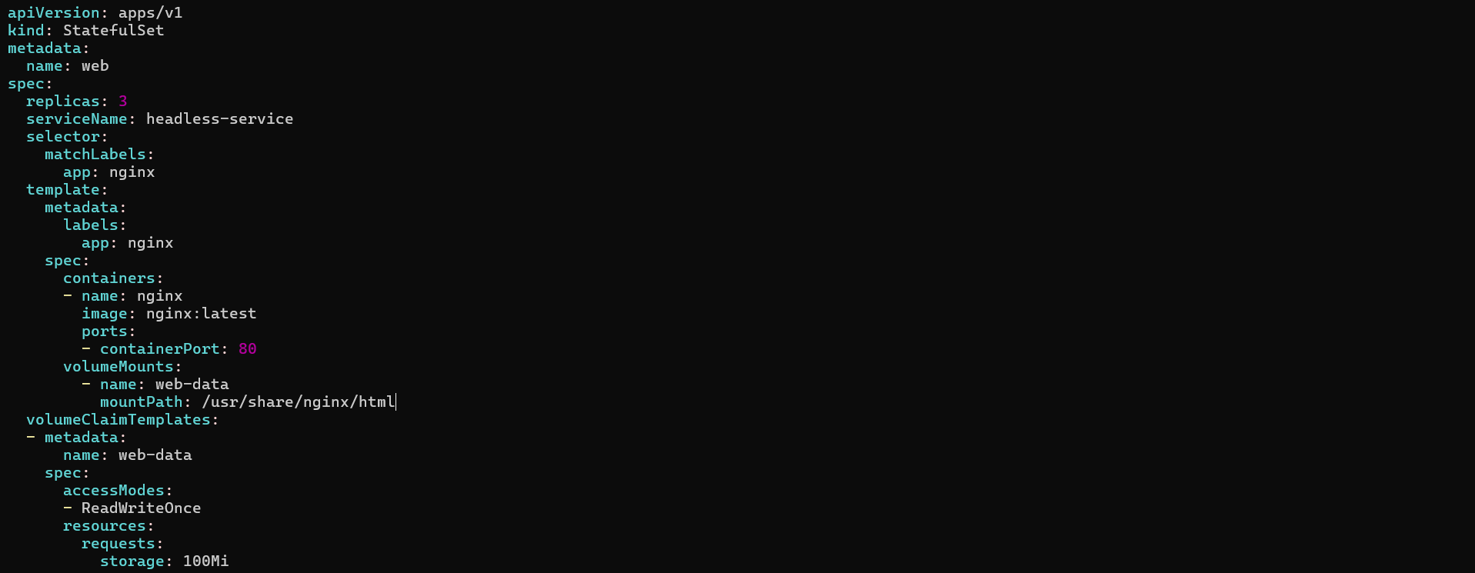
volumeClaimTemplates:
- metadata:
name: web-data

Kubernetes will create PVC for every statefulset pod
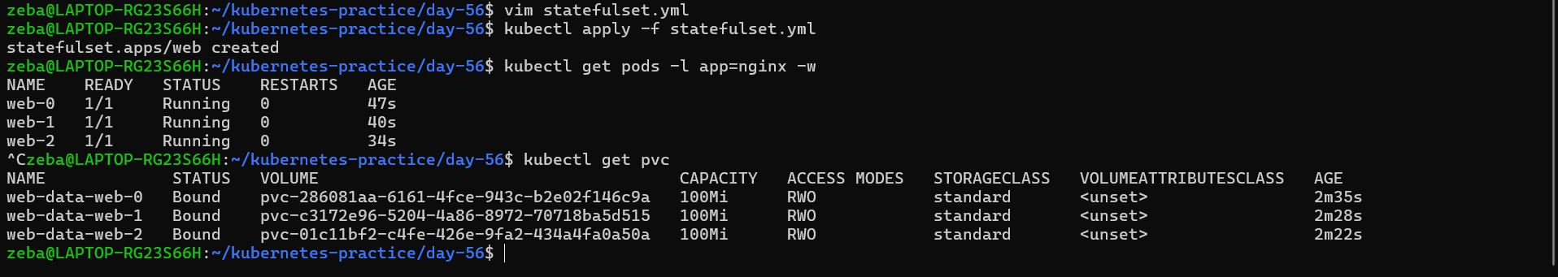

Task 4: Stable Network Identity
Each StatefulSet pod gets a DNS name: <pod-name>.<service-name>.<namespace>.svc.cluster.local
- Run a temporary busybox pod and use nslookup to resolve web-0.<your-headless-service>.default.svc.cluster.local
- Do the same for web-1 and web-2
- Confirm the IPs match kubectl get pods -o wide
Verify: Does the nslookup IP match the pod IP?
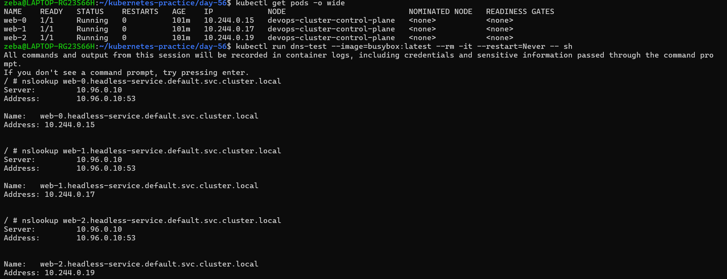
Task 5: Stable Storage — Data Survives Pod Deletion
- Write unique data to each pod: kubectl exec web-0 -- sh -c "echo 'Data from web-0' > /usr/share/nginx/html/index.html"
- Delete web-0: kubectl delete pod web-0
- Wait for it to come back, then check the data — it should still be "Data from web-0"
The new pod reconnected to the same PVC.
Verify: Is the data identical after pod recreation?
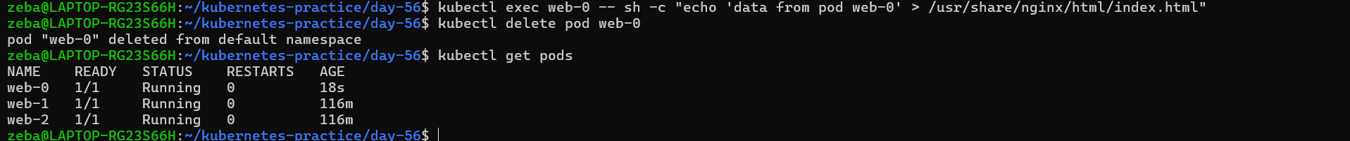
Data entered in web-0 pod and deleted the pod web-0
And we can see web-0 pod recreated
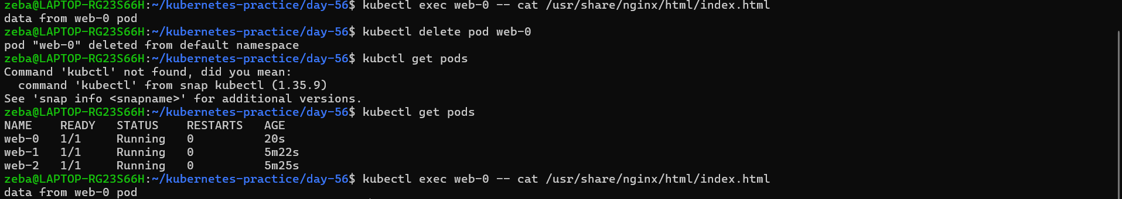
After recreating the pod data survived

Task 6: Ordered Scaling
- Scale up to 5: kubectl scale statefulset web --replicas=5 — pods create in order (web-3, then web-4)
- Scale down to 3 — pods terminate in reverse order (web-4, then web-3)
- Check kubectl get pvc — all five PVCs still exist. Kubernetes keeps them on scale-down so data is preserved if you scale back up.
Verify: After scaling down, how many PVCs exist?
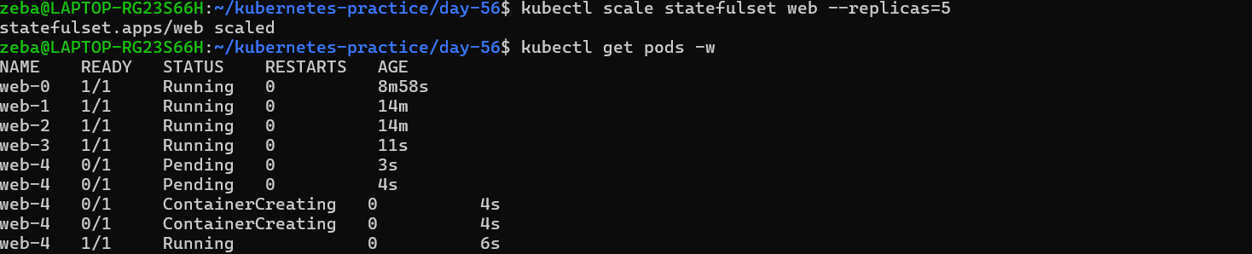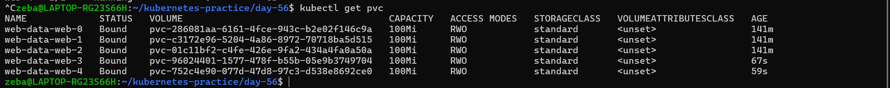
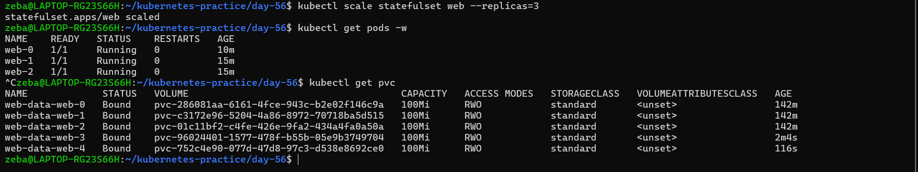
Task 7: Clean Up
- Delete the StatefulSet and the Headless Service
- Check kubectl get pvc — PVCs are still there (safety feature)
- Delete PVCs manually
Verify: Were PVCs auto-deleted with the StatefulSet?
