Kubernetes ConfigMaps and Secrets

Task 1: Create a ConfigMap from Literals
- Use kubectl create configmap with --from-literal to create a ConfigMap called app-config with keys APP_ENV=production, APP_DEBUG=false, and APP_PORT=8080
- Inspect it with kubectl describe configmap app-config and kubectl get configmap app-config -o yaml
- Notice the data is stored as plain text — no encoding, no encryption
Verify: Can you see all three key-value pairs?
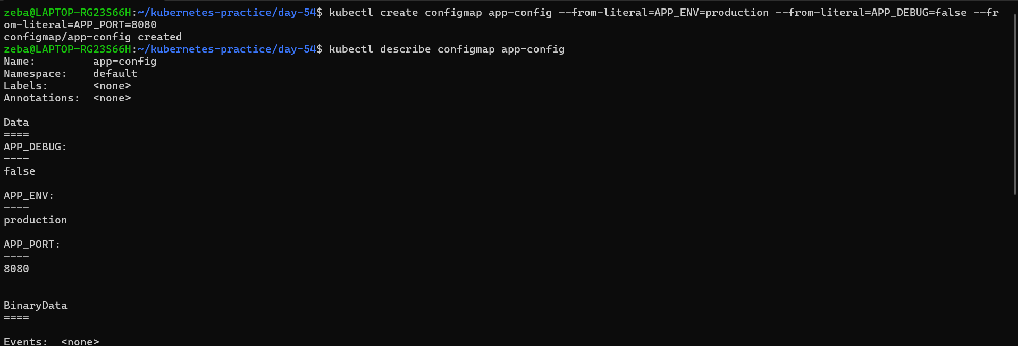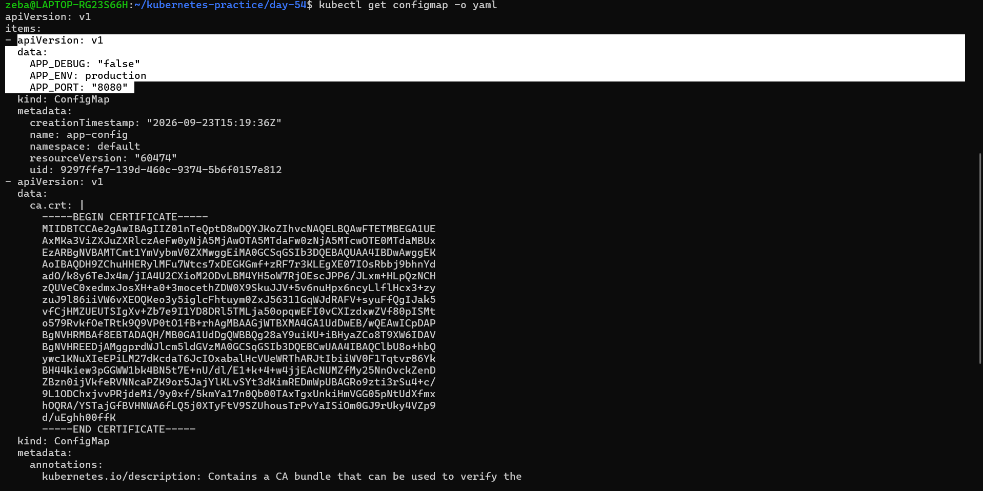
Task 2: Create a ConfigMap from a File
- Write a custom Nginx config file that adds a /health endpoint returning "healthy"
- Create a ConfigMap from this file using kubectl create configmap nginx-config --from-file=default.conf=<your-file>
- The key name (default.conf) becomes the filename when mounted into a Pod
Verify: Does kubectl get configmap nginx-config -o yaml show the file contents?
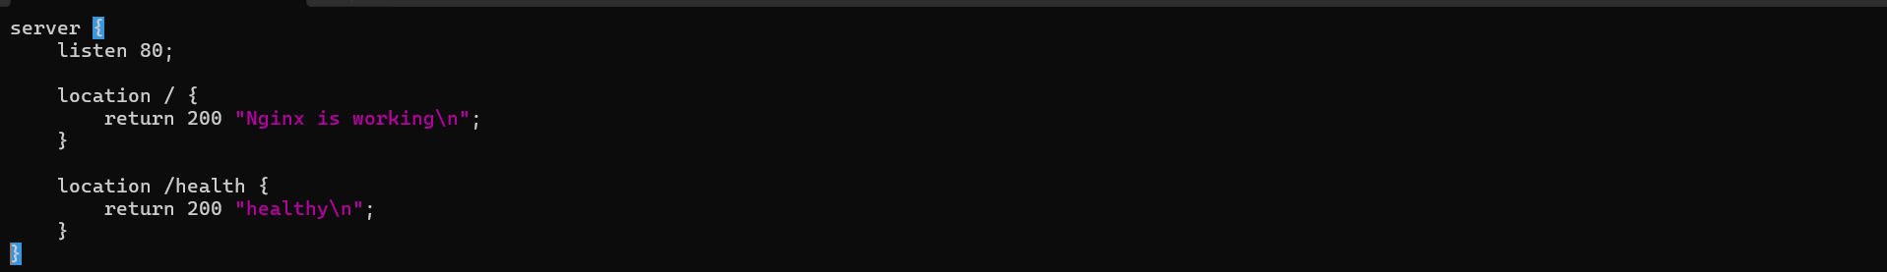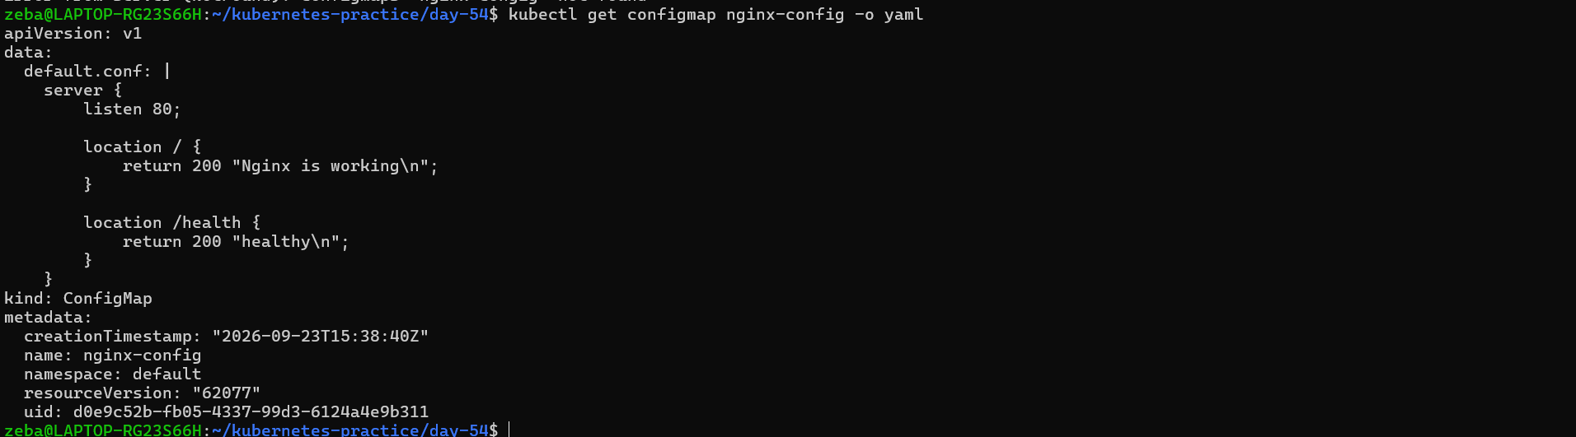
Task 3: Use ConfigMaps in a Pod
- Write a Pod manifest that uses envFrom with configMapRef to inject all keys from app-config as environment variables. Use a busybox container that prints the values.
- Write a second Pod manifest that mounts nginx-config as a volume at /etc/nginx/conf.d. Use the nginx image.
- Test that the mounted config works: kubectl exec <pod> -- curl -s http://localhost/health
Use environment variables for simple key-value settings. Use volume mounts for full config files.
Verify: Does the /health endpoint respond?
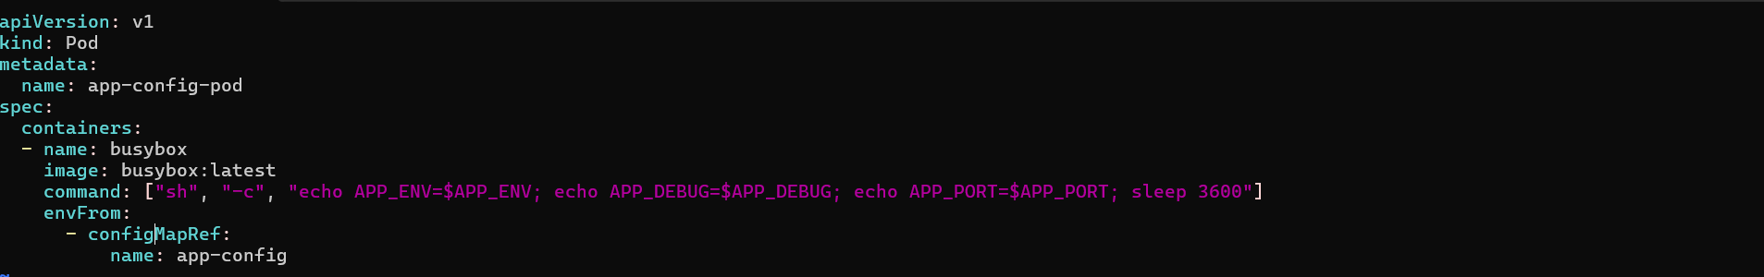
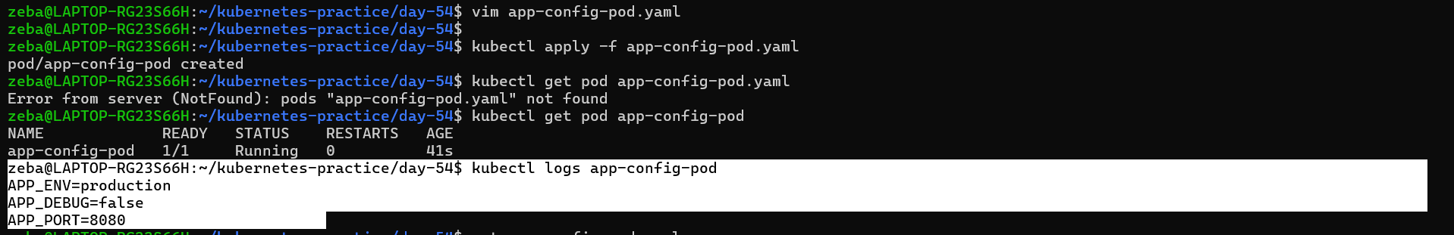

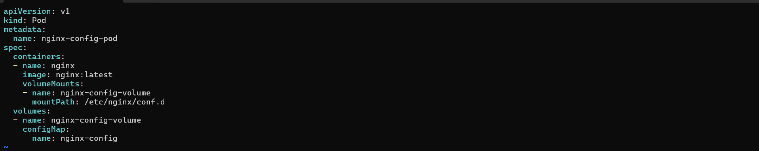

Environment variables:
==========================
envFrom:
- configMapRef:
name: app-config
Good for simple key/value application settings.

Volume mount:
======================
volumes:
- configMap:
name: nginx-config
Good when the ConfigMap contains a complete configuration file.

Key-value configuration → environment variables
Configuration files → volume mounts

Task 4: Create a Secret
- Use kubectl create secret generic db-credentials with --from-literal to store DB_USER=admin and DB_PASSWORD=s3cureP@ssw0rd
- Inspect with kubectl get secret db-credentials -o yaml — the values are base64-encoded
- Decode a value: echo '<base64-value>' | base64 --decode
base64 is encoding, not encryption. Anyone with cluster access can decode Secrets. The real advantages are RBAC separation, tmpfs storage on nodes, and optional encryption at rest.
Verify: Can you decode the password back to plaintext?
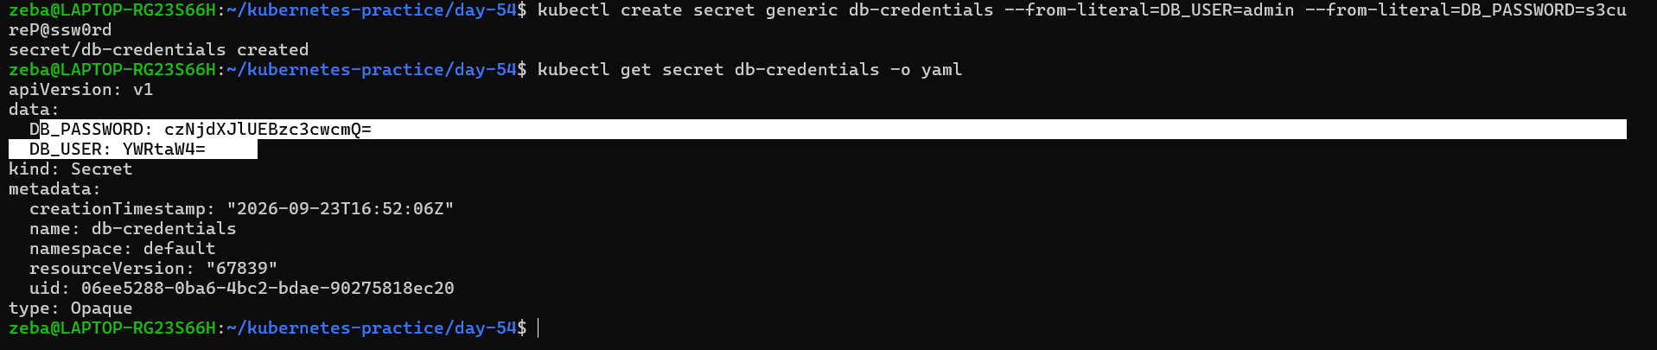

Task 5: Use Secrets in a Pod
- Write a Pod manifest that injects DB_USER as an environment variable using secretKeyRef
- In the same Pod, mount the entire db-credentials Secret as a volume at /etc/db-credentials with readOnly: true
- Verify: each Secret key becomes a file, and the content is the decoded plaintext value
Verify: Are the mounted file values plaintext or base64?
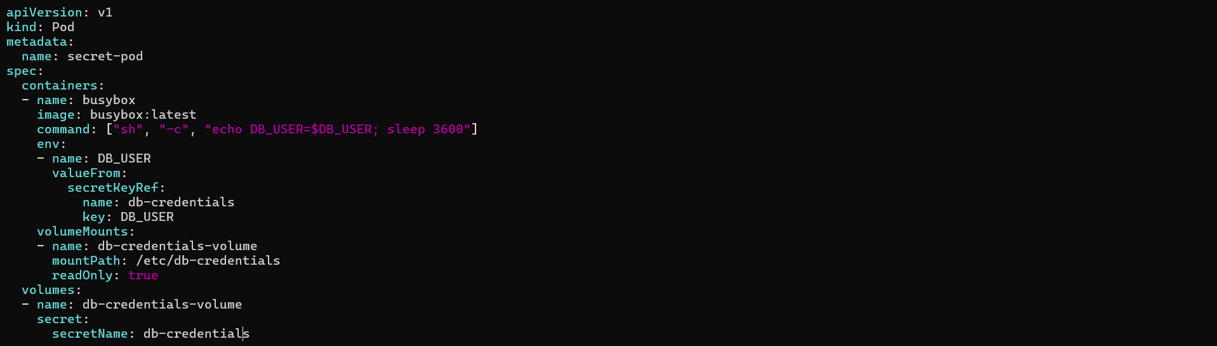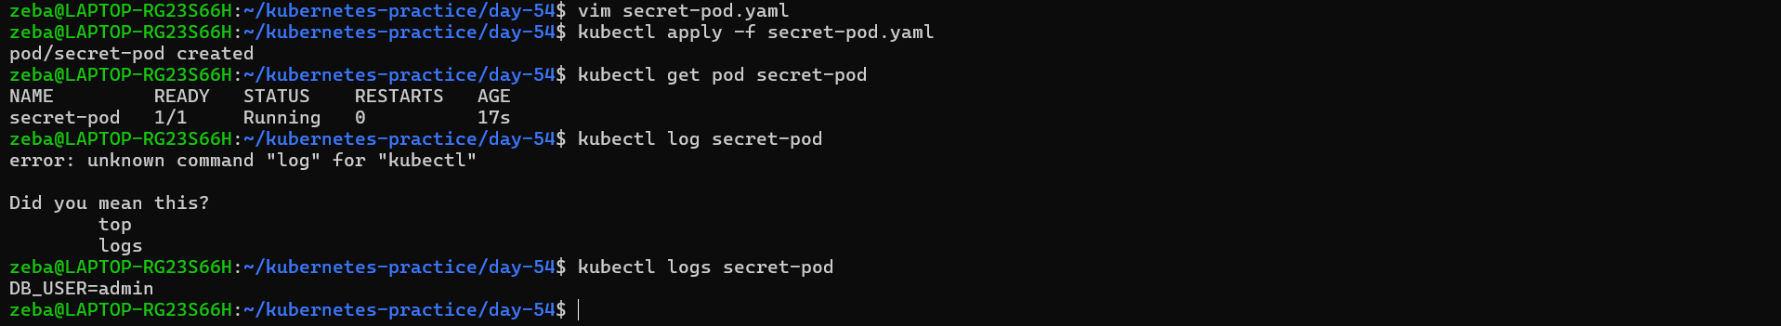
Task 6: Update a ConfigMap and Observe Propagation
- Create a ConfigMap live-config with a key message=hello
- Write a Pod that mounts this ConfigMap as a volume and reads the file in a loop every 5 seconds
- Update the ConfigMap: kubectl patch configmap live-config --type merge -p '{"data":{"message":"world"}}'
- Wait 30-60 seconds — the volume-mounted value updates automatically
- Environment variables from earlier tasks do NOT update — they are set at pod startup only
Verify: Did the volume-mounted value change without a pod restart?
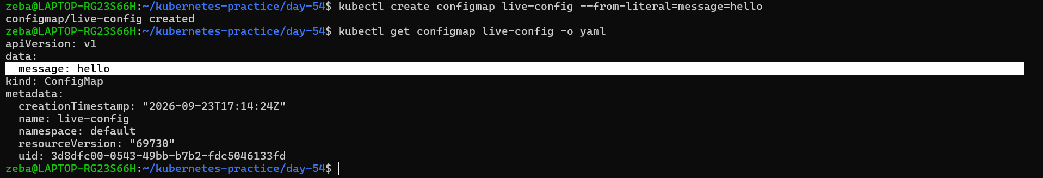

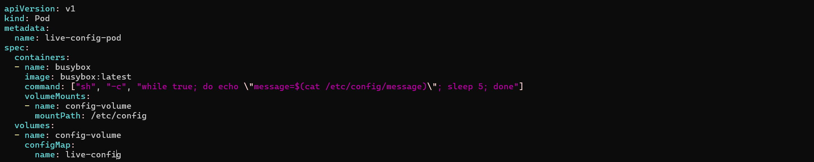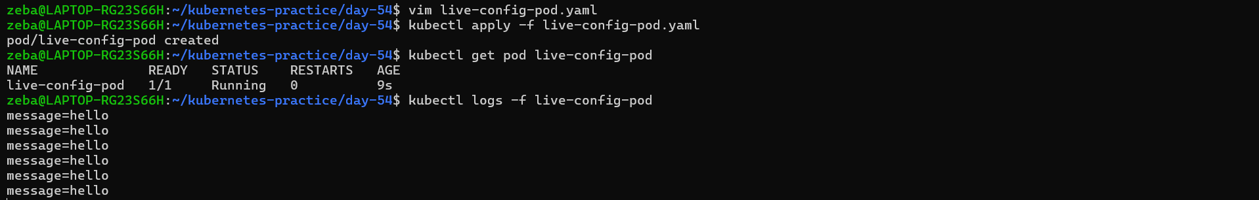

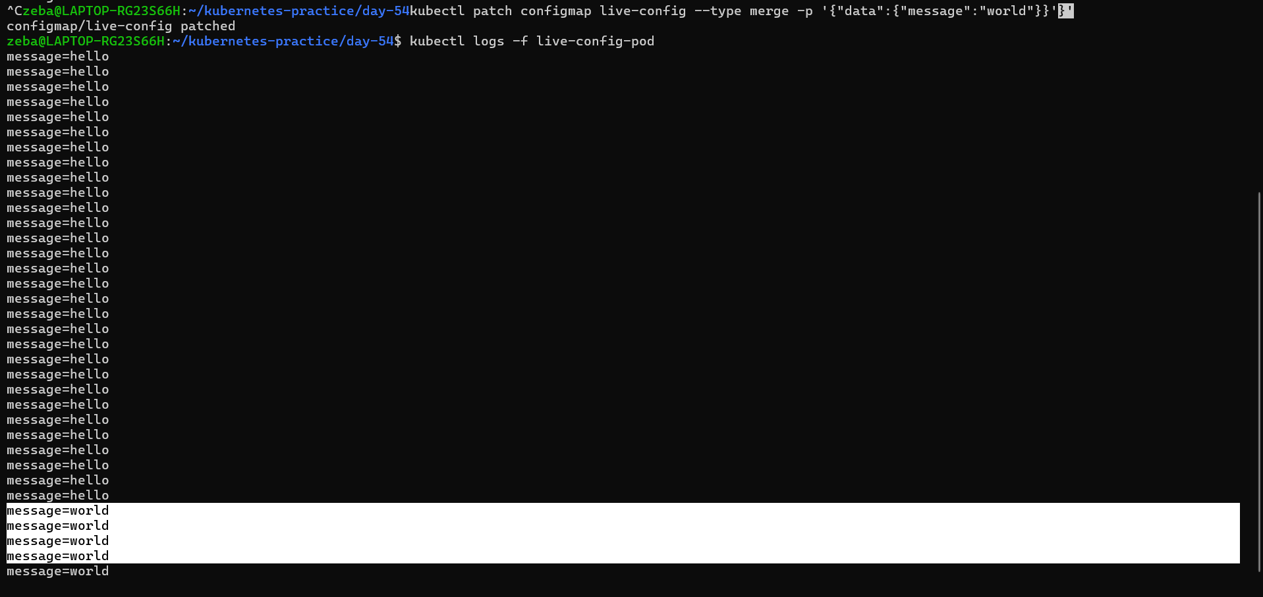

Task 7: Clean Up
Delete all pods, ConfigMaps, and Secrets you created.
