Day 60 – Capstone: Deploy WordPress + MySQL on Kubernetes
Task 1: Create the Namespace (Day 52)
- Create a capstone namespace
- Set it as your default: kubectl config set-context --current --namespace=capstone
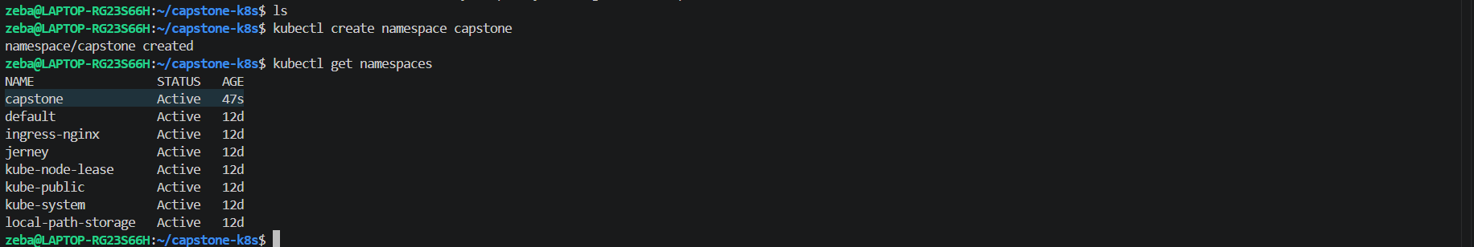
Namespace created
Set capstone namespace as default namespace
Task 2: Deploy MySQL (Days 54-56)
- Create a Secret with MYSQL_ROOT_PASSWORD, MYSQL_DATABASE, MYSQL_USER, and MYSQL_PASSWORD using stringData
- Create a Headless Service (clusterIP: None) for MySQL on port 3306
- Create a StatefulSet for MySQL with:
  - Image: mysql:8.0
  - envFrom referencing the Secret
  - Resource requests (cpu: 250m, memory: 512Mi) and limits (cpu: 500m, memory: 1Gi)
  - A volumeClaimTemplates section requesting 1Gi of storage, mounted at /var/lib/mysql
- Verify MySQL works: kubectl exec -it mysql-0 -- mysql -u <user> -p<password> -e "SHOW DATABASES;"
Verify: Can you see the wordpress database?
mysql-secret.yml
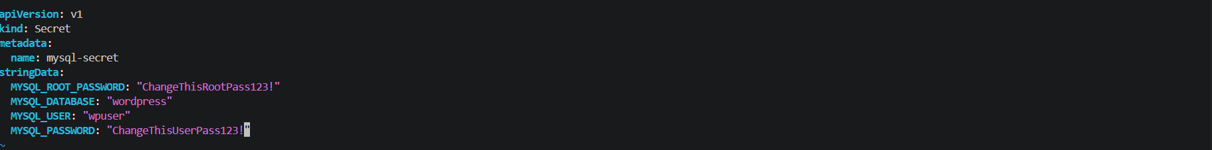
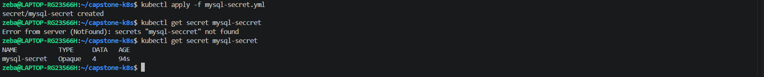
Applied and verified

mysql-service.yml
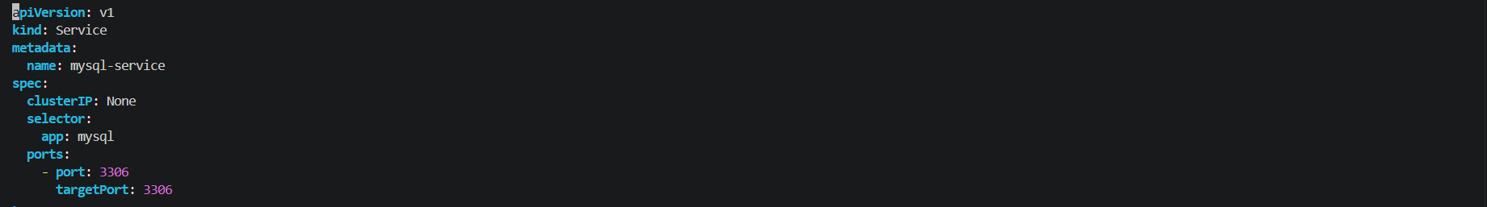
Applied and verified

mysql-statefulset.yml
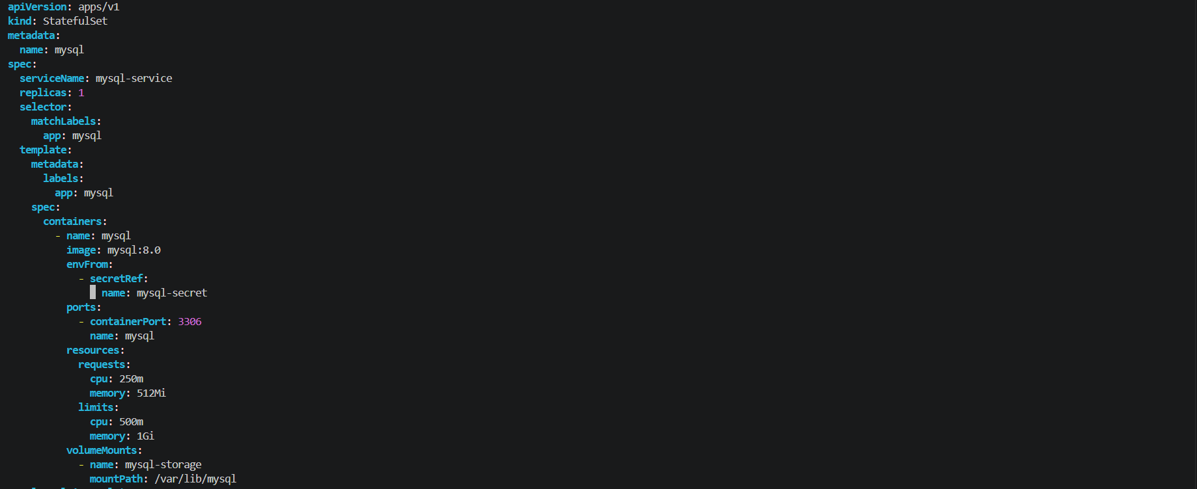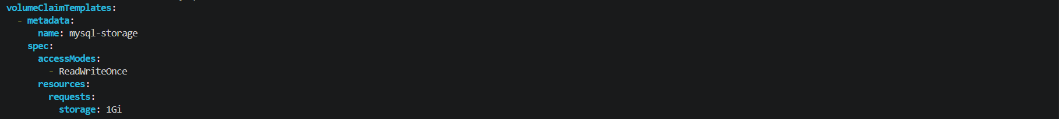
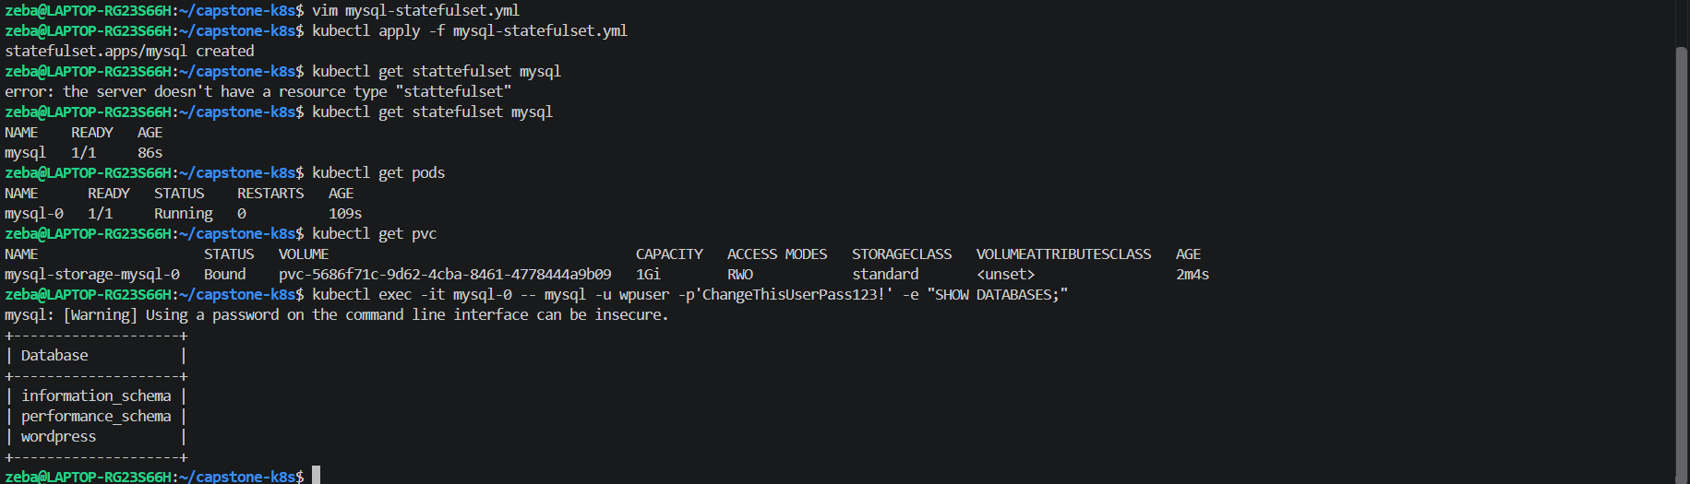
Applied and verified
Task 3: Deploy WordPress (Days 52, 54, 57)
- Create a ConfigMap with WORDPRESS_DB_HOST set to mysql-0.mysql.capstone.svc.cluster.local:3306 and WORDPRESS_DB_NAME
- Create a Deployment with 2 replicas using wordpress:latest that:
  - Uses envFrom for the ConfigMap
  - Uses secretKeyRef for WORDPRESS_DB_USER and WORDPRESS_DB_PASSWORD from the MySQL Secret
  - Has resource requests and limits
  - Has a liveness probe and readiness probe on /wp-login.php port 80
- Wait until both pods show 1/1 Running
Verify: Are both WordPress pods running and ready?

wordpress-configmap.yml
Applied and verified

wordpress-deployment.yml
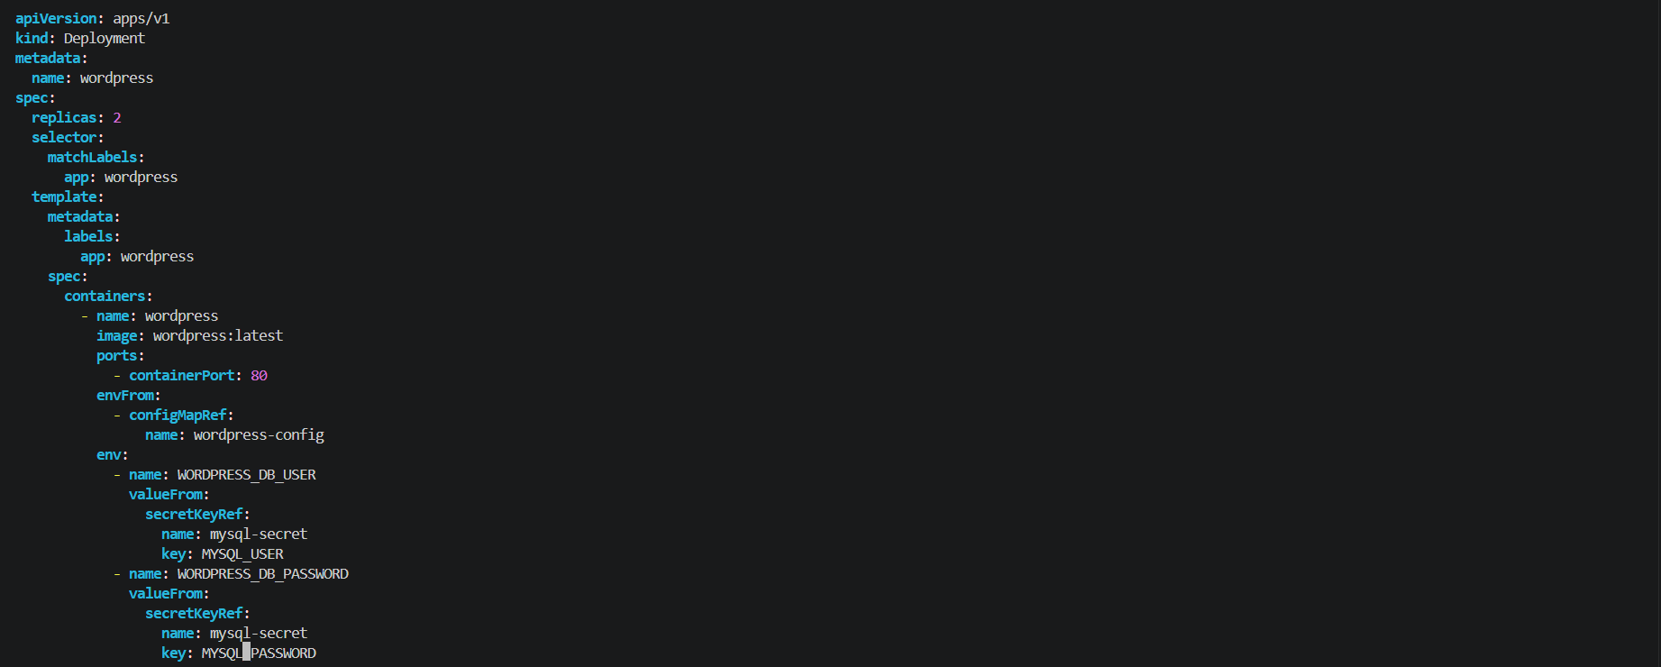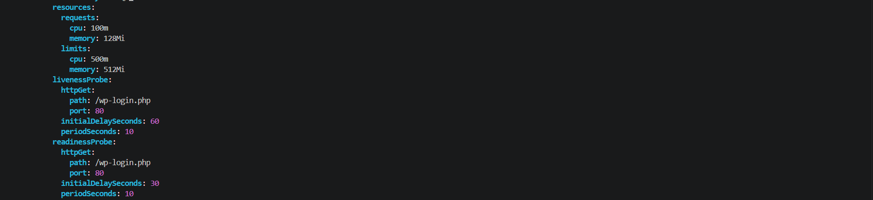
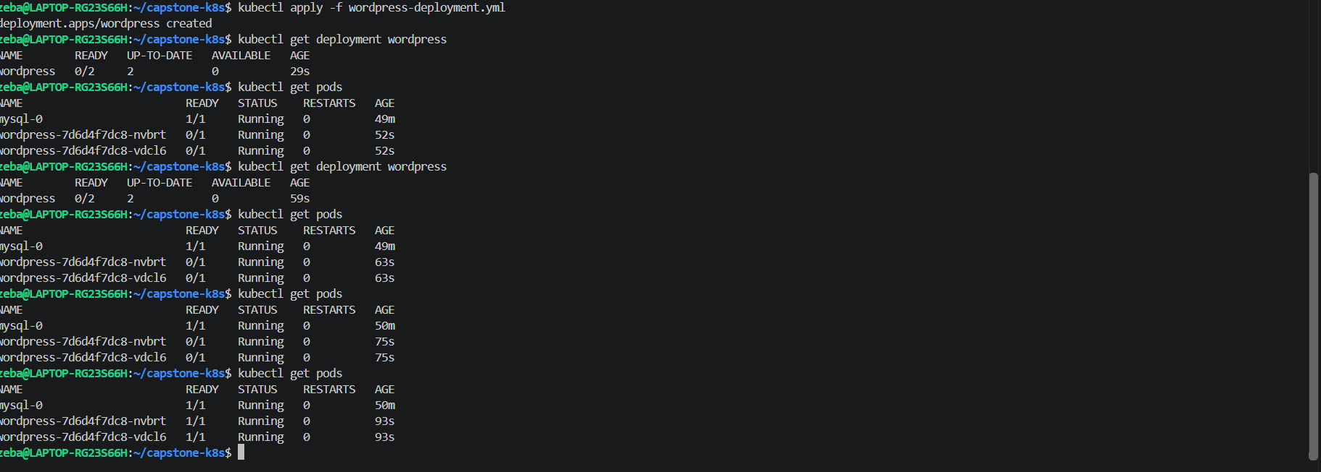
Applied and verified
Both wordpress pods became ready
Task 4: Expose WordPress (Day 53)
- Create a NodePort Service on port 30080 targeting the WordPress pods
- Access WordPress in your browser:
  - Minikube: minikube service wordpress -n capstone
  - Kind: kubectl port-forward svc/wordpress 8080:80 -n capstone
- Complete the setup wizard and create a blog post
Verify: Can you see the WordPress setup page?

wordpress-service.yml
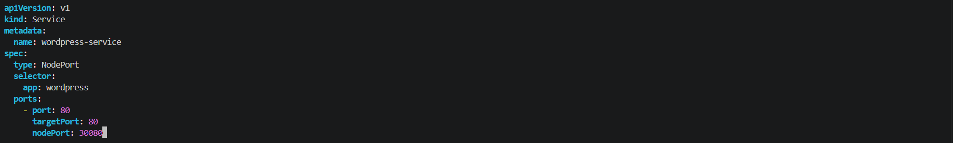
Applied and verified

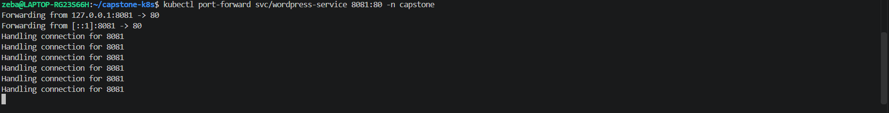
Port forwarding
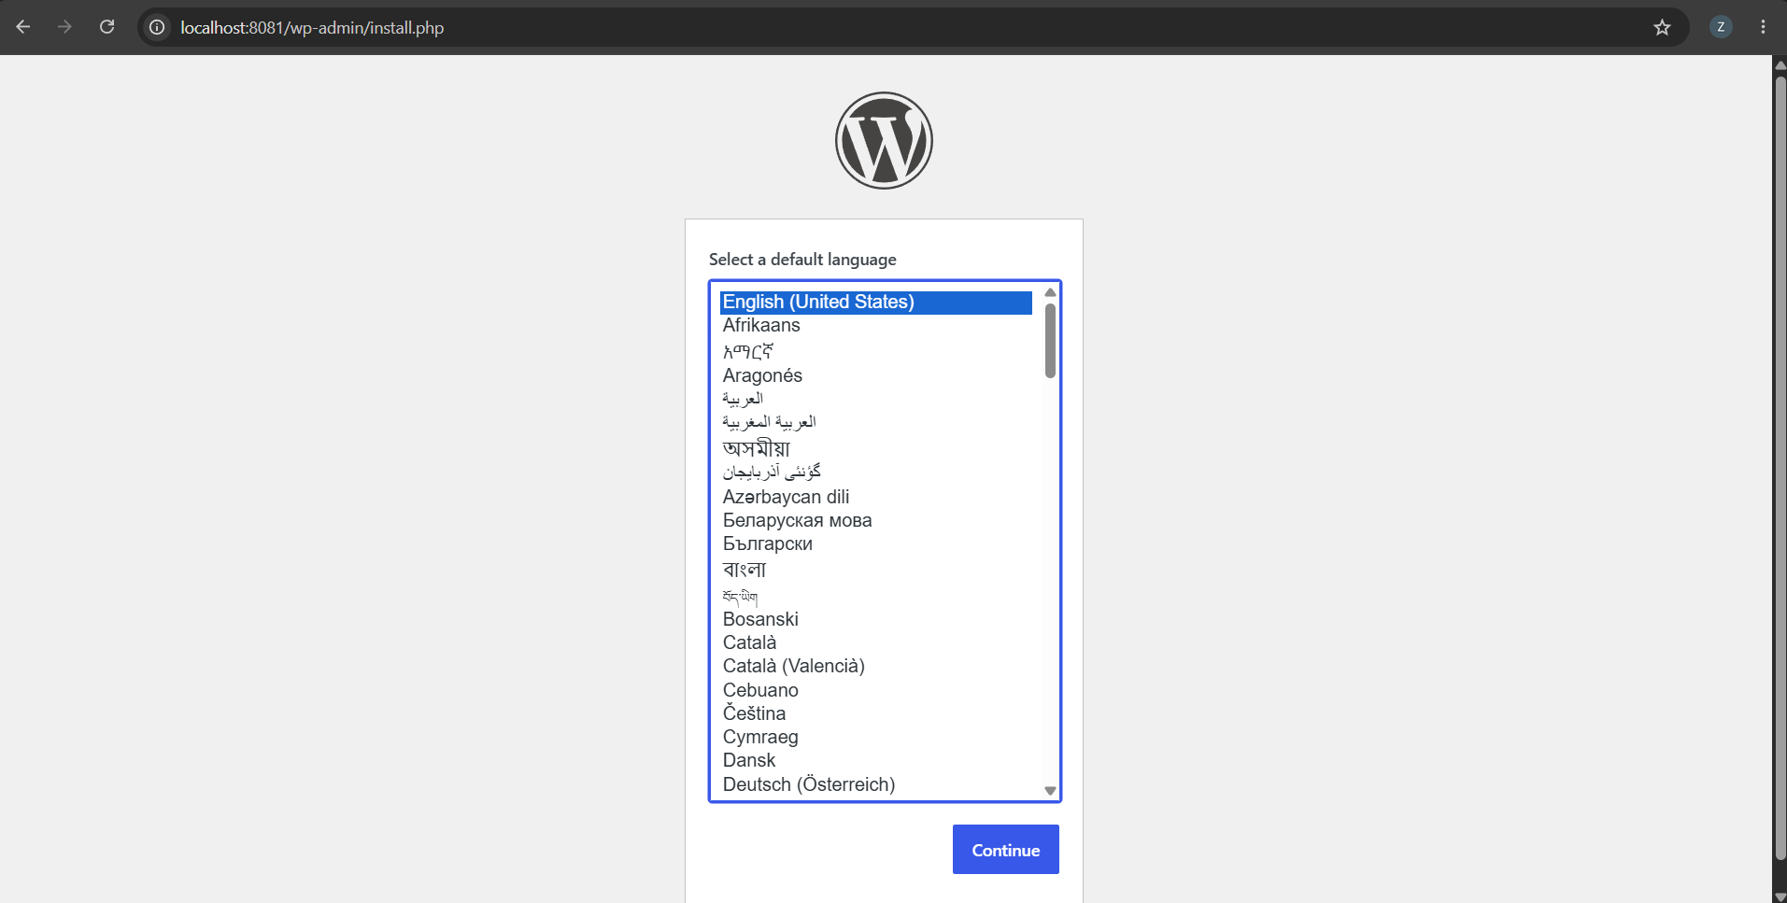
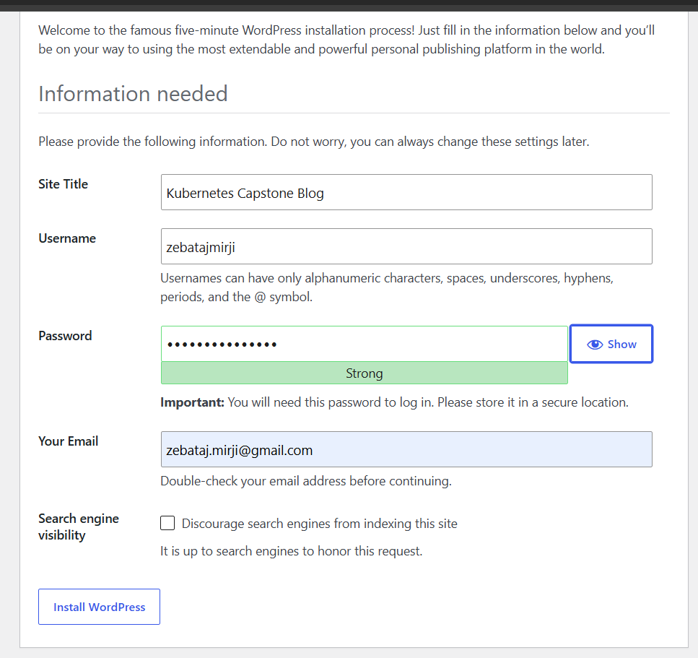
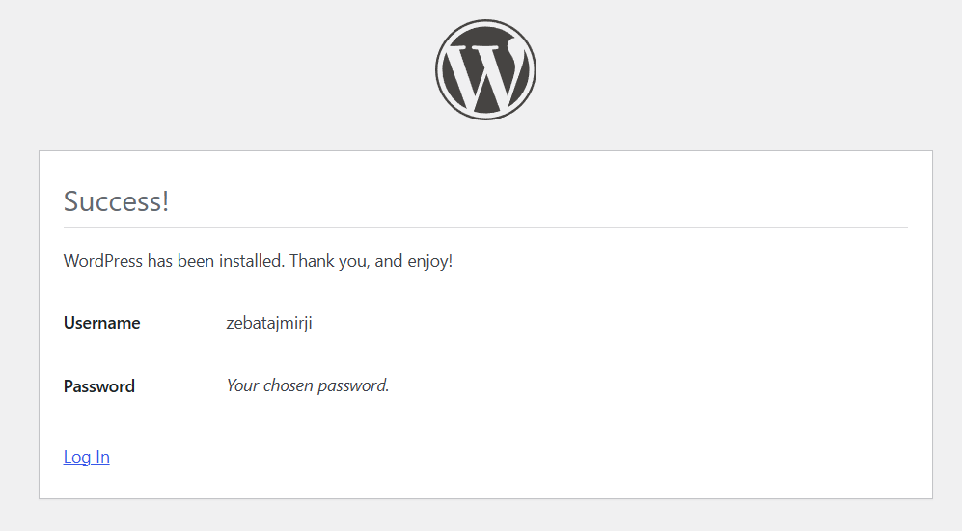
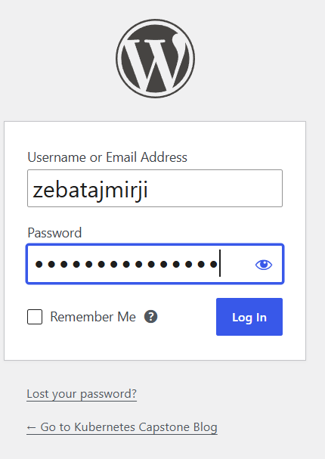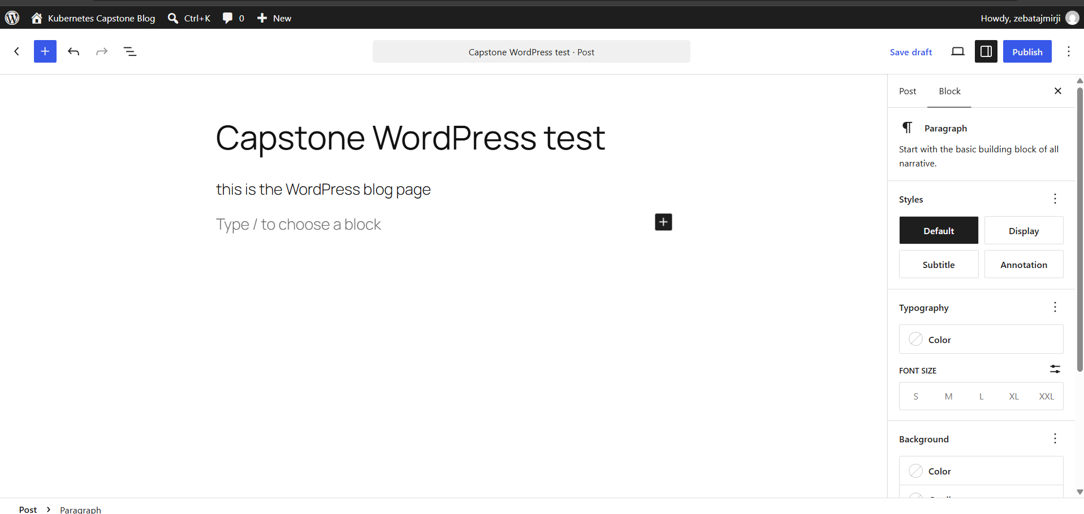
Created the blog in wordPress and published
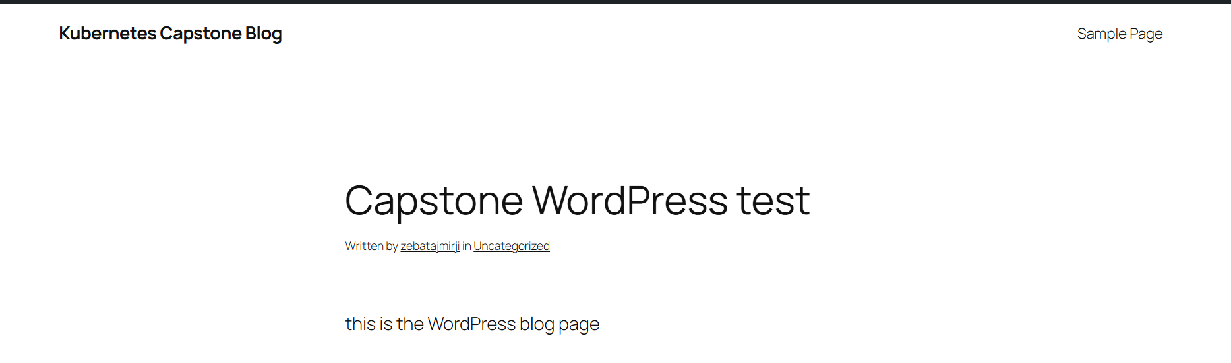
Task 5: Test Self-Healing and Persistence
- Delete a WordPress pod — watch the Deployment recreate it within seconds. Refresh the site.
- Delete the MySQL pod: kubectl delete pod mysql-0 -n capstone — watch the StatefulSet recreate it
- After MySQL recovers, refresh WordPress — your blog post should still be there
Verify: After deleting both pods, is your blog post still there?
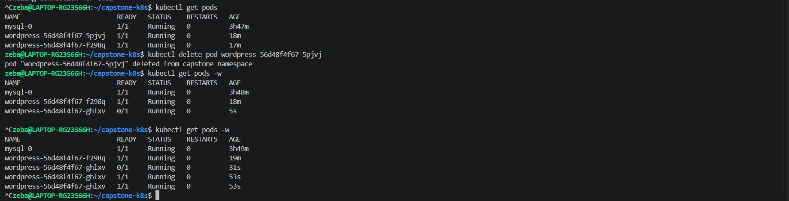
Wordpress pods getting recreating
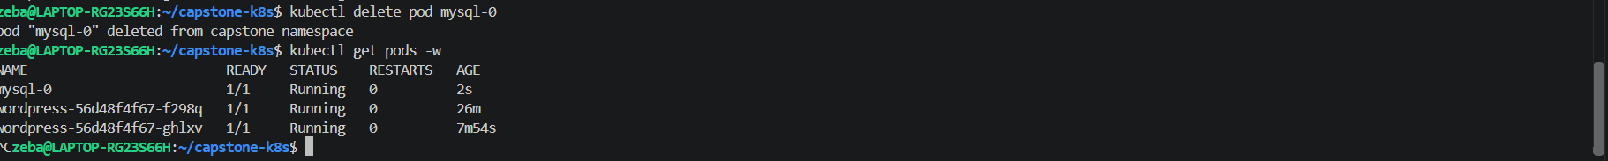
mysql pod recreated
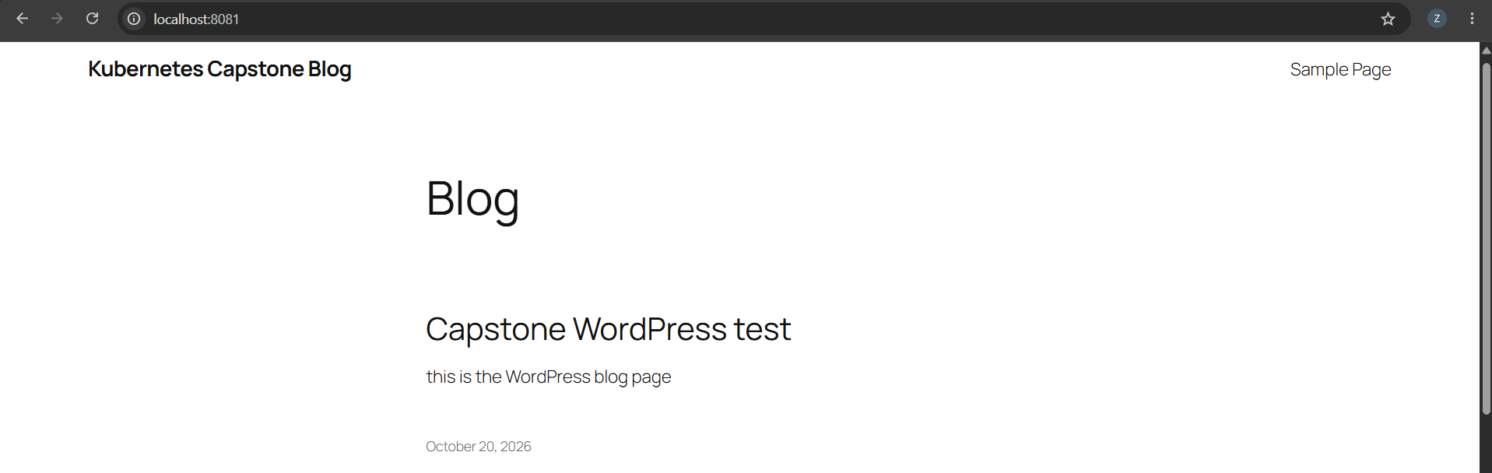
Even after pods got recreated our blog still present , this is the proof of the persistant data
Task 6: Set Up HPA (Day 58) horizontal pod autoscaler
- Write an HPA manifest targeting the WordPress Deployment with CPU at 50%, min 2, max 10 replicas
- Apply and check: kubectl get hpa -n capstone
- Run kubectl get all -n capstone for the complete picture
Verify: Does the HPA show correct min/max and target?

wordpress-hpa.yml
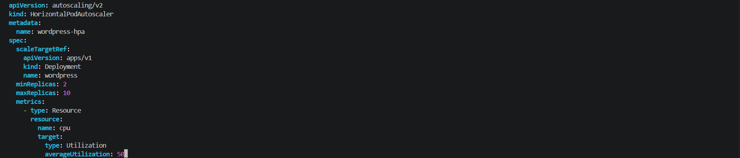
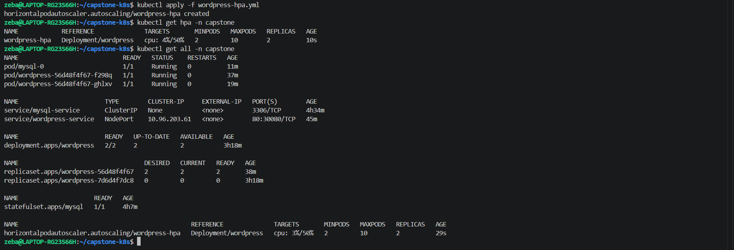
Verified
Task 7: (Bonus) Compare with Helm (Day 59)
- Install WordPress using helm install wp-helm bitnami/wordpress in a separate namespace
- Compare: how many resources did each approach create? Which gives more control?
- Clean up the Helm deployment
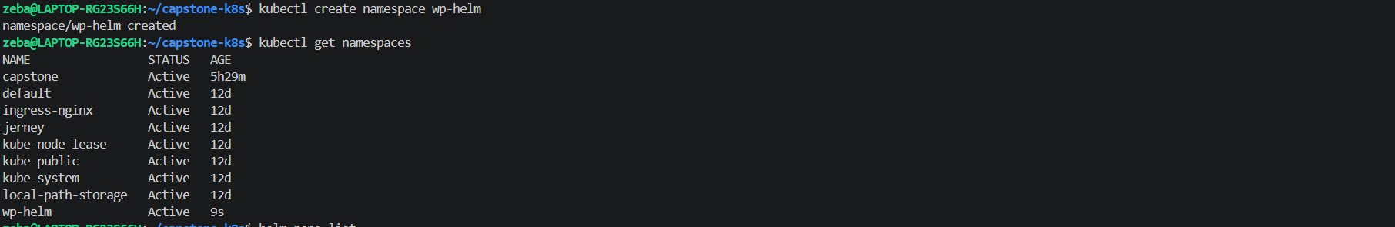
New namespace wp-helm created
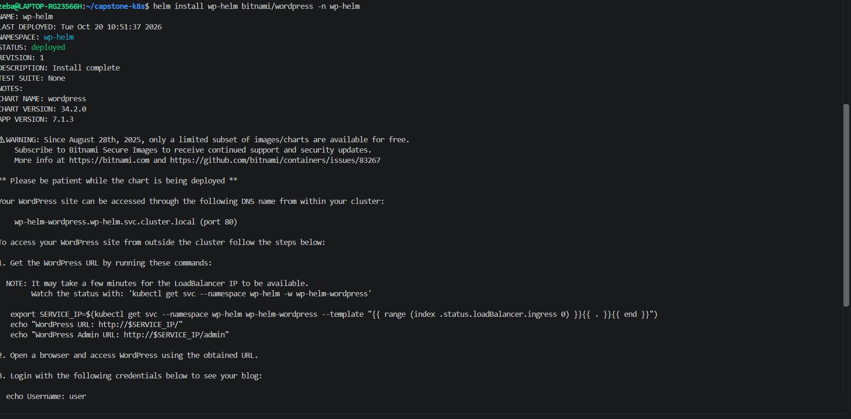
wp-helm bitnami/wordpress installed in wp-helm namespace
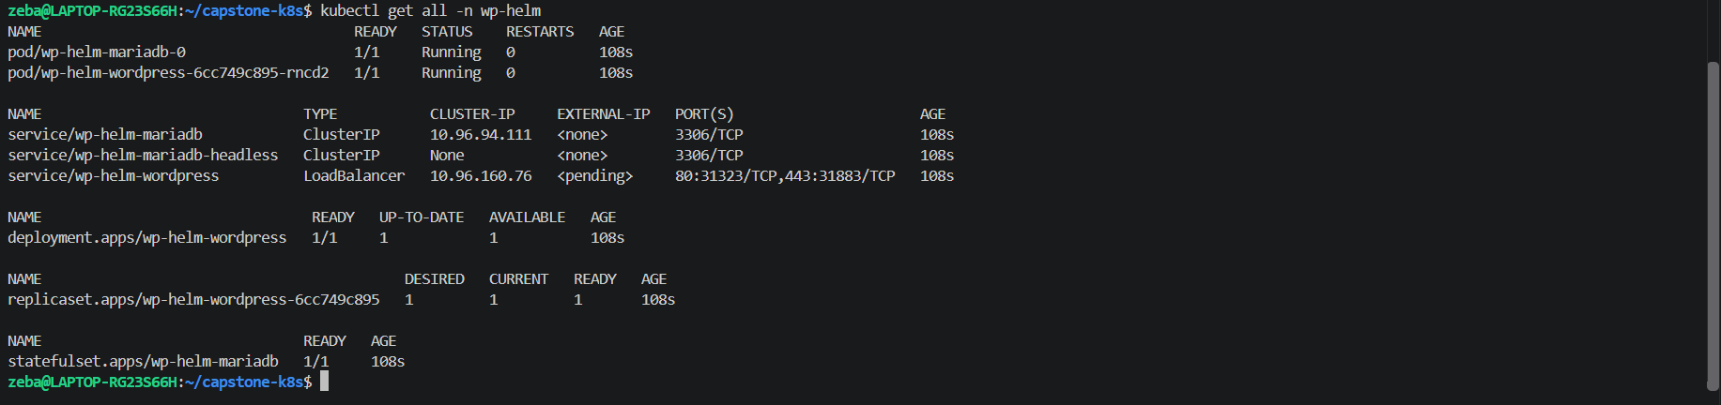
Helm created the below services

Resource type | Count
Pods | 2
Services | 3
Deployment | 1
ReplicaSet | 1
StatefulSet | 1
Total displayed | 8
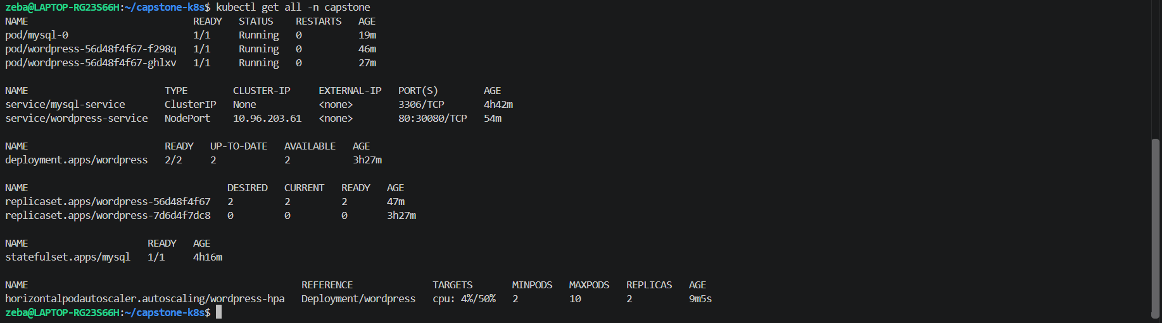
1. Resource comparison
Resource | Manual capstone | Helm wp-helm
Pods | 3 | 2
Services | 2 | 3
Deployments | 1 | 1
ReplicaSets | 2 | 1
StatefulSets | 1 | 1
HPAs | 1 | 0
Total shown by kubectl get all | 10 | 8

Which approach gives more control?
- Manual manifests: More direct control over each Kubernetes resource. You explicitly configured the MySQL StatefulSet, persistent storage, WordPress probes, resource limits, Services, and HPA.
- Helm: Installs a complete application stack with fewer manual steps. It created WordPress and MariaDB resources from a chart, and supports customization through values files and upgrades.
Clean up helm deployment
Task 8: Clean Up and Reflect
- Take a final look: kubectl get all -n capstone
- Count the concepts you used: Namespace, Secret, ConfigMap, PVC, StatefulSet, Headless Service, Deployment, NodePort Service, Resource Limits, Probes, HPA, Helm — twelve concepts in one deployment
- Delete the namespace: kubectl delete namespace capstone
- Reset default: kubectl config set-context --current --namespace=default
Verify: Did deleting the namespace remove everything?
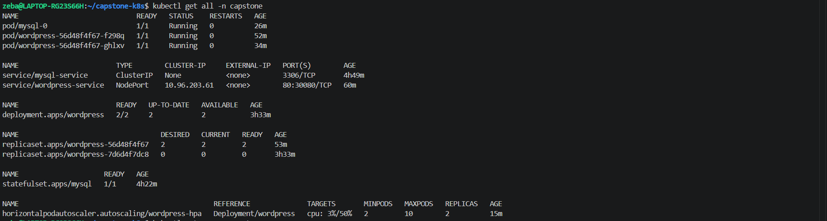
Namespace capstone deleted and default anmespace changed to default
After deteting namespace all resources got deleted

