Task 1: The Problem
- Run a Postgres or MySQL container
- Create some data inside it (a table, a few rows — anything)
- Stop and remove the container
- Run a new one — is your data still there?
Write what happened and why.

To run postgres db
docker run -d --name postgres-day32 -e POSTGRES_PASSWORD=devops123 postgres
docker exec -it postgres-day32 psql -U postgres
container created and entered in it
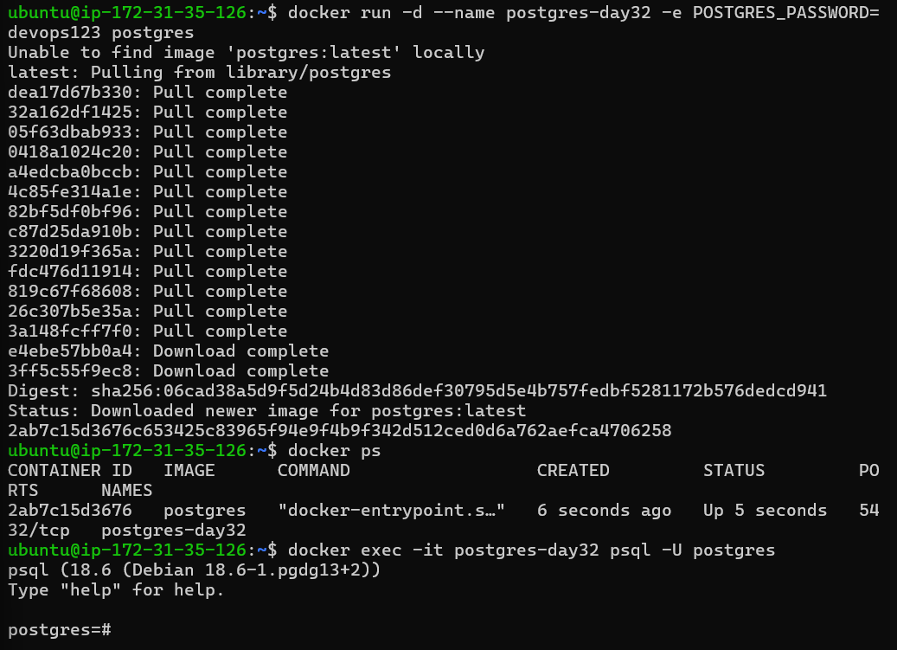

Created table and entered the data
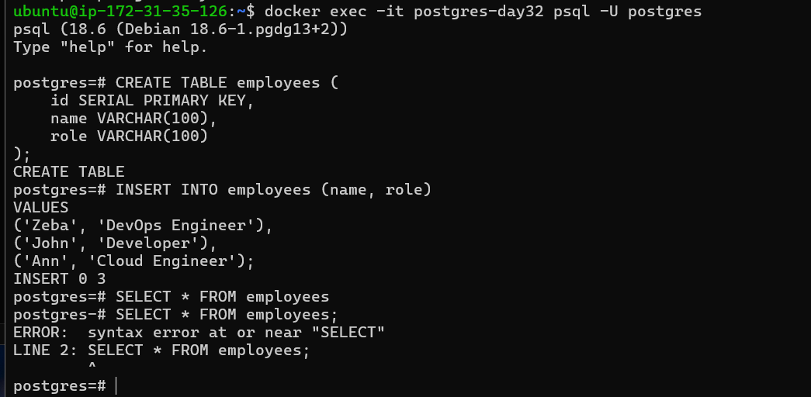
Stopped and removed container
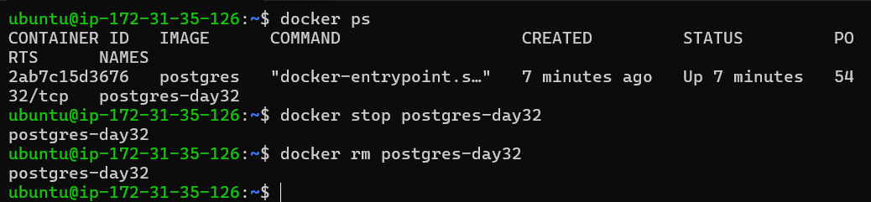
Run the container and checked no data available its gone
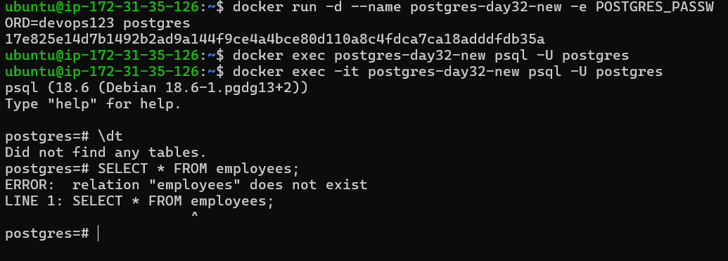Task 1 — The Problem
I created a PostgreSQL container and added an employees table with three rows. After stopping and removing the container, I created a new PostgreSQL container from the same image. The table and its data were gone.
This happened because data written directly inside a container is stored in its writable layer. That layer belongs to that container and is deleted when the container is removed. Therefore, databases and other important data should use persistent storage such as Docker volumes

Task 2: Named Volumes
- Create a named volume
- Run the same database container, but this time attach the volume to it
- Add some data, stop and remove the container
- Run a brand new container with the same volume
- Is the data still there?
Verify: docker volume ls, docker volume inspect

To create a volume: docker volume create <vol_name>
docker volume ls – list volumes
docker volume inspect postgres-data – gives detail
docker run -d --name postgres-volume-1 -e POSTGRES_PASSWORD=devops123 -v postgres-data:/var/lib/postgresql postgres--- runs container with volume attached.

We have attached volume to the container and run it
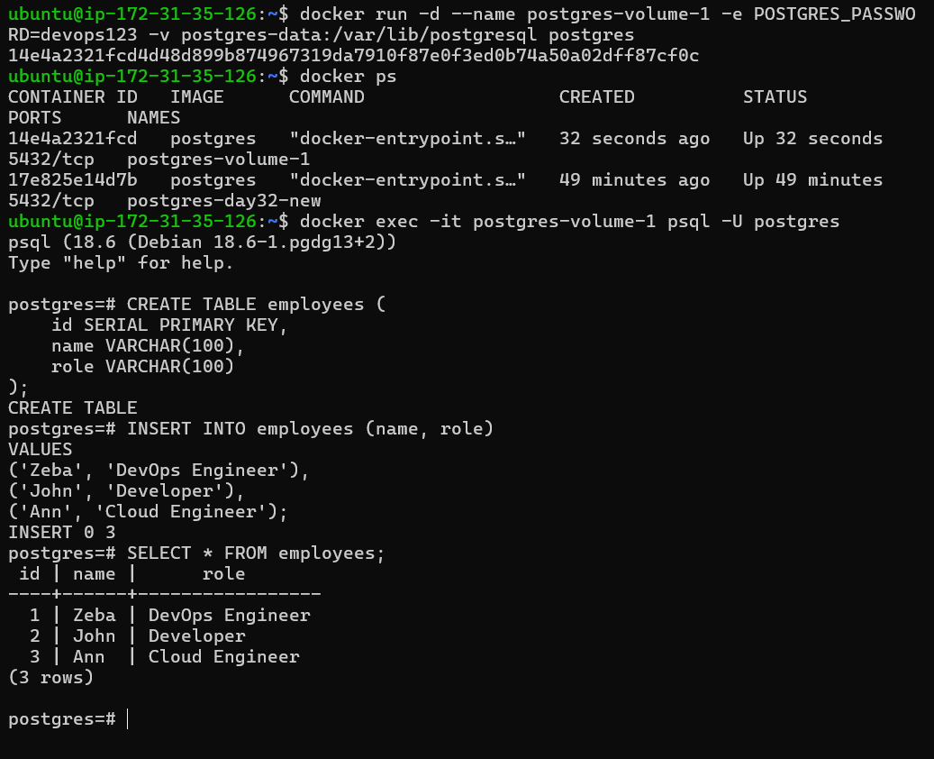
We stopped and removed the container
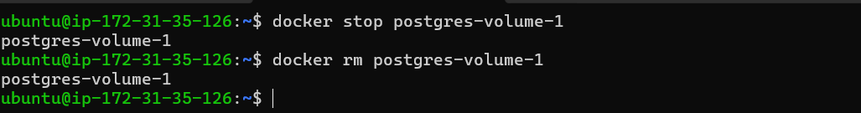

Created new container and saw the data in it which we have entered previosly
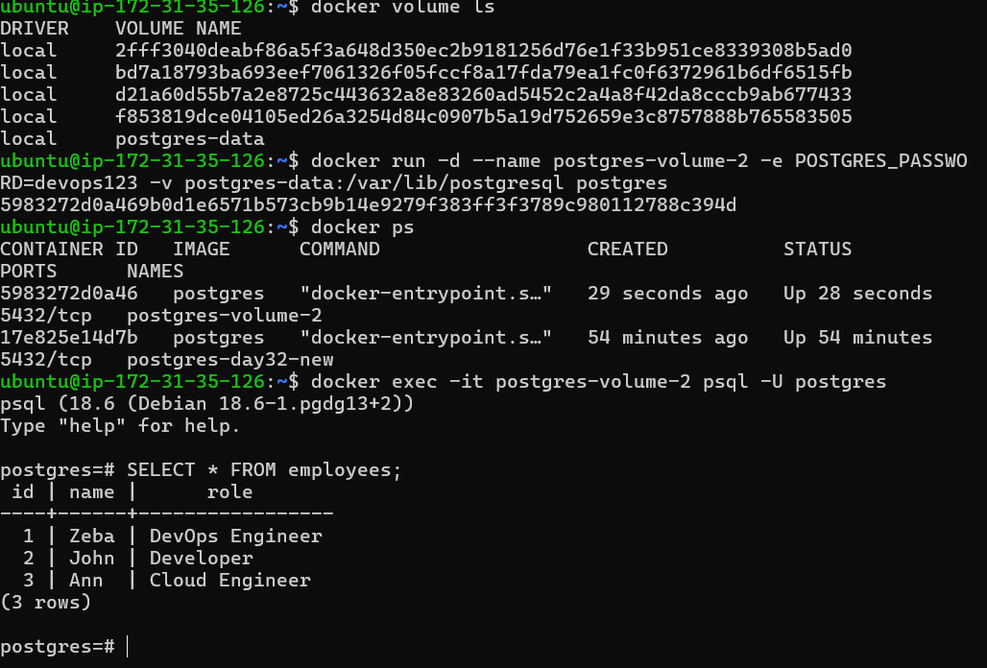

Task 3: Bind Mounts
- Create a folder on your host machine with an index.html file
- Run an Nginx container and bind mount your folder to the Nginx web directory
- Access the page in your browser
- Edit the index.html on your host — refresh the browser
Write in your notes: What is the difference between a named volume and a bind mount?

Create a folder on your host machine with an index.html file, Run an Nginx container and bind mount your folder to the Nginx web directory. Access the page in your browser
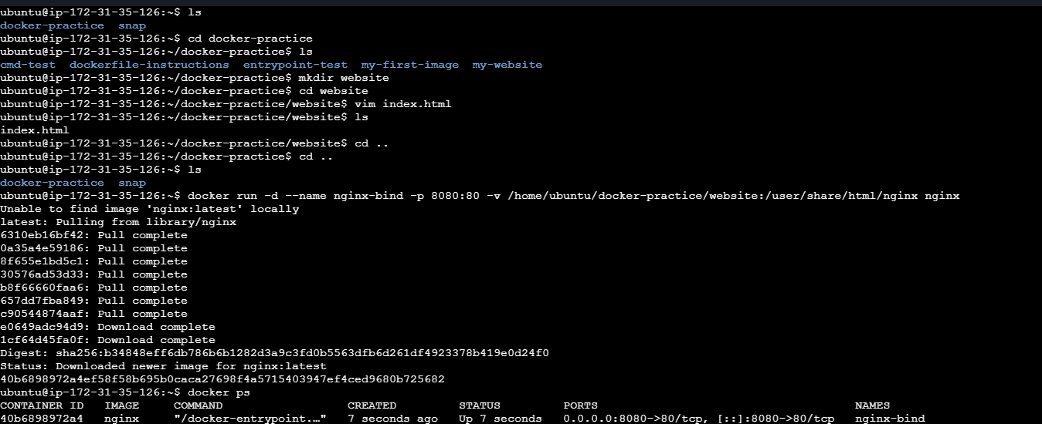 Edit the index.html on your host — refresh the browser
- 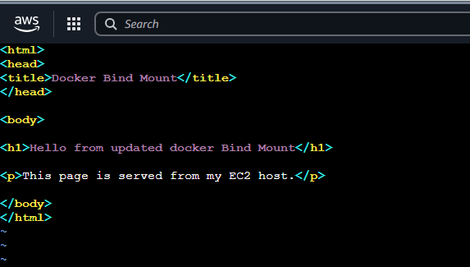

Why did it update instantly?
Because the container is not storing the HTML file.
The container is reading directly from your host folder.
Named Volume vs Bind Mount
Named Volume
Example:
docker run -v postgres-data:/var/lib/postgresql postgres
Characteristics:
- Docker manages the storage location.
- Best for production databases.
- Easier backup and migration.
- Docker controls permissions and lifecycle.
Example use:
- PostgreSQL data
- MySQL data
- Redis data
Bind Mount
Example:
docker run -v /home/ubuntu/site:/usr/share/nginx/html nginx
Characteristics:
- You specify the host path.
- Direct connection between host and container.
- Changes on host immediately appear in container.
- Common for development.
Example use:
- Website code
- Application source code
- Configuration files
- Comparison Table

Feature Named Volume Bind Mount
Managed by Docker User
Location Docker decides User decides
Example postgres-data:/data /home/user/app:/app
Best for Production data Development
Backup Easier User manages
Host access Not direct Direct
Security Better isolation More access

Task 4: Docker Networking Basics
- List all Docker networks on your machine
- Inspect the default bridge network
- Run two containers on the default bridge — can they ping each other by name?
- Run two containers on the default bridge — can they ping each other by IP?

List all Docker networks on your machine
docker network ls
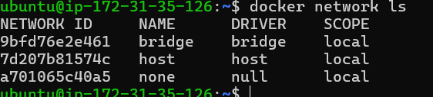
- Bridge
- 2. Host
- None
- Overlay
- Macvlan
- Ipvlan
Network | Purpose
bridge | Default network for containers
host | Container shares host's network stack
none | No network connectivity

Inspect the default bridge network
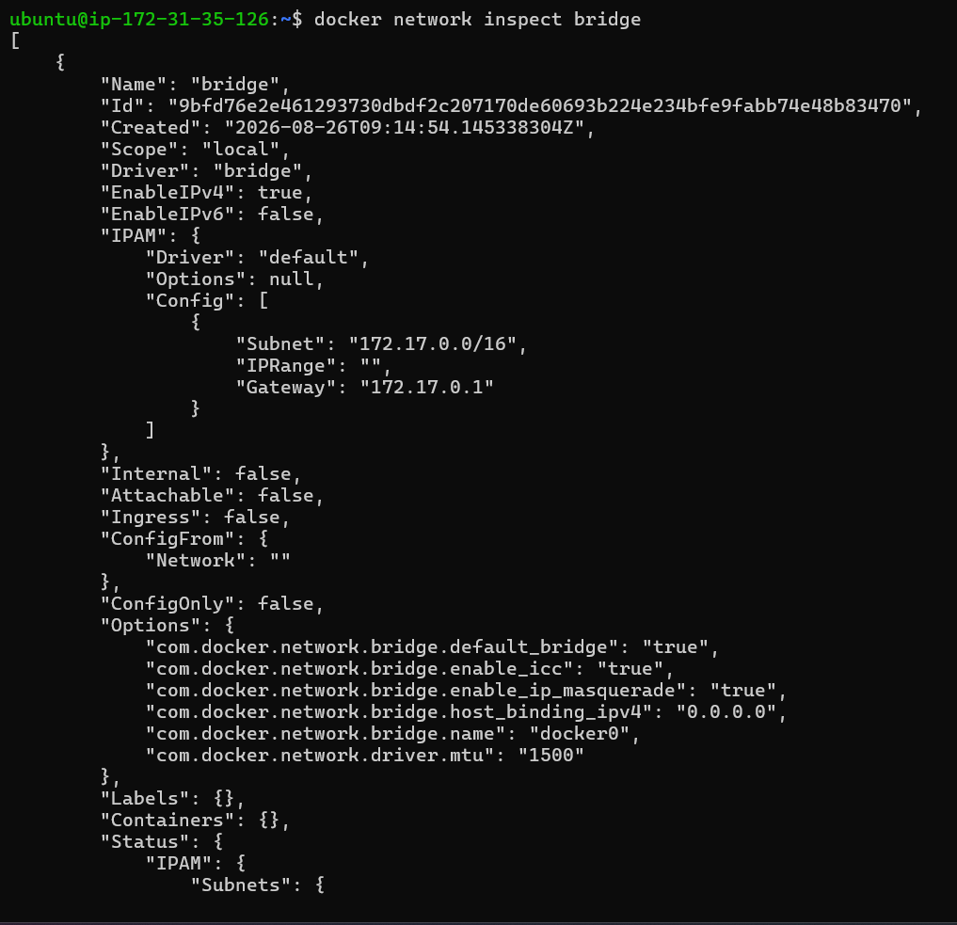

run two containers on the default bridge — can they ping each other by name?
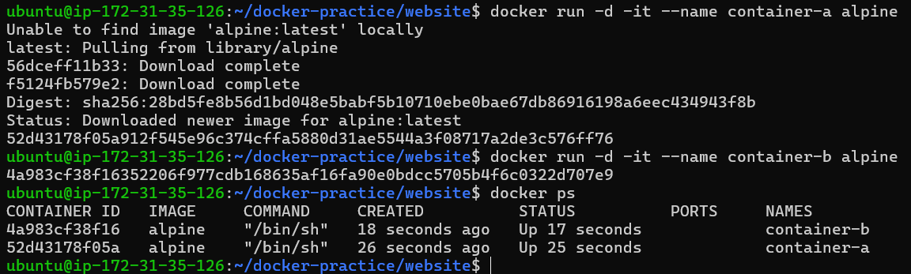

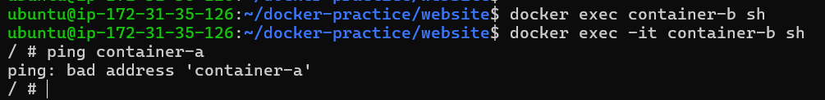
Ping by container name — ❌ Failed
This means the default bridge network does not provide automatic DNS resolution by container name.

Run two containers on the default bridge — can they ping each other by IP?
Ping by IP — ✅ Worked
search for ipaddress = “ ”
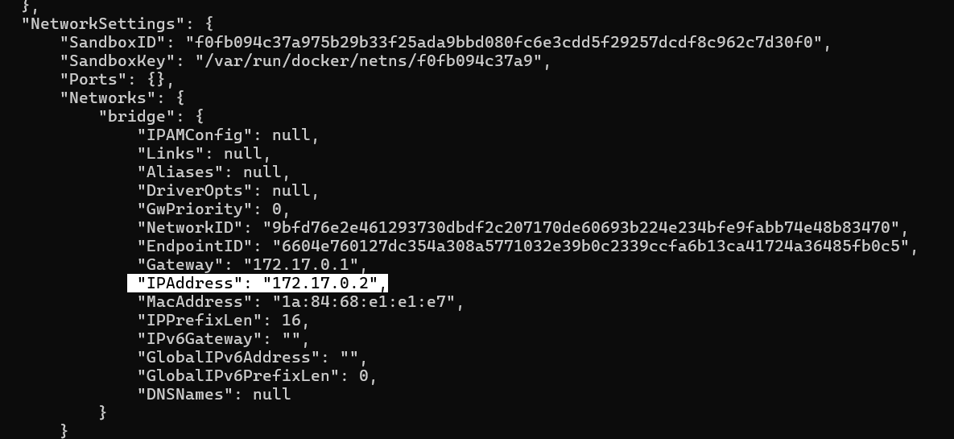
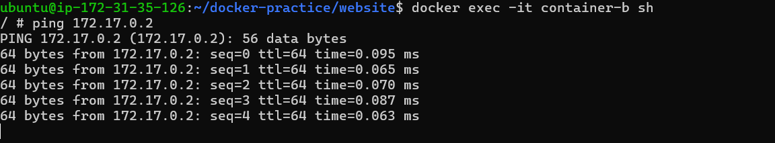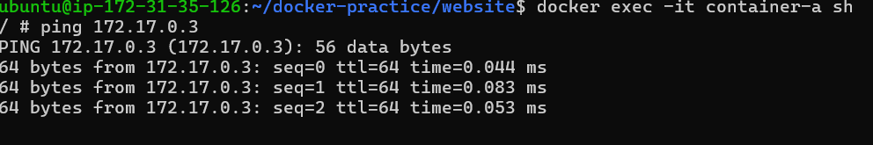

Task 5: Custom Networks
- Create a custom bridge network called my-app-net
- Run two containers on my-app-net
- Can they ping each other by name now?
- Write in your notes: Why does custom networking allow name-based communication but the default bridge doesn't?

Create a custom bridge network called my-app-net
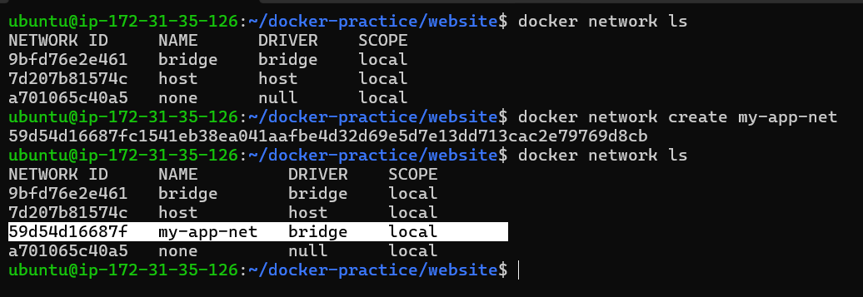
Run two containers on my-app-net
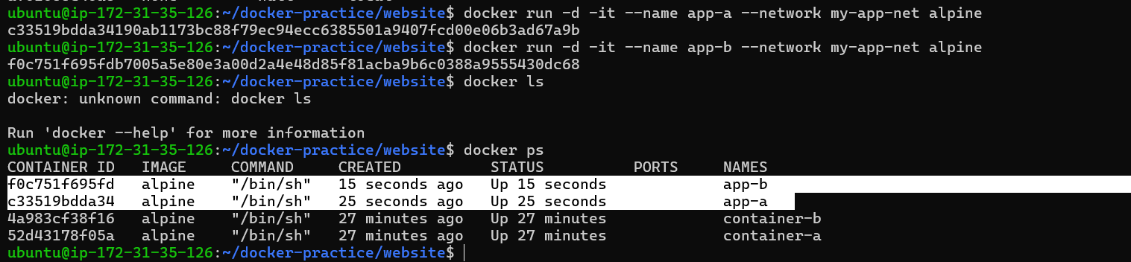
Can they ping each other by name now?
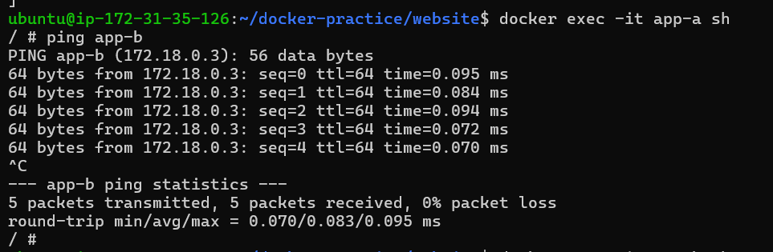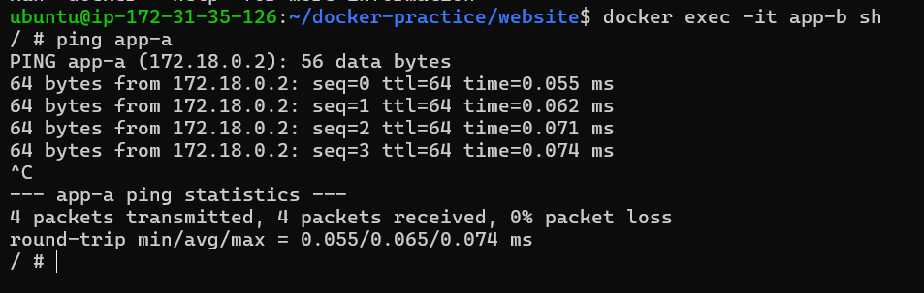
- I created a user-defined bridge network called my-app-net and connected two Alpine containers to it. Unlike the default bridge network, the containers were able to communicate using each other's container names.
- User-defined bridge networks provide Docker's built-in DNS service. Docker automatically resolves container names to their IP addresses on the network. This allows applications to communicate using stable names instead of hard-coded IP addresses, which is useful because container IP addresses can change when containers are recreated.
Easy way to remember
Default bridge
→ IP communication ✅
→ Name communication ❌
Custom bridge
→ IP communication ✅
→ Name communication ✅
→ Docker DNS ✅
Task 6: Put It Together
- Create a custom network
- Run a database container (MySQL/Postgres) on that network with a volume for data
- Run an app container (use any image) on the same network
- Verify the app container can reach the database by container name
Create a custom network
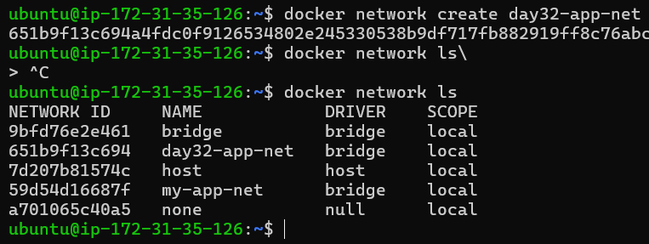
Run a database container (MySQL/Postgres) on that network with a volume for data
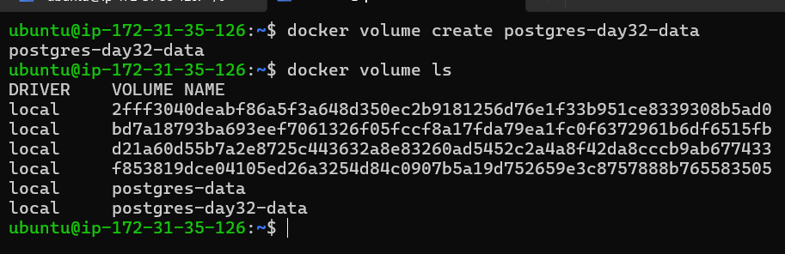
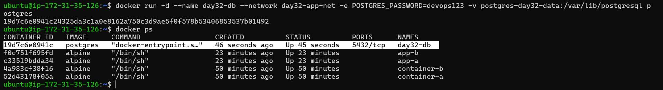
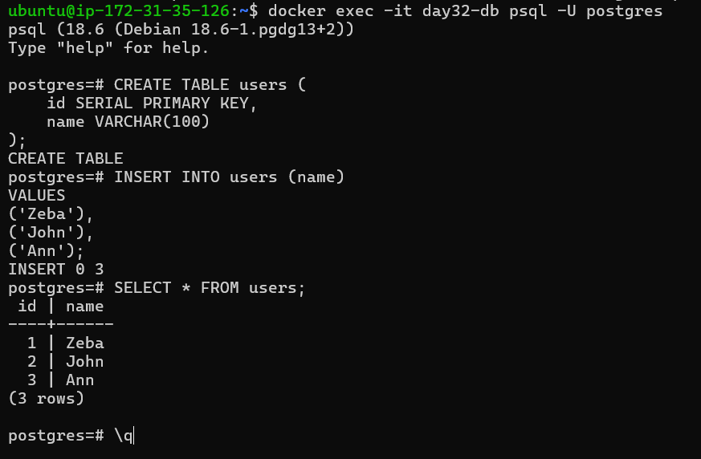
Run an app container (use any image) on the same network
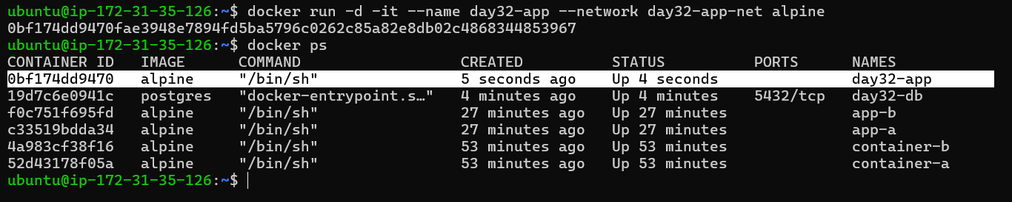
Verify the app container can reach the database by container name
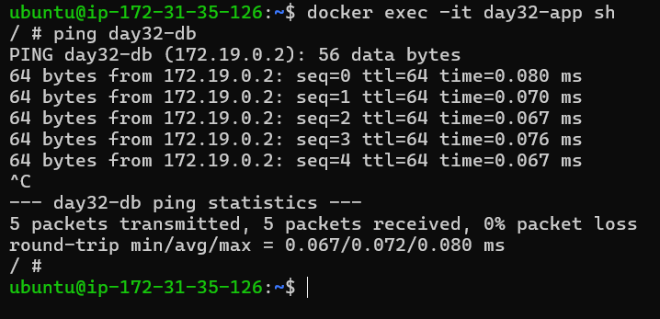
- I created a custom bridge network called day32-app-net and a named volume called postgres-day32-data. I ran a PostgreSQL database container on the custom network and mounted the named volume to PostgreSQL's data directory for persistent storage.
- I then ran an Alpine container as the application container on the same custom network. From the application container, I successfully resolved the database container using its name day32-db and verified that PostgreSQL's port 5432 was reachable.
- This demonstrates how Docker networking and volumes work together: the custom network provides container-to-container communication and DNS-based name resolution, while the named volume provides persistent database storage.

