Task 1: Understand workflow_call
Before writing any code, research and answer in your notes:
- What is a reusable workflow?
- What is the workflow_call trigger?
- How is calling a reusable workflow different from using a regular action (uses:)?
- Where must a reusable workflow file live?

1. What is a reusable workflow?
A reusable workflow is a GitHub Actions workflow that is designed to be called and used by another workflow instead of duplicating the same CI/CD logic in multiple workflow files.

What is the workflow_call trigger?
workflow_call is a GitHub Actions trigger that makes a workflow callable by another workflow.
Example:
on:
workflow_call:

3. How is calling a reusable workflow different from using a regular action (uses:)?
The main difference is where and what you are calling.
Regular action:
- Used inside a job's steps
- Performs a particular task or a group of steps
Reusable workflow:
- Called directly at the job level
- Can contain multiple jobs and steps
- Reuses an entire workflow rather than just an action step

Quick revision
Question | Answer
Reusable workflow | A workflow designed to be called and reused by other workflows
workflow_call | Trigger that makes a workflow callable
Regular action | Used inside steps to perform a task
Reusable workflow | Called directly at the job level and can contain multiple jobs
Location | .github/workflows/

Task 2: Create Your First Reusable Workflow
Create .github/workflows/reusable-build.yml:
- Set the trigger to workflow_call
- Add an inputs: section with:
  - app_name (string, required)
  - environment (string, required, default: staging)
- Add a secrets: section with:
  - docker_token (required)
- Create a job that:
  - Checks out the code
  - Prints Building <app_name> for <environment>
  - Prints Docker token is set: true (never print the actual secret)
Verify: This file alone won't run — it needs a caller. That's next.

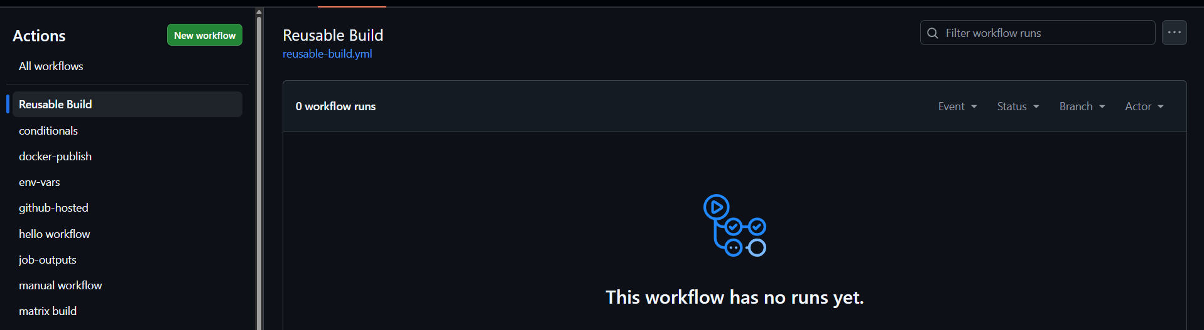
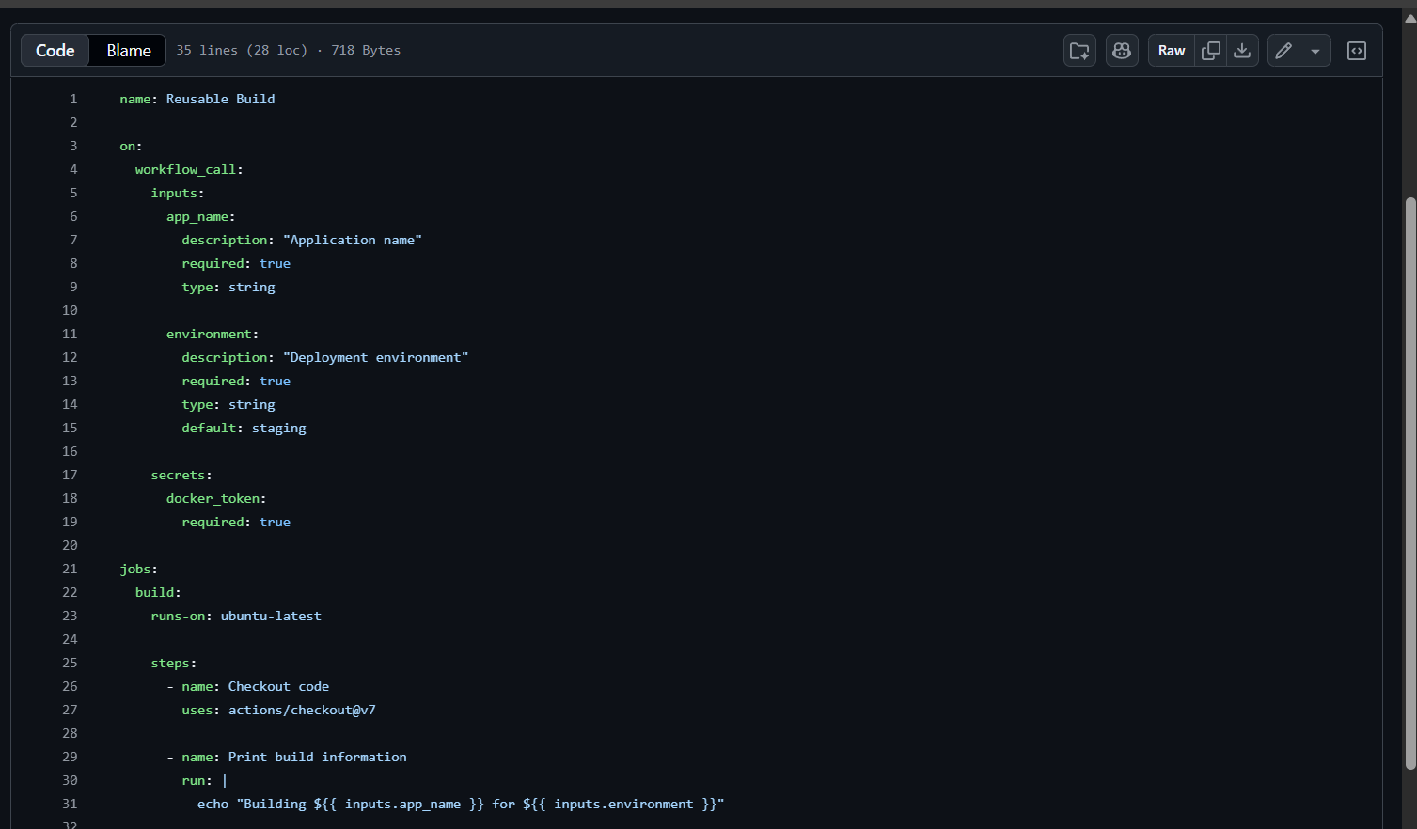

Task 3: Create a Caller Workflow
Create .github/workflows/call-build.yml:
- Trigger on push to main
- Add a job that uses your reusable workflow:
- jobs:
- build:
- uses: ./.github/workflows/reusable-build.yml
- with:
- app_name: "my-web-app"
- environment: "production"
- secrets:
docker_token: ${{ secrets.DOCKER_TOKEN }}
- Push to main and watch it run
Verify: In the Actions tab, do you see the caller triggering the reusable workflow? Click into the job — can you see the inputs printed?
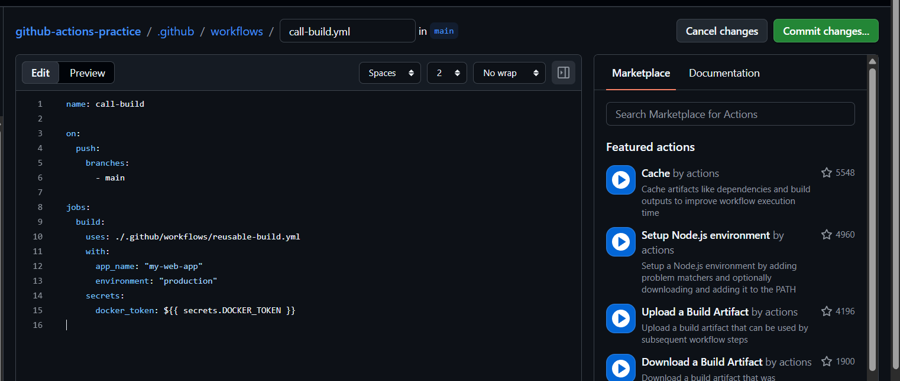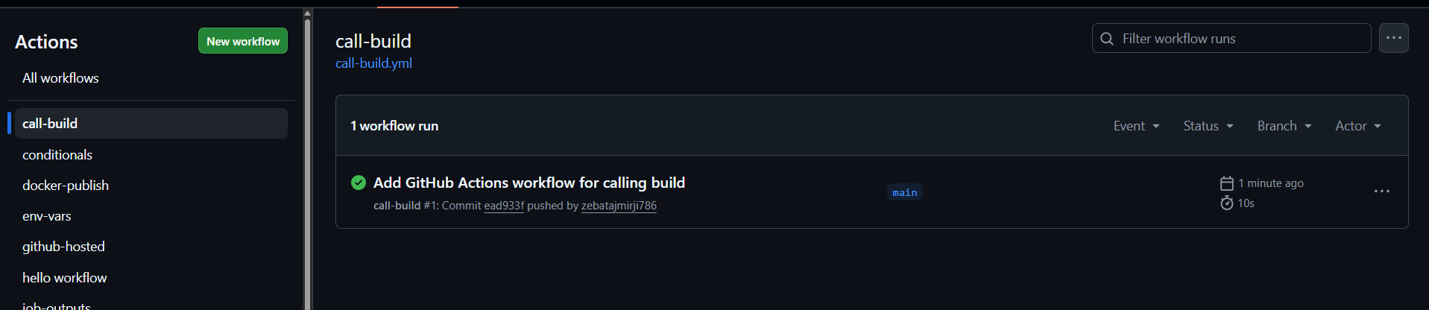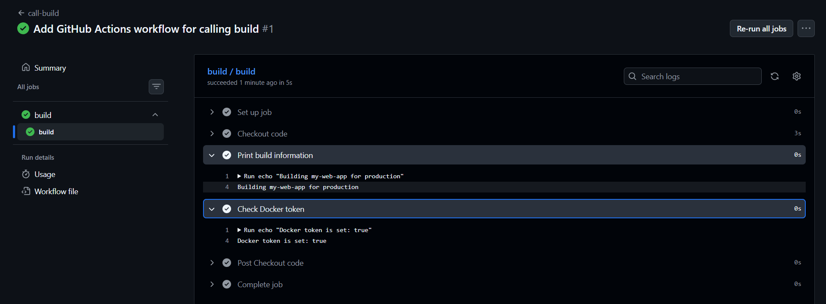

Task 4: Add Outputs to the Reusable Workflow
Extend reusable-build.yml:
- Add an outputs: section that exposes a build_version value
- Inside the job, generate a version string (e.g., v1.0-<short-sha>) and set it as output
- In your caller workflow, add a second job that:
  - Depends on the build job (needs:)
  - Reads and prints the build_version output
Verify: Does the second job print the version from the reusable workflow?
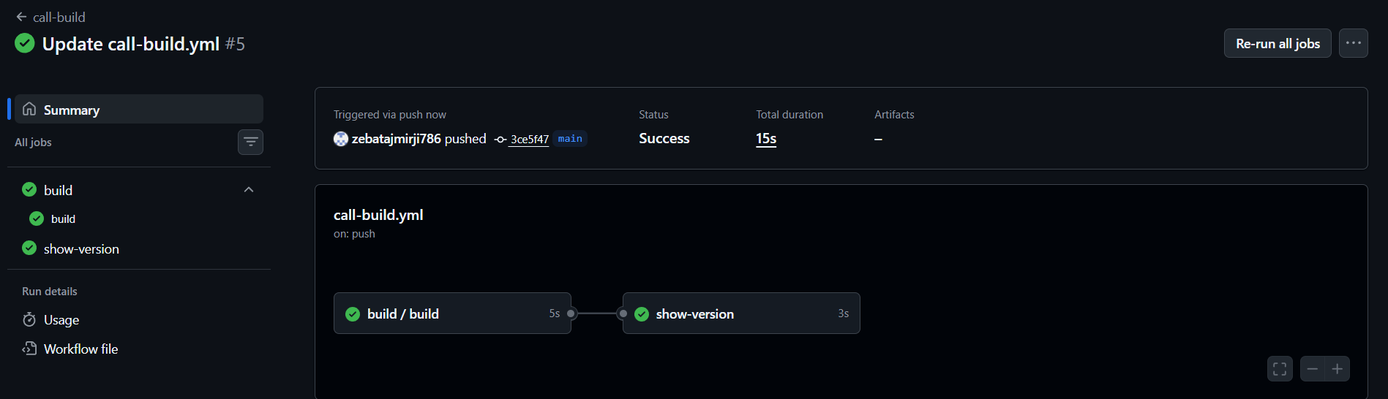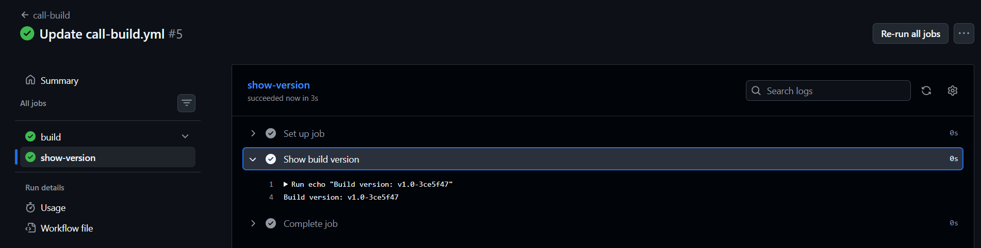
Task 5: Create a Composite Action
Create a custom composite action in your repo at .github/actions/setup-and-greet/action.yml:
- Define inputs: name and language (default: en)
- Add steps that:
  - Print a greeting in the specified language
  - Print the current date and runner OS
  - Set an output called greeted with value true
- Use the composite action in a new workflow with uses: ./.github/actions/setup-and-greet
Verify: Does your custom action run and print the greeting?
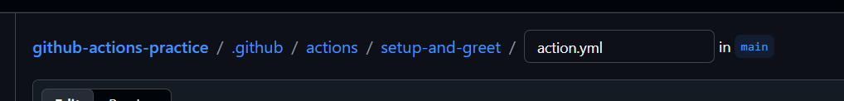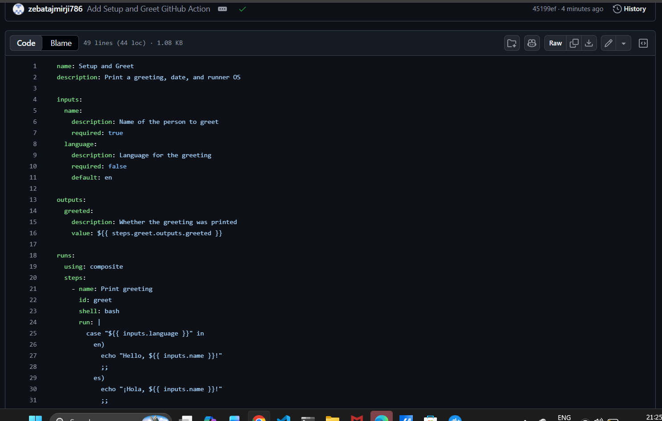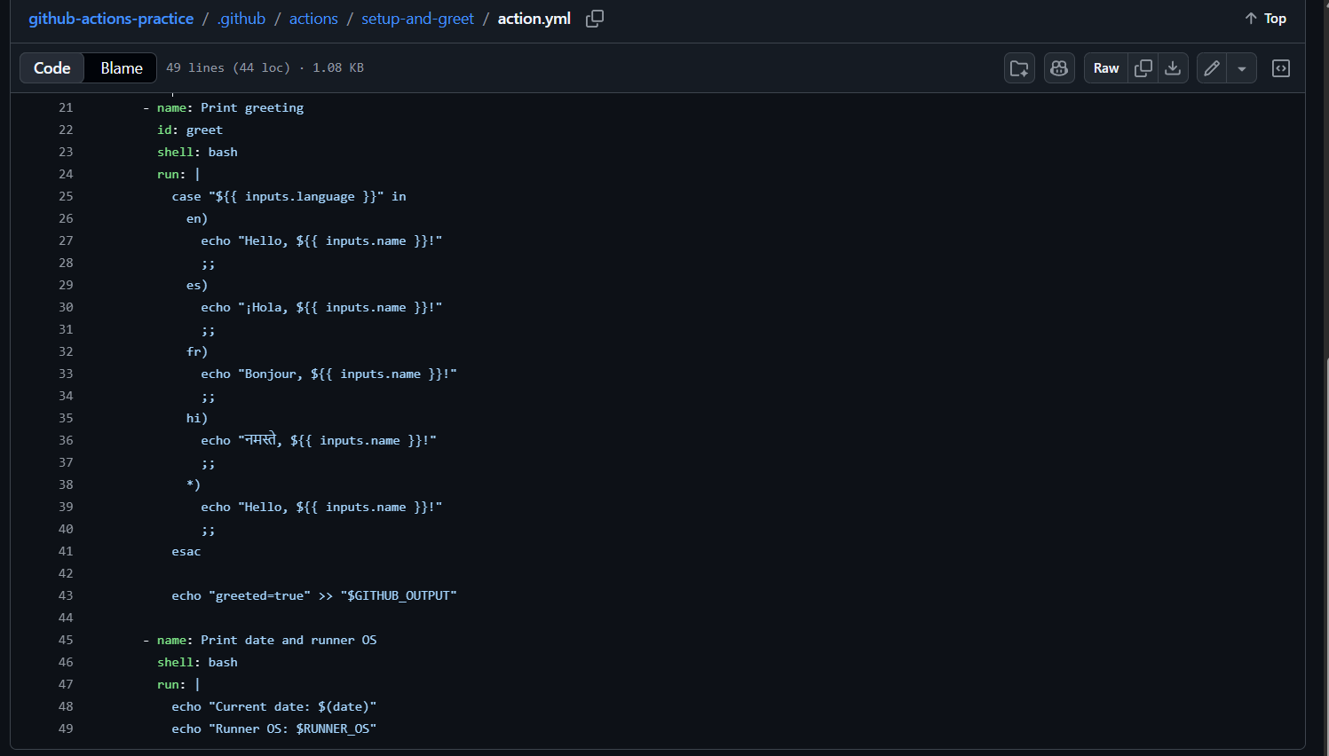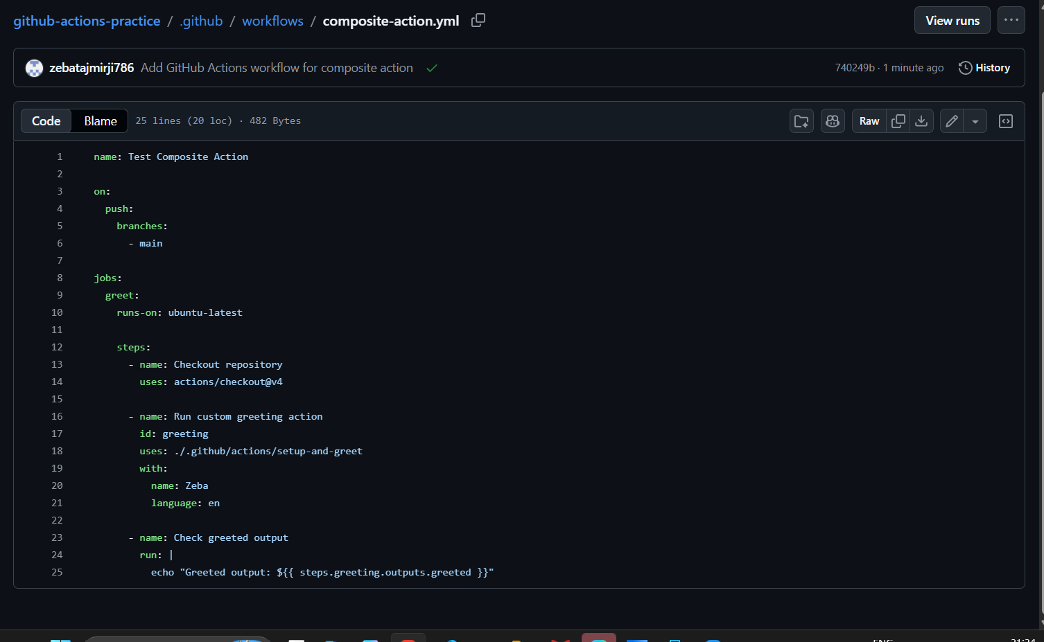
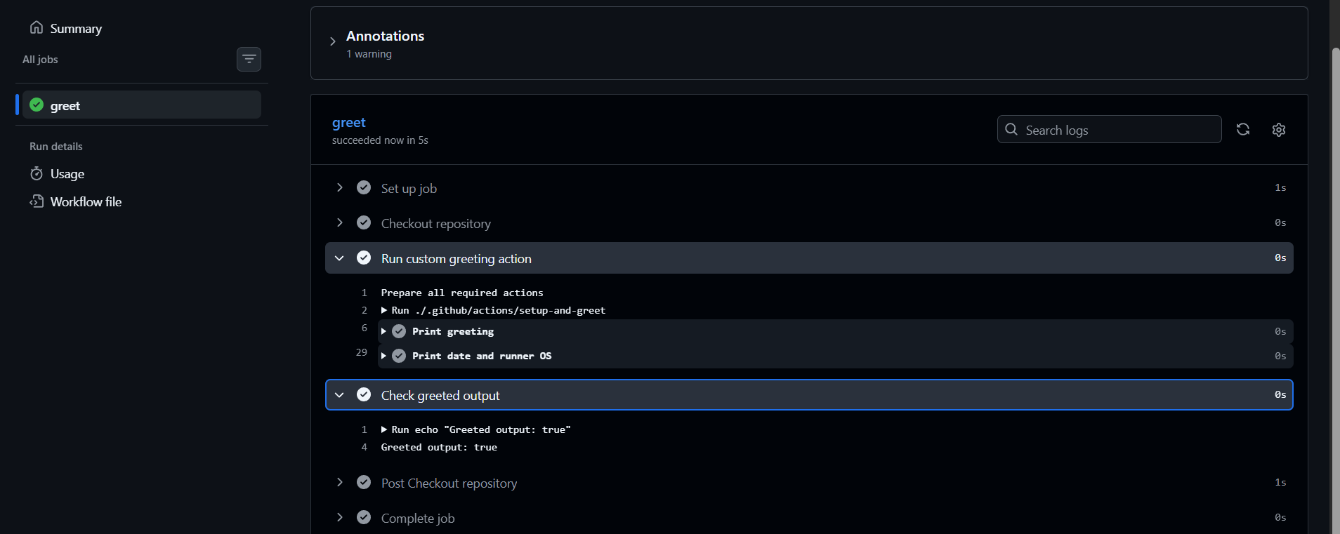

Reusable Workflow | Composite Action
Triggered by: workflow_call | Triggered by: uses: in a step
Can contain jobs? ✅ Yes | Can contain jobs? ❌ No
Can contain multiple steps? ✅ Yes, across jobs | Can contain multiple steps? ✅ Yes
Lives where? .github/workflows/ | .github/actions/<action-name>/action.yml
Can accept secrets directly? ✅ Yes, through workflow_call secrets | ❌ No, not directly; secrets can be passed as inputs/environment
Best for: Reusing complete workflows/jobs and CI/CD processes | Best for: Reusing a group of steps within a job

