Day 63 -- Variables, Outputs, Data Sources and Expressions

Task 1: Extract Variables
Take your Day 62 infrastructure config and refactor it:
- Create a variables.tf file with input variables for:
  - region (string, default: your preferred region)
  - vpc_cidr (string, default: "10.0.0.0/i16")
  - subnet_cidr (string, default: "10.0.1.0/24")
  - instance_type (string, default: "t2.micro")
  - project_name (string, no default -- force the user to provide it)
  - environment (string, default: "dev")
  - allowed_ports (list of numbers, default: [22, 80, 443])
  - extra_tags (map of strings, default: {})
- Replace every hardcoded value in main.tf with var.<name> references
- Run terraform plan -- it should prompt you for project_name since it has no default
Document: What are the five variable types in Terraform? (string, number, bool, list, map)
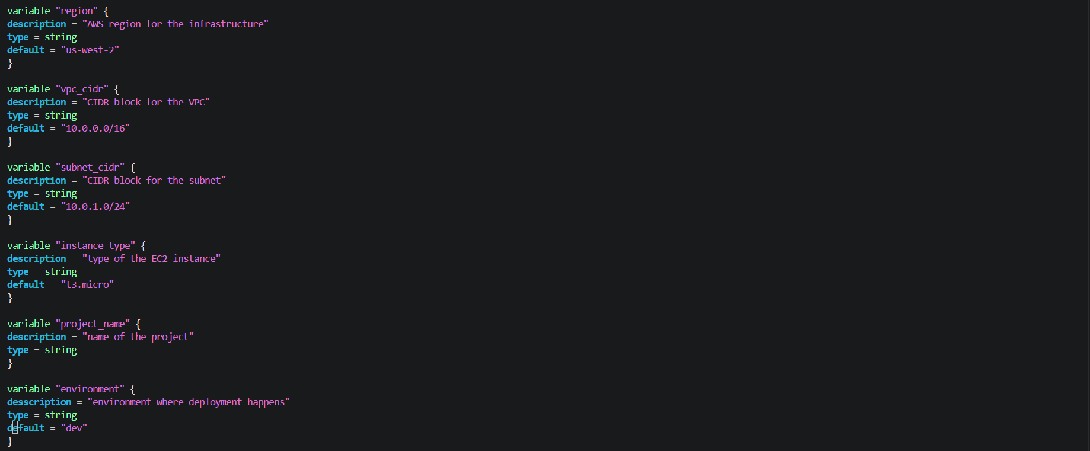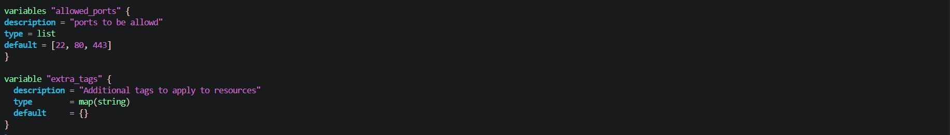
Update provider.tf for region
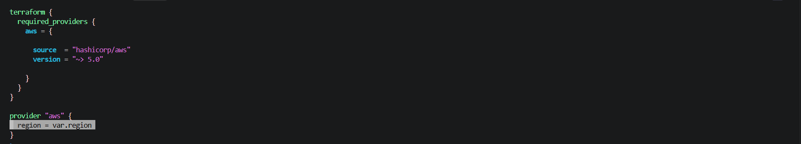
Update Main.tf
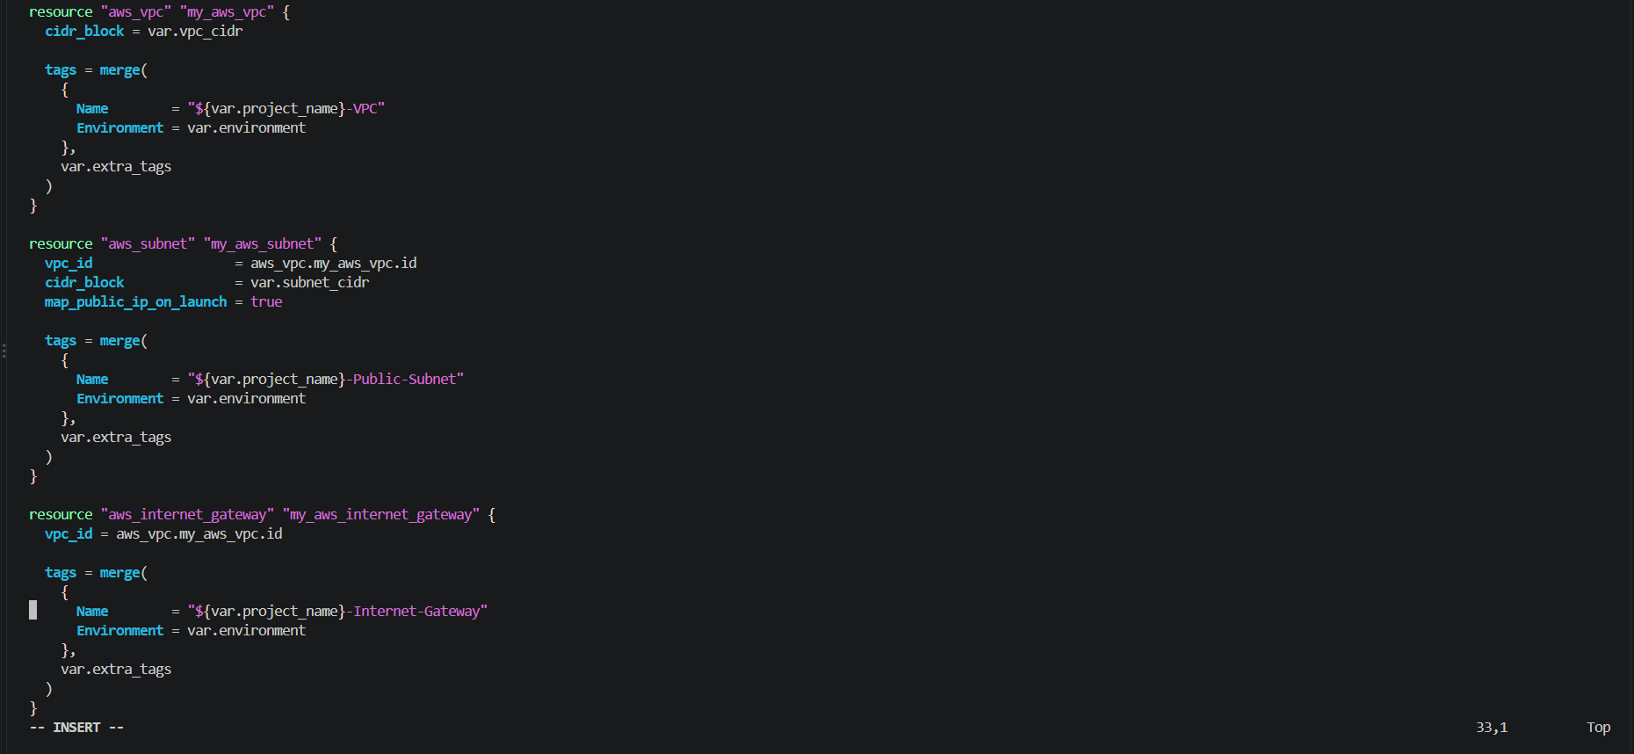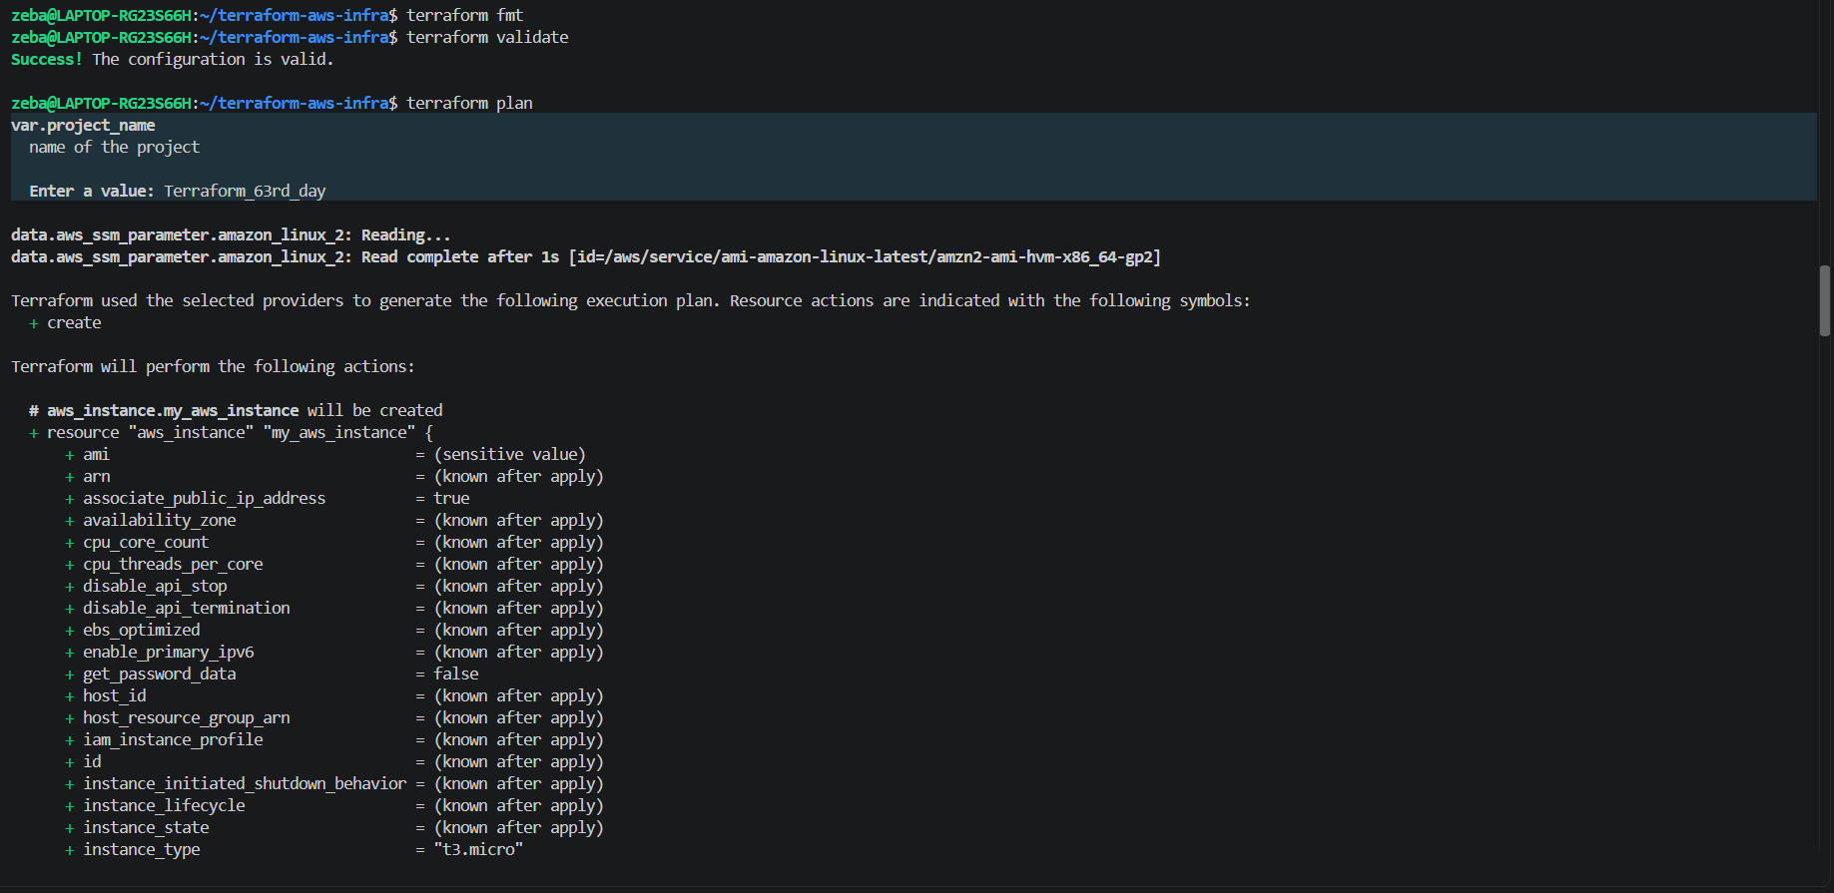
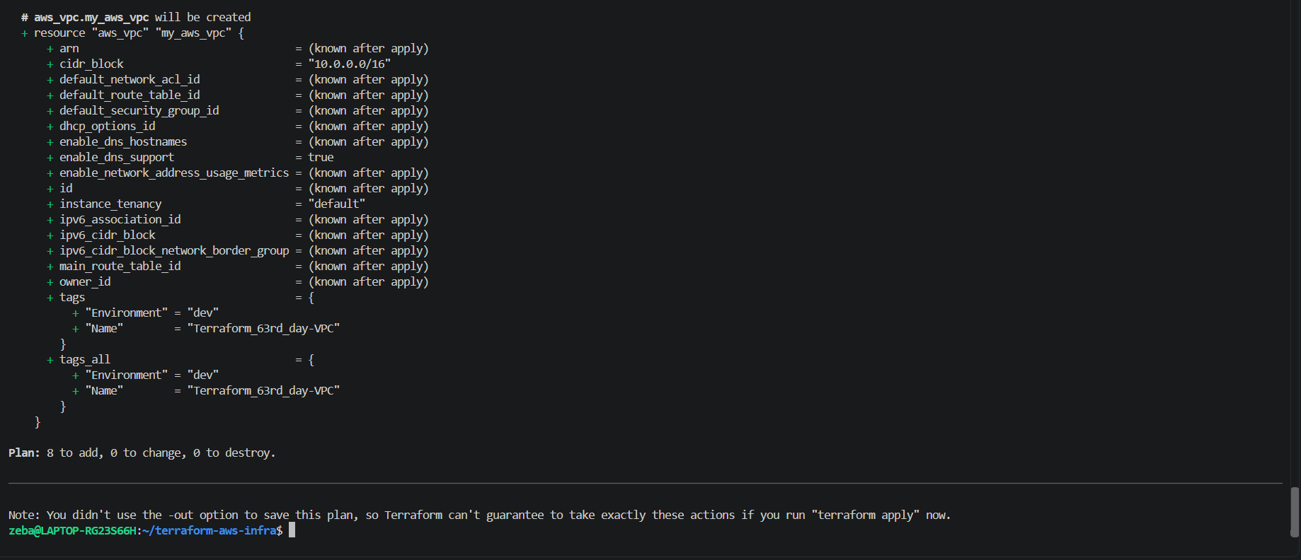
Terraform variables allow us to pass configurable values into our infrastructure code instead of hardcoding them.
Variable type | Description | Example
string | Stores text values. | "us-west-2"
number | Stores numeric values, including integers and decimals. | 8080
bool | Stores Boolean values: true or false. | true
list | Stores an ordered collection of values, usually of the same type. | [22, 80, 443]
map | Stores key-value pairs, usually with values of the same type. | { environment = "dev", team = "ops" }

Task 2: Variable Files and Precedence
- Create terraform.tfvars:
project_name = "terraweek"
environment = "dev"
instance_type = "t2.micro"
- Create prod.tfvars:
project_name = "terraweek"
environment = "prod"
instance_type = "t3.small"
vpc_cidr = "10.1.0.0/16"
subnet_cidr = "10.1.1.0/24"
- Apply with the default file:
terraform plan # Uses terraform.tfvars automatically
- Apply with the prod file:
terraform plan -var-file="prod.tfvars" # Uses prod.tfvars
- Override with CLI:
terraform plan -var="instance_type=t2.nano" # CLI overrides everything
- Set an environment variable:
export TF_VAR_environment="staging"
terraform plan # env var overrides default but not tfvars
Document: Write the variable precedence order from lowest to highest priority.

terraform.tfvars

prod.tfvars

As per the output we can see its using dev , t2 micro and .. , so by default it is using terraform.tfvars
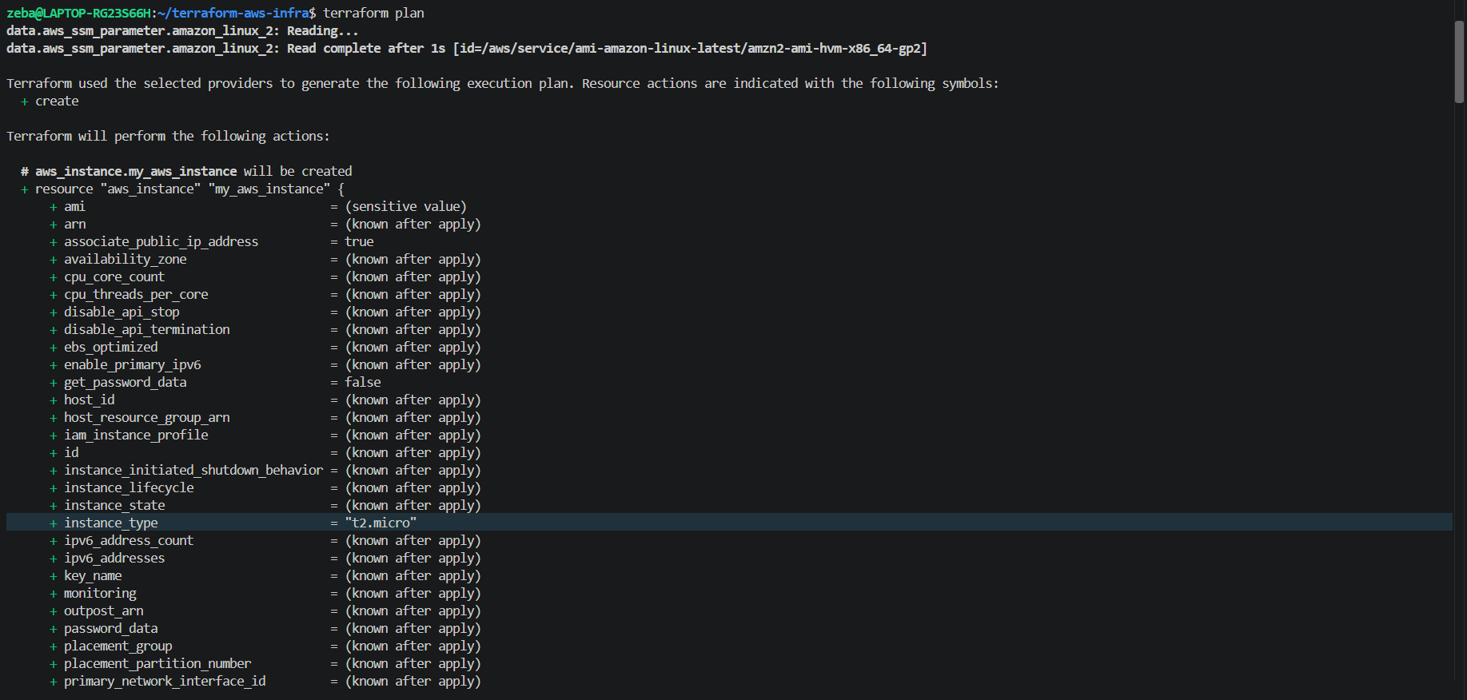

Specified particular file
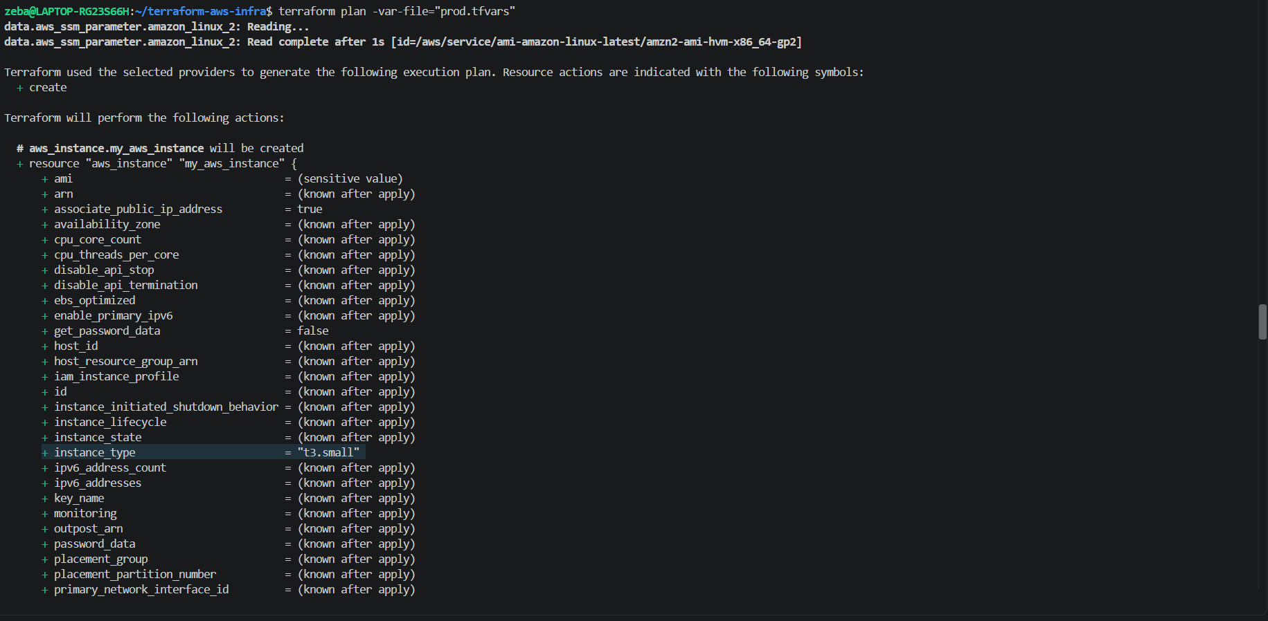

Override with cli
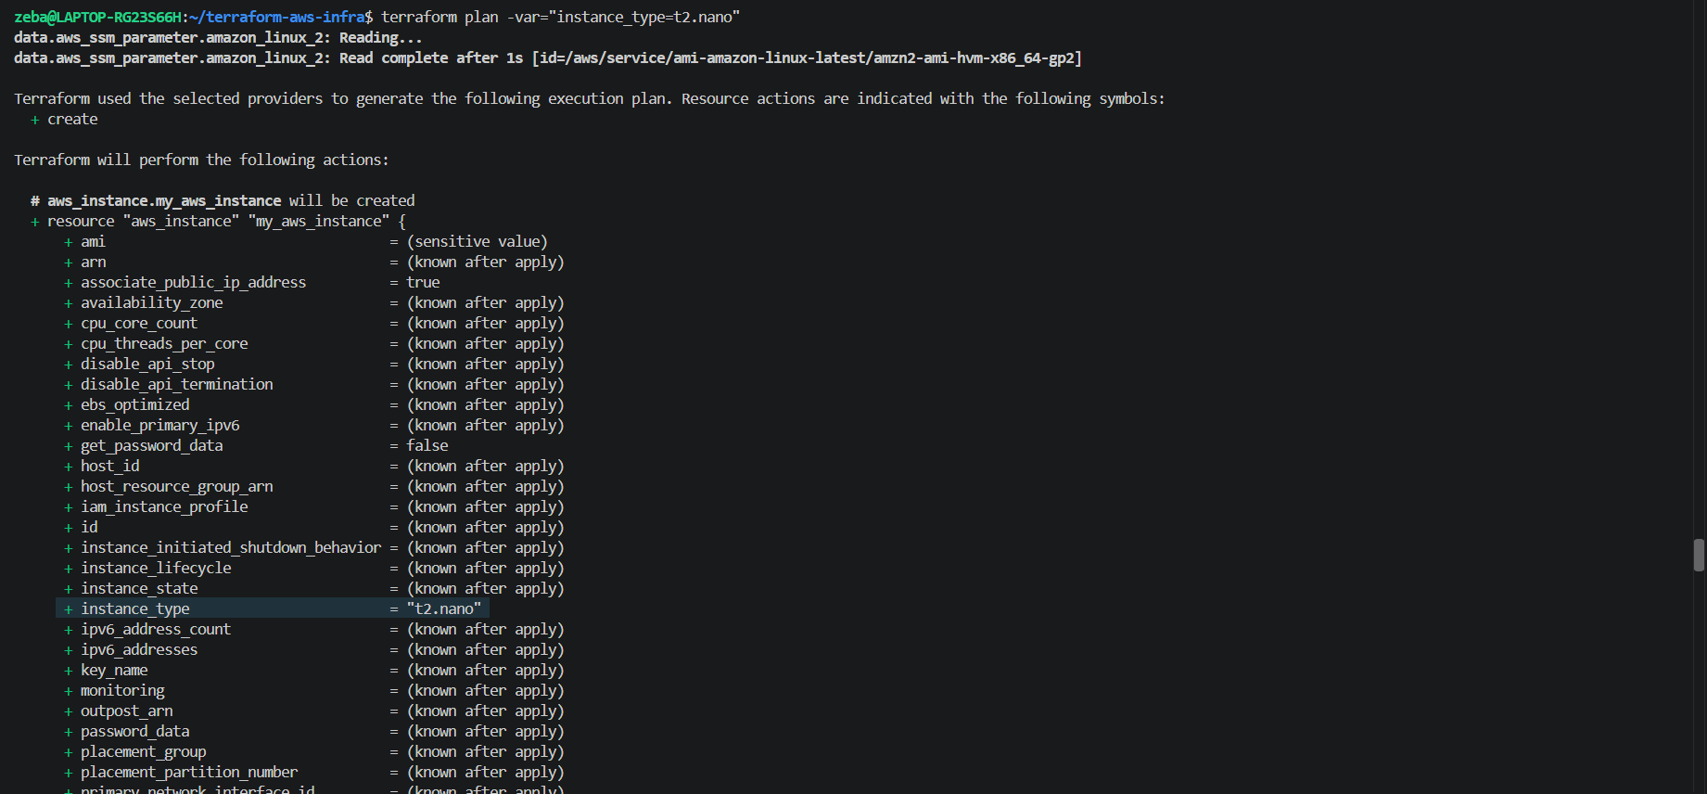

- Set an environment variable:
export TF_VAR_environment="staging"
terraform plan # env var overrides default but not tfvars
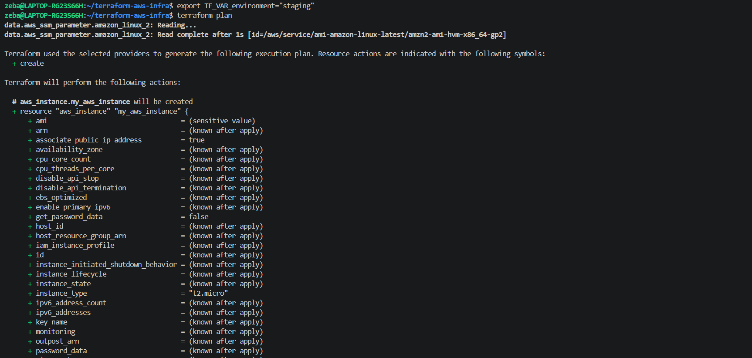
We could see environment as dev
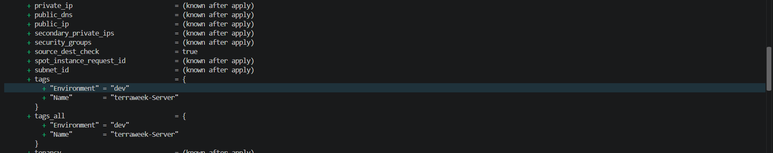
Variable precedence order (lowest to highest)
Terraform uses the following order to determine which value wins when the same variable is defined in multiple places.
Priority | Source | Description
1 — Lowest | Default value in variables.tf | Used when no higher-priority value is provided.
2 | Environment variable (TF_VAR_name) | Example: TF_VAR_environment="staging".
3 | terraform.tfvars / terraform.tfvars.json | Loaded automatically by Terraform.
4 | *.auto.tfvars / *.auto.tfvars.json | Automatically loaded variable files.
5 — Highest | CLI arguments (-var and -var-file) | Explicit command-line values take priority over the sources above.
If multiple -var or -var-file arguments are supplied, later arguments take precedence over earlier ones for variables they both define.

- Variable defaults — Values defined using default in variables.tf.
- Environment variables — Values set using TF_VAR_name, such as TF_VAR_environment="staging".
- terraform.tfvars and terraform.tfvars.json — Automatically loaded variable files.
- *.auto.tfvars and *.auto.tfvars.json — Automatically loaded variable files.
- Command-line arguments (-var and -var-file) — Highest priority.

Task 3: Add Outputs
Create an outputs.tf file with outputs for:
- vpc_id -- the VPC ID
- subnet_id -- the public subnet ID
- instance_id -- the EC2 instance ID
- instance_public_ip -- the public IP of the EC2 instance
- instance_public_dns -- the public DNS name
- security_group_id -- the security group ID
Apply your config and verify the outputs are printed at the end:
terraform apply

# After apply, you can also run:
terraform output # Show all outputs
terraform output instance_public_ip # Show a specific output
terraform output -json # JSON format for scripting
Verify: Does terraform output instance_public_ip return the correct IP?
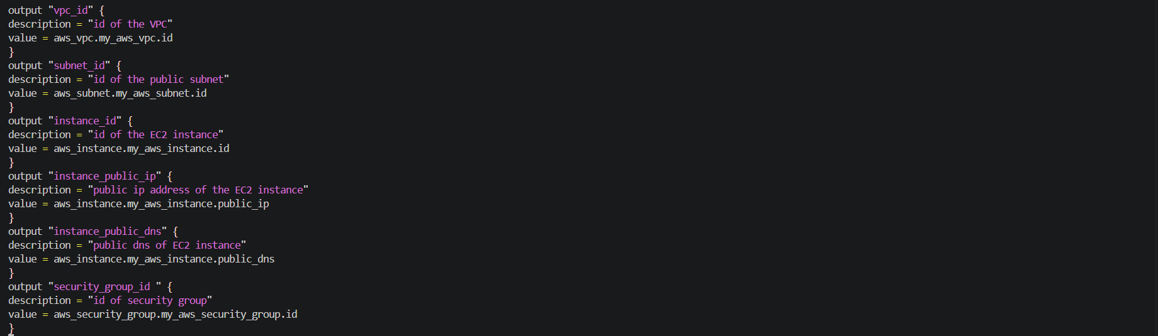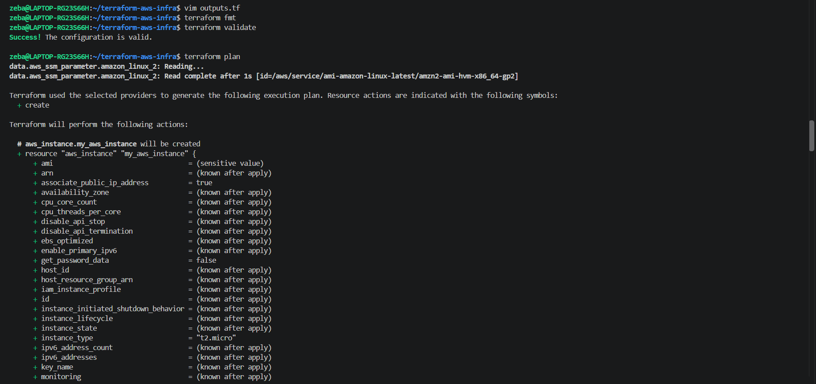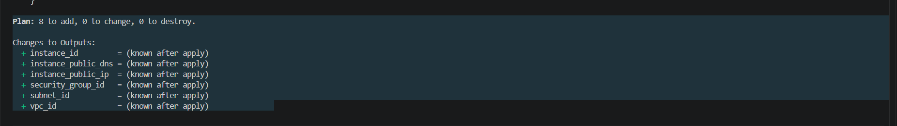
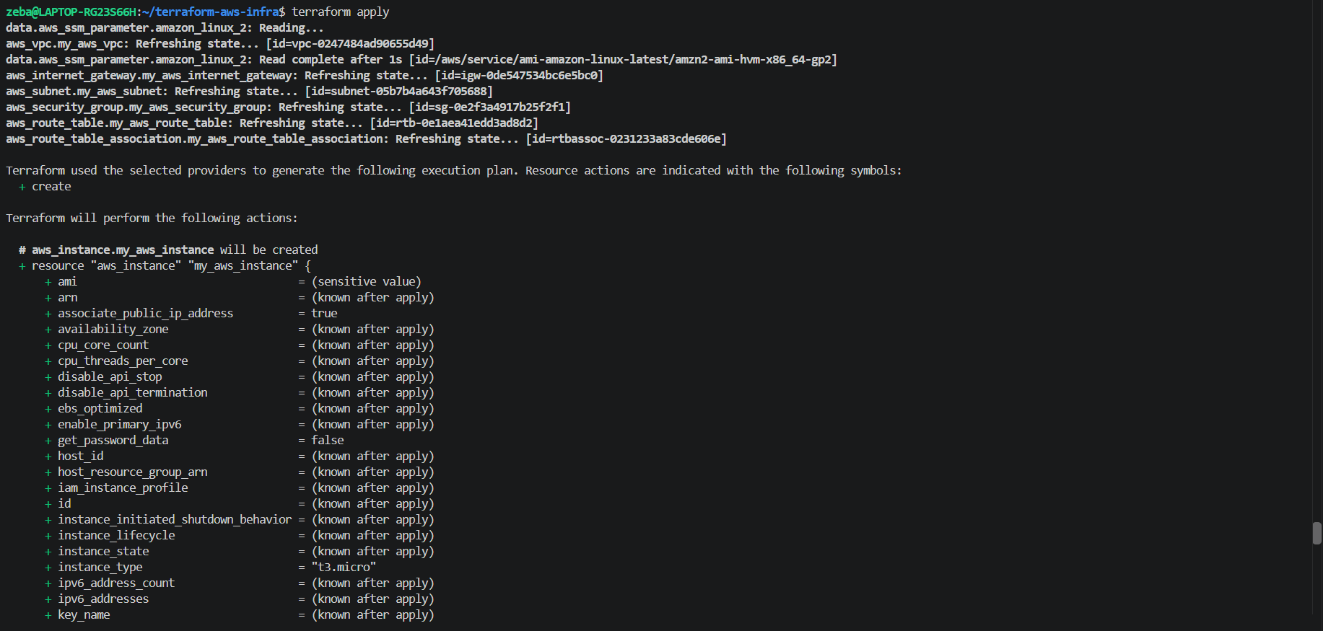

After terraform apply we got output also
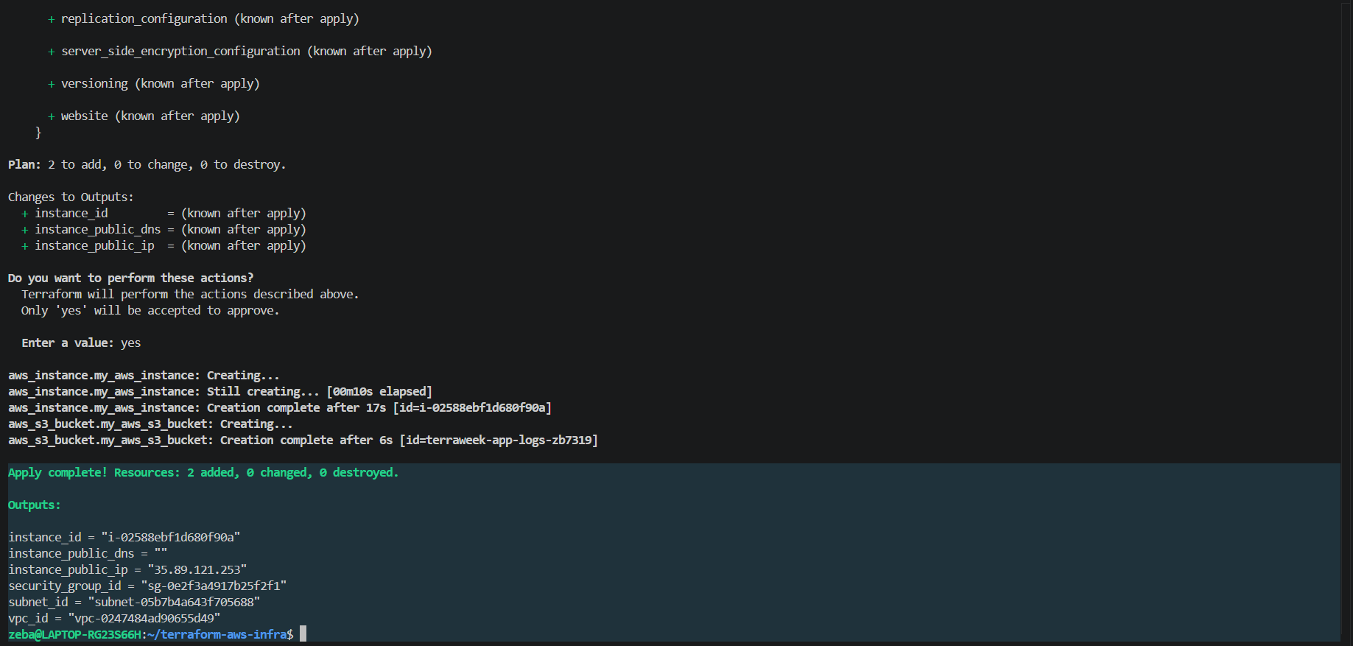
terraform output # Show all outputs
terraform output instance_public_ip # Show a specific output
terraform output -json # JSON format for scripting
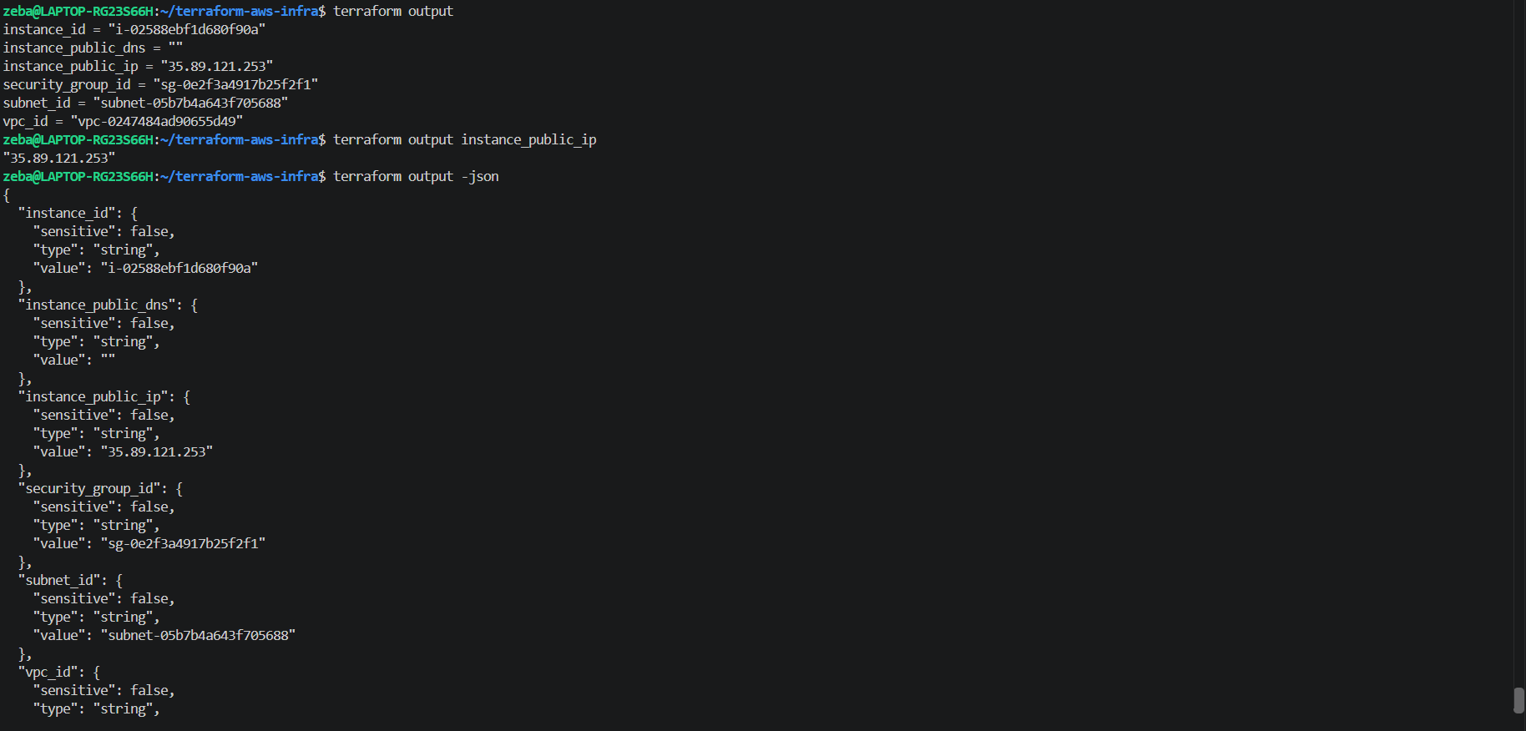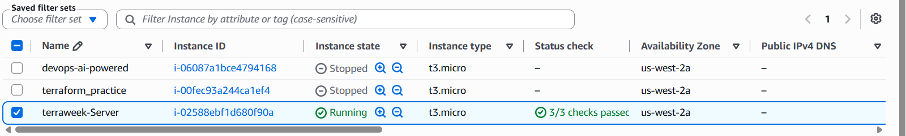

Task 4: Use Data Sources
Stop hardcoding the AMI ID. Use a data source to fetch it dynamically.
- Add a data "aws_ami" block that:
  - Filters for Amazon Linux 2 images
  - Filters for hvm virtualization and gp2 root device
  - Uses owners = ["amazon"]
  - Sets most_recent = true
- Replace the hardcoded AMI in your aws_instance with data.aws_ami.amazon_linux.id
- Add a data "aws_availability_zones" block to fetch available AZs in your region
- Use the first AZ in your subnet: data.aws_availability_zones.available.names[0]
Apply and verify -- your config now works in any region without changing the AMI.
Document: What is the difference between a resource and a data source?

Added aws_ami block
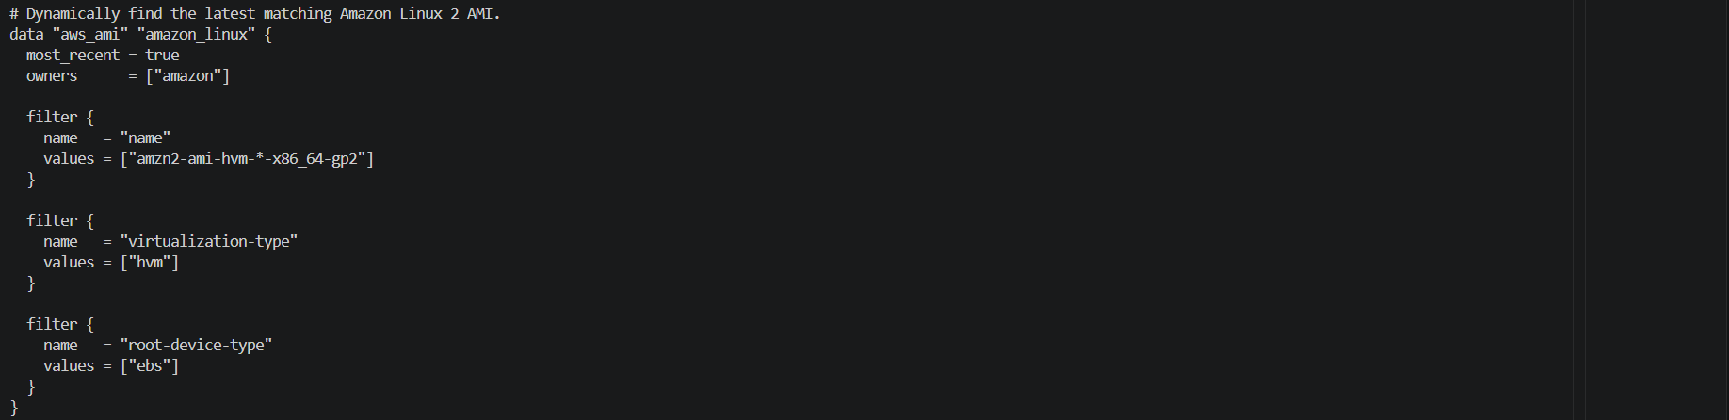
Replaced hardcoded ami value
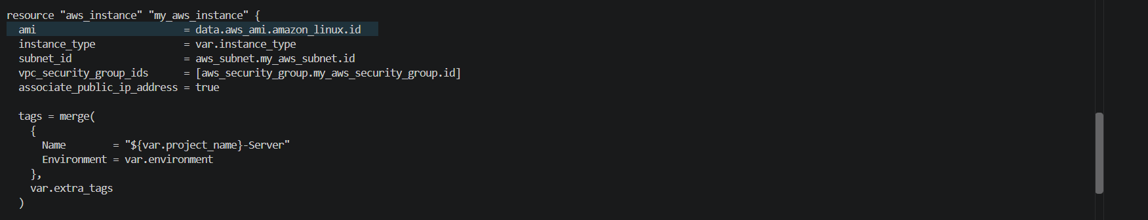

Added block to find aws_available zone
Added the available zone in subnet
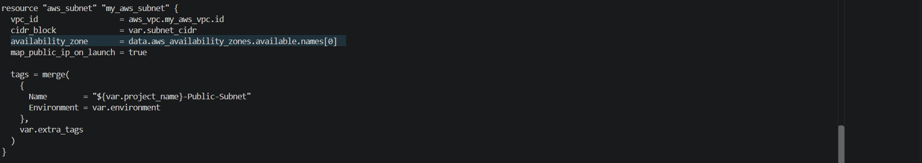
Got terraform plan
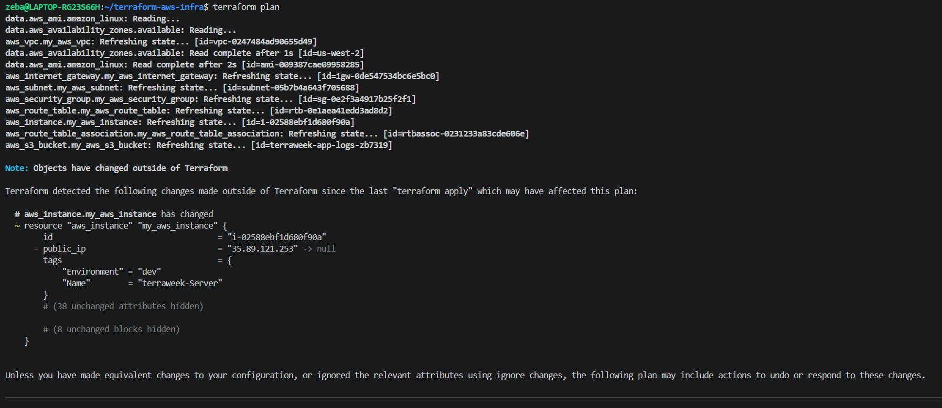
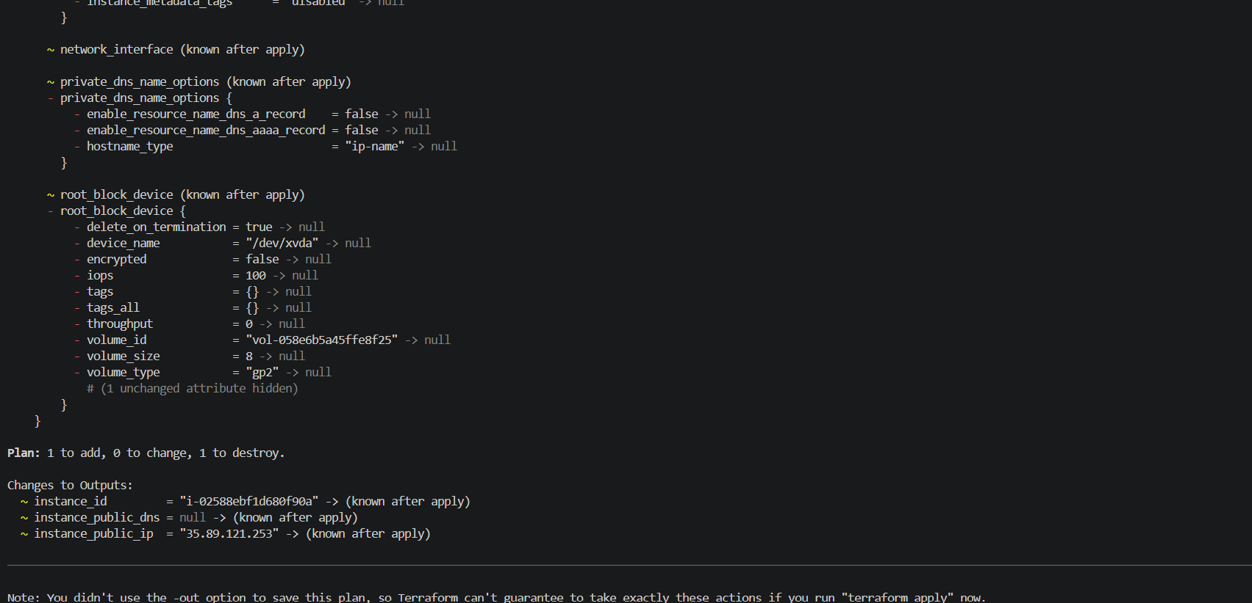
Difference Between a Terraform Resource and a Data Source
A resource creates and manages infrastructure, while a data source retrieves information about existing infrastructure or external data for use in Terraform configuration.

Resource | Data Source
Creates and manages infrastructure. | Reads and retrieves information.
Can create, update, and destroy managed objects. | Looks up information for use in the configuration.
Declared using the resource keyword. | Declared using the data keyword.
Example: aws_instance creates an EC2 instance. | Example: aws_ami finds an Amazon Machine Image (AMI).

Examples

Resource:
resource "aws_instance" "my_server" {
ami = data.aws_ami.amazon_linux.id
instance_type = var.instance_type
}

This resource tells Terraform to create and manage an EC2 instance.

Data source:
data "aws_ami" "amazon_linux" {
most_recent = true
owners = ["amazon"]

filter {
name = "name"
values = ["amzn2-ami-hvm-*-x86_64-gp2"]
}
}
This data source searches for a matching Amazon Linux 2 AMI and makes its ID available to the EC2 resource.

Key Takeaway
A resource manages infrastructure; a data source looks up information that Terraform can use.
Task 5: Use Locals for Dynamic Values
- Add a locals block:
locals {
name_prefix = "${var.project_name}-${var.environment}"
common_tags = {
Project = var.project_name
Environment = var.environment
ManagedBy = "Terraform"
}
}
- Replace all Name tags with local.name_prefix:
  - VPC: "${local.name_prefix}-vpc"
  - Subnet: "${local.name_prefix}-subnet"
  - Instance: "${local.name_prefix}-server"
- Merge common tags with resource-specific tags:
tags = merge(local.common_tags, {
Name = "${local.name_prefix}-server"
})
Apply and check the tags in the AWS console -- every resource should have consistent tagging.

Local block lets you define a value once and reuse it whenever needed through out the configuration

Local.tf
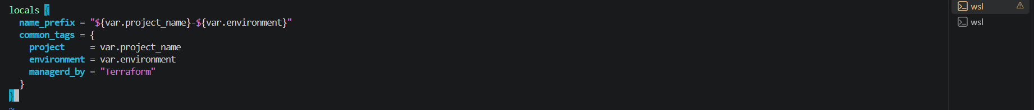

Replaced tags
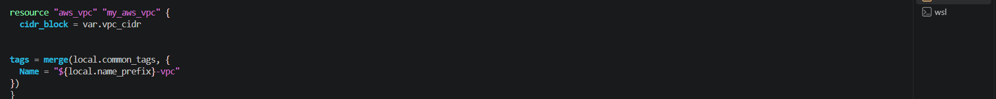
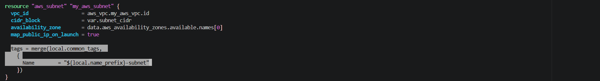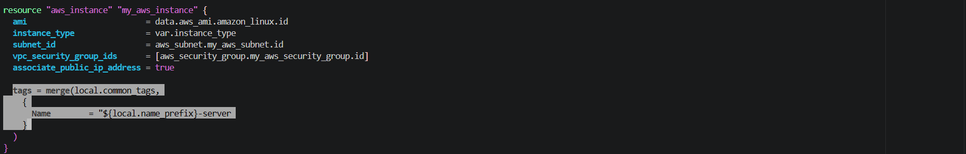

Terraform plan
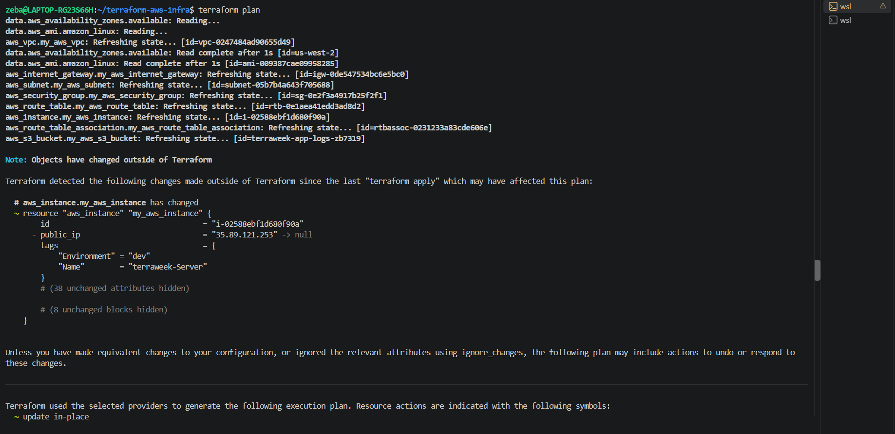

We can notice the tags
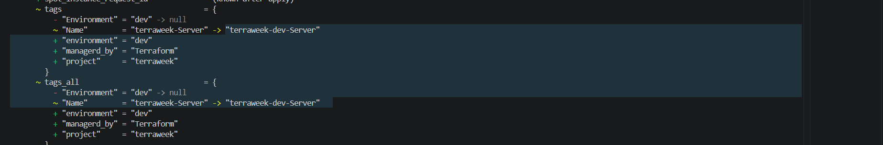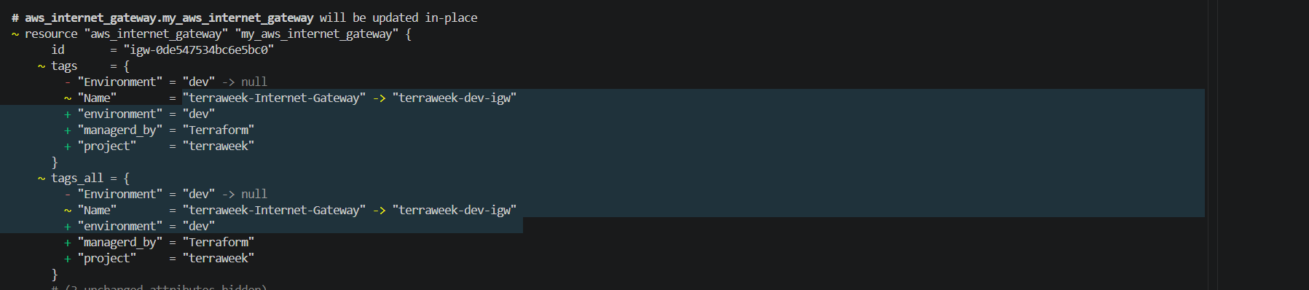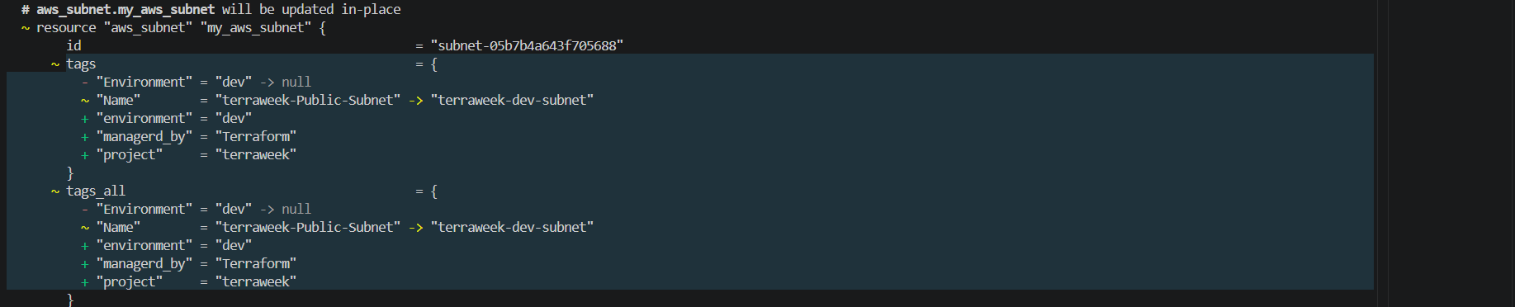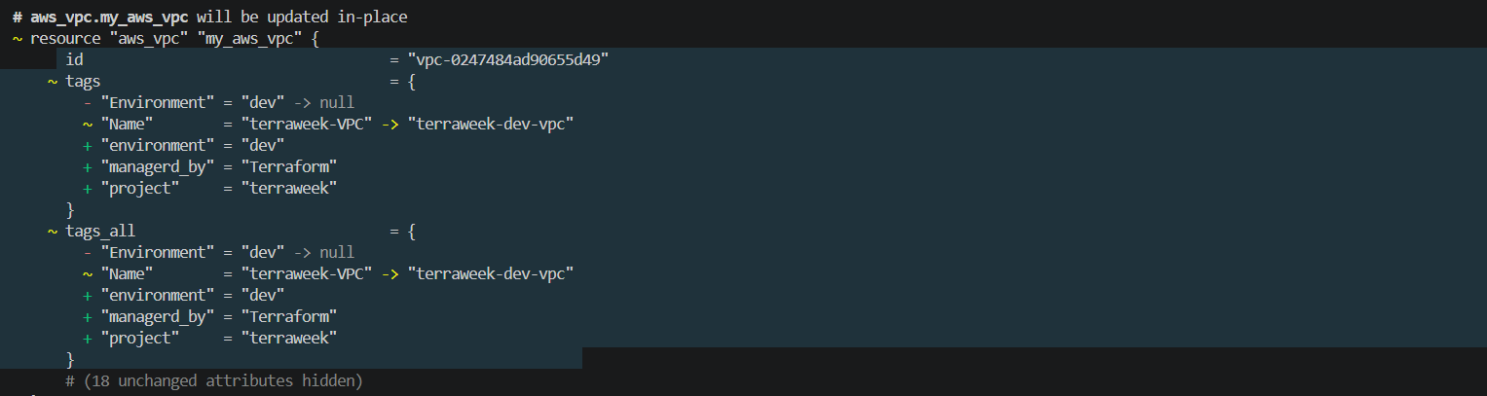

After terraform apply
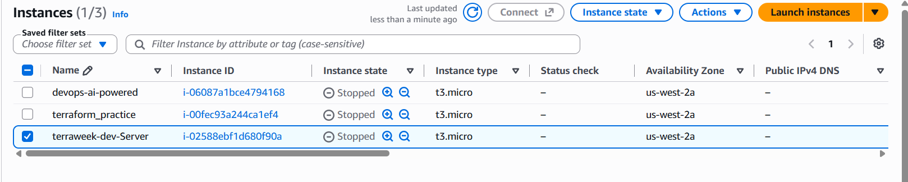
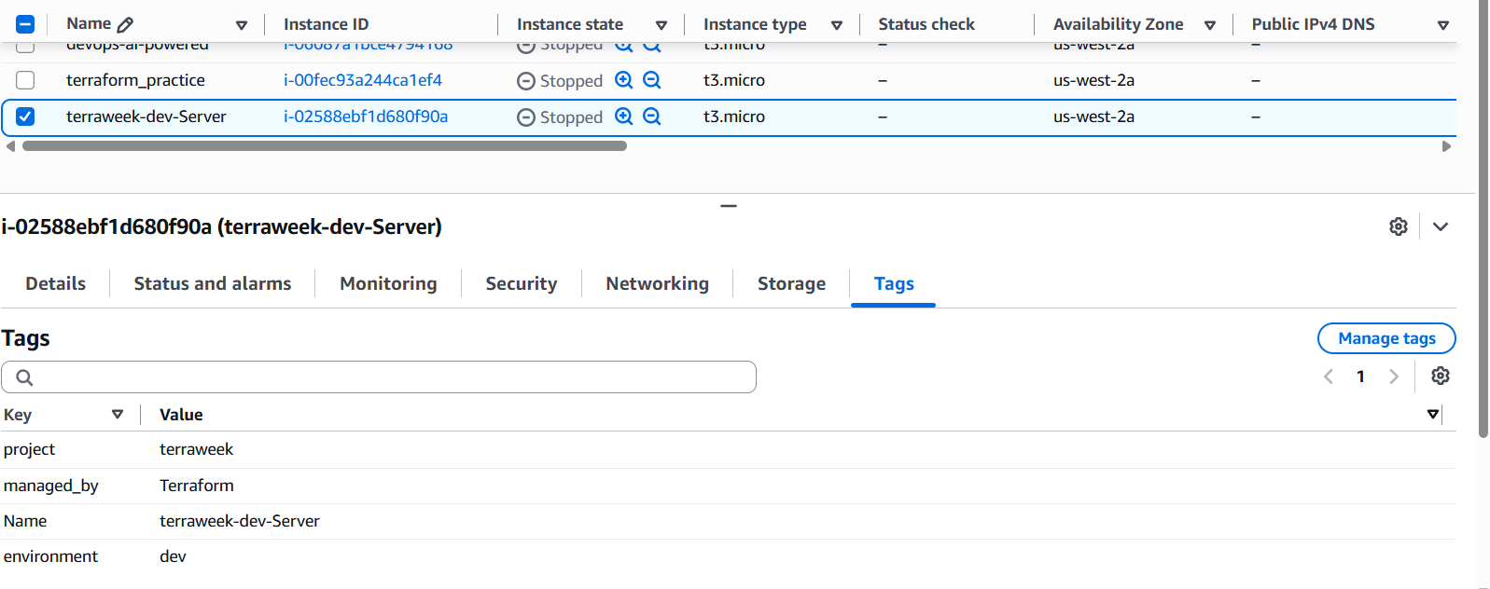
Task 6: Built-in Functions and Conditional Expressions
Practice these in terraform console:
terraform console
- String functions:
  - upper("terraweek") -> "TERRAWEEK"
  - join("-", ["terra", "week", "2026"]) -> "terra-week-2026"
  - format("arn:aws:s3:::%s", "my-bucket")
- Collection functions:
  - length(["a", "b", "c"]) -> 3
  - lookup({dev = "t2.micro", prod = "t3.small"}, "dev") -> "t2.micro"
  - toset(["a", "b", "a"]) -> removes duplicates
- Networking function:
  - cidrsubnet("10.0.0.0/16", 8, 1) -> "10.0.1.0/24"
- Conditional expression -- add this to your config:
instance_type = var.environment == "prod" ? "t3.small" : "t2.micro"
Apply with environment = "prod" and verify the instance type changes.
Document: Pick five functions you find most useful and explain what each does.

  - upper() — convert text to uppercase
  - join() — combine list elements into a string
  - format() — construct a formatted string
- length() — count elements
- lookup() — retrieve a value by key
- toset() — convert a list into a set by removing duplicates
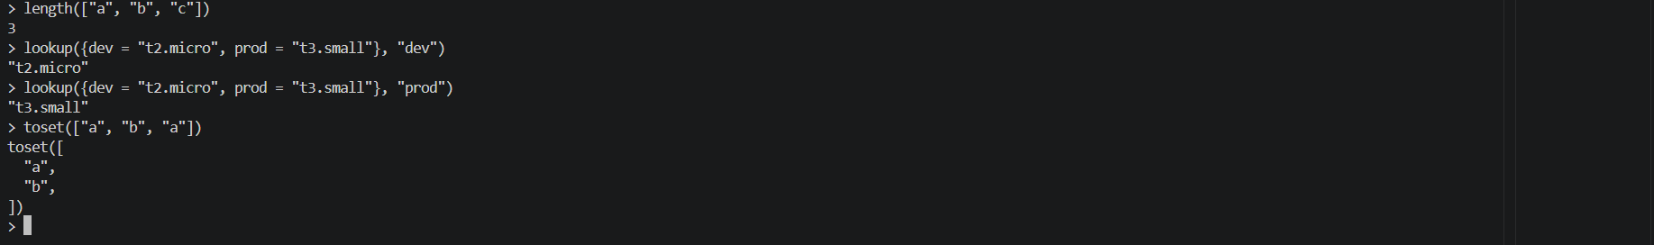
- cidrsubnet("10.0.0.0/16", 8, 1)
- "10.0.0.0/16" — the original network.
- 8 — add 8 bits to the network prefix, changing /16 to /24.
- 1 — select subnet number 1.

condition ? value_if_true : value_if_false
instance_type = var.environment == "prod" ? "t3.small" : "t2.micro"
- prod → t3.small
- Any other environment → t2.micro

In instance_type gave the condition
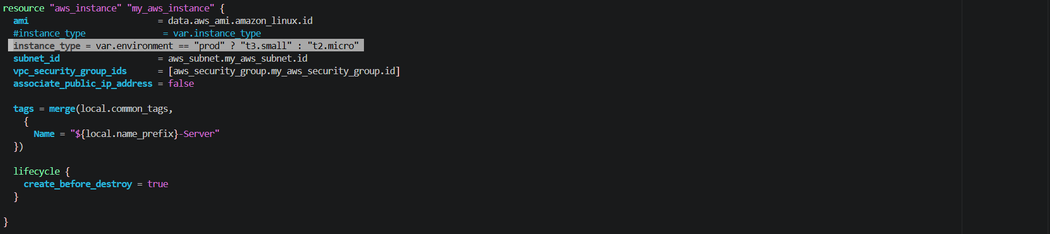

As we are working with dev env instance typr is t2 micro wee can see in plan
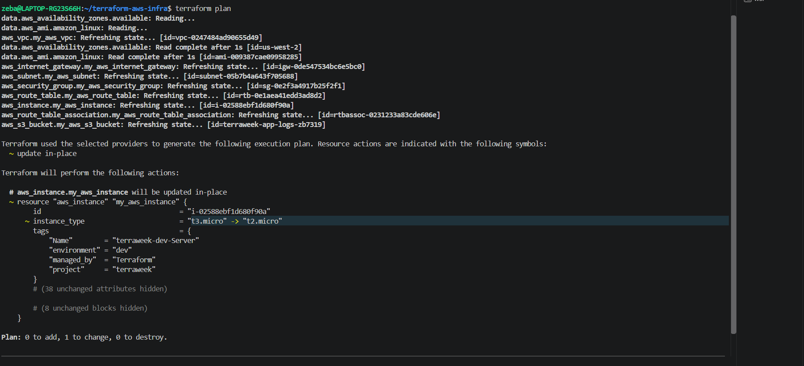

Document: Pick five functions you find most useful and explain what each does.

1. upper()
Purpose: Converts a string to uppercase.
Example:
upper("terraweek")
Output: "TERRAWEEK"
Use case: Useful for standardizing text and creating uppercase names or identifiers.

2. join()
Purpose: Combines a list of strings into a single string using a specified separator.
Example:
join("-", ["terra", "week", "2026"])
Output: "terra-week-2026"
Use case: Useful for constructing resource names from multiple values.

3. lookup()
Purpose: Retrieves a value from a map using a specified key.
Example:
lookup({dev = "t2.micro", prod = "t3.small"}, "dev")
Output: "t2.micro"
Use case: Useful for selecting configuration values based on an environment, such as development or production.

4. length()
Purpose: Returns the number of elements in a collection or the number of characters in a string.
Example:
length(["a", "b", "c"])
Output: 3
Use case: Useful for checking the size of lists, such as the number of subnets or availability zones.

5. cidrsubnet()
Purpose: Calculates a subnet CIDR range from a parent network, additional prefix bits, and a subnet number.
Example:
cidrsubnet("10.0.0.0/16", 8, 1)
Output: "10.0.1.0/24"
Use case: Useful for calculating subnet ranges when designing AWS VPC networks.

Conditional Expressions
Purpose: Selects a value based on whether a condition is true or false.
Example:
instance_type = var.environment == "prod" ? "t3.small" : "t2.micro"
Explanation: If var.environment equals "prod", Terraform selects t3.small. Otherwise, it selects t2.micro.
Use case: Useful for configuring different infrastructure settings for development and production environments.

