CICD?
CI – continues integration
CD – continues deployment/ continues delivery

Task 1: The Problem
Think about a team of 5 developers all pushing code to the same repo manually deploying to production.
Write in your notes:
- What can go wrong?
- What does "it works on my machine" mean and why is it a real problem?
- How many times a day can a team safely deploy manually?

What can go wrong?
- Difficult rollback : if something goes wrong then manually identifying and restoring previous working version can be difficult and can take more time.
- Communication problem: the developers may not know who change what and what deployment is currently happening
- Deployment downtime: during deployment the application can temporary go down
- Merge conflict: developers can edit the same file and while combining merge conflict can occur
- Different environments: the application may behave differently in development , testing and production
- Human dependencies: the deployment process heavily depends on the people who knows the correct process/ steps
- Manual deployment error: while deploying if some one forgets the command or wrong configuration or deployed wrong version.

What does "it works on my machine" mean and why is it a real problem?
It works on my machine – means when a developer develops an application and tests it it will work on developers environment but it fails to run in production environment.

It can happen because of the environments may have different
- Operation system
- Libraries
- Dependencies
- Configurations
- Programing language versions
- System permission
- Database version

Why is this a real problem?
The developer may have tested the application successfully but in production it fails bcz may be the production environment is not same

Ex:
Developer:
Python 3.12
Library version 2.1
Linux

Production:
Python 3.10
Library version 1.9
Windows

This is the problem where the technologies like docker are useful, it will packages all the necessary packages, libraries and other dependencies together to provide the environment which is required for an application to run.

How many times a day can a team safely deploy manually?
There is no such a fix time to deploy safely
It depends of developers, application, testing and risk involved
5team of 5 developers may do multiple deployments in a day but can cause the issues like :
- Human error
- Missed testing steps
- Configuration mistakes
- Deploying the wrong version
- Deployment conflicts
- Production incidents
So here CICD comes into the picture, rather than manually relaying on the people to deploy CICD can automate the deployment more efficient and easy
Manual deployment is efficient only for small scale deployments as number of developers and deployment increases the automation of deployment is becomes important.

Task 2: CI vs CD
Research and write short definitions (2-3 lines each):
- Continuous Integration — what happens, how often, what it catches
- Continuous Delivery — how it's different from CI, what "delivery" means
- Continuous Deployment — how it differs from Delivery, when teams use it
Write one real-world example for each.

- Continues integration:
When the developers changes the code and push to the shared repository it will automatically gets build and tests, it help to identify the bugs, issues and broken code.
The developers should integrate frequently as completion of small task rather than waiting for the project end
It caches the below things:
- Code that does not get build
- Failed tests
- Bugs
- Problem caused by combining developers code

- Continues delivery:
When code passes all the checks from CI the the system make the code ready to be release.
But human approval will be required before releasing it.
Delivery – means getting the validated version of the software ready to be release for the users , rather than releasing it immediately.

- Continues deployment:
When the code passes all the required checks then it will get automatically deployed on production.
There is no manual approval step for each successful deployment.

Simple comparison
Concept | Simple meaning
CI | Check the code
Continuous Delivery | Prepare the code for release
Continuous Deployment | Automatically release the code

One-line summary
CI checks the code, Continuous Delivery makes it ready to release, and Continuous Deployment releases it automatically.

Task 3: Pipeline Anatomy
A pipeline has these parts — write what each one does:
- Trigger — what starts the pipeline
- Stage — a logical phase (build, test, deploy)
- Job — a unit of work inside a stage
- Step — a single command or action inside a job
- Runner — the machine that executes the job
- Artifact — output produced by a job

Trigger -> stage -> job -> step ->runner -> artifact

Trigger:
It is an even that tells pipeline to start running
Common triggers are :-
- A developer pushes code
- A pull request is created
- A pull request is merged
- A scheduled time arrives
- Someone manually starts the pipeline
Trigger = what starts the pipeline

Stage:
It is a phase of a pipeline
EX: Build -> test -> deploy
- stage 1: build phase
- stage 2: test phase
- stage 3: deploy phase
Stage = a big phase of a pipeline

Job:
Is a specific piece of work that happens inside the phase
In one phase there can be one or more number of jobs
Ex: in test stage
Job 1: integration test
Job 2 : unit test
Job = a specific ask/work inside phase

Step:
Is a single command or action inside the job
Ex:
In a build job
Step 1: install dependencies
Step 2: compile code
Step 3: create the application
Step = one individual command / action

Runner:
It is a computer/machine where the jobs runs
Pipeline needs a machine to execute the commands
Runners could be:-
- a virtual machine
- a physical machine
- a cloud machine
- a container
runner = the machine that does the work

Artifacts:
Are the output produced by the jobs
Which can be save and used later
Artifact = useful output produce by the job

Task 4: Draw a Pipeline
Draw a CI/CD pipeline for this scenario:
A developer pushes code to GitHub. The app is tested, built into a Docker image, and deployed to a staging server.
Include at least 3 stages. Hand-drawn and photographed is perfectly fine.

Push code -> triggers -> stage 1 : test phase -> run tests : npm test ->stage 2 : build phase -> build docker image : docker build -> stage 3: deploy stage -> deploy docker container : staging server -> deployed to staging server

Here
Push is a trigger which starts the pipeline
In stage test if the tests fail pipeline stops
In the build stage the docker image is the artifact which will later used by deploy stage

Task 5: Explore in the Wild
- Open any popular open-source repo on GitHub (Kubernetes, React, FastAPI — pick one you know)
- Find their .github/workflows/ folder
- Open one workflow YAML file
- Write in your notes:
  - What triggers it?
  - How many jobs does it have?
  - What does it do? (best guess)

FastAPI repo:-
https://github.com/fastapi/fastapi?utm_source=chatgpt.com

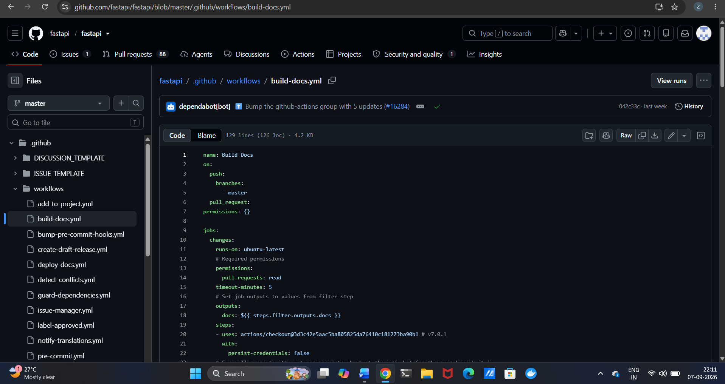
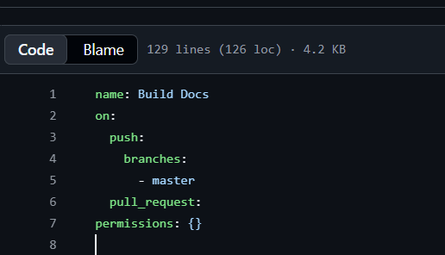
Workflow name: build docks
On: trigger
It tells when the workflow starts
When the code is pushed and when the pull request is created

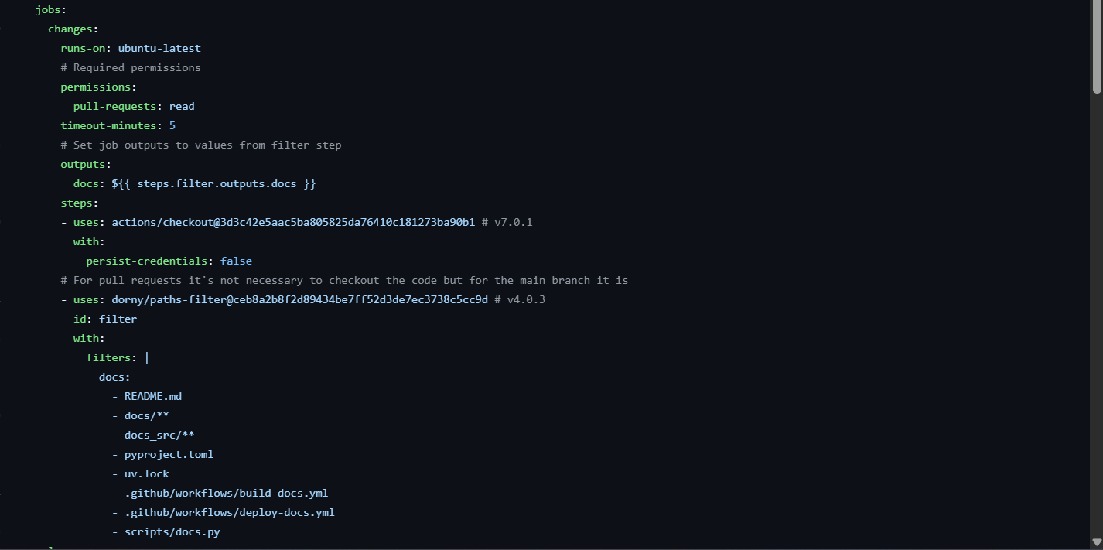
Each item directly under jobs: is a job.
Here changes is a job

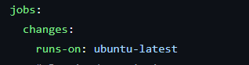
Runs 0n – runner
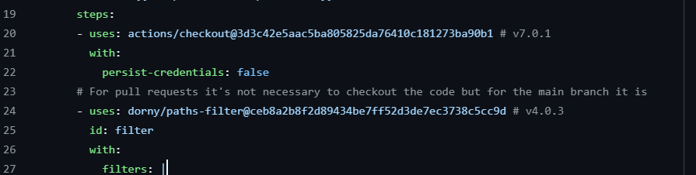
Here 2 steps are shown

What triggers it?
The workflow is triggered by:
- A push to the `master` branch
- A pull request

How many jobs does it have?
The workflow has 1 job visible in this file:
- `changes`

What does it do?
The workflow checks whether documentation-related files have changed.

The `changes` job runs on an `ubuntu-latest` runner
It has steps that:
- Checkout the repository code.
- Check which documentation-related files have changed.

In simple terms:
Developer makes a change
↓
GitHub triggers workflow
↓
Run `changes` job
↓
Get the repository code
↓
Check whether documentation files changed

