Day 67 -- TerraWeek Capstone: Multi-Environment Infrastructure with Workspaces and Modules

Task 1: Learn Terraform Workspaces
Before building the project, understand workspaces:
mkdir terraweek-capstone && cd terraweek-capstone
terraform init

# See current workspace
terraform workspace show # default

# Create new workspaces
terraform workspace new dev
terraform workspace new staging
terraform workspace new prod

# List all workspaces
terraform workspace list

# Switch between them
terraform workspace select dev
terraform workspace select staging
terraform workspace select prod
Answer:
- What does terraform.workspace return inside a config?
- Where does each workspace store its state file?
- How is this different from using separate directories per environment?

Terraform initialized
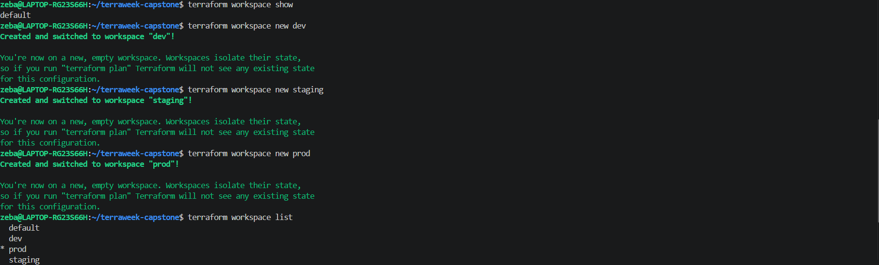
dev, staging, prod workspaces created
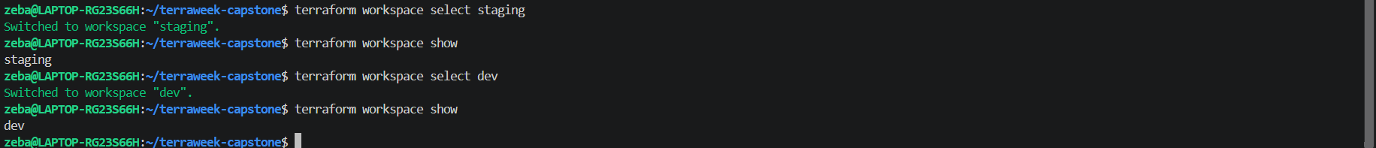
Switch between workspaces
List all the workspaces

- What does terraform.workspace return? The name of the currently selected workspace, such as dev, staging, or prod.
- Where is each workspace's state stored? With the default local backend, the default workspace uses terraform.tfstate, while named workspaces use terraform.tfstate.d/<workspace-name>/terraform.tfstate.
- How do workspaces differ from separate directories? Workspaces share the same configuration but maintain separate state. Separate directories can have independent configurations as well as independent state.

Task 2: Set Up the Project Structure
Create this layout:
terraweek-capstone/
main.tf # Root module -- calls child modules
variables.tf # Root variables
outputs.tf # Root outputs
providers.tf # AWS provider and backend
locals.tf # Local values using workspace
dev.tfvars # Dev environment values
staging.tfvars # Staging environment values
prod.tfvars # Prod environment values
.gitignore # Ignore state, .terraform, tfvars with secrets
modules/
vpc/
main.tf
variables.tf
outputs.tf
security-group/
main.tf
variables.tf
outputs.tf
ec2-instance/
main.tf
variables.tf
outputs.tf
Create the .gitignore:
.terraform/
*.tfstate
*.tfstate.backup
*.tfvars
.terraform.lock.hcl
Document: Why is this file structure considered best practice?

.gitignore
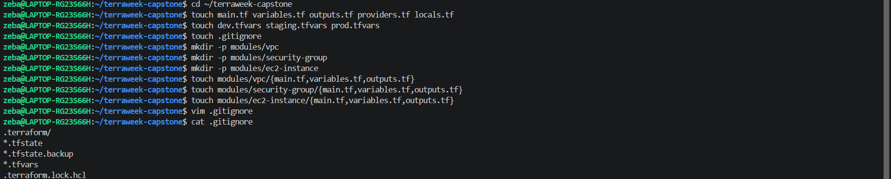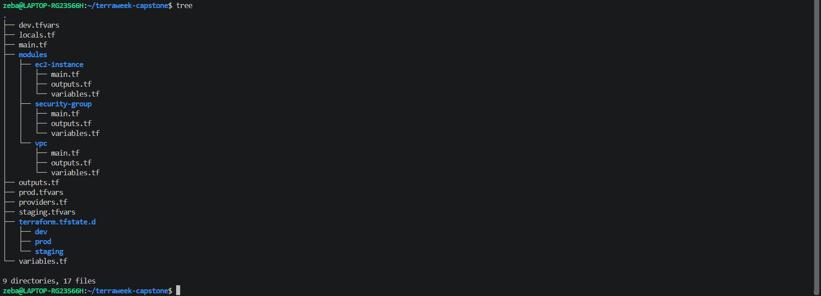
Why This Terraform Project Structure Is Best Practice

1. Separation of concerns: Root files manage the overall infrastructure,
while child modules manage individual components.

2. Reusability: VPC, security group, and EC2 modules can be reused
across development, staging, and production.

3. Maintainability: Separate files for variables, outputs, providers,
and locals make the configuration easier to understand and update.

4. Environment-specific configuration: Separate tfvars files allow
different settings for each environment while sharing the same modules.

5. State isolation: Terraform workspaces maintain separate state for
each workspace when using the local backend.

6. Security: .gitignore helps prevent state files and environment
variable files from being accidentally committed to Git.

7. Scalability: New modules and infrastructure components can be added
without duplicating the entire configuration.

Conclusion: This structure improves reuse, organization, maintainability,
and environment management. Production should also use secure remote state,
appropriate access controls, and safeguards against accidental changes.
Task 3: Build the Custom Modules
Create three focused modules:
Module 1: modules/vpc/
- Input: cidr, public_subnet_cidr, environment, project_name
- Resources: VPC, public subnet, internet gateway, route table, route table association
- Output: vpc_id, subnet_id
- All resources tagged with environment and project name
Module 2: modules/security-group/
- Input: vpc_id, ingress_ports, environment, project_name
- Resources: Security group with dynamic ingress rules, allow all egress
- Output: sg_id
Module 3: modules/ec2-instance/
- Input: ami_id, instance_type, subnet_id, security_group_ids, environment, project_name
- Resources: EC2 instance with tags
- Output: instance_id, public_ip
Write and validate each module:
terraform validate

modules/vpc/variable.tf
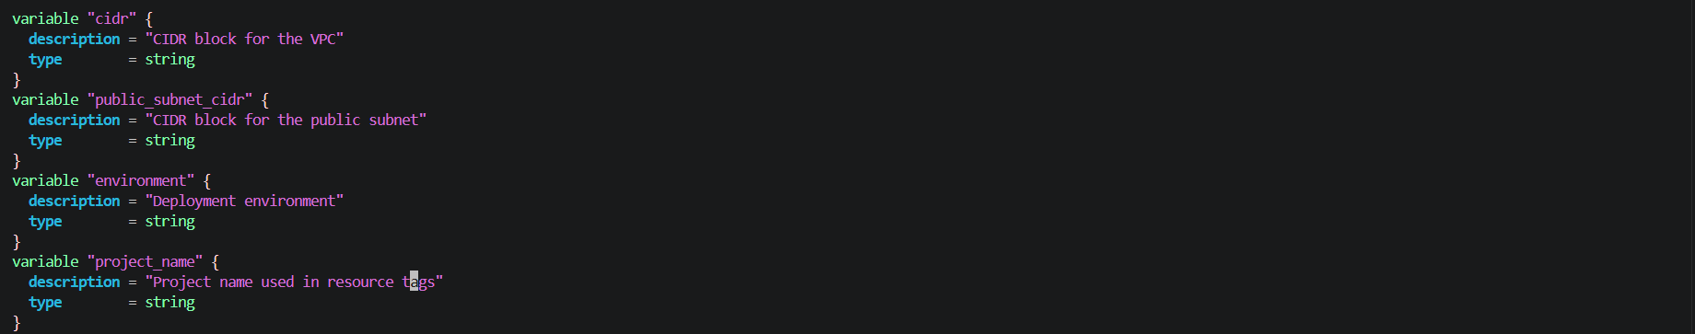
modules/vpc/main.tf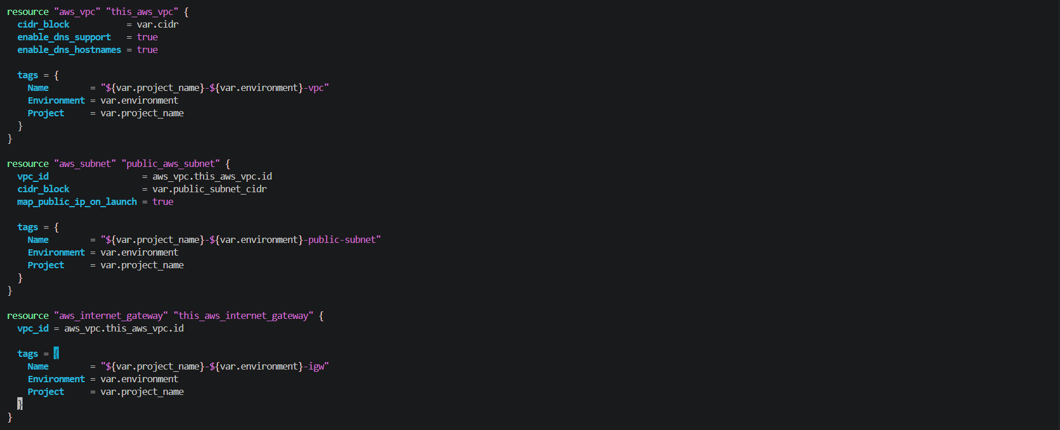 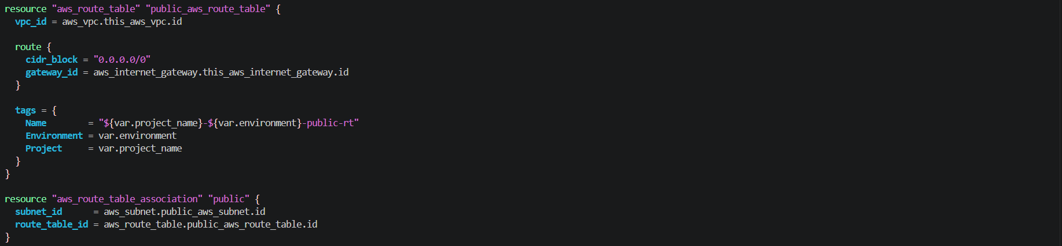
modules/vpc/outputs.tf
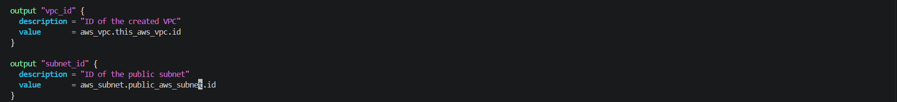
validated

modules/security-group/variable.tf
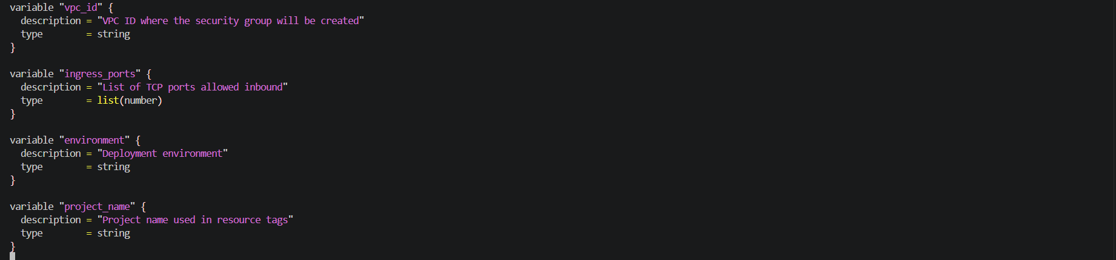
modules/security-group/main.tf
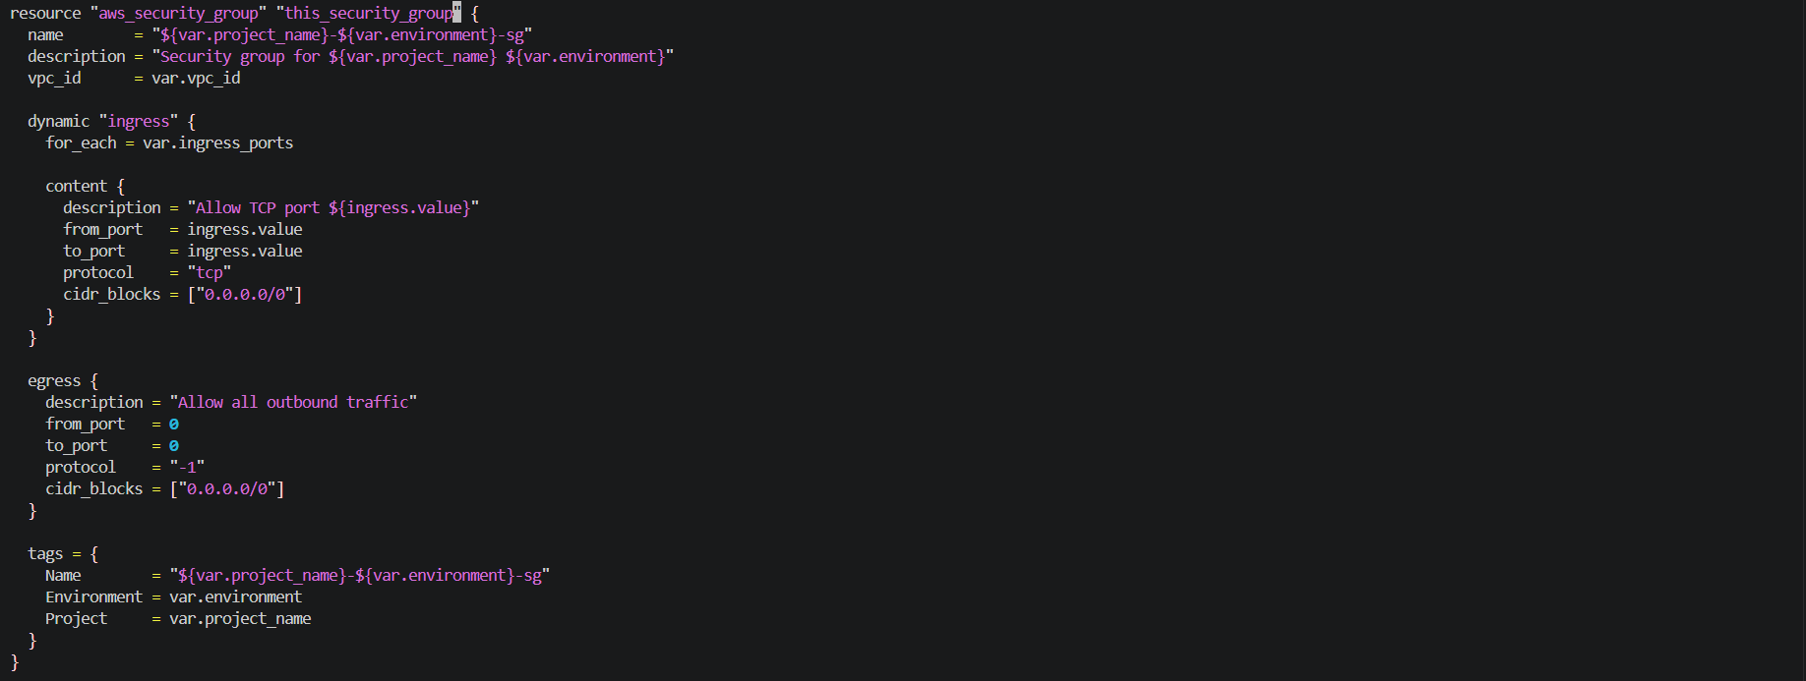
modules/security-group/outputs.tf
Validated

modules/ ec2-instance/variable.tf
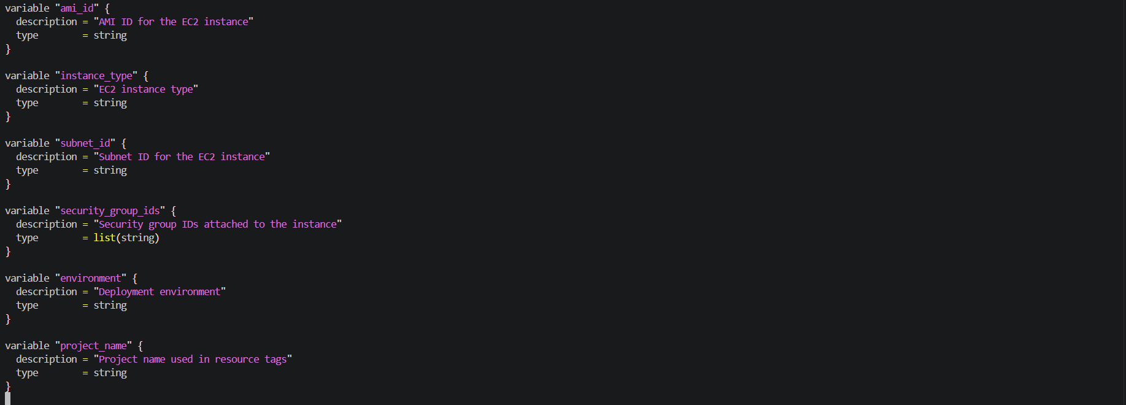
modules/ ec2-instance/main.tf
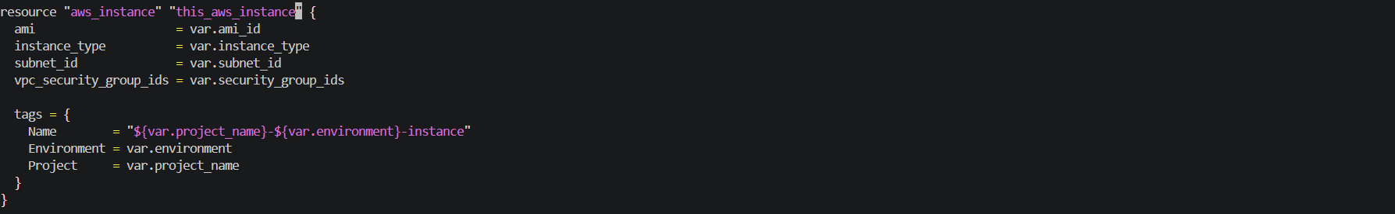
modules/ ec2-instance/outputs.tf
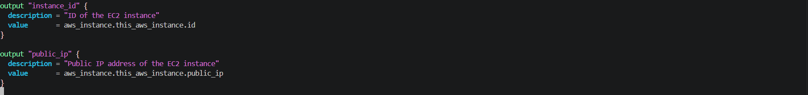
validated
Task 4: Wire It All Together with Workspace-Aware Config
In the root module, use terraform.workspace to drive environment-specific behavior.
locals.tf:
locals {
environment = terraform.workspace
name_prefix = "${var.project_name}-${local.environment}"

common_tags = {
Project = var.project_name
Environment = local.environment
ManagedBy = "Terraform"
Workspace = terraform.workspace
}
}
variables.tf:
variable "project_name" {
type = string
default = "terraweek"
}

variable "vpc_cidr" {
type = string
}

variable "subnet_cidr" {
type = string
}

variable "instance_type" {
type = string
}

variable "ingress_ports" {
type = list(number)
default = [22, 80]
}
main.tf -- call all three modules, passing workspace-aware names and variables.
Environment-specific tfvars:
dev.tfvars:
vpc_cidr = "10.0.0.0/16"
subnet_cidr = "10.0.1.0/24"
instance_type = "t2.micro"
ingress_ports = [22, 80]
staging.tfvars:
vpc_cidr = "10.1.0.0/16"
subnet_cidr = "10.1.1.0/24"
instance_type = "t2.small"
ingress_ports = [22, 80, 443]
prod.tfvars:
vpc_cidr = "10.2.0.0/16"
subnet_cidr = "10.2.1.0/24"
instance_type = "t3.small"
ingress_ports = [80, 443]
Notice: dev allows SSH, prod does not. Different CIDRs prevent overlap. Instance types scale up per environment.

Locals.tf
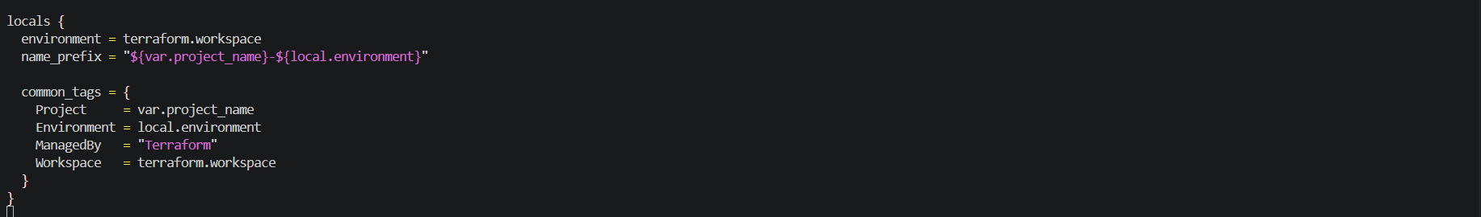
variables.tf
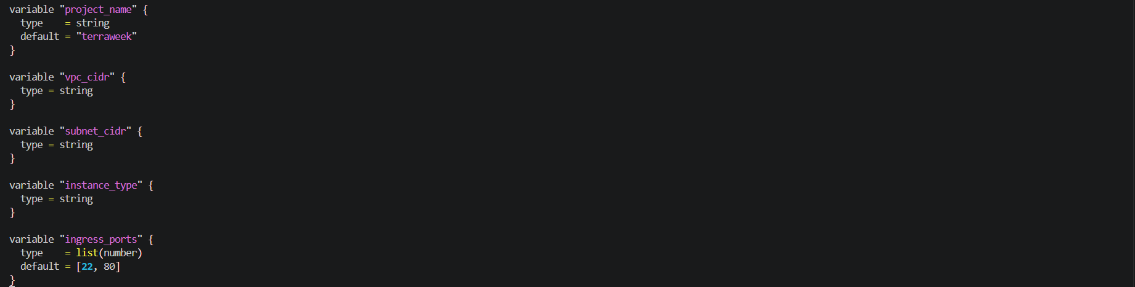
Main.tf
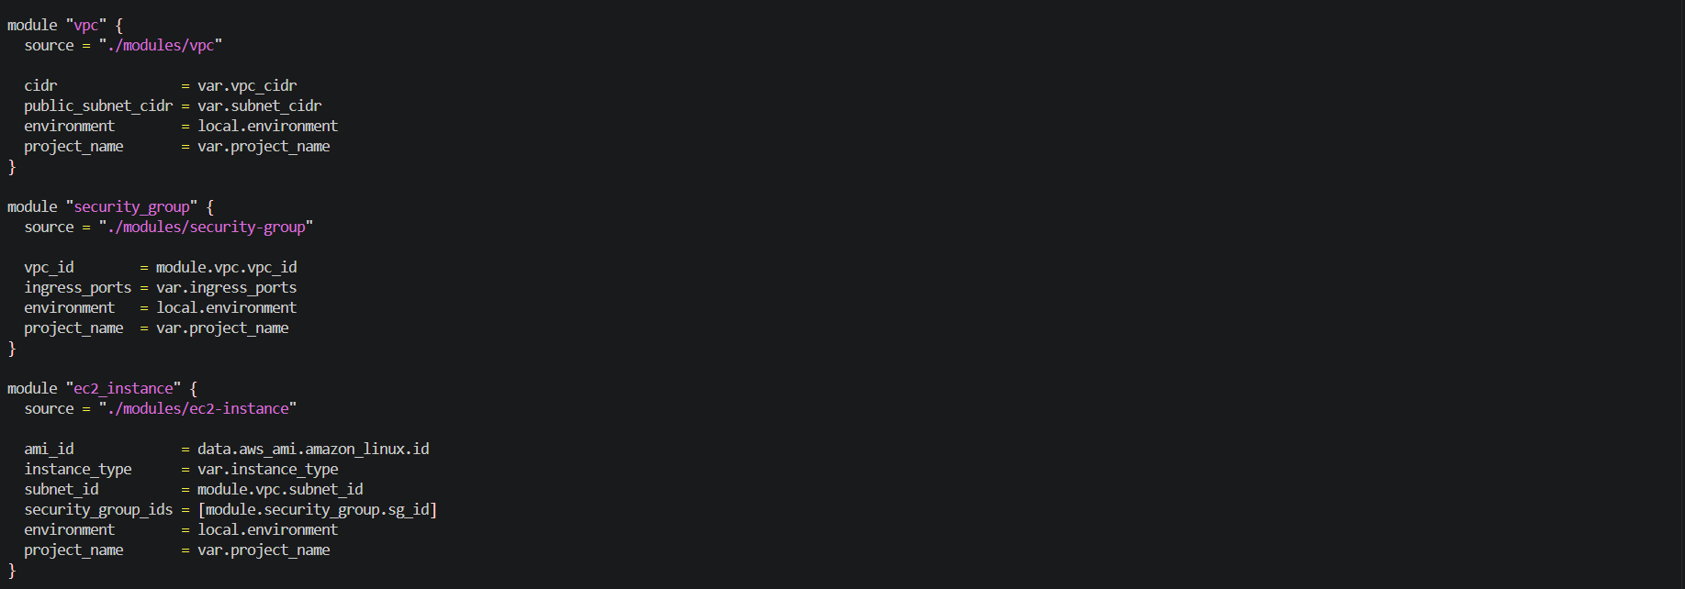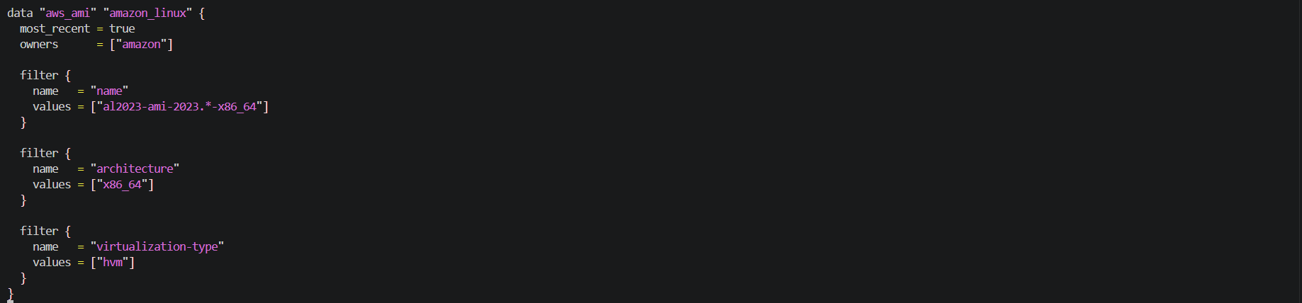
Providers.tf
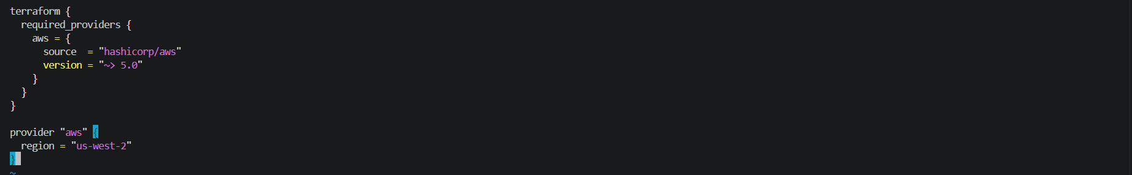
dev.tfvars
staging.tfvars
prod.tfvars

Task 5: Deploy All Three Environments
Deploy each environment using its workspace and tfvars file:
Dev:
terraform workspace select dev
terraform plan -var-file="dev.tfvars"
terraform apply -var-file="dev.tfvars"
Staging:
terraform workspace select staging
terraform plan -var-file="staging.tfvars"
terraform apply -var-file="staging.tfvars"
Prod:
terraform workspace select prod
terraform plan -var-file="prod.tfvars"
terraform apply -var-file="prod.tfvars"
After all three are deployed, verify:
# Check each workspace's resources
terraform workspace select dev && terraform output
terraform workspace select staging && terraform output
terraform workspace select prod && terraform output
Go to the AWS console and verify:
- Three separate VPCs with different CIDR ranges
- Three EC2 instances with different instance types
- Different Name tags per environment: terraweek-dev-server, terraweek-staging-server, terraweek-prod-server
Verify: Are all three environments completely isolated from each other?

Deploy Dev
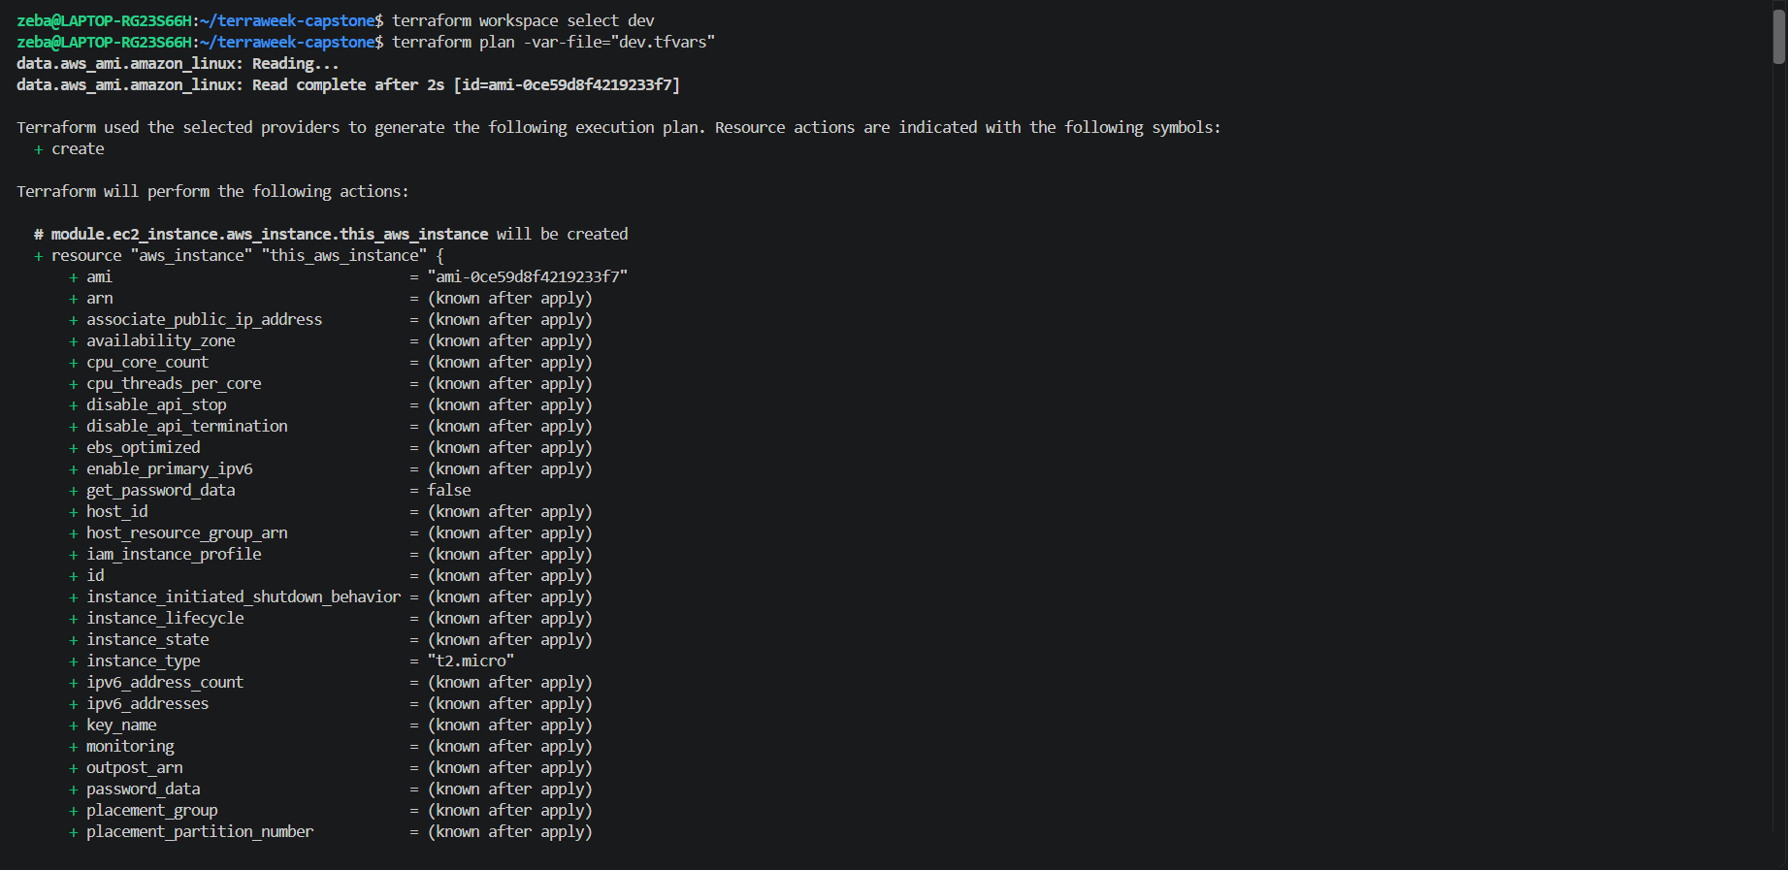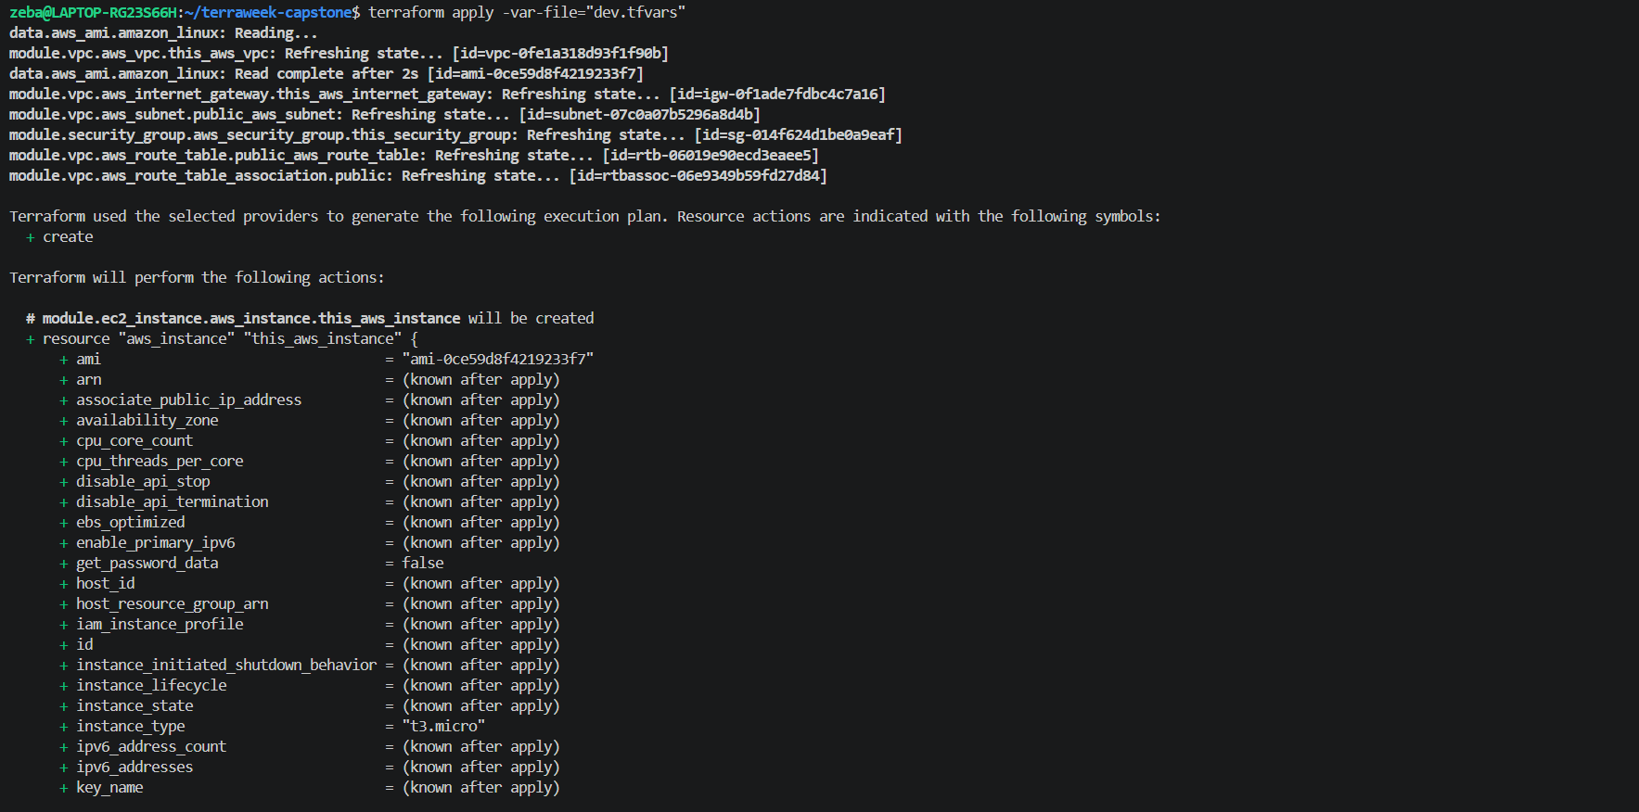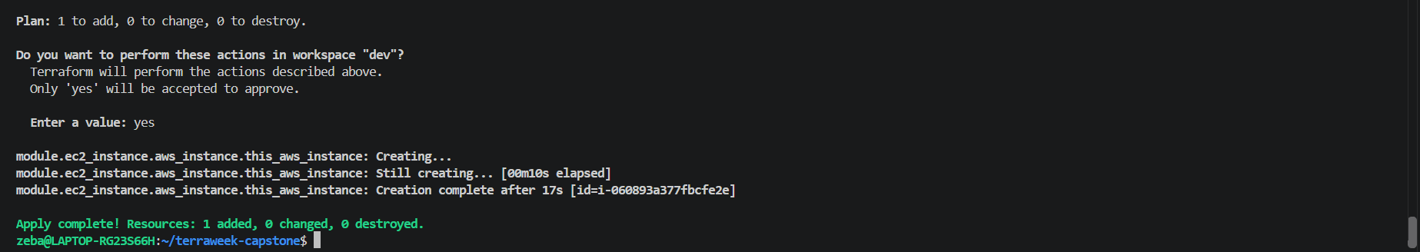

Deploy staging
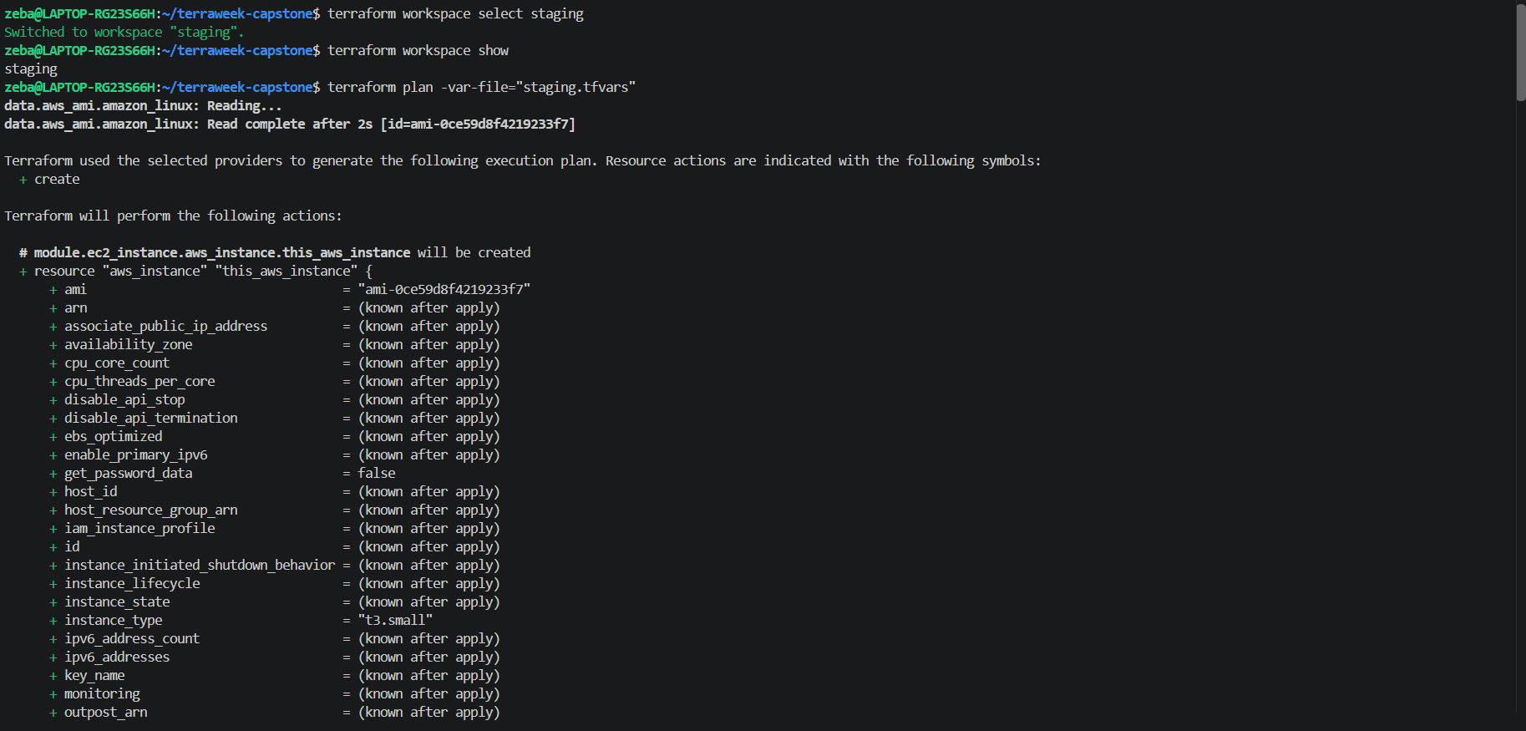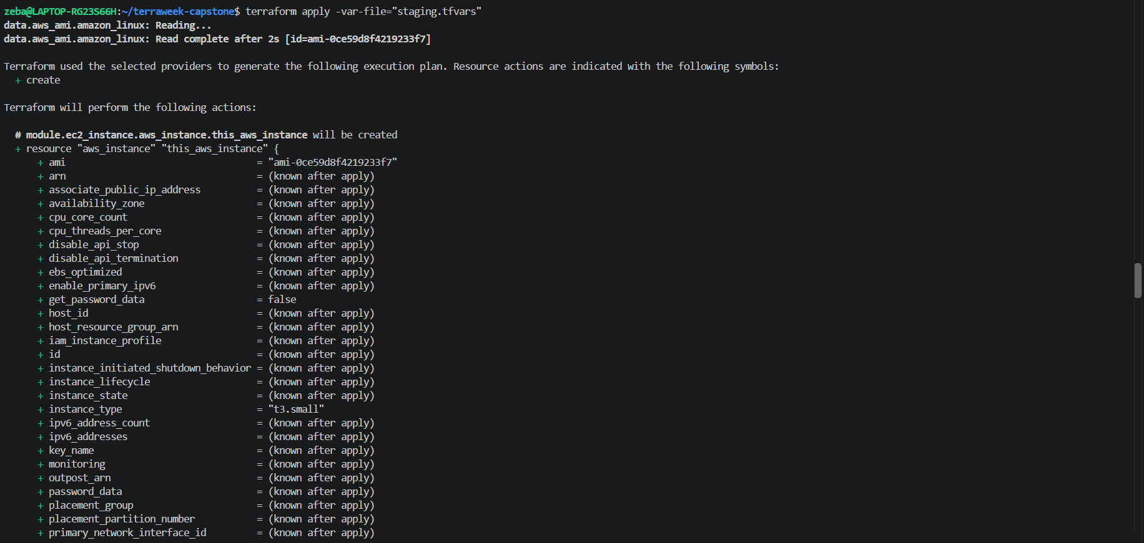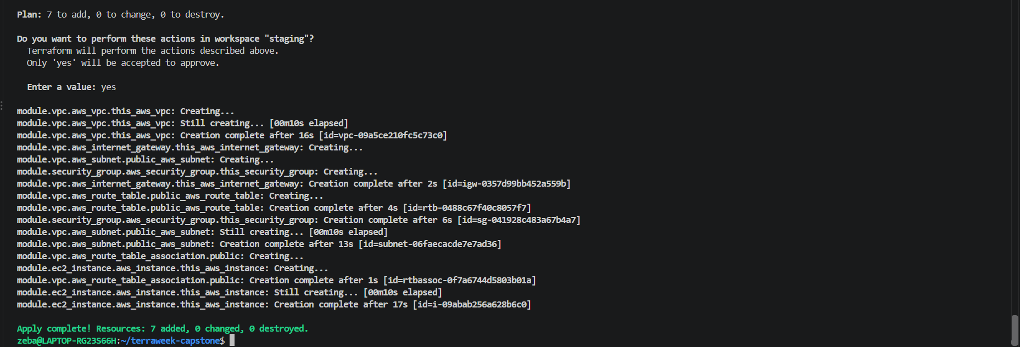

Deploy prod
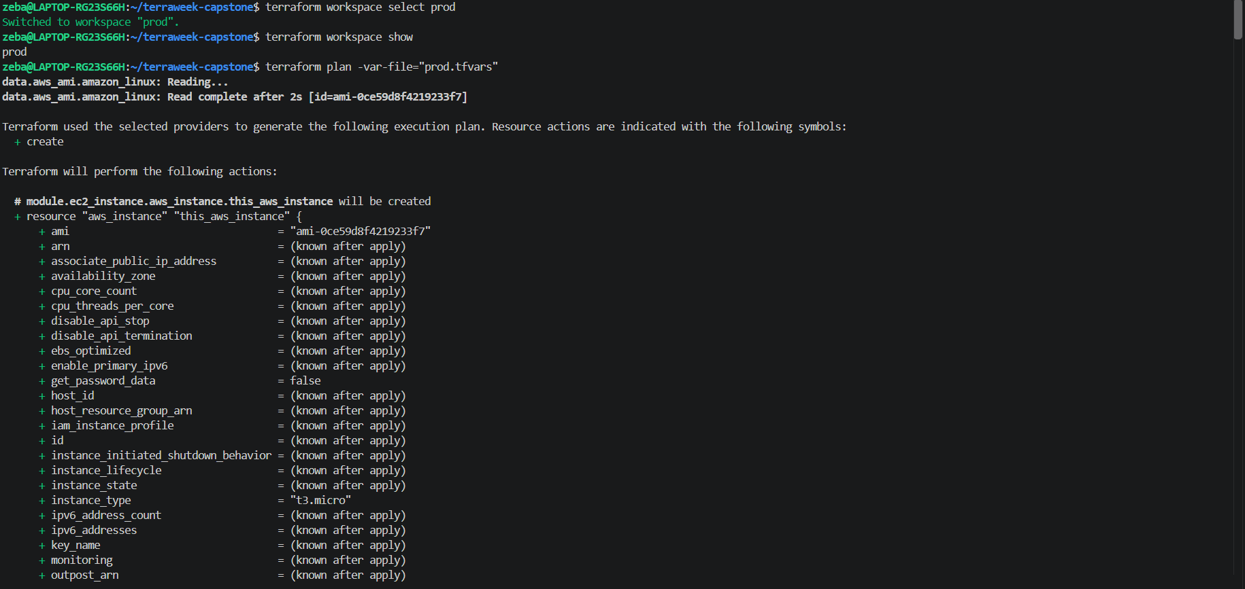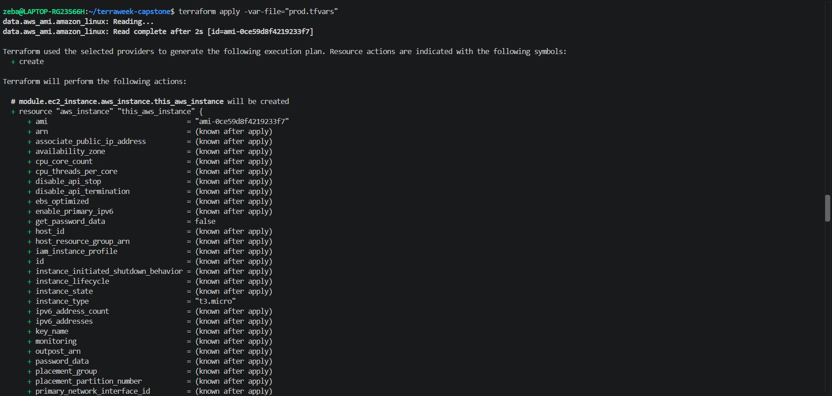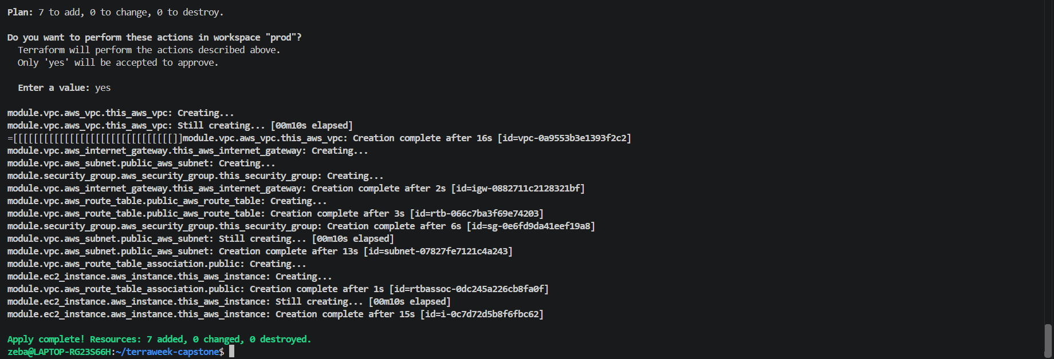

outputs.tf
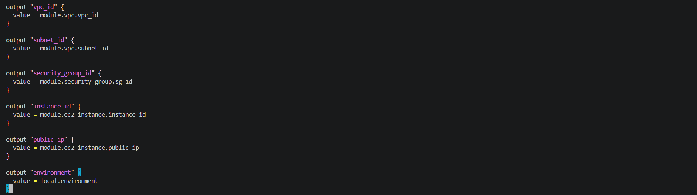
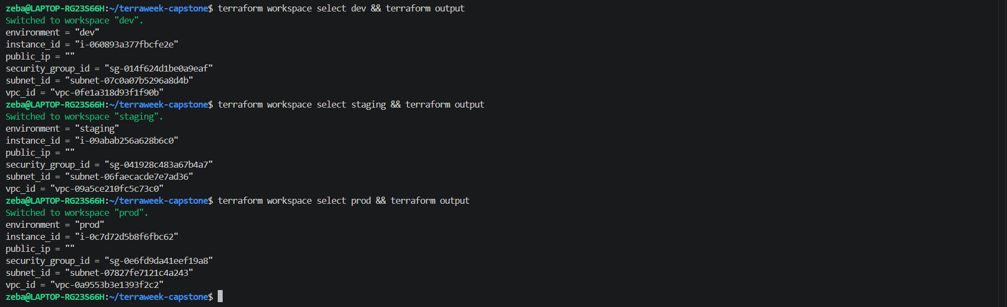
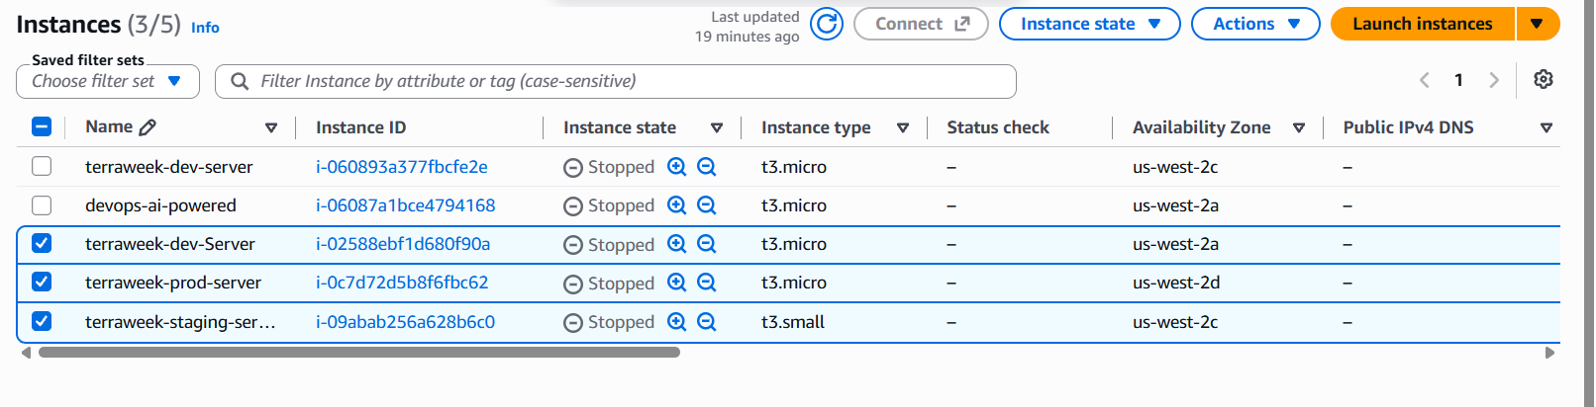
Verify: Are all three environments completely isolated from each other?
Why aren't they completely isolated?
- Terraform workspaces separate Terraform state, not AWS accounts or permissions.
- Separate VPCs provide network separation by default, but connectivity can be introduced through VPC peering, Transit Gateway, VPNs, or other networking configurations.
- Security groups control traffic to instances. Your configuration allows inbound traffic from 0.0.0.0/0 on the configured ports, including SSH port 22 in Dev and Staging.
- Shared AWS account and region mean the environments may still share account-level permissions, quotas, and other resources.

Task 6: Document Best Practices
Write down everything you have learned this week as a Terraform best practices guide:
- File structure -- separate files for providers, variables, outputs, main, locals
- State management -- always use remote backend, enable locking, enable versioning
- Variables -- never hardcode, use tfvars per environment, validate with validation blocks
- Modules -- one concern per module, always define inputs/outputs, pin registry module versions
- Workspaces -- use for environment isolation, reference terraform.workspace in configs
- Security -- .gitignore for state and tfvars, encrypt state at rest, restrict backend access
- Commands -- always run plan before apply, use fmt and validate before committing
- Tagging -- tag every resource with project, environment, and managed-by
- Naming -- consistent prefix pattern: <project>-<environment>-<resource>
- Cleanup -- always terraform destroy non-production environments when not in use

Terraform Best Practices Guide
TerraWeek Capstone — Task 6
1. File Structure
Organize Terraform configurations into separate files so the project is easy to understand and maintain.
Recommended structure:
terraweek-capstone/
├── providers.tf
├── main.tf
├── variables.tf
├── outputs.tf
├── locals.tf
├── dev.tfvars
├── staging.tfvars
├── prod.tfvars
├── modules/
│ ├── vpc/
│ ├── security-group/
│ └── ec2-instance/
└── .gitignore
- providers.tf: provider and Terraform version requirements.
- main.tf: root resources and module calls.
- variables.tf: input variable declarations.
- outputs.tf: useful values returned by Terraform.
- locals.tf: reusable expressions and common tags.
- Environment-specific .tfvars files: configuration values for each environment.
2. State Management
Terraform state maps configuration to real infrastructure. Protect it carefully.
- Use a remote backend for team projects and shared infrastructure.
- Enable state locking where supported by the backend.
- Enable versioning for the state storage location to support recovery.
- Restrict access to state files because they may contain sensitive information.
- Avoid editing state files manually.
3. Variables
Use variables instead of hardcoding values throughout the configuration.
- Declare variables in variables.tf.
- Keep environment-specific values in separate files: dev.tfvars, staging.tfvars, and prod.tfvars.
- Define appropriate types, descriptions, and sensible defaults where appropriate.
- Use validation blocks to reject invalid values.
Example:
variable "instance_type" {
description = "EC2 instance type for this environment"
type = string

validation {
condition = contains(["t3.micro", "t3.small", "t2.small"], var.instance_type)
error_message = "Choose an approved instance type."
}
}
4. Modules
Use reusable modules to group related infrastructure.
- Keep each module focused on one responsibility.
- Define input variables and outputs for every reusable module.
- Use clear names for resources and module inputs.
- Pin module versions when consuming modules from a registry.
- Test modules independently where practical.
In this project, the VPC, security group, and EC2 instance are separate modules.
5. Workspaces
Terraform workspaces maintain separate state instances for the same configuration.
- Use terraform workspace list to list workspaces.
- Use terraform workspace select dev to select an environment.
- Reference terraform.workspace when environment-specific behavior is needed.
- Use separate variable files when planning or applying each environment.
Important: Workspaces separate state, not AWS accounts or permissions. They do not guarantee complete environment isolation.
6. Security
Protect Terraform configuration, credentials, and state.
- Add state files, variable files containing sensitive values, and local Terraform working directories to .gitignore.
- Never commit credentials, private keys, or secrets to Git.
- Encrypt remote state at rest and use secure transport.
- Restrict backend access using appropriate IAM permissions.
- Avoid exposing sensitive values in logs or outputs.
- Restrict inbound security group rules to trusted sources whenever possible.
7. Essential Commands
Run formatting, validation, and planning before applying changes.
terraform fmt -recursive
terraform validate
terraform workspace show
terraform plan -var-file="dev.tfvars"
terraform apply -var-file="dev.tfvars"
terraform output
terraform state list
Best practices:
- Run terraform fmt to standardize formatting.
- Run terraform validate to check configuration syntax and consistency.
- Review terraform plan before every apply.
- Confirm unexpected additions, replacements, or destructions before proceeding.
- Use the correct workspace and variable file for each environment.
8. Tagging
Apply consistent tags to resources that support them.
Recommended tags:
tags = {
Project = var.project_name
Environment = terraform.workspace
ManagedBy = "Terraform"
}
Tags help identify ownership, filter resources, track costs, and distinguish environments.
9. Naming Conventions
Use consistent resource names based on:
<project>-<environment>-<resource>
Examples:
- terraweek-dev-server
- terraweek-staging-server
- terraweek-prod-server
Apply consistent naming to resources such as EC2 instances, security groups, and other resources where names or tags are supported.
10. Cleanup
Remove unused non-production infrastructure when it is no longer required to reduce unnecessary costs.
- Select the correct workspace before cleanup.
- Review the workspace and variable file.
- Run a destroy plan where supported by your Terraform version and workflow, or carefully review the destroy plan generated by terraform plan -destroy.
- Run terraform destroy -var-file="dev.tfvars" only after confirming the selected workspace and reviewing the plan.
- Never destroy production infrastructure without explicit authorization and a verified recovery plan.
- Remember that stopping an EC2 instance is not the same as destroying it; attached resources may continue to incur costs.
Conclusion
Following these practices makes Terraform projects more consistent, reusable, secure, and maintainable. Separating files and modules, protecting state, using environment-specific variables, reviewing plans, applying consistent tags, and cleaning up unused infrastructure all contribute to reliable infrastructure management.

Task 7: Destroy All Environments
Clean up all three environments in reverse order:
terraform workspace select prod
terraform destroy -var-file="prod.tfvars"

terraform workspace select staging
terraform destroy -var-file="staging.tfvars"

terraform workspace select dev
terraform destroy -var-file="dev.tfvars"
Verify in the AWS console -- all VPCs, instances, security groups, and gateways should be gone.
Delete the workspaces:
terraform workspace select default
terraform workspace delete dev
terraform workspace delete staging
terraform workspace delete prod
Verify: Is your AWS account completely clean?

Destroy prod
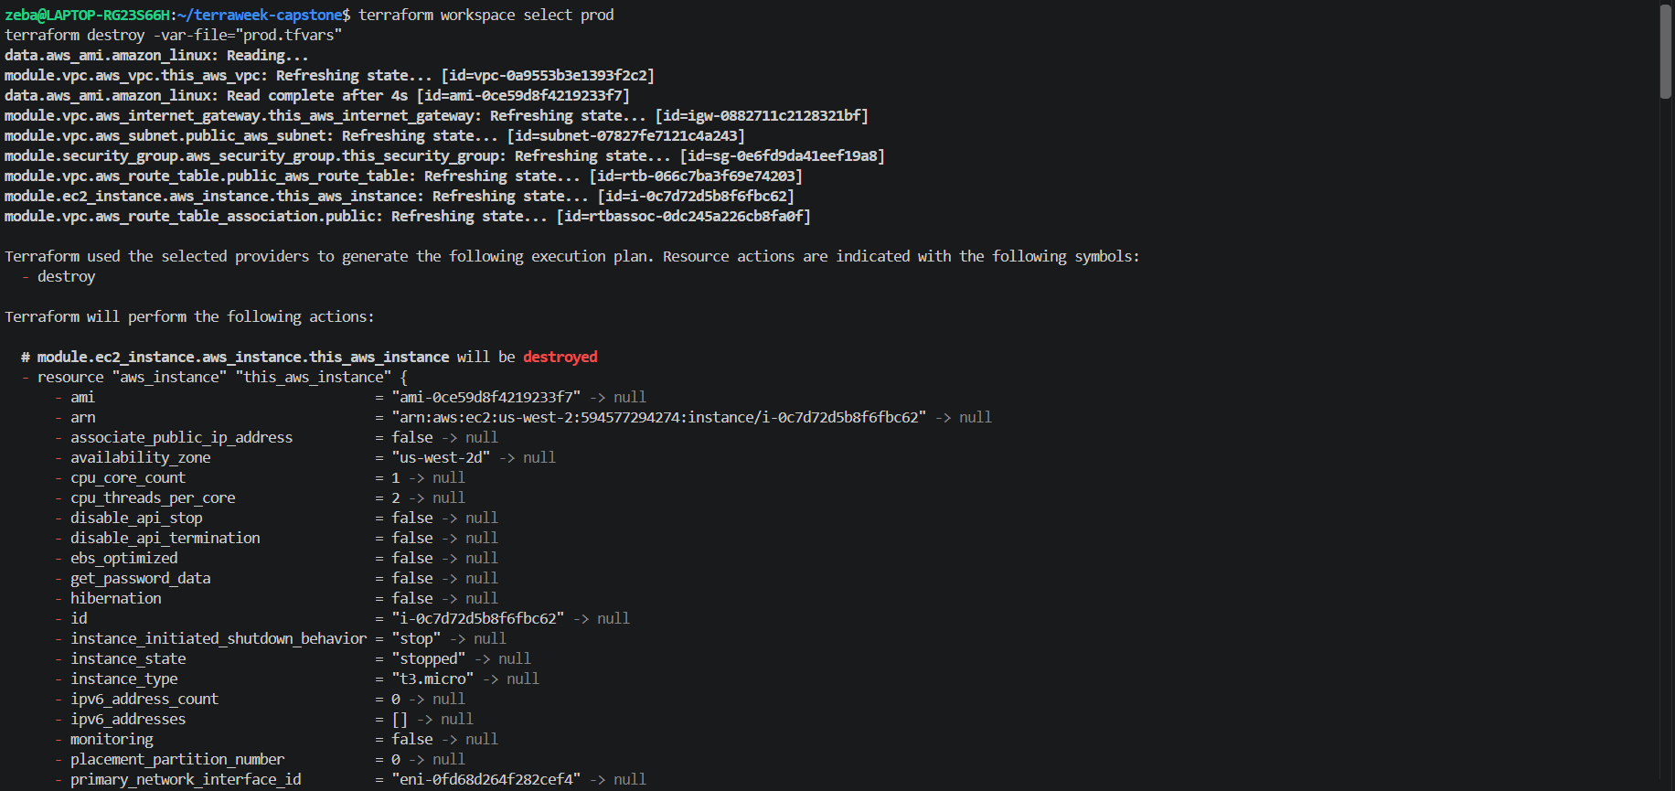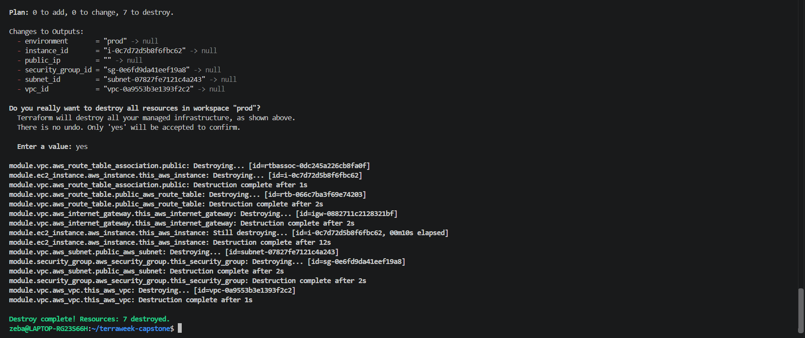

Destroy staging
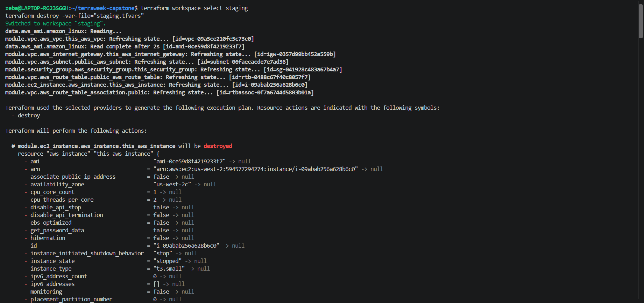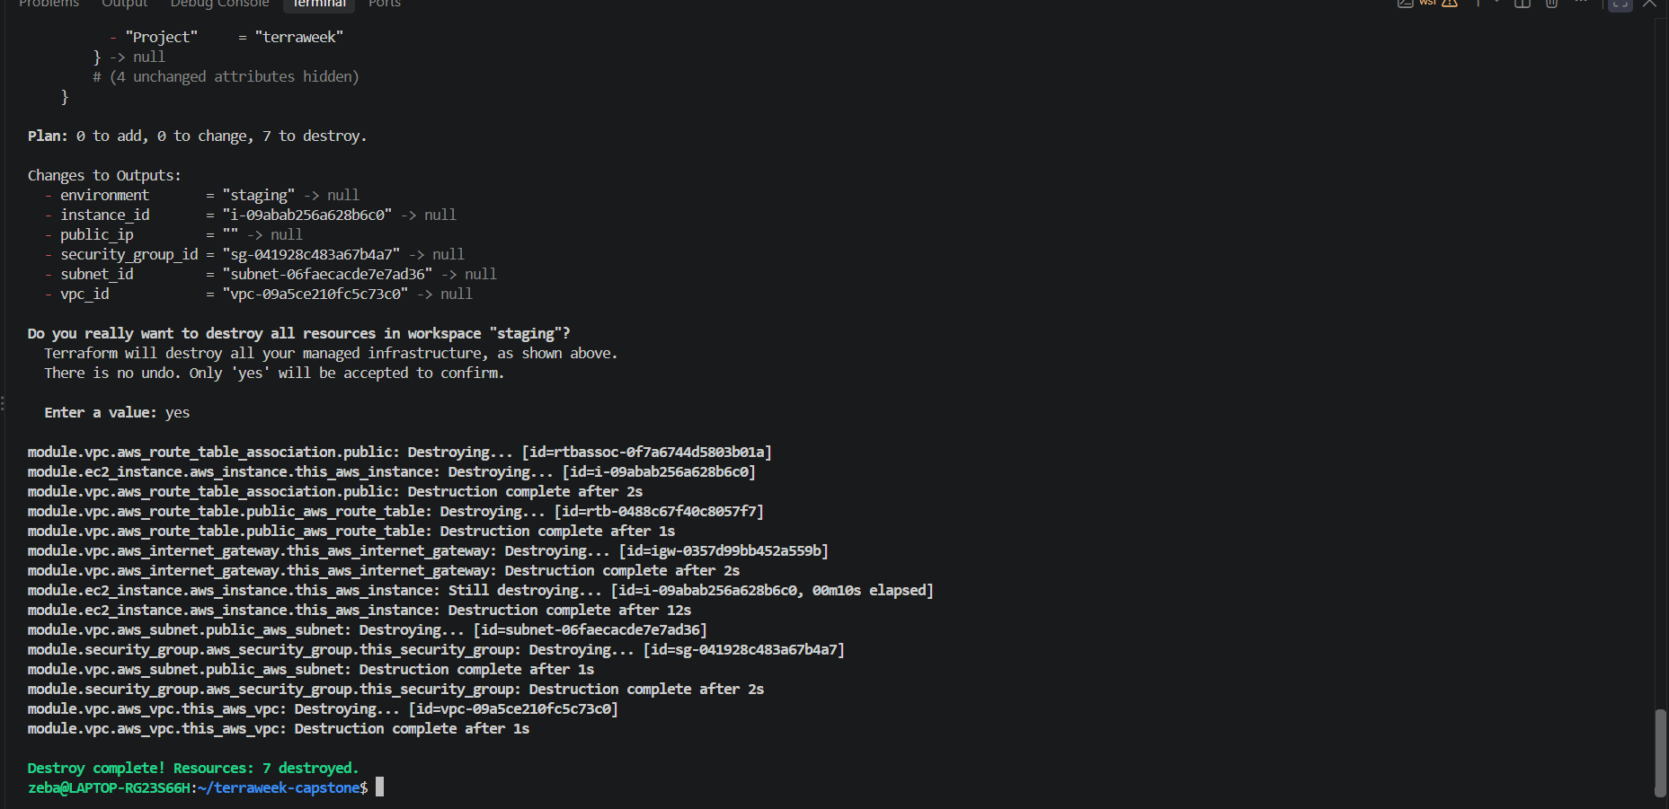

Destroy dev


