Task 1: Install & Verify
- Check if Docker Compose is available on your machine
- Verify the version
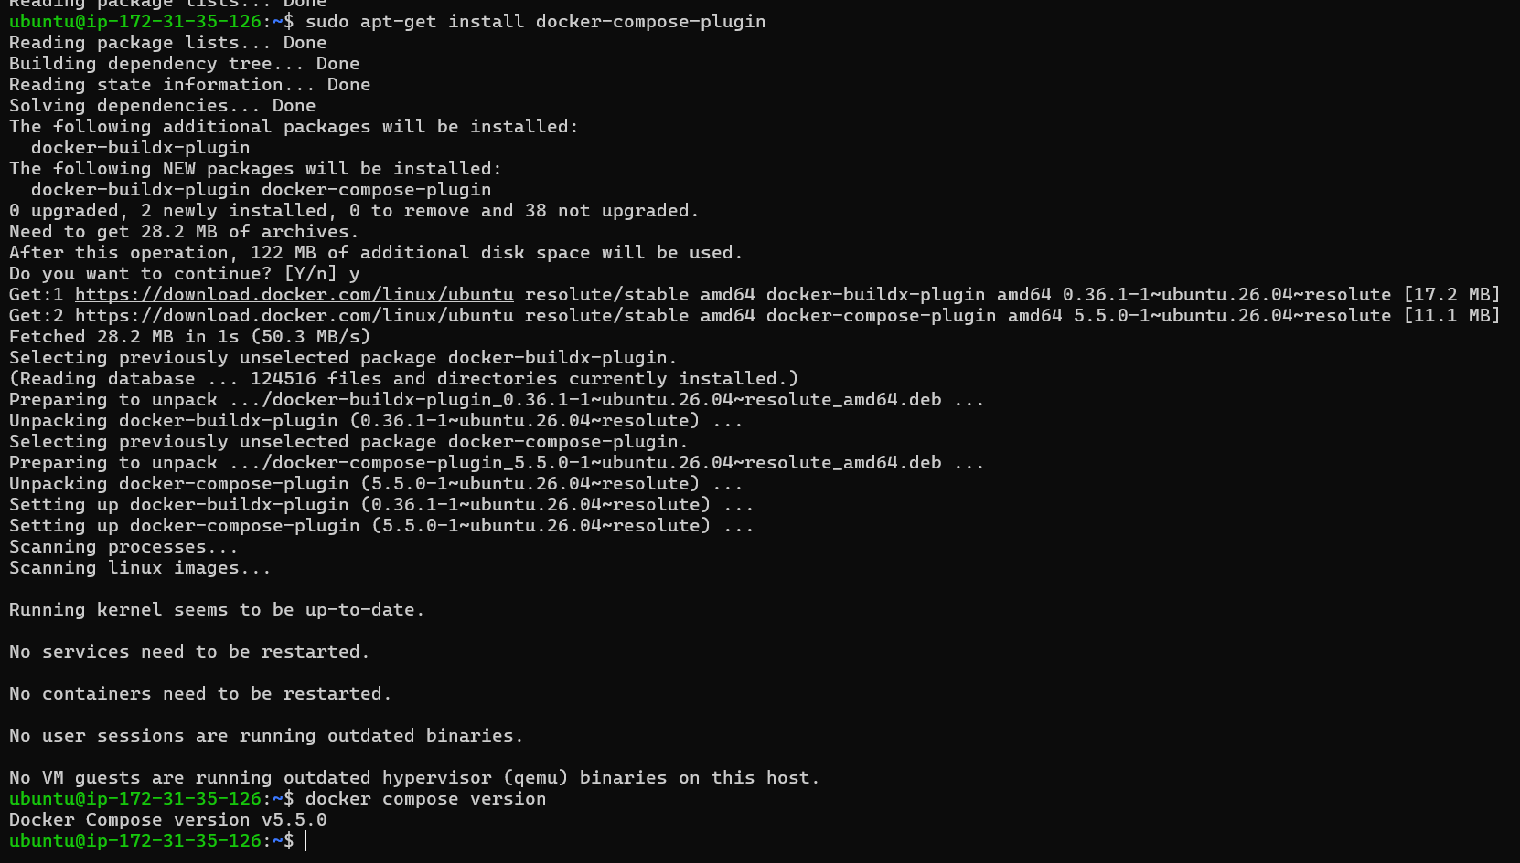
Task 2: Your First Compose File
- Create a folder compose-basics
- Write a docker-compose.yml that runs a single Nginx container with port mapping
- Start it with docker compose up
- Access it in your browser
- Stop it with docker compose down

Create a folder compose-basics
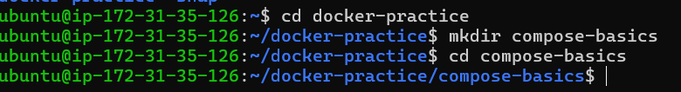
Write a docker-compose.yml that runs a single Nginx container with port mapping
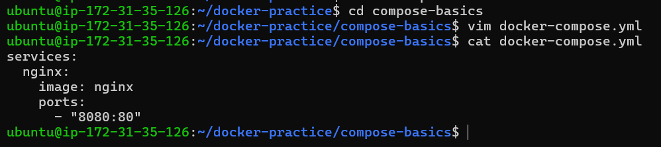
services:
nginx:
image: nginx
ports:
- "8080:80"

services: - These are the containers/services that Compose should manage.
Here nginx: is a service name
image: nginx - Create the container using the nginx image.
ports: - "8080:80"
EC2 host Container
8080 ───────────────→ 80
│
↓
Nginx

Start it with docker compose up
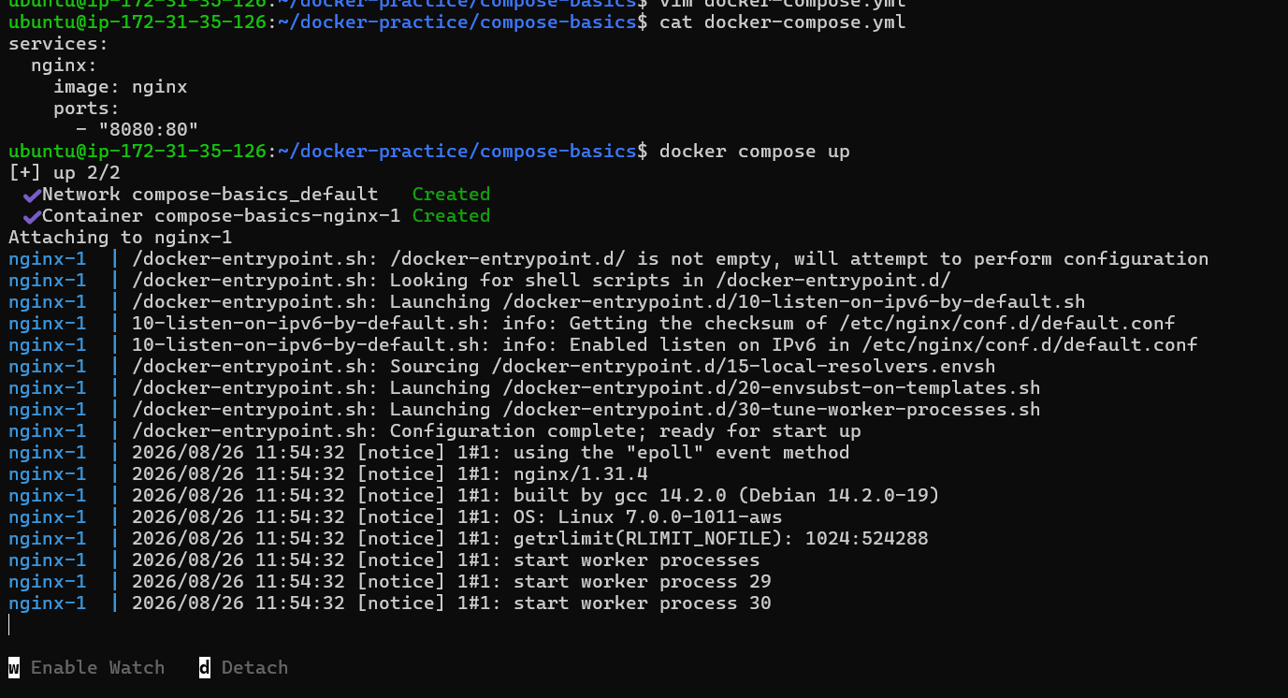
Access it in your browser
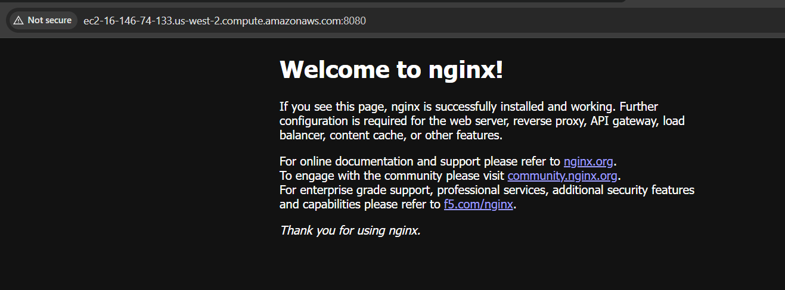
Stop it with docker compose down

Task 3: Two-Container Setup
Write a docker-compose.yml that runs:
- A WordPress container
- A MySQL container
They should:
- Be on the same network (Compose does this automatically)
- MySQL should have a named volume for data persistence
- WordPress should connect to MySQL using the service name
Start it, access WordPress in your browser, and set it up.
Verify: Stop and restart with docker compose down and docker compose up — is your WordPress data still there?
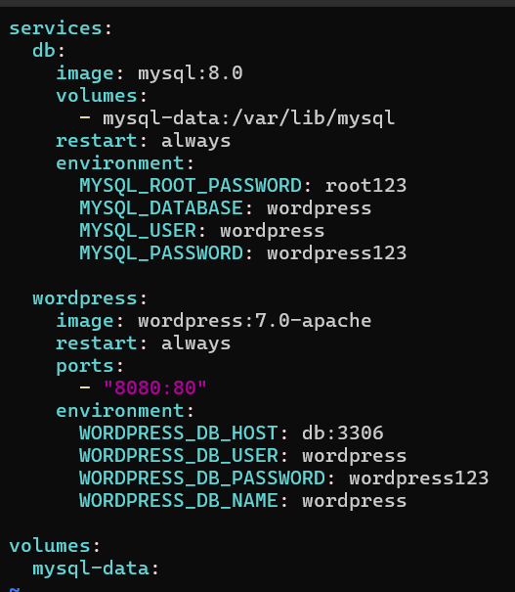
- restart: always --- This tells Docker: If the container stops unexpectedly, restart it automatically.
- environment: --- This section passes environment variables into the WordPress container.
- These variables tell WordPress:
- "How should I connect to my MySQL database?"
- This is extremely common in DevOps.
- Instead of hard-coding configuration inside the application, we provide it through environment variables.

- WORDPRESS_DB_HOST: db:3306 --- It tells WordPress: My database is available at db, port 3306.
- WORDPRESS_DB_USER: wordpress --- This tells WordPress: Use the MySQL user named wordpress. Remember that we created this user in the MySQL service:
- WORDPRESS_DB_PASSWORD: wordpress123 --- This tells WordPress: The password for the database user is wordpress123.
- WORDPRESS_DB_NAME: wordpress --- This tells WordPress: Use the database named wordpress.

Check using docker compose config

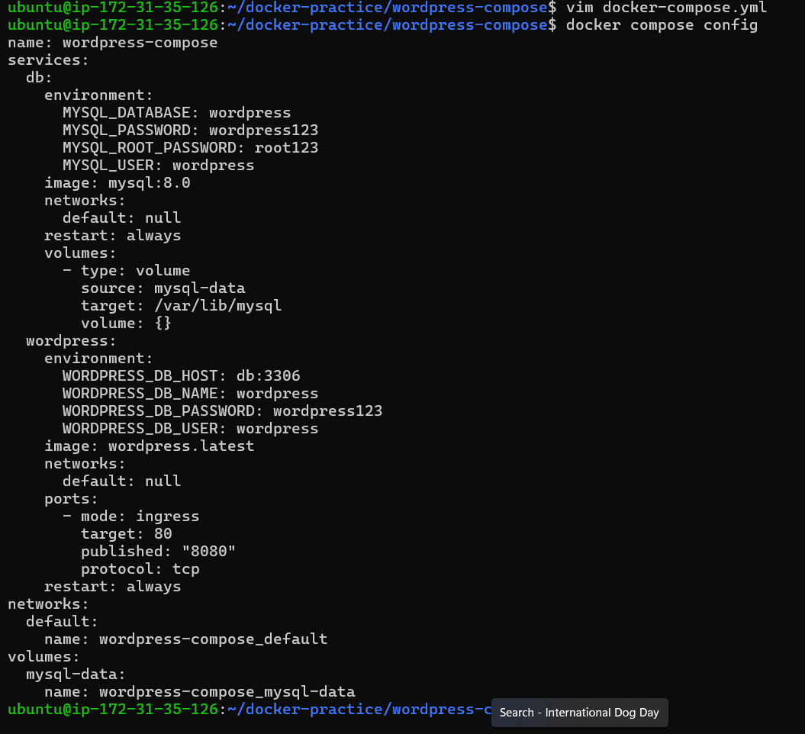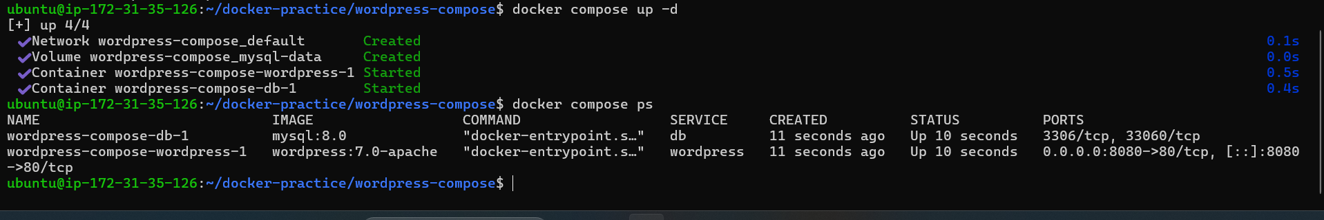
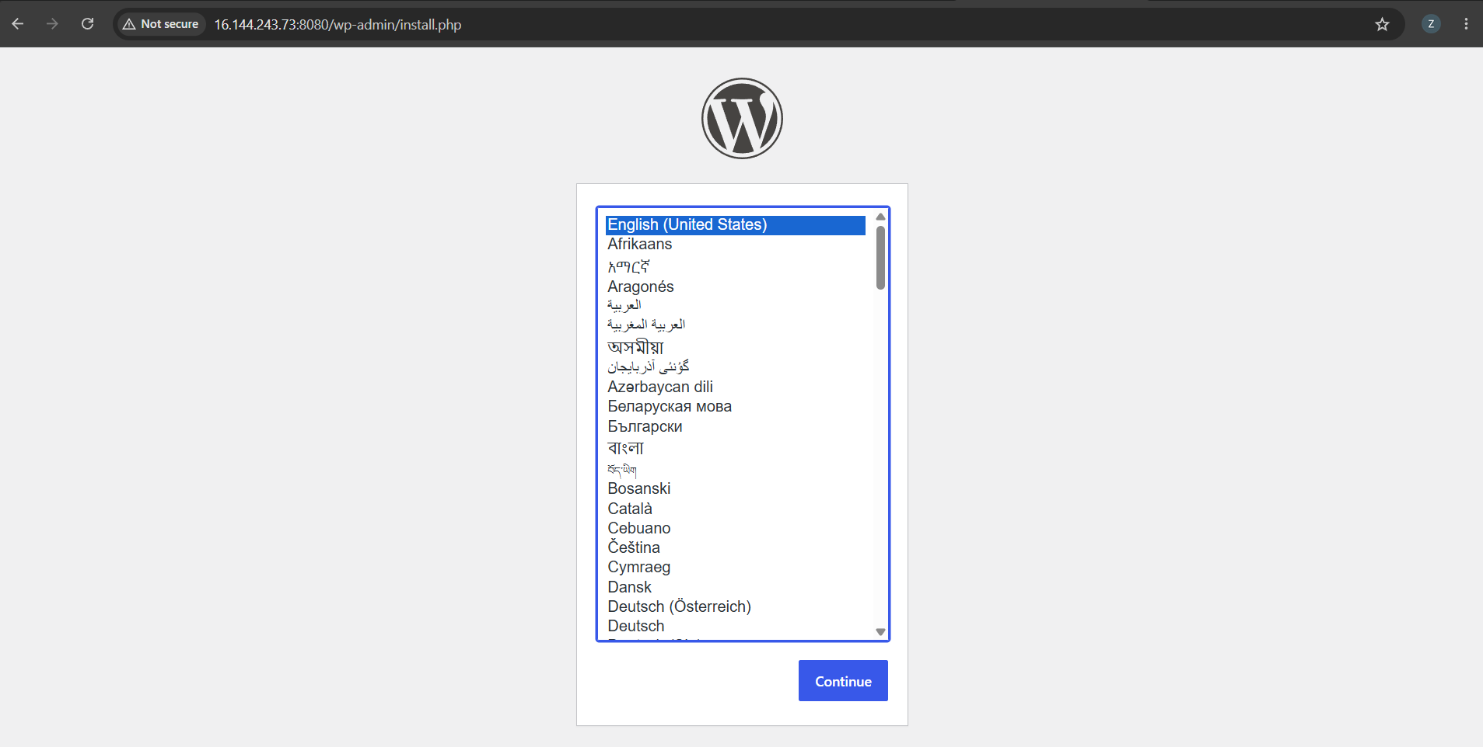

Data entered
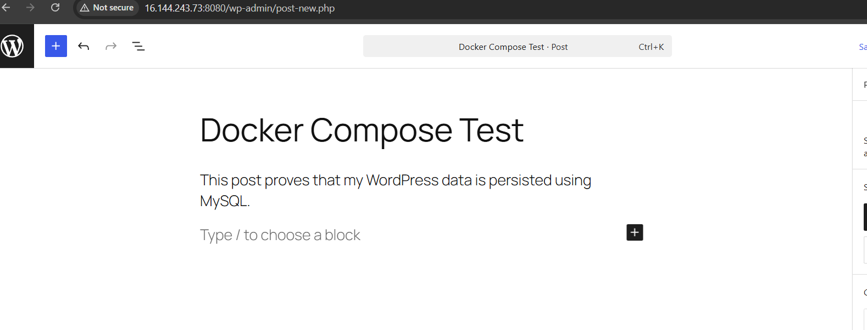
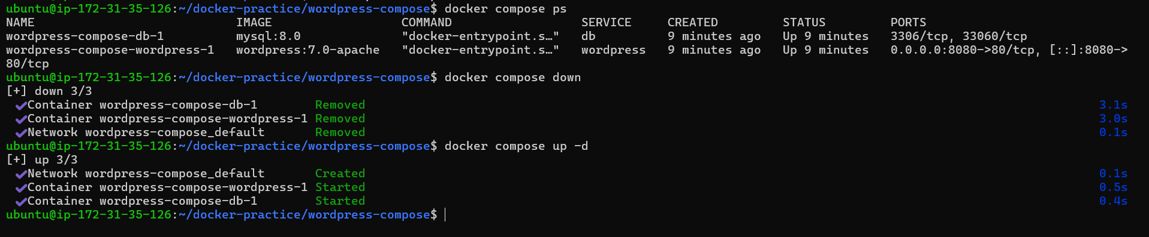
We did compose down and up
Data still der

Task 4: Compose Commands
Practice and document these:
- Start services in detached mode
- View running services
- View logs of all services
- View logs of a specific service
- Stop services without removing
- Remove everything (containers, networks)
- Rebuild images if you make a change

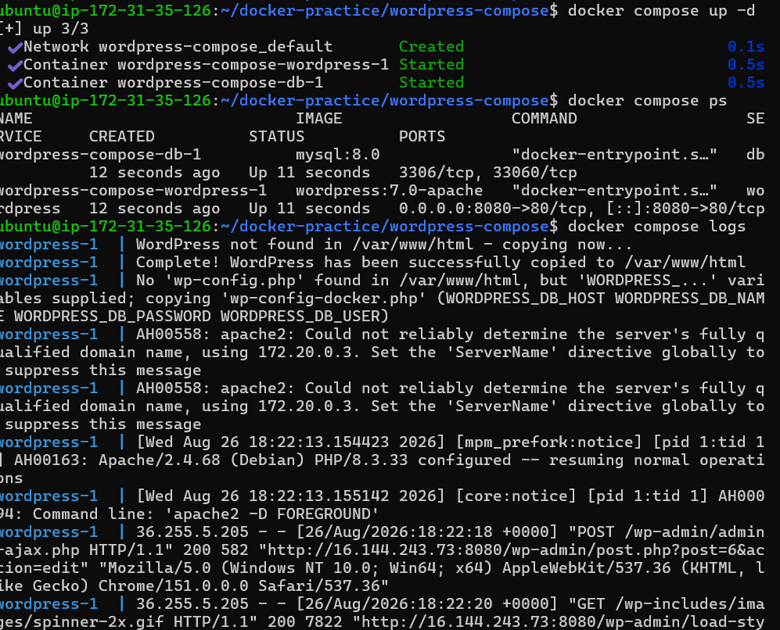
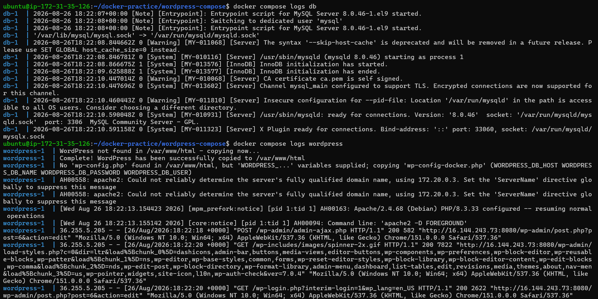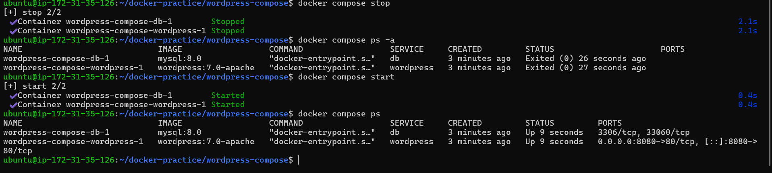
Remove everything (container , everything)

Rebuild images if you make a change
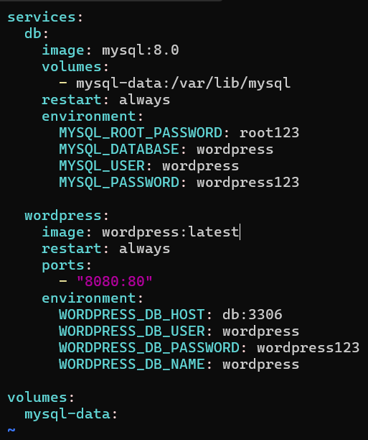
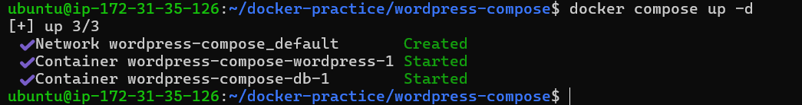

Task 5: Environment Variables
- Add environment variables directly in your docker-compose.yml
- Create a .env file and reference variables from it in your compose file
- Verify the variables are being picked up

Add environment variables directly in your docker-compose.yml
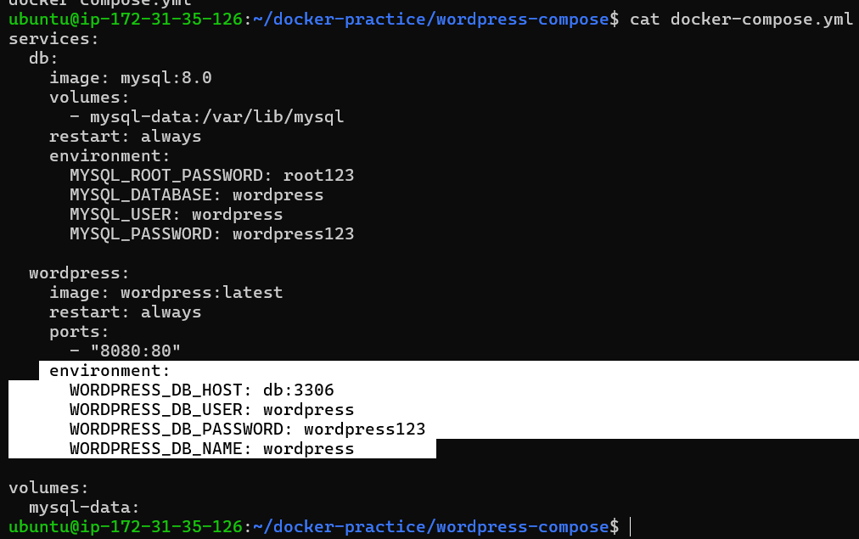
Create a .env file and reference variables from it in your compose file

