Task 1: Trigger on Pull Request
- Create .github/workflows/pr-check.yml
- Trigger it only when a pull request is opened or updated against main
- Add a step that prints: PR check running for branch: <branch name>
- Create a new branch, push a commit, and open a PR
- Watch the workflow run automatically
Verify: Does it show up on the PR page?

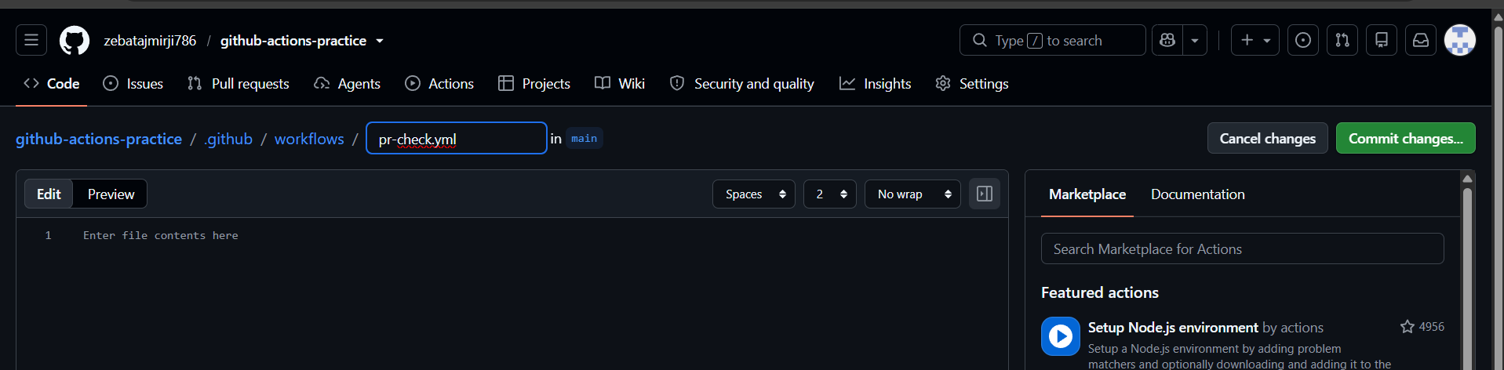
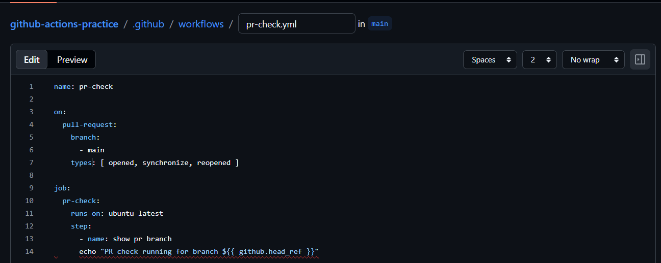
Here github.head_ref = source branch of the pull request
Types:
Events for the pull request
- Opened = when a new pull request is open
- Synchronize = when you push a new commit to the existing pr
- Reopened = when pr gets reopen

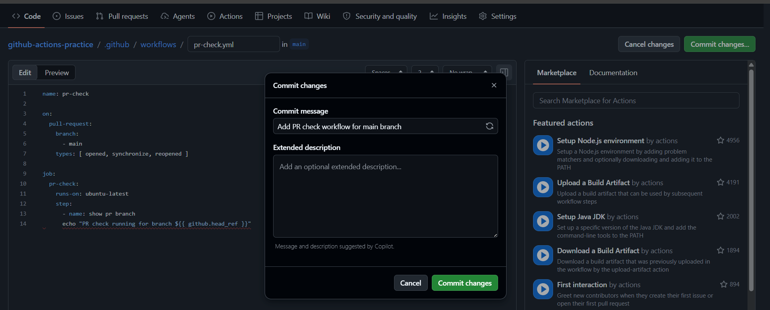
Commit the changes

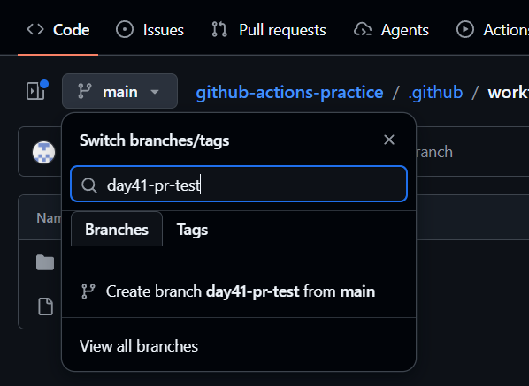
Create a new branch

Made changes

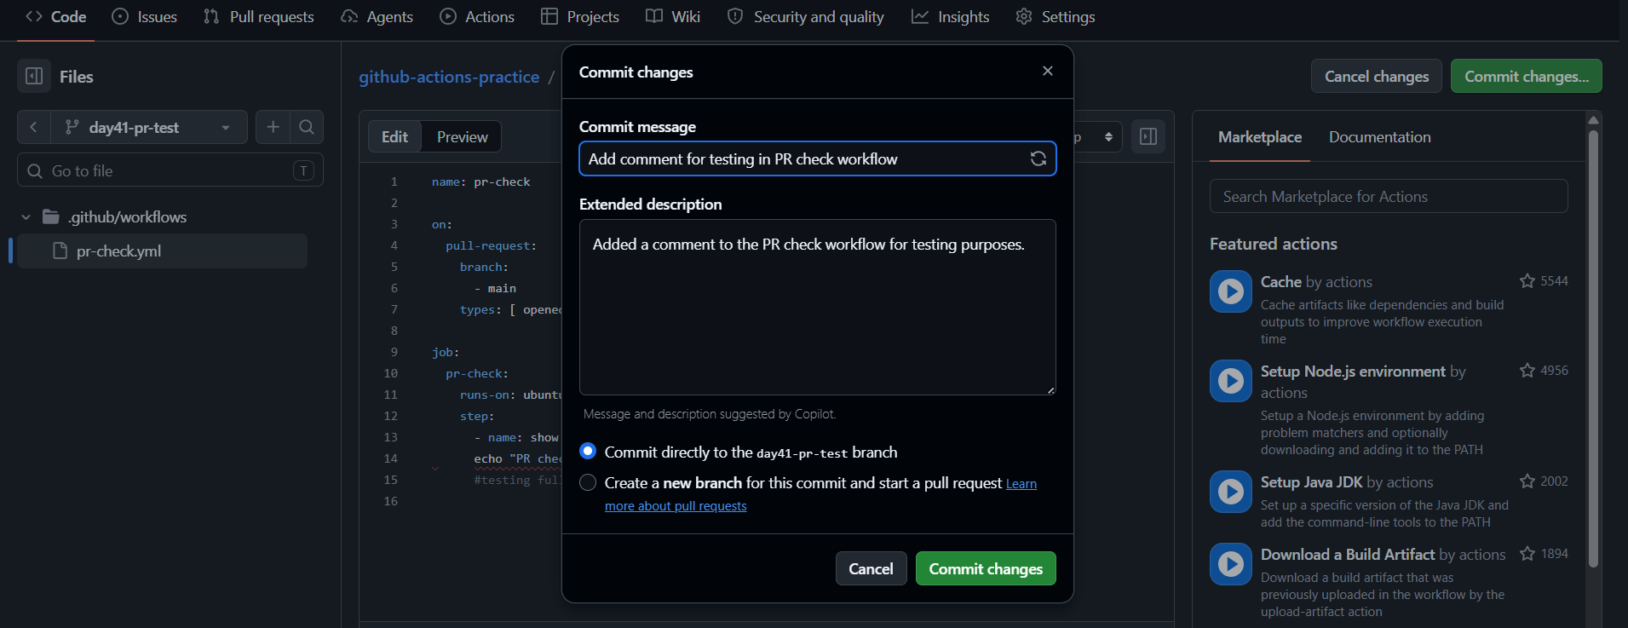
Committed on the test branch
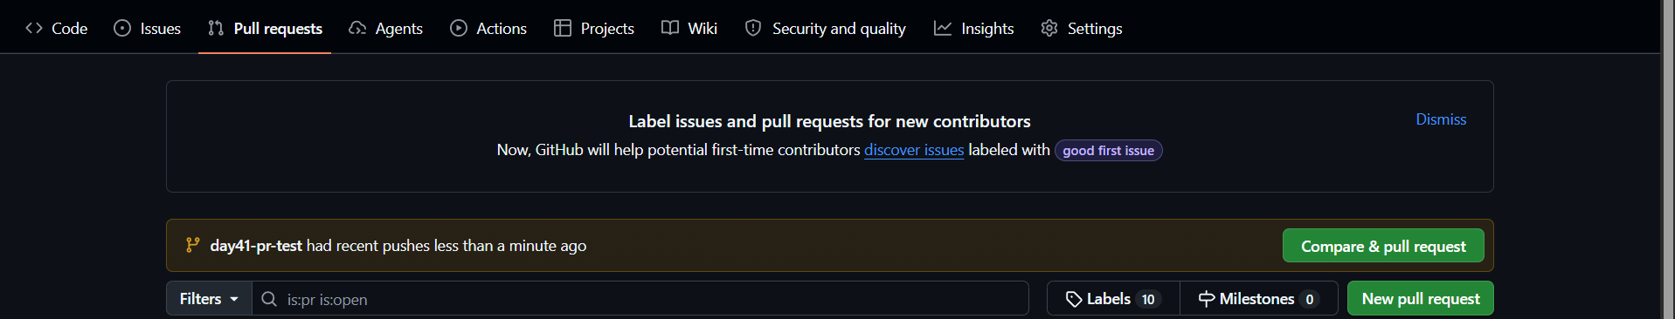
Now create a pull request
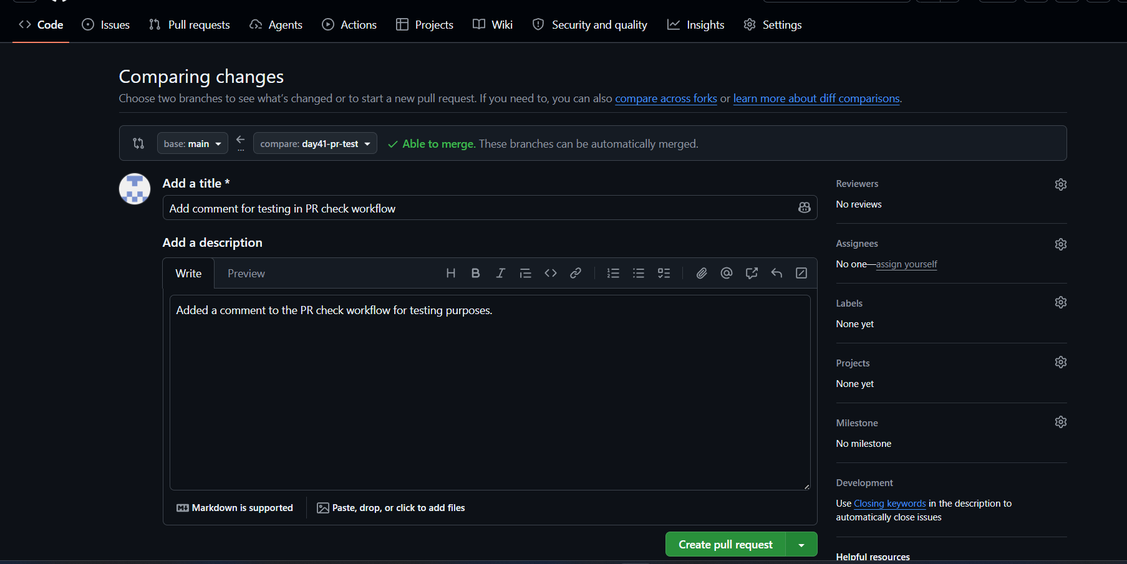
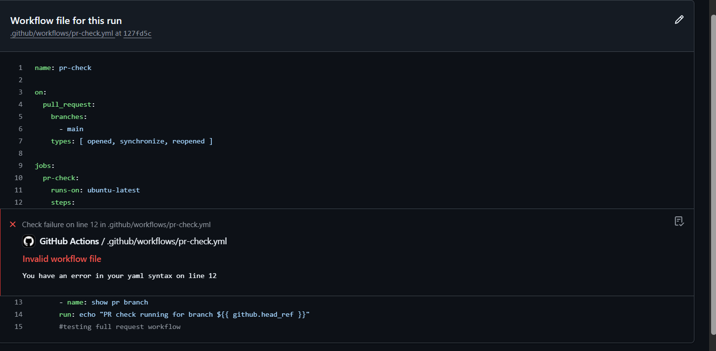
Trouble shooting

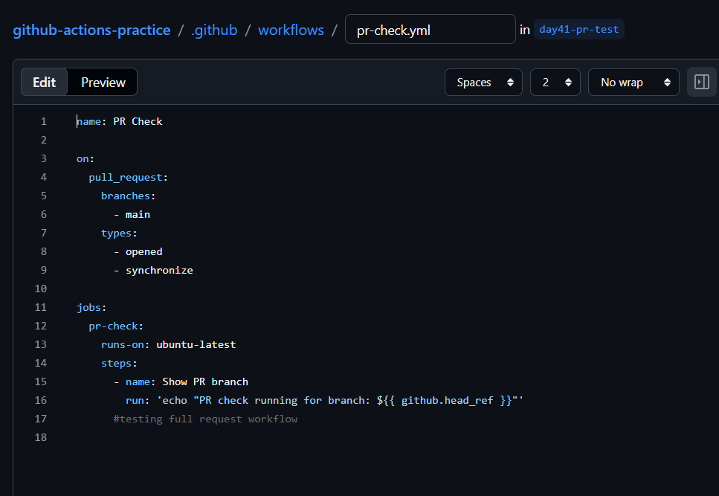
Corrected the file with syntax

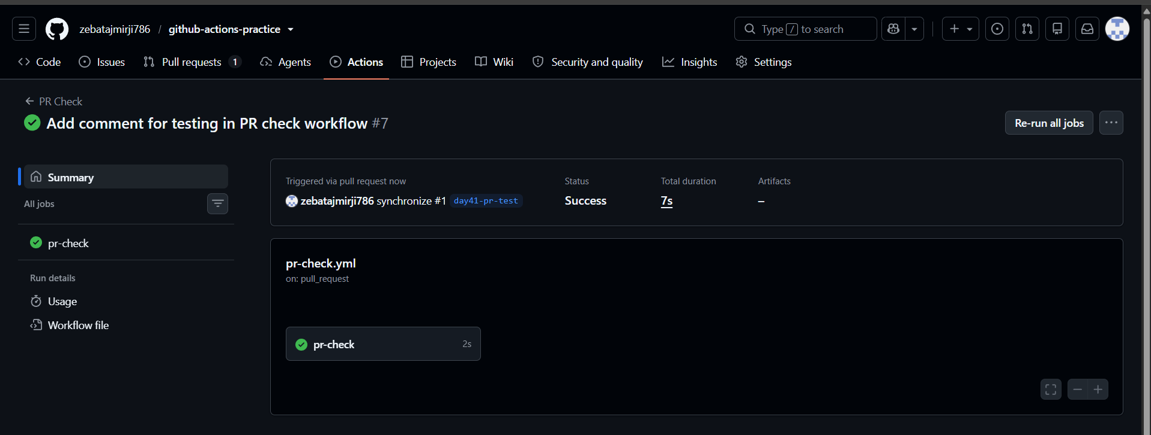
Pr check passed
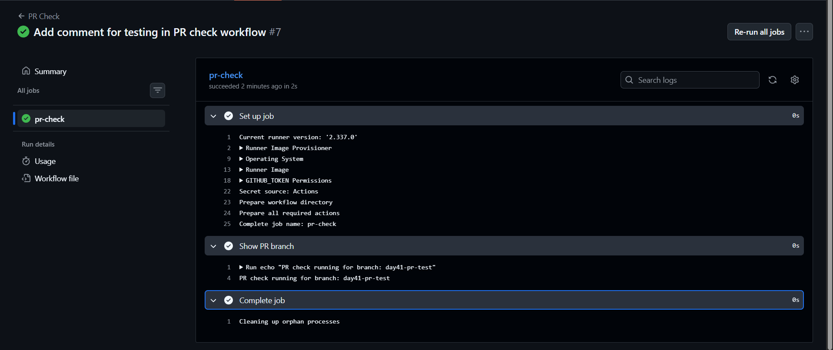

Task 2: Scheduled Trigger
- Add a schedule: trigger to any workflow using cron syntax
- Set it to run every day at midnight UTC
- Write in your notes: What is the cron expression for every Monday at 9 AM?
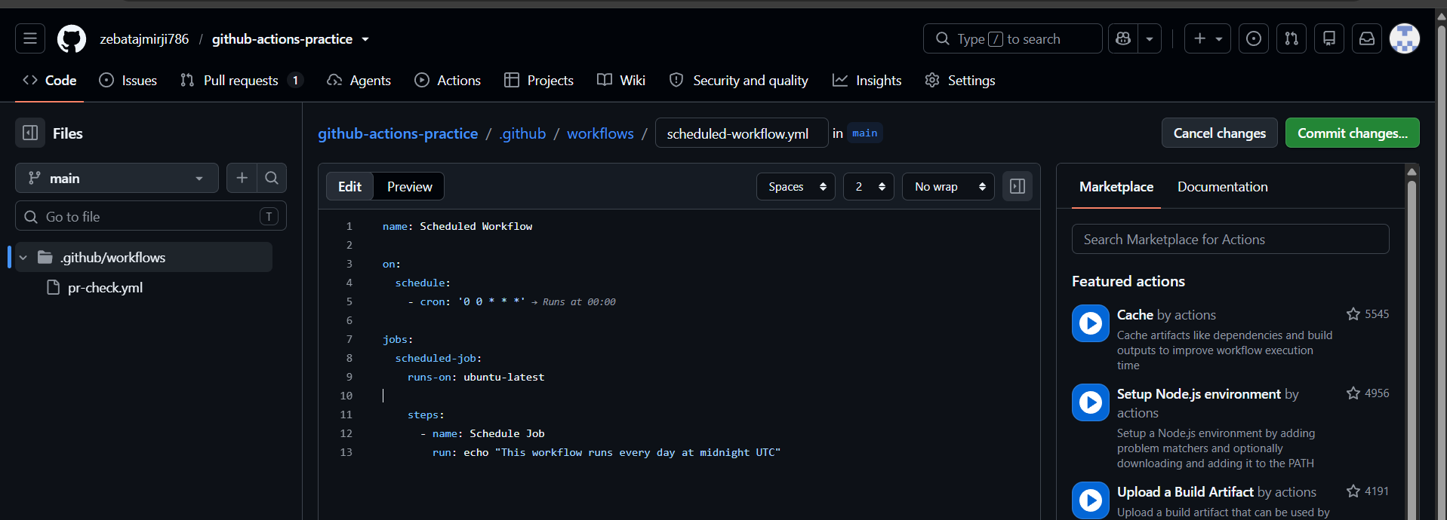
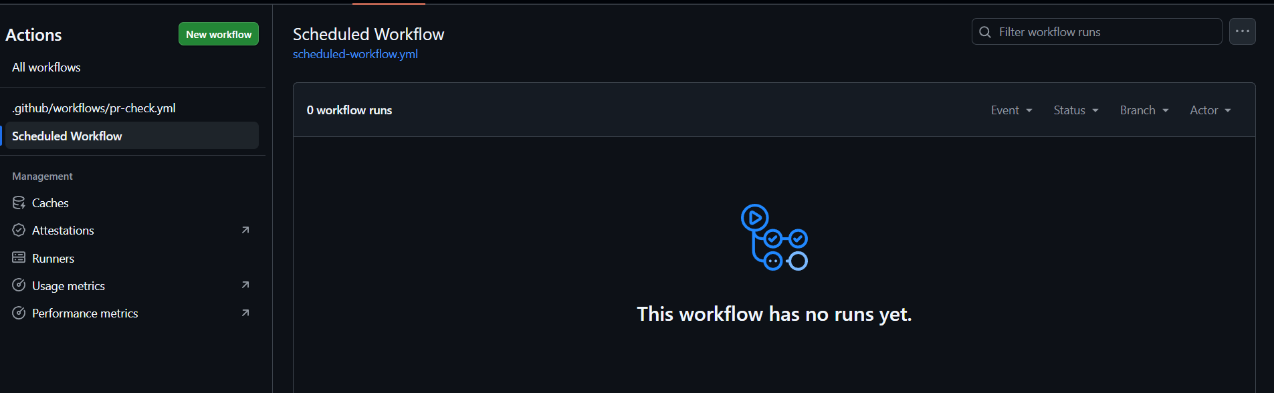
We can see this is in scheduled workflow tab

Write in your notes: What is the cron expression for every Monday at 9 AM?
Every day at midnight UTC:
0 0 * * *
Every Monday at 9 AM UTC:
0 9 * * 1

Task 3: Manual Trigger
- Create .github/workflows/manual.yml with a workflow_dispatch: trigger
- Add an input that asks for an environment name (staging/production)
- Print the input value in a step
- Go to the Actions tab → find the workflow → click Run workflow
Verify: Can you trigger it manually and see your input printed?

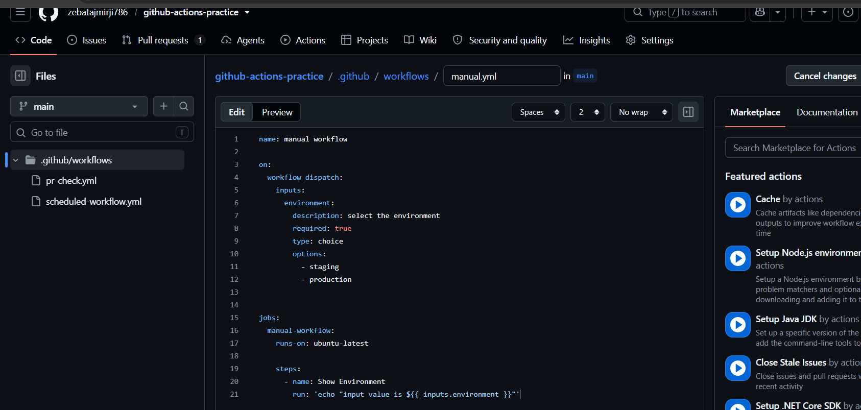
workflow_dispatch = manually trigger
input = when we want to run the workflow it will ask for the inputs
environment = it is just a name of the input, it can be any thing
description = instruction/ question shown on the screen
required = mandatorily need to choose one option
type: choice = it will give the list of choices
options: = give the choices
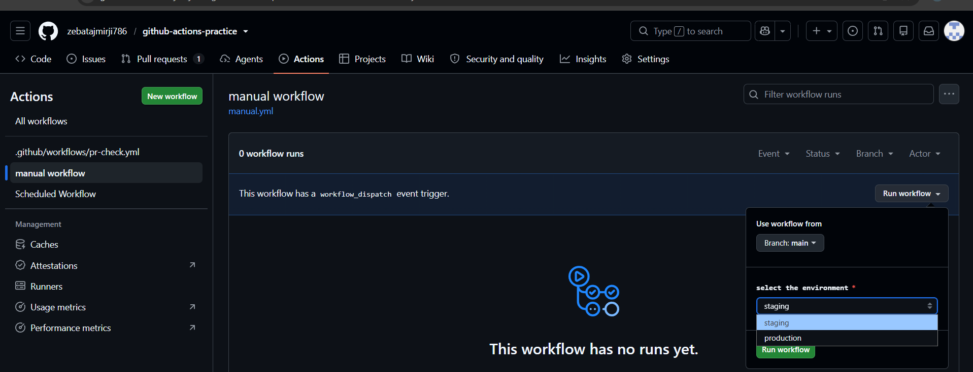
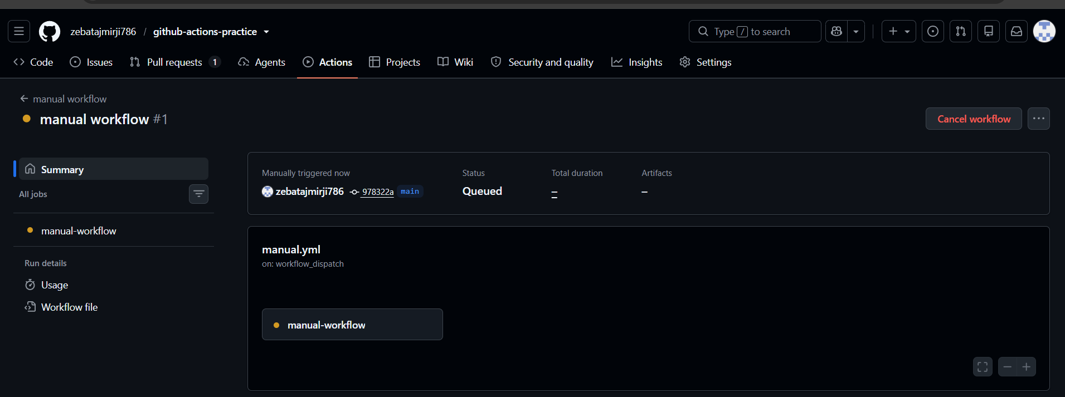
Workflow triggered manually
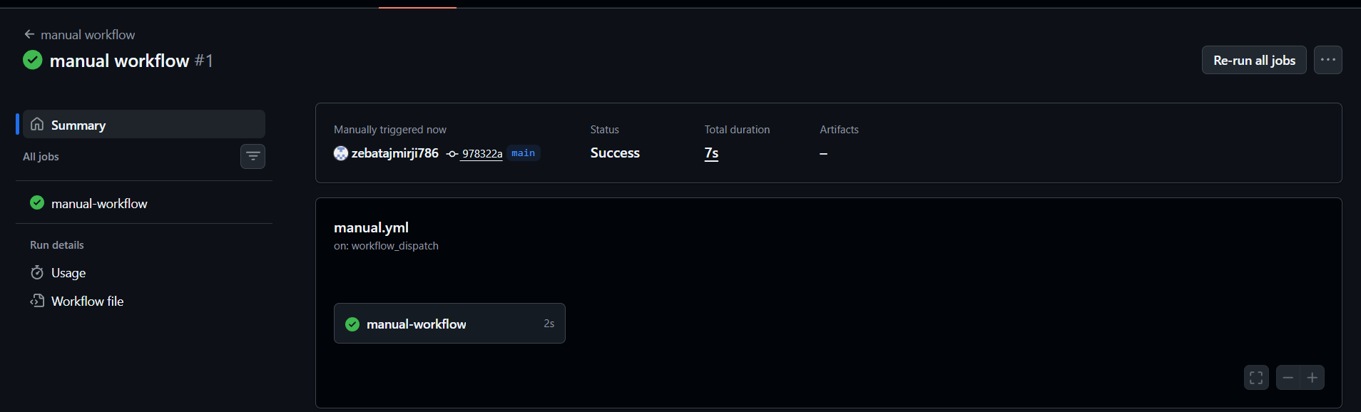
Successful

Task 4: Matrix Builds
Create .github/workflows/matrix.yml that:
- Uses a matrix strategy to run the same job across:
  - Python versions: 3.10, 3.11, 3.12
- Each job installs Python and prints the version
- Watch all 3 run in parallel
Then extend the matrix to also include 2 operating systems — how many total jobs run now?

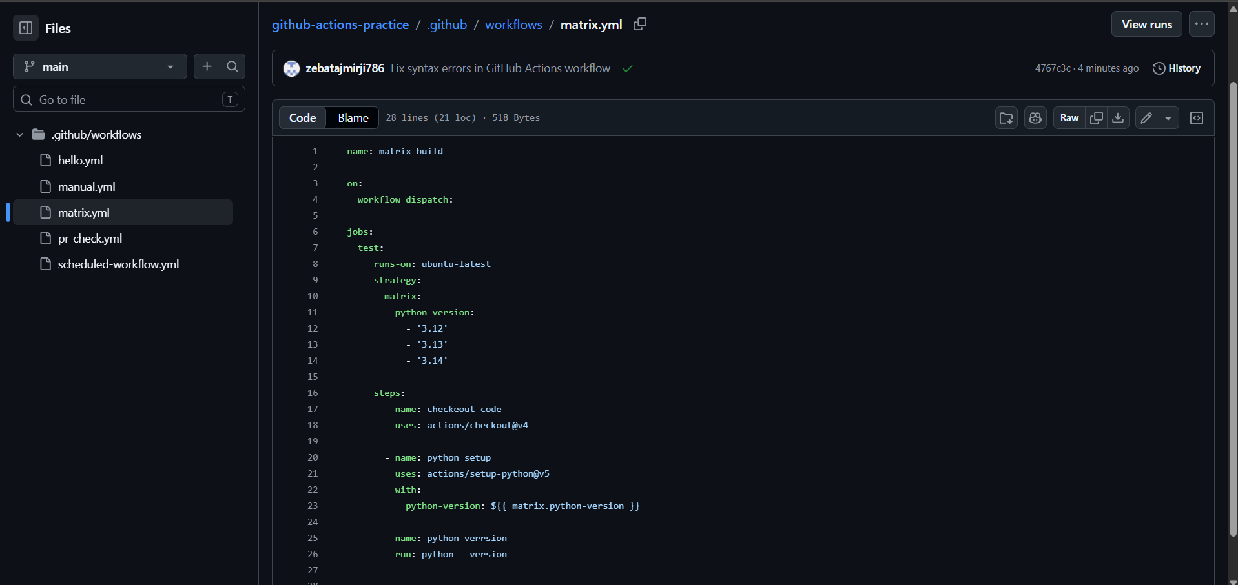
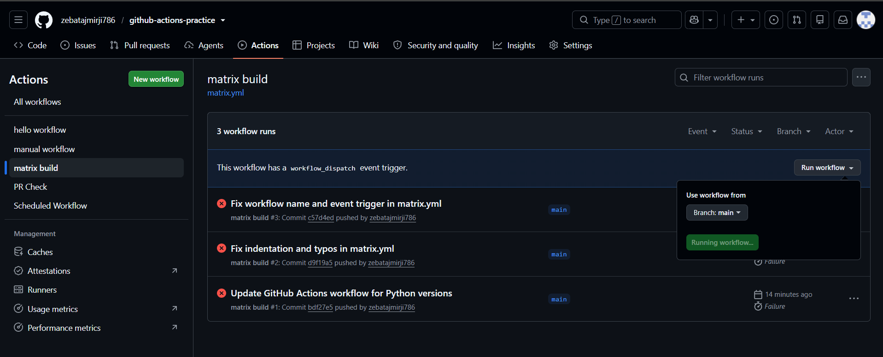
Triggered manually as we used workflow_dispach: as a trigger
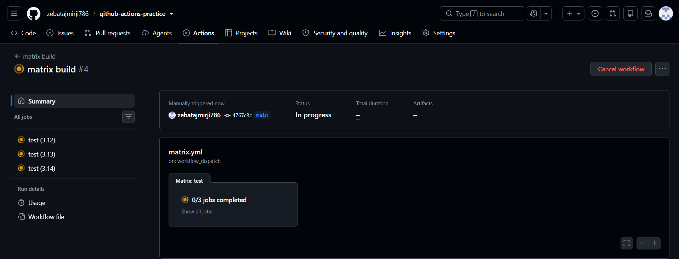
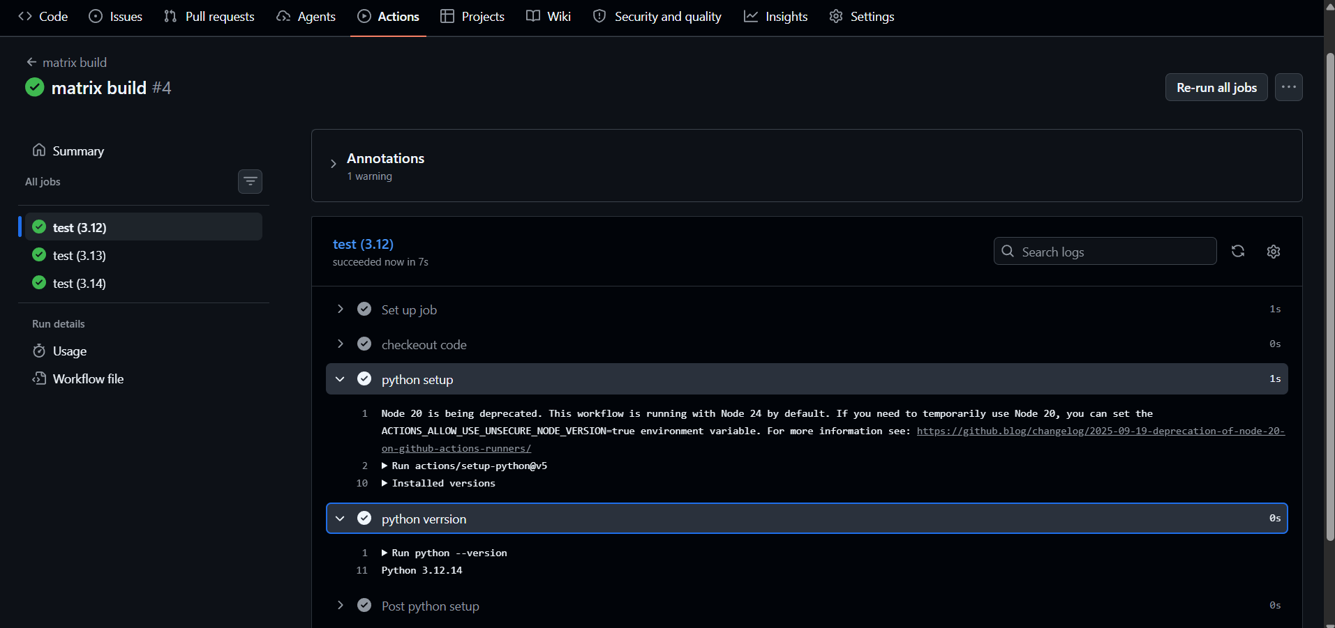
All three jobs passes
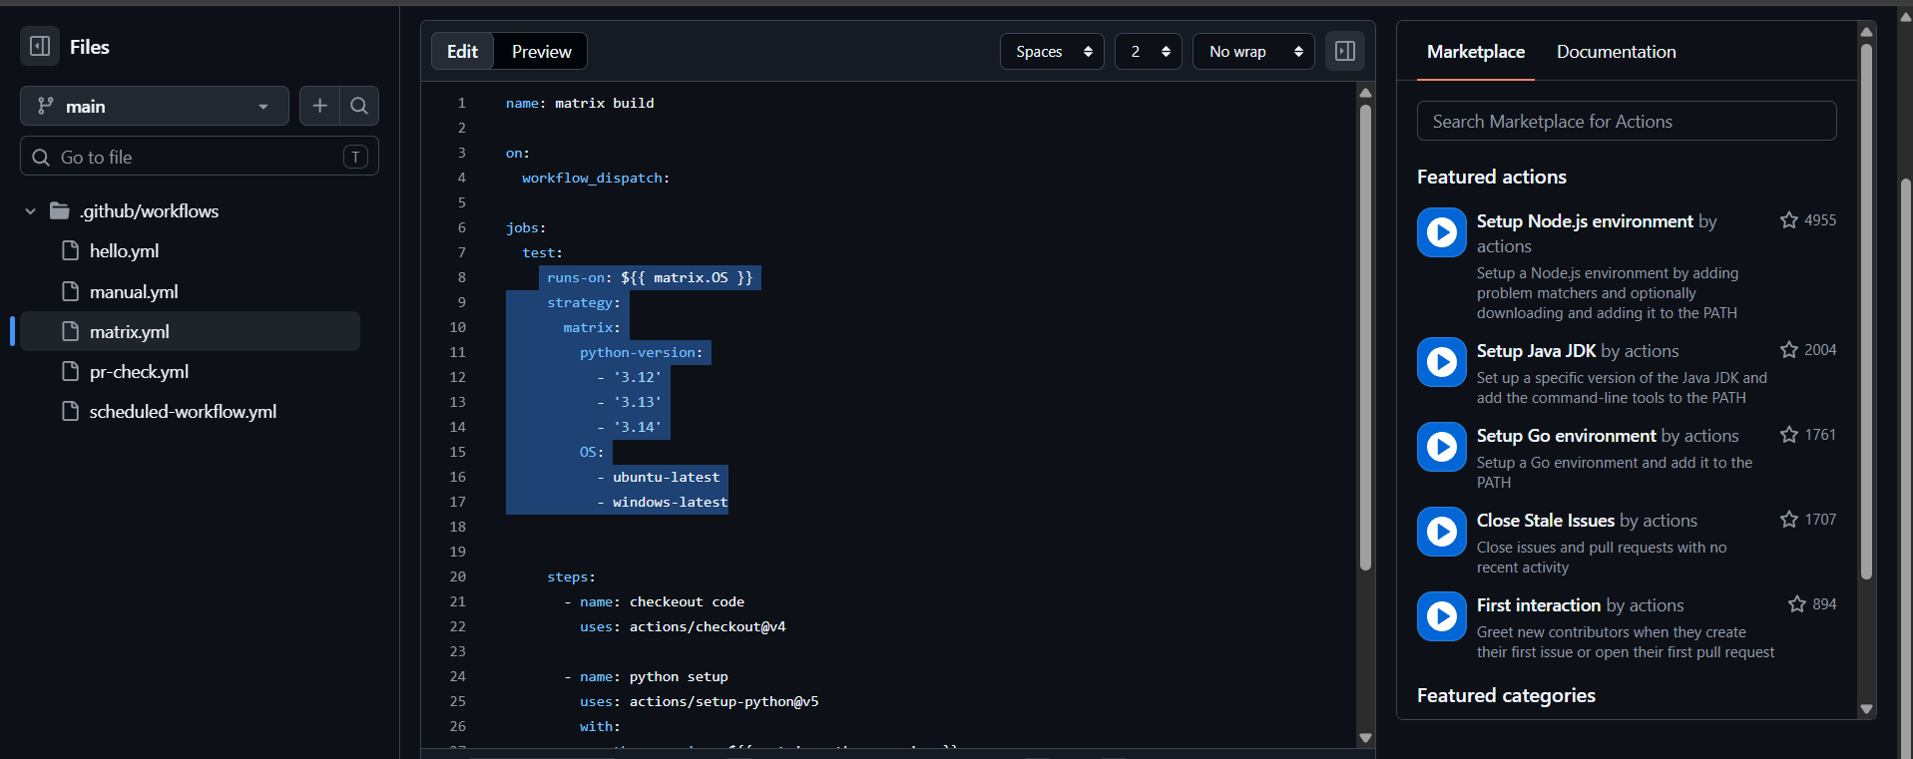
Updated yaml file to check 2 os types also in matrix
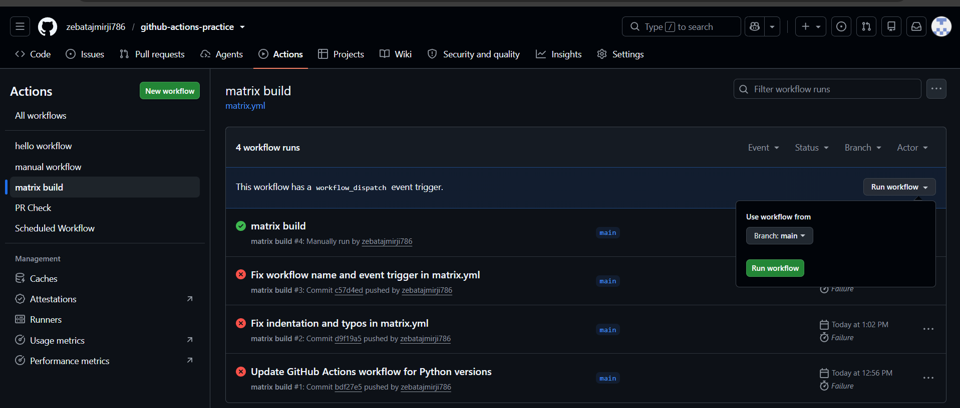
Run the workflow again
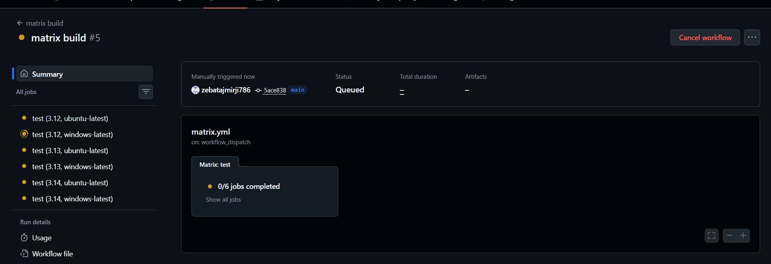
There are total 6 jobs
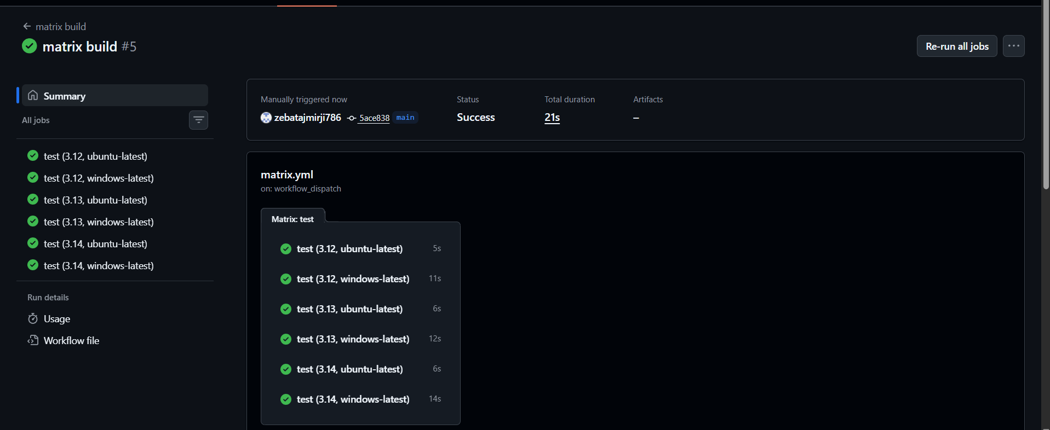
Successful workflow

Task 5: Exclude & Fail-Fast
- In your matrix, exclude one specific combination (e.g., Python 3.10 on Windows)
- Set fail-fast: false — trigger a failure in one job and observe what happens to the rest
- Write in your notes: What does fail-fast: true (the default) do vs false?
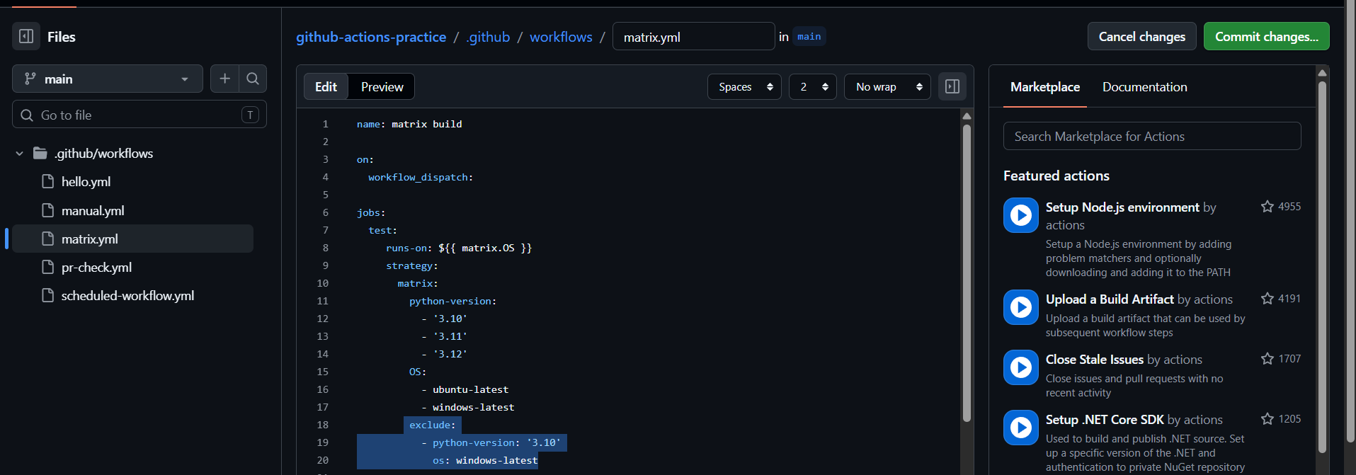
Excude:
- Python-version: ‘3.10’
Os: ubuntu-latest

exclude – will exclude the particular job from jobs in matrix
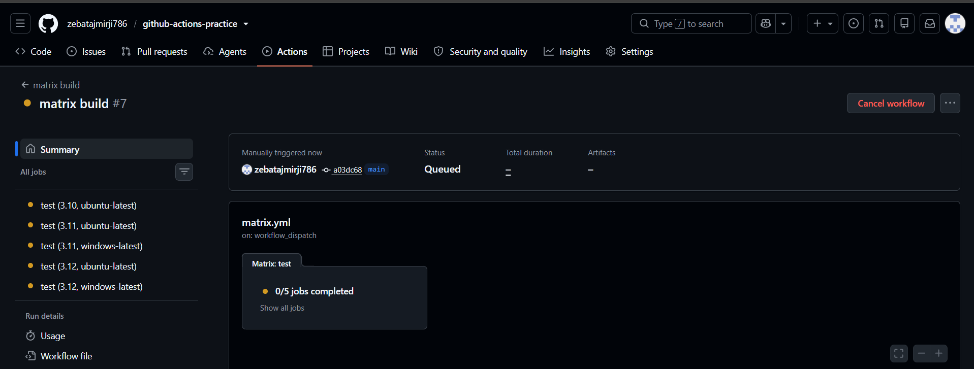
5 jobs are running
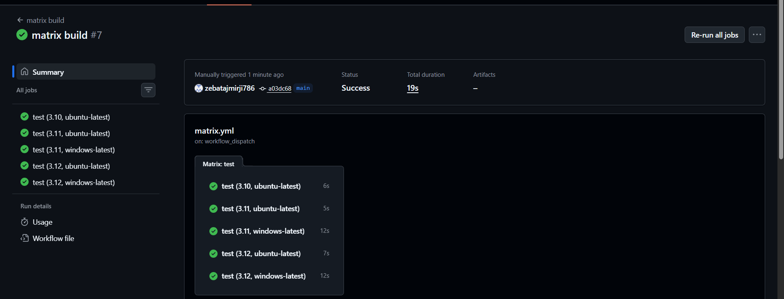
Job python-version:3.10 + windows latest got excluded

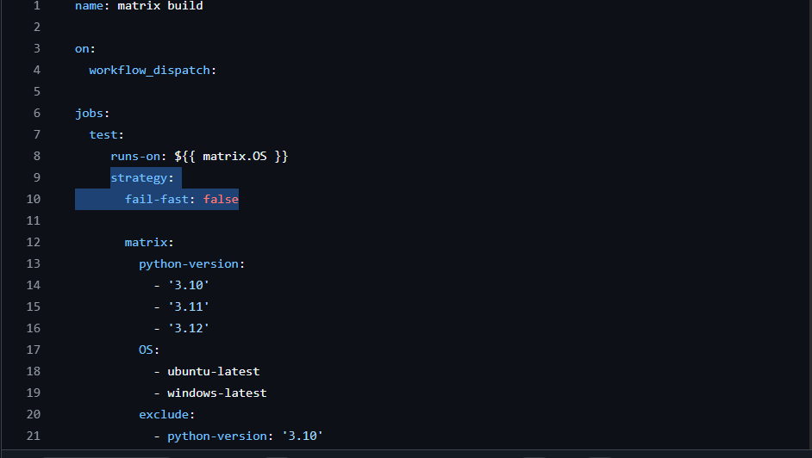
Added fail-fast: false in strategy – if one job fails it will let other jobs run normally
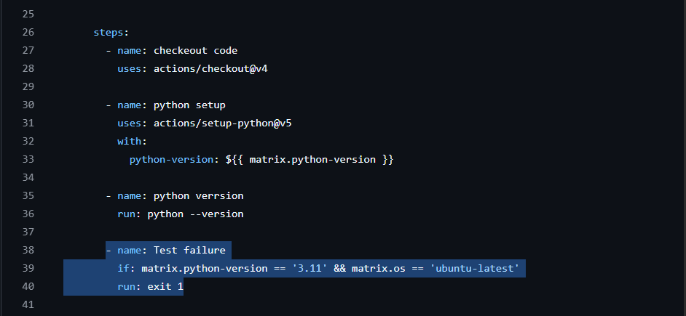
Added 1 step to fail that particular job
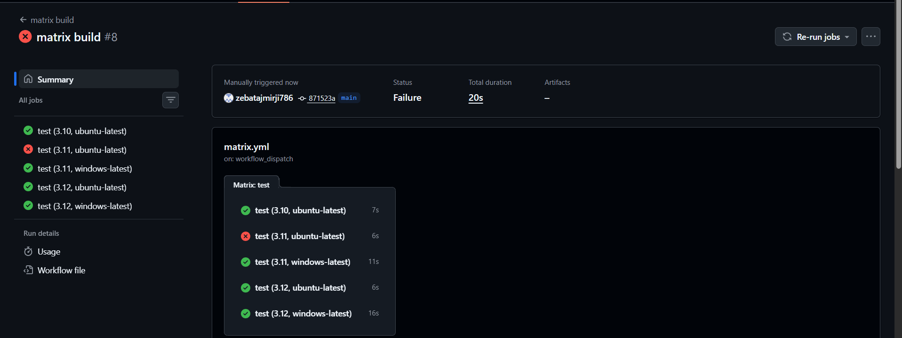only one job failed other ran successfully

Fail-fast: true – if any job fails then it will stop the other running jobs and the jobs got successful it wont undo them
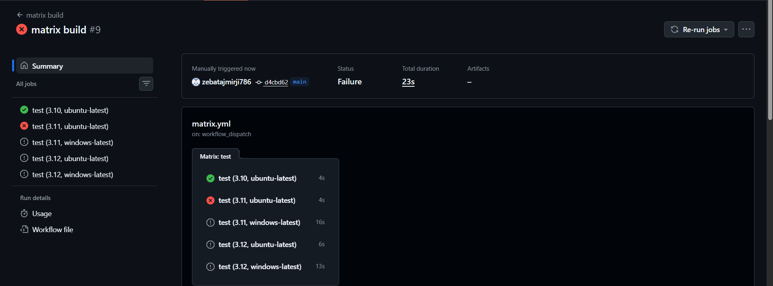

fail-fast: true vs false
- fail-fast: true is the default. If one matrix job fails, GitHub cancels the other matrix jobs that are still running.
- fail-fast: false means that even if one matrix job fails, the other matrix jobs continue running.
Easy way to remember
true → One fails → stop the remaining jobs ❌
false → One fails → let the other jobs continue ✅

