Task 1: Explore Default Namespaces
Kubernetes comes with built-in namespaces. List them:
kubectl get namespaces
You should see at least:
- default — where your resources go if you do not specify a namespace
- kube-system — Kubernetes internal components (API server, scheduler, etc.)
- kube-public — publicly readable resources
- kube-node-lease — node heartbeat tracking
Check what is running inside kube-system:
kubectl get pods -n kube-system
These are the control plane components keeping your cluster alive. Do not touch them.
Verify: How many pods are running in kube-system?

Default namespaces
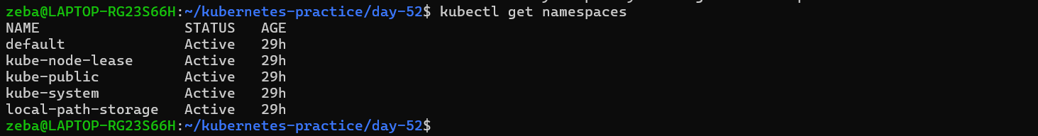

kube-system — Kubernetes internal components (API server, scheduler, etc.)
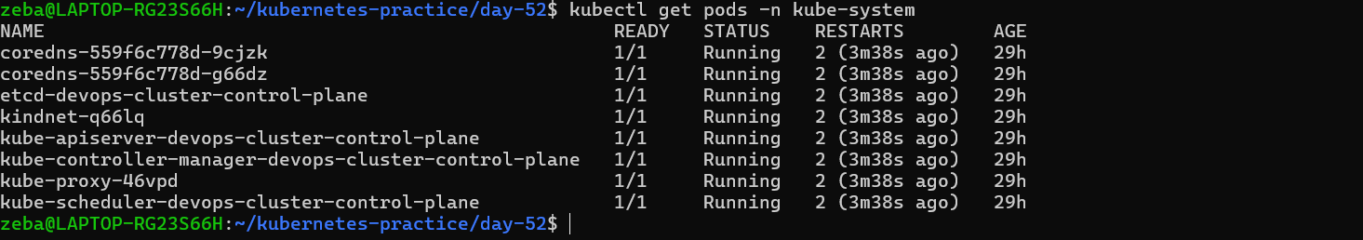

Task 2: Create and Use Custom Namespaces
Create two namespaces — one for a development environment and one for staging:
kubectl create namespace dev
kubectl create namespace staging
Verify they exist:
kubectl get namespaces
You can also create a namespace from a manifest:
# namespace.yaml
apiVersion: v1
kind: Namespace
metadata:
name: production
kubectl apply -f namespace.yaml
Now run a pod in a specific namespace:
kubectl run nginx-dev --image=nginx:latest -n dev
kubectl run nginx-staging --image=nginx:latest -n staging
List pods across all namespaces:
kubectl get pods -A
Notice that kubectl get pods without -n only shows the default namespace. You must specify -n <namespace> or use -A to see everything.
Verify: Does kubectl get pods show these pods? What about kubectl get pods -A?

Dev, staging namespaces created
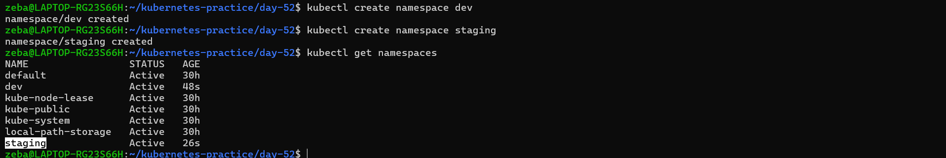
Namespaces can also be created by the manifest file
Here namespace created with name “production”
Now run a pod in a specific namespace:
kubectl run nginx-dev --image=nginx:latest -n dev
kubectl run nginx-staging --image=nginx:latest -n staging
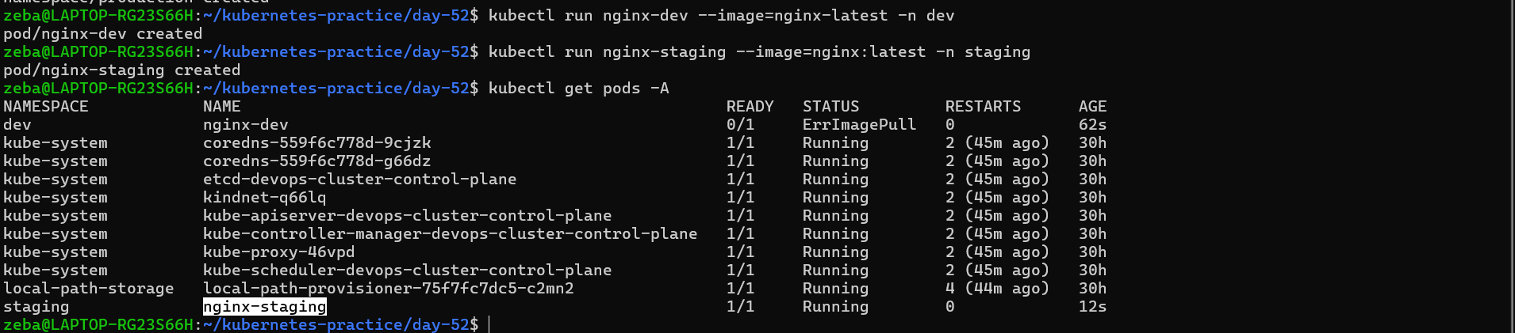
2 pods created in dev and staging namespace

Task 3: Create Your First Deployment
A Deployment tells Kubernetes: "I want X replicas of this Pod running at all times." If a Pod crashes, the Deployment controller recreates it automatically.
Create a file nginx-deployment.yaml:
apiVersion: apps/v1
kind: Deployment
metadata:
name: nginx-deployment
namespace: dev
labels:
app: nginx
spec:
replicas: 3
selector:
matchLabels:
app: nginx
template:
metadata:
labels:
app: nginx
spec:
containers:
- name: nginx
image: nginx:1.24
ports:
- containerPort: 80
Key differences from a standalone Pod:
- kind: Deployment instead of kind: Pod
- apiVersion: apps/v1 instead of v1
- replicas: 3 tells Kubernetes to maintain 3 identical pods
- selector.matchLabels connects the Deployment to its Pods
- template is the Pod template — the Deployment creates Pods using this blueprint
Apply it:
kubectl apply -f nginx-deployment.yaml
Check the result:
kubectl get deployments -n dev
kubectl get pods -n dev
You should see 3 pods with names like nginx-deployment-xxxxx-yyyyy.
Verify: What do the READY, UP-TO-DATE, and AVAILABLE columns mean in the deployment output?
- Creating a deployment
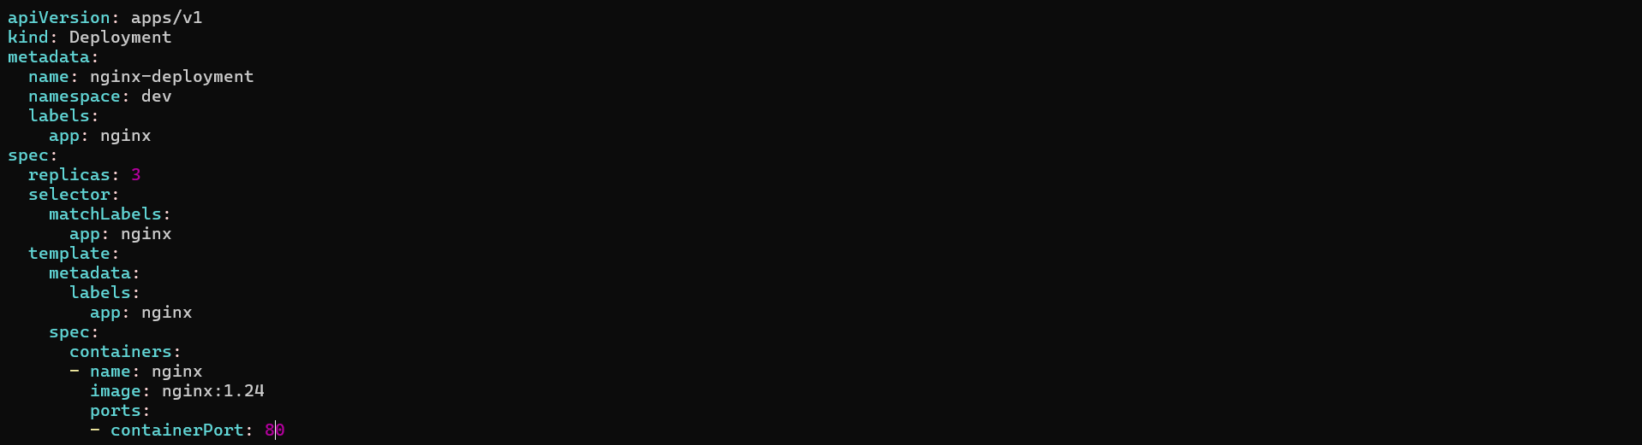
Deployment created

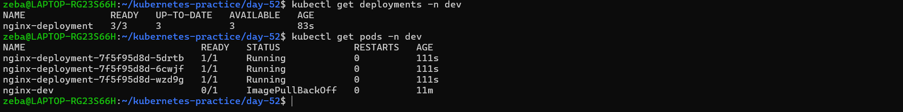
Verified deployment created and 3 replicas of pod running

Task 4: Self-Healing — Delete a Pod and Watch It Come Back
This is the key difference between a Deployment and a standalone Pod.
# List pods
kubectl get pods -n dev

# Delete one of the deployment's pods (use an actual pod name from your output)
kubectl delete pod <pod-name> -n dev

# Immediately check again
kubectl get pods -n dev
The Deployment controller detects that only 2 of 3 desired replicas exist and immediately creates a new one. The deleted pod is replaced within seconds.
Verify: Is the replacement pod's name the same as the one you deleted, or different?
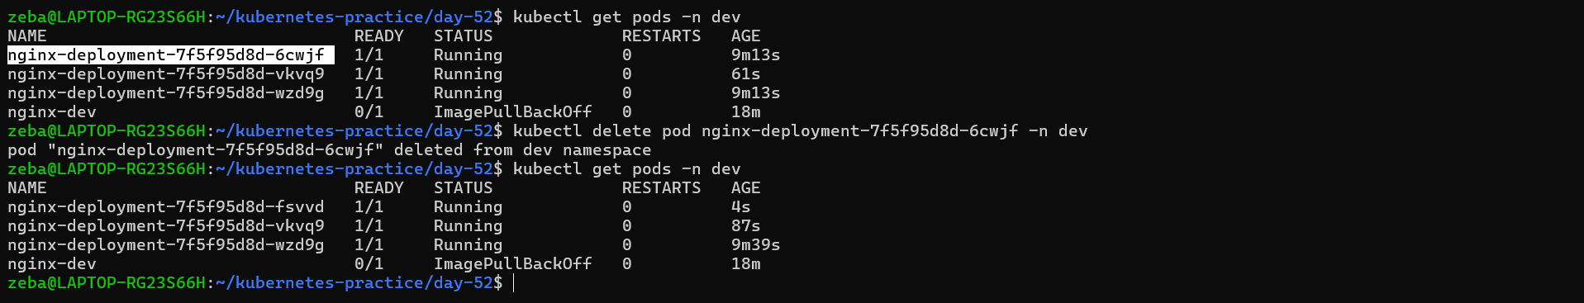
I deleted 1st pod then immediately a new pod gets create by deployment controller

Task 5: Scale the Deployment
Change the number of replicas:
# Scale up to 5
kubectl scale deployment nginx-deployment --replicas=5 -n dev
kubectl get pods -n dev

# Scale down to 2
kubectl scale deployment nginx-deployment --replicas=2 -n dev
kubectl get pods -n dev
Watch how Kubernetes creates or terminates pods to match the desired count.
You can also scale by editing the manifest — change replicas: 4 in your YAML file and run kubectl apply -f nginx-deployment.yaml again.
Verify: When you scaled down from 5 to 2, what happened to the extra pods?

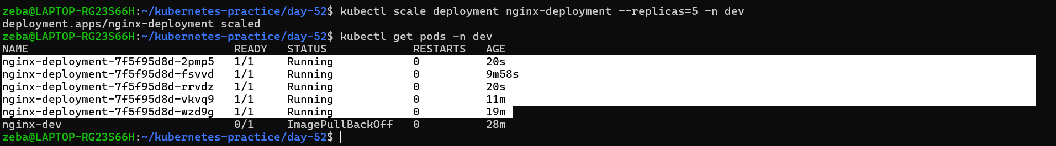
We scaled up to 5 pods

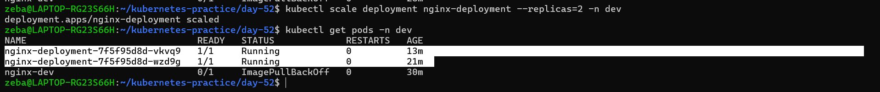
We scaled down to 2 pods
Task 6: Rolling Update
Update the Nginx image version to trigger a rolling update:
kubectl set image deployment/nginx-deployment nginx=nginx:1.25 -n dev
Watch the rollout in real time:
kubectl rollout status deployment/nginx-deployment -n dev
Kubernetes replaces pods one by one — old pods are terminated only after new ones are healthy. This means zero downtime.
Check the rollout history:
kubectl rollout history deployment/nginx-deployment -n dev
Now roll back to the previous version:
kubectl rollout undo deployment/nginx-deployment -n dev
kubectl rollout status deployment/nginx-deployment -n dev
Verify the image is back to the previous version:
kubectl describe deployment nginx-deployment -n dev | grep Image
Verify: What image version is running after the rollback?
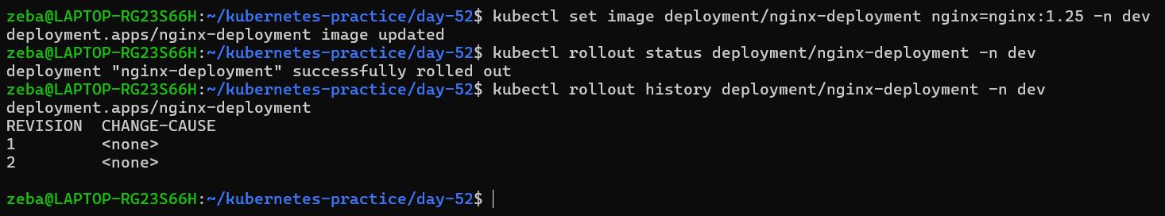
Changes rolled out here its image
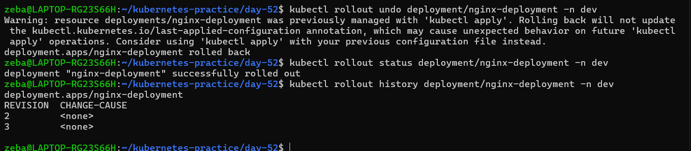
Rolled back to the previous version
Verified, its in previous version
Task 7: Clean Up
kubectl delete deployment nginx-deployment -n dev
kubectl delete pod nginx-dev -n dev
kubectl delete pod nginx-staging -n staging
kubectl delete namespace dev staging production
Deleting a namespace removes everything inside it. Be very careful with this in production.
kubectl get namespaces
kubectl get pods -A
Verify: Are all your resources gone?
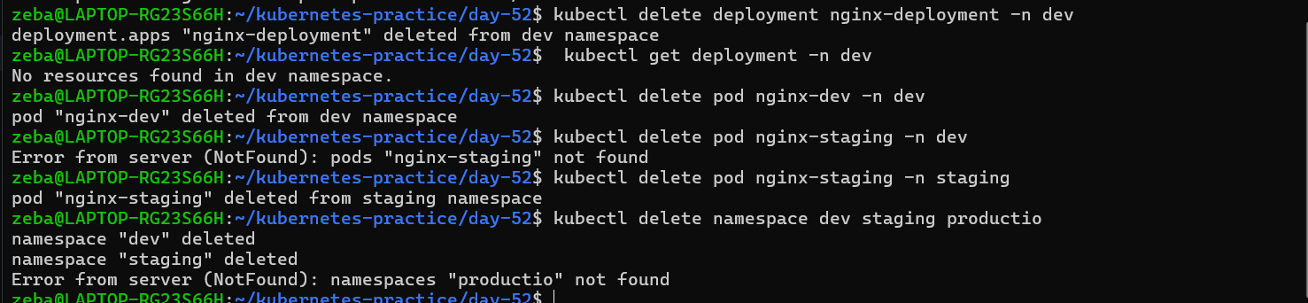
Deleted deployment, pods and namespaces

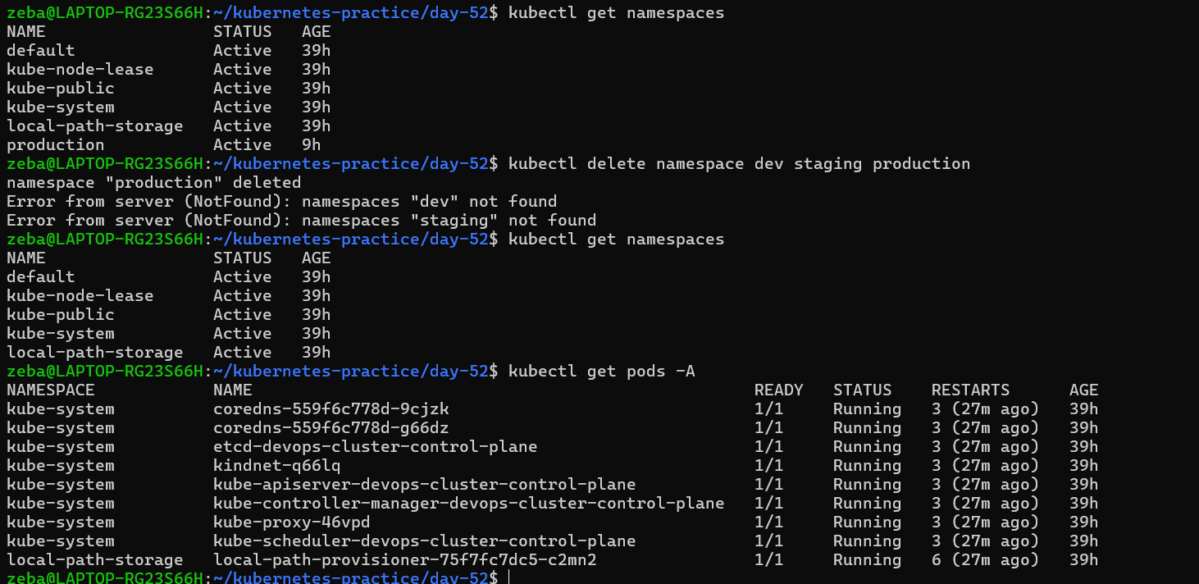
Namespace production was not deleted so verified and deleted again, hence no resources left

