Basic pod manifest file -

apiVersion: v1
kind: pod
metadata:
name: my-pod
labels:
app: my-app
spec:
containers:
- my-container
Image: nginx:latest
Ports:
- containerPort: 80

- apiVersion — tells Kubernetes which API group to use. For Pods, it is v1.
- kind — the resource type. Today it is Pod. Later you will use Deployment, Service, etc.
- metadata — the identity of your resource. name is required. labels are key-value pairs used for organization and selection.
- spec — the desired state. For a Pod, this means which containers to run, which images, which ports, etc.

Task 1: Create Your First Pod (Nginx)
Create a file called nginx-pod.yaml:
apiVersion: v1
kind: Pod
metadata:
name: nginx-pod
labels:
app: nginx
spec:
containers:
- name: nginx
image: nginx:latest
ports:
- containerPort: 80
Apply it:
kubectl apply -f nginx-pod.yaml
Verify:
kubectl get pods
kubectl get pods -o wide
Wait until the STATUS shows Running. Then explore:
# Detailed info about the pod
kubectl describe pod nginx-pod

# Read the logs
kubectl logs nginx-pod

# Get a shell inside the container
kubectl exec -it nginx-pod -- /bin/bash

# Inside the container, run:
curl localhost:80
exit
Verify: Can you see the Nginx welcome page when you curl from inside the pod?

Create 1st pod
Create file nginx-pod.yaml
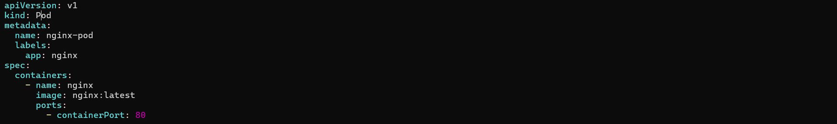
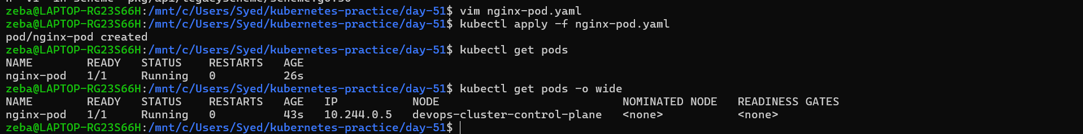

# Detailed info about the pod
kubectl describe pod nginx-pod
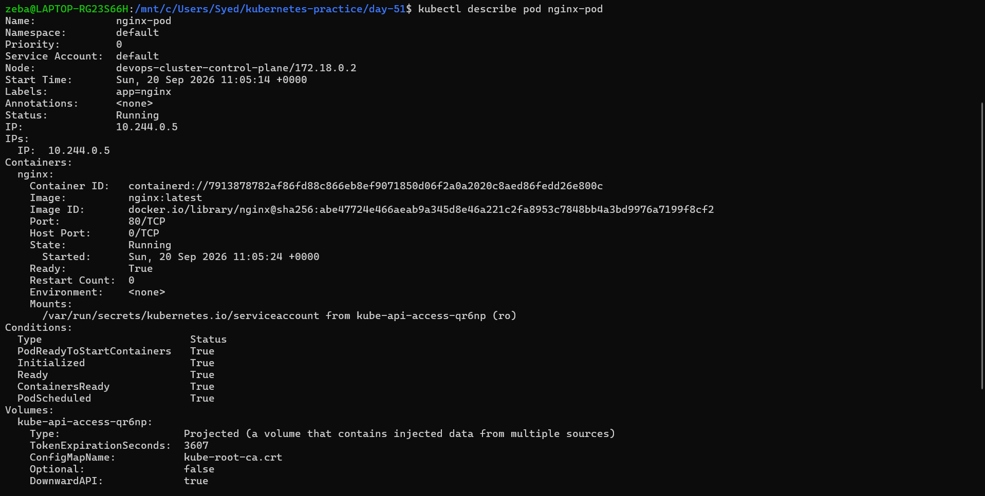

# Read the logs
kubectl logs nginx-pod
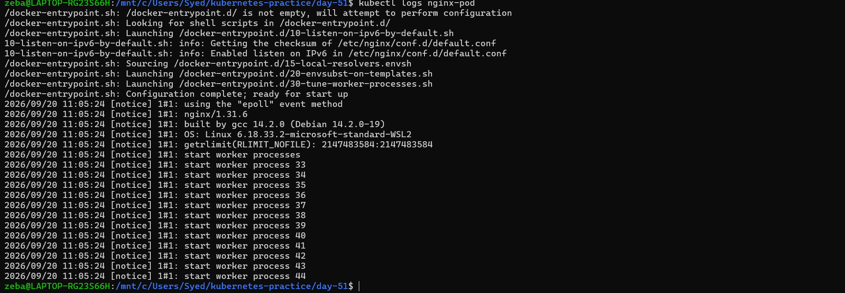

# Get a shell inside the container
kubectl exec -it nginx-pod -- /bin/bash
# Inside the container, run:
curl localhost:80
exit
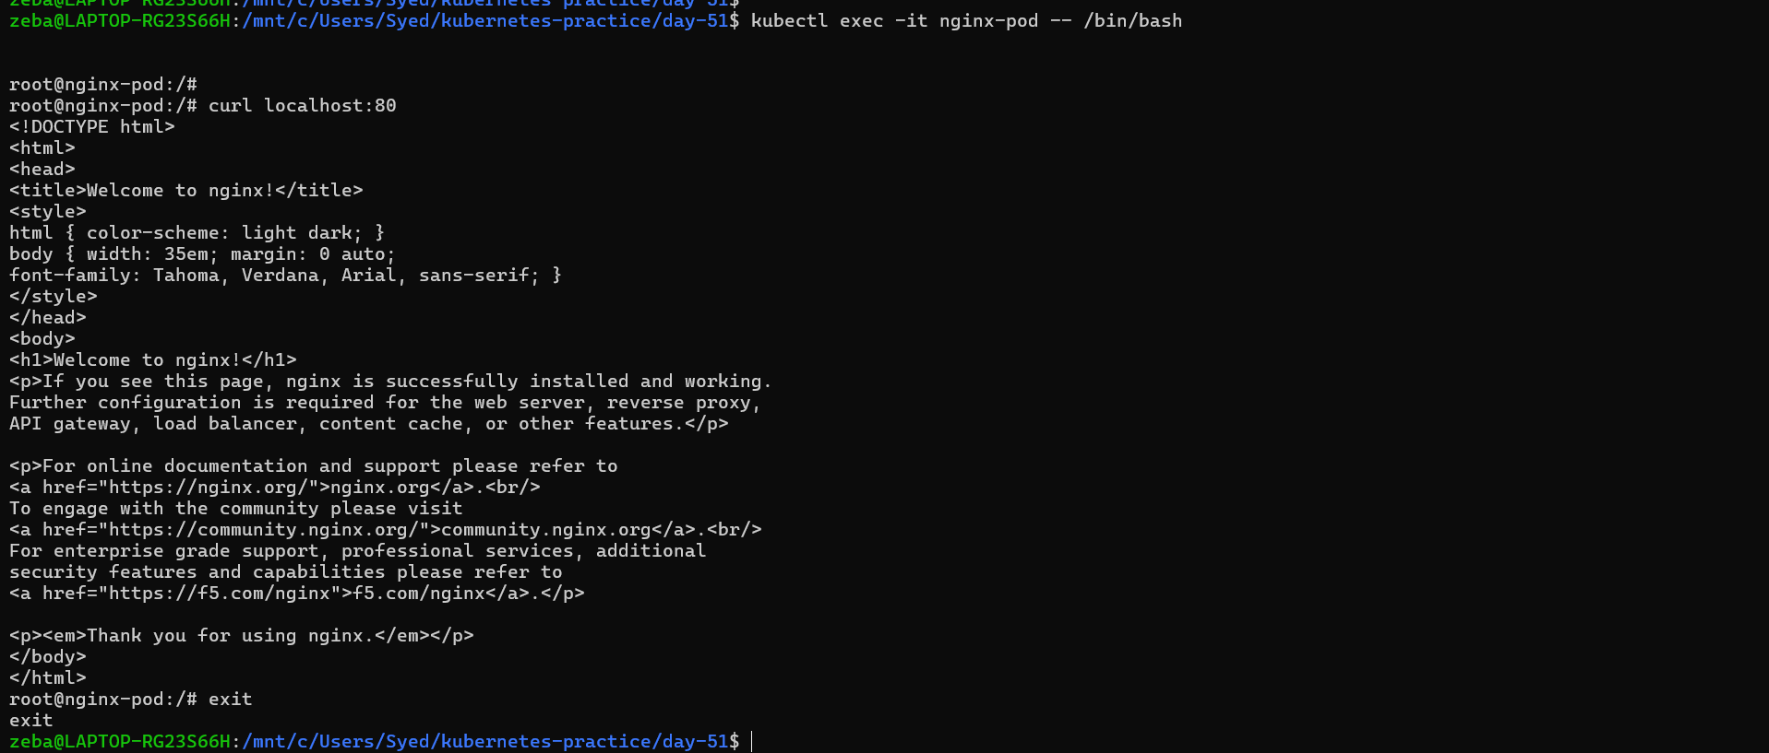

Task 2: Create a Custom Pod (BusyBox)
Write a new manifest busybox-pod.yaml from scratch (do not copy-paste the nginx one):
apiVersion: v1
kind: Pod
metadata:
name: busybox-pod
labels:
app: busybox
environment: dev
spec:
containers:
- name: busybox
image: busybox:latest
command: ["sh", "-c", "echo Hello from BusyBox && sleep 3600"]
Apply and verify:
kubectl apply -f busybox-pod.yaml
kubectl get pods
kubectl logs busybox-pod
Notice the command field — BusyBox does not run a long-lived server like Nginx. Without a command that keeps it running, the container would exit immediately and the pod would go into CrashLoopBackOff.
Verify: Can you see "Hello from BusyBox" in the logs?
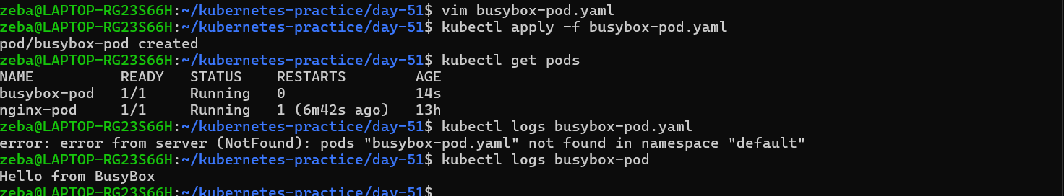

Task 3: Imperative vs Declarative
You have been using the declarative approach (writing YAML, then kubectl apply). Kubernetes also supports imperative commands:
# Create a pod without a YAML file
kubectl run redis-pod --image=redis:latest

# Check it
kubectl get pods
Now extract the YAML that Kubernetes generated:
kubectl get pod redis-pod -o yaml
Compare this output with your hand-written manifests. Notice how much extra metadata Kubernetes adds automatically (status, timestamps, uid, resource version).
You can also use dry-run to generate YAML without creating anything:
kubectl run test-pod --image=nginx --dry-run=client -o yaml
This is a powerful trick — use it to quickly scaffold a manifest, then customize it.
Verify: Save the dry-run output to a file and compare its structure with your nginx-pod.yaml. What fields are the same? What is different?

Imperative way to create a pod
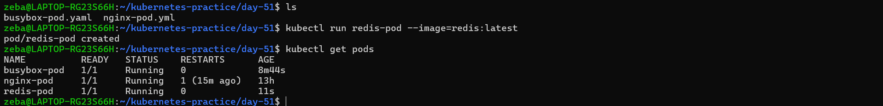
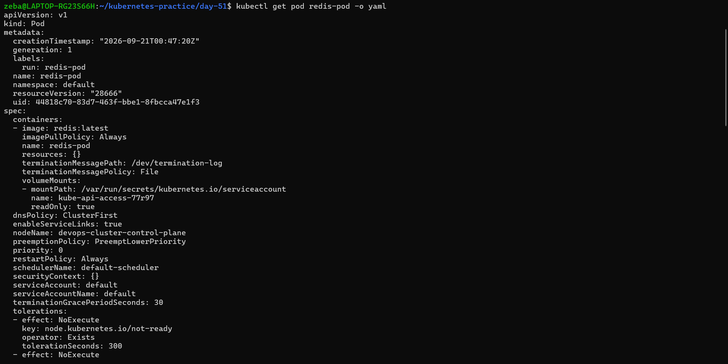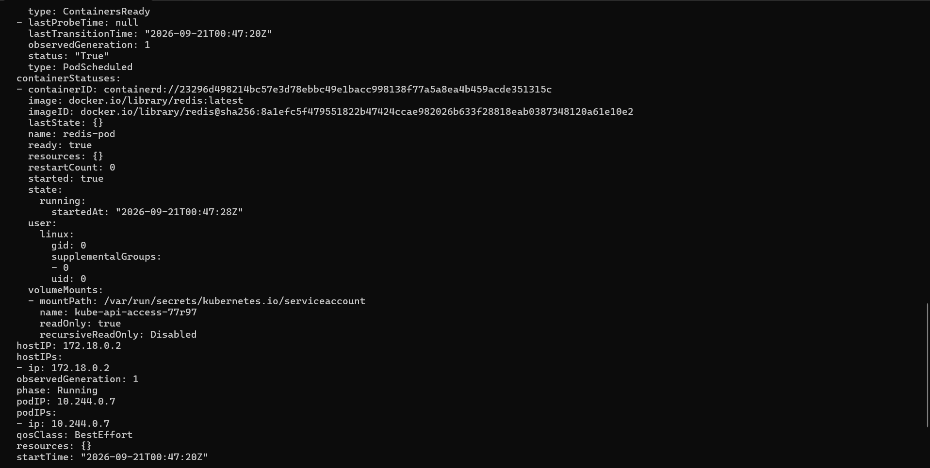

use dry-run to generate YAML
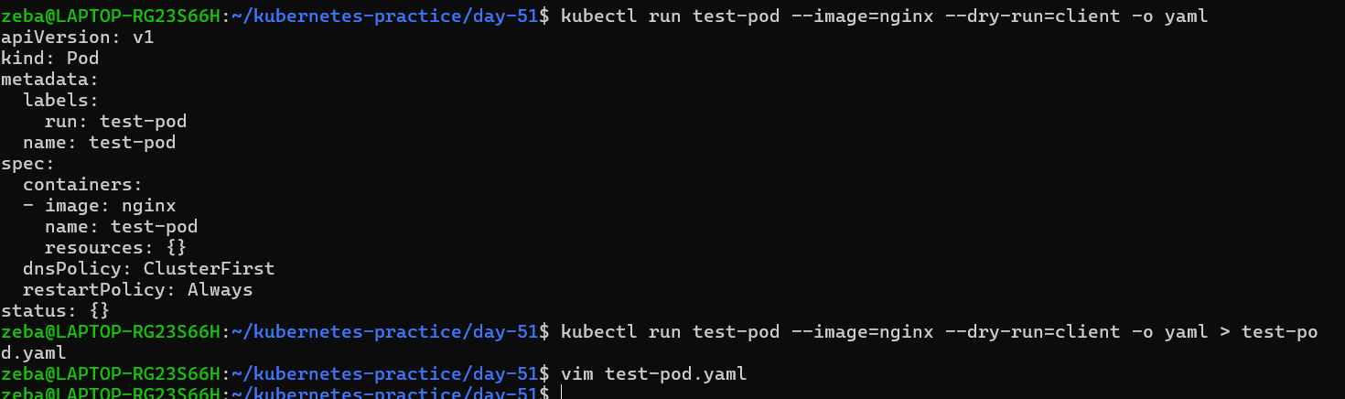
dry-run will not generate the pod instead it generates the manifest file locally without the resources, it can use as the starting point of declarative type.
Task 4: Validate Before Applying
Before applying a manifest, you can validate it:
# Check if the YAML is valid without actually creating the resource
kubectl apply -f nginx-pod.yaml --dry-run=client

# Validate against the cluster's API (server-side validation)
kubectl apply -f nginx-pod.yaml --dry-run=server
Now intentionally break your YAML (remove the image field or add an invalid field) and run dry-run again. See what error you get.
Verify: What error does Kubernetes give when the image field is missing?
--dry-run=client – this checks manifest locally without creating/updating resources
--dry-run=server – this sends request to Kubernetes API server but does not persists the changes
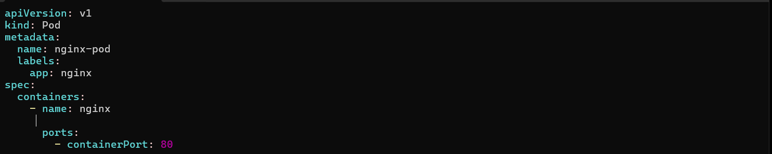
Intentionally break
--dry-run=client checks the manifest locally without sending it to the API server, while --dry-run=server sends the request to the Kubernetes API server for validation without persisting the change.
Task 5: Pod Labels and Filtering
Labels are how Kubernetes organizes and selects resources. You added labels in your manifests — now use them:
# List all pods with their labels
kubectl get pods --show-labels

# Filter pods by label
kubectl get pods -l app=nginx
kubectl get pods -l environment=dev

# Add a label to an existing pod
kubectl label pod nginx-pod environment=production

# Verify
kubectl get pods --show-labels

# Remove a label
kubectl label pod nginx-pod environment-
Write a manifest for a third pod with at least 3 labels (app, environment, team). Apply it and practice filtering.

# List all pods with their labels
kubectl get pods --show-labels
It will give all the pods along with their labels

# Filter pods by label
kubectl get pods -l app=nginx
kubectl get pods -l environment=dev
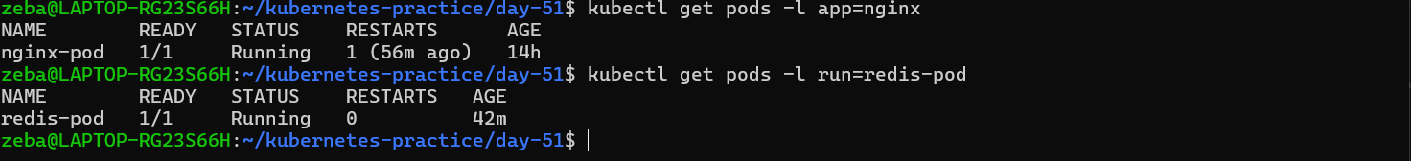

# Add a label to an existing pod
kubectl label pod nginx-pod environment=production
# Verify
kubectl get pods --show-labels
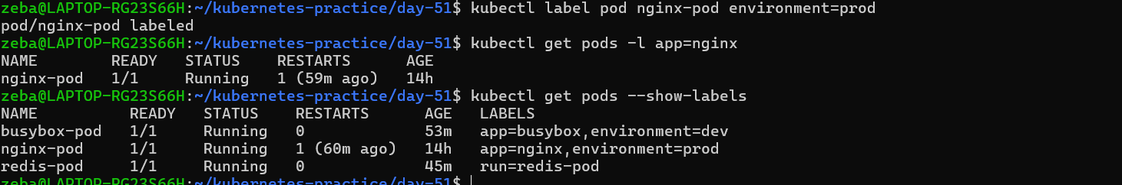

# Remove a label
kubectl label pod nginx-pod environment-
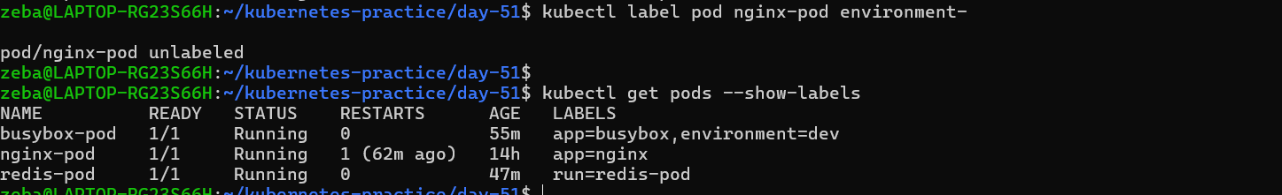

Write a manifest for a third pod with at least 3 labels (app, environment, team). Apply it and practice filtering.
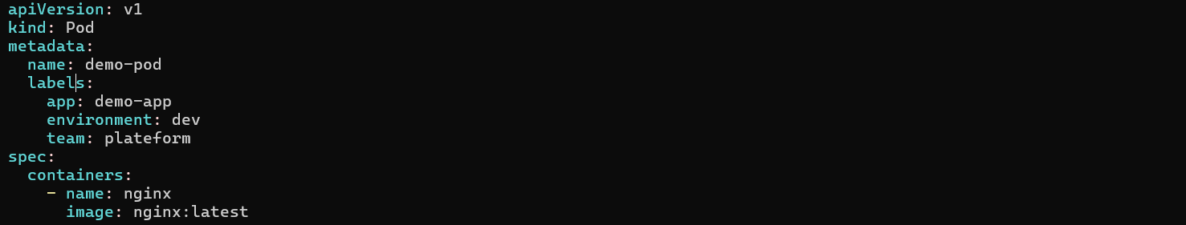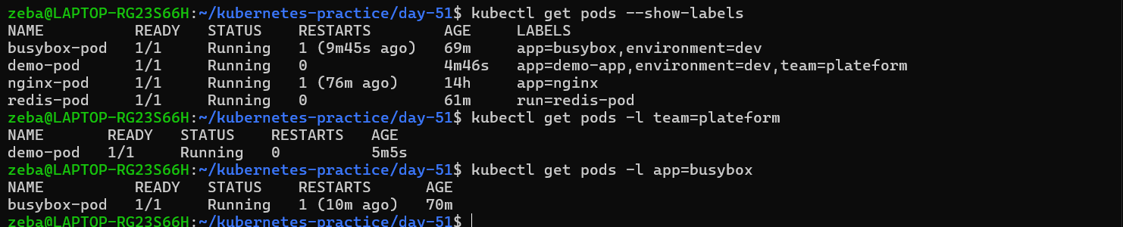
Task 6: Clean Up
Delete all the pods you created:
# Delete by name
kubectl delete pod nginx-pod
kubectl delete pod busybox-pod
kubectl delete pod redis-pod

# Or delete using the manifest file
kubectl delete -f nginx-pod.yaml

# Verify everything is gone
kubectl get pods
Notice that when you delete a standalone Pod, it is gone forever. There is no controller to recreate it. This is why in production you use Deployments (coming on Day 52) instead of bare Pods.

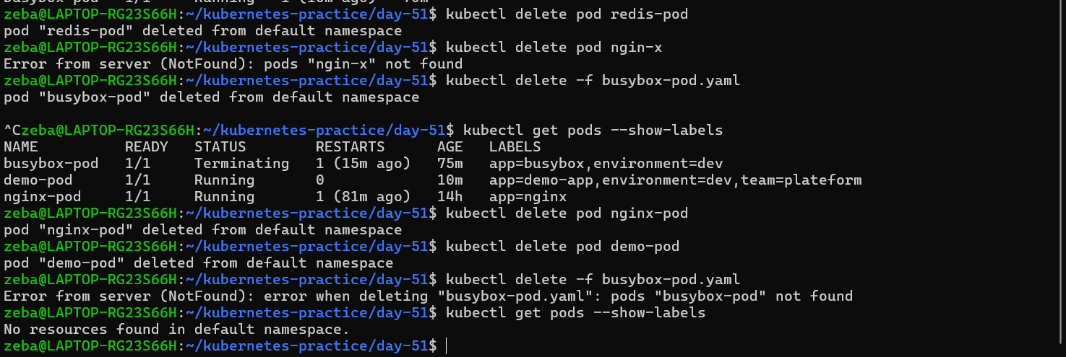
Deleting a standalone Pod permanently removes it. Since no controller manages it, Kubernetes does not recreate it automatically.

