Multiple jobs: how to divide work in multiple jobs
Steps: single command/ action to be run inside the job
Environment variables: the variables stores and uses the values like names and all
Conditionals: run the jon when a particular condition me

needs is used to make one job wait for another job to finish successfully.

Task 1: Multi-Job Workflow
Create .github/workflows/multi-job.yml with 3 jobs:
- build — prints "Building the app"
- test — prints "Running tests"
- deploy — prints "Deploying"
Make test run only after build succeeds. Make deploy run only after test succeeds.
Verify: Check the workflow graph in the Actions tab — does it show the dependency chain?
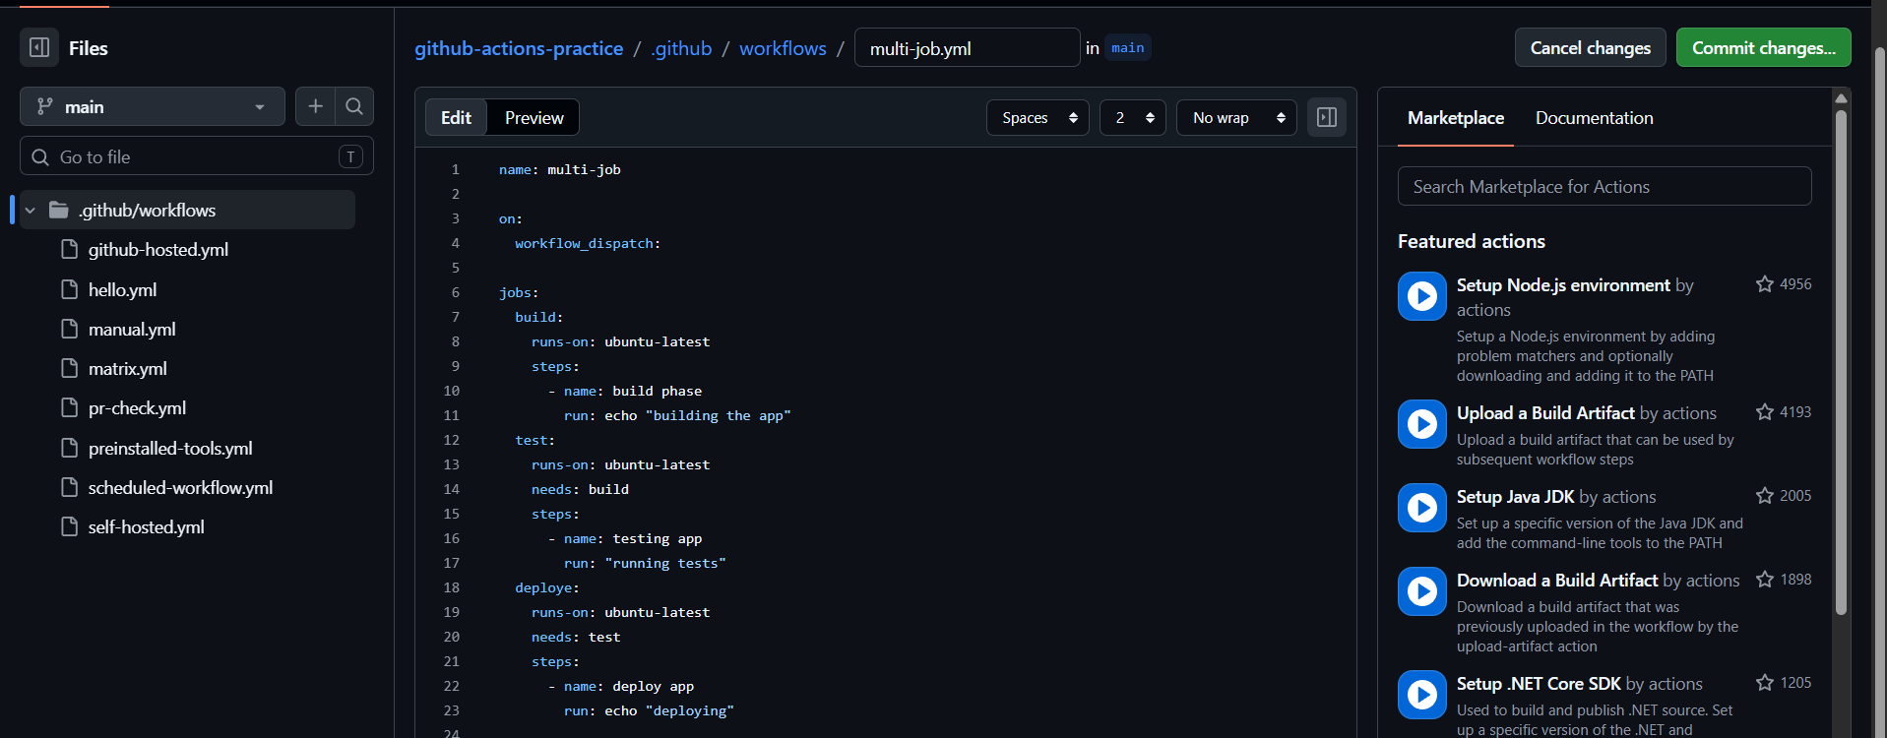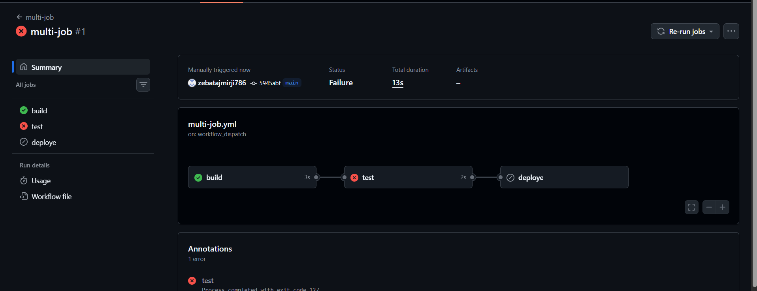
Here we can see jobs are running one after other bcz I used needs: <job name>
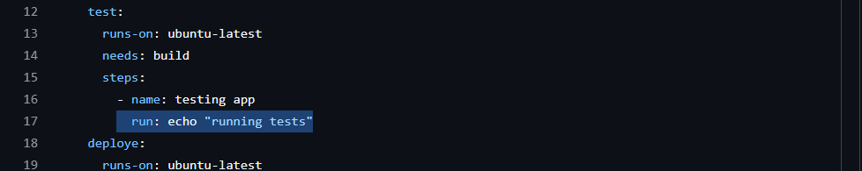
Issues fixed
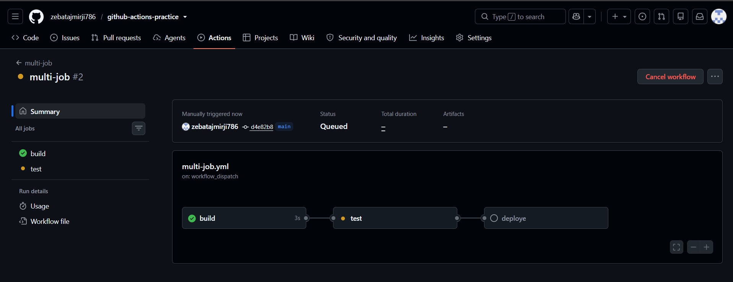
Only when 1 job succussed then after job is running
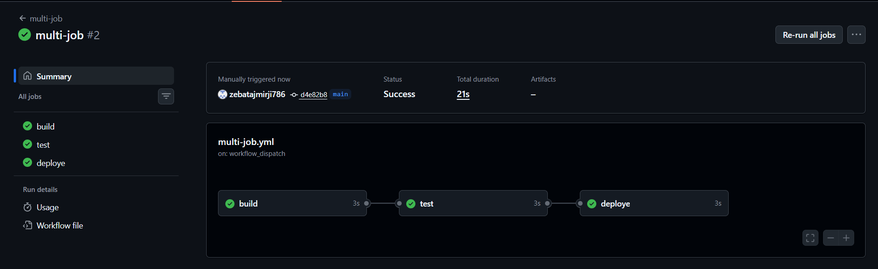
Key concept
needs is used to make one job wait for another job to finish successfully.
Example:
test:
needs: build

Task 2: Environment Variables
svg
In a new workflow, use environment variables at 3 levels:
- Workflow level — APP_NAME: myapp
- Job level — ENVIRONMENT: staging
- Step level — VERSION: 1.0.0
Print all three in a single step and verify each is accessible.
Then use a GitHub context variable — print the commit SHA and the actor (who triggered the run).

3 Levels of environment variables:
- Workflow level: available to all the jobs inside the workflow
- Job level: available only inside the particular job
- Step level: available only inside the particular step

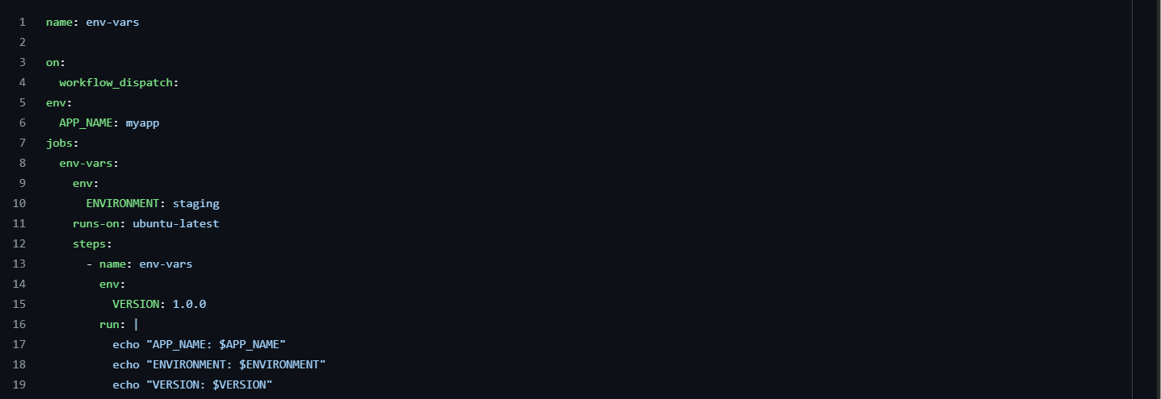
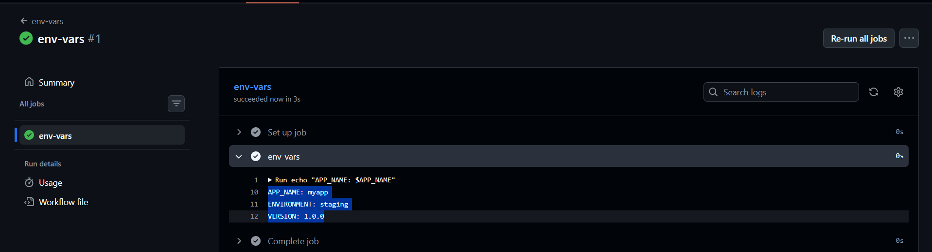
Github context variables:
Github provides context variables we don’t need to create them like environment variables
Ex:
Commit SHA = ${{ github.sha }}
Actor = ${{ github.actor }}
github.actor = the GitHub username of the person who triggered the workflow
github.sha = commit's unique ID.

$VAR = shell/ environment variable syntax
${{ }} = github action expression syntax
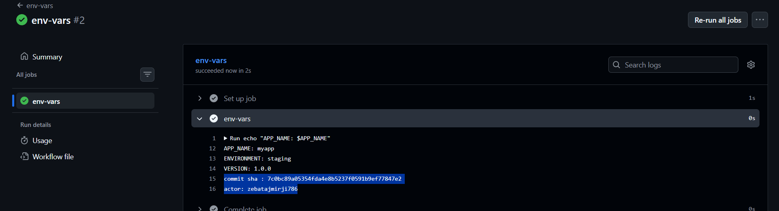
Task 3: Job Outputs
- Create a job that sets an output — e.g., today's date as a string
- Create a second job that reads that output and prints it
- Pass the value using outputs: and needs.<job>.outputs.<name>
Write in your notes: Why would you pass outputs between jobs?
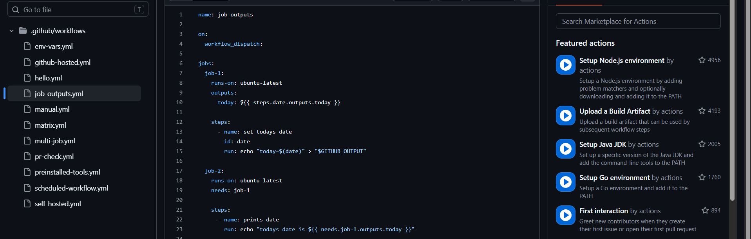
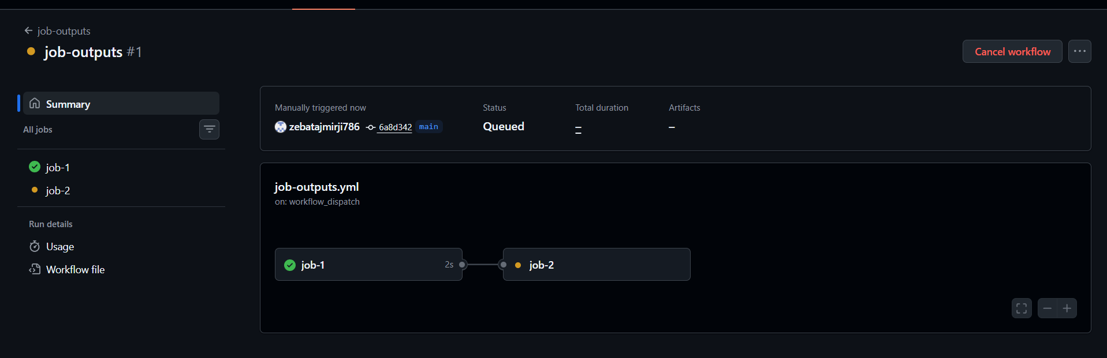
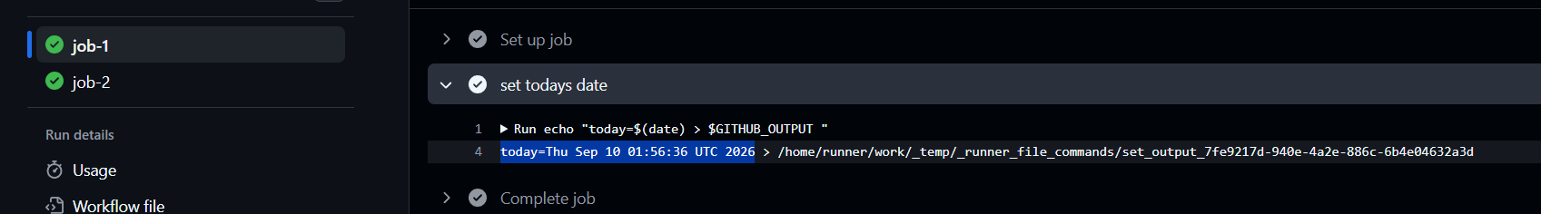
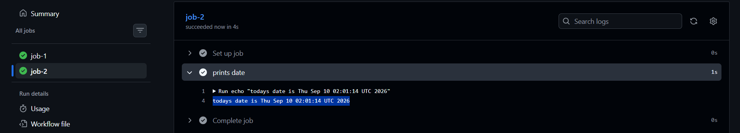
We pass outputs between jobs when one job creates or calculates some information that another job needs.
For example:
- Job 1 gets today's date.
- Job 1 saves the date as an output.
- Job 2 reads that output and uses the date.

This allows different jobs to share important information without repeating the same work.
Easy way to remember
Job 1 → Creates information → Passes it as output → Job 2 uses it
Example:
Job 1: Build → creates version number
Job 2: Deploy → uses that version number
Task 4: Conditionals
In a workflow, add:
- A step that only runs when the branch is main
- A step that only runs when the previous step failed
- A job that only runs on push events, not on pull requests
- A step with continue-on-error: true — what does this do?

github.ref === branch
refs/heads/main === main branch
github.event_name === even that causes workflow to start

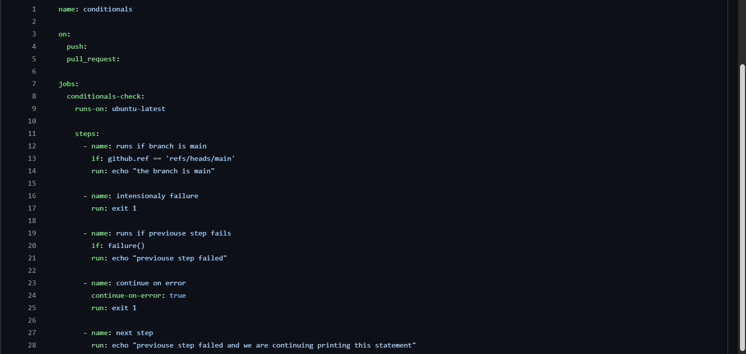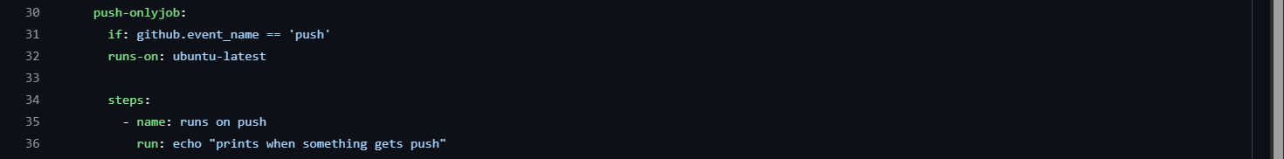
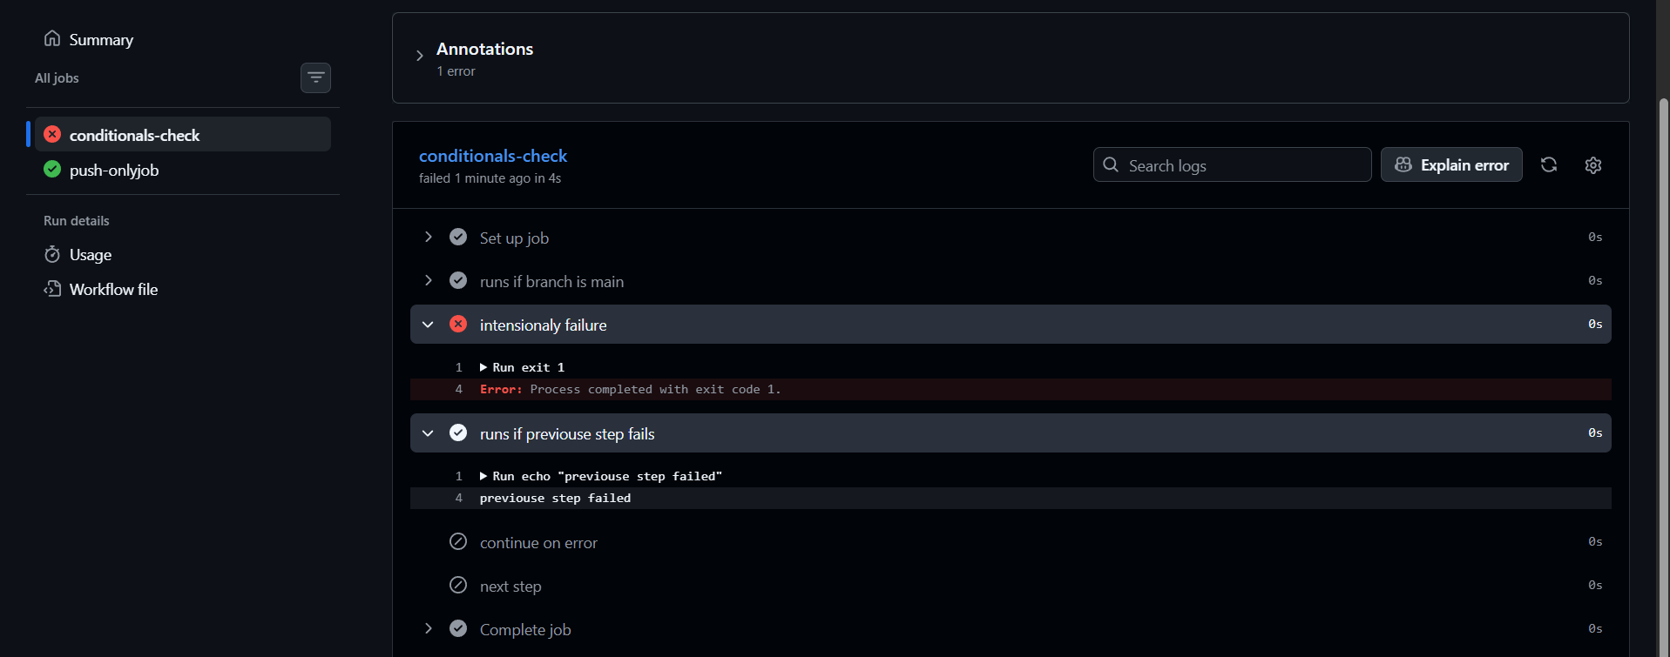
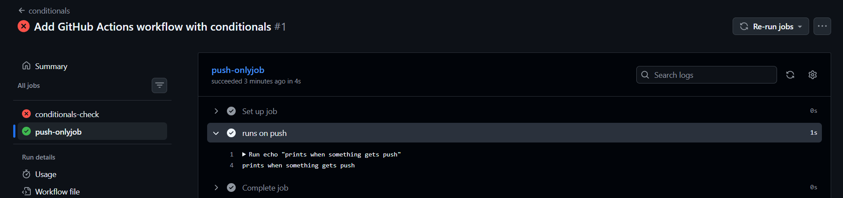
Here we can see step 2 failed that was intentional fail
And we used if: failure() so that means if this task fails run the next step so step 3 executed
But step 4 having continue-on-error() – tells if this step 4 fails don’t stop but proceed further , but here it wont ignore the previous step 2 failure
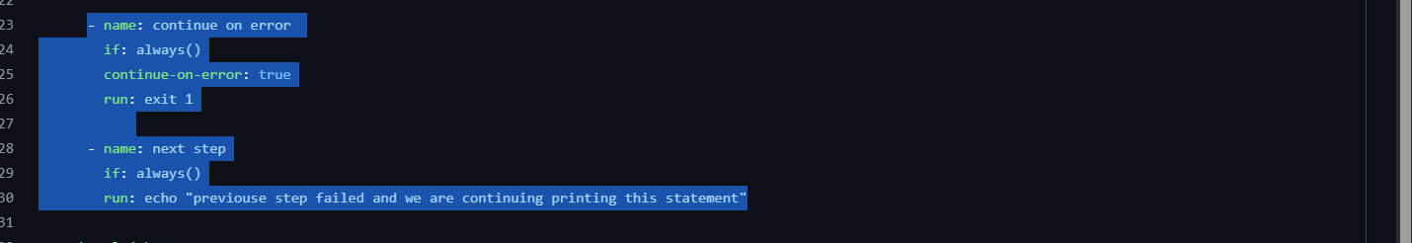
We added if: always() for step 4, 5
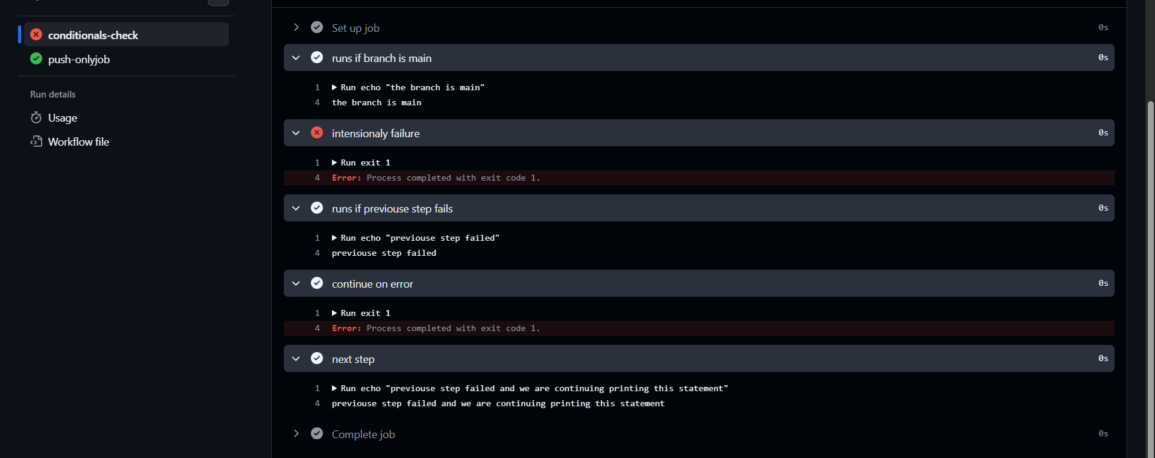
⭐ The 3 things to remember
Code | Simple meaning
if: failure() | Run this because something failed
if: always() | Run this no matter what happened before
continue-on-error: true | If this step fails, continue the job

Task 5: Putting It Together
Create .github/workflows/smart-pipeline.yml that:
- Triggers on push to any branch
- Has a lint job and a test job running in parallel
- Has a summary job that runs after both, prints whether it's a main branch push or a feature branch push, and prints the commit message

