Day 55 – Persistent Volumes (PV) and Persistent Volume Claims (PVC)

Task 1: See the Problem — Data Lost on Pod Deletion
- Write a Pod manifest that uses an emptyDir volume and writes a timestamped message to /data/message.txt
- Apply it, verify the data exists with kubectl exec
- Delete the Pod, recreate it, check the file again — the old message is gone
Verify: Is the timestamp the same or different after recreation?
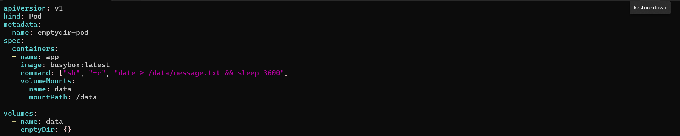
Pod deleted and recreated , got the new msg , and old msg (data) is gone
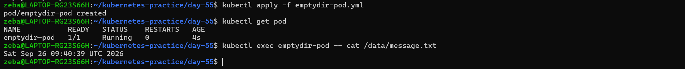
Task 2: Create a PersistentVolume (Static Provisioning)
- Write a PV manifest with capacity: 1Gi, accessModes: ReadWriteOnce, persistentVolumeReclaimPolicy: Retain, and hostPath pointing to /tmp/k8s-pv-data
- Apply it and check kubectl get pv — status should be Available
Access modes to know:
- ReadWriteOnce (RWO) — read-write by a single node
- ReadOnlyMany (ROX) — read-only by many nodes
- ReadWriteMany (RWX) — read-write by many nodes
hostPath is fine for learning, not for production.
Verify: What is the STATUS of the PV?
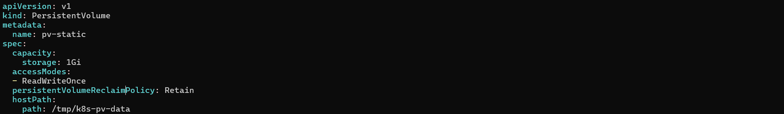
Task 3: Create a PersistentVolumeClaim
- Write a PVC manifest requesting 500Mi of storage with ReadWriteOnce access
- Apply it and check both kubectl get pvc and kubectl get pv
- Both should show Bound — Kubernetes matched them by capacity and access mode
Verify: What does the VOLUME column in kubectl get pvc show?
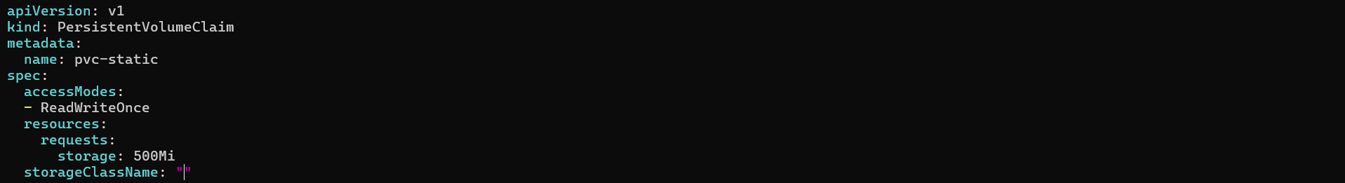
storageClassName: manual ---- manual and “” both are same
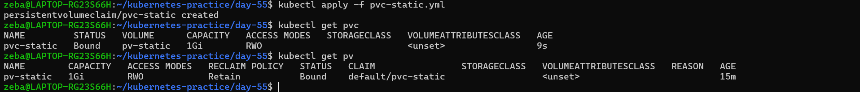
Task 4: Use the PVC in a Pod — Data That Survives
- Write a Pod manifest that mounts the PVC at /data using persistentVolumeClaim.claimName
- Write data to /data/message.txt, then delete and recreate the Pod
- Check the file — it should contain data from both Pods
Verify: Does the file contain data from both the first and second Pod?

- emptyDir → data disappears when the Pod is deleted.
- PVC → the Pod can be deleted/recreated, while the storage remains.

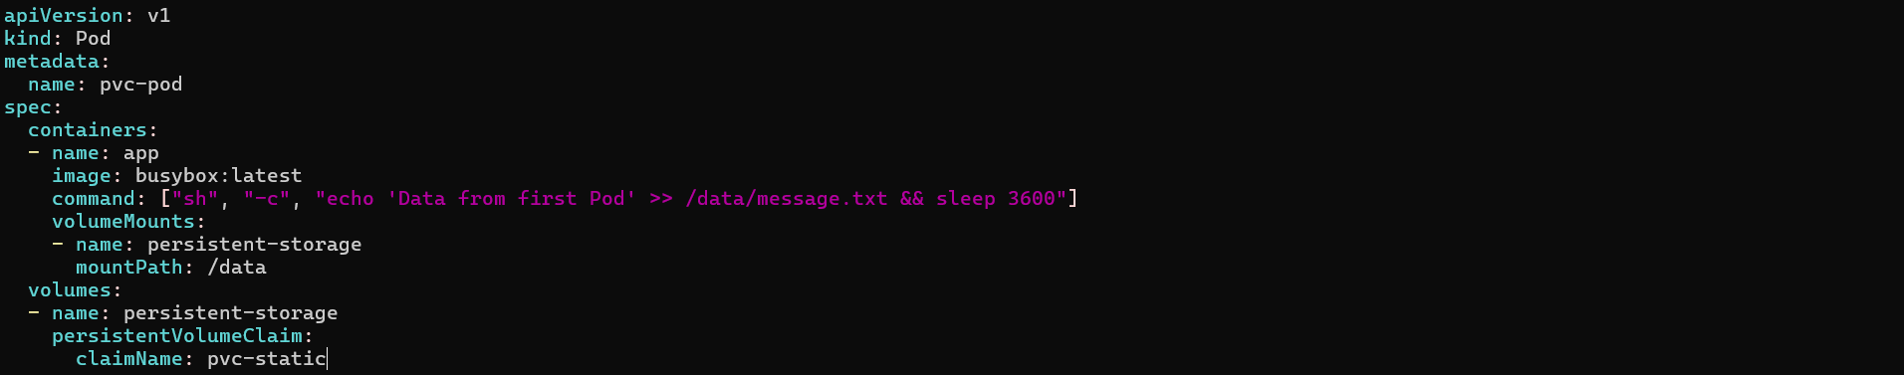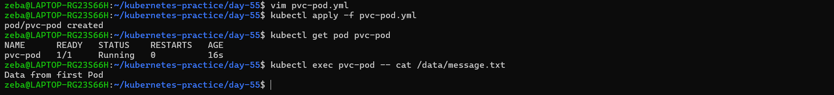

Deleted the pod and recreated it
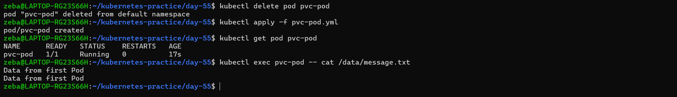
The output shows first line is output b4 the pod gets delete
after recreating we got both data from previous and present pod

Task 5: StorageClasses and Dynamic Provisioning
- Run kubectl get storageclass and kubectl describe storageclass
- Note the provisioner, reclaim policy, and volume binding mode
- With dynamic provisioning, developers only create PVCs — the StorageClass handles PV creation automatically
Verify: What is the default StorageClass in your cluster?

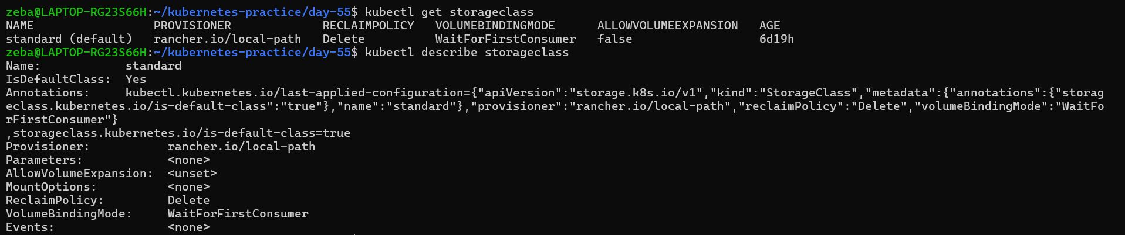
- Storageclass name - If in a PVC storageClass is not provided then kubernetes will take the default storageclass that is standard
- In our PVC – task 3 I have not given any storage class I kept in blank so here Kubernetes will take default (standard) storage class
- Provisioner – is a component responsible for providing/provisioning the storage
- In our example it is rancher.io/local-path which is used in local Kubernetes environment like kind
- ReclaimPolicy – what should happen to PV/Storage when PVC gets delete
- In our example of storage it is delete
- VolumeBindingMode - wait until a Pod actually uses the claim before binding/provisioning the volume.

Static vs Dynamic

YOU │ ├── create PV
│ └── create PVC
↓ Bound

YOU │ └── create PVC
↓ StorageClass
↓ Provisioner
↓ PV automatically created
↓ Bound

A StorageClass defines how kubernete dynamically provisions the persistent storage allowing developers to create a PVC directly without creating PV

Task 6: Dynamic Provisioning
- Write a PVC manifest that includes storageClassName: standard (or your cluster's default)
- Apply it — a PV should appear automatically in kubectl get pv
- Use this PVC in a Pod, write data, verify it works
Verify: How many PVs exist now? Which was manual, which was dynamic?
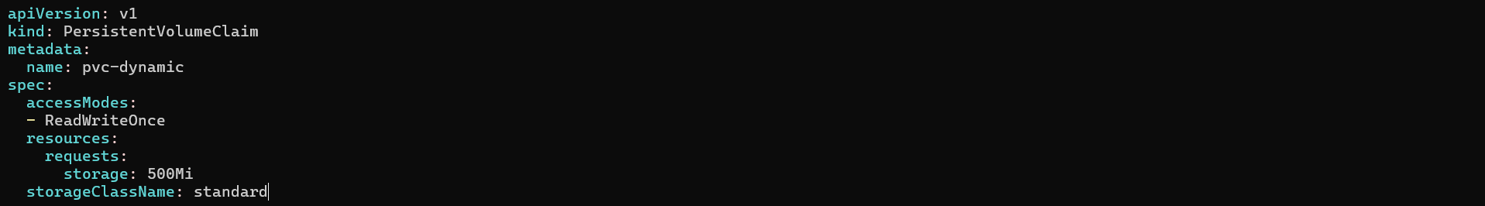
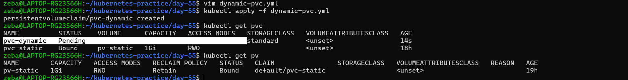
- Here pvc-dynamic is in pending and pv did not create because of VolumeBinddingMode = waitforfirstconsumer
- Once pod is created and it requests to use the storage then it will create the PV and that can use by the pod
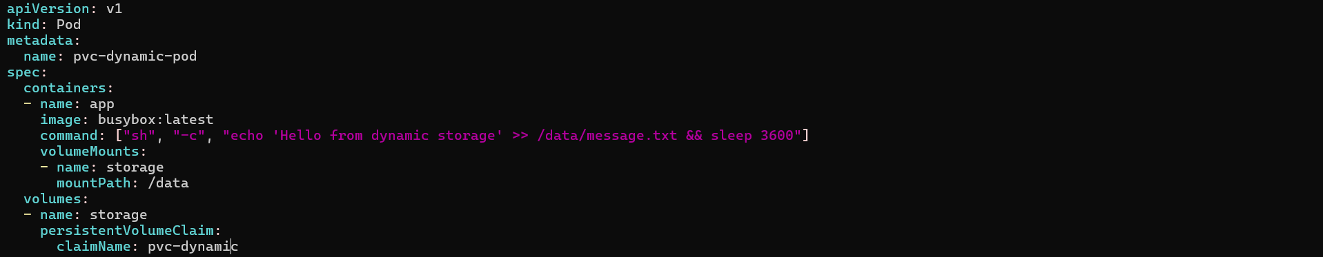
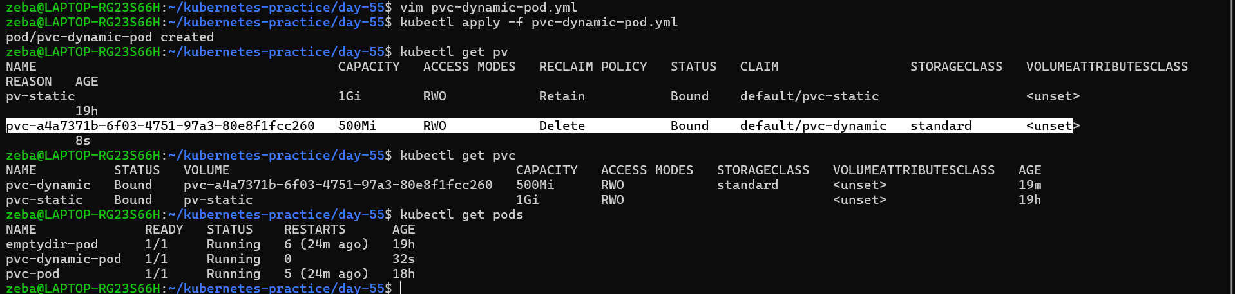
Task 7: Clean Up
- Delete all pods first
- Delete PVCs — check kubectl get pv to see what happened
- The dynamic PV is gone (Delete reclaim policy). The manual PV shows Released (Retain policy).
- Delete the remaining PV manually
Verify: Which PV was auto-deleted and which was retained? Why?
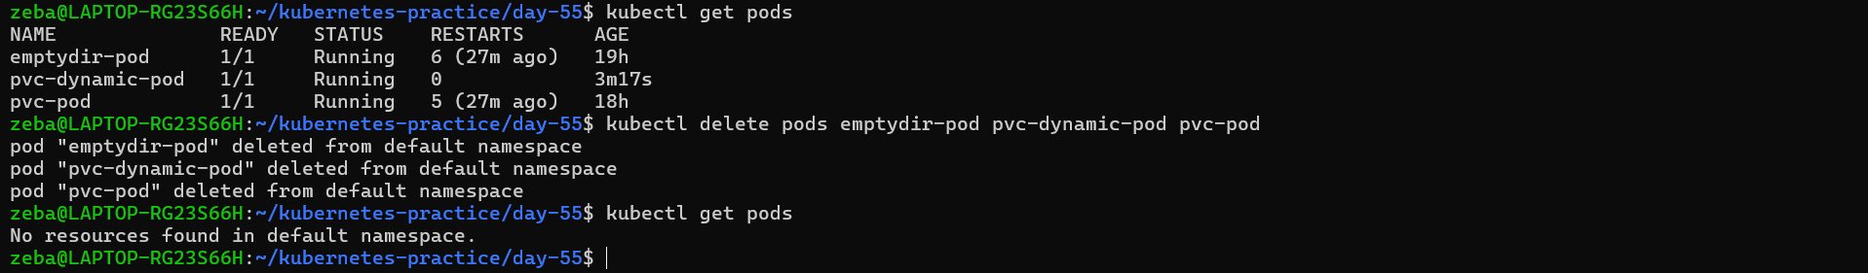
Pods deleted

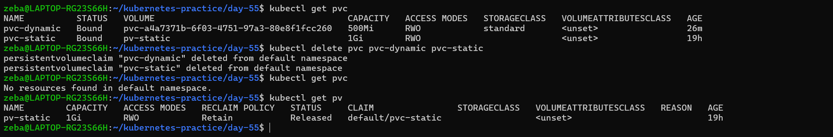
- PVCs deleted
- Here we can see pv-dynamic is gone bcz it was dynamically created when I deleted the pvc-dynamic it deleted the respective pv also bcz in reclaim policy wee have used delete
- And here we can see pv-static is in released status, when we deleted the pvc-static its respective pv which was bind to it that will get release bcz in recmaim policy we have used Retain
Deleted the remaining PV

