Task 1: Create Files (10 minutes)
- Create empty file devops.txt using touch
- Create notes.txt with some content using cat or echo
- Create script.sh using vim with content: echo "Hello DevOps"
Verify: ls -l to see permissions

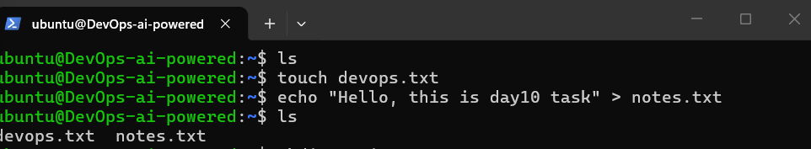
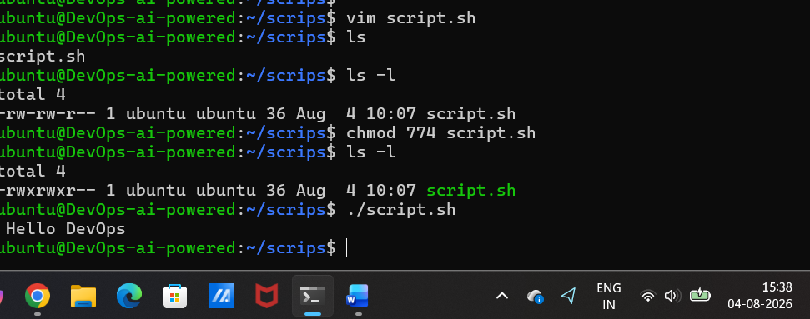
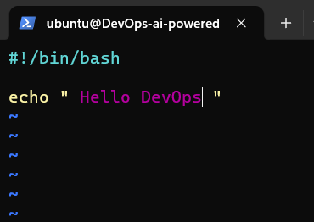

Task 2: Read Files (10 minutes)
- Read notes.txt using cat
- View script.sh in vim read-only mode
- Display first 5 lines of /etc/passwd using head
- Display last 5 lines of /etc/passwd using tail

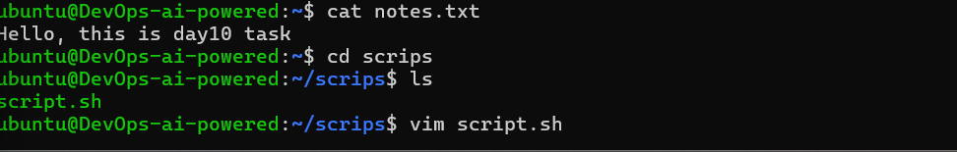
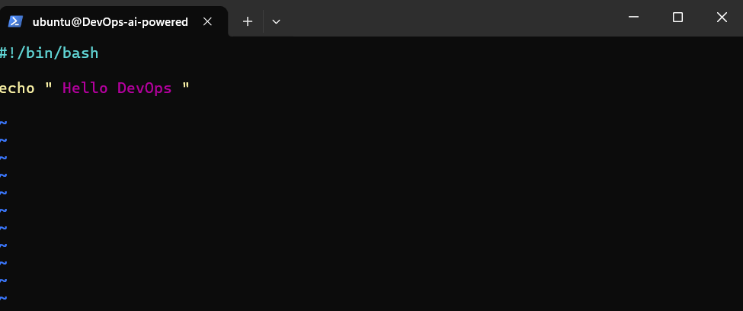
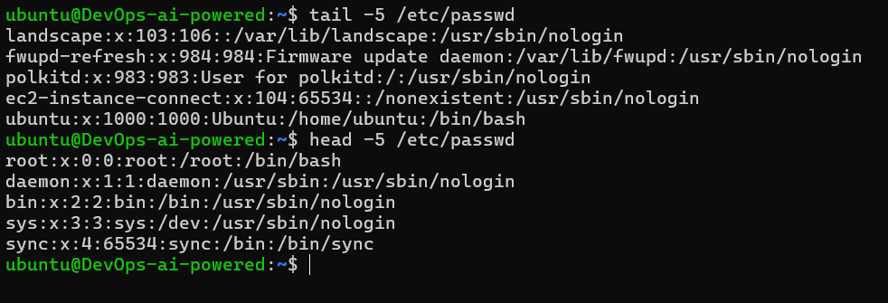

Task 3: Understand Permissions (10 minutes)
Format: rwxrwxrwx (owner-group-others)
- r = read (4), w = write (2), x = execute (1)
Check your files: ls -l devops.txt notes.txt script.sh
Answer: What are current permissions? Who can read/write/execute?
Devops.txt and notes.txt have rw-rw-r-- = 664
Owners = rw-
Groups = rw-
Others = r—
Script.sh have rwxrwxr-- = 774
Owners = rwx
Groups = rwx
Others = r—
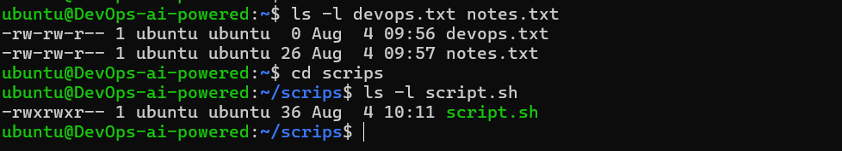

Task 4: Modify Permissions (20 minutes)
- Make script.sh executable → run it with ./script.sh
- Set devops.txt to read-only (remove write for all)
- Set notes.txt to 640 (owner: rw, group: r, others: none)
- Create directory project/ with permissions 755
Verify: ls -l after each change
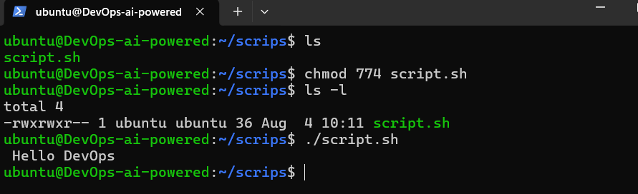
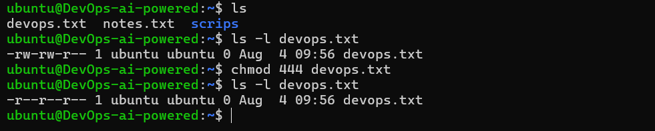
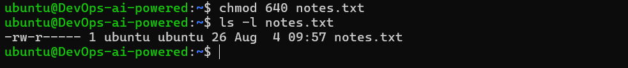
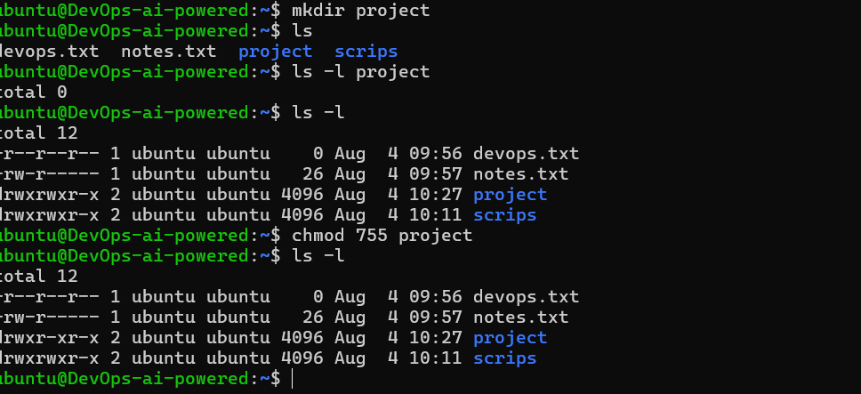

Task 5: Test Permissions (10 minutes)
- Try writing to a read-only file - what happens?
- Try executing a file without execute permission
- Document the error messages
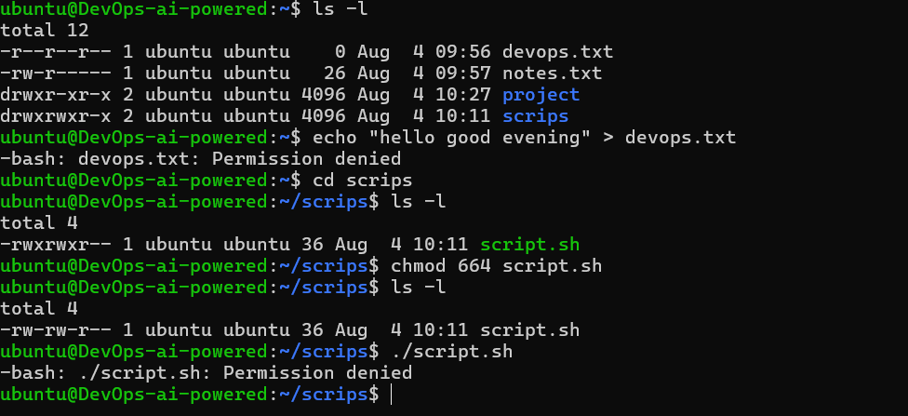

Test | Command | Error Message
Write to a read-only file | echo "hello good evening" > devops.txt | bash: devops.txt: Permission denied
Execute a file without execute permission | ./script.sh | bash: ./script.sh: Permission denied

