Task 1: Git Merge — Hands-On
- Create a new branch feature-login from main, add a couple of commits to it
- Switch back to main and merge feature-login into main
- Observe the merge — did Git do a fast-forward merge or a merge commit?
- Now create another branch feature-signup, add commits to it — but also add a commit to main before merging
- Merge feature-signup into main — what happens this time?
- Answer in your notes:
  - What is a fast-forward merge?
  - When does Git create a merge commit instead?
  - What is a merge conflict? (try creating one intentionally by editing the same line in both branches)

Create a new branch feature-login from main, add a couple of commits to it
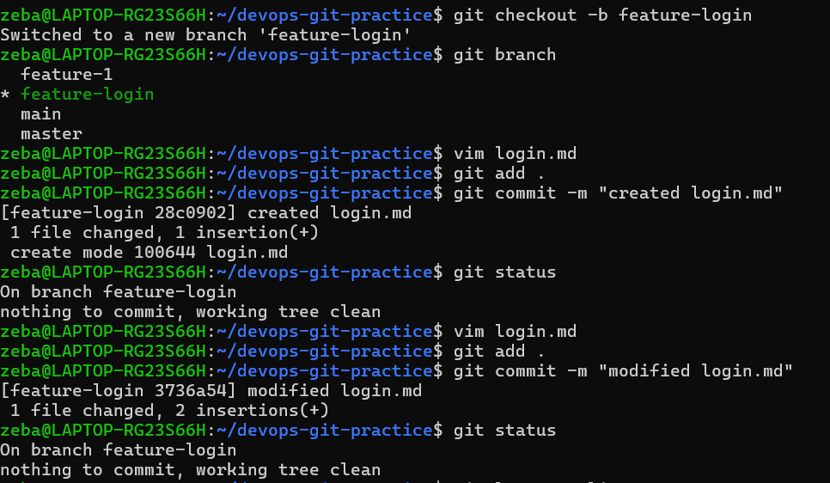

Switch back to main and merge feature-login into main
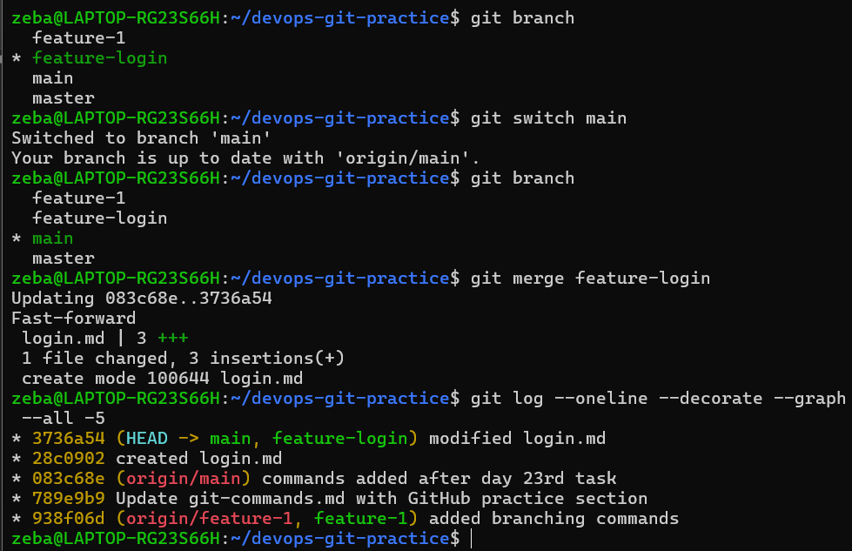
Observe the merge — did Git do a fast-forward merge or a merge commit?
This is a fast-forward merge. Because we haven't made any new commits on main after creating feature-login.
---------
Now create another branch feature-signup, add commits to it — but also add a commit to main before merging
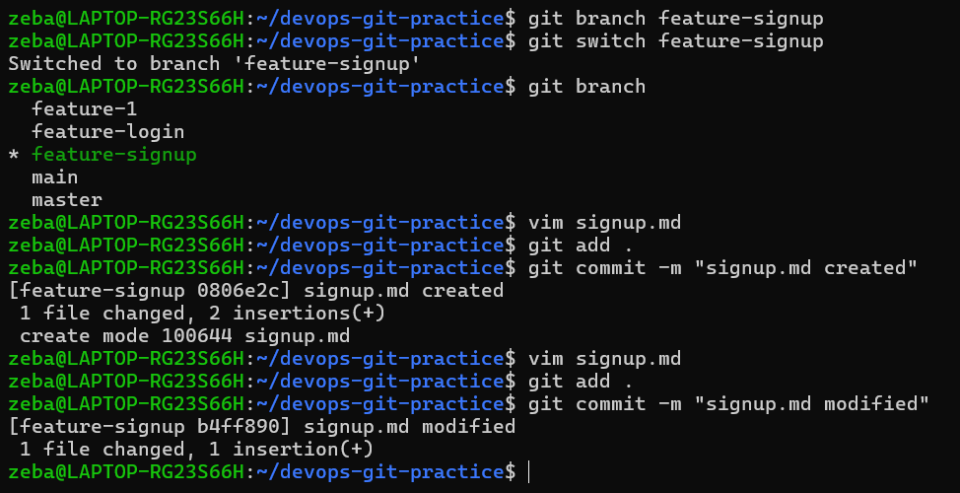
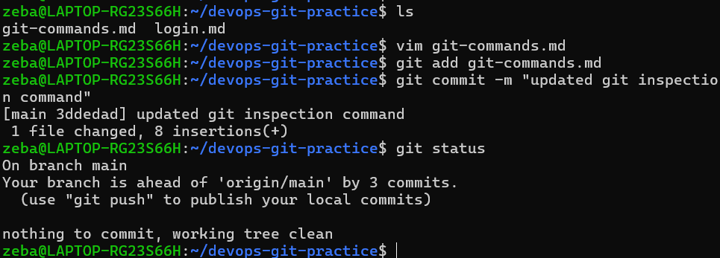

Merge feature-signup into main — what happens this time?
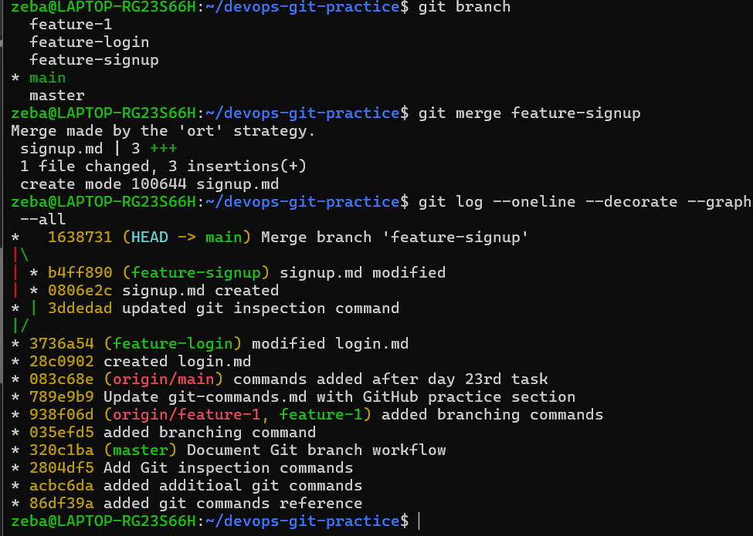
Merge commit happened

- Answer in your notes:

  - What is a fast-forward merge?
  - When does Git create a merge commit instead?
  - What is a merge conflict? (try creating one intentionally by editing the same line in both branches)

What is a fast-forward merge?
A fast-forward merge happens when the current branch has no new commits after the feature branch was created. Git can simply move the branch pointer forward without creating a new merge commit.
Example:
A → B → C
↑
main/feature

When does Git create a merge commit?
Git creates a merge commit when the two branches have diverged and both branches contain commits that are not present in the other branch.
Example:
D → E
/ \
A → B → C M
\ /
F ──
The M commit combines the two branch histories.

What is a merge conflict?
A merge conflict occurs when Git cannot automatically combine changes from two branches, commonly because both branches modified the same line or the same part of a file differently.
Git marks the conflicting section in the file:
<<<<<<< HEAD
Version from main
=======
Version from feature
>>>>>>> feature-branch
I must manually choose or combine the correct changes, then stage and commit the resolved file.
----------
(try creating one intentionally by editing the same line in both branches) ----
Created conflict.txt in main and added text
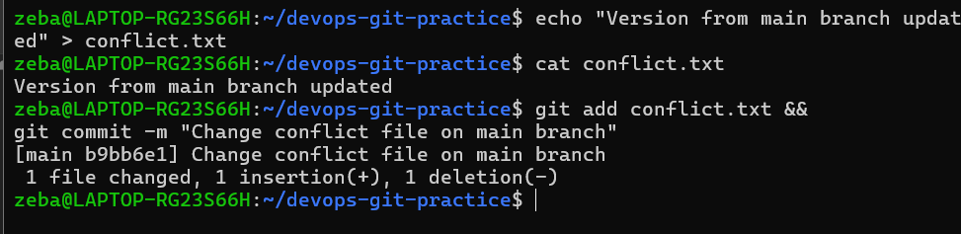
Created conflict-demo branch from main and same file conflict.txt and added some different text to it
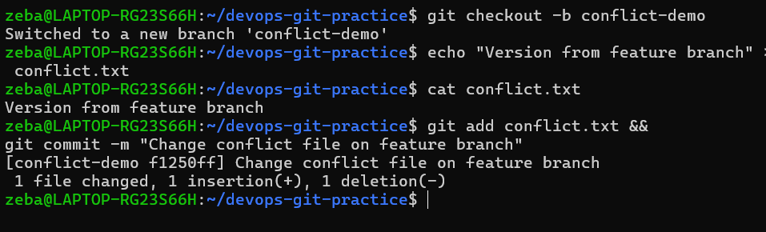

Be on main and merge it --- then merge conflict happens
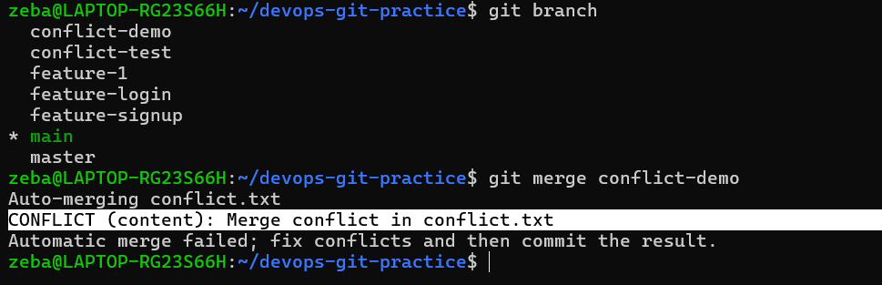 ┌── conflict-demo
│ "Version from feature branch"
│
A ── B ── C ─────┤
│
└── main
"Version from main branch updated"

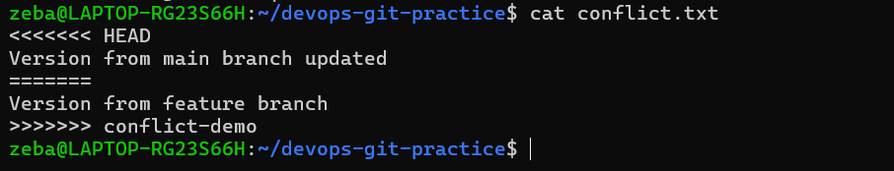

Manually edit the file
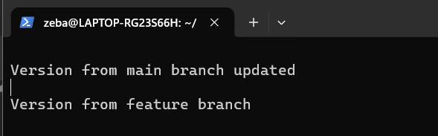

Resolve the conflict
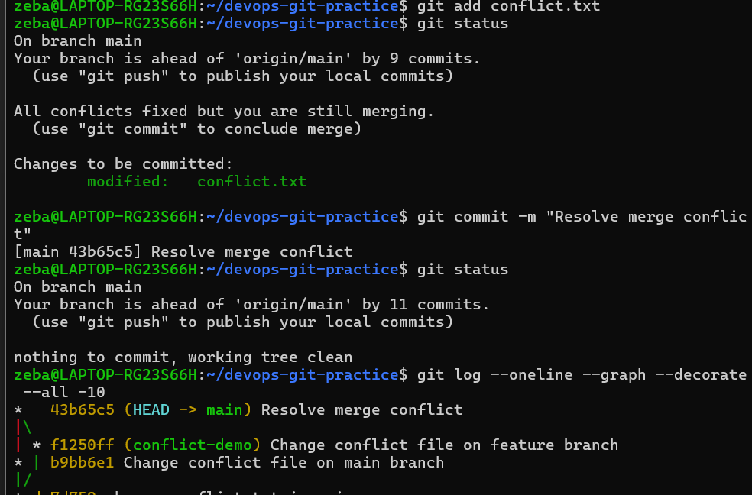

Task 2: Git Rebase — Hands-On
- Create a branch feature-dashboard from main, add 2-3 commits
- While on main, add a new commit (so main moves ahead)
- Switch to feature-dashboard and rebase it onto main
- Observe your git log --oneline --graph --all — how does the history look compared to a merge?
- Answer in your notes:
  - What does rebase actually do to your commits?
  - How is the history different from a merge?
  - Why should you never rebase commits that have been pushed and shared with others?
  - When would you use rebase vs merge?

Create a branch feature-dashboard from main, add 2-3 commits
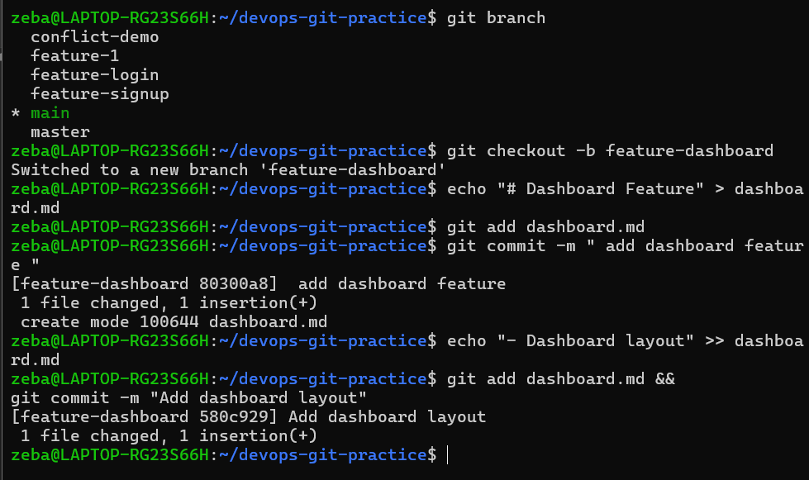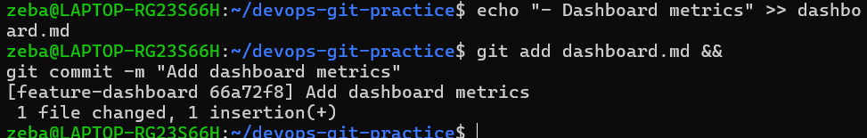

While on main, add a new commit (so main moves ahead)
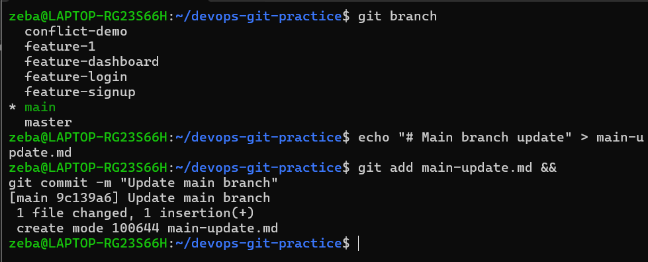

Switch to feature-dashboard and rebase it onto main
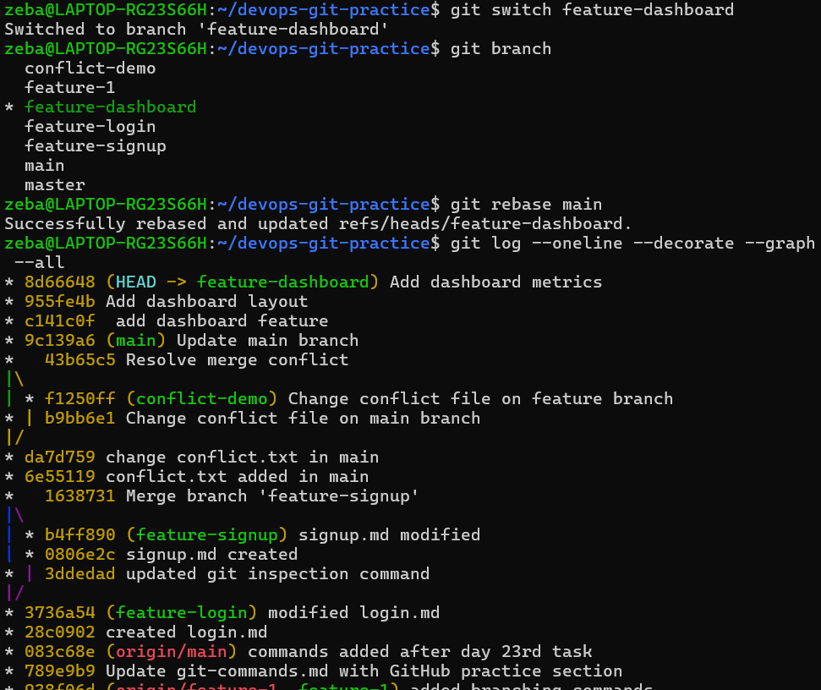
Before rebase, you had:
D ── E ── F
/
A ── B ── C ── G
After rebase, you should have a straight line:
A ── B ── C ── G ── D' ── E' ── F'
↑
feature-dashboard

main remains at G:
A ── B ── C ── G ── D' ── E' ── F'
↑ ↑
main feature-dashboard

Answer in your notes:
  - What does rebase actually do to your commits?
  - How is the history different from a merge?
  - Why should you never rebase commits that have been pushed and shared with others?
  - When would you use rebase vs merge?

What does rebase actually do to your commits?
Rebase takes the commits from my current branch and replays them on top of another branch. The commits are recreated with new commit IDs.

Example:
Before:
A → B → C
\
D → E

After rebase:
A → B → C → D' → E'

How is the history different from a merge?
Merge preserves the original branch history and usually creates a merge commit when the branches have diverged.
Rebase creates a linear history by replaying the feature commits on top of the latest base branch.

Why should you never rebase commits that have been pushed and shared with others?
Rebase changes commit history and creates new commit IDs. If other people already have the old commits, rebasing can cause their history and the remote history to differ, leading to confusion and difficult synchronization.

When would you use rebase vs merge?
I would use rebase when I want to update my private feature branch with the latest main changes and keep the history clean and linear.
I would use merge when I want to preserve the actual branch history, especially for shared branches or collaborative work.

Task 3: Squash Commit vs Merge Commit
- Create a branch feature-profile, add 4-5 small commits (typo fix, formatting, etc.)
- Merge it into main using --squash — what happens?
- Check git log — how many commits were added to main?
- Now create another branch feature-settings, add a few commits
- Merge it into main without --squash (regular merge) — compare the history
- Answer in your notes:
  - What does squash merging do?
  - When would you use squash merge vs regular merge?
  - What is the trade-off of squashing?

Create a branch feature-profile, add 4-5 small commits (typo fix, formatting, etc.)
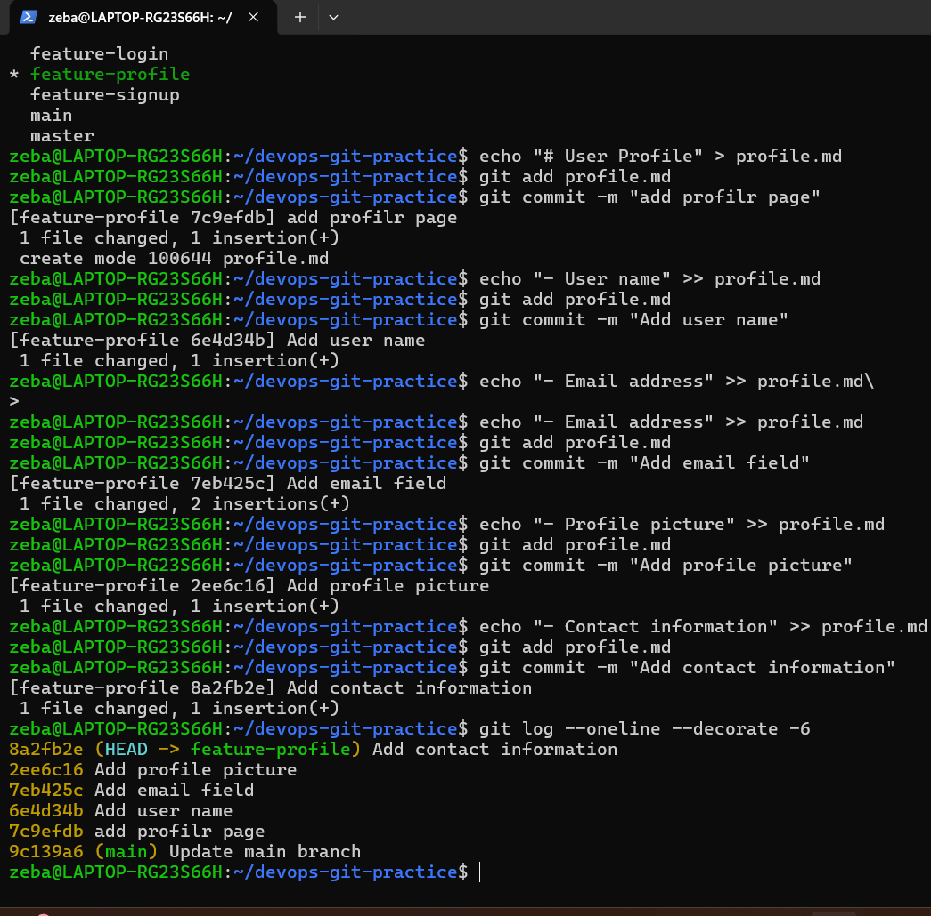

Merge it into main using --squash — what happens?
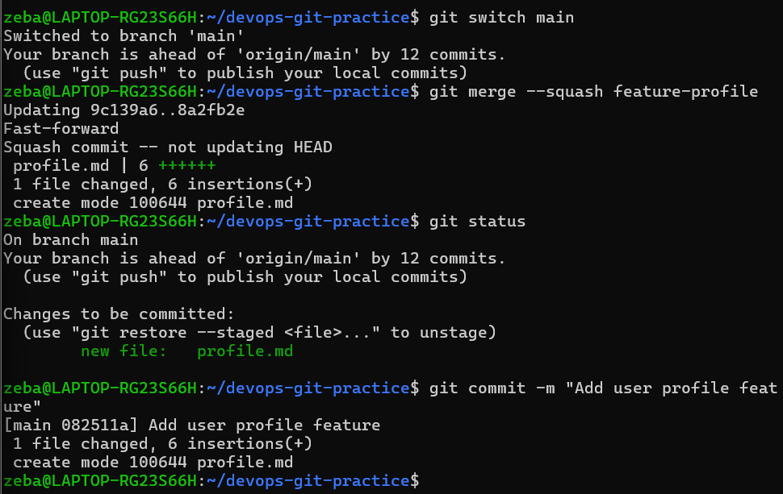 At this point Git has prepared the changes, but it has NOT created the commit yet.
So need to commit

Check git log — how many commits were added to main?
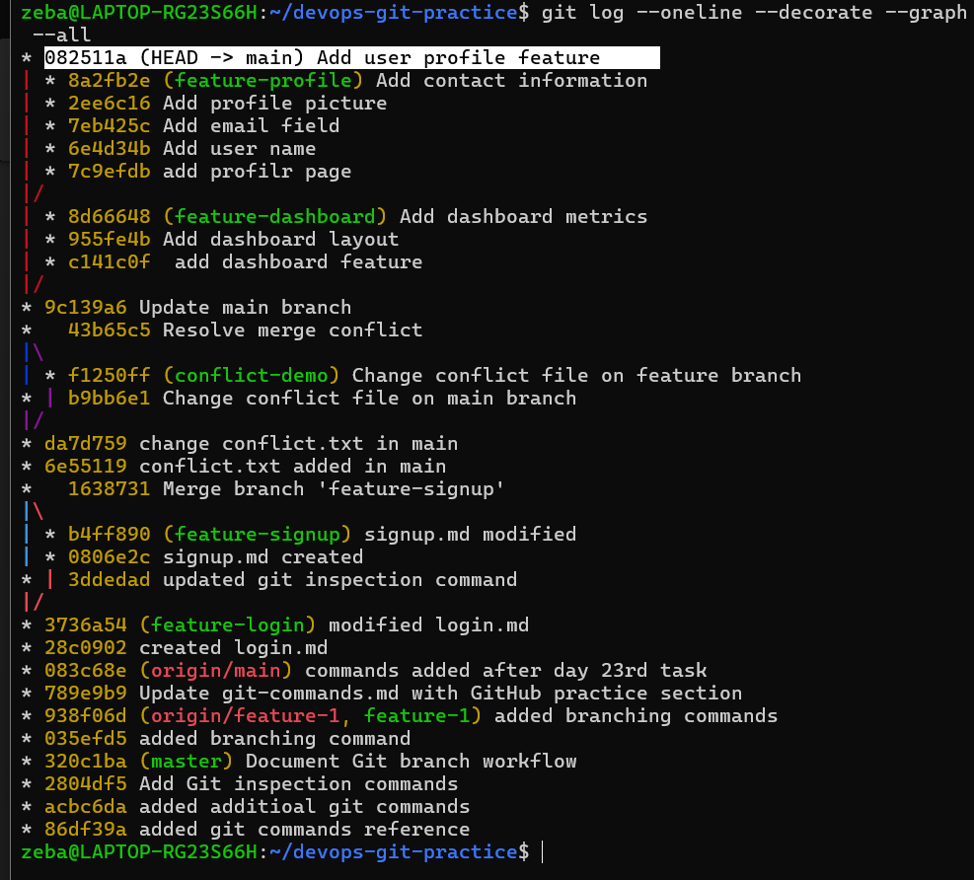
Only one commit will get add to the main
The original 5 commits still exist on the feature-profile branch, but they were not added individually to main.
- git merge --squash does NOT automatically create the commit.
- We need to commit it separately

Now create another branch feature-settings, add a few commits
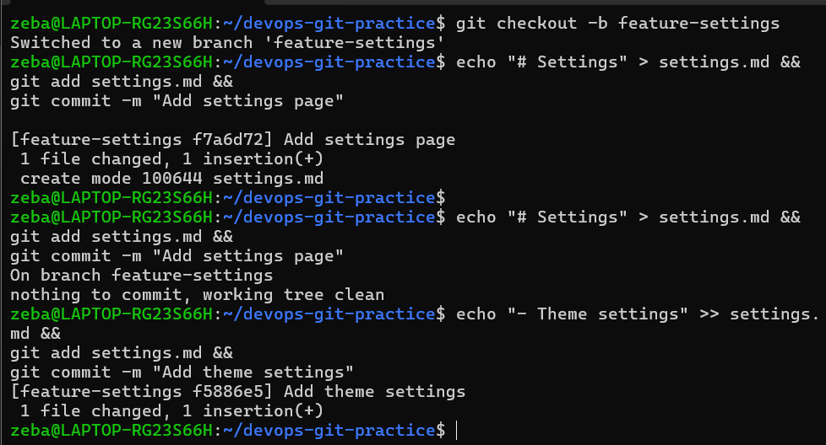

Merge it into main without --squash (regular merge) — compare the history
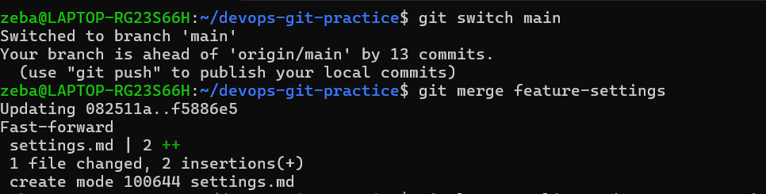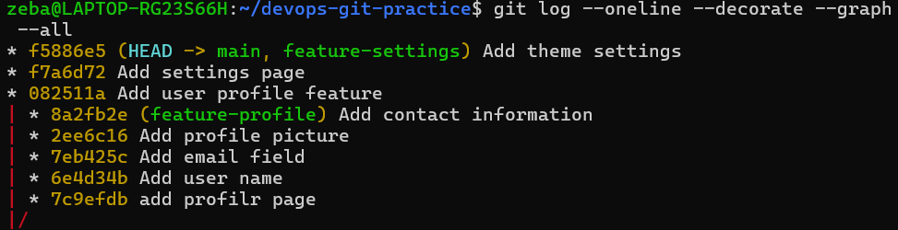
Answer in your notes:
  - What does squash merging do?
  - When would you use squash merge vs regular merge?
  - What is the trade-off of squashing?

What does squash merging do?
Squash merging combines all the commits from a feature branch into one set of changes and creates one new commit on the target branch.

Example:
Feature:
A → B → C → D

Main after squash:
A → S
- The four feature commits are combined into one commit on main.

When would you use squash merge vs regular merge?
I would use squash merging when a feature branch contains many small or temporary commits such as typo fixes, formatting changes, and work-in-progress commits. It keeps the main branch history clean and easy to read.
I would use a regular merge when I want to preserve the individual commits and the development history of the feature.

What is the trade-off of squashing?
The advantage is a clean and simple main branch history with one commit representing the complete feature.
The disadvantage is that the individual commits and their detailed development history are not preserved in the target branch. This can make it harder to see how the feature was developed or identify a specific intermediate change later.

Task 4: Git Stash — Hands-On
- Start making changes to a file but do not commit
- Now imagine you need to urgently switch to another branch — try switching. What happens?
- Use git stash to save your work-in-progress
- Switch to another branch, do some work, switch back
- Apply your stashed changes using git stash pop
- Try stashing multiple times and list all stashes
- Try applying a specific stash from the list
- Answer in your notes:
  - What is the difference between git stash pop and git stash apply?
  - When would you use stash in a real-world workflow?

Start making changes to a file but do not commit
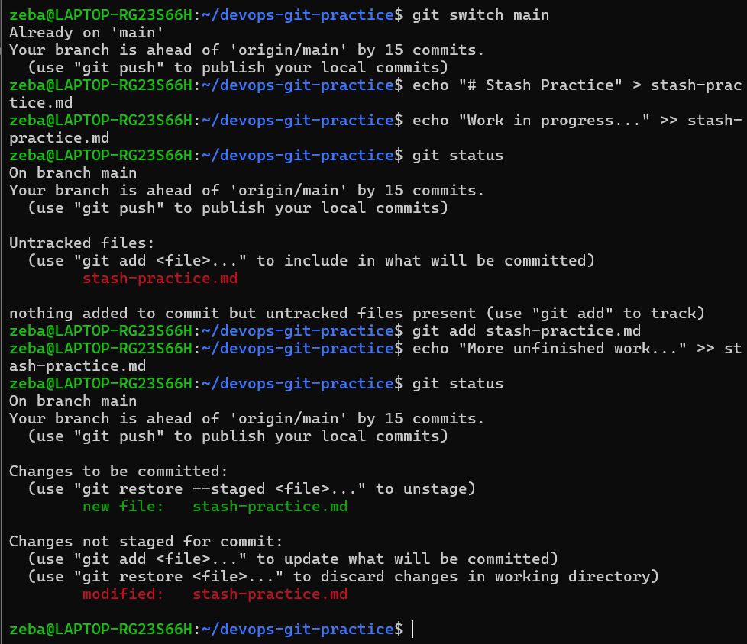
Now imagine you need to urgently switch to another branch — try switching. What happens?
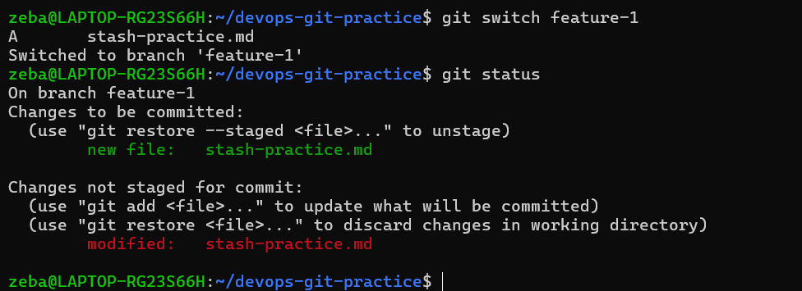
That's actually an important point:
Git does not always refuse a branch switch when you have uncommitted changes.
It refuses when switching would overwrite/conflict with your local changes.

Use git stash to save your work-in-progress
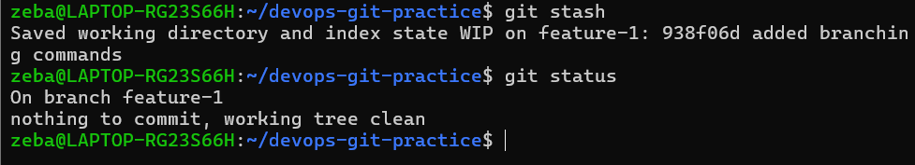 Your work has temporarily disappeared from the working directory, but it has not been deleted.

Switch to another branch, do some work, switch back
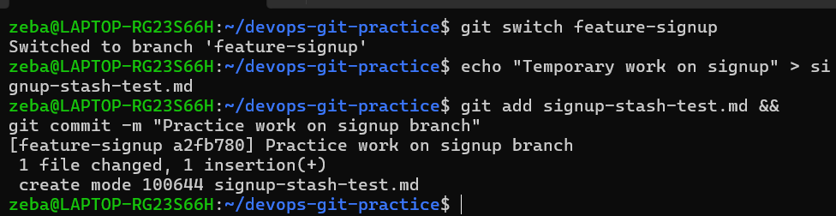
Apply your stashed changes using git stash pop
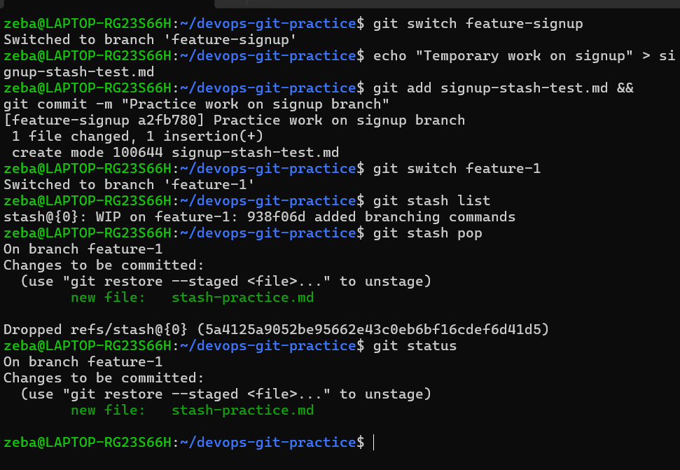
Try stashing multiple times and list all stashes
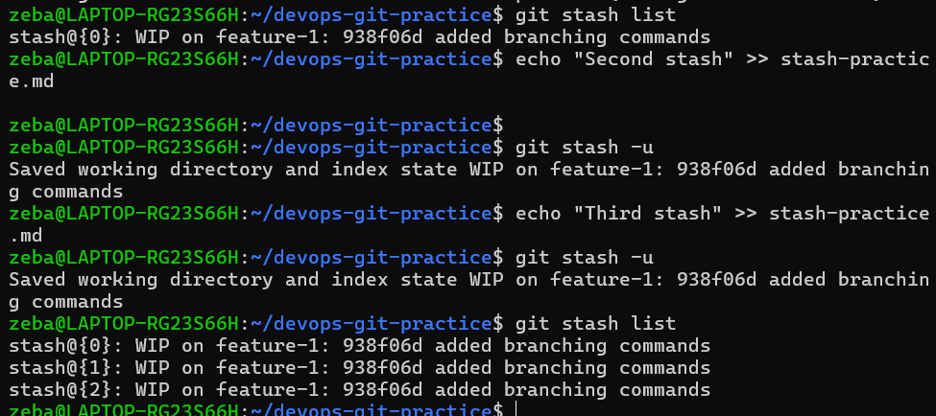
After 1st stash if w want to stash further then we need to use
git stash -u

Try applying a specific stash from the list
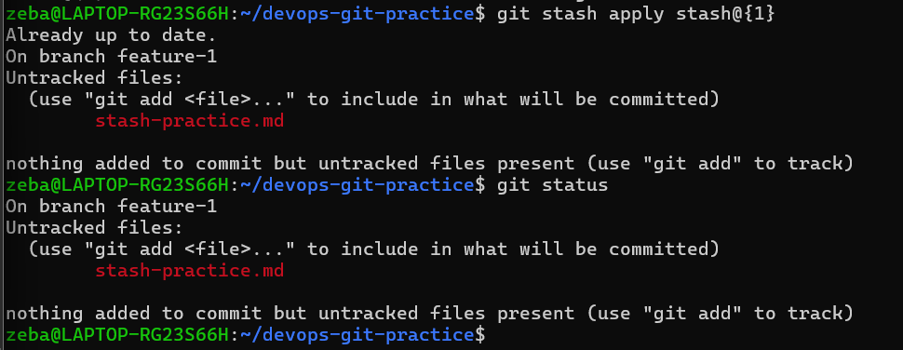git stash apply stash@{1} – it will apply it and it wont remove the stash
Where as git stash pop stash@{1} – it will apply it and will remove the stash

- Answer in your notes:
  - What is the difference between git stash pop and git stash apply?
  - When would you use stash in a real-world workflow?

What is the difference between git stash pop and git stash apply?
git stash pop applies the stashed changes and removes that stash from the stash list.
git stash pop stash@{1}
git stash apply applies the stashed changes but keeps the stash in the stash list.
git stash apply stash@{1}

When would you use stash in a real-world workflow?
I would use git stash when I have unfinished work but need to temporarily switch to another branch for an urgent task, bug fix, or production issue.
Instead of making an incomplete commit, I can stash my changes, switch branches, complete the urgent work, and then return to my original branch and restore my changes.

Task 5: Cherry Picking
- Create a branch feature-hotfix, make 3 commits with different changes
- Switch to main
- Cherry-pick only the second commit from feature-hotfix onto main
- Verify with git log that only that one commit was applied
- Answer in your notes:
  - What does cherry-pick do?
  - When would you use cherry-pick in a real project?
  - What can go wrong with cherry-picking?

Create a branch feature-hotfix, make 3 commits with different changes
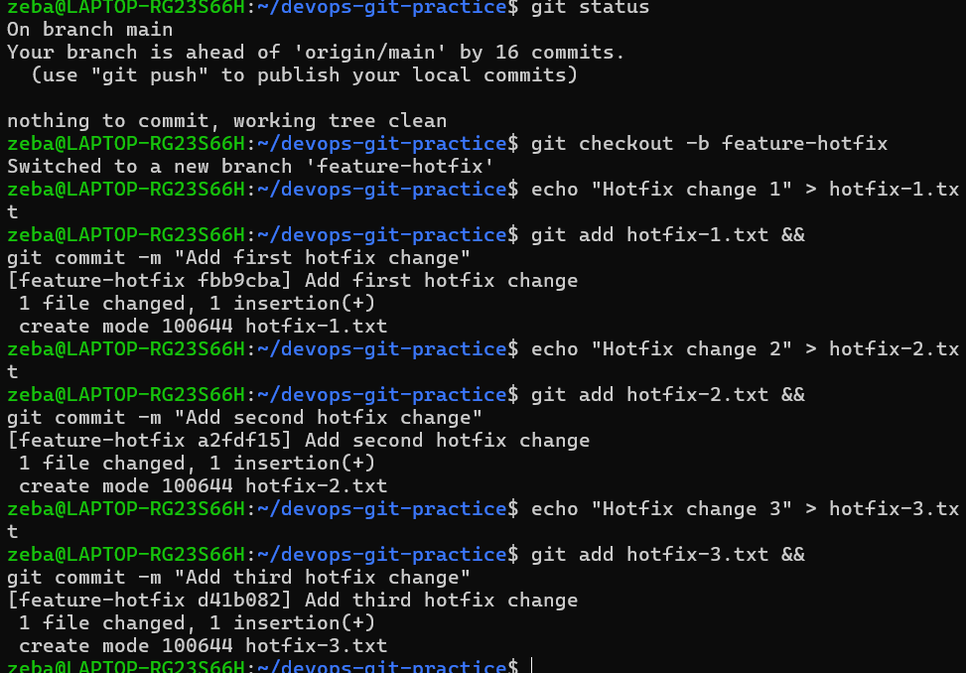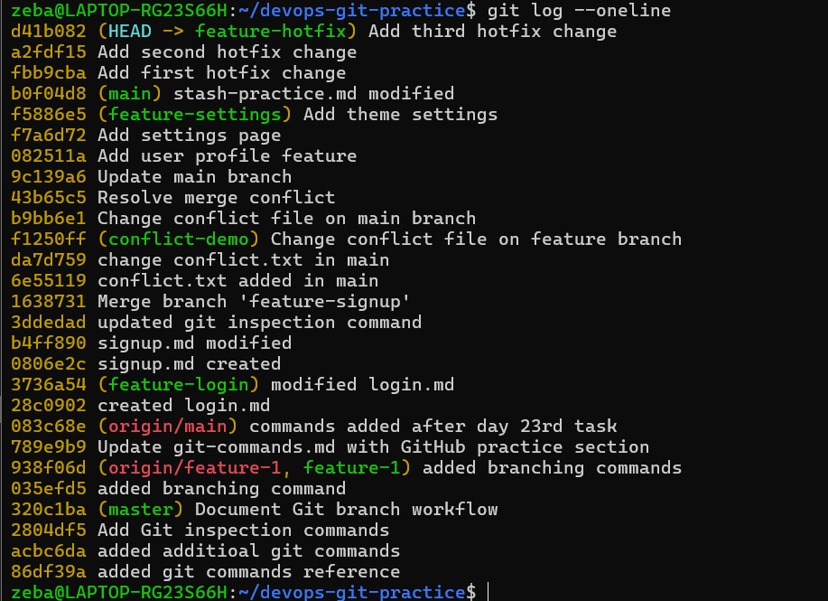

Switch to main
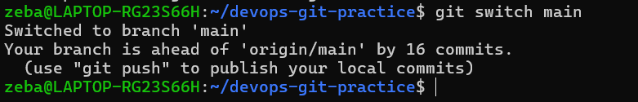
Cherry-pick only the second commit from feature-hotfix onto main
Verify with git log that only that one commit was applied

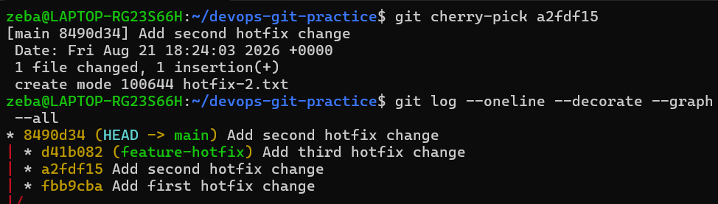
- Answer in your notes:
  - What does cherry-pick do?
  - When would you use cherry-pick in a real project?
  - What can go wrong with cherry-picking?

What does cherry-pick do?
0git cherry-pick takes the changes introduced by a specific commit from another branch and applies them to the current branch.
It creates a new commit on the current branch.
Example:
git cherry-pick <commit-id>

When would you use cherry-pick in a real project?
I would use cherry-pick when I need a specific fix or change from another branch without merging the entire branch.
For example, if a bug fix is available on a development branch but the other unfinished features should not go to production, I can cherry-pick only the bug-fix commit into the production branch.

What can go wrong with cherry-picking?
Cherry-picking can cause merge conflicts if the changes in the selected commit conflict with the current branch.
It can also create duplicate changes or confusing history if the same change is later merged through another branch.
Cherry-picking also creates a new commit, so the original and cherry-picked commits have different commit IDs.

