Day 73 -- Introduction to Observability and Prometheus

Task 1: Understand Observability
Research and write short notes on:
- What is observability? How is it different from traditional monitoring?
  - Monitoring tells you when something is wrong (alerts, thresholds)
  - Observability tells you why something is wrong (explore, query, correlate)
- The three pillars of observability:
  - Metrics -- numerical measurements over time (CPU usage, request count, error rate). Tools: Prometheus, Datadog, CloudWatch
  - Logs -- timestamped text records of events (application output, error messages). Tools: Loki, ELK Stack, Fluentd
  - Traces -- the journey of a single request across multiple services. Tools: OpenTelemetry, Jaeger, Zipkin
- Why do DevOps engineers need all three?
  - Metrics tell you what is broken (high error rate on /api/users)
  - Logs tell you why it broke (stack trace showing a database timeout)
  - Traces tell you where it broke (the payment service call took 12 seconds)
- Draw or describe this architecture -- this is what you will build over the next 5 days:
[Your App] --> metrics --> [Prometheus] --> [Grafana Dashboards]
[Your App] --> logs --> [Promtail] --> [Loki] --> [Grafana]
[Your App] --> traces --> [OTEL Collector] --> [Grafana/Debug]
[Host] --> metrics --> [Node Exporter] --> [Prometheus]
[Docker] --> metrics --> [cAdvisor] --> [Prometheus]

- Observablity :-
It is the ability to understand the internal health and behaviour of the system by analysing the data it generated.
Traditional monitoring detects the known problem, but observability helps in investigating that known problem.

- 3 pillars:
Matrics – it is the numerical data collected over the time, ex: cpu %, memory, http error rate. Tool = prometheus
Logs – record of the events generated by the applications or the system, ex: authentication failure, database connection timeout. Tool = Loki
Trace – tracks the request as it travels over multiple resources, ex: API Gateway -> authentication -> payment -> database. Tool = OpenTelemetry

- Y devops engineers need these 3
- Matrics - tells what is broken
- Logs – tell why it is broken
- Trace – where it is broken

- Architecture

Let's break it down.
Data source | Collection tool | Storage / processing | Visualization
Application metrics | Application metrics endpoint | Prometheus | Grafana
Application logs | Promtail | Loki | Grafana
Application traces | OTEL Collector | Trace backend | Grafana / tracing tools
Linux host metrics | Node Exporter | Prometheus | Grafana
Docker metrics | cAdvisor | Prometheus | Grafana

Task 2: Set Up Prometheus with Docker
Create a project directory for this entire observability block -- you will keep adding to it over the next 5 days.
mkdir observability-stack && cd observability-stack
Create a prometheus.yml configuration file:
global:
scrape_interval: 15s
evaluation_interval: 15s

scrape_configs:
- job_name: "prometheus"
static_configs:
- targets: ["localhost:9090"]
This tells Prometheus to scrape its own metrics every 15 seconds.
Create a docker-compose.yml to run Prometheus:
services:
prometheus:
image: prom/prometheus:latest
container_name: prometheus
ports:
- "9090:9090"
volumes:
- ./prometheus.yml:/etc/prometheus/prometheus.yml
- prometheus_data:/prometheus
command:
- '--config.file=/etc/prometheus/prometheus.yml'
restart: unless-stopped

volumes:
prometheus_data:
Start Prometheus:
docker compose up -d
Open http://localhost:9090 in your browser. You should see the Prometheus web UI.
Verify: Go to Status > Targets. You should see one target (prometheus) with state UP.

prometheus.yml
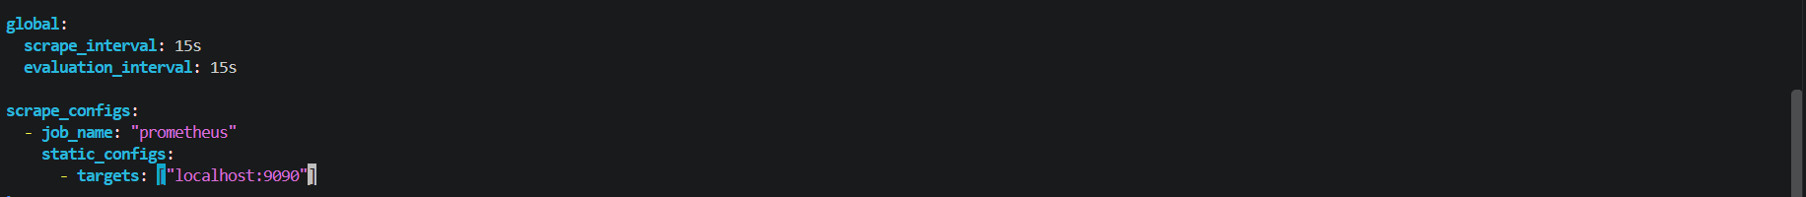
This tells Prometheus to scrape its own metrics every 15 seconds.

compose.yml
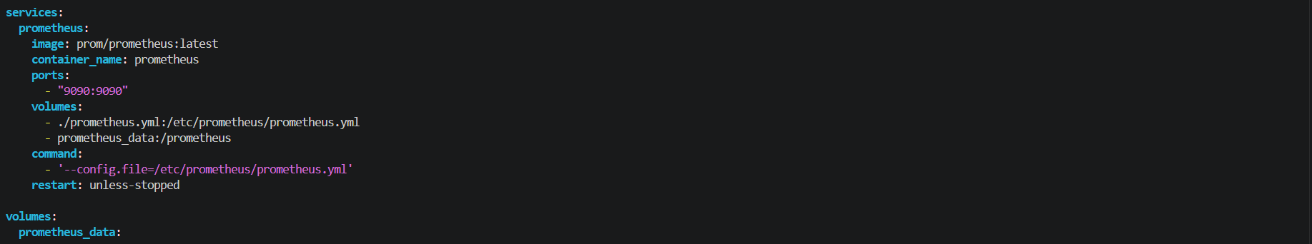
It runs Prometheus

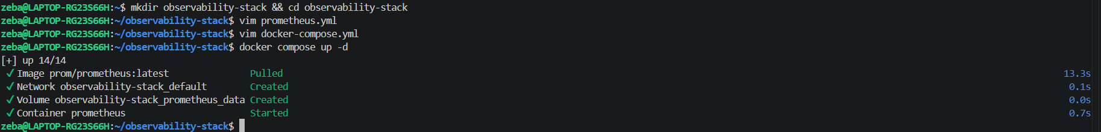
Prometheus started
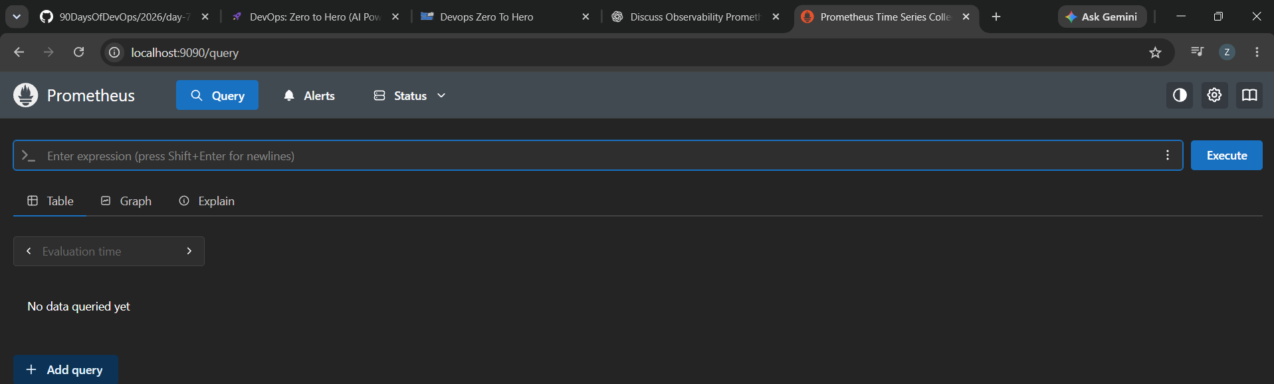
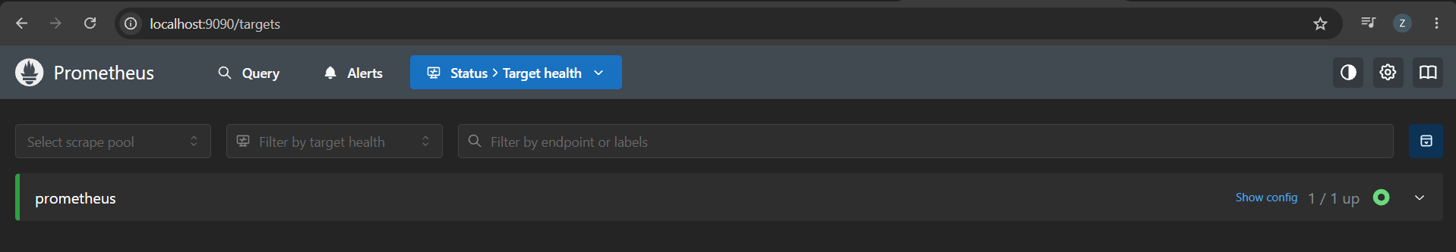
Task 3: Understand Prometheus Concepts
Explore the Prometheus UI and understand these concepts:
- Scrape targets -- endpoints that Prometheus pulls metrics from at regular intervals (pull-based model)
- Metrics types:
  - Counter -- only goes up (total requests served, total errors)
  - Gauge -- goes up and down (current CPU usage, memory in use, active connections)
  - Histogram -- distribution of values in buckets (request duration: how many took <100ms, <500ms, <1s)
  - Summary -- similar to histogram but calculates percentiles on the client side
- Labels -- key-value pairs that add dimensions to metrics (e.g., http_requests_total{method="GET", status="200"})
- Time series -- a unique combination of metric name + labels
Go to the Prometheus UI graph page (http://localhost:9090/graph) and run these queries:
# How many metrics is Prometheus collecting about itself?
count({__name__=~".+"})

# How much memory is Prometheus using?
process_resident_memory_bytes

# Total HTTP requests to the Prometheus server
prometheus_http_requests_total

# Break it down by handler
prometheus_http_requests_total{handler="/api/v1/query"}
Document: What is the difference between a counter and a gauge? Give one real-world example of each.

- Scrape targets: it is the endpoints from which Prometheus scrape data/ pulls data (pull based method)

- Matrics type:

- Counter : it is a kind matrics whose value will increase until it restarts, until application restarts
Ex: http requests, login failed attempts, payment successful
- Gauge : it is the one who’s value will increase or decrease. Ex. CPU utilization, memory usage

Counter : how many events occurred
Gauge : what is the current value

- Histogram : it groups the observations into the configured buckets
Suppose we receive 1000 API requests
100 requests – lass than 100ms
300 requests – less than 500ms
600 requests = less than 1 sec

- Summary : A Summary also measures observations, but it calculates quantile at client side

- Labels: labels are the key-value pair which adds additional information to the matrics.
Suppose we received HTTP Requests without label 1000
http_request_total 1000

With label
http_request_total{method=”GET”, status=”200”} 100
http_request_totao{method=”POST”, status=”200”} 400
http_request-total{method=”POST”, status=”500”} 500

- Time series: A time series is a sequence of timestamped values identified by a unique metric name and label combination.
Metric name + unique label combination = one time series.

5.
# How many metrics is Prometheus collecting about itself?
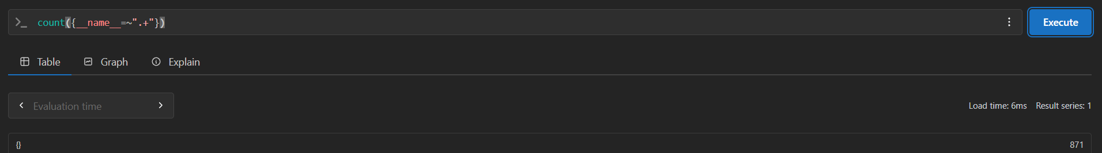

# How much memory is Prometheus using?
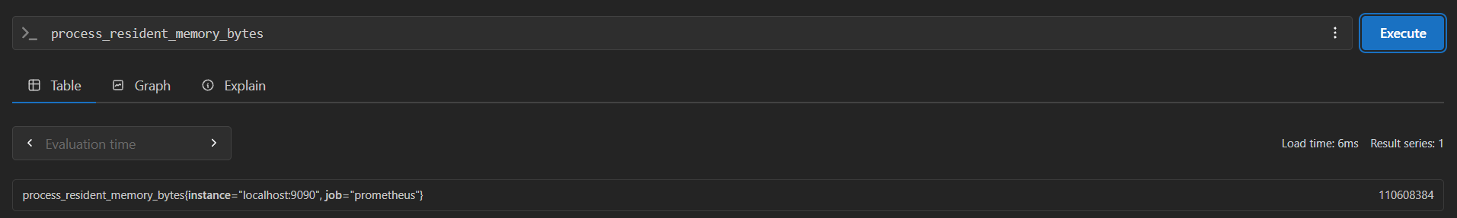
# Total HTTP requests to the Prometheus server
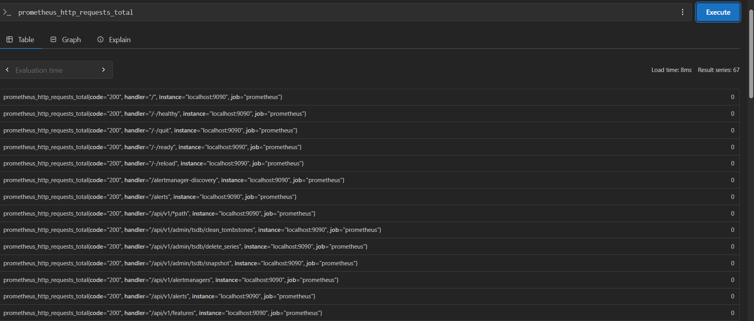
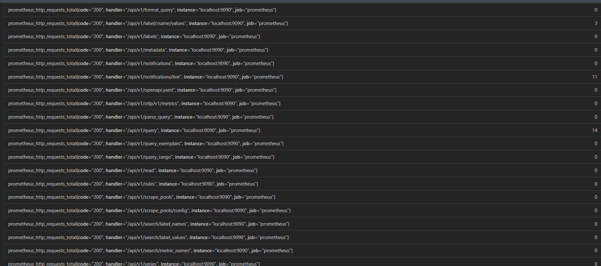
# Break it down by handler
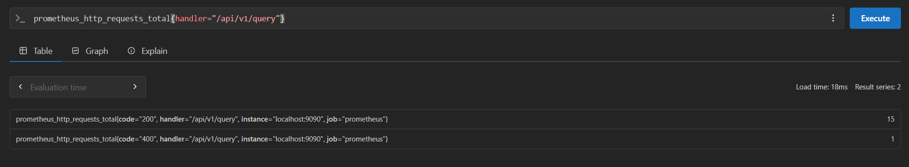
Task 4: Learn PromQL Basics
PromQL (Prometheus Query Language) is how you ask questions about your metrics. Run these queries in the Prometheus UI:
- Instant vector -- current value of a metric:
up
This returns 1 (up) or 0 (down) for each scrape target.
- Range vector -- values over a time window:
prometheus_http_requests_total[5m]
Returns all values from the last 5 minutes.
- Rate -- per-second rate of a counter over a time window:
rate(prometheus_http_requests_total[5m])
This is the most common function you will use. Counters always go up -- rate() converts them to a useful per-second speed.
- Aggregation -- sum across all label combinations:
sum(rate(prometheus_http_requests_total[5m]))
- Filter by label:
prometheus_http_requests_total{code="200"}
prometheus_http_requests_total{code!="200"}
- Arithmetic:
process_resident_memory_bytes / 1024 / 1024
This converts bytes to megabytes.
- Top-K:
topk(5, prometheus_http_requests_total)
Try this exercise: Write a PromQL query that shows the per-second rate of non-200 HTTP requests to Prometheus over the last 5 minutes. (Hint: use rate() with a label filter on code!="200")

- Instant vector -- current value of a metric:
up
This returns 1 (up) or 0 (down) for each scrape target.
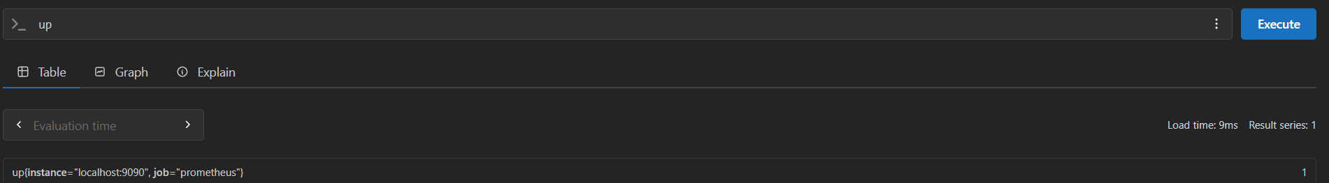

- Range vector -- values over a time window:
prometheus_http_requests_total[5m]
Returns all values from the last 5 minutes.
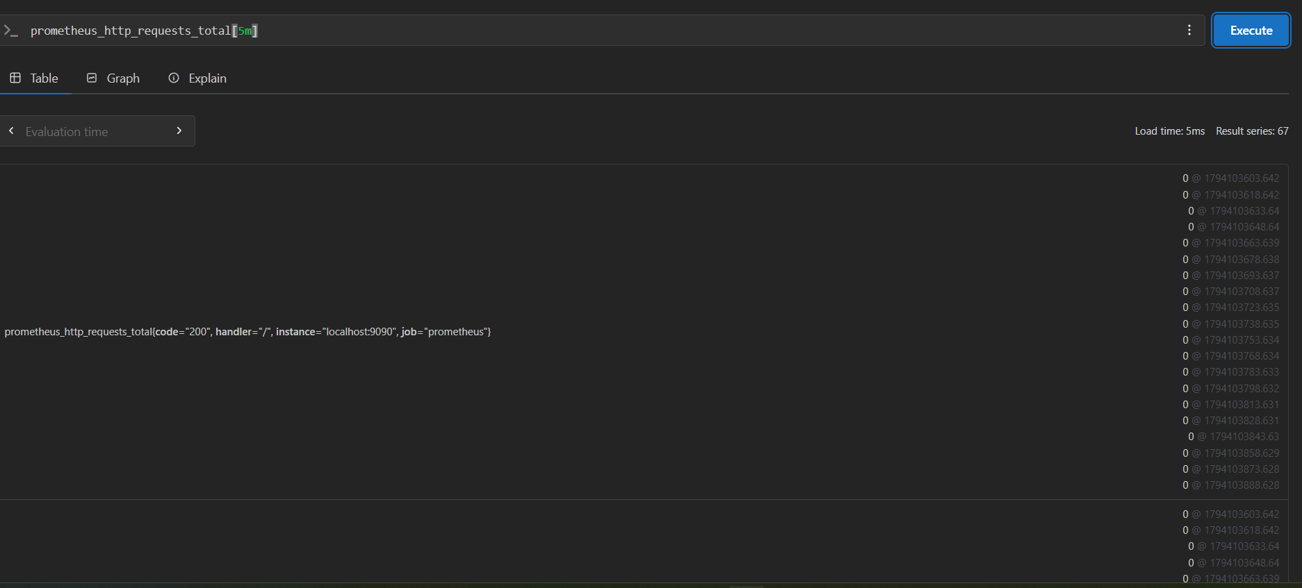
- Rate -- per-second rate of a counter over a time window:
rate(prometheus_http_requests_total[5m])
This is the most common function you will use. Counters always go up -- rate() converts them to a useful per-second speed.
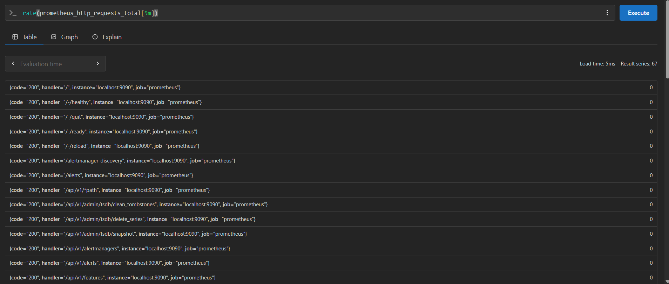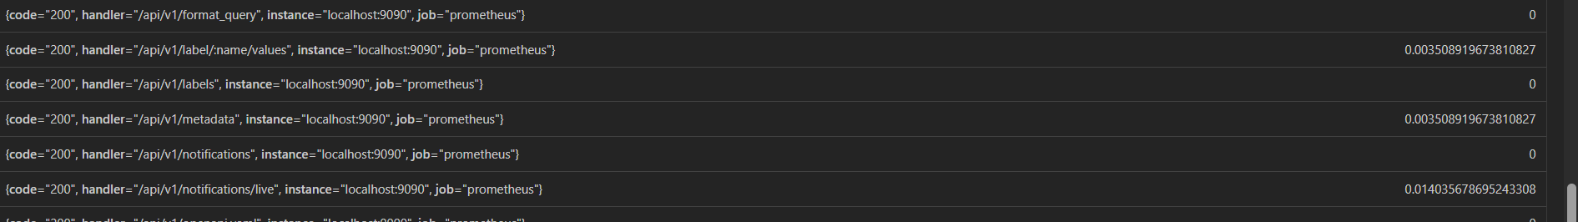

- Aggregation -- sum across all label combinations:
sum(rate(prometheus_http_requests_total[5m]))
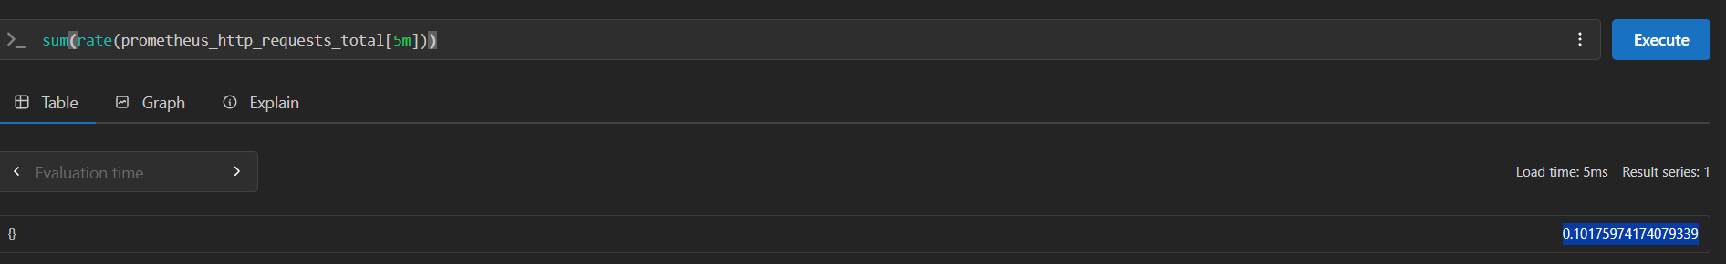

- Filter by label:
prometheus_http_requests_total{code="200"}
prometheus_http_requests_total{code!="200"}
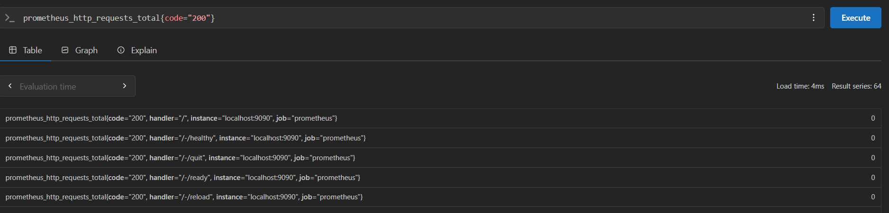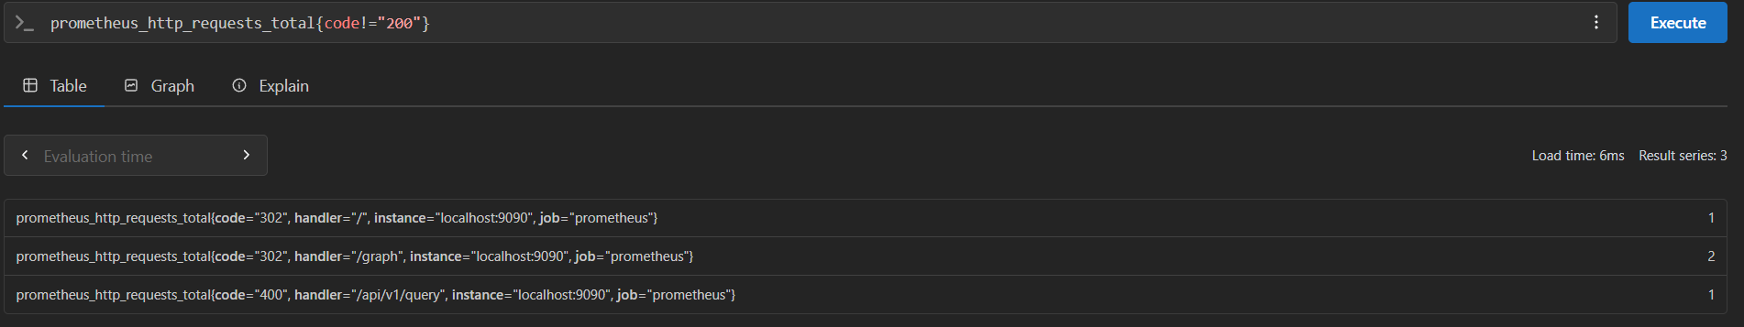

- Arithmetic:
process_resident_memory_bytes / 1024 / 1024
This converts bytes to megabytes.
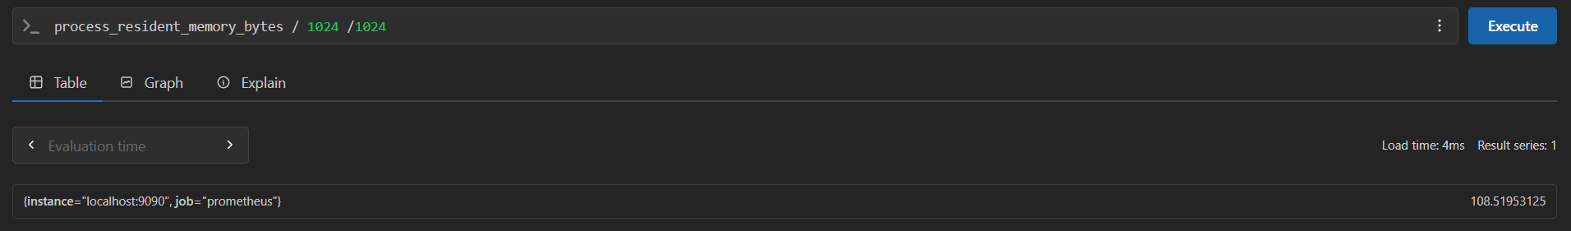

- Top-K:
topk(5, prometheus_http_requests_total)
Try this exercise: Write a PromQL query that shows the per-second rate of non-200 HTTP requests to Prometheus over the last 5 minutes. (Hint: use rate() with a label filter on code!="200")
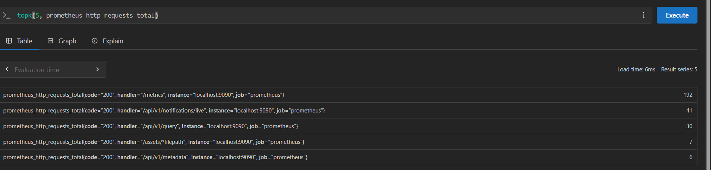

Task 5: Add a Sample Application as a Scrape Target
Prometheus needs something to monitor. Add a simple metrics-generating service.
Update your docker-compose.yml to include a sample app that exposes Prometheus metrics:
services:
prometheus:
image: prom/prometheus:latest
container_name: prometheus
ports:
- "9090:9090"
volumes:
- ./prometheus.yml:/etc/prometheus/prometheus.yml
- prometheus_data:/prometheus
command:
- '--config.file=/etc/prometheus/prometheus.yml'
restart: unless-stopped

notes-app:
image: trainwithshubham/notes-app:latest
container_name: notes-app
ports:
- "8000:8000"
restart: unless-stopped

volumes:
prometheus_data:
Update prometheus.yml to scrape the app:
global:
scrape_interval: 15s
evaluation_interval: 15s

scrape_configs:
- job_name: "prometheus"
static_configs:
- targets: ["localhost:9090"]

- job_name: "notes-app"
static_configs:
- targets: ["notes-app:8000"]
Restart the stack:
docker compose up -d
Go back to Status > Targets. You should now see two targets. Generate some traffic to the app:
curl http://localhost:8000
curl http://localhost:8000
curl http://localhost:8000
Note: Not all applications expose Prometheus metrics natively. In later days you will learn how Node Exporter, cAdvisor, and OTEL Collector act as metric exporters for systems that do not have built-in Prometheus support.

docker-compose.yml
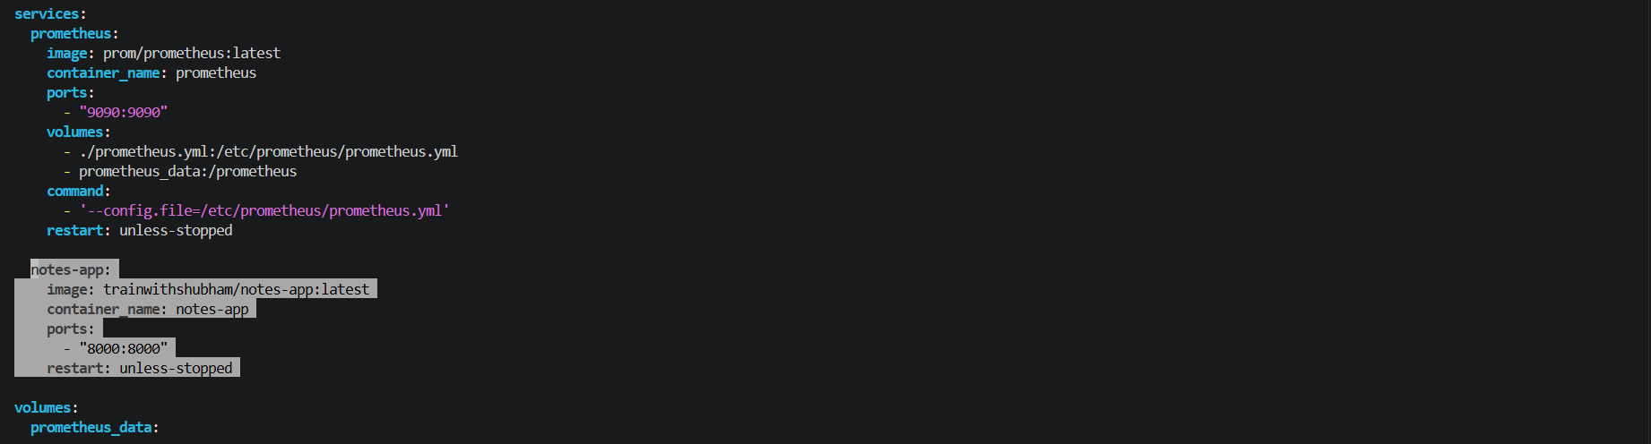
prometheus.yml
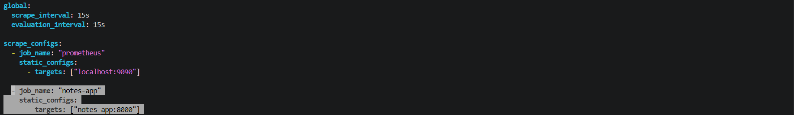
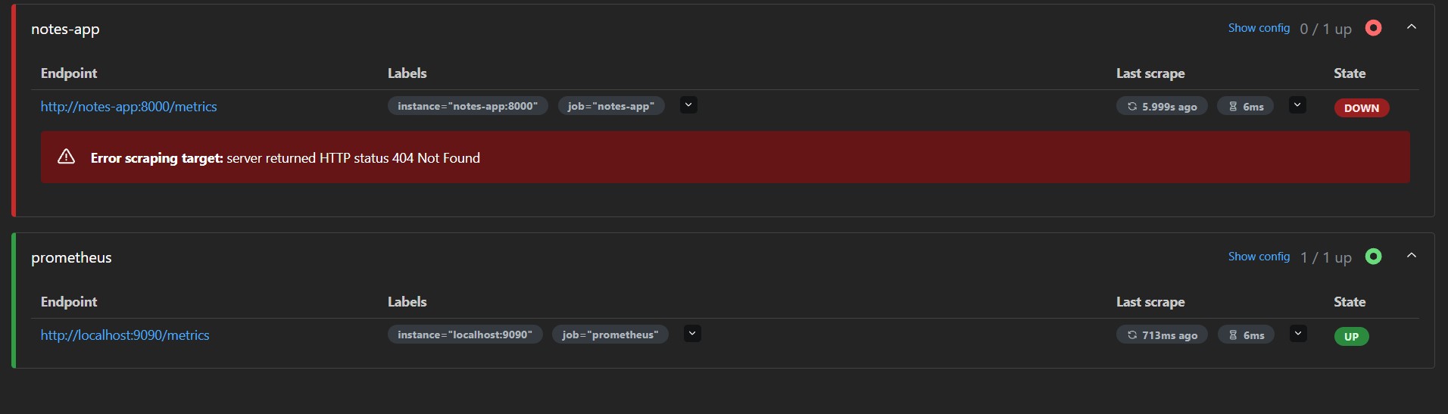
Here we can see the Prometheus is reaching to node app nut the node app is not exposing the matrics
Task 6: Explore Data Retention and Storage
Understand how Prometheus stores data:
- Check how much disk space Prometheus is using:
docker exec prometheus du -sh /prometheus
- Prometheus stores data in a local time-series database (TSDB). Default retention is 15 days. You can change it:
command:
- '--config.file=/etc/prometheus/prometheus.yml'
- '--storage.tsdb.retention.time=30d'
- '--storage.tsdb.retention.size=1GB'
- Check the TSDB status in the UI: Status > TSDB Status
Document: What happens when retention is exceeded? Why is a volume mount important for Prometheus data?
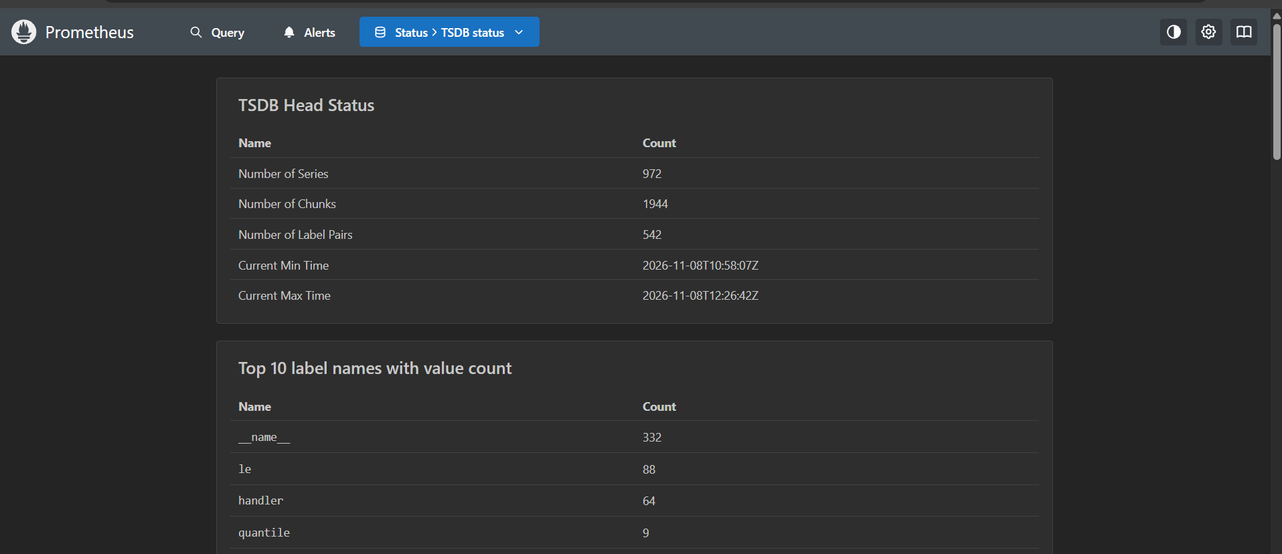
TSDB Status – Practical Results:-
- Number of Series: 972
- Number of Chunks: 1944
- Number of Label Pairs: 542
- Prometheus disk usage: 3.1 MiB

What happens when retention is exceeded?:-
Prometheus automatically removes older historical data blocks during background cleanup when the configured retention time or size limit is exceeded.

Why is a volume mount important?:-
A Docker named volume provides persistent storage for Prometheus TSDB data.
When a Prometheus container is removed and recreated, the stored data remains available as long as the named volume is preserved.

