# User Test 1:

I have explained the concept initially about the purpose of the site. Here goes her comments and suggestions:

“Wow, the website seems superb & very impressive. Let me add some points:

1- The style of the interface is fresh and concise, with unified tone and wonderful color scheme selected.

2- Both the information framework and the function of navigation bar are clear, being easy to find the content needed.

3- Feedback box should have some more space to adjust my contents :)

4- One thing, Scrollbar shouldn’t appear on right side. Try removing that.”

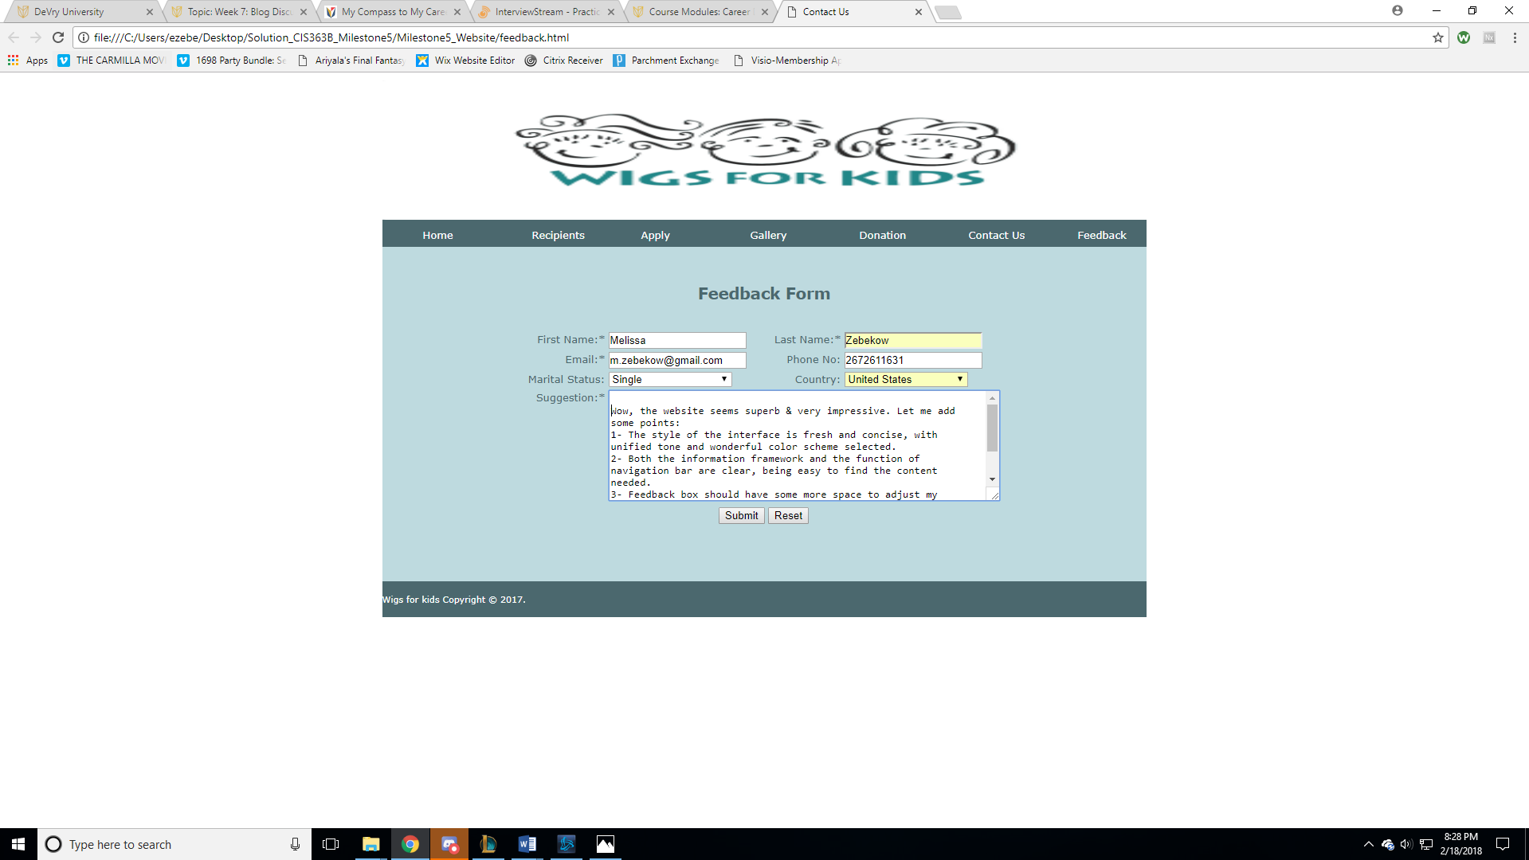

# My Response to User Test 1:

1. Thanks.
2. Thanks.
3. Will adjust this one to handle huge contents
4. This can be worked on.

# User Test 2:

He doesn’t seem like having any confusion. I have to explain him too the purpose of the website.. As for his response is concerned,

“The site looks simple. Design looks awesome and it seems easy to use. Site navigation is simpler & user friendly. PFB few suggestions:

1. There can be a page that highlights different payment methods to collect the payments for trust school like paypal etc.

2. Tooltip design can be improved. Right now the contents appear as congested from both side.

3.The Copy right contents in the footer are left aligned totally. You can add some space at the beginning.”

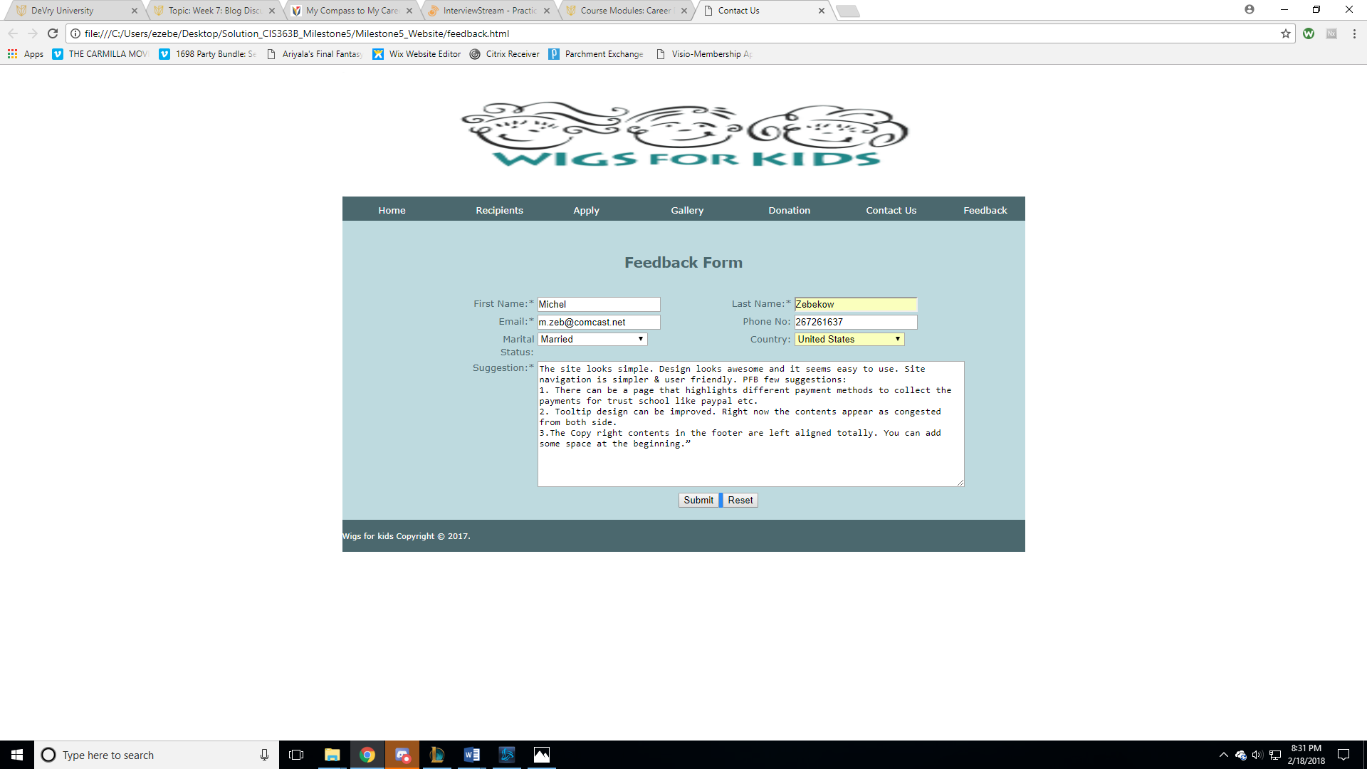

# My Response to User Test 2:

1. Well, the requirement u added here looks good for an actual trust based website but since that’s a fictional website and a course project so we can skip this requirement.
2. This can be worked on.
3. This can be worked on.

# Comparison of User Responses with My Expectation:

I am glad that I got a chance to work and build a website in HTML. For me that’s an achievement and I got to learn so much working on it. As for the responses collected from the users, they can be done and I don’t see any critical error or issue in their suggestions, most of them are design related. In milestone 7, all the possible highlighted issues are fixed and adjust as mentioned in the responses above. Also, the feedback form is redesigned to accommodate the changes.