HW2

Problem 1



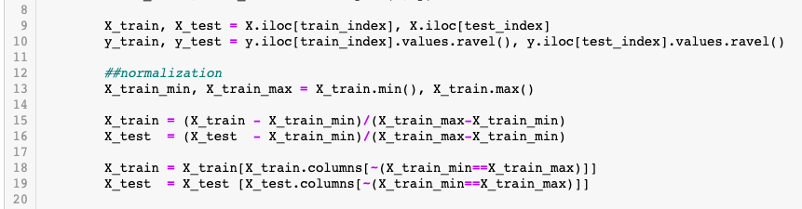



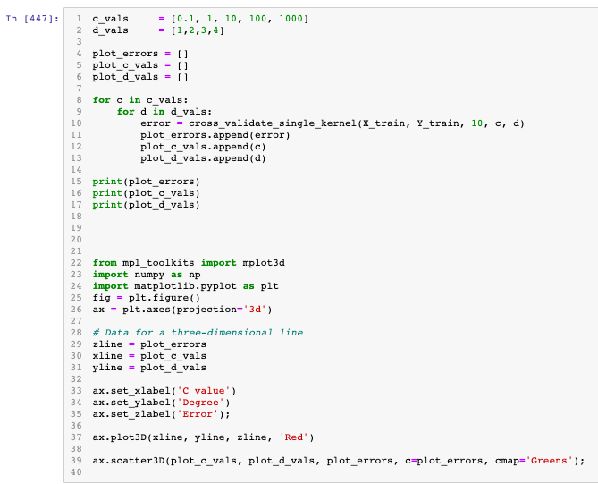

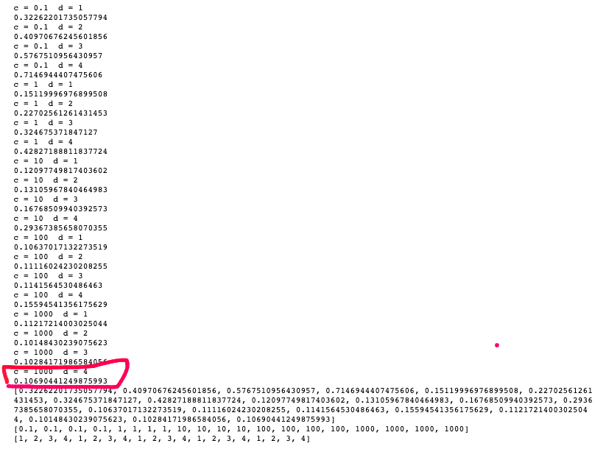

The best value is C = 1000 and d = 4



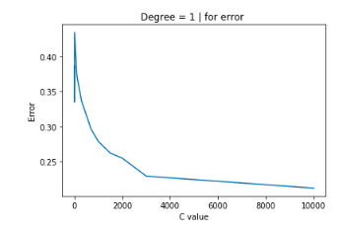

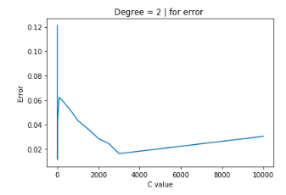

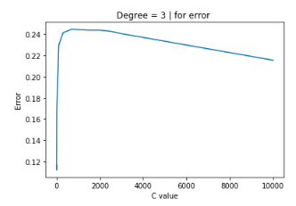

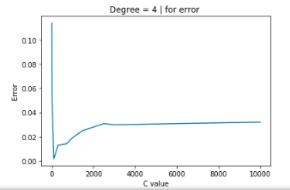



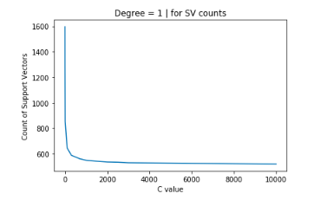

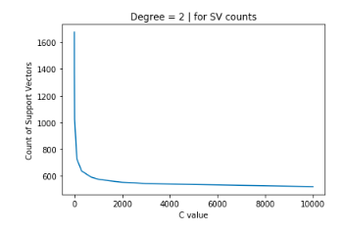

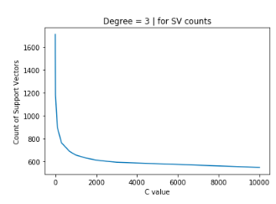

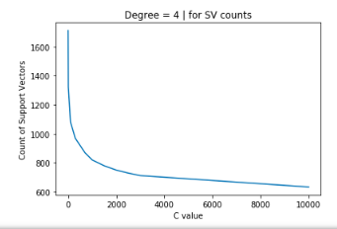

1. Sorry I am trying to use the y\*f(x) > 1 to calculate the points but failed.

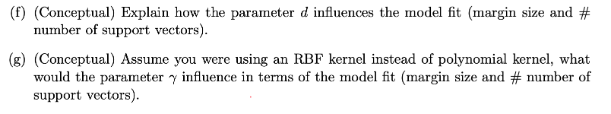

When the d become larger, the number of support vectors change more smoothly with C value. On the other side, when d = 1, it leads to a liner separation. When d becomes bigger, it allow more flexible decision boundary.

1. The behavior of the model (RBF) is very sensitive to the gamma parameter.

* too large, the radius of the area of influence of the support vectors only includes the support vector itself and no amount of regularization with C will be able to prevent overfitting.
* too small, the model is too constrained and cannot capture the complexity or “shape” of the data. The region of influence of any selected support vector would include the whole training set. And the model will behave similarly to a linear model with a set of hyperplanes that separate the centers of high density of any pair of two classes.

Problem 2



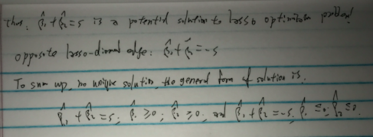

Problem 3

See Jupyter notebook