UIN: 128007734 | Zebo Xiong

1 (a)

We use the unpickle function to extract the data

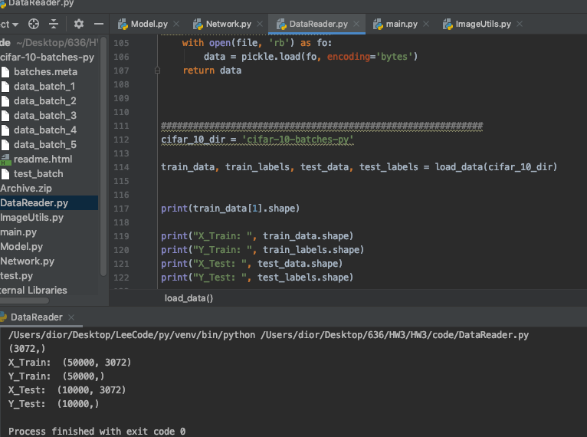

1(b)

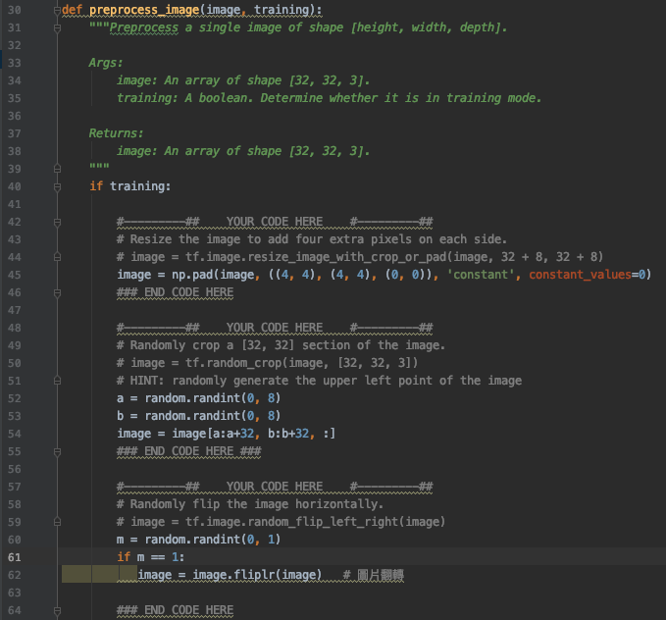

1(c)

* Batch norm relu

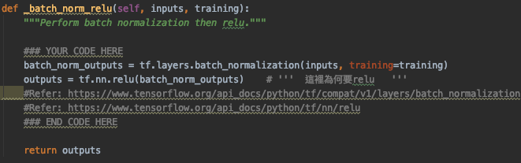

* Start layer 🡪 which use to start the network

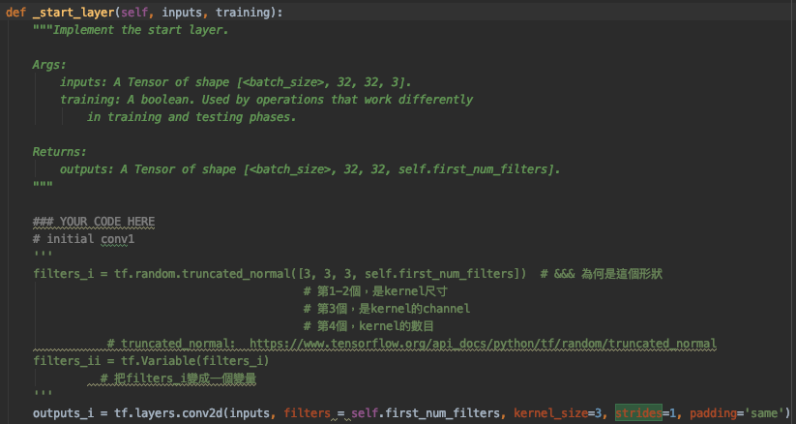

* Output layer 🡪 which finish the network

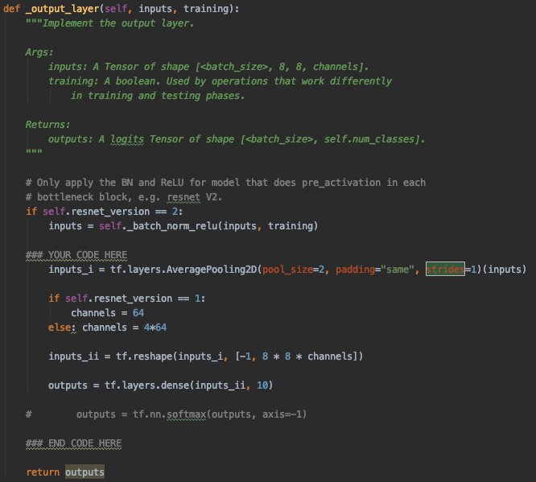

* Stack layer 🡪 which content the several components

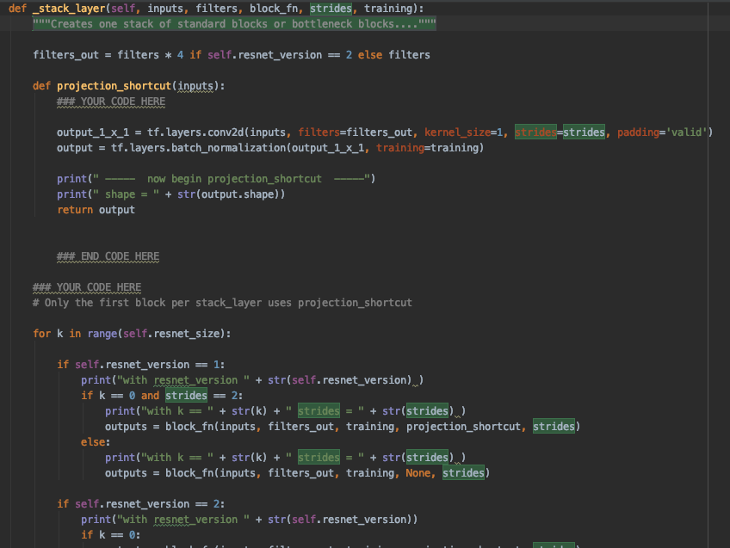

* standard residual block 🡪 this is what we need to construct

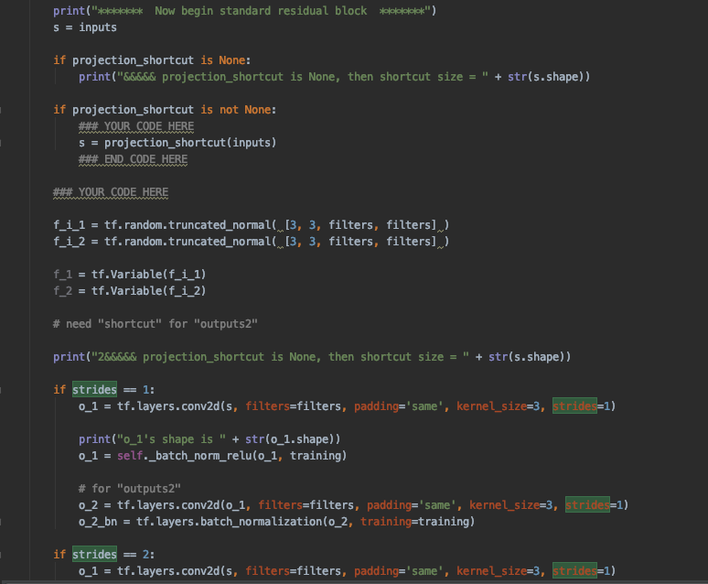

* bottleneck block 🡪 this is also what we need to construct

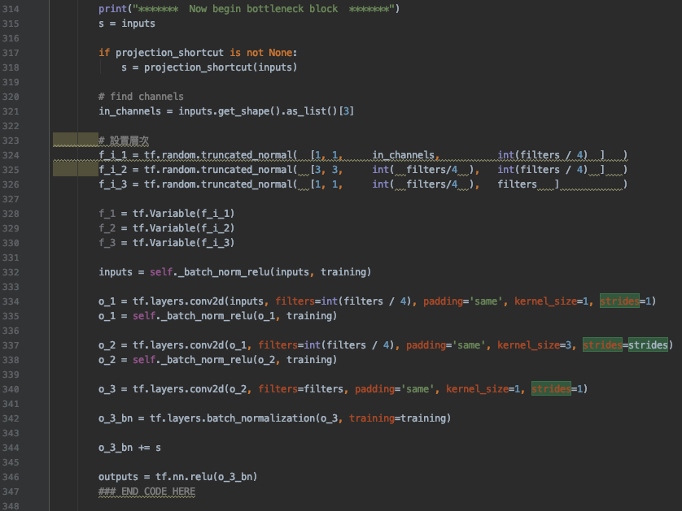

1(d)

Setup 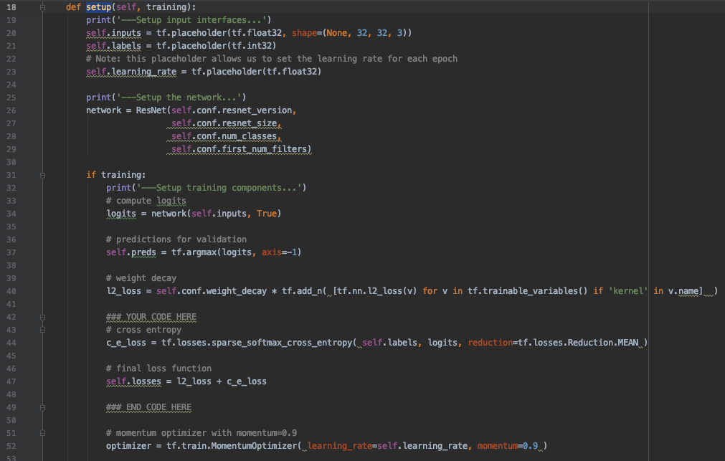

train

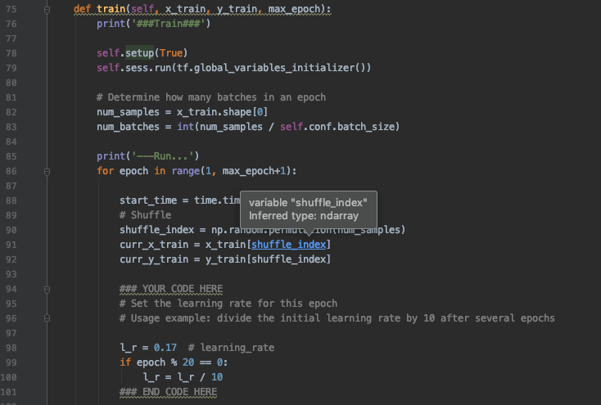

* test_or_validate

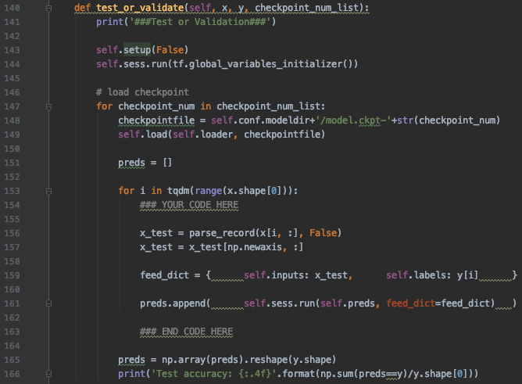

1(e)

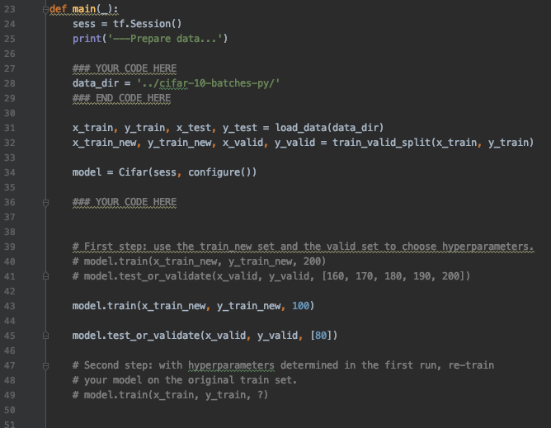

2. 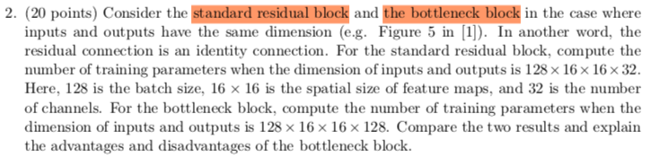

1. standard residual block

32*3*3*32 + 32*3*3*32 = **18432**

Reference graph ONLY

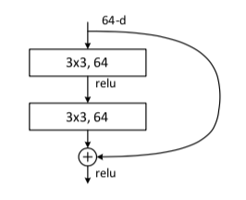

We only consider 32 🡪 the channel number

1. the bottleneck block

Reference graph ONLY

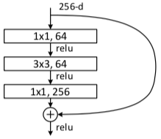

128*1*1*32 + 32*3*3*32 + 32*1*1*128 = **17408**

🡪 the advantage for bottleneck block is: less computation complexity

3.

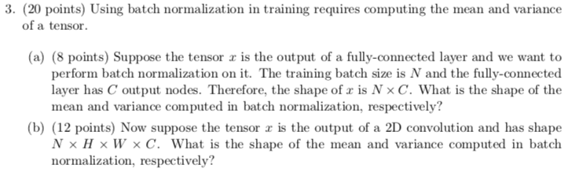

1. 1*C for both mean and variance
2. 1*1*1*C for both mean and variance

Reference:

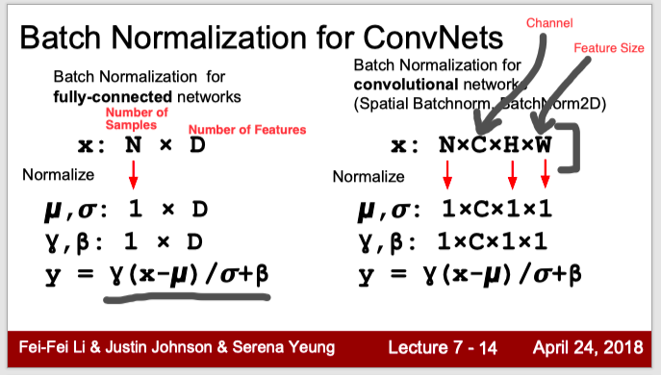

4.

